Sediment Trap Data from the Strait of Georgia

May 1995 to January 1999

M.C. O’Brien, M. Soon, B. Nielsen, C. Elliot, T. Juhasz, R.W. Macdonald,
K.L. Denman, R.E. Thomson, S.E. Calvert

Institute of Ocean Sciences
Department of Fisheries and Oceans
Sidney, B.C. V8L 4B2

2000

Canadian Data Report of
Hydrography and Ocean Sciences
NO. 155

Canadian Data Report of Hydrography and Ocean Sciences No. 155

2000

Sediment Trap Data from the Strait of Georgia

May 1995 to January 1999

by

M.C. O’Brien, M. Soon, B. Nielsen, C. Elliot, T. Juhasz, R.W. Macdonald,
K.L. Denman, R.E. Thomson, S.E. Calvert

Institute of Ocean Sciences
Department of Fisheries and Oceans
Sidney, B.C. V8L 4B2

Copyright Minister of Supply and Services Canada – 2000
Cat. No. Fs 97 – 16/155E ISSN 0711-6721

Correct citation for this publication :

M.C. O’Brien, M. Soon, B. Nielsen, C. Elliot, T. Juhasz, R.W. Macdonald,
K.L. Denman, R.E. Thomson, S.E. Calvert, 2000, Sediment Trap Data from the Strait of Georgia, May 1995 to January 1999. Can. Data Rep. Hydrogr. Ocean. Sci.: 155, 92pp.
Table of Contents

1. INTRODUCTION 1
1.1 Overview of the Field Work 2
2. FIELD SAMPLING METHODS AND EQUIPMENT 3
2.1 Baker Sequential Sediment Traps and Preparations for Deployment 3
3. sample handling and Analytical methods 4
3.1 Subsampling 4
3.2 Total dry weight flux 4
3.3 Total carbon, organic carbon, total nitrogen and carbonate analysis 5
3.4 Biogenic silica analysis 5
3.5 Carbon and Nitrogen isotope analysis 6
3.6 Quality control procedures 7
4. REFERENCES 8
5. LIST OF FIGURES 9
6. LIST OF TABLES 17
7. LIST OF APPENDICES 35

Abstract

M.C. O’Brien, M. Soon, B. Nielsen, C. Elliot, T. Juhasz, R.W. Macdonald,
K.L. Denman, R.E. Thomson, S.E. Calvert, 2000, Sediment Trap Data from the Strait of Georgia, May 1995 to January 1999. Can. Data Rep. Hydrogr. Ocean. Sci.: 155, 92pp.

Sediment traps were deployed in four locations in the Strait of Georgia during the period May 1995 to January 1999. The less than 500 micron portion of captured sediment was analyzed for percent composition values for total carbon, organic carbon, total nitrogen, carbonate carbon and biogenic silica as well as for stable isotopes of carbon and nitrogen. Fluxes for total dry weight, organic carbon, carbonate carbon, total nitrogen and biogenic silica were calculated for each collection interval. Collection intervals varied from 8 to 20 days. There is a three year record from nine deployments from March 1996 to January 1999 for the 150 metre sediment trap at station GSCM3 which is located in the deep basin between Valdes Island and Sturgeon Bank. Also at station GSCM3, there is a one year record from three deployments at 225 and 300 metres from February 1998 to January 1999. At station GSCM2, located off Saturna Island and GSCM4 off Gabriola Island, there is a two year record from six deployments at 150 metres for March 1996 to February 1998. At station GS, also off Gabriola Island, there is a record from two deployments at 325 and 340 metres respectively from May 1995 to April 1996.

Key words: Strait of Georgia, sediment trap, carbon, nitrogen, biogenic silica, carbonate, carbon isotopes, nitrogen isotopes, flux.

Résumé

M.C. O’Brien, M. Soon, B. Nielsen, C. Elliot, T. Juhasz, R.W. Macdonald,
K.L. Denman, R.E. Thomson, S.E. Calvert 2000. Sediment Trap Data from the Strait of Georgia, May 1995 to January 1999. Can. Data Rep. Hydrogr. Ocean. Sci.: 155, 92pp.

Des pièges à sédiments ont été déployés à quatre sites du détroit Georgia de mai 1995 à janvier 1999. Les particules de moins de 500 microns récoltées ont été analysées pour en déterminer la composition en pourcentage du carbone total, carbone organique, azote total, carbone sous forme de carbonate et silice biogénique, de même que la composition des isotopes stables du carbone et de l'azote. Les flux en poids sec total, carbone organique, carbone sous forme de carbonate, azote total et silice biogénique ont été calculés pour chacun des intervalles de temps entre les déploiements, ceux-ci variant entre 8 et 20 jours. Nous rapportons l'enregistrement de trois années de données pour neuf déploiements de mars 1996 à janvier 1999 à 150 m de profondeur à la station GSCM3, laquelle est située dans le bassin profond entre l'île Valdes et le banc Sturgeon. Nous rapportons également, pour cette même station, l'enregistrement d'une année de données pour trois déploiements à 225 et 300 m de profondeur de février 1998 à janvier 1999. Pour les stations GSCM2 et GSCM4, respectivement situées au large des îles Saturna et Gabriola, nous rapportons l'enregistrement de deux années de données pour six déploiements à 150 m de profondeur de mars 1996 à février 1998. Enfin, nous rapportons un enregistrement de données pour deux déploiements à 325 et 340 m de profondeur de mai 1995 à avril 1996 à la station GS, également située au large de l'île Gabriola.

Mots clés: Détroit Georgia, piège à sédiments , carbone, azote, silice biogénique, carbonate, isotopes du carbone, isotopes de l'azote, flux.

Acknowledgments

This work was funded by the Department of Fisheries and Oceans, Canada as part of the program entitled “Study of factors Influencing the marine survival of Coho and Chinook salmon in the Strait of Georgia”. We are indebted to the officers and the crews of CCGS Vector and CCGS John P. Tully for their assistance in the deployments and recoveries of 27 moorings over the three year period. Thanks to Patricia Kimber for preparing the mooring figures and to Charles Gobiel for assisting us with the translation of the abstract into French.

INTRODUCTION
As part of larger programs designed to study the transport of particles and factors influencing the marine survival of coho and chinook salmon, sediment traps were deployed in the central basin of the Strait of Georgia. The data will be used to assist in the determination of the timing of biological production and the timing and geographic extent of sinking particles from the Fraser River.

There is strong evidence of changes in the Strait of Georgia ecosystem and it has been hypothesized that these changes are associated with climatic changes as, for example, manifested in a warming trend in the waters of the Strait of Georgia. Comparisons of surface phytoplankton biomass and sediment trap materials will help to resolve the relationship between surface production and vertical transport of particles.

Sediment traps and current meters were deployed during the period from May 1995 to January 1999 at stations GS, GSCM2, GSCM3 and GSCM4. The data from the analysis of the trap material from the less than 500 micron portion is reported here with the exception of the microscopic analysis which will be reported elsewhere. The greater than 500 micron portion has been set aside for future analysis. The samples were sieved and subsampled at the Institute of Ocean Sciences and a portion was sent to the Department of Earth and Ocean Sciences at the University of British Columbia for analysis. This report documents the analysis conducted by UBC and includes data for the percent composition values for total carbon, organic carbon, total nitrogen, carbonate carbon and biogenic silica. Also reported are the flux data for the collection intervals including total dry weight flux, organic carbon flux, carbonate carbon flux, total nitrogen flux and biogenic silica flux as well as the stable isotope data for carbon and nitrogen.

At station GSCM3, in the deep basin (408 metres) between Valdes Island and Sturgeon Bank, there is a three year continuous sediment trap record at 150 metres (March 1996 to January 1999) and a one year record at 225 and 300 metres (February 1998 to January 1999). At station GSCM2 off Saturna Island and GSCM4 off Gabriola Island, there are two years of continuous sediment trap record at 150 metres (March 1996 to February 1998). At station GS off Gabriola Island and not far from GSCM4 there is a continuous sediment trap record from two deployments (325 and 340 metres) from May 1995 to April 1996. Figure 1 shows the locations of the mooring stations.

Current meter records were collected at stations GSCM1, GSCM2, GSCM3 and GSCM4 to assist in the interpretation of the sediment trap data and are reported elsewhere. The depths of the current meters on the moorings are noted Table 2. There were no current meters deployed on the moorings at station GS. See Figures 3 and 4 for the mooring configurations at stations GSCM1, GSCM2, GSCM3 and GSCM4.

CTD/Rosette transects were done at the times of deployment and recovery of the moorings and Figure 2 shows the locations of these stations. Table 1b lists the cruise identifications and dates for the CTD/R work done in the Strait of Georgia during the period from January 1996 to January 1999. Water samples for dissolved oxygen, salinity and nutrients (nitrate plus nitrite, silicate and orthophosphate) were taken and analyzed during these cruises. The CTD and water chemistry data is reported elsewhere.

Overview of the Field Work
The sampling program consisted of the following operations:

- Moorings deployed at four stations (GSCM1, GSCM2, GSCM3 and GSCM4) for a period of 2 years from March 1996 to February 1998. See Figure 1 for a map of the station locations and Figure 3 for the mooring configurations. At each of the four sites, there were six deployments (A to F) of the moorings to cover the two year time period. The deployments were designated by the station name followed by a letter (eg GSCM3-A and GSCM3-B for the first and second deployments at GSCM3). The moorings at stations GSCM2, GSCM3 and GSCM4 in the central basin of the Strait of Georgia had Baker type sediment traps at 150 metres with Aanderaa RCM4 current meters just below the traps as well as one or two additional current meters depending on the depth of the site. See Table 2 and Figure 3 for current meter depths on each mooring. The mooring at GSCM1 was located in Haro Strait and had current meters at 100 and 125 meters but no sediment trap. See Tables 1, 2 ,3 and 4 for additional mooring details and information.

- Moorings deployed at station GSCM3 for one year from February 1998 to January 1999. There were three deployments made at GSCM3 for this period (deployments G, H and I) and the moorings consisted of three Baker type sediment traps at 150, 225 and 300 meters and five Aanderaa RCM4 current meters at 50, 151.65, 126.65, 301.65, 330 metres. The sediment traps on the moorings were designated by the station name, followed by a letter designating the deployment (G,H or I) and the depth of the trap (eg. GSCM3-H-225). See Figure 4 for the mooring configuration and Tables 1, 2, 3 and 4 for mooring details.

- Moorings deployed at station GS (close to station GSCM4) from May 1995 to September 1995 and again from October 1995 to April 1996. This mooring consisted of a single Baker type sediment trap at 325 metres for the first deployment and at approximately 340 metres for the second. The deployments are designated GS1 and GS2. See Tables 1, 2, 3 and 4 for mooring information. There were no current meters deployed with this mooring. The sediment trap stalled on cup 5 at station GS1 and stayed there for the remainder of the deployment so that the interval for this cup was very long (81.75 days). The sample appeared intact on recovery but it is possible that there was some sample lost given that the cup had not closed.

FIELD SAMPLING METHODS AND EQUIPMENT
Baker type sediment traps were used on the moorings (see Figure 4). A brief description of the trap, deployment and recovery details, and a chain of custody up to and including sample splitting is described below.

Baker Sequential Sediment Traps and Preparations for Deployment
The Baker trap shown in Figure 5, is a 1 metre long, 220 cm ID pvc tube that houses an asymmetrical polyethylene funnel (Baker and Milburn 1983). The gravitationally settling particles in the water column are collected via the funnel into one of ten 200 mL acrylic sample tubes. The collection area of the Baker trap is 0.032 m². The bottles are rotated into position at time-intervals determined by switch settings on the timer electronics board. The traps were set up with a delay long enough that the carousel does not rotate to the first position until the mooring is deployed and settled in place. The moorings were deployed top first, anchor last. The time intervals were set so that the collection intervals at stations GSCM2, GSCM3 and GSCM4 were the same. The collection intervals varied from 8 days to 20 days depending on the cruise logistics.

In preparation for deployment, the sample tubes and carousels were soaked in a RBS bath (20 mL RBS concentrate per liter of water) overnight, rinsed well with warm tap water, soaked in a 1 N HCl bath for 4 hours, rinsed with double run Milli-Q water and air dried. To inhibit bacterial growth and to create a density gradient, 200 mg HgCl₂ and 2 g NaCl were added to each sample tube for deployments A to F at stations GSCM2, GSCM3 and GSCM4. The final concentration of HgCl₂ in these tubes was 1 g/L. A high purity grade of NaCl (Suprapur) was used. For the last deployments at station GSCM3 (GSCM3-150, GSCM3-225 and GSCM3-300 - deployments G, H and I), the amount of HgCl₂ was reduced slightly and added to the tubes dissolved in double run Milli-Q water. The final concentration was 0.75 g/L (3 mL of a 50 mg/mL solution was added to each tube along with the 2 grams of NaCl). For station GS, sodium azide was used as the preservative, but no record was kept of the amount added or how much NaCl was added to the tubes. After the addition of the preservative, the tubes were filled with seawater collected at the depth at which the trap was to be deployed.

The deployment and recovery dates and times are listed in Tables 1 to 4 along with the station location, cruise identification, collection intervals, trap settings, sample preservation, notes on trap recoveries and current meter depths.

sample handling and Analytical methods
On retrieval, the traps were covered and kept cool until they could be dismantled and the samples transferred to a cooler. Onboard, the samples were wet sieved through a 500 micron Nitex or polypropylene sieve using the supernatant liquid or filtered seawater where necessary. The less than 500 micron portion was transferred to a 250 mL wide mouth polybottle (acid cleaned overnight in 1N HCl and rinsed with double Mill-Q water) and stored in the dark at 4 degrees Centigrade. The greater than 500 micron fraction was transferred to an acid cleaned scintillation vial and stored at 4 degrees Centrigrade. The samples were brought back to the laboratory at the Institute of Ocean Sciences for subsampling and analysis as described below.

Subsampling
In the Lab at the Institute of Ocean Sciences, the less than 500 micron samples were split into four equal portions using a rotary splitter. Two of these portions were recombined into the original 250 mL bottle and sent as a wet sample to the Department of Earth and Ocean Sciences at the University of British Columbia. One quarter of the sample was set aside as a wet sample for future contaminant analysis. The remaining quarter was set aside for possible metal analysis and for archival purposes. Before splitting, a sample of the supernatant was sampled into an acid cleaned, polycarbonate test tube or 15mL polybottle and stored at 4 degrees Centigrade. Where possible, only the supernatant was used in the splitting process. The samples from station GSCM2 were often larger, and when necessary, filtered seawater was used to complete the splitting. See Figure 6 for a schematic of the sample splitting.

Total dry weight flux
After splitting the main <500 micron sample into four subsamples. Two of the subsamples were combined to one portion comprising one half of the total and sent as a wet sample in the original 250 mL polybottle or in a plastic cup to the lab at the Department for Earth and Ocean Sciences at the University of British Columbia. At UBC, the trap samples were prepared for analysis by removing sea salt by washing and centrifugation with distilled de-ionized water. After rinsing, the samples were freeze dried and gently disaggregated in an agate mortar and pestle and transferred to a clean plastic vial. The total weight of the sediment collected was determined by multiplying by 2 to represent the total sample. The dried sample was used for the total carbon, total nitrogen, carbonate carbon, biogenic silica, δ¹³C_{organic} and δ¹⁵N_{total} analysis.

The total dry weight flux was determined as follows :

$F=W\left(A×I\right)$ (1)

where

= Total dry weight flux
= Total weight of sample in grams
= Collection area of the Baker trap funnel (0.032 m²)
= collection interval in days

Total carbon, organic carbon, total nitrogen and carbonate analysis
Total carbon, total nitrogen and carbonate analysis were performed in the laboratory at the Department of Earth and Ocean Sciences at the University of British Columbia. Total carbon and nitrogen were determined by combustion/gas chromatography using a Carlo Erba CHN analyzer (Verardo, Froelich et al. 1990; King, Kennedy et al. 1998). Carbonate carbon was separately determined by acid evolution of CO2 and quantification using a UIC coulometer (Huffman 1977; Johnson, Willis et al. 1993). Organic carbon was obtained by subtracting the carbonate carbon from the total carbon. The precision of the analyses was ±3% for organic C, carbonate C and nitrogen.

For total nitrogen (0.089 to 2.260%) the pooled standard deviation (s_{p}) was 0.021% for 33 pairs. For total carbon (0.832 to 19.109%) s_{p} was 0.094% for 33 pairs. For organic carbon (0.708 to 19.068%) s_{p} was 0.114% for 33 pairs. For carbonate carbon (0.001 to 0.930%) s_{p} was 0.013% for 36 pairs. See Tables 5 and 6 for a data summary. See Table 7 and Table 8 for the values of the individual replicates. The data reported in Appendix 1 reports the first replicate value and is not an average of the two values. The fluxes are also calculated using the first replicate values.

Biogenic silica analysis
The analysis was performed in the laboratory at the Department of Earth and Ocean Sciences at the University of British Columbia.

Biogenic silica was determined following the method and equations of (Mortlock and Froelich 1989). The method consists of extracting amorphous silica from a sediment sample with 2M Na₂CO3 and then measuring the dissolved silicon concentration in the extract by molybdate-blue spectrophotometry.

There were 31 samples run in duplicate and the pooled standard deviation s_{p} is 0.573% for biogenic silica (range 1.579 to 28.056%). See Tables 5 and 6 for a data summary and Table 9 for the values of the individual replicates. The Data reported in Appendix 1 reports the first replicate value and is not an average of the two values.

Carbon and Nitrogen isotope analysis
The analysis was performed in the laboratory at the Center for Earth and Ocean Sciences at the University of British Columbia. The isotopic composition of organic carbon (δ¹³C_{organic}) was determined on decarbonated (10% HCl) subsamples using a VG PRISM isotope ratio mass spectrometer, with a Carlo Erba CHN analyzer fitted in-line as the gas preparation device (Calvert, Pedersen et al. 1995). The isotopic data for organic carbon are reported in the conventional δ-notation (equation 2) with respect to the PDB standard. Precision was ±0.2 ppt. δ¹⁵N_{total} values were determined on a second set of untreated subsamples using the same CHN-PRISM setup (Waser, Yin et al. 1998; Waser, Harrison et al. 1998). The results are reported relative to air N₂ (equation 3) and the precision was ±0.3 ppt.

The isotopic composition of organic carbon is measured relative to the PDB (Pee Dee Belemnite) standard and is reported as follows:

(2)

The isotopic composition of total nitrogen is referenced to air and is reported as follows:

(3)

The pooled standard deviation (s_{p}) for δ¹³C_{organic} (-24.2 to -19.4) is 0.064 ppt for 24 duplicate pairs and for δ¹⁵N_{total} (3.54 to 9.18), s_{p} is 0.149 ppt for 26 duplicate pairs. See Table 6 for a summary and Table 10 for the values of the individual replicates for the carbon isotope analysis and Table 11 for the values of the individual replicates for the nitrogen analysis. The data reported in Appendix 1 reports the first replicate value and is not an average of the two values.

Quality control procedures
The precision of the methods used was estimated by analyzing replicates and is expressed as the pooled standard deviation $s_{p}$, which is calculated as

$s_{p}=\sqrt{\frac{\sum{ν_{i}}s_{i^{2}}}{\sum{ν_{i}}}}$ or $s_{p}=\sqrt{\frac{\sum{{d_{i}}^{2}}}{2k}}$ (4)

where $ν_{i}=n_{i}−1$ degrees of freedom, and the $n_{i}$ and $s_{i}$, refer to the number of replicates and their standard deviation for the individual components used in the pooled standard deviation calculation. In most cases, the replicate data consists of $k$ duplicates, and $d_{i}$is defined as the difference between duplicates. Table 5 summarizes the pooled standard deviations calculated for the analysis reported here.

REFERENCES
Baker, E. T. and H. B. Milburn (1983). “An instrument for the investigation of particle fluxes.” Continental Shelf Research 1: 425-435.
Calvert, S. E., T. F. Pedersen, et al. (1995). “On the organic carbon maximum on the continental slope of the eastern Arabian Sea.” Journal of Marine Research 53: 269-296.
Huffman, E. W. D. (1977). “Performance of a new automatic CO₂ coulometer.” Microchemical Journal 22: 567-573.
Johnson, K. M., K. D. Willis, et al. (1993). “Coulometric total carbon dioxide analysis for marine studies: maximizing the performance of an automated gas extraction system and coulometric detector.” Marine Chemistry 44: 167-187.
King, P., H. Kennedy, et al. (1998). “Analysis of total organic carbon and total nitrogen in settling oceanic particles and a marine sediment: an interlaboratory comparison.” Marine Chemistry 60: 203-216.
Mortlock, R. A. and P. N. Froelich (1989). “A simple method for the rapid determination of biogenic opal in pelagic marine sediments.” Deep Sea Research 36(9): 1415-1426.
Verardo, D. J., P. N. Froelich, et al. (1990). “Determination of organic carbon and nitrogen in marine sediments using the Carlo Erba NA-1500 Analyzer.” Deep Sea Research 37(1): 157-165.
Waser, N. A., K. Yin, et al. (1998). “Nitrogen isotope fractionation during nitrate, ammonium and urea uptake by marine diatoms and coccolithophores under various conditions of N availability.” Marine Ecology Progress Series 169: 29-41.
Waser, N. A. D., P. J. Harrison, et al. (1998). “Nitrogen isotope fractionation during the uptake and assimilation of nitrate, nitrite, ammonium, and urea by a marine diatom.” Limnology and Oceanography 43(2): 215-224.

LIST OF FIGURES
Figure 1: Strait of Georgia mooring locations (p10).
Figure 2: Strait of Georgia CTD and CTD/R stations (p11).
Figure 3: Mooring layouts for stations GSCM1, GSCM2, GSCM3 and GSCM4 (deployments A to F) (p12).
Figure 4: Mooring layout for station GSCM3 (deployments G, H and I) (p13).
Figure 5: Baker sequential sediment trap (p14).
Figure 6: Sieving and subsampling scheme for sediment trap material (p15).

Figure 1: Strait of Georgia mooring locations.

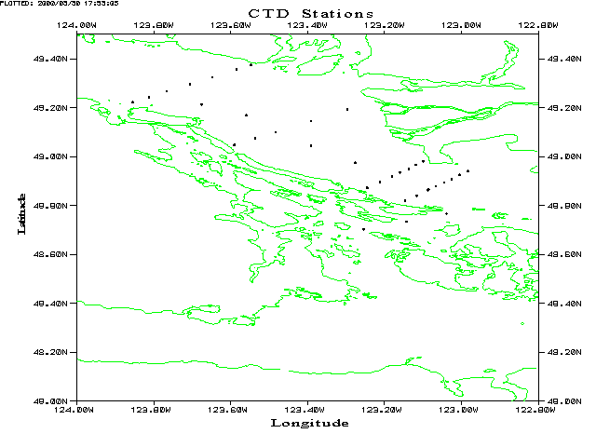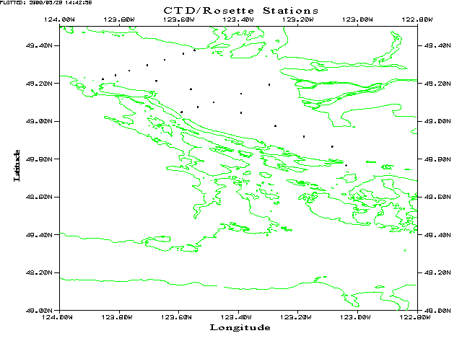

Figure 2: Strait of Georgia CTD and CTD/Rosette stations.

Figure 3: Mooring layouts for stations GSCM1, GSCM2, GSCM3 and GSCM4 (deployments A to F).

Figure 4: Mooring layout for station GSCM3 (deployments G,H and I).
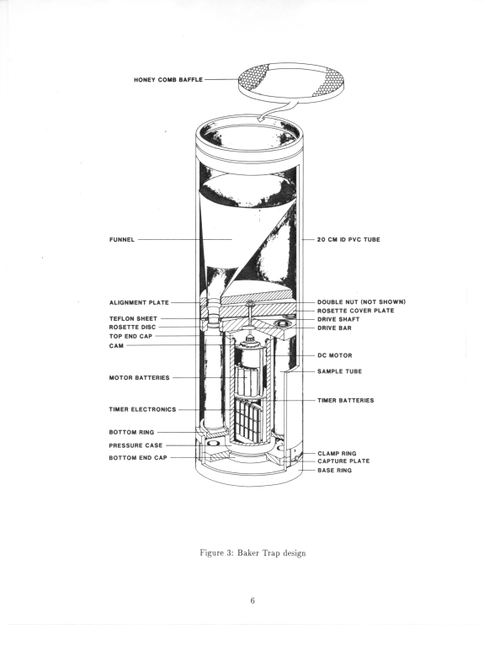Figure 5: Baker sequential sediment trap.

Figure 6: Sieving and subsampling scheme for sediment trap material.

LIST OF TABLES
Table 1a: Mooring station information (pp18-19).
Table 1b: Cruise identification for CTD and CTD/R casts in the Strait of Georgia (p20).
Table 2: Mooring and sediment trap information (pp21-22).
Table 3: Timing of sequential traps and sample preservation (pp23-24).
Table 4: Notes on the sediment trap deployments (pp25-26).
Table 5: Pooled standard deviation for sediment trap analysis (p27).
Table 6: Summary of data set (p28).
Table 7: Duplicate values for CHN analysis (p29).
Table 8: Duplicate values for carbonate carbon analysis (p30).
Table 9: Duplicate values for biogenic silica analysis (p31).
Table 10: Duplicate values for carbon isotope analysis (p32).
Table 11: Duplicate values for nitrogen isotope analysis (p33).

LIST OF APPENDICES

Appendix 1: Percent composition, CN ratios and CN isotopes (pp37-46).
Appendix 2: Flux data (pp47-56).
Appendix 3: Plots for Station GS - 1995 to 1996 (pp57-62).
Appendix 4: Plots for Stations GSCM2, GSCM3 and GSCM4 -1996 to1998 (pp63-79).
Appendix 5: Plots for Station GSCM3 (3 depths) - 1998 to 1999 (pp81-92).

