2012 Halibut Bank Fluorometer Time Series Summary
Stephanie King, Sea This Consulting, kingstepha@gmail.com
January 4 2012

A chlorophyll fluorescence time series is maintained on the Halibut Bank ODAS buoy 46146 (49.43N, 123.72W) for monitoring phytoplankton concentrations in the Strait of Georgia. A Wetlabs ECO fluorometer is deployed every few months on a schedule depending on season and sensor availability. The instrument hangs by a chain attached to the side of the buoy and measures chlorophyll using the fluorescence emission at 695nm. The sampling window is at 1m depth, but can be up to 20cm lower with a full load of seals or sealions (Figure 3, lower left panel). The instrument also measures turbidity by detecting the scattered light at 700nm. It has internal batteries and data storage and is programmed to make a group of 5 measurements every 30 minutes. A copper wiper covers the sampling window between groups of measurements to reduce fouling. Times are in UTC unless otherwise stated. Data are stored in the IOS data archive (osd_data_archive on 'dcBCiosNA01a\ios_osd$'\Fluorometer Data from Jim Gower\Halibut Bank) after processing.

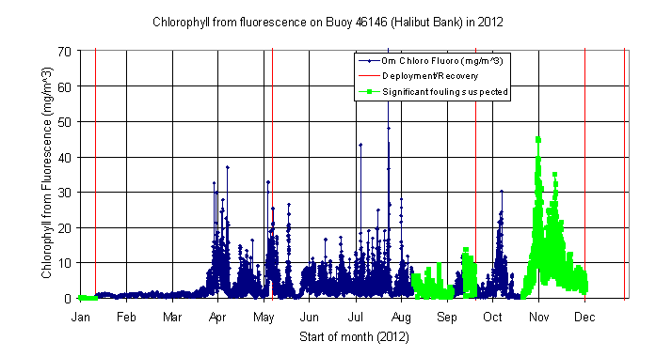
2012 chlorophyll summary (figure 1): Chlorophyll values were below 1.0 mg/m³ until the spring bloom started on March 27, with peak chlorophyll concentrations reaching above 30mg/m³ by March 30. Waters were productive for most of the summer with concentrations often around 5 to 20 mg/m³. Most problems with fouling occur when organisms like mussels, barnacles or hydroids grow on the sensor and/or casing and obstruct the sensor window. Obstructions are clearly seen in the turbidity time series (figure 2) and on instrument recovery (figure 3). The turbidity time series helps determine periods of significant fouling (green series – figure 1). Measurements in 2012 were made from 5 different deployments from Coast Guard or private vessels (figure 3).
Figure 1. 2012 Halibut Bank chlorophyll fluorescence time series.
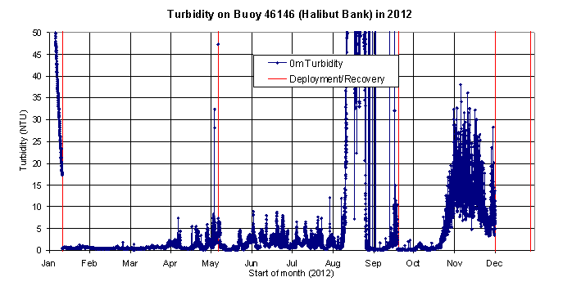
Figure 2. 2012 Halibut Bank turbidity time series. Mussels covering sensor window (shown in figure 3) cause high signal in early January. Other fouling affected data in August and November.

The 2012 data series is from 5 different deployments (table 1). Data before January 11 2012 were from the Jun. 2011 deployment and were heavily fouled. There were three deployments between January 11 and December 2, and a gap in the data series between December 2 and 29 when we waited for a weather window to deploy. The 5th deployment was on December 29 with recovery planned for March or April 2013. In 2012 the deployment/recoveries were planned every 3 to 4 months. In 2013, we will consider decreasing the deployment time, particularly in late summer and fall when fouling is evident in the time series after 1 to 3 months.

Date on | Date off | Instrument | Comments
Jun. 14 2011 | Jan. 11 2012 | FLNTUSB-1638 | Fouled from Oct. ’11 to Jan. ‘12
Jan. 11 2012 | May 8 2012 | FLNTUSB-2195
May 8 2011 | Sept 20 2012 | FLNTUSB-2236 | Periods of fouling in Aug/Sept
Sept. 20 2012 | Dec 2 2012 | FLNTUSB-2195 | Fouled from Oct 22 end of series
Dec. 29 2012 | Planned March or April 2013 | FLNTUSB-2195
Table 1. Instrument deployments giving data in 2012: All instruments measure chlorophyll from fluorescence and turbidity. Units 1638 and 2236 also measure temperature. Unit 2195 needs to be sent back to Wetlabs to have a thermistor installed.
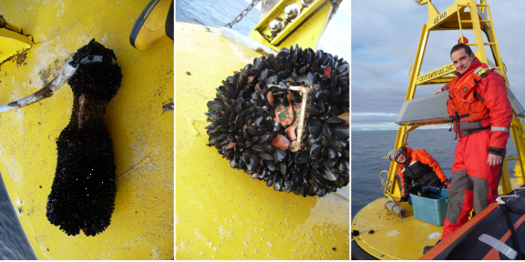
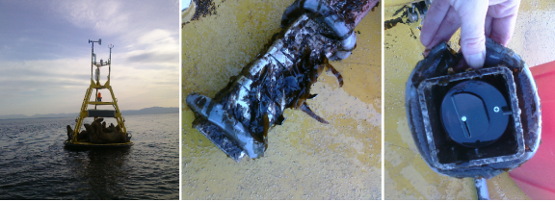
Figure 3. Top row: January 11 deployment. Fouling from mussels (left), sensing window obstructed by mussels (center), Steph and Kyle (CCG) deploy new sensor (right). Bottom row: May 7 deployment. Sea lions on buoy (left), moderate fouling from weeds on casing (center), clear sensor window on recovered fluorometer (right).

