Spring 2014 Chlorophyll fluorescence at Halibut Bank buoy (C46146) in the Strait of Georgia: deployment/recovery report

June 2014

Stephanie King, Sea This Consulting

[king@seathisconsulting.com](mailto:king@seathisconsulting.com)

# Background

A chlorophyll fluorescence time series is maintained on the Halibut Bank ODAS buoy 46146 (49.34N, 123.72W) for the purpose of monitoring phytoplankton concentrations in the Strait of Georgia. Fluorometers are deployed every few months on a schedule depending on season and senor availability.

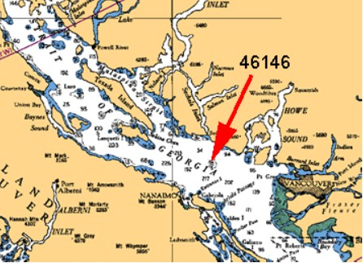

Figure . Location of the Halibut Bank Buoy (46146) in the Strait of Georgia.

# Sensor and settings

The Wetlabs ECO Fluorometer (FLNTUSB-2195) used in this deployment measures chlorophyll fluorescence emission at 695nm, turbidity from scattered light at 700nm and temperature. A copper wiper covers the sampling window between groups of measurements to reduce fouling, and the sensor is housed in an aluminum case painted with an anti-fouling paint (Figure 2).

For this deployment, the sensor was programmed to make a group of 5 measurements, each about 1-2 seconds apart, every 30 minutes. The sensor has internal data storage and was powered by 6 Rayovac 9-volt batteries, which were installed the evening prior to deployment. Instrument set-up, communication and data recovery was done in the ECO View software v1.20 or v1.23 (Figure 3).

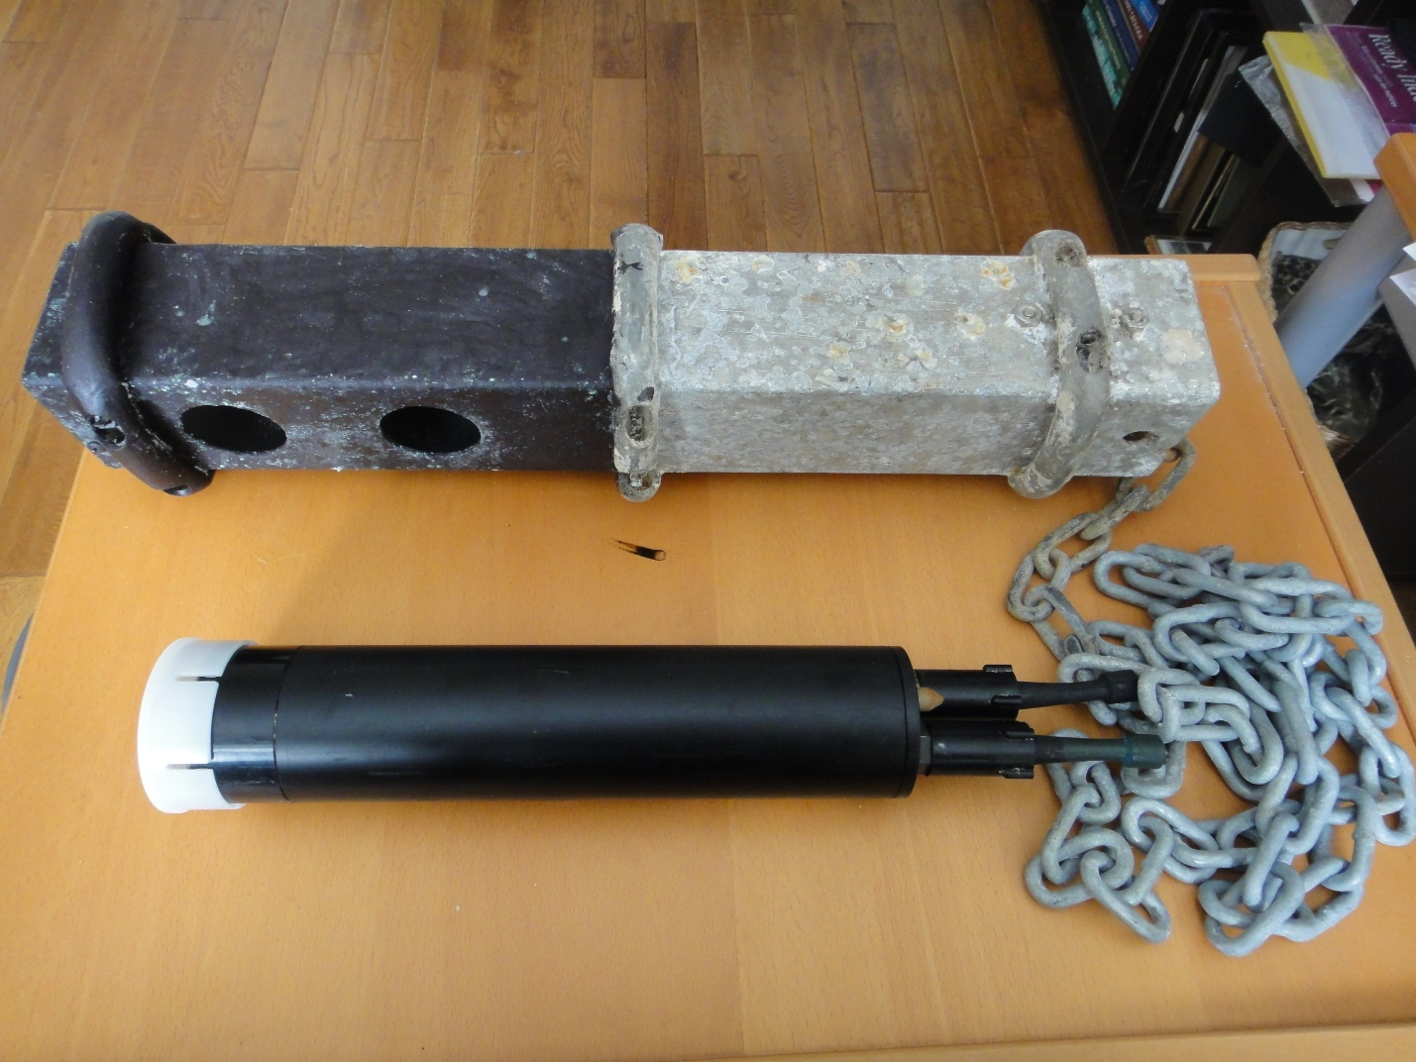

Figure . Sensor and protective aluminum case. The lower half of the aluminum case which is submerged on deployment is painted in antifouling paint.

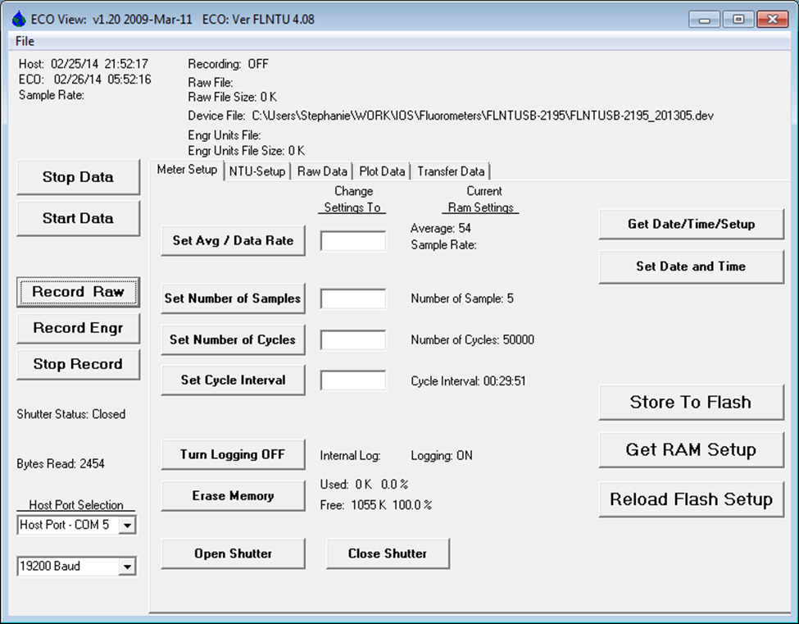

Figure . ECO View meter setup window for the Spring 2014 Halibut Bank fluorometer deployment.

# Deployment

FLNTUSB-2195 was deployed the morning of February 26 2014 by S. King and T. Learmonth from a private vessel. The instrument, housed in an aluminum case, was hung off the side of the buoy by a chain attached to one the buoy’s lifting rings (Figure 4). The senor’s sampling window was located at a depth of about 1m. Fluorometer FLNTUSB-1638 was recovered on the same trip (described in a separate report).

Figure . The Halibut Bank buoy with red arrow pointing to the chain wrapped in plastic tubing that supports the fluorometer.

# Recovery

FLNTUSB-2195 was recovered the evening of June 16, 2014 by S. King and T. Learmonth from a private vessel. There was surprisingly little fouling on the instrument and nothing appeared to be obstructing the sampling window. Another fluorometer was not deployed during this trip which means there will be a gap in the time series.

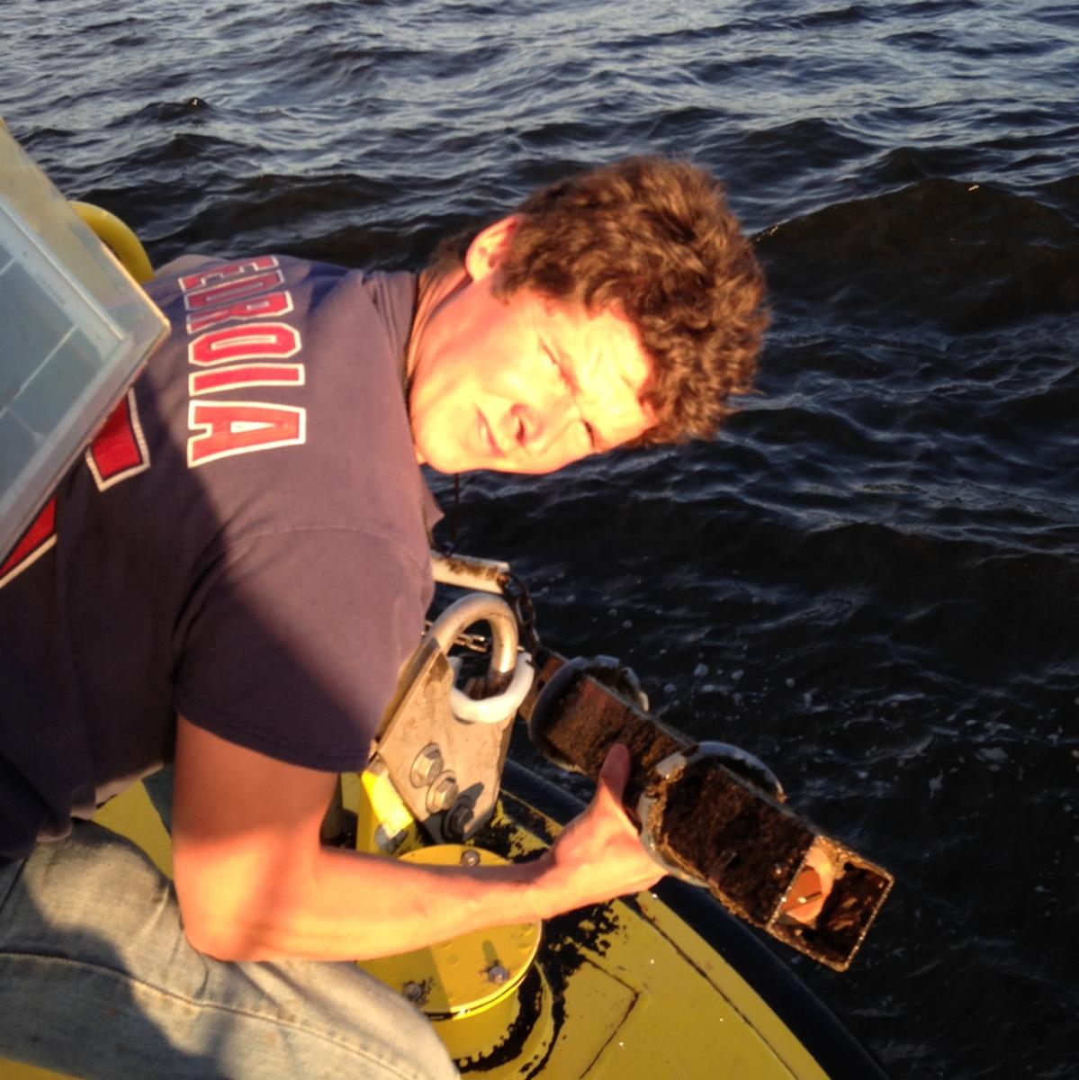

Figure . FLNTUSB-2195 on recovery.

# Data output

The instrument’s clock lost about one minute during the deployment. The data have not been corrected for this time difference. Times are in UTC unless otherwise stated.

The raw output was downloaded from the instrument as a text file. The text file was processed with a program written in IDL to output the average and standard deviation from each group of measurements. Measurements in air from prior to deployment and after recovery have been removed and scaling factors in Table 1 applied using the following equations:

Chlorophyll = Scale Factor*(Output-Dark Counts)

Turbidity = Scale Factor*(Output-Dark Counts)

Temperature = (output x slope) + intercept

Table . Calibration factors provided by Wetlabs during May 21, 2013 instrument servicing.

|  |  |  |  |  |  |
| --- | --- | --- | --- | --- | --- |
| **Chlorophyll** | | **Turbidity** | | **Thermistor** | |
| Dark counts | Scaling factor | Dark counts | Scaling factor | slope | intercept |
| 49 | 0.0182 | 50 | 0.0464 | -0.0056 | 70.8835 |

The following files have been provided for the IOS data archive:

* An excel file containing the scaled, unprocessed (i.e. not averaged) data
* A text file with the metadata
* This deployment summary

# Additional comments and/or issues

The scaled and processed data are shown in Figure 6 to Figure 8. Despite the long deployment, there are no clear signs of fouling in the optical data. However, fouling may be difficult to detect with no in-situ samples for calibration or additional instrument for comparison. A high standard deviation in the chlorophyll and turbidity time series around May 16 may indicate something waving in front of the sampling window. However, the baseline does not drift upward which can be an indicator of fouling.

There is a clear start to the spring bloom in late March (Figure 9) with chlorophyll concentrations reaching over 20mg/m3 by April 4. This appears to agree with chlorophyll fluorescence observations from satellite, although there were relatively few cloud-free images during March and April.

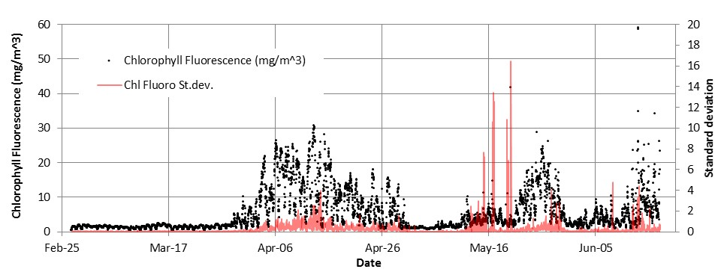

Figure . Averaged time series for chlorophyll fluorescence. The standard deviation (red series) is for each burst of 5 measurements.

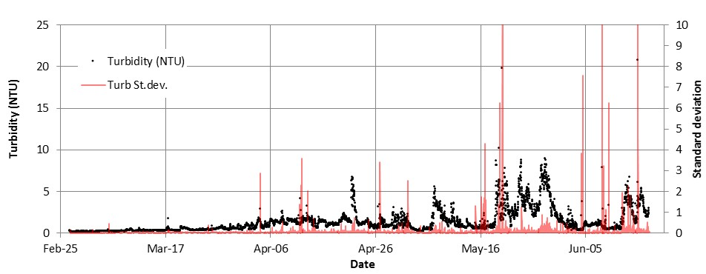

Figure . Averaged time series for turbidity. The standard deviation (red series) is for each burst of 5 measurements.

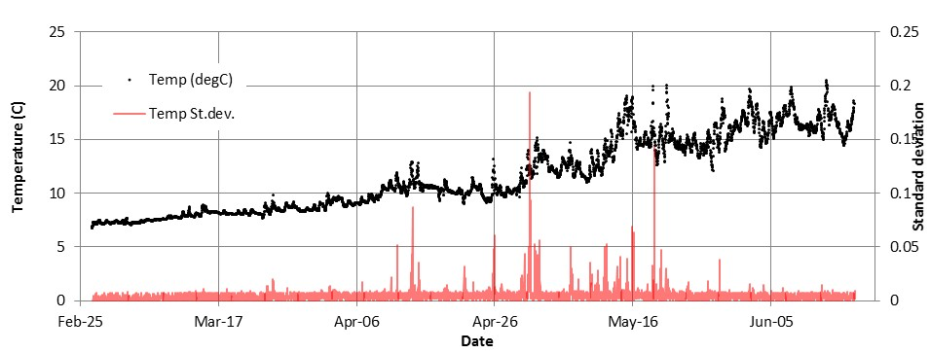

Figure . Averaged time series for temperature. The standard deviation (red series) is for each burst of 5 measurements.

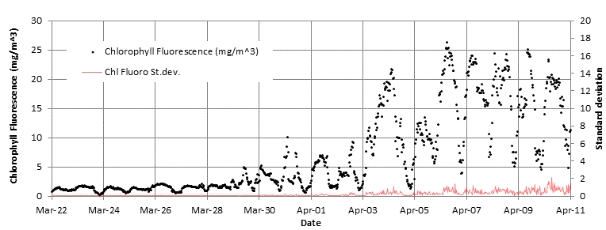

Figure . Averaged time series for chlorophyll fluorescence from March 22 to April 11, 2014 showing the spring bloom starting in late March.

However, given the long deployment, users should be cautious using the data from at least May onward