Fall/winter 2013 Chlorophyll fluorescence at Halibut Bank buoy (C46146) in the Strait of Georgia: deployment/recovery report

June 2014

Stephanie King, Sea This Consulting

[king@seathisconsulting.com](mailto:king@seathisconsulting.com)

# Background

A chlorophyll fluorescence time series is maintained on the Halibut Bank ODAS buoy 46146 (49.34N, 123.72W) for the purpose of monitoring phytoplankton concentrations in the Strait of Georgia. Fluorometers are deployed every few months on a schedule depending on season and senor availability.

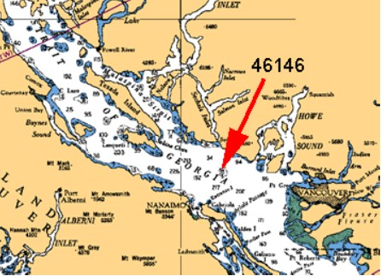

Figure 1. Location of the Halibut Bank Buoy (46146) in the Strait of Georgia.

# Sensor and settings

The Wetlabs ECO Fluorometer FLNTUSB-1638 used in this deployment measures chlorophyll fluorescence emission at 695nm, turbidity from scattered light at 700nm and temperature. A copper wiper covers the sampling window between groups of measurements to reduce fouling, and the sensor is housed in an aluminum case painted with an anti-fouling paint (Figure 2).

For this deployment, the sensor was programmed to make a group of 5 measurements, each about 1-2 seconds apart, every 30 minutes. The sensor has internal data storage and was powered by six 9-volt batteries. Instrument set-up, communication and data recovery was done in the ECO View software v1.20 or v1.23.

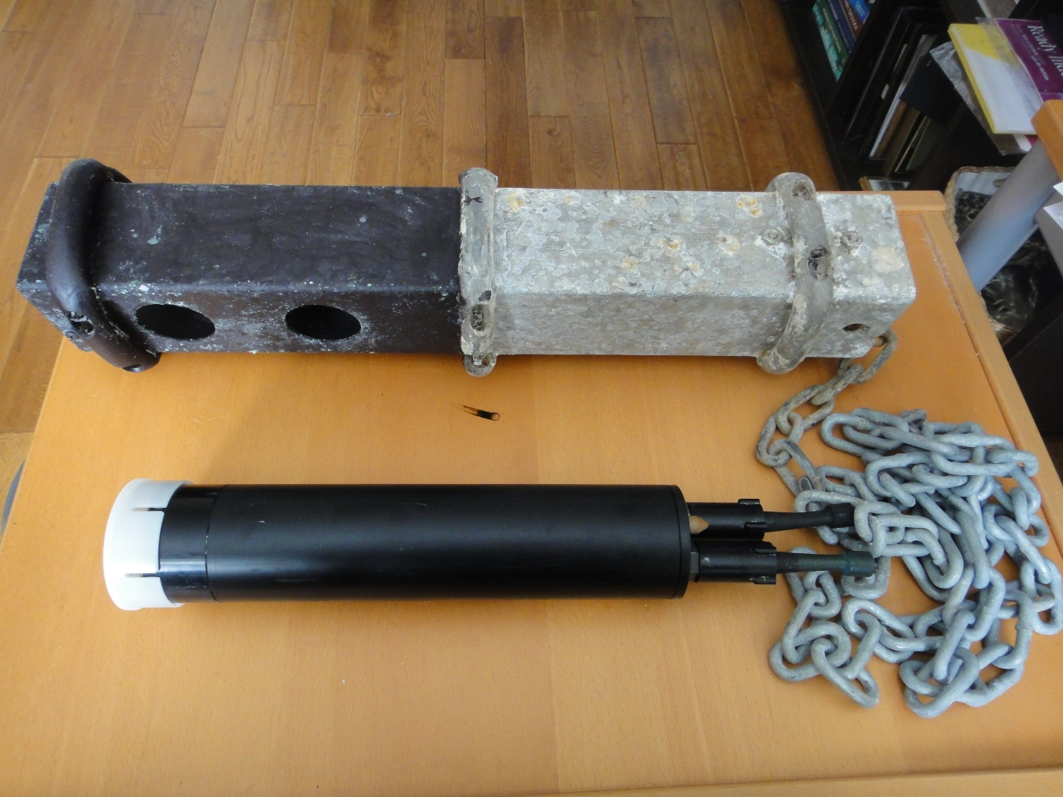

Figure 2. Sensor and protective aluminum case. The lower half of the aluminum case which is submerged on deployment is painted in antifouling paint.

# Deployment

FLNTUSB-1638 was deployed on August 14 2013 by S. King and T. Learmonth from a private vessel. The instrument, housed in an aluminum case, was hung off the side of the buoy by a chain attached to one the buoy’s lifting rings (Figure 3). The senor’s sampling window was located at a depth of about 1m. Fluorometer FLNTUSB-2236 was recovered on the same trip.

# Recovery

FLNTUSB-1638 was recovered the morning of Feb. 26, 2014 by S. King and T. Learmonth from a private vessel. Fluorometer FLNTUSB-2195 was deployed on the same trip. The housing and fluorometer had significant fouling, but the copper face and window of the fluorometer appeared to be clean. There was a noticeable difference in the fouling between the lower, copper painted end and the top, unpainted end of the aluminum housing (Figure 4).

Figure 3. The Halibut Bank buoy with red arrow pointing to the chain wrapped in plastic tubing that supports the fluorometer.

Figure 4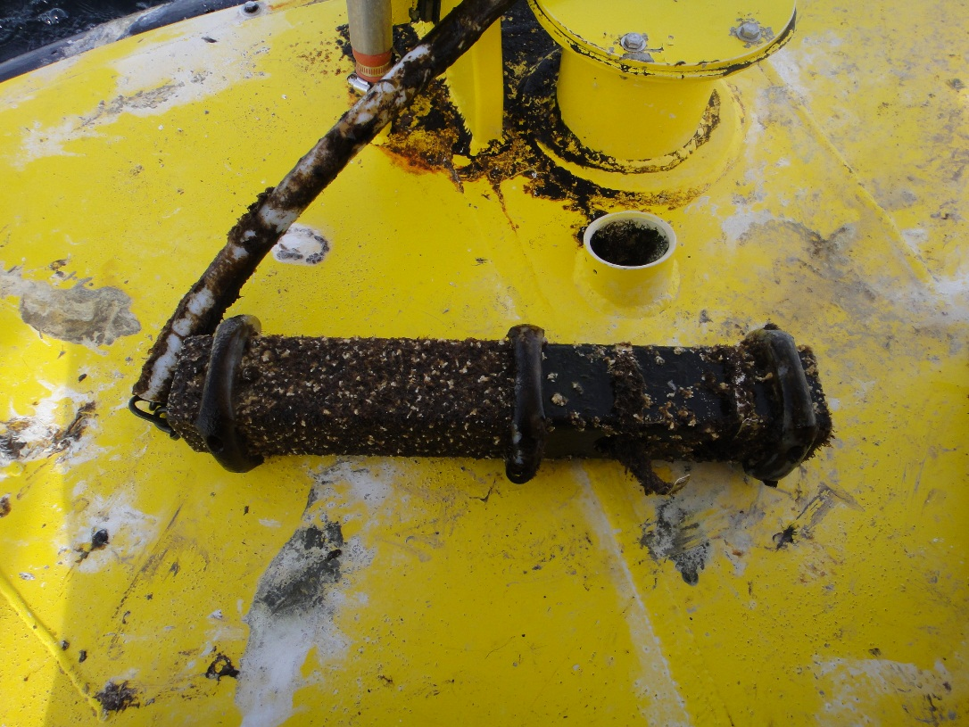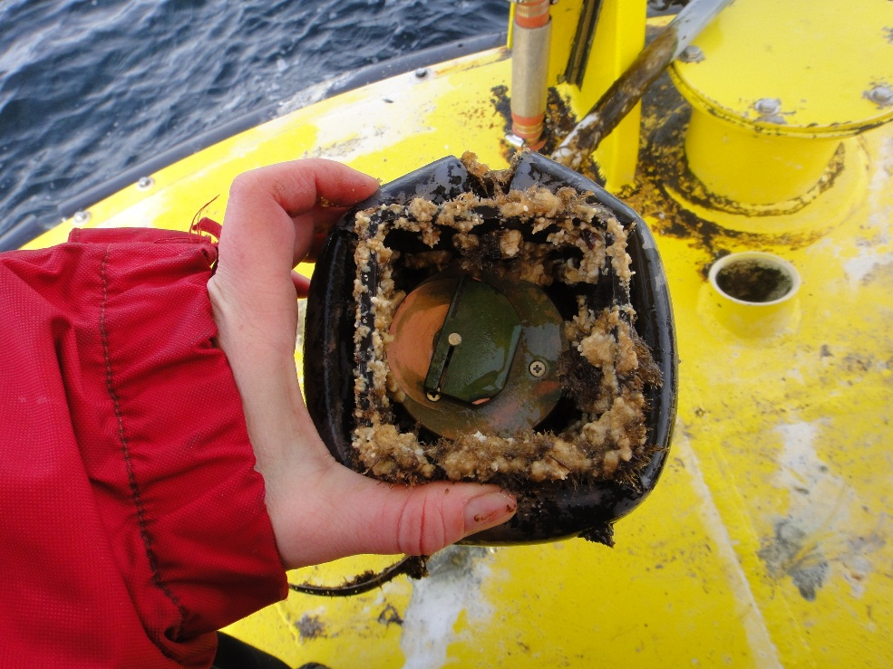. Copper face and wiper covering the sampling window off fluorometer FLNTUSB-1638 (left picture) shows considerable growth surrounding the sampling area. Aluminum housing has less fouling on the lower (right-side) end which has been painted with anti-fouling paint.

# Data output

The raw output was downloaded from the instrument as a text file. The text file was processed with a program written in IDL to output the average and standard deviation from each group of measurements. Measurements in air from prior to deployment and after recovery have been removed and scaling factors in Table 1 applied using the following equations:

Chlorophyll = Scale Factor*(Output-Dark Counts)

Turbidity = Scale Factor*(Output-Dark Counts)

Temperature = (output x slope) + intercept

Table 1. Calibration factors provided by Wetlabs during Jan. 15, 2013 instrument servicing.

|  |  |  |  |  |  |
| --- | --- | --- | --- | --- | --- |
| **Chlorophyll** | | **Turbidity** | | **Thermistor** | |
| Dark counts | Scaling factor | Dark counts | Scaling factor | slope | intercept |
| 49 | 0.0180 | 50 | 0.0465 | -0.0056 | 71.5777 |

The following files have been provided for the IOS data archive:

* An excel file containing the scaled, unprocessed (i.e. not averaged) data
* A text file with the metadata
* This deployment summary

# Additional comments and/or issues

The scaled and processed data are shown in Figure 5. There is no clear drift in the chlorophyll or turbidity baseline, however increased variability between bursts of measurements and within bursts of measurements suggest fouling later in the time series (January and February).

By comparing the end of the time series in February and data from beginning of the following time series (Feb.2014 to Jun.2014 from FLNTUSB-2195) there is a difference in the standard deviation between the two sensors which may indicate fouling. More noticeably, the end of the FLNTUSB-1638 turbidity time series was much more scattered than the beginning of the FLNTUSB-2195 turbidity time series.

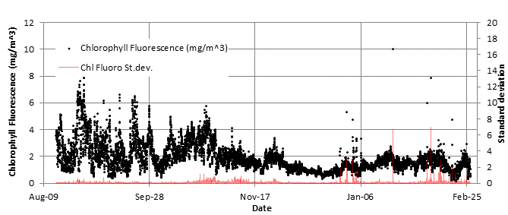

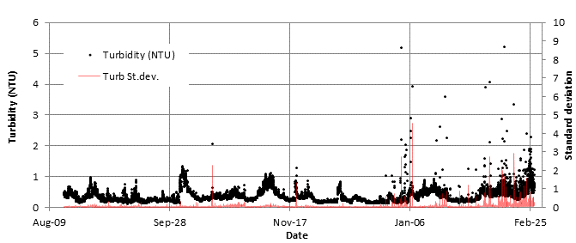

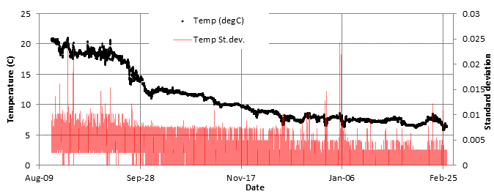

Figure 5. Averaged time series for chlorophyll fluorescence, turbidity and temperature. The standard deviation (red series) is for each burst of 5 measurements.

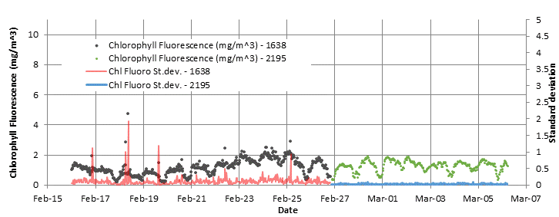

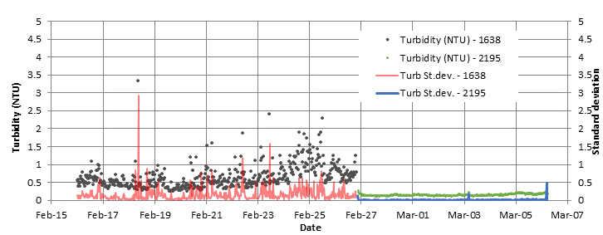

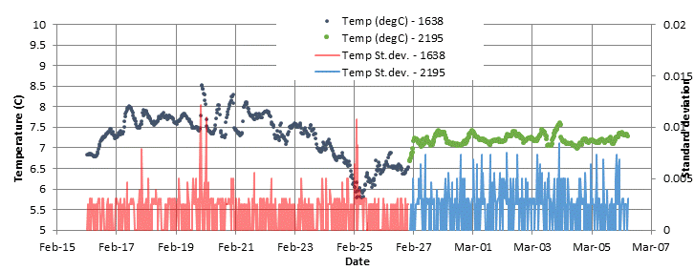

Figure 6. Comparison of the last several days of the 1638 deployment with the beginning of the 2195 deployment on Halibut Bank.