Summary of Hydrographic/CTD Observations Made Along Line P and at Station P: 1991-1999

B. G. Minkley and F. A Whitney

Fisheries and Oceans Canada
Institute of Ocean Sciences
9860 West Saanich Road
Sidney, British Columbia V8L 4B2

2001

Canadian Data Report of
Hydrography and Ocean Sciences 156

Canadian Data Report of Hydrography
and Ocean Sciences 156

2001

Summary of Hydrographic/CTD Observations Made Along Line P and at Station P: 1991-1999

by

B.G. Minkley and F.A. Whitney

Fisheries and Oceans Canada
Institute of Ocean Sciences
9860 West Saanich Road
Sidney, BC, Canada
V8L 4B2

© Her Majesty the Queen in Right of Canada, 2001,
as represented by the Minister of Fisheries and Oceans.
Cat. No. Fs-97-16/156E ISSN 0711-6721

Correct citation for this publication:

Minkley, B.G., and F.A. Whitney. 2001. Summary of hydrographic/CTD observations made along Line P and at Station P: 1991-1999. Can. Data Rep. Hydrogr. Ocean Sci. 156: 45 p.

CONTENTS

ABSTRACT iv
Introduction 1
Ships and Personnel 2
Table 1. List of ships, dates, and personnel, 1991 to 1999 5
Table 2. Types of samples taken on each mission. 17
Water Sampling Equipment 19
Table 3 of JGOFS and WOCE designated missions. 21
Plots of CTD Locations for missions done 1991 to 1999 23
Figure 1. IOS Rosette 35
Figure 2. General Oceanics Rosette 37
Figure 3. Heave Compensator mounted on CCGS Tully A-frame 39
Figure 4. CSS Parizeau 41
Figure 5. CCGS J.P. Tully 43
Figure 6. CNAV Endeavour 45

ABSTRACT

Minkley, B.G., and F.A. Whitney. 2001. Summary of hydrographic/CTD observations made along Line P and at Station P: 1991-1999. Can Data Rep Hydrogr Ocean Sci 156: 45 p.

A summary of 30 missions which sampled part or all of Line P between January 1991 and December 1999 is provided. Plots of mission tracks show the areas surveyed, participants are listed, and types of sampling, inventoried. A review of sampling equipment outlines the conversion from 1.7 litre Niskin bottles mounted on 5/32-inch wire hydro wire to CTD/Rosette cast sampling using 10 litre bottles. Missions which supported programs for World Ocean Circulation Experiment and Joint Global Ocean Flux Studies are listed.

A previous report contained observations for the period January 1980 to December 1989 and is found in Canadian Data Report of Hydrography and Ocean Sciences No.136, by Tabata and Brown.

Key words: North Pacific Ocean, open-ocean time-series, hydrographic/CTD data.

Résumé

Minkley, B.G., and F.A. Whitney. 2001. Summary of hydrographic/CTD observations made along Line P and at Station P: 1991-1999. Can. Data Rep. Hydrogr. Ocean Sci. 156: 45 p.

Ce rapport fourni un sommaire de 30 croisières océanographiques durant lesquelles la ligne P a été échantillonnée en tout ou en partie entre janvier 1991 et décembre 1999. Chaque sommaire comprend la région explorée représentée par la trajectoire du navire, la liste des participants, ainsi qu'un inventaire du type d'échantillons collectés. Une révision du matériel d'échantillonnage souligne la conversion de bouteilles Niskin de 1.7 litre montées sur un câble de 5/32" à des profils de CTD/Rosette utilisant des bouteilles de 10 litres. Les croisières faisant partie des programmes WOCE (World Ocean Circulation Experiment) et JGOFS (Joint Global Ocean Flux Studies) sont énumérées.

Un rapport précédant contenant les observations pour la période de janvier 1980 à décembre 1989 se trouve dans Can. Data Rep. Hydrogr. Ocean Sci. 136, par Tabata et Brown.

Introduction

The Line P program has been an important part of ocean research in Canada since the 1950s. Considerable effort has been expended to keep this monitoring program viable in the Northeast Pacific Ocean, the result being that the time series of measurements is proving extremely valuable in demonstrating the impact of climate change and variability on oceans. Early history and data from this program have been summarized by Tabata and Peart (1985). Dr. Tabata was largely responsible for ensuring the quality of the large temperature, oxygen and salinity data set up to 1990.

In the early 1990s, the Line P program came under the umbrella of the World Ocean Circulation Experiment (WOCE). Funding became available to upgrade virtually every measurement. Over a period of three years, the Institute of Ocean Sciences (IOS) switched from hydrographic bottle casts to CTD/rosette casts, with the result that CTD and water sampling became much better meshed, and depth measurements for samples improved. This was also the era that saw improved horizontal positioning due to the increased use and availability of the GPS for ship’s navigation. With time, we added instruments to the CTD/rosette package so that we now routinely profile particle distribution to deep ocean, and light and fluorescence to 400 m. Data from 15 Line P surveys between 1991 and 1997 were submitted to the WOCE Hydrographic Program Office, and are available from http://oceanic.cms.udel.edu/woce/; ftp://nemo.ucsd.edu/woce/Data/Pacific/Repeat/PR6/.

Improvements were also made to routine chemical analyses. More analyses were done on fresh samples at sea than ever before. In part this was possible because the research vessel, CCGS John P Tully, has adequate lab space in which to set up analytical instruments. In addition to oxygen and nutrients, in the past decade we have measured CFCs, iron, total CO₂, alkalinity, pCO₂, chlorophyll and dimethyl sulfide at sea.

Line P also became a focus of activity under the Joint Global Ocean Flux Study program (JGOFS). The Canadian JGOFS program, from 1992 to 1997, decided to concentrate effort on understanding the controls of biological growth in the Gulf of Alaska. Great effort to solve this riddle came from the University of British Columbia (UBC) and other Canadian universities and international collaborators. A result of this work was the publication of a special volume of Deep Sea Research II (vol. 46, No. 11-12, 1999) which contains a review of the Line P program (Whitney and Freeland, 1999) and an additional 25 papers on biological, geochemical and physical processes of the NE Pacific. Core measurements from JGOFS studies are available from the Marine Environment Data Service, Fisheries and Oceans at http://www.meds-sdmm.dfo-mpo.gc.ca/.

The focus on processes in the Northeast Pacific during WOCE and JGOFS have spurred several important findings that relate climate change and variability to ocean productivity. Freeland et al (1998) have shown that the upper ocean mixed layer has been shoaling over the past 40 years, with the result that nutrient supply to phytoplankton is weaker. Between the 1970s and 1990s, Whitney and Freeland (1999) found an approximately 30% decline in the winter supply of nitrate to surface waters. Also, about 40% of the interannual variability in this supply appears to be modulated by El Nino – La Nina cycles (Whitney et al, 1998). We are now confident that iron is a limiting nutrient in open waters in this area (Boyd et al, 1996) and still are uncertain about the interactions of light, temperature and nutrient supply in controlling plankton growth. Also unresolved is the understanding of how various nutrients are transported to the surface ocean.

Interest in open ocean research remains strong. The Alaskan Gyre region of the Northeast Pacific is a major habitat of Pacific salmon and a sizeable heat sink/source which moderates Canadian west coast weather. We foresee the Line P program continuing as an important contribution in understanding the impacts of climate variability on world oceans.

Ships and Personnel
The majority of the scientific personnel participating in these mission were from IOS. A few members have made 10 or more trips to Ocean Station Papa during this decade:

 | Trips |  | trips
Ron Bellegay | 12 | Wendy Richardson | 16
Reg Bigham | 10 | Marie Robert | 14
John Love | 11 | Tim Soutar | 21
Hugh Maclean, UBC | 21 | Frank Whitney | 19
Bernard Minkley | 23

In addition to IOS staff, personnel from the following agencies participated:

Canadian Wildlife Service
Japanese scientists from both industry and universities
Memorial University, St. Johns, Newfoundland
McGill University
Pacific Biological Station, Nanaimo
Pacific Oceanological Institute of Russia
Princeton University
Third Institute of Oceanography of China
University of British Columbia
University of Rimouski
University of Southampton
University of Toronto
University of Victoria

References:

Boyd, P.W., D.L. Muggli, D.E. Varela, R.H. Goldblatt, R. Chretien, K.J. Orians, and P.J. Harrison. 1996. In Vitro Iron Enrichment Experiments in the Northeast Subarctic Pacific. Mar. Ecol. Prog. Ser. 136: 179-193.

Endeco/YSI Inc.,1992. Shock Absorber Cord. 13 Atlantis Drive, Marion, Massachusetts, USA

Foster, Derek , 1993, Pneumatic Heave Compensator. Lands End Technology, Victoria, BC.

Freeland, H.J., K.L. Denman, C.S. Wong, F.A. Whitney, and R. Jacques. 1998. Evidence of Change in the Winter Mixed Layer in the Northeast Pacific Ocean. Deep-Sea Res. 44: 2117-2129.

Guildine Instruments, 1994, Operating manual for model 8730Expandable precision digital CTD System, 21 Gilroy Street, P.O. Box 99, Smiths Falls, Ontario, Canada, K7A 4S9.

Seabird Electronics, Inc., 1996, CTD System Operating and Repair Manual for 911plus CTD, 1808 136th Place Northeast, Bellevue, Washington, 98005, USA

Tabata, S and L.J. Peart. 1985. Statistics of Oceanographic Data Based on Hydrographic/STD Casts Made at Ocean Station P During August 1956 through June 1981. Can. Data Rep. Hydrogr. Ocean Sci. 31: 133 p.

Tabata, S. and Brown, R. 1994. Hydrographic/CTD Observations Made During Ocean Climate Monitoring Study: 1981-1991 – A Summary of Operational Phase of Study, Can. Data Rep. Hydrogr. Ocean Sci. 136: 42 p.

Whitney, F.A. and H.J. Freeland. 1999. Variability in Upper Ocean Water Properties in the Northeast Pacific Ocean. Deep-Sea Res. II, 46: 2351-2370.

Whitney, F.A., C.S. Wong, and P.W. Boyd. 1998. Interannual Variability in Nitrate Supply to Surface Waters of the Northeast Pacific Ocean. Mar. Ecol. Prog. Ser. 170: 15-23.

Table 1. List of ships, dates, and personnel, 1991 to 1999

Mission ship start date end date master area

91-03 Tully 19-Feb-91 11-March-91 John Anderson Line P, Line Z, line R,
lines MB and MA
CTD: Guildline 8715 SN 53501.
Ron Bellegay IOS chief scientist
Beg Bigham IOS
Gilles Desmeules
Bernard Minkley IOS
Tim Soutar IOS
Darren Tuele IOS
Jinping Wu UBC

91-08 Parizeau 28-Apr-91 10-May-91 John Campbell line P, line R, line MA
CTD: Guildline SN 53501 and 58483
Sus Tabata IOS chief scientist
Mary-Beth Bérubé IOS
John Love IOS
Bernard Minkley IOS
Graeme Quin contractor
Les Spearing IOS
Jin Ping Wu UBC

91-15 Endeavour 17-Oct-91 1-Nov-91 W. McMunagle Line P, line Z
CTD: Guildline 8706 SN 43571 and 8715 SN 58483
Reversing thermometers used with 1.7 litre Niskin bottles.
Ron Bellegay IOS chief scientist
Mike Dempsey contractor
Hugh Maclean UBC
Bernard Minkley IOS
Robert Mugo UTC
Ron Perkin IOS
Tim Soutar IOS
Les Spearing IOS
Jinping Wu UBC

92-01 Tully 03-Feb-92 14-Feb-92 John Anderson Line P, line R (partial)
CTD: Guildline 8706 SN 43501 and 8715 SN 58483
Frank Whitney IOS chief scientist
Ron Bellegay IOS
Keith Johnson IOS
Robert Millar co-op student
Bernard Minkley IOS
Tom Moore Guildline Instruments
Wendy Richardson IOS
Les Spearing IOS
Clayton Stark co-op student
Shu Lun Wang UBC

92-06 Endeavour 26-Mar-92 13-April-91 W. McMunagle Line P line Z, line R,
and line J
CTD: Guildline 8715 SN 53501 and 8715 SN 58483
Reversing thermometers used with 1.7 litre Niskin bottles.
Ron Perkin IOS chief scientist
Ron Bellegay IOS
Reg Bigham IOS
Bernard Minkley IOS
Tim Soutar IOS
Les Spearing IOS
Jin Ping Wu UBC

92-15 Tully 08-Sep-92 29-Sept-92 Paul Frost Line P, line Z,
line R (partial)
CTD: Guildline SN 58483 and 59901 (testing only), Swann CTD winch
General Oceanics Rosette frame.
Reversing thermometers used for depths greater than 3000 m.
Frank Whitney IOS chief scientist
Reg Bigham IOS
Marty Davelaar IOS
Nick Hall-Patch Co-op student
John Love IOS
Hugh Maclean UBC
Brad McKelvey UBC
Bernard Minkley IOS
Marie Robert contractor
Tim Soutar IOS
Diana Varela UBC

93-03 Tully 06-Mar-93 18-March-93 John Anderson Line P
CTD: Guildline SN 59901 and 58483, Lantec winch used for Rosette casts.
New and much larger A-frame on deck
1 ½ “ diameter shock cords used to help eliminate ship motion from Rosette.
Reversing thermometers used for depths greater than 3000 m.
Ron Perkin IOS chief scientist
Ron Bellegay IOS
Philip Boyd UBC
Anna Flak Poland
John Love IOS
Hugh Maclean UBC
Bernard Minkley IOS
Helen Nicolidakas UBC
Wendy Richardson IOS
Marie Robert contractor
Tim Soutar IOS
Diana Varela UBC
Frank Whitney IOS

93-09 Tully 14-May-93 31-May-93 John Anderson Line P, line R, line J
CTD: Guildline SN 59901 and 58483, Lantec winch used for Rosette casts
1 ½ “ diameter shock cords used to help eliminate ship motion from Rosette.
Strain gauge on wire to determine maximum loading of wire.
Ron Bellegay IOS
Reg Bigham IOS
Philip Boyd UBC
Sean Doherty UBC
Nick Hall-Patch Co-op student
Hugh Maclean UBC
Bernard Minkley IOS
Marie Robert contractor
Steven Ruskey
Tim Soutar IOS
Diana Verela UBC
Mark Wen UBC
Frank Whitney IOS chief scientist
Jin Ping Wu UBC

94-01 Tully 07-Feb-94 18-Feb-94 John Anderson Line P (partial)
CTD: Guildline SN 59901, Lantec winch used for Rosette casts.
A-frame mounted heavy compensator system.
Ron Perkin IOS chief scientist
Ron Bellegay IOS
Reg Bigham IOS
Philip Boyd UBC
Sean Doherty UBC
Bill Green IOS
John Love IOS
Hugh Maclean UBC
Bernard Minkley IOS
Dario Stucchi IOS
Diana Varela UBC
Mark Wen UBC
Frank Whitney IOS

94-02 Tully 10-May-94 27-May-94 John Anderson Line P, R16, R12 and R8.
CTD: Guildline SN 59901 and 58483, Lantec winch
Training mission in Saanich Inlet and Haro Strait for the following personnel:
Mary Beth Bérubé, Robin Brown, Tracy Feeney, Howard Freeland, John Garrett, Bill Green, Rhiannon, Johnson, Tom Juhasz, Bernard Minkley , Taimi Mulder, Ron Perkin, Wendy Richardson, Dennis Simmott, Terry Sowden, Carol Steward, Neil Sutherland, Sarah Thornton, Linda White, Frank Whitney , Bob Wilson.
Most of these people departed the ship in Esquimalt harbour and the following personnel joined the ship for mission out to Ocean Station Papa:
Frank Whitney IOS chief scientist
Ron Bellegay IOS
Reg Bigham IOS
Philip Boyd UBC
Marty Davelaar IOS
Sean Doherty UBC
Keith Johnson IOS
John Love IOS
Hugh Maclean UBC
Bernard Minkley IOS
Jim Powlik contractor
Wendy Richardson IOS
Marie Robert contractor
Tim Soutar IOS
Diana Varela UBC
Mark Wen UBC

94-03 Tully 06-Sep-94 9-Nov-94 John Anderson Line P, WOCE line P15N
CTD: Guildline SN 59901 and 58483, Lantec winch used.
John Garrett IOS chief scientist
Andrei Andreev POI, Vladivostak Russia
Ron Bellegay IOS
Mary-Beth Bérubé IOS
Reg Bigham IOS
Valerie Knight contractor
John Love IOS
Bernard Minkley IOS
Galina Pavlova POI, Vladivostak, Russia
Leo Rebele UBC
Marie Robert contractor
Tim Soutar IOS
Dario Stucchi IOS
Sarah Thornton UBC
Louise Timmermans UBC
Pavel Tishchenko POI, Vladivostak Russia
Linda White contractor
Frank Whitney IOS

95-01 Tully 07-Feb-95 23-Feb-95 Al Combs Line P
CTD: Guildline SN 59901 and 58483, Swann 329 winch used for rosette casts.
Frank Whitney IOS chief scientist
Reg Bigham IOS
Philip Boyd UBC
Tracy Feeney UBC
Robert Goldblatt UBC
John Love IOS
Hugh Maclean UBC
Bernard Minkley IOS
Tim Soutar IOS

95-05 Tully 09-May-95 25-May-95 Al Coombs Line P, 130W grid
CTD: Guildline SN 59901 and 58483
Frank Whitney IOS chief scientist
John Berges UBC
Reg Bigham IOS
Philip Boyd UBC
Stuart Brock Co-op student
John Love IOS
Hugh Maclean UBC
Bernard Minkley IOS
Kate Read
Wendy Richardson IOS
Tim Soutar IOS
Sarah Thornton UBC

95-12 Tully 22-Aug-95 13-Sept-95 Al Coombs Line P
CTD: Guildline SN 59901 and 58483
Philip Boyd UBC chief scientist
Janet Barwell-Clarke contractor
Ron Bellegay IOS
Reg Bigham IOS
John Love IOS
Hugh Maclean UBC
Wendy Richardson IOS

96-01 Tully 20-Feb-96 8-March-96 John Anderson Line P
CTD: Guildline SN 59901 and 58483
Frank Whitney IOS chief scientist
Ron Bellegay IOS
Jim Bishop UVIC
Philip Boyd UBC
Stacey Cooper UVIC
Ken Crocker MUN
Robert Goldblatt UBC
Nick Hall-Patch Co-op student
Bernard Minkley IOS
Todd Mudge UVIC
Jennifer Putland MUN
Wendy Richardson IOS
Susanne Roy Rimouski U
Nelson Sherry UBC
Maureen Soon UBC
Tim Soutar IOS

96-09 Tully 07-May-96 30-May-96 John Anderson Line P, 129W grid
CTD: Guildline SN 59901 and 58483
Philip Boyd UBC chief scientist
Janet Barwell-Clarke contractor
Ron Bellegay IOS
Jim Bishop UVIC
Ken Crocker MUN
Robert Goldblatt UBC
John Love IOS
Hugh Maclean UBC
Paul Mathews MUN
Bernard Minkley IOS
Ken Morgan CWS
Todd Mudge UVIC
Jennifer Putland MUN
Wendy Richardson IOS
Nelson Sherry UBC
Robert Schultz UVIC
Maureen Soon UBC
Tim Soutar IOS
Delphine Thibault Rimouski U

96-18 Tully 12-Aug-96 6-Sept-96 John Anderson Line P, line R
CTD: Guildline SN 59901 and 58483
Frank Whitney IOS chief scientist
Doug Anderson IOS
Ron Bellegay IOS
Michael Bentley contractor
Philip Boyd UBC
Ken Crocker MUN
Edmund Fok IOS
Robert Goldblatt UBC
Julie Granger McGill U
Hugh Maclean UBC
Maite Maldonado McGill U
Paul Matthews MUN
Wendy Richardson IOS
Nelson Sherry UBC
Maureen Soon UTC
Tim Soutar IOS
Delphine Thibault Rimouski U

97-02 Tully 10-Feb-97 28-Feb-97 Kay Gimbel Line P
CTD: Seabird 0437
Frank Whitney IOS chief scientist
Laurent Audaire
Michael Bentley contractor
Jim Bishop UVIC
Philip Boyd UBC
Robert Goldblatt UBC
John Love IOS
Hugh Maclean UBC
Maite Maldonado McGill U
Paul Matthews MUN
Bernard Minkley IOS
Todd Mudge UVIC
Wendy Richardson IOS
Nelson Sherry UBC
Maureen Soon UBC
Tim Soutar IOS
Todd Wood UVIC
Jim Zakreski contractor

97-11 Tully 02-Jun-97 26-June-97 John Anderson Lines P, Z and AB
CTD: Seabird 0433
Philip Boyd UBC chief scientist
Doug Anderson IOS
Janet Barwell-Clarke contractor
Michael Bentley contractor
Robert Goldblatt UBC
Tara Ivanochko UBC
Keith Johnson IOS
Hugh Maclean UBC
Bernard Minkley IOS
Wendy Richardson IOS
Nelson Sherry UBC
Maureen Soon UBC
Tim Soutar IOS
Nes Sutherland contractor
Darren Tuele IOS

97-15 Tully 25-Aug-97 17-Sept-97 Paul Frost Lines P and MS (south of P)
CTD: Seabird 0437
Frank Whitney IOS chief scientist
Stuart Brock IOS
Lyle Fairley contractor
Kimio Fukami Japan
Takahiko Inoue Japan
Tara Ivanochko UBC
Keith Johnson IOS
Hiroshi Kiyosawa JAPAN
Hugh Maclean UBC
Bernard Minkley IOS
Jun Nishioka JAPAN
Wendy Richardson IOS
Marie Robert contractor
Mark Schmidt U. Delaware
Tim Soutar IOS
Nes Sutherland contractor
Shigenobu Takeda Japan

97-37 Tully 20-Oct-97 30-Oct-97 Tom Hull lines BP, G, D, line P
(5 to 10), C, and B.
CTD: Seabird 0437
Doug Yelland IOS chief scientist
Mike Bentley contractor
Beth Bornhold UBC
Bridgett Ferris
Shannon Harris UBC
Hugh Maclean UBC
Bernard Minkley IOS
Doug Moore IOS
Jennifer Putland UBC
Marie Robert contractor
Steve Romaine IOS
Diana Varela UBC

97-45 Laurier 01-Dec-97 4-Dec-97 Syd Webb Line P (1-12)
CTD: Seabird 0437
Marie Robert contractor
Sheila Toews contractor

98-02 Laurier 18-Jan-98 21-Jan-98 Syd Webb Line P (1-12), El Nino
Watch
CTD: Seabird 0437
Marie Robert contractor
Sheila Toews contractor

98-03 Tully 16-Feb-98 6-March-98 Tom Hull Line P
CTD: Seabird 0437
Frank Whitney IOS chief scientist
Doug Anderson IOS
Michael Bentley contractor
David Crawford IOS
Tara Ivanochko UBC
Keith Johnson IOS
Michael Lipsen UBC
Hugh Maclean UBC
Bernard Minkley IOS
Tom Plath volunteer
Wendy Richardson IOS
Marie Robert contractor
Nes Sutherland contractor
S. Takeda Japan
Sheila Toews contractor

98-13 Laurier 07-Apr-98 10-April-98 Norm Thomas Line P (1-12)
CTD: Seabird 0443
Doug Anderson IOS
Linda White contractor

98-15 Tully 01-Jun-98 26-June-98 Paul Frost Line P, line Z to Alaska,
Bowie Seamount
CTD: Seabird 0443 and 0437
Ron Perkin IOS chief scientist
Doug Anderson IOS
Janet Barwell-Clarke IOS
Michael Bentley contractor
David Crawford UBC
Keith Johnson IOS
Michael Lipsen UBC
Hugh Maclean UBC
Jun Nishioka UBC
Wendy Richardson IOS
Tim Soutar IOS
Nes Sutherland contract
Phillipe Tortell Princeton U
Darren Tuele IOS
Cathleen Vestfalls UBC

98-29 Tully 24-Aug-98 20-Sept-98 John Anderson Line P, eddy
CTD: Seabird 0443
Frank Whitney IOS chief scientist
Elaine Baird contractor
David Crawford UBC
Keith Johnson IOS
Hiroshi Kiyosawa Japan
Michael Lipsen UBC
Hugh Maclean UBC
Adrian Marchetti IOS, student
Bernard Minkley IOS
Jennifer Putland contractor
Wendy Richardson IOS
Marie Robert contractor
Tim Soutar IOS
Nes Sutherland contractor

99-01 Tully 8-Feb-99 28-Feb-99 John Anderson Line P, eddy
CTD: Seabird 0443
Frank Whitney IOS chief scientist
Doug Anderson IOS
Michael Bentley contractor
David Crawford IOS
Keith Johnson IOS
Michael Lipsen UBC
Hugh Maclean UBC
Jun Nishioka Japan
Wendy Richardson IOS
Marie Robert contractor
Tim Soutar IOS
Nes Sutherland contractor
Cathleen Vestfals UBC

99-10 Tully 31-May-99 24-June-99 Bill Noon Lines P1E and P
CTD: Seabird 0443
Ron Perkin IOS chief scientist
Michael Arychuk IOS
Elaine Baird contractor
Janet Barwell-Clarke IOS
Michael Bentley contractor
Vincent Coronini IOS, student
Mary Davelaar IOS
Michael Lipsen UBC
Hugh Maclean UBC
Angelica Pena IOS
Melanie Quenneville contractor
Wendy Richardson IOS
Marie Robert contractor
Tim Soutar IOS
Nes Sutherland contractor
Darren Tuele IOS
Cathleen Vestfals UBC

99-21 Tully 23-Aug-99 14-Sept-99 Paul Frost Line P, line Z to Alaska,
Bowie Seamount
CTD: Seabird 0437
Frank Whitney IOS chief scientist
Doug Anderson IOS
Michael Arychuk IOS
Michael Bentley contractor
Beth Bornhold IOS
David Crawford U. Southampton
Chantale Freeman UVIC
Phoebe Lam Princeton U
Michael Lipsen UBC
Hugh Maclean UBC
Jacqueline O Connell UBC
Jennifer Putland contractor
Marie Robert contractor
Tim Soutar IOS
Philippe Tortell Princeton U

Table 2. Types of samples taken on each mission.
mission | Start date | ship | Sal | oxy | nut | NH₄ | Chl | POC | DON | TCO₂ | Alk | pCO₂ | CFCs | Fe | ¹³C | ¹⁸O | DMS
91-03 | 19-Feb-91 | T | X | X | X(f) |  |  | X |  | X | X
91-08 | 28-Apr-91 | P | X | X | X(f)
91-15 | 17-Oct-91 | E | X | X | X(f)
92-01 | 03-Feb-92 | T | X | X | X |  |  | X |  | X |  |  | X
92-06 | 26-Mar-92 | E | X | X | X |  |  | X
92-15 | 08-Sep-92 | T | X | X | X |  |  | X |  | X
93-03 | 06-Mar-93 | T | X | X | X |  |  | X |  | X |  |  | X |  | X
93-09 | 14-May-93 | T | X | X | X |  |  | X |  | X |  |  |  |  | X
94-01 | 07-Feb-94 | T | X | X | X
94-02 | 10-May-94 | T | X | X | X |  |  | X |  | X | X | X | X
94-03 | 06-Sep-94 | T | X | X | X |  |  |  |  | X | X |  | X |  | X
95-01 | 07-Feb-95 | T | X | X | X |  |  | X |  |  |  |  |  |  | X
95-05 | 09-May-95 | T | X | X | X |  | X | X |  | X |  | X | X |  | X
95-12 | 22-Aug-95 | T | X | X | X |  |  | X |  |  |  | X |  |  | X
96-01 | 20-Feb-96 | T | X | X | X |  | X | X | X | X | X | X |  |  | X | X | X
96-09 | 07-May-96 | T | X | X | X |  | X | X | X | X | X | X |  |  | X | X | X
96-18 | 12-Aug-96 | T | X | X | X | X | X | X | X | X | X | X |  |  | X | X | X
97-02 | 10-Feb-97 | T | X | X | X | X | X |  | X | X | X | X |  |  | X | X
97-11 | 02-Jun-97 | T | X | X | X | X | X | X | X | X | X | X |  | X | X | X | X
97-15 | 25-Aug-97 | T | X | X | X | X | X | X | X | X | X | X |  | X | X | X | X
97-37 | 20-Oct-97 | T | X | X | X(f) | X | X
97-45 | 01-Dec-97 | L
98-02 | 18-Jan-98 | L | X | - | X(f)
98-03 | 16-Feb-98 | T | X | X | X |  | X | X | X |  |  | X |  | X | X | X | X
98-13 | 07-Apr-98 | L | X | - | X(f)
98-15 | 01-Jun-98 | T | X | X | X | X | X | X |  | X | X | X |  | X | X | X | X
98-29 | 24-Aug-98 | T | X | X | X | X | X | X | X | X | X |  | X | X |  | X | X
99-01 | 08-Feb-99 | T | X | X | X |  | X | X |  | X | X | X | X | X | X | X | X
99-10 | 31-May-99 | T | X | X | X | X | X | X |  | X | X | X | X |  | X |  | X
99-21 | 23-Aug-99 | T | X | X | X | X |  | X |  | X | X | X | X | X | X | X

Abbreviations:
T | CCGS John P Tully | E | CNAV Endeavour
P | CCS Parizeau | L | CCGS Sir Wilfrid Laurier
sal | Salinity | TCO₂ | Total carbon dioxide
oxy | dissolved oxygen | Alk | Alkalinity
nut | nutrients, Si, NO₃,PO₄ (f = frozen) | pCO₂ | partial pressure of CO₂ in water
NH₄ | Ammonium | CFCs | Chlorofluorocarbons
chl | Chlorophyll | Fe | Iron
POC | Particulate Organic Carbon (+ N) | ¹³C | Carbon 12/13 ratio in TCO₂
DON | Dissolved Organic Nitrogen | ¹⁸O | Oxygen 16/18 ratio in water
DMS | dimethyl sulphide | X(f) | Nutrient samples frozen

Water Sampling Equipment

Reversing Thermometers
Deep sea reversing thermometers had been used on all missions up to 92-01 to obtain water temperatures. These thermometers were mounted on 1.7 litre Niskin bottles which were clamped to 5/32 inch diameter hydro wire (Seale construction, right regular lay, improved plough steel, galvanized, torque-balanced). The Niskin bottles collected water for oxygen and salinity analyses. Two protected and one unprotected thermometer was mounted in each bottle. In September 1992 we started using a General Oceanic Rosette frame with 10 litre Niskin bottles. Reversing thermometers were not used with this Rosette. For pressures greater than 3000 dbars (maximum depth of CTD) a bottle cast was done using 1.7-litre bottles fitted with reversing thermometers. After March 1993 reversing thermometers were no longer required to obtain temperatures, as an improved pressure sensor on the CTD allowed profiles to reach the ocean bottom.

CTD’s used during years 1991 to 1999
A digital CTD made by Guildline Instruments of Smith Falls, Ontario was used for missions 91-03 to 92-15. Digital CTD model number 8715, serial numbers 53501 and 58483 have the following specifications:
Parameter | Accuracy | Resolution | Stability
Conductivity | ±.005 psu | .001 psu | .002 psu/6 month
Temperature | ±.005° | .001° | .002/30 days
Pressure | ±.15% | .15 % FS | FS = 3000 dbars

In September 1992, a Guildline CTD, model 8737 (WOCE) serial number 59901 was purchased to allow us to meet World Ocean Circulation Study (WOCE) requirements for CTD observations. During mission 92-15, the high precision Guildline CTD was tested. This new system has the following specifications:
Parameter | Accuracy | Resolution | Response
Conductivity | ±.002 psu | .00006 psu | < 50 ms
Temperature | ±.002°C | .0004°C | < 50 ms
Pressure | ±2 dbars | .3 dbars | < 1 ms
Accuracy specified is for 30 days and includes linearity, resolution, hysteresis, temperature and calibration uncertainty relative to national standards.

During years 1993 to1996, the WOCE CTD and CTD 58483 were used. Due to difficulties with the temperature sensors of these CTD’s, a replacement system was purchased from Seabird Electronics, Seattle, Washington, USA. This system was a model SBE 11 plus deckunit, model SBE 911 plus CTD, and SBE Carousel water sampler model 32 for 24 bottles. The CTD has the following specifications:
Parameter | Accuracy | Resolution | Stability
Conductivity | ±.003 psu | .0004 psu | .0003 psu/month
Temperature | ±.001° | .0002° | .0002°/month
Pressure | ±.015% | .001 % FS | .0015% full scale

Rosette
Prior to 1997, a rosette frame made by General Oceanics was used (Figure 2). This unit had a diameter of 152.4 cm and area of 18,200 cm², and could hold 24 ten-litre Niskin bottles. With 136 kg’s of lead added to assist the frame to “fall”, this unit required an additional 90 kg’s of weight on a bridle suspended beneath the frame to stop it from tilting. The tilt angle was measured by two tilt sensors mounted on the rosette frame, and the signal feed into the CTD for logging. With no bridle on the Rosette frame, tilt angles greater than 45 degrees were measured. The 90 kg lead weight reduced tilt to a few degrees.
A more compact rosette frame but still holding 24 bottles, modelled on a unit designed by Pacific Marine Environmental Laboratory (PMEL), Seattle, Washington, USA, was built in June 1999 (Figure 1). This unit has a diameter of 121.9 cm, an area of 11,700 cm² and a height of 183 cm.
Water samplers from Ocean Test Equipment and from General Oceanics have both been used on these rosettes. In recent years, nylon coated steel springs have been used to close bottles instead of 11mm latex tubing. These springs are a good choice for relatively clean sampling and minimal Freon contamination. Sensors added to the Seabird CTD include transmissometers, fluorometers, an underwater light sensor, and a pH probe. Sea-bird CTD’s make the addition of other sensors simple. In addition an independent 12 kHz pinger was used to detect the proximity of the CTD/rosette package to the bottom.

Heave Compensation:
On missions 93-03 and 93-09, a load accumulating system using Endeco 1” diameter shock-cords was used to decrease cable loading due to ships motion from the CTD/rosette package. This system consisted of:
- three doubled 1” shock-cords spliced to a 1” square braid rope
- A 1.5” double braid nylon pennant, longer than the shock-cords, all attached at both ends, by 4.25T shackles, to steel yokes.
- One end is anchored to a load cell, a pennant from the outer end passes through a block and the pennant suspends the block through which the CTD/rosette is lowered.
In shallow depths the shock-cord acts as a spring to reduce motion on the rosette, at greater depths the shock-cord is at full stretch and the 1.5” double braid nylon pennant also carries the load. For safety reasons this system of heavy compensation was discontinued and replaced in September of 1993, with a pneumatic heave compensator installed on the large A-frame on the stern of the CCGS JOHN P. TULLY (figure 3).
The heave compensator consists of a double-ended air cylinder with double rope sheaves mounted on each rod end. Two equal lengths of wire rope are attached to fixed points on the underside of the cylinder. Each rope passes over one sheave at each end of the cylinder then through a swinging deflector sheave block and is terminated on the travelling Tri-plate block. When the load on the Tri-plate block increases (due to line tension), the trapped air pressure in the cylinder no longer fully supports the load and the cylinder compresses until a load/pressure equilibrium is again established. A decrease in line load similarly causes the cylinder to extend raising the Tri-plate. The trapped air is also contained in expansion chambers located adjacent to the cylinder. One chamber is permanently open to the cylinder charge pressure. When only the expansion chamber is in use, the compensator provides a “stiff” system. (A relatively large change in line tension is required to fully stroke the cylinder.) When the second larger expansion chamber is also utilized the compensator provides a “soft” system. (a much smaller change in line tension is required to stroke the cylinder.) The rod ends of the cylinder are connected to a low pressure (approximately 5 psi.) expansion chamber to ensure that the cylinder does not suck in any moist air when it is being compressed. The large expansion chamber is always connected to the cylinder main charge pressure via a small orifice. This ensures that the large chamber slowly follows the system pressure and there will not be any major change of pressure and Tri-plate position when the expansion chamber is engaged.
This system has been used on missions since 1994 to diminished cable loading during CTD/rosette casts. Also used on missions 93-03 and 93-09 was a cable tensiometer to measure maximum cable loading. Tension measurements were in the range of 1360 to 1812 kilograms, but did on occasion exceed 2265 kilograms when the Rosette was started back up after reaching maximum depth (4200 metres) or the ship manoeuvred to correct the wire angle.

Table 3 of JGOFS and WOCE designated missions.
JGOFS = Joint Global Ocean Flux Study, WOCE = World Ocean Circulation Experiment
Mission | JGOFS | WOCE | Comments
91-03
91-08
91-15 |  | X | First WOCE survey on line PR6 (line P)
92-01 |  | X
92-06 |  | X
92-15 | X | X | First Canadian JGOFS mission
93-03 | X | X
93-09 | X | X
94-01 | X | X
94-02 | X | X
94-03 |  | X | Line P and P15N (down 165°W)
95-01 | X | X
95-05 | X | X
95-12 | X | X
96-01 | X | X
96-09 | X | X
96-18 | X | X
97-02 | X | X | Last WOCE repeat hydrographic line
97-11 | X |  | Last JGOFS mission on line P
97-15 |  |  | First attempt to deploy open ocean enclosures
97-37 |  |  | GLOBEC mission
97-45 |  |  | El Nino Watch
98-02 |  |  | El Nino Watch
98-03
98-13 |  |  | El Nino Watch
98-15
98-29 |  |  | First eddy survey
99-01
99-10
99-21

Plots of CTD Locations for missions done 1991 to 1999
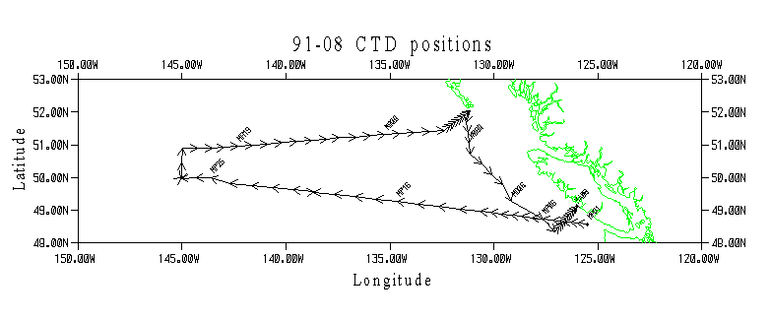
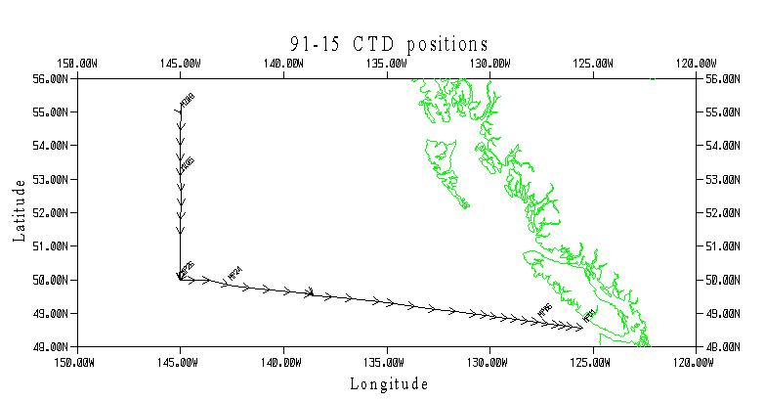
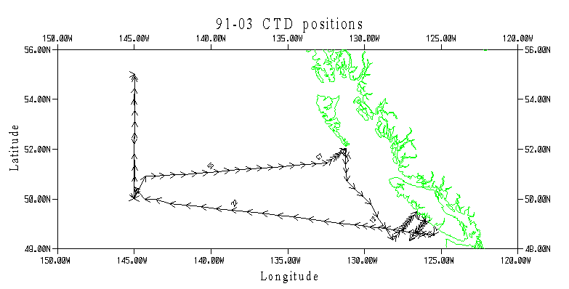
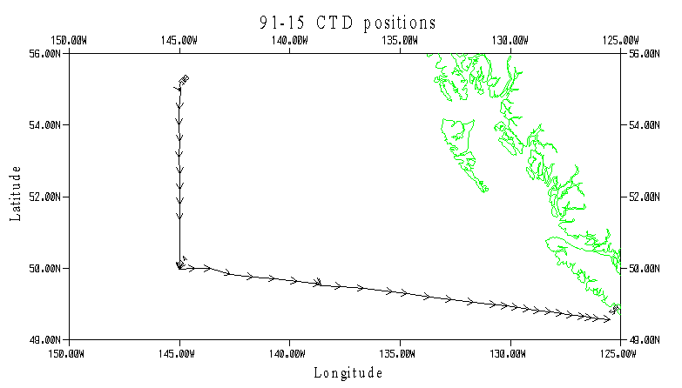
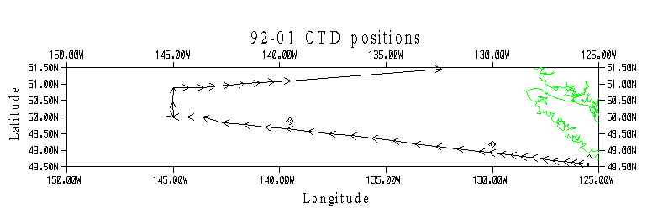

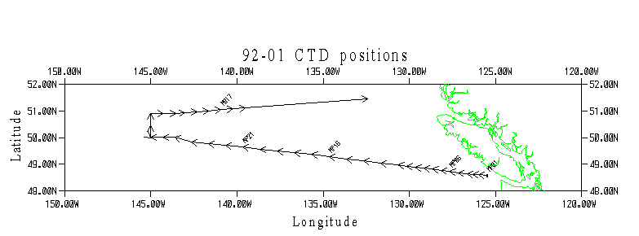
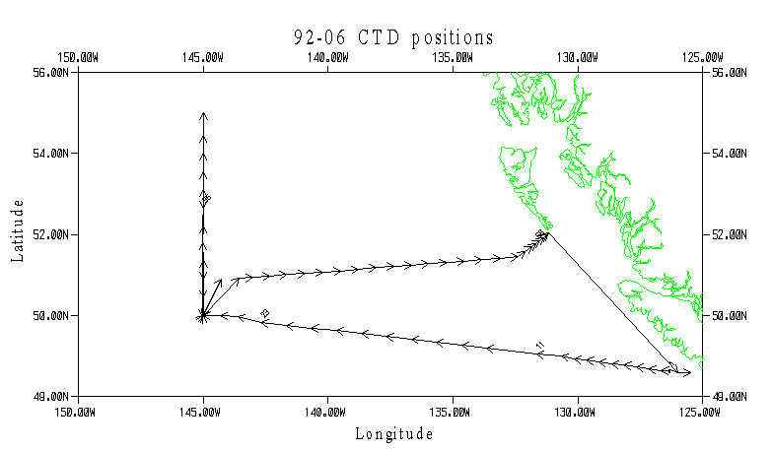
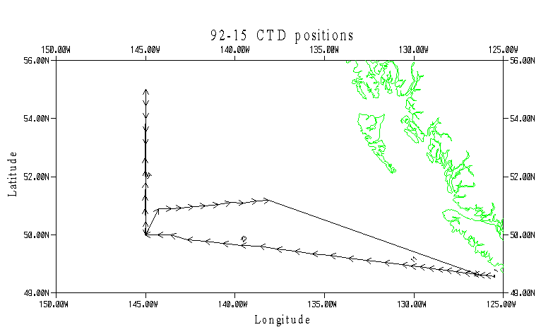

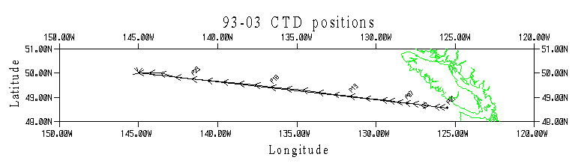
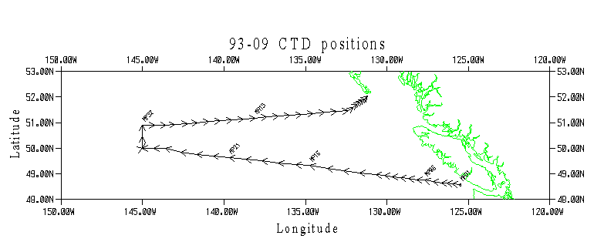
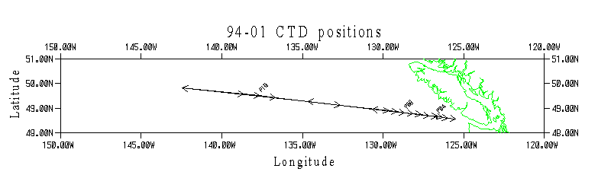
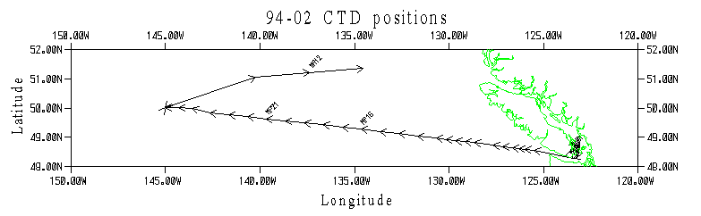
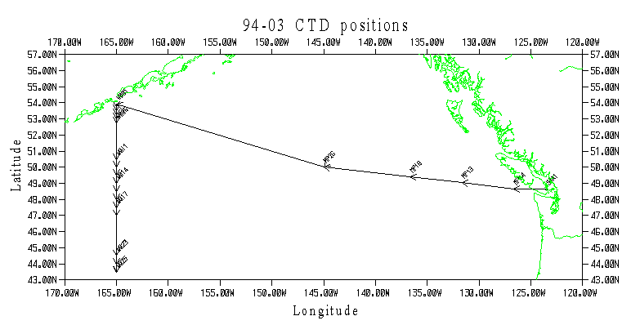
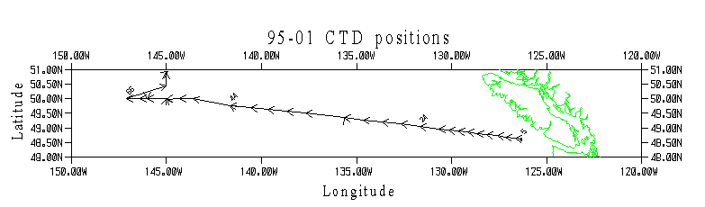
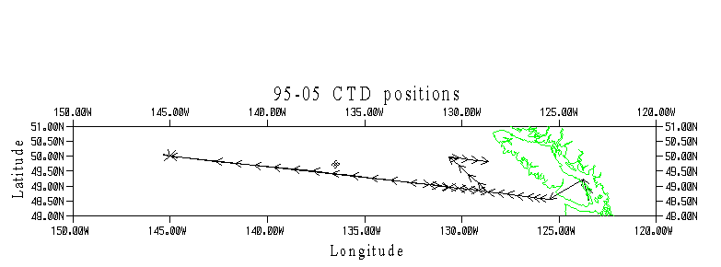
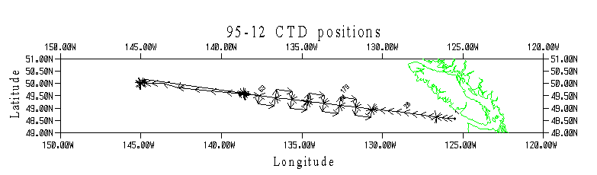
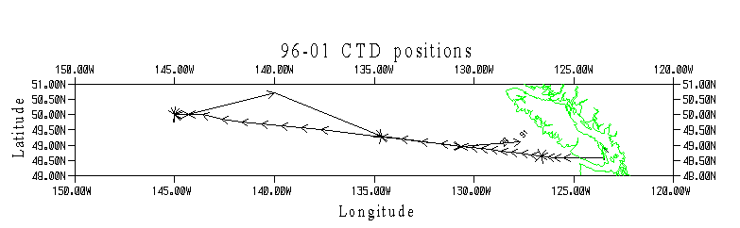
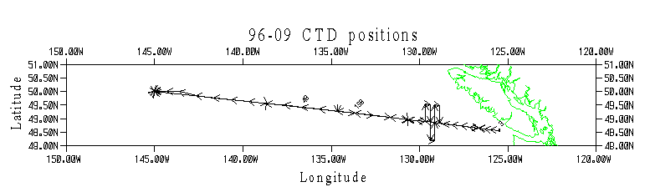
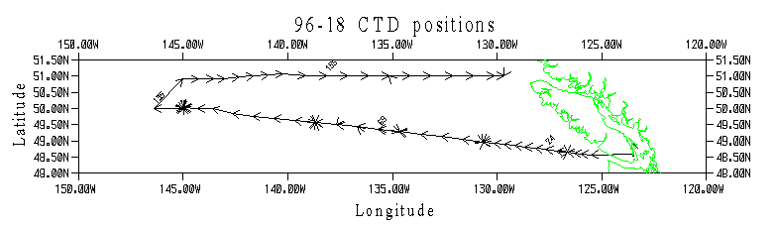
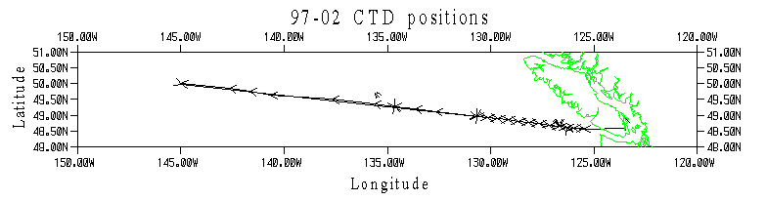
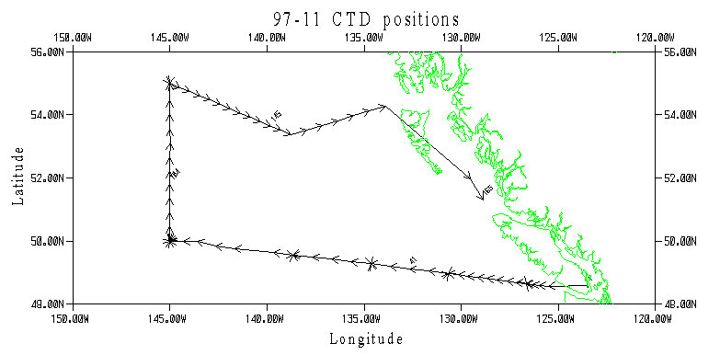
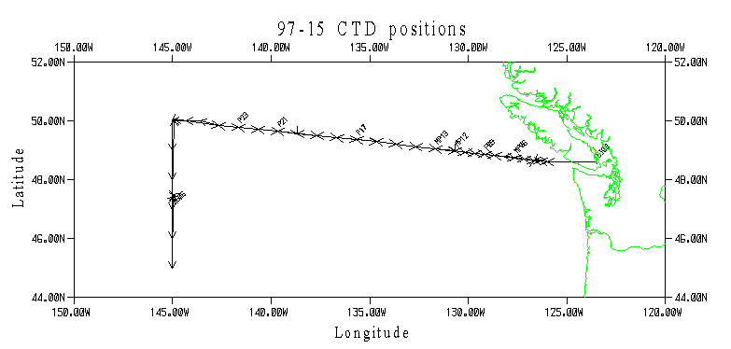
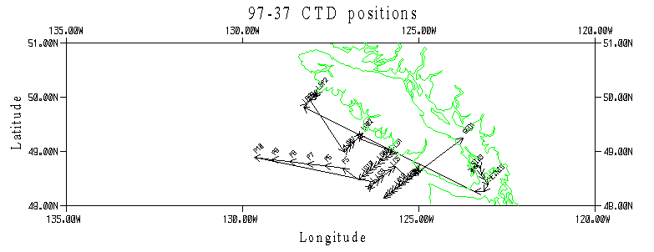
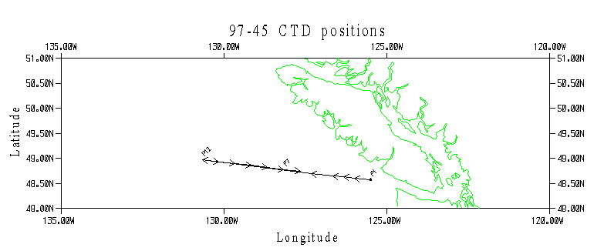
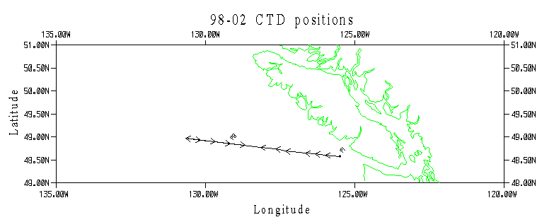
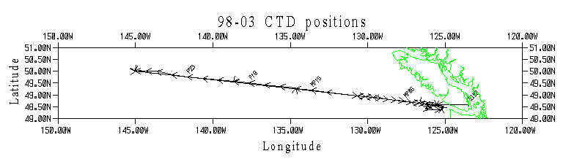

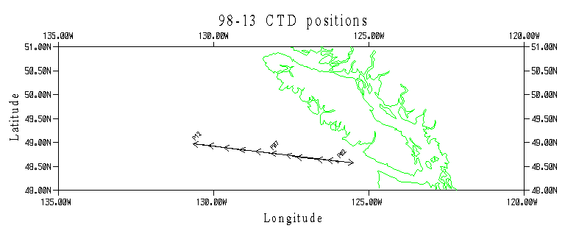

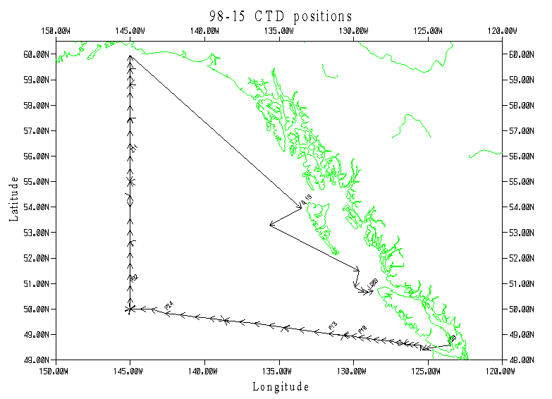

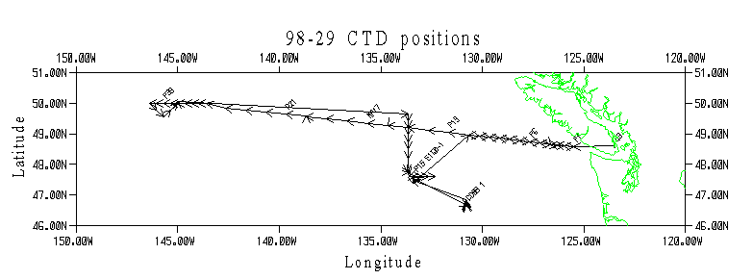

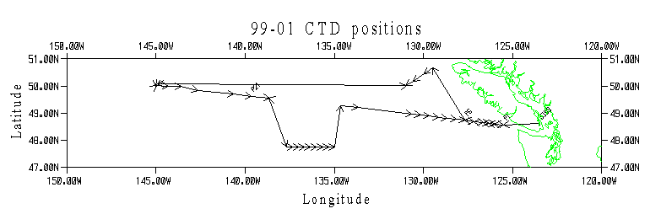

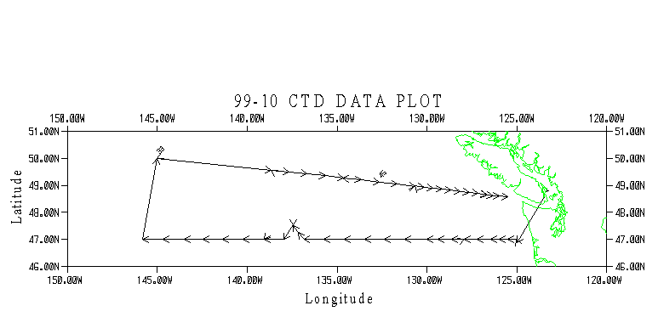

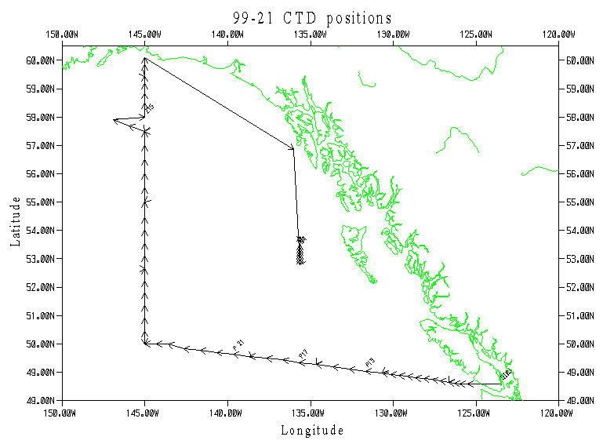

Figure 1. IOS Rosette
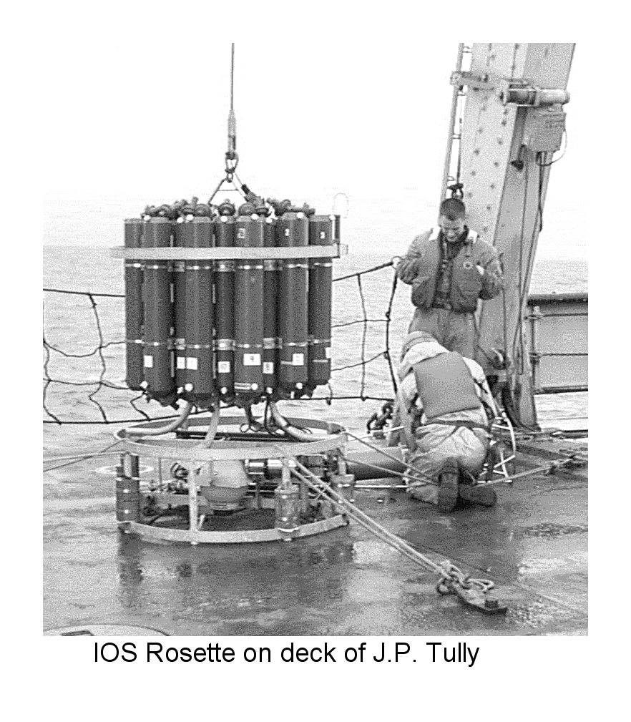

Figure 2. General Oceanics Rosette
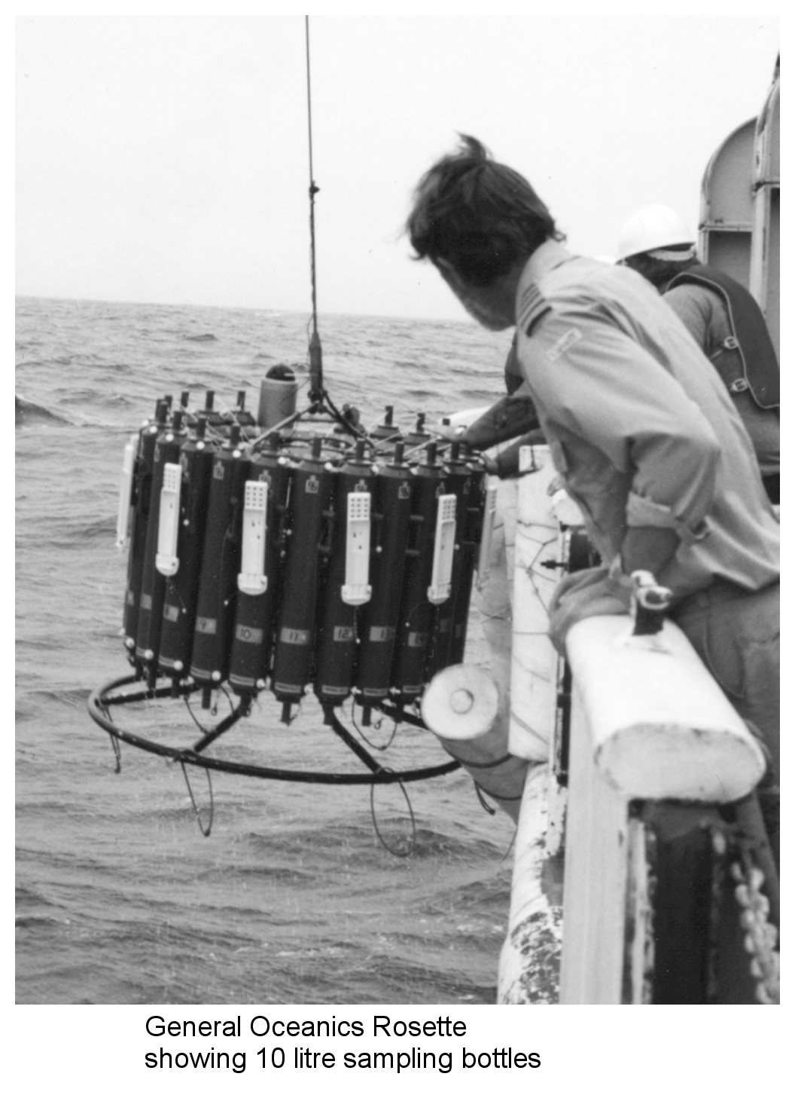

Figure 3. Heave Compensator mounted on CCGS Tully A-frame
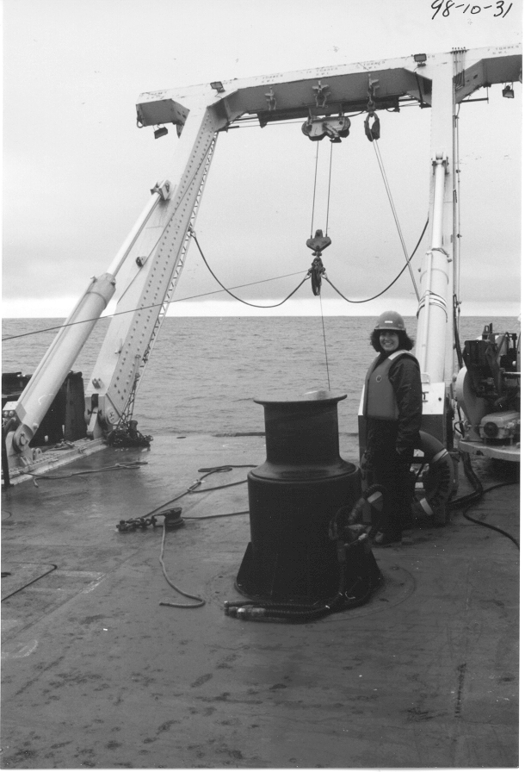

Figure 4. CSS Parizeau
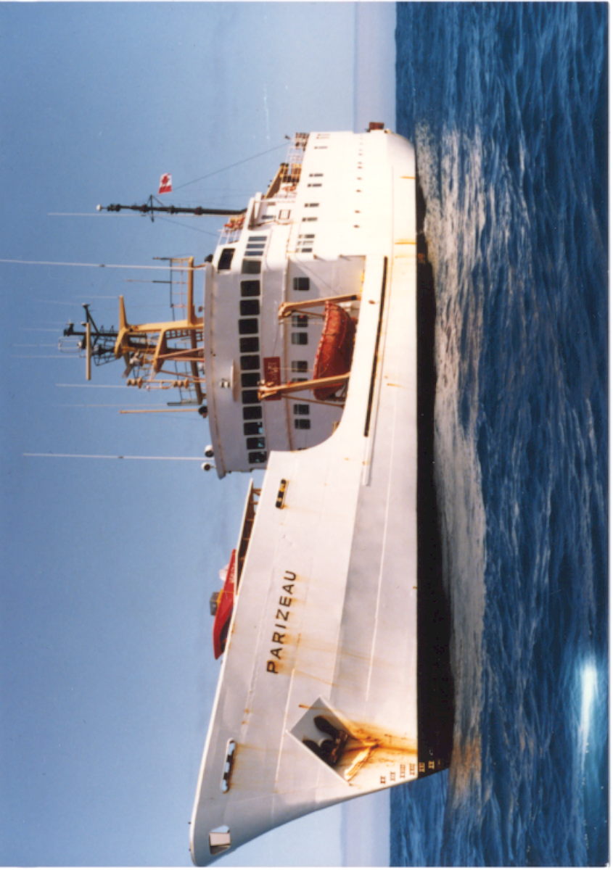

Figure 5. CCGS J.P. Tully
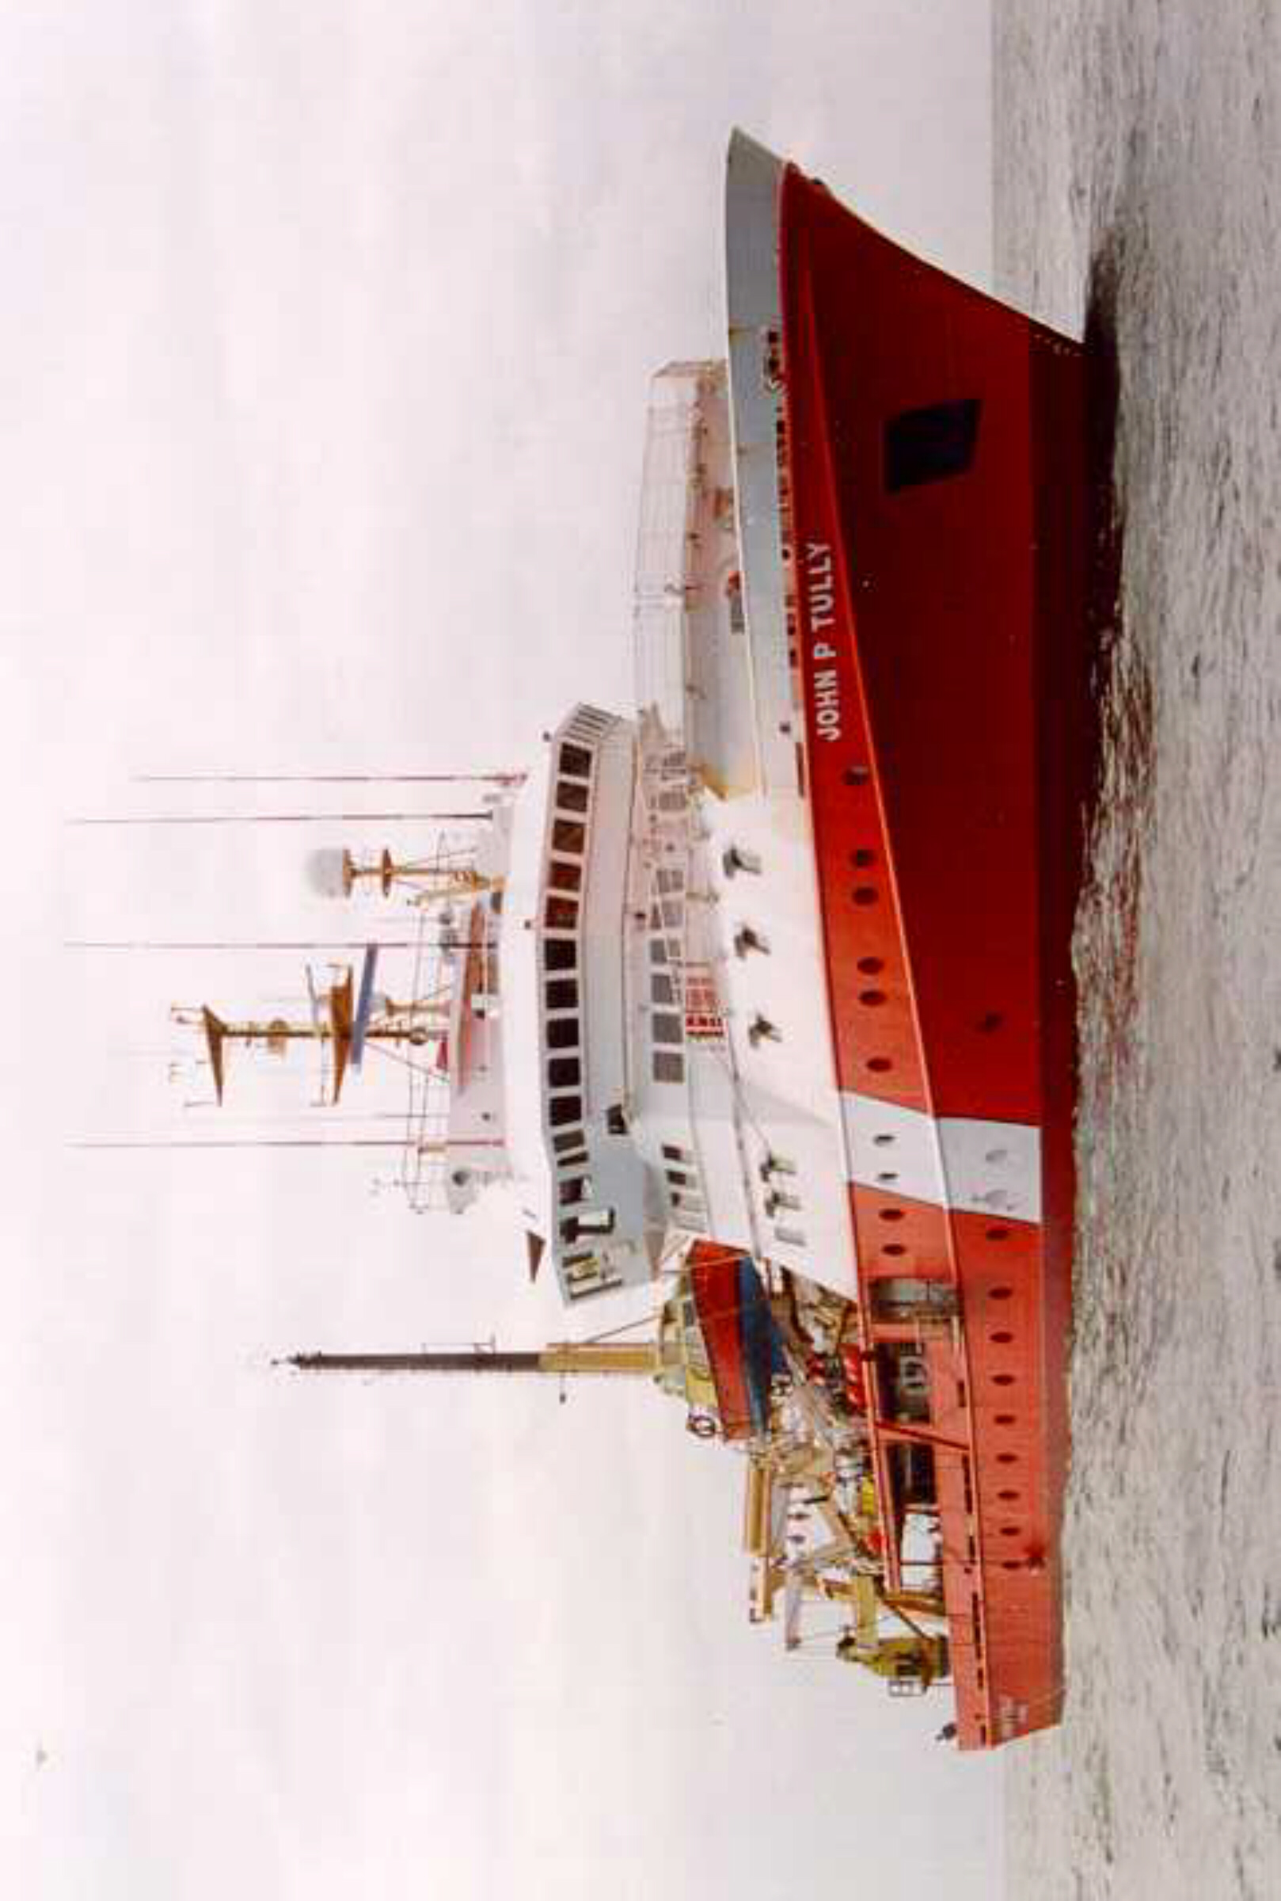

Figure 6. CNAV Endeavour

