RBR CTD DATA PROCESSING NOTES
Cruise: 2026-076
Agency: OSD
Locations: Douglas Channel
Project: OPP-DPNM Port of Kitimat Monitoring
Party Chief: Blanken H.
Platform: Other Vessel
Date: September 8, 2026

Processed by: Samantha Huntington
Date of Processing: September 16, 2026 – September 24, 2026
Number of Raw files: 33 Number of Processed Files: 33

Instrument Summary
Equipment: RBR Concerto3 CTD (s/n 241289) with Turbidity sensor (RBR coda Tu 241289) and oxygen sensor (JFE Advantech Rinko III 0529)
Sampling frequency was at 8Hz.

Summary of Quality and Concerns
A cast list of times and locations was provided, “wcmrc_ctd_stations.xlsx”, the times of the casts in the Ruskin file to not match the times in the log of locations. Time will need to be adjusted for each cast later in processing.

The casts that were originally detected by the Ruskin software all started below 3 metres. Ruskin was used to REDECT the casts before extracting the profiles, after this the casts started at the surface.

The Ruskin file 241289_20260911_1627.rsk contained 33 casts, all casts went to 46 metres, the CTD was lowered by hand on a line from a Western Canada Marine Response Corporation vessel. Descent rate varied but it was approximately 0.6m/s.

Processing Summary
- Conversion to IOS Headers

The 33 casts in the Ruskin file were extracted using python function READ_RSK().
A single file (2026-076_CTD_Data.csv) with all the data including event numbers and a single line of headers was prepared using python function MERGE_FILES().
A 6-line header was inserted using python function Add_6Lineheader_2().
File “2026-076_header-merge.csv” was created, based on the information provided by the chief scientist.
- Column “File_Name”: entries were derived from the event number.
- Column “LOC:LATITUDE”: latitude was provided and reformatted to “XX XX.XXXX N !(deg min)”.
- Column “LOC:LONGITUDE”: longitude was provided and reformatted to “XX XX.XXXX W !(deg min)”.
- Column “LOC: Event Number”: entries were event numbers.
- Column “LOC: STATION”: entries were taken from the Log file.
- Column “LOC:WATER DEPTH: was not used as all casts went to 46m and water depth was not recorded.

The sampling site was mapped (Figure 1) using from “2026-076_header-merge.csv” using python function Plot_Track_Location() to check the location of all casts.
Prior to conversion to IOS header format, the presence of zero-order holds were checked using Python function Plot_Pressure_Diff() and python function check_for_zoh(). This function returned a need for a correction and this was done using python function READ_RSK() but this time using the pyRSKTools internal correct hold function. A new file, “2026-076_CTD_DATA_6linehdr_corr_hold.csv
CONVERT Spreadsheet Files was run to produce files with IOS Header format. Header entries of “Administration”, “File”, “Instrument” and “Geographic Area” were filled in this step.
Next CLEAN was run to add a start time and event numbers to headers.
The routine “Merge:CSV Files to headers” was run to add location headers to the IOS files.
Raw data were plotted and examined:
- Salinity looks good.
- Temperature looks good.
- Conductivity looks good.
- Oxygen looks good.
- Turbidity has some spikes at the surface with some very high values, this will be examined again after DELETE.

A record number was added to each record using the routine Add time channel, times were added to files individually, the amount of time added is recorded in the file “2026-076_times_changes.csv”. The time was adjusted to the correct hours and minutes but not seconds.

- Data processing
- Correction to Pressure: No negative pressures were seen and so Pressure was not calibrated.

- CLIP: Pressure is steady for a variable number of scans. Initial records were removed until the downcast began using file “2026-076_CLIP.csv”, only 5 casts needed a clip, 26 and 28-31.

- Filter: a Gull-winged filter, size 3, was applied to temperature, conductivity, and pressure. Salinity will be calculated in the next step.

- SHIFT: Based on suggested values in document “Guidelines for processing RBR CTD profiles”, the alignment of temperature and conductivity was corrected by applying a shift of -2 scans in conductivity.

- SHIFT: Better alignment with Oxygen profiles was found by advancing it by 11 scans. The advice given in document “Guidelines for processing RBR CTD Profiles” was that an advance between 2 and 3 seconds is appropriate. T-O plots before and after alignment were compared.

- Derive Oxygen Concentration:

- Data from the shift files was extracted using python function get_rbr_data(). Oxygen:Dissolved:Concentration was derived using python function convert_oxy(). Both of these functions can be found in the python file rbr_oxy.py. A file containing the derived oxygen “2026-076_Oxygen_for_IOSshell.csv” was created so that it could be converted into the IOS shell files.

- MERGE was used to merge the derived Oxygen:Dissolved:Concentration back into the IOS Shell file.

- Delete was run to remove records with a descent rate lower than 0.1m/s over 8 points. This was not applied in the top 10m to avoid loss of surface records as the CTD began its descent. The CTD was lowered by hand so a low descent rate was used. Little difference was found between using 0.1m/s and 0.3m/s.

- Profile plots were examined after DELETE and confirm that plots show reasonable values for salinity and conductivity.

- Bad Data Removal: Extreme spikes in Turbidity were removed from almost all casts at the surface.

- Final checks and header editing
- REMOVE was run to remove the following channels from all casts: Date, Time:UTC, Event and Record Number.
- REORDER was run to order the channels.

- BIN AVERAGE was used to metre-average data.

- CALIBRATE was run to convert conductivity units to S/m using file 2026-076-recal2.ccf.

- Header Edit was used to fix channel names and format as listed below:
- Temperature: deg C(ITS90) ==> deg C (ITS90)
- Oxygen:Dissolved:Saturation:RBR [%]:
- Oxygen:Dissolved:Saturation ==> Oxygen:Dissolved:Saturation:RBR
- Format: F11.4 ==> F8.2
- Pressure [decibar]
- Format: F11.2 ==> F7.1
- Depth [metres]
- Units: meters ==> metres
Salinity:CTD ==> Salinity
- Oxygen:Dissolved:Rinko [mL/L]
- Oxygen_mL_L ==> Oxygen:Dissolved:Rinko
- Format: F10.6 ==> F7.2
- Oxygen:Dissolved:Rinko [umol/kg]
- Name: Oxygen_umol_kg ==> Oxygen:Dissolved:Rinko
- Units: ==> umol/kg
- Format: F10.6 ==> F6.1
- Turbidity:Seapoint ==> Turbidity:RBR:Coda

CLEAN was run to reset the Maximum and Minimum values in the Header.
- Header Check was run and no problems were found.

Figure 1 – location of casts – basemap resolution does not cover the extent of the inlets.

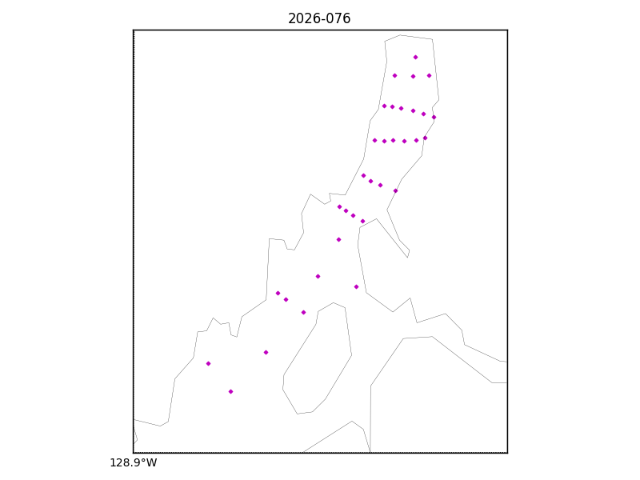

Figure 2 – Zero order holds
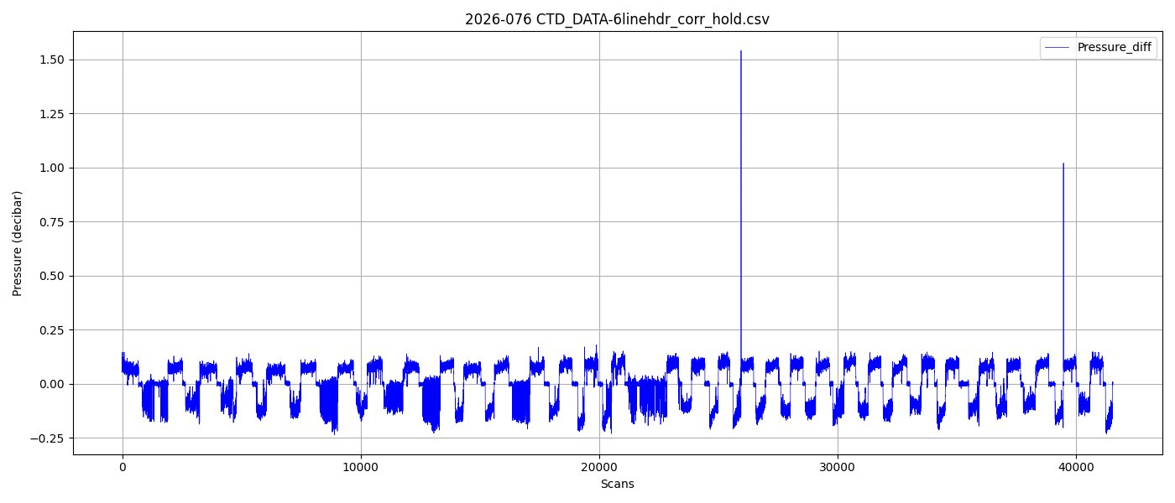
Figure 3 – Zero order holds removed