RBR CTD DATA PROCESSING NOTES
Cruise: 2025-085
Agency: OSD
Locations: Clayoquot Sound
Project: Ahousaht Territory CTD Monitoring Program
Party Chief: Bianucci, Laura
Platform: Other Vessel
Date: January 23, 2025 – December 11, 2025

Processed by: Samantha Huntington
Date of Processing: April 9, 2026 – April 15, 2026
Number of Raw files: 234 Number of Processed Files: 106

Instrument Summary
RBR Maestro CTD (s/n 235984) with a RINKO III Dissolved Oxygen sensor (s/n 0499 ), RBRCoda3 PAR (s/n 34392).
Sampling was done at 8Hz. The RBR was lowered either by hand or by prawn pull.

Summary of Quality and Concerns

Sampling took place throughout the year over several trips.
Five Ruskin files were received containing a total of 234 casts, some of the files contained casts from previous sampling days leading to a lot of duplication of profiles. Dissolved Oxygen was recalibrated and the new coefficients was applied to the casts from October onwards.
A list of casts and locations and stations names was also provided, 2025MHSS_CTDLog_Final.xlsx2025MHSS_CTDLog_Final.xlsx, with many notes explaining issues with the timestamp and location logger, the depth sounder, and the oxygen sensor. Some casts have no associated metadata.
File 235984_20250123_1631.rsk contained 41 casts, the first 34 casts were from the 2024 sampling and will be discarded, casts 35-41 are events 1-7. There were issues with the collection of time and location, times were taken from the Ruskin file and station locations were used.
File 235984_20250124_1351.rsk contained 48 casts, 41 from the previous file and 7 new casts. The first one from this day will be skipped because the RBR came up sideways and the cast was repeated. The first 42 casts from this file will be skipped and casts 43-48 are Events 8-13.
File 235984_20250724_1515 contains 64 casts, but the log has 53 casts associated with this file. Some casts have a note to disregard due to lack of metadata. Station locations were used since collecting time and location data was a challenge. In a few cases the wrong locations were attached to stations and this was fixed in preparing the header-merge file. Casts 1-35 are Events 14-48, Casts 36 and 37 were named 9901 and 9902 in order to be discarded, they are bad at the end of casts but recognized as profiles. Casts 38 -42 Are Events 49 - 53 (Station Herbert 1 was repeated on June 17th with a note saying it was repeated but not why, this will be examined in the plots after conversion to IOS Shell format. Casts 43-51 have no associated metadata and were named 9903-9911 in order to be discarded. Casts 52-55 have inaccurate metadata that does not align with the Ruskin metadata, they were named 9911-9915 to be discarded. Casts 56 to 64 had the same coordinates, correct coordinates were taken from the master station list provided by the chief scientists. These casts are Events 54-62.
File 23594_20250827_1454 contains 13 casts which are Events 63-75. The coordinates in the Log were identical for each station, this was corrected from the master list of coordinates.
File 235984_20260116_1349newDOcoefficients.rsk contains 69 casts, the first 14 are from previous sampling and were skipped. Casts 15-20 are Events 76-81. Casts 21-26 had no associated metadata and were named 9916-9921 to be discarded after IOS Shell conversion. Casts 27- 51 are Events 82-106. The remaining casts in the file are from 2026.
Full details of how event numbers match profiles in the Ruskin file can be found int 2025-085_HeaderMerge_Reformat.xlxs.
The samples were collected by the Maaqutusiis Hahoulthee Stewardship Society (MHSS) team,
led by Gemma Macfarlane, Hanna Meyer and Ryan Teremy.

Data overall look good, there is some bad data at the bottom of many casts, there are some negative Pressure, Oxygen, Conductivity and PAR values, these will be examined again after DELETE. Negative PAR values will be replaced with PAD.

Some spikes in casts 13, 31, 62, 99 and 105 will be examined after DELETE.

Processing Summary
- Conversion to IOS Headers

A Header Merge “2025-085_header-merge.csv” file was created for the extraction of all profiles in the Ruskin file using python function READ_RSK. Profiles from the first 4 Ruskin files were successfuhttps://calgaryherald.com/news/calgary-police-respond-reports-armed-individual-mount-royal-university-campuslly extracted with this function. A second file “2025-085_header-merge_2.csv” was made so that the profiles in the final Ruskin file could be extracted using python function READ_RSK with a slight alteration in the code.
Two files (2025-085_CTD_Data.csv and 2025-085_CTD_Data_2.csv) with all the data including event numbers and a single line of headers were prepared using python function MERGE_FILES().
A 6-line header was inserted using python function Add_6Lineheader_2(). Two files were made for this as well.
Prior to conversion to IOS header format, the presence of zero-order holds were checked using Python function Plot_Pressure_Diff(). Zero-order holds were found (Figure 2.) and these values were replaced with interpolated values using the python function READ_RSK incorporating the pyRSKtools function to correct the zero-order holds.
Two new csv files were created “2025-085_CSV_DATA-6Linedr_corr_hold.csv” (and _2) and the corrected values were checked in python function Plot_Pressure_Diff(). Zero-order holds were found to be removed (Figure 3.).
File “2025-085_header-merge_ios.csv” was created, based on the information provided by the chief scientist.
- Column “File_Name”: entries were derived from the event number.
- Column “LOC:LATITUDE”: latitude was provided and reformatted to “XX XX.XXXX N !(deg min)”.
- Column “LOC:LONGITUDE”: longitude was provided and reformatted to “XX XX.XXXX W !(deg min)”.
- Column “LOC: Event Number”: entries were event numbers.
- Column “LOC: STATION”: station information was provided.
- Column “LOC:Water Depth: not used in this cruise due to the depth sounder being unreliable throughout most of the excursions.

The sampling site was mapped (Figure 1) using from “2025-085_header-merge.csv” using python function Plot_Track_Location() to check the location of all casts.
CONVERT Spreadsheet Files was run to produce files with IOS Header format. Header entries of “Administration”, “File” and “Instrument” were filled in this step. Some were kept blank to be populated later with Merge:CSV. Time Increment, Instrument and Serial Number were not consistent throughout the cruise.
Using ADD TIME CHANNEL a record number was added to each record.
Next CLEAN was run to add a start time and event numbers to headers.
Raw data were plotted and examined:
- Salinity and Conductivity look good with some spikes in casts 31, 99 and 105.
- Temperature looks good.
- Oxygen looks good with some quite high values at the surface but these were kept after discussion with the chief scientist. Some data in cast 13 will be examined after DELETE.
- PAR has some negative values which were replaced with NaN during the clean step. Par will be examined again after the DELETE step.

The routine “Merge:CSV Files to headers” was run to add location, model, serial number and time increment headers to the files.

- Data processing

- CLIP: Pressure is steady for a variable number of scans. Initial records were removed until the downcast began using file “2025-085_CLIP.csv”.
- Correction to Pressure: Many casts had negative pressures at the end of the upcast and corresponding conductivity of 29 mS/cm. A pressure correction of 0.1 decibar was applied to these four files using calibration file 2025-085-recal1.ccf.

- Filter: a Gull-winged filter, size 3, was applied to temperature, conductivity, and pressure. Salinity will be calculated in the next step.

- SHIFT: Based on suggested values in document “Guidelines for processing RBR CTD profiles”, the alignment of temperature and conductivity was corrected by applying a shift of -2 scans in conductivity.

- SHIFT: Better alignment with Oxygen profiles was found by advancing it by 11 scans. The advice given in document “Guidelines for processing RBR CTD Profiles” was that an advance between 2 and 3 seconds is appropriate. T-O plots before and after alignment were compared.

- Derive Oxygen Concentration:

- Data from the shift files was extracted using python function get_rbr_data(). Oxygen:Dissolved:Concentration was derived using python function convert_oxy(). Both of these functions can be found in the python file rbr_oxy.py. A file containing the derived oxygen “2025-055_Oxygen_for_IOSshell.csv” was created so that it could be converted into the IOS shell files.

- MERGE was used to merge the derived Oxygen:Dissolved:Concentration back into the IOS Shell file.

- Delete was run to remove records with a descent rate lower than 0.2m/s over 8 points. The RBR was lowered by hand or prawn pull so the descent rate was not consistent.

- DESPIKE and Bad data removal:

Plots after DELETE were examined to look for any remained bad data at the bottom of casts. The Oxygen data in casts 13 and 62 looked fine after Delete.

Bad data was removed from the bottom of casts 1, 6, 7, 13, 19, 24, 25, 32, 39, 40, 41, 48, 52, 53, 59, 63, 66, 67, 69, 70, 74, 78, 81, 95, 99 and 105.
Spikes in Salinity and Conductivity were removed from cast 57.

- Profile plots were examined after DELETE and confirm that plots show reasonable values for salinity and conductivity and dissolved oxygen.
- CLEAN was run to replace negative PAR values with PAD and then to replace some negative Dissolved Oxygen Values in casts 43-47 and 57-58 with PAD.
- REORDER was run to reorder the channels.

- Final checks and header editing
- REMOVE was run to remove the following channels from all casts: Date, Time:UTC, Event and Record number.
- BIN AVERAGE was used to metre-average data.

- CALIBRATE was run to convert conductivity units to S/m using file 2025-085-recal2.ccf.

- Header Edit was used to fix channel names and format as listed below:
- Salinity:CTD ==> Salinity
- Oxygen:Dissolved:Saturation F11.4 ==> Oxygen:Dissolved:Saturation:RBR F8.2
- Oxygen_umol_kg F10.6 ==> Oxygen:Dissolved:RinkomL/L==> F6.1
- Oxygen_mL_L F10.6 ==> Oxygen:Dissolved:Rinko F7.2
- CLEAN was run to reset the Maximum and Minimum values in the Header.

- Header Check and Standards Check were run and no problems were found.
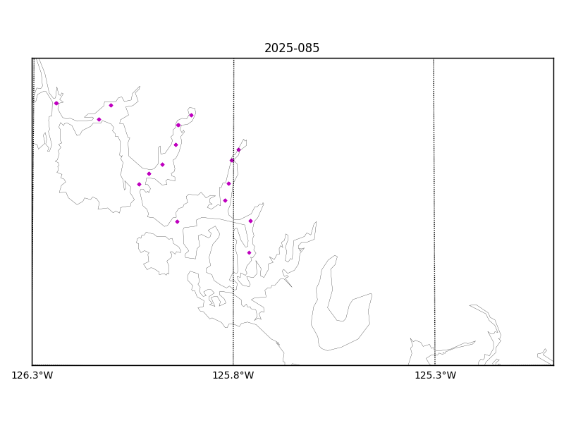

Figure 1 – location of casts.
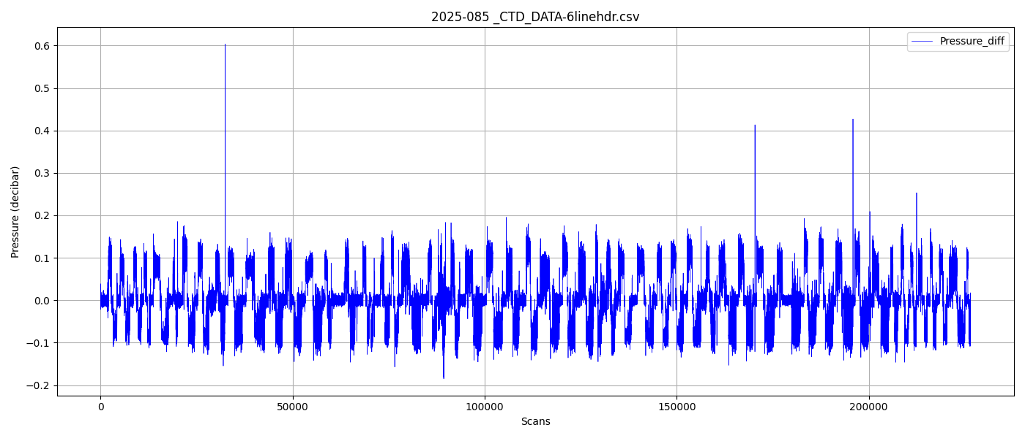
Figure 2 – zero-order holds
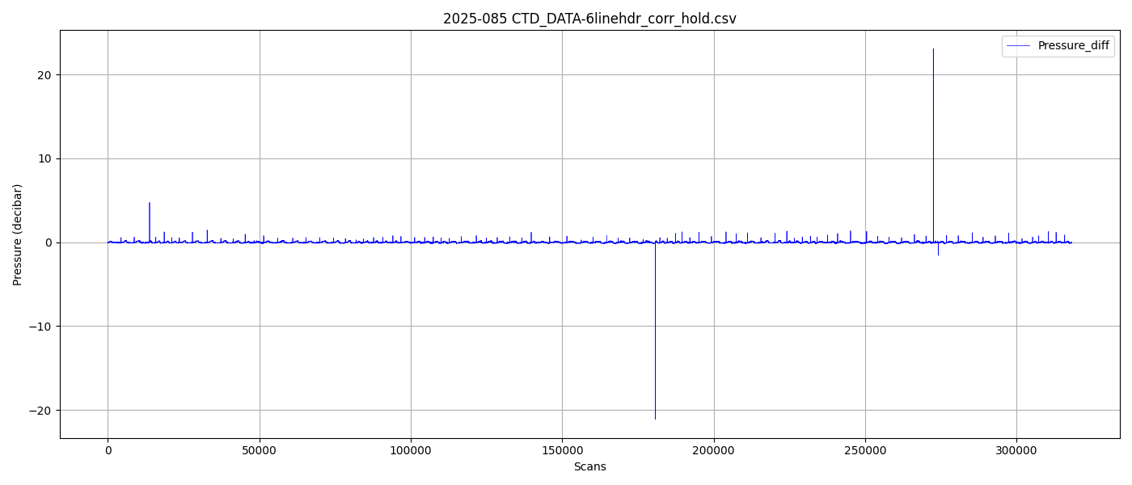
Figure 3 – zero order holds removed

