RBR CTD DATA PROCESSING NOTES
Cruise: 2025-084
Agency: OSD
Locations: Clayoquot Sound
Project: Pacific Salmon Strategy Initiative
Party Chief: Bianucci L., Cooper G.
Platform: Doug Anderson
Date: November 26, 2025 – December 1, 2025

Processed by: Samantha Huntington
Date of Processing: December 29, 2025 – December 31, 2025
Number of Raw files: 121 Number of Processed Files: 42

Instrument Summary
Equipment: RBR Maestro CTD (s/n 208765) with a Turner Cyclops Fluorometer (s/n 2110792), a JFE Advantech Rinko III oxygen sensor (s/n 0447), and a Turbidity Sensor (Seapoint s/n 208765).
Sampling frequency was at 8Hz.

Summary of Quality and Concerns
A cast list of times and locations was provided, “2025-084CTDLogFile_Finalxlxs”. The Ruskin file contained 121 casts, this cruise began 78 casts conducted for cruise 2025-085, a separate project that used the RBR in conjunction with a LISST sensor. Four of the casts in the Log File were Plankton Haul Nets and these events were removed from the Header Merge file. It was extremely windy for the first 6 casts.

The data overall look good with some spikes in Fluorescence and Turbidity. Oxygen is also a bit spiky due to some spikes in the Rinko Temperature sensor data. These will be examined after Clip and removing the upcast.

Processing Summary
- Conversion to IOS Headers

File “2025-084_header-merge.csv” was created, based on the information provided by the chief scientist. Cast three was removed from this file before extracting the profiles.
- Column “File_Name”: entries were derived from the event number.
- Column “LOC:LATITUDE”: latitude was provided and reformatted to “XX XX.XXXX N !(deg min)”.
- Column “LOC:LONGITUDE”: longitude was provided and reformatted to “XX XX.XXXX W !(deg min)”.
- Column “LOC: Event Number”: entries were event numbers.
- Column “LOC: STATION”: entries were taken from the Log file.

File 208765_20251130_1636.rsk contained the 121 profiles , of which the final 42 were extrated python function READ_RSK().
A single file (2025-084_CTD_Data.csv) with all the data including event numbers and a single line of headers was prepared using python function MERGE_FILES().
A 6-line header was inserted using python function Add_6Lineheader_2().
Python function check_for_zoh() was used to check for the presence of zero order holds. These holds were replaced with interpolated values using the pyRSKTools package in Python.
A new csv file was created “2025-084_CSV_DATA-6Linedr_corr_hold.csv” and the corrected values were checked in python function Plot_Pressure_Diff(). Zero-order holds were found to be removed (Figure 3.).
The sampling site was mapped (Figure 1) using from “2025-084_header-merge.csv” using python function Plot_Track_Location() to check the location of all casts.
CONVERT Spreadsheet Files was run to produce files with IOS Header format. Header entries of “Administration”, “File” and “Instrument” were filled in this step.
The routine “Merge:CSV Files to headers” was run to add location headers to the IOS files.
Next CLEAN was run to add a start time and event numbers to headers.
Raw data were plotted and examined:
- Salinity looks good.
- Temperature looks good.
- Conductivity looks good.
- Oxygen looks spiky due to the spikes in the Rinko Temperature values.
- Fluorescence has some spikes.
- Fluorescence and Turbidity have some negative values.

- Data processing

- A record number was added to the files.
- Correction to Pressure: no negative values were found in Pressure and so no calibration was necessary.

- CLIP: Pressure is steady for a variable number of scans. Initial records were removed until the downcast began using file “2025-084_CLIP.csv”.

- Filter: a Gull-winged filter, size 3, was applied to temperature, conductivity, fluorescence and pressure. Salinity will be calculated in the next step.

- SHIFT: Based on suggested values in document “Guidelines for processing RBR CTD profiles”, the alignment of temperature and conductivity was corrected by applying a shift of -2 scans in conductivity.

- SHIFT: Better alignment with Oxygen profiles was found by advancing it by 11 scans. The advice given in document “Guidelines for processing RBR CTD Profiles” was that an advance between 2 and 3 seconds is appropriate. T-O plots before and after alignment were compared.

- Derive Oxygen Concentration:

- Data from the shift files was extracted using python function get_rbr_data(). Oxygen:Dissolved:Concentration was derived using python function convert_oxy(). Both of these functions can be found in the python file rbr_oxy.py. A file containing the derived oxygen “2025-043_Oxygen_for_IOSshell.csv” was created so that it could be converted into the IOS shell files.

- MERGE was used to merge the derived Oxygen:Dissolved:Concentration back into the IOS Shell file.

- Oxygen values were found to be a little bit spiky due to spikes in the RinkoIII temperature values. Oxygen:Dissolved:Saturation and Oxygen:Dissolved:Concentration were smoothed using a Moving Average filter with a filter size 5.
- Delete was run to remove records with a descent rate lower than 0.3m/s over 8 points. This was not applied in the top 10m to avoid loss of surface records as the CTD began its descent.

- Profile plots were examined after DELETE and confirm that plots show reasonable values for salinity and conductivity and fluorescence. Spikes were found in Fluorescence.
- Prior to removing the spikes, negative Fluorescence and Turbidity values were replaced with PAD values using CLEAN.
- Data despiking: Using CTD EDIT, Fluorescence spikes were manually replaced with PAD values in most casts. Bad data at the bottom of any cast were removed in this step. Oxygen values did not need to be padded, the filter in a previous step was sufficient.

- Final checks and header editing
- REMOVE was run to remove the following channels from all casts: Date, Time:UTC and Event. After replacing negative Turbidity values, there was not much turbidity data left, suggesting that the turbidity sensor needs calibrating. Turbidity values were dropped from this cruise.
- REORDER was run to order the channels.

- BIN AVERAGE was used to metre-average data.

- CALIBRATE was run to convert conductivity units to S/m using file 2025-084-recal2.ccf.
- Header Edit was used to fix channel names and format as listed below:
  - Pressure: format F11.2 ==> F7.1
  - Salinity:CTD ==> Salinity
  - Fluorescence ==> Fluorescence:URU
  - Oxygen_mL_L ==> Oxygen:Dissolved:Rinko
  - Oxygen_umol_kg ==> Oxygen:Dissolved:Rinko
- CLEAN was run to reset the Maximum and Minimum values in the Header.

- Header Check was run and no problems were found.

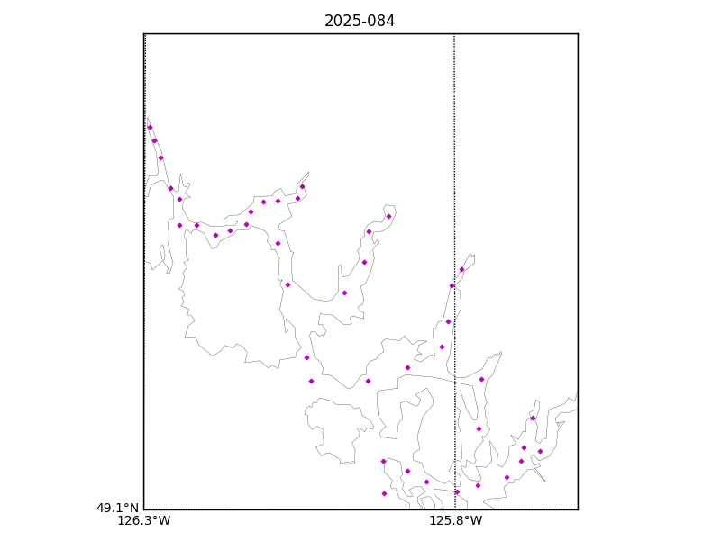
Figure 1 – location of casts. 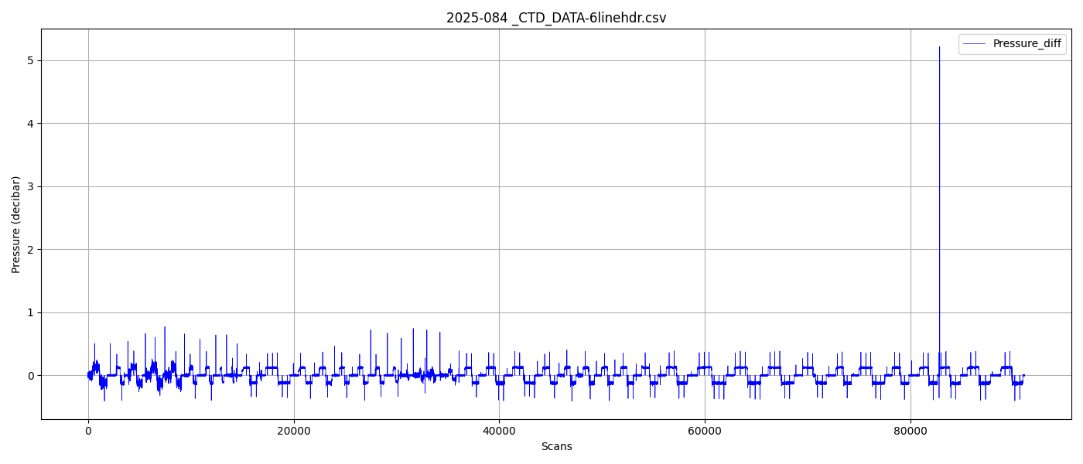

Figure 2 – zero order holds.
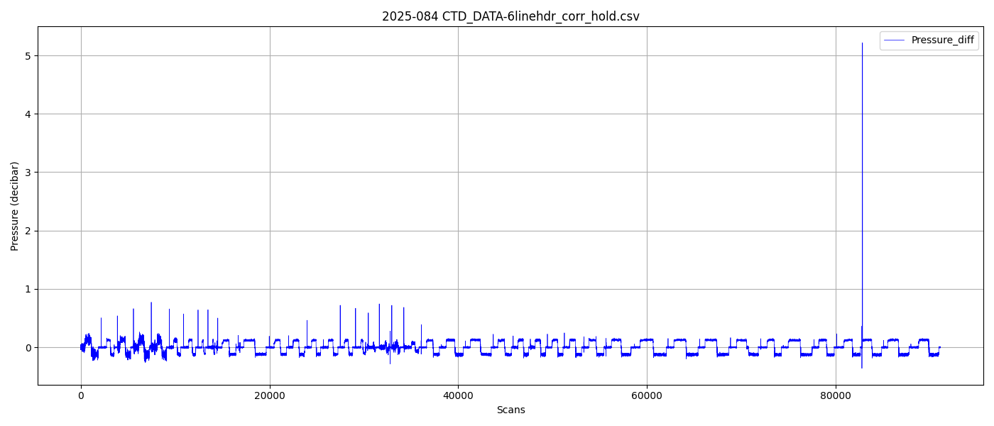
Figure 3 – zero order holds removed

