RBR CTD DATA PROCESSING NOTES
Cruise: 2025-071
Agency: OSD
Locations: Quatsino Sound
Project: Quatsino Sound CTD Monitoring Program
Party Chief: Cooper G.
Platform: Blackfish
Date: January 1, 2025 – July, 2025

Processed by: Samantha Huntington
Date of Processing: September 30, 2025 – October 31, 2025
Number of Raw files: 178 Number of Processed Files: 176

Instrument Summary
Casts 1-104: Equipment: RBR Maestro3 CTD (s/n 208765) with a Turner Cyclops Fluorometer (s/n 2110792), a JFE Advantech Rinko III oxygen sensor (s/n 0447), and a Turbidity Sensor (Seapoint s/n 208765).
Casts 105-177: Equipment: RBR Maestro3 CTD (s/n 232531) with a Turner Cyclops Fluorometer, a JFE Advantech Rinko III oxygen sensor, and a Turbidity Sensor.

Sampling frequency was at 8Hz.

Summary of Quality and Concerns
A cast list of times and locations was provided, “2025QuatsinoFirstNations_CTD_Taplog_Final.xlxs”.

The data overall look good with some spikes in Fluorescence and Turbidity. These will be examined after Clip and removing the upcast.

Cast 101 had no Conductivity in the profile and was discarded after conversion to headers, Cast 103 had very bad data at the end of the cast, this was removed during CLIP prior to processing.

Starting at cast 105 with RBR CTD 232531 there was bad data at the end of the upcast in most of the casts. This data was cut during the CLIP process.

Some casts had bad data at the bottom, this will be examined again after the DELETE step.

Processing Summary
- Conversion to IOS Headers

Seven files from two different CTDs were provided. They contained 177 casts in total. The event numbers started at 1 for each excursion. They were renamed to 1-177 from first excursion to the final file.
208765_20250122_1101.rsk contained casts 1-26.
208765_20250222_1224 Feb CTD.rsk contained casts 27-52.
208765_20250325_1027.rsk contained casts 53-78.
208765_20250414_1005.rsk contained casts 79-104. Cast 101 was not recognized by Ruskin.
232531_20250606_1406.rsk contained casts 105-125. Cast 20 is missing from the log, there is a profile 20 but without any corresponding metadata, this profile was not processed. It was labelled 99 and discarded prior to merging the profiles together.
232531_20250701_0823 June CTD.rsk contained casts 126-151.
232531_20250729_1028 July CTD.rsk contained casts 152-177.

The profiles were extracted from each file individually using python function Read_RSK(). For profile 101 the excel export was altered to included only that profile so it could be extracted using python function Read_Excel(). This cast was later discarded.

A single file (2025-071_CTD_Data.csv) for each Ruskin file, with all the data including event numbers and a single line of headers was prepared using python function MERGE_FILES().
A 6-line header was inserted using python function Add_6Lineheader_2(), a separate spreadsheet was made for each file and renamed to reflect the casts it represents, for example “_1to26.csv”.
File “2025-071_header-merge.csv” was created, based on the information provided by the chief scientist.
- Column “File_Name”: entries were derived from the event number.
- Column “LOC:LATITUDE”: latitude was provided and reformatted to “XX XX.XXXX N !(deg min)”.
- Column “LOC:LONGITUDE”: longitude was provided and reformatted to “XX XX.XXXX W !(deg min)”.
- Column “LOC: Event Number”: entries were event numbers.
- Column “LOC: STATION”: entries were taken from the Log file.

The sampling site was mapped (Figure 1) using from “2025-071_header-merge.csv” using python function Plot_Track_Location() to check the location of all casts.
Prior to conversion to IOS header format, the presence of zero-order holds using python function Plot_pressure_diff(). Zero order holds were corrected using python function READ_RSK() with pyRSKtools correcting the hold before extracting the profiles.
A new csv file was created “2025-071_CSV_DATA-6Linedr_corr_hold.csv” for each Ruskin file and the corrected values were checked in python function Plot_Pressure_Diff(). Zero-order holds were found to be removed (one example at Figure 3.).
CONVERT Spreadsheet Files was run to produce files with IOS Header format. Header entries of “Administration”, “File” and “Instrument” were filled in this step. This was done for each 6 Line Header, and the different CTD serial numbers were taken into account.
The routine “Merge:CSV Files to headers” was run to add location headers to the IOS files.
Next CLEAN was run to add a start time and event numbers to headers.
A record number was added using the routing ADD TIME CHANNELS.
Raw data were plotted and examined:

- Salinity looks good.
- Temperature looks good.
- Conductivity looks good.
- Oxygen looks good with some spikes in a few casts, these will be examined again later.
- Fluorescence has some significant spikes in many casts, these will be examined again after the DELETE step. Occasionally Fluorescence did not have enough range in the sensor and this shows in the data. The casts without enough range are 1-3, 42, 126, 154 and 155.
- Turbidity has some large negative spikes which will be removed after DELETE.

- Data processing
- Correction to Pressure: there were some negative pressures found but Conductivity was always very low and the RBR was on the surface, and so pressure was not calibrated.

- CLIP: Pressure is steady for a variable number of scans. Initial records were removed until the downcast began using file “2025-071_CLIP.csv”.

- Filter: a Gull-winged filter, size 3, was applied to temperature, conductivity, and pressure. Salinity will be calculated in the next step.

- SHIFT: Based on suggested values in document “Guidelines for processing RBR CTD profiles”, the alignment of temperature and conductivity was corrected by applying a shift of -2 scans in conductivity.

- SHIFT: Better alignment with Oxygen profiles was found by advancing it by 11 scans. The advice given in document “Guidelines for processing RBR CTD Profiles” was that an advance between 2 and 3 seconds is appropriate. T-O plots before and after alignment were compared.

- Derive Oxygen Concentration:

- Data from the shift files was extracted using python function get_rbr_data(). Oxygen:Dissolved:Concentration was derived using python function convert_oxy(). Both of these functions can be found in the python file rbr_oxy.py. A file containing the derived oxygen “2025-043_Oxygen_for_IOSshell.csv” was created so that it could be converted into the IOS shell files.

- MERGE was used to merge the derived Oxygen:Dissolved:Concentration back into the IOS Shell file.

- Delete was run to remove records with a descent rate lower than 0.2m/s over 8 points. This was not applied in the top 10m to avoid loss of surface records as the CTD began its descent.

- Profile plots were examined after DELETE and confirm that plots show reasonable values for salinity and conductivity and fluorescence.

- Data DESPIKING and bad data REMOVAL: The program CTD Edit was used to remove spikes as well as any bad data at the bottom of any casts. The log files from this program detail the changes that were made. Spikes in Oxygen were removed from casts 34, 59, 80, 82, 83 and 85.

- Final checks and header editing
- REMOVE was run to remove the following channels from all casts: Date, Time:UTC and Event.
- CLEAN was run to replace negative Fluorescence and Turbidity values with PAD.
- REORDER was run to order the channels.

- BIN AVERAGE was used to metre-average data.

- CALIBRATE was run to convert conductivity units to S/m using file 2025-071-recal2.ccf.

- REMOVE was run to remove the turbidity channel from casts 1-104 since the data suggested that the sensor used for these casts needs to be calibrated.
- Header Edit was used to fix channel names and format as listed below:
  - Pressure: format F11.2 ==> F7.1
  - Salinity:CTD ==> Salinity
  - Fluorescence ==> Fluorescence:URU
  - Oxygen_mL_L ==> Oxygen:Dissolved:Rinko
  - Oxygen_umol_kg ==> Oxygen:Dissolved:Rinko
  - Turbidity FTU ==> Turbidity NTU
- CLEAN was run to reset the Maximum and Minimum values in the Header.

- Header Check was run and no problems were found.

Figure 1 – location of casts. 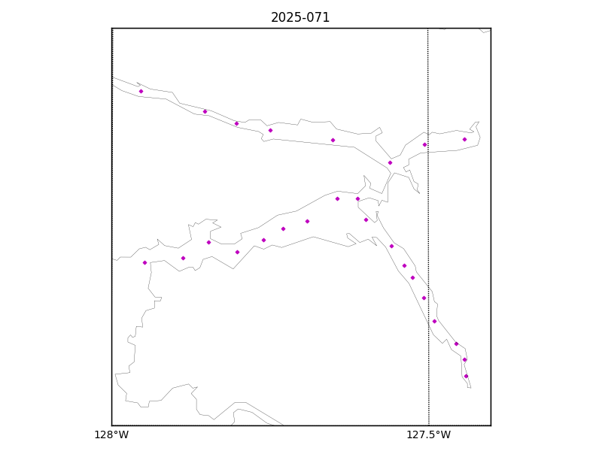

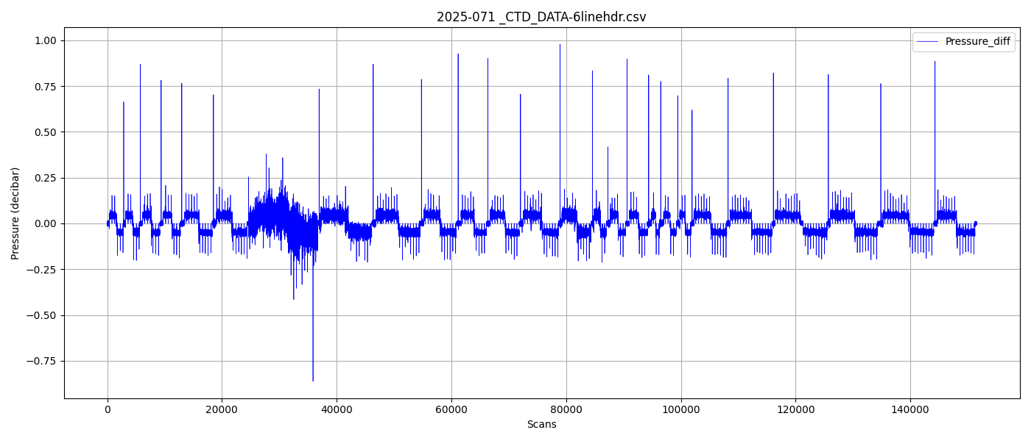
Fig 2 - zero order holds detected.
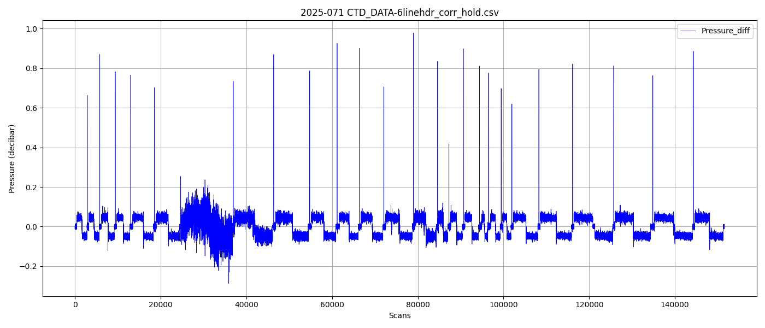Figure 3 – zero order holds removed

