**RBR CTD DATA PROCESSING NOTES**

Cruise: 2025-035

Agency: OSD

Locations: Vancouver Harbour

Project: OPP Vancouver Harbour Oceanography Survey

Party Chief: Blanken H.

Platform: Doug Anderson

Date: March 17, 2025 – March 21, 2025

Processed by: Samantha Huntington

Date of Processing: July 30, 2025 – August 5, 2025

Number of Raw files: 125 Number of Processed Files: 125

**Instrument Summary**

Equipment: RBR Concerto3 CTD (s/n 204694) with a Fluorometer (Chlorophyll a Turner Cyclops s/n 211012) and oxygen sensor (JFE Advantech Rinko III BT s/n 411)

Sampling frequency was at 8Hz.

**Summary of Quality and Concerns**

A cast list of times and locations was provided, “Tap Log Export 20250321.csv”, this contained the log data from a few previous trips and this data was ignored. The battery on the tablet died on the second to last day so 13 casts were logged manually and added into the file which was formatted to create “2025-035CTDLogFinal.xlsx”. Event 100 was not recorded properly so the sequence of subsequent events was disrupted. The event numbers were corrected to show the proper sequence. Refer to the final log file for further details.

One Ruskin file was provided, “204694_20250326_1511.rsk”, cast 28 was detected as two casts, and had to be combined into one.

The data overall look good although there is some bad data at the top and bottom of some casts, this will be re-examined after DELETE. There are some negative pressure spikes at the top of some of the upcasts.

**Processing Summary**

1. **Conversion to IOS Headers**

File 204694_20250326_1511.rsk contained 126 profile which were extracted using python function READ_RSK(). Profiles 28 and 29 were combined into profile 28.

A single file (2025-035_CTD_Data.csv) with all the data including event numbers and a single line of headers was prepared using python function MERGE_FILES().

A 6-line header was inserted using python function Add_6Lineheader_2().

File “2025-035_header-merge.csv” was created, based on the information provided by the chief scientist.

* Column “File_Name”: entries were derived from the event number.
* Column “LOC:LATITUDE”: latitude was provided and reformatted to “XX XX.XXXX N !(deg min)”.
* Column “LOC:LONGITUDE”: longitude was provided and reformatted to “XX XX.XXXX W !(deg min)”.
* Column “LOC: Event Number”: entries were event numbers.
* Column “LOC: STATION”: entries were taken from the Log file.
* Column “LOC:WATER DEPTH: entries were taken from the Log file

The sampling site was mapped (Figure 1) using from “2025-035_header-merge.csv” using python function Plot_Track_Location() to check the location of all casts.

Prior to conversion to IOS header format, the presence of zero-order holds were checked using Python function Plot_Pressure_Diff() and python function check_for_zoh(). This function returned a need for a correction and this was done using python function CORRECT_HOLD(). A new file, “2025-035_CTD_DATA_6linehdr_corr_hold.csv

CONVERT Spreadsheet Files was run to produce files with IOS Header format. Header entries of “Administration”, “File”, “Instrument” and “Geographic Area” were filled in this step.

Next CLEAN was run to add a start time and event numbers to headers.

The routine “Merge:CSV Files to headers” was run to add location headers to the IOS files.

Raw data were plotted and examined:

* Salinity looks good.
* Temperature looks good.
* Conductivity looks good.
* Oxygen looks good with some bad data at top and bottom of some casts which will be examined after Shift and Delete.
* Fluorescence has some bad data at top and there are some negative values. There are some spikes, these will be examined again after DELETE.

A record number was added to each record using the routine Add time channel.

1. **Data processing**

* Correction to Pressure: Negative pressures were not seen in all casts but they were present in many, a pressure correction of 0.1 was added to Pressure and Depth.
* CLIP: Pressure is steady for a variable number of scans. Initial records were removed until the downcast began using file “2025-035_CLIP.csv”.
* Filter: a Gull-winged filter, size 3, was applied to temperature, conductivity, and pressure. Salinity will be calculated in the next step.
* SHIFT: Based on suggested values in document “Guidelines for processing RBR CTD profiles”, the alignment of temperature and conductivity was corrected by applying a shift of -2 scans in conductivity.
* SHIFT: Better alignment with Oxygen profiles was found by advancing it by 11 scans. The advice given in document “Guidelines for processing RBR CTD Profiles” was that an advance between 2 and 3 seconds is appropriate. T-O plots before and after alignment were compared.
* Derive Oxygen Concentration:
* Data from the shift files was extracted using python function get_rbr_data(). Oxygen:Dissolved:Concentration was derived using python function convert_oxy(). Both of these functions can be found in the python file rbr_oxy.py. A file containing the derived oxygen “2025-035_Oxygen_for_IOSshell.csv” was created so that it could be converted into the IOS shell files.
* MERGE was used to merge the derived Oxygen:Dissolved:Concentration back into the IOS Shell file.
* Delete was run to remove records with a descent rate lower than 0.2m/s over 8 points. This was not applied in the top 10m to avoid loss of surface records as the CTD began its descent.
* Profile plots were examined after DELETE and confirm that plots show reasonable values for salinity and conductivity and fluorescence. DO saturation levels at the surface ranged from 7% to 131%. However there was no calibration sampling and no climatology to enable a judgement about the data reliability.
* Data Despiking and bad data removal: Bad data was removed from the bottom of casts 1-3, 6, 41, 42, 49, 50, 68, 80, 83, 87, 98, 106, 109, 112, 116.
* Spikes in Salinity and Conductivity were removed from cast 11. A spike in fluorescence was removed from casts 24, 36, 40, 41, 43, 44 and 116-119,

1. **Final checks and header editing**

* REMOVE was run to remove the following channels from all casts: Date, Time:UTC and Event.
* REORDER was run to order the channels.
* BIN AVERAGE was used to metre-average data.
* CALIBRATE was run to convert conductivity units to S/m using file 2025-035-recal2.ccf.
* Header Edit was used to fix channel names and format as listed below:
* Temperature: deg C(ITS90) ==> deg C (ITS90)
* Fluorescence:URU [mg/m^3]: Fluorescence ==> Fluorescence:URU
* Oxygen:Dissolved:Saturation:RBR [%]:
* Oxygen:Dissolved:Saturation ==> Oxygen:Dissolved:Saturation:RBR
* Format: F11.4 ==> F8.2
* Pressure [decibar]
* Format: F11.2 ==> F7.1
* Depth [metres]
* Units: meters ==> metres

Salinity:CTD ==> Salinity

* Oxygen:Dissolved:Rinko [mL/L]
* Oxygen_mL_L ==> Oxygen:Dissolved:Rinko
* Format: F10.6 ==> F7.2
* Oxygen:Dissolved:Rinko [umol/kg]
* Name: Oxygen_umol_kg ==> Oxygen:Dissolved:Rinko
* Units: ==> umol/kg
* Format: F10.6 ==> F6.1

CLEAN was run to reset the Maximum and Minimum values in the Header.

* Header Check and Standards Check were run and no problems were found.

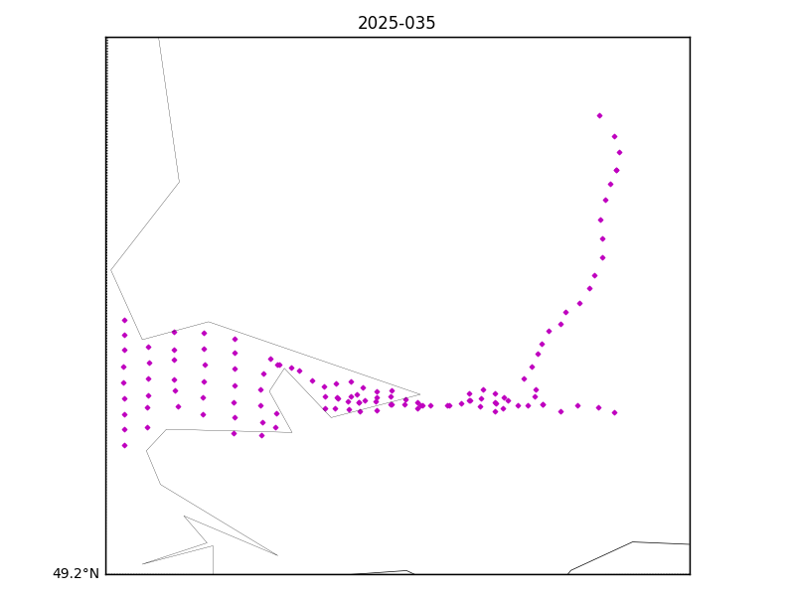

Figure 1 – location of casts – basemap resolution does not cover the extent of the inlets.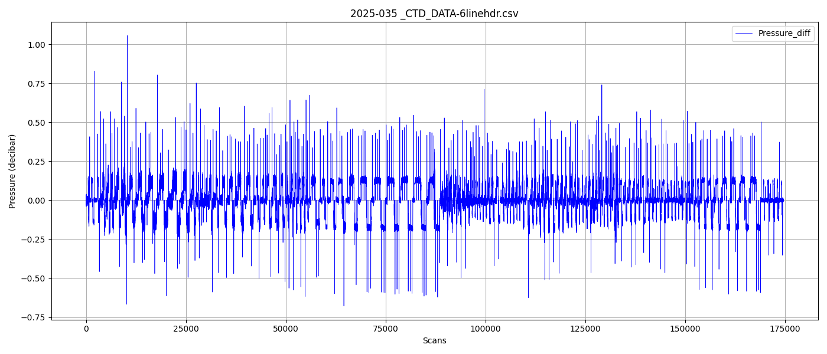

Figure 2 – Zero order holds check

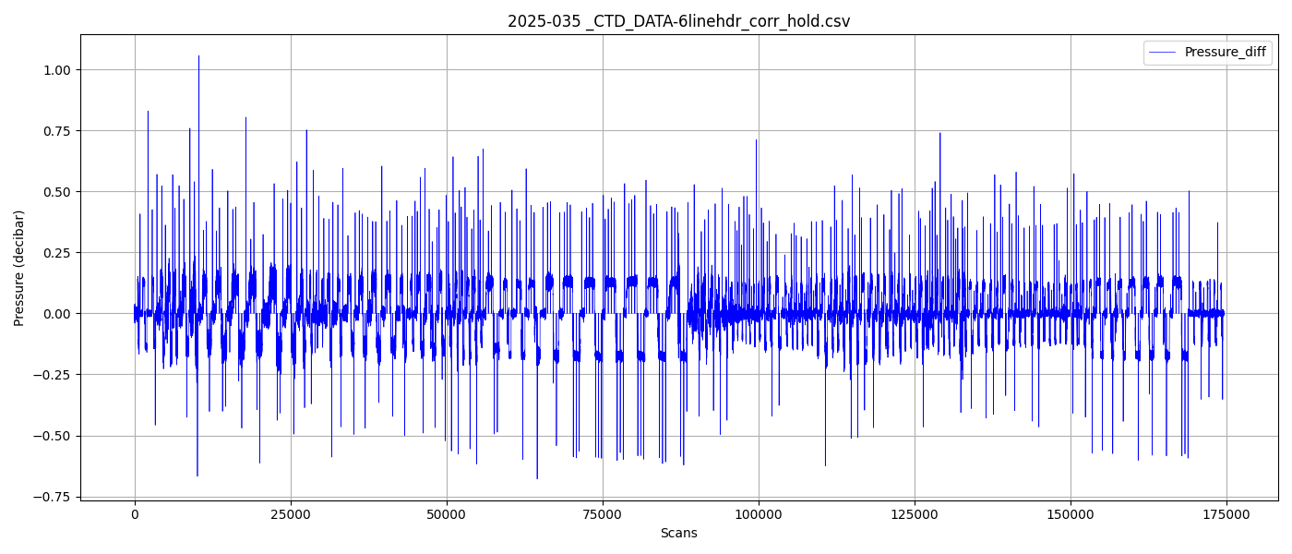

Figure 3 – Zero order holds removed