**RBR CTD DATA PROCESSING NOTES**

Cruise: 2025-029

Agency: OSD

Locations: Sooke Harbour

Project: Sooke Harbour RELIOPS survey

Party Chief: Blanken H.

Platform: Doug Anderson

Date: January 27, 2025 – January 31, 2025

Processed by: Samantha Huntington

Date of Processing: June 2, 2025 – July 15, 2025

Number of Raw files: 89 Number of Processed Files: 89

**Instrument Summary**

Equipment: RBR Concerto3 CTD (s/n 204694) with a Fluorometer (Chlorophyll a Turner Cyclops s/n 211012) and oxygen sensor (JFE Advantech Rinko III BT s/n 411)

Sampling frequency was at 8Hz.

**Summary of Quality and Concerns**

A cast list of times and locations was provided, “Tap Log Export 20250206.csv”. This was formatted to create “2025-029CTDLogFinal.xlsx”. Four Ruskin files were provided, one for each day of sampling, but file “204694_20250131_2136.rsk” was the file from the final day and contained the data for all the sampling days. This file was used to extract the profiles, though it contained 87 profiles while the log recorded 91 samples.

There was no data in the time frame of casts 47 and 63 and so there are no profiles associated with these event numbers.

There was data for casts 48 and 82 but it was not detected as profiles by the Ruskin software, this data will be extracted separately to obtain the profiles.

Event numbers 1-46 in the log match profiles 1-46 in the Ruskin file.

Event numbers 49-62 in the Log match profiles 47-60 in the Ruskin file.

Even numbers 64-81 in the Log match profiles 61-78 in the Ruskin file.

Event numbers 83-91 match profiles 79-87 in the Ruskin file.

The data overall look good except that the Fluorometer was set manually to 5 ug/L which was not enough range for this sampling area. There are quite a few negative fluorescence values. There is some bad data at the bottom of many casts and this will be re-examined after the Delete step. There were many very shallow casts which made the preliminary plots look messy due to the scale.

**Processing Summary**

1. **Conversion to IOS Headers**

File 204694_20250131_2136.rsk contained the 89 profiles although only 87 were recognized. Those 87 were extracted using python function READ_RSK(), while the remaining two profiles were extracted using python function READ_EXCEL().

A single file (2025-029_CTD_Data.csv) with all the data including event numbers and a single line of headers was prepared using python function MERGE_FILES().

A 6-line header was inserted using python function Add_6Lineheader_2().

File “2025-029_header-merge_2.csv” was created, based on the information provided by the chief scientist.

* Column “File_Name”: entries were derived from the event number.
* Column “LOC:LATITUDE”: latitude was provided and reformatted to “XX XX.XXXX N !(deg min)”.
* Column “LOC:LONGITUDE”: longitude was provided and reformatted to “XX XX.XXXX W !(deg min)”.
* Column “LOC: Event Number”: entries were event numbers.
* Column “LOC: STATION”: entries were taken from the Log file.

The sampling site was mapped (Figure 1) using from “2025-029_header-merge.csv” using python function Plot_Track_Location() to check the location of all casts.

Prior to conversion to IOS header format, the presence of zero-order holds were checked using Python function Plot_Pressure_Diff() and python function check_for_zoh(). This function returned no zero order holds and so no correction was made to remove them.

CONVERT Spreadsheet Files was run to produce files with IOS Header format. Header entries of “Administration”, “File”, “Instrument” and “Geographic Area” were filled in this step.

Next CLEAN was run to add a start time and event numbers to headers.

The routine “Merge:CSV Files to headers” was run to add location headers to the IOS files.

Raw data were plotted and examined:

* Salinity looks good.
* Temperature looks good.
* Conductivity looks good.
* Oxygen looks good with some bad data at top and bottom of most casts, and a loop in cast 45 which will be examined after Shift and Delete.
* Fluorescence has some bad data at top and bottom of most casts and the range does not extend beyond 5 ug/L
* Cast 15 has some bad data at the bottom and top of the cast. Cast 16 has some noisy Oxygen and Fluorescence data. Both of these casts will be examined again after Delete.

A record number was added to each record using the routine Add time channel.

1. **Data processing**

* Correction to Pressure: Negative pressures were not seen in all casts but they were present in many, a pressure correction of 0.1 was added to Pressure and Depth.
* CLIP: Pressure is steady for a variable number of scans. Initial records were removed until the downcast began using file “2025-029_CLIP.csv”.
* Filter: a Gull-winged filter, size 3, was applied to temperature, conductivity, and pressure. Salinity will be calculated in the next step.
* SHIFT: Based on suggested values in document “Guidelines for processing RBR CTD profiles”, the alignment of temperature and conductivity was corrected by applying a shift of -2 scans in conductivity.
* SHIFT: Better alignment with Oxygen profiles was found by advancing it by 11 scans. The advice given in document “Guidelines for processing RBR CTD Profiles” was that an advance between 2 and 3 seconds is appropriate. T-O plots before and after alignment were compared.
* Derive Oxygen Concentration:
* Data from the shift files was extracted using python function get_rbr_data(). Oxygen:Dissolved:Concentration was derived using python function convert_oxy(). Both of these functions can be found in the python file rbr_oxy.py. A file containing the derived oxygen “2025-029_Oxygen_for_IOSshell.csv” was created so that it could be merged back into the IOS shell files.
* MERGE was used to merge the derived Oxygen:Dissolved:Concentration back into the IOS Shell file.
* Delete was run to remove records with a descent rate lower than 0.2m/s over 8 points. This was not applied in the top 10m to avoid loss of surface records as the CTD began its descent.
* Profile plots were examined after DELETE and confirm that plots show reasonable values for salinity and conductivity and fluorescence. DO saturation levels at the surface ranged from 57% to 120%. However there was no calibration sampling and no climatology to enable a judgement about the data reliability.
* Data despiking and bad data removal: Bad data was removed from the bottom of casts 5, 6, 8, 11, 15, 16, 19, 21, 30, 31, 34, 35, 48, 54, 57 and 60.
* CLEAN was run to reset the maximum and minimum values and to replace all negative Fluorescence values to PAD.

1. **Final checks and header editing**

* REMOVE was run to remove the following channels from all casts: Date, Time:UTC and Event.
* REORDER was run to order the channels.
* BIN AVERAGE was used to metre-average data.
* CALIBRATE was run to convert conductivity units to S/m using file 2025-029-recal2.ccf.
* Header Edit was used to fix channel names and format as listed below:
* Temperature: deg C(ITS90) ==> deg C (ITS90)
* Fluorescence:URU [mg/m^3]: Fluorescence ==> Fluorescence:URU
* Oxygen:Dissolved:Saturation:RBR [%]:
* Oxygen:Dissolved:Saturation ==> Oxygen:Dissolved:Saturation:RBR
* Format: F11.4 ==> F8.2
* Pressure [decibar]
* Format: F11.2 ==> F7.1
* Depth [metres]
* Units: meters ==> metres

Salinity:CTD ==> Salinity

* Oxygen:Dissolved:Rinko [mL/L]
* Oxygen_mL_L ==> Oxygen:Dissolved:Rinko
* Format: F10.6 ==> F7.2
* Oxygen:Dissolved:Rinko [umol/kg]
* Name: Oxygen_umol_kg ==> Oxygen:Dissolved:Rinko
* Units: ==> umol/kg
* Format: F10.6 ==> F6.1

CLEAN was run to reset the Maximum and Minimum values in the Header.

* Header Check and Standards Check were run and no problems were found.

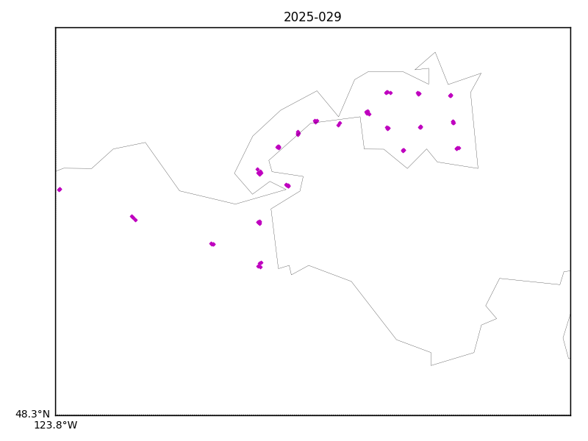

Figure 1 – location of casts – some casts are very nearshore and appear on land.

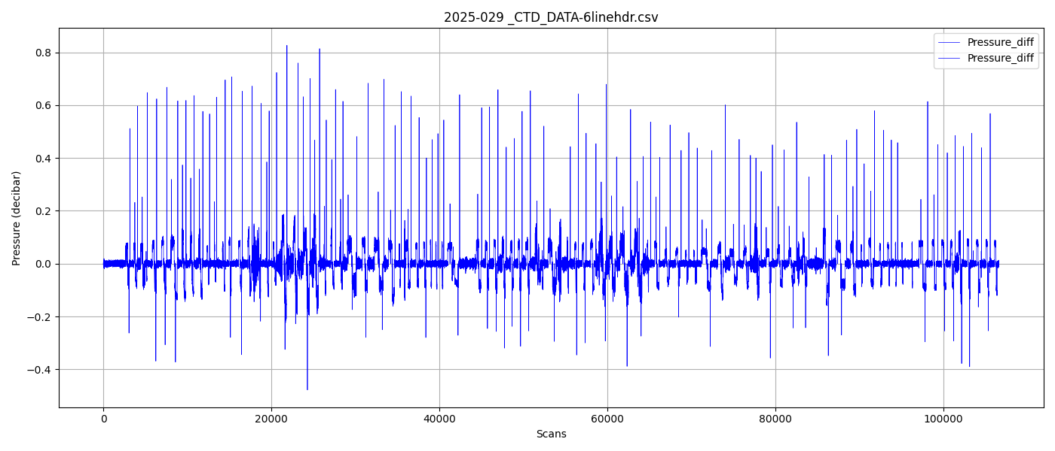

Figure 2 – Zero order holds check