RBR CTD DATA PROCESSING NOTES
Cruise: 2025-023
Agency: OSD
Locations: WCVI, Salish Sea, Haro Strait
Project: Passive Acoustics
Party Chief: Burnham R.
Platform: Vector
Date: October 11, 2025 – October 15, 2025

Processed by: Samantha Huntington
Date of Processing: April 15, 2026 – April 28, 2026
Number of Raw files: 44 Number of Processed Files: 44

Instrument Summary
Equipment: RBR Concerto3 CTD (s/n 214098).
Sampling frequency was at 1Hz.

Summary of Quality and Concerns
A cast list of times and locations was provided, “2025-023_Daily Science Log_V.FEB2025.xlxs”. The RBR profiles corresponded to the SET casts in the daily science log.

The RBR was attached to an R5 transducer and lowered at 0.5m/s to depth.

Data overall look good with some bad data at the bottom of a few casts, this will be examined again after the DELETE step.

Processing Summary
- Conversion to IOS Headers
Profiles were matched to the cruise log and are not sequential.
File 214089_20251012_1443_Oct11-12.rsk contained 7 profiles .
File 214089_20251014_2336_Oct12-14.rsk contained 25 profiles.
File 214089_20251015_1558_Oct14-15.rsk contained 12 profiles.
A single file (2025-023_CTD_Data.csv) with all the data including event numbers and a single line of headers was prepared using python function MERGE_FILES().
A 6-line header was inserted using python function Add_6Lineheader_2().
File “2025-023_header-merge.csv” was created, based on the information provided by the chief scientist.
- Column “File_Name”: entries were derived from the event number.
- Column “LOC:LATITUDE”: latitude was provided and reformatted to “XX XX.XXXX N !(deg min)”.
- Column “LOC:LONGITUDE”: longitude was provided and reformatted to “XX XX.XXXX W !(deg min)”.
- Column “LOC: Event Number”: entries were event numbers from the log.
- Column “LOC: STATION”: entries were taken from the Log file.

The sampling site was mapped (Figure 1) using from “2025-023_header-merge.csv” using python function Plot_Track_Location() to check the location of all casts.
Prior to conversion to IOS header format, the presence of zero-order holds were checked using Python function Plot_Pressure_Diff(). No Zero-order holds were found (Figure 2.) and so no correction was made.
CONVERT Spreadsheet Files was run to produce files with IOS Header format. Header entries of “Administration”, “File” and “Instrument” were filled in this step.
The routine “Merge:CSV Files to headers” was run to add location headers to the IOS files.
Next CLEAN was run to add a start time and event numbers to headers.
Raw data were plotted and examined:
- Salinity looks good.
- Temperature looks good.
- Conductivity looks good.

- Data processing
- Correction to Pressure: there were no negative pressures found so pressure was not calibrated.

- CLIP: Pressure is steady for a variable number of scans. Initial records were removed until the downcast began using file “2025-023_CLIP.csv”.

- Filter: a Gull-winged filter, size 1, was applied to temperature, conductivity, and pressure. Salinity will be calculated in the next step.

- SHIFT: Based on suggested values in document “Guidelines for processing RBR CTD profiles”, the alignment of temperature and conductivity was corrected by applying a shift of -1 scans in conductivity.

- Delete was run to remove records with a descent rate lower than 0.4m/s over 1 points. This was not applied in the top 10m to avoid loss of surface records as the CTD began its descent.

- Profile plots were examined after DELETE and confirm that plots show reasonable values for salinity and conductivity .

- Data despiking: Bad data were removed from the bottom of casts 51, 58, 67, 69, 73, 92, 94 and 100.

- Final checks and header editing
- REMOVE was run to remove the following channels from all casts: Date, Time:UTC and Event.

- BIN AVERAGE was NOT used to metre average the data due to the low sampling frequency.

- CALIBRATE was run to convert conductivity units to S/m using file 2025-023-recal2.ccf.
- Header Edit was used to fix channel names and format as listed below:
  - Salinity:CTD ==> Salinity
- CLEAN was run to reset the Maximum and Minimum values in the Header.

- Header Check was run and no problems were found.
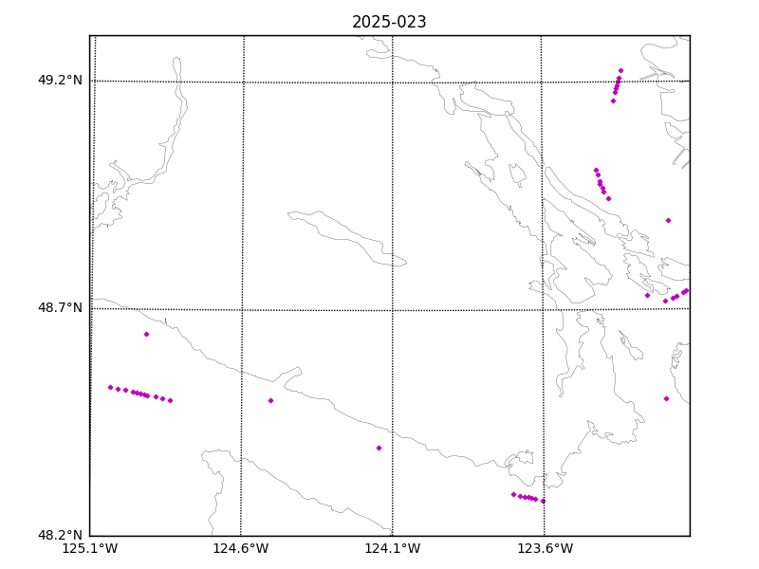

Figure 1 – location of casts.

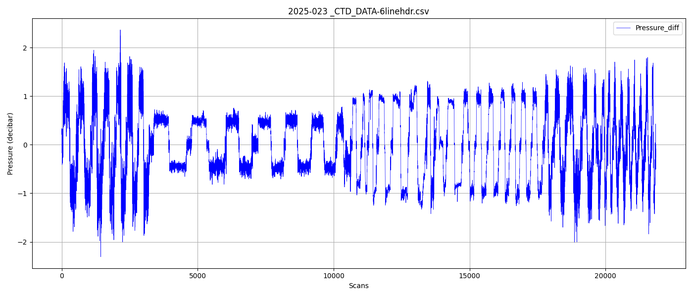 Figure 2 – Zero order holds

