**RBR CTD DATA PROCESSING NOTES**

**Cruise: 2024-084**

**Agency: OSD**

**Locations: Clayoquot Sound**

**Project: Clayoquot Sound CTD Monitoring Program**

**Party Chief: Bianucci, Laura**

**Platform: Other Vessel**

**Date: March 5, 2024 – December 12, 2024**

Processed by: Samantha Huntington

Date of Processing: April 5, 2025 – April 9, 2025

Number of Raw files: 129 Number of Processed Files: 124

**Instrument Summary**

RBR Maestro CTD (s/n 203655) with an RBR Coda T.ODO Dissolved Oxygen sensor, RBR Licor PAR sensor and a Seapoint Turbidity sensor. Serial numbers for the additional sensors were not provided.

Sampling was done at 8Hz. The RBR was lowered either by hand or by prawn pull.

**Summary of Quality and Concerns**

There were 12 files provided containing the data from the separate sampling excursions:

203655_20240305_1229.rsk

203655_20240306_1625.rsk

203655_20240624_1010.rsk

203655_20240627_1204.rsk

203655_20240730_1322.rsk

203655_20240801_1203.rsk

203655_20240923_1430.rsk

203655_20241028_1320.rsk

203655_20241127_1617.rsk

203655_20241129_1200.rsk

203655_20241213_0936.rsk

203655_20241217_0943.rsk

A list of casts and locations and stations names was also provided, 2024Uu-a-thlukCTDLogFinal.xlsx, with comments about which casts to ignore and which Ruskin files contained the casts.

There was a note to advise that the water depth sometimes exceeded the depth reached by the CTD.

On casts where the bottom coordinates were not recorded, the beginning coordinates were used in the Header Merge file.

The samples were collected by Uu-a-thluk Fisheries, led by Carillia Horning, along with Ahousaht, Hesquiaht, and/or Tla-o-qui-aht First Nations. Five casts collected along with the Ahousaht nation fisheries guardians are not included due to missing metadata.

The samples were collected over several distinct days during the year, with some being recorded in PDT and others in UTC. Some test casts needed to be cut.

The casts found in the various Ruskin files were matched to the event numbers in the Log that was provided. Changes were made to the event numbers so that they are sequential.

The version of the Ruskin files was too old for the profiles to be extracted in Python, and there was no update available using the Ruskin software. Each file was converted to an excel file and the profiles were extracted from the spreadsheets using Python. Profiles were first detected in the Ruskin software and then the times of the profiles that had to be cut were manually deleted from the corresponding spreadsheet so that they would not be captured.

203655_20210305_1229.rsk contained 14 casts and the Log had a note to ignore the first 3. Casts 1-11 from that file remained Events 1-11 in the output files. Casts are in PDT in both the Log and the data, a time offset of +7 hours will be applied during processing.

203655_20210306_1625.rsk contained 5 casts. Casts 12-16 remained Events 12-16. Casts are in PDT in both the Log and the data, a time offset of +7 hours will be applied during processing.

203655_20210624_1010.rsk contained 16 casts. Casts 1-16 were renamed to Events 17-32. Casts are in PDT in both the Log and the data, a time offset of +7 hours will be applied during processing.

203655_20240627_1204.rsk contained 13 casts. Casts 1-13 from the Log were renamed Events 33-45. Casts are in PDT in the Log and the data, a time offset of +7 hours will be applied during processing.

203655_20240730_1322.rsk contained 16 casts. Casts 1-16 in the Log were renamed events 46-61. Casts are in UTC in the Log and the data.

203655_20240801_1203.rsk contained 16 casts. Casts 1-16 in the Log were renamed events 62-77. Casts are in UTC in the Log and in the data.

203655_20240923_1430.rsk contained 16 casts. Casts 1-16 in the Log were renamed events 78-92. Casts are in UTC in the Log and in the data.

203655_20241028_1320.rsk contained 6 casts with a note to exclude the first cast. The time for this cast were deleted from the spreadsheet. Casts 1-5 in the Log were renamed events 93-97. Casts were in UTC in the Log and in the data.

203655_20241127_1617.rsk contained 12 casts. Casts 1-12 in the Log were renamed events 98-109. Casts are in UTC in the Log and in the data.

203655_20241129_1200.rsk contained 3 casts. Casts 1-3 in the Log were renamed events 110-112. Casts are in UTC in the Log and in the data.

203655_20241213_0936.rsk contained 10 casts. Casts 1-10 in the Log were renamed events 113-122. Casts are in UTC in the Log and in the data.

203655_20241217_0943.rsk contained 2casts. Casts 1-2 in the Log were renamed events 123-124. Casts are in UTC in the Log and in the data.

The data overall look good. There are a few bad values at the bottom of some casts. Negative PAR values were replaced with PAD which removed a lot of data at depth in some casts.

**Processing Summary**

1. **Conversion to IOS Headers**

Profiles were extracted from the Ruskin files using python function READ_Excel(), dissolved Oxygen concentration was calculated from dissolved Oxygen saturation in this step using Python.

A single file (2024-084_CTD_Data.csv) with all the data including event numbers and a single line of headers was prepared using python function MERGE_FILES().

A 6-line header was inserted using python function Add_6Lineheader_2().

Prior to conversion to IOS header format, the presence of zero-order holds were checked using Python function Plot_Pressure_Diff(). Zero-order holds were found (Figure 2.) and these values were replaced with Nan using the python function Correct_Hold().

A new csv file was created “2024-084_CSV_DATA-6Linedr_corr_hold.csv” and the corrected values were checked in python function Plot_Pressure_Diff(). Zero-order holds were found to be removed (Figure 3.).

File “2024-084_header-merge.csv” was created, based on the information provided by the chief scientist.

* Column “File_Name”: entries were derived from the event number.
* Column “LOC:LATITUDE”: latitude was provided and reformatted to “XX XX.XXXX N !(deg min)”.
* Column “LOC:LONGITUDE”: longitude was provided and reformatted to “XX XX.XXXX W !(deg min)”.
* Column “LOC: Event Number”: entries were event numbers.
* Column “LOC: STATION”: station information was provided.

The sampling site was mapped (Figure 1) using from “2024-084_header-merge.csv” using python function Plot_Track_Location() to check the location of all casts.

CONVERT Spreadsheet Files was run to produce files with IOS Header format. Header entries of “Administration”, “File” and “Instrument” were filled in this step. Some were kept blank to be populated later with Merge:CSV.

Using ADD TIME CHANNEL a record number was added to each record and add 7 hours to the time for events 1-45.

Next CLEAN was run to add a start time and event numbers to headers as well as replace negative PAR values with zero.

Raw data were plotted and examined:

* Salinity some bad data at the bottom of casts 3-5, 7, 11, 16, 22-27, 30-32, 35, 39, 48-51, 62, 68, 71, 73, 75, 76, 80, 89-91, 93, 97, 100, 101, 105-108, 118, 119, 121, 122, 124.
* Temperature has some bad data in cast 17, this will be examined again after processing. There is also some bad data at the bottom of casts 24, 35, 80, 89-91, 122,
* Conductivity has some bad data at the bottom of casts 3-5, 7, 11, 16, 22-27, 30-33, 35, 38, 39, 48-51, 62, 68, 71, 73, 75, 76, 80, 89-91, 93, 97, 100, 101, 105-108, 118, 119, 121, 122, 124.
* Oxygen looks good with some bad data in cast 17, and at the bottom of casts 11, 16, 18, 19, 20, 22-27, 30-32, 35, 46, 48-51, 62, 68, 71, 73, 75, 76, 80, 89-91, 93, 97, 98, 105-108, 118, 119, 121, 122, 124.

The routine “Merge:CSV Files to headers” was run to add location, model, serial number and time increment headers to the files.

1. **Data processing**

* Correction to Pressure: There were some negative pressures so pressure was calibrated using file 2024-084-recal1.ccf. The correction of 0.1 was made to both Pressure and Depth. A spike in pressure of -7.9db in cast 115 was then replaced with a pad value.
* CLIP: Pressure is steady for a variable number of scans. Initial records were removed until the downcast began using file “2024-084_CLIP.csv”.
* Then REORDER was run to reorder the channels in all files.
* Filter: a Gull-winged filter, size 3, was applied to temperature, conductivity, and pressure. Salinity will be calculated in the next step.
* SHIFT: Based on suggested values in document “Guidelines for processing RBR CTD profiles”, the alignment of temperature and conductivity was corrected by applying a shift of -2 scans in conductivity.
* SHIFT: Better alignment with Oxygen profiles was found by advancing it by 11 scans. The advice given in document “Guidelines for processing RBR CTD Profiles” was that an advance between 2 and 3 seconds is appropriate. T-O plots before and after alignment were compared.
* Delete was run to remove records with a descent rate lower than 0.2m/s over 8 points. This was not applied in the top 10m to avoid loss of surface records as the CTD began its descent.
* DESPIKE and Bad data removal:

Plots after DELETE were examined to look for any remained bad data at the bottom of casts.

Bad data was removed from the bottom of casts 3, 4, 7, 11, 16, 19, 23- 27, 30-32, 34, 35, 39, 46-51, 68, 73, 75, 76, 80, 89-91, 93, 101, 104, 105, 106-108, 118, 119, 121 and 124. .

A spike in Salinity and Conductivity was replaced with a pad value at 36 decibar.

* Profile plots were examined after DELETE and confirm that plots show reasonable values for salinity and conductivity and dissolved oxygen. Dissolved Oxygen Saturation values ranged from 4.59 % to 130.73 %.

1. **Final checks and header editing**

* REMOVE was run to remove the following channels from all casts: Date, Time:UTC, Event and Record number.
* BIN AVERAGE was used to metre-average data.
* CALIBRATE was run to convert conductivity units to S/m using file 2024-084-recal2.ccf.
* Header Edit was used to fix channel names and format as listed below:
* Salinity:CTD ==> Salinity
* Oxygen:Dissolved:Saturation F11.4 ==> Oxygen:Dissolved:Saturation:RBR F8.2
* Oxygen_umol_kg F10.6 ==> Oxygen:Dissolved:RinkomL/L==> F6.1
* Oxygen_mL_L F10.6 ==> Oxygen:Dissolved:Rinko F7.2
* CLEAN was run to reset the Maximum and Minimum values in the Header.
* Header and Standards Checks were run and no problems were found.

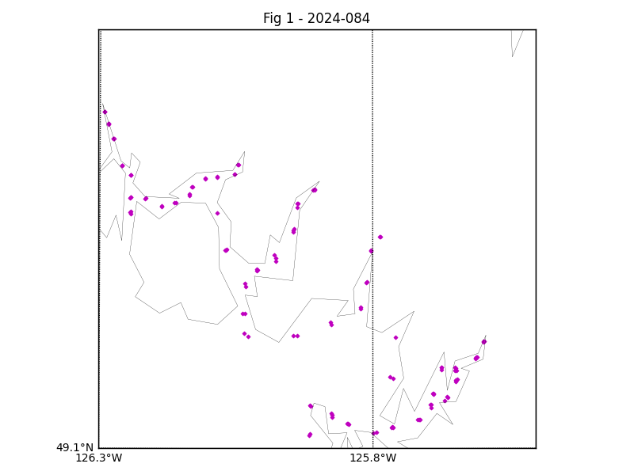

Figure 1 – location of casts.

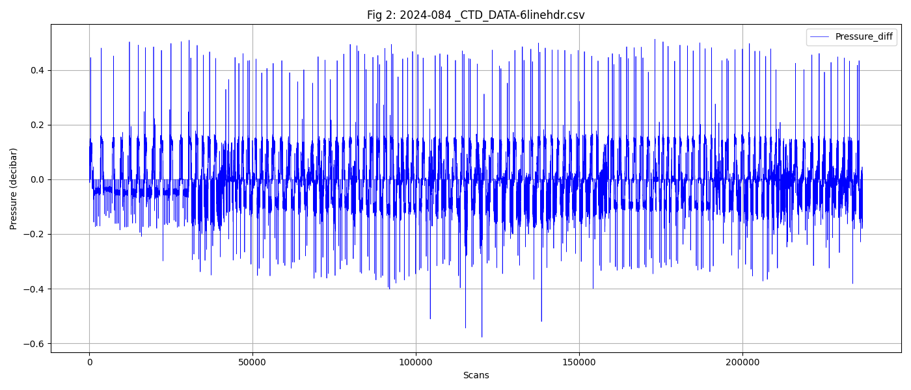

Figure 2 – zero-order holds

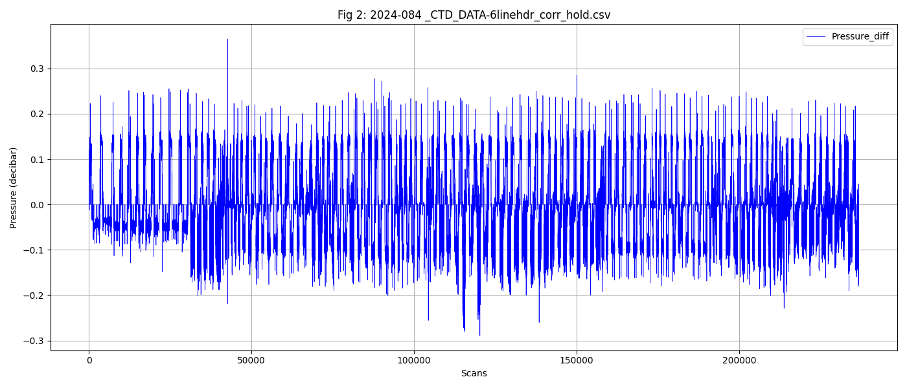

Figure 3 – zero order holds removed