**RBR CTD DATA PROCESSING NOTES**

**Cruise: 2024-083**

**Agency: OSD**

**Locations: Clayoquot Sound**

**Project:** Ahousaht Territory CTD Monitoring Program

**Party Chief: Bianucci, Laura**

**Platform: Other Vessel**

**Date: October 23, 2024 – December 13, 2024**

Processed by: Samantha Huntington

Date of Processing: February 10, 2025 – April 4, 2025

Number of Raw files: 41 Number of Processed Files: 26

**Instrument Summary**

RBR Maestro CTD (s/n 235984) with a RINKO III Dissolved Oxygen sensor (s/n 0499 ), RBRCoda3 PAR (s/n 34392).

Sampling was done at 8Hz. The RBR was lowered either by hand or by prawn pull.

**Summary of Quality and Concerns**

The file 235984_20250123_1631.rsk was provided and contained 41 casts.

A list of casts and locations and stations names was also provided, MHSS_CTDLogFile_Final.xlsx, with a note to ignore the first and final 7 casts in the Ruskin file. The first cast on December 13, 2024 was detected as two casts. Casts 30 and 31 in the Ruskin file needed to be concatenated into profile 23 from the log file.

The samples were collected by the Maaqutusiis Hahoulthee Stewardship Society (MHSS) team,

led by Gemma Macfarlane.

The data overall look good. There are a few bad values at the bottom of some casts. Negative PAR values were replaced with NaN.

**Processing Summary**

1. **Conversion to IOS Headers**

A Header Merge “2024-083_header-merge_1.csv” file was created for the extraction of all profiles in the Ruskin file using python function READ_RSK(), dissolved Oxygen concentration was calculated from dissolved Oxygen saturation in this step using Python.

A single file (2024-083_CTD_Data.csv) with all the data including event numbers and a single line of headers was prepared using python function MERGE_FILES().

A 6-line header was inserted using python function Add_6Lineheader_2().

Prior to conversion to IOS header format, the presence of zero-order holds were checked using Python function Plot_Pressure_Diff(). Zero-order holds were found (Figure 2.) and these values were replaced with Nan using the python function Correct_Hold().

A new csv file was created “2024-083_CSV_DATA-6Linedr_corr_hold.csv” and the corrected values were checked in python function Plot_Pressure_Diff(). Zero-order holds were found to be removed (Figure 3.).

File “2024-083_header-merge.csv” was created, based on the information provided by the chief scientist.

* Column “File_Name”: entries were derived from the event number.
* Column “LOC:LATITUDE”: latitude was provided and reformatted to “XX XX.XXXX N !(deg min)”.
* Column “LOC:LONGITUDE”: longitude was provided and reformatted to “XX XX.XXXX W !(deg min)”.
* Column “LOC: Event Number”: entries were event numbers.
* Column “LOC: STATION”: station information was provided.

The sampling site was mapped (Figure 1) using from “2024-083_header-merge.csv” using python function Plot_Track_Location() to check the location of all casts.

CONVERT Spreadsheet Files was run to produce files with IOS Header format. Header entries of “Administration”, “File” and “Instrument” were filled in this step. Some were kept blank to be populated later with Merge:CSV. Time Increment, Instrument and Serial Number were not consistent throughout the cruise.

Using ADD TIME CHANNEL a record number was added to each record.

Next CLEAN was run to add a start time and event numbers to headers.

Raw data were plotted and examined:

* Salinity some bad data at the bottom of casts 5, 6, and 13.
* Temperature has some bad data at the bottom of cast 9 and 13.
* Conductivity has some bad data at the bottom of casts 5, 6 and 13.
* Oxygen looks good with some bad data at the bottom of casts 6, 13 and 26.
* PAR has some negative values which were replaced with NaN during the clean step. Par will be examined again after the DELETE step.

The routine “Merge:CSV Files to headers” was run to add location, model, serial number and time increment headers to the files.

1. **Data processing**

* Correction to Pressure: Casts 23-26 had some negative pressures at the end of the upcast and corresponding conductivity of 29 mS/cm. A pressure correction of 0.2 decibar was applied to these four files using calibration file 2024-083-recal1.ccf.
* CLIP: Pressure is steady for a variable number of scans. Initial records were removed until the downcast began using file “2024-083_CLIP.csv”. Clip was done in two stages the first 22 casts without a pressure calibration followed by the final 4 casts that had a pressure calibration.
* Then REORDER was run to reorder the channels in all files.
* Filter: a Gull-winged filter, size 3, was applied to temperature, conductivity, and pressure. Salinity will be calculated in the next step.
* SHIFT: Based on suggested values in document “Guidelines for processing RBR CTD profiles”, the alignment of temperature and conductivity was corrected by applying a shift of -2 scans in conductivity.
* SHIFT: Better alignment with Oxygen profiles was found by advancing it by 11 scans. The advice given in document “Guidelines for processing RBR CTD Profiles” was that an advance between 2 and 3 seconds is appropriate. T-O plots before and after alignment were compared.
* Delete was run to remove records with a descent rate lower than 0.2m/s over 8 points.
* DESPIKE and Bad data removal:

Plots after DELETE were examined to look for any remained bad data at the bottom of casts.

Bad data was removed from the bottom of casts 3, 5, 6, 9 and 12.

Spikes in PAR were removed from casts 3, 18, 21 and 23.

* Profile plots were examined after DELETE and confirm that plots show reasonable values for salinity and conductivity and dissolved oxygen.

1. **Final checks and header editing**

* REMOVE was run to remove the following channels from all casts: Date, Time:UTC, Event and Record number.
* BIN AVERAGE was used to metre-average data.
* CALIBRATE was run to convert conductivity units to S/m using file 2024-083-recal2.ccf.
* Header Edit was used to fix channel names and format as listed below:
* Salinity:CTD ==> Salinity
* Oxygen:Dissolved:Saturation F11.4 ==> Oxygen:Dissolved:Saturation:RBR F8.2
* Oxygen_umol_kg F10.6 ==> Oxygen:Dissolved:RinkomL/L==> F6.1
* Oxygen_mL_L F10.6 ==> Oxygen:Dissolved:Rinko F7.2
* PAR:Licor ==> PAR
* CLEAN was run to reset the Maximum and Minimum values in the Header.
* Header Check was run and no problems were found.

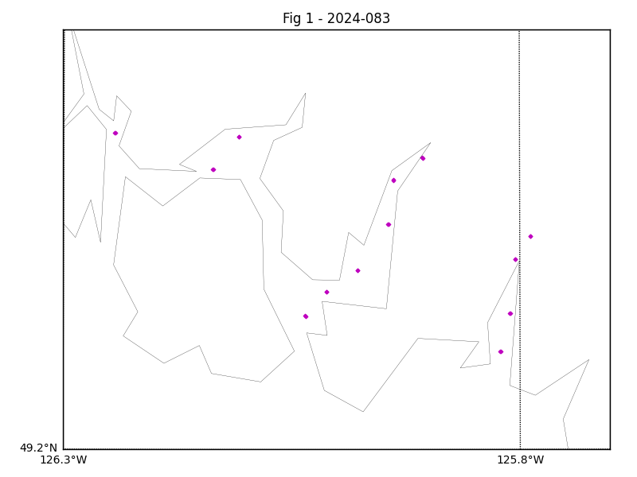

Figure 1 – location of casts.

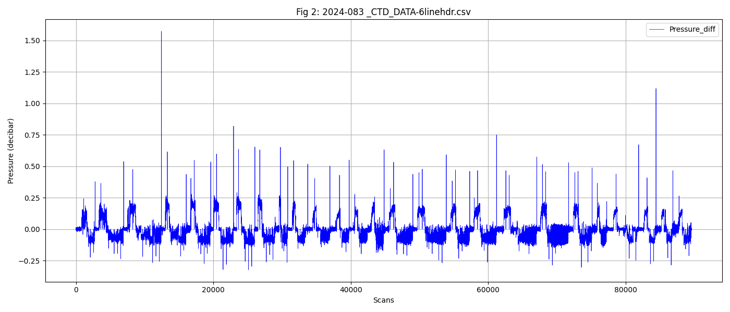

Figure 2 – zero-order holds

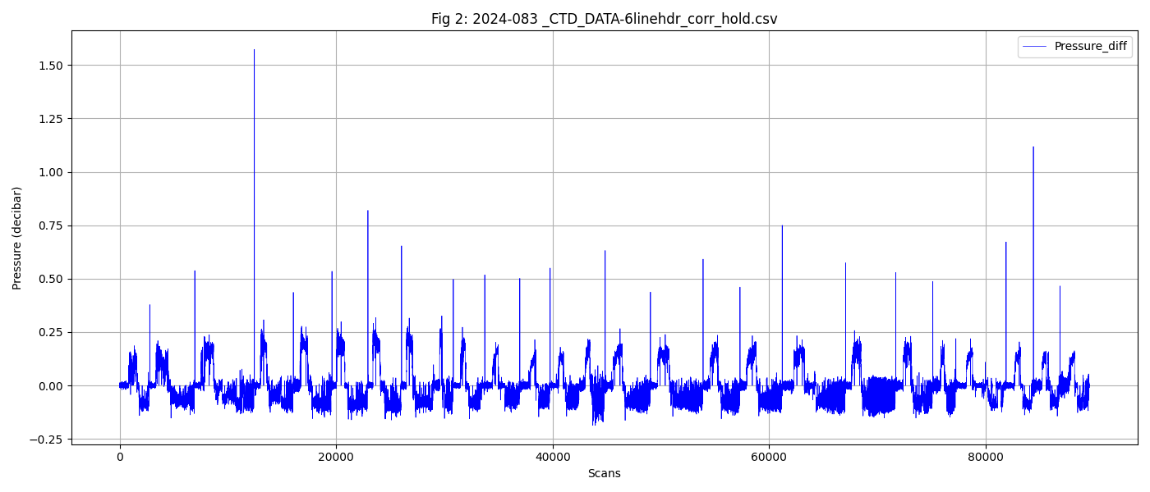

Figure 3 – zero order holds removed