**RBR CTD DATA PROCESSING NOTES**

Cruise: 2024-081

Agency: OSD

Locations: Quatsino Sound, Holberg Inlet and Neroutsos Inlet

Project: Meteorological Network - ADRCP

Party Chief: Cooper G.

Platform: Blackfish

Date: October 15, 2024 – October 19, 2024

Processed by: Samantha Huntington

Date of Processing: November 21, 2024 -

Number of Raw files: 25 Number of Processed Files: 25

**Instrument Summary**

Equipment: RBR Concerto CTD (s/n 208765) with a Turner Cyclops Fluorometer (s/n 2110792) and a JFE Advantech Rinko III oxygen sensor (s/n 447).

Sampling frequency was at 8Hz.

**Summary of Quality and Concerns**

A cast list of times and locations was provided, “2024-081CTDLogFileFinal.xlxs”. No comments were made about any of the casts for this cruise.

The data overall look good with some bad data at the bottom of casts 3 and 12. It is possible that in cast 12 the RBR hit the bottom.

**Processing Summary**

1. **Conversion to IOS Headers**

Multiple profiles were found in the 208765_20241018_1611.rsk file.

File 208765_20241018_1611.rsk was found to contain 25 files which were extracted using python function READ_ExcelRSK().

A single file (2024-0081_CTD_Data.csv) with all the data including event numbers and a single line of headers was prepared using python function MERGE_FILES().

A 6-line header was inserted using python function Add_6Lineheader_2().

File “2024-081_header-merge.csv” was created, based on the information provided by the chief scientist.

* Column “File_Name”: entries were derived from the event number.
* Column “LOC:LATITUDE”: latitude was provided and reformatted to “XX XX.XXXX N !(deg min)”.
* Column “LOC:LONGITUDE”: longitude was provided and reformatted to “XX XX.XXXX W !(deg min)”.
* Column “LOC: Event Number”: entries were event numbers.
* Column “LOC: STATION”: station names were provided by the Chief Scientist.

The sampling site was mapped (Figure 1) using from “2024-081_header-merge.csv” using python function Plot_Track_Location() to check the location of all casts.

Prior to conversion to IOS header format, the presence of zero-order holds were checked using Python function Plot_Pressure_Diff(). Zero-order holds were found (Figure 2.) and these values were replaced with interpreted values using the python function correcthold().

A new csv file was created “2024-081_CSV_DATA-6Linedr_corr_hold.csv” and the corrected values were checked in python function Plot_Pressure_Diff(). Zero-order holds were found to be removed (Figure 3.).

CONVERT Spreadsheet Files was run to produce files with IOS Header format. Header entries of “Administration”, “File” and “Instrument” were filled in this step.

The routine “Merge:CSV Files to headers” was run to add location headers to the IOS files.

Raw data were plotted and examined:

* Salinity looks good with some bad data at the bottom of casts 3 and 12.
* Temperature looks good with some bad data at the bottom of casts 3 and 12.
* Conductivity looks good with some bad data at the bottom of casts 2, 3 and 12 .
* Oxygen looks good with some bad data at the bottom of casts 3 and 12
* Fluorescence looks good with some spikes on most casts and some bad data at the bottom of casts 3 and 12.

Next CLEAN was run to add a start time and event numbers to headers.

Then REORDER was run to reorder the channels in all files.

A record number was added to each record using Add Time Channel

1. **Data processing**

* Correction to Pressure: no correction was required.
* Data despiking: There are no significant spikes in temperature, conductivity and salinity. So there is no need to apply data despiking. Spikes in Fluorescence will be examined after Delete.
* CLIP: Pressure is steady for a variable number of scans. Initial records were removed until the downcast began using file “2024-081_CLIP.csv”.
* Filter: a Gull-winged filter, size 3, was applied to temperature, conductivity, fluorescence, and pressure. Salinity will be calculated in the next step.
* SHIFT: Based on suggested values in document “Guidelines for processing RBR CTD profiles”, the alignment of temperature and conductivity was corrected by applying a shift of -2 scans in conductivity.
* SHIFT: Better alignment with Oxygen profiles was found by advancing it by 11 scans. The advice given in document “Guidelines for processing RBR CTD Profiles” was that an advance between 2 and 3 seconds is appropriate. T-O plots before and after alignment were compared.
* Delete was run to remove records with a descent rate lower than 0.3m/s over 8 points. This was not applied in the top 10m to avoid loss of surface records as the CTD began its descent.
* Profile plots were examined after DELETE and confirm that plots show reasonable values for salinity and conductivity and fluorescence. DO saturation levels at the surface ranged from 75% to 105%. However there was no calibration sampling and no climatology to enable a judgement about the data reliability.
* Spikes were removed from Fluorescence and replaced with Nan for casts 3, 8, 22, 23, and 24. Bad data was removed from the bottom of cast 12 at the same time.

1. **Final checks and header editing**

* REMOVE was run to remove the following channels from all casts: Date, Record, Time:UTC and Event.
* BIN AVERAGE was used to metre-average data.
* CALIBRATE was run to convert conductivity units to S/m using file 2024-081-recal2.ccf.
* Header Edit was used to fix channel names and format as listed below:
* Pressure: format F11.2 ==> F7.1
* Salinity:CTD ==> Salinity
* Oxygen==> Fluorescence:URU
* mL/L==> %
* F11.4==>F8.2
* Conductivity: F10.5 ==> F10.6
* CLEAN was run to reset the Maximum and Minimum values in the Header.
* Header Check was run and no problems were found.

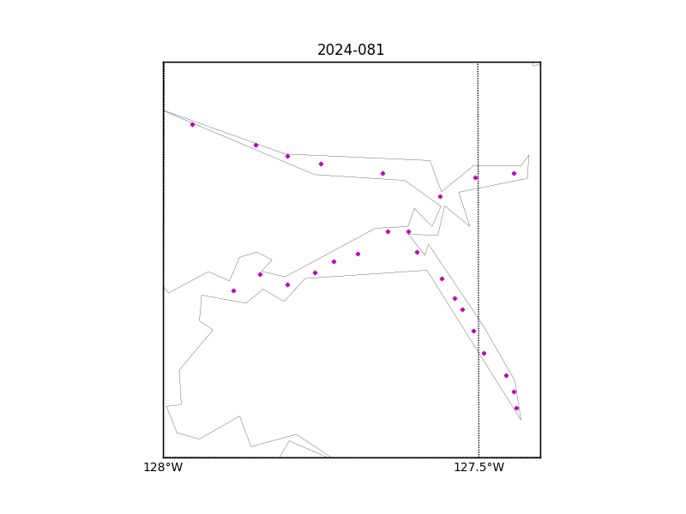

Figure 1 – location of casts.

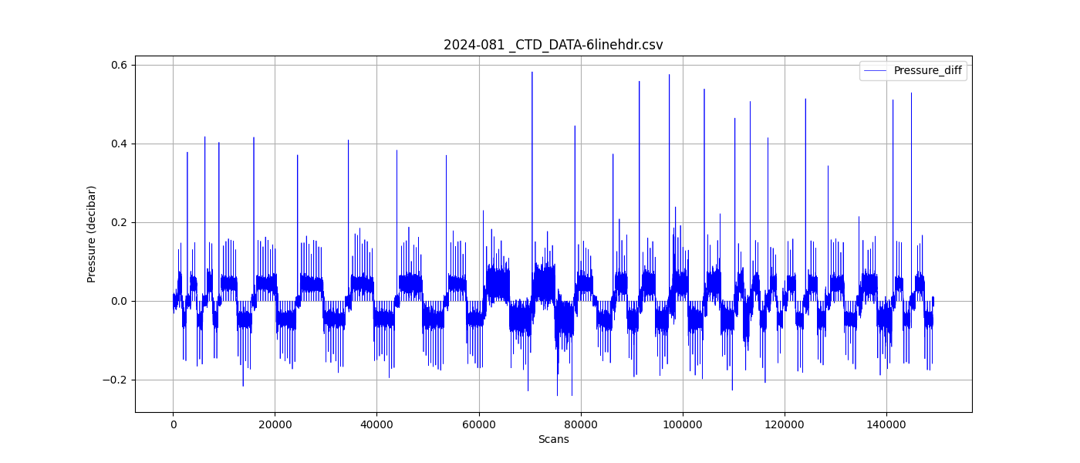

Figure 2 – zero-order holds

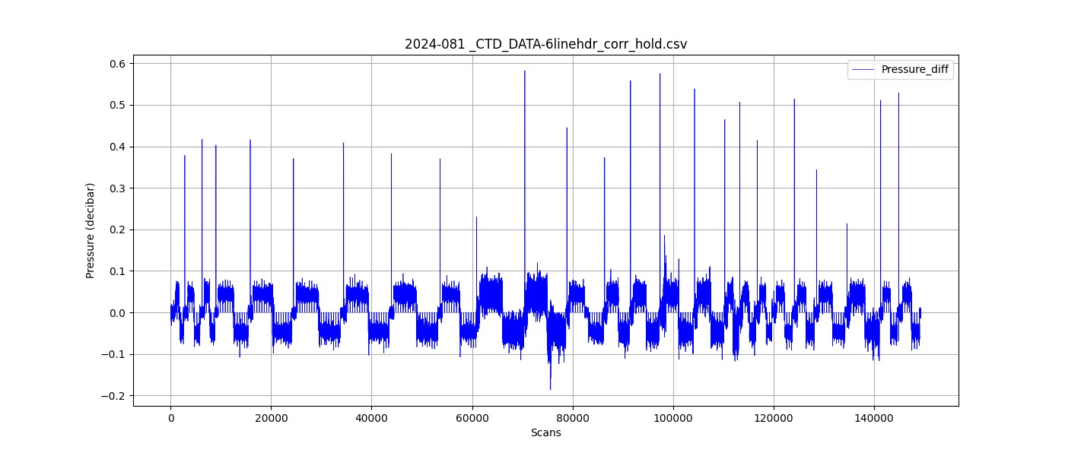

Figure 3 – zero order holds removed