**RBR CTD DATA PROCESSING NOTES**

Cruise: 2024-080

Agency: ESD

Locations: Bedwell Sound

Project: Pacific Aquaculture Monitoring Program Oceanographic Modeling Collaboration

Party Chief: Trueman J.

Platform: Sixgill

Date: August 23, 2024 – August 23, 2024

Processed by: Samantha Huntington

Date of Processing: September 11, 2024 – November 20, 2024

Number of Raw files: 8 Number of Processed Files: 8

**Instrument Summary**

Equipment: RBR Concerto CTD (s/n 206828) with a Turner Cyclops Fluorometer.

Sampling frequency was at 8Hz.

**Summary of Quality and Concerns**

A summary of casts was provided “CTD Transects Aug 2024.xlsx”. Time is in local time and will need to be changed to UTC.

The data overall look good with some bad data a the bottom of casts 5 and 8.

**Processing Summary**

1. **Conversion to IOS Headers**

Multiple profiles were found in the 206828_20240905_1408.rsk file, the profiles were extracted using python function READ_EXCELrsk().

profiles were identified by date and extracted using python function READ_EXCELrsk().

A single file (2021-0045_CTD_Data.csv) with all the data including event numbers and a single line of headers was prepared using python function MERGE_FILES().

A 6-line header was inserted using python function Add_6Lineheader_2().

File “2024-080_header-merge.csv” was created, based on the information provided by the chief scientist.

* Column “File_Name”: entries were derived from the event number.
* Column “LOC:LATITUDE”: latitude was provided and reformatted to “XX XX.XXXX N !(deg min)”.
* Column “LOC:LONGITUDE”: longitude was provided and reformatted to “XX XX.XXXX W !(deg min)”.
* Column “LOC: Event Number”: entries were event numbers.
* Column “LOC: STATION”: all stations were set to the station names that were provided.

The sampling site was mapped (Figure 1) using from “2024-080_header-merge.csv” using python function Plot_Track_Location() to check the location of all casts.

Prior to conversion to IOS header format, the presence of zero-order holds were checked using Python function Plot_Pressure_Diff(). Zero-order holds were found (Figure 2.) and these values were replaced with Nan using the python function Correct_Hold().

A new csv file was created “2024-080_CSV_DATA-6Linedr_corr_hold.csv” and the corrected values were checked in python function Plot_Pressure_Diff(). Zero-order holds were found to be removed (Figure 3.).

CONVERT Spreadsheet Files was run to produce files with IOS Header format. Header entries of “Administration”, “File” and “Instrument” were filled in this step.

Raw data were plotted and examined:

* Salinity looks good with some bad data at the bottom of casts 6 and 7.
* Temperature looks good with some bad data at bottom of casts 5 and 8.
* Conductivity looks good with some bad data at the bottom of casts 6 and 7.
* Fluorescence looks good with some spikes in the data.

Next CLEAN was run to add a start time and event numbers to headers.

Then REORDER was run to reorder the channels in all files.

Then Add Time Channels was used to add a record number to the files.

1. **Data processing**

* Correction to Pressure: although there were negative pressures seen in the raw data, the corresponding Conductivity was found to be low, so pressure was not calibrated.
* Data despiking: There are no significant spikes in temperature, conductivity and salinity. So there is no need to apply data despiking. Fluorescence spikes will be examined after the upcast is removed.
* CLIP: Pressure is steady for a variable number of scans. Initial records were removed until the downcast began using file “2024-080_CLIP.csv”.
* Filter: a Gull-winged filter, size 3, was applied to temperature, conductivity, and pressure. Salinity will be calculated in the next step.
* SHIFT: Based on suggested values in document “Guidelines for processing RBR CTD profiles”, the alignment of temperature and conductivity was corrected by applying a shift of -2 scans in conductivity.
* Delete was run to remove records with a descent rate lower than 0.1m/s over 8 points. This was not applied in the top 10m to avoid loss of surface records as the CTD began its descent.
* Profile plots were examined after DELETE and confirm that plots show reasonable values for salinity and conductivity and fluorescence.
* Delete S & C spikes in Casts 2, 3, 4, 8. Some bad data was removed from the bottom of casts 3, 4, 5, and 8.

1. **Final checks and header editing**

* The routine “Merge:CSV Files to headers” was run to add location headers to the IOS files.
* Time was converted from PDT to UTC using ADD TIME CHANNELS
* REMOVE was run to remove the following channels from all casts: Date, Time:UTC, Record Number and Event.
* BIN AVERAGE was used to metre-average data.
* CALIBRATE was run to convert conductivity units to S/m using file 2024-080-recal2.ccf.
* Header Edit was used to fix channel names and format as listed below:
* Pressure: format F11.2 ==> F7.1
* Salinity:CTD ==> Salinity
* Oxygen==> Fluorescence:URU
* mL/L==> %
* F11.4==>F8.2
* Conductivity: F10.5 ==> F10.6
* CLEAN was run to reset the Maximum and Minimum values in the Header.
* Header Check was run and no problems were found.

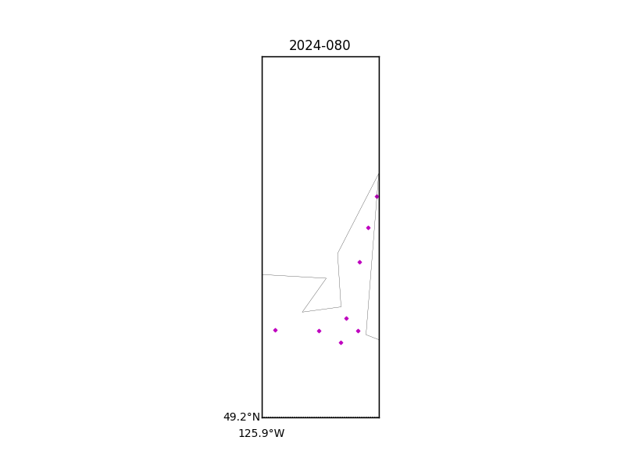

Figure 1 – location of casts.

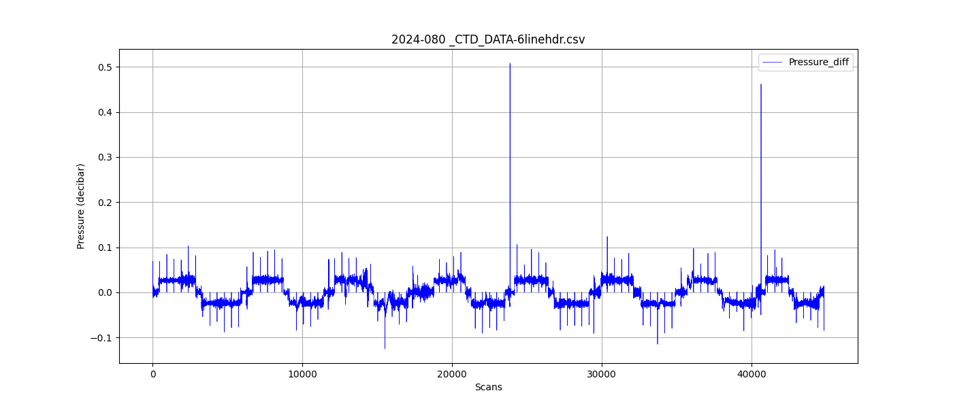

Figure 2 – zero-order holds

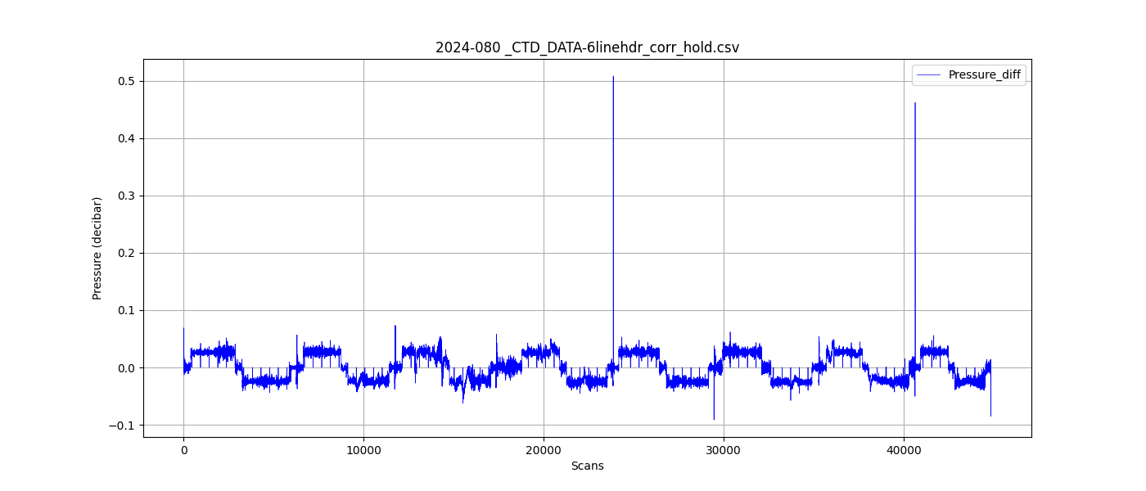

Figure 3 – zero order holds removed