**RBR CTD DATA PROCESSING NOTES**

Cruise: 2024-075

Agency: OSD

Locations: Ladysmith Harbour

Project: Ladysmith Harbour RELIOPS Survey - OPP

Party Chief: Blanken H.

Platform: Doug Anderson

Date: August 26, 2024 – August 30, 2024

Processed by: Samantha Huntington

Date of Processing: December 20, 2024 – January 6, 2025

Number of Raw files: 157 Number of Processed Files: 157

***Instrument Summary***

*RBR Maestro CTD (s/n 232531) with a Fluorometer (Chlorophyll a Turner Cyclops 7F s/n 21101617), Dissolved Oxygen sensor (JFE Advantech Rinko III BT s/n 0480), Turbidity Sensor (Seapoint s/n 18082)*

Sampling frequency was at 8Hz.

**Summary of Quality and Concerns**

The chief scientist prepared a header-merge csv file containing the list of casts, times, and locations.

The data overall look good with some bad data seen at the top during the soak and at the bottom of casts 78, 84, 134 and 139. Spikes in Fluorescence will be re-examined after the DELETE step.

**Processing Summary**

1. **Conversion to IOS Headers**

Casts 1-48 were found in file 232531_20240826_1904.rsk, and the remaining casts (49-157) were in file 232531_20240830_1829.rsk. The data were extracted from these files using python function READ_RSK().

A single file (2024-075_CTD_Data.csv) with all the data including event numbers and a single line of headers was prepared using python function MERGE_FILES().

A 6-line header was inserted using python function Add_6Lineheader_2().

File “2024-075_header-merge.csv” was provided by the chief scientist.

* Column “File_Name”: entries were derived from the event number.
* Column “LOC:LATITUDE”: latitude was provided and reformatted to “XX XX.XXXX N !(deg min)”.
* Column “LOC:LONGITUDE”: longitude was provided and reformatted to “XX XX.XXXX W !(deg min)”.
* Column “LOC: Event Number”: entries were event numbers.
* Column “LOC: STATION”: entries were taken from the Log file.

The sampling site was mapped (Figure 1) using from “2024-075_header-merge.csv” using python function Plot_Track_Location() to check the location of all casts.

Prior to conversion to IOS header format, the presence of zero-order holds were checked using Python function Plot_Pressure_Diff() Zero-order holds were found (Figure 2.) these values were replaced with an interpolated value using the python function Correct_Hold().

A new csv file was created “2024-075_CSV_DATA-6Linedr_corr_hold.csv” and the corrected values were checked in python function Plot_Pressure_Diff(). Zero-order holds were found to be removed (Figure 3.).

CONVERT Spreadsheet Files was run to produce files with IOS Header format. Header entries of “Administration”, “File” and “Instrument” were filled in this step.

The routine “Merge:CSV Files to headers” was run to add location headers to the IOS files.

Next CLEAN was run to add a start time and event numbers to headers.

Raw data were plotted and examined:

* Salinity looks good.
* Temperature looks good.
* Conductivity looks good.
* Oxygen looks good.
* Fluorescence has some significant spikes in casts 126 and 139.

Then REORDER was run to reorder the channels in all files. ADD TIME CHANNELS was used to add a record number to the files.

1. **Data processing**

* Correction to Pressure: a few negative pressures were found towards the end of the upcast after the CTD was removed from the water, pressure was not corrected.
* CLIP: Pressure is steady for a variable number of scans. Initial records were removed until the downcast began using file “2024-075_CLIP.csv”.
* Filter: a Gull-winged filter, size 3, was applied to temperature, conductivity, and pressure. Salinity will be calculated in the next step.
* SHIFT: Based on suggested values in document “Guidelines for processing RBR CTD profiles”, the alignment of temperature and conductivity was corrected by applying a shift of -2 scans in conductivity.
* SHIFT: Better alignment with Oxygen profiles was found by advancing it by 11 scans. The advice given in document “Guidelines for processing RBR CTD Profiles” was that an advance between 2 and 3 seconds is appropriate. T-O plots before and after alignment were compared.
* Delete was run to remove records with a descent rate lower than 0.3m/s over 8 points. This was not applied in the top 10m to avoid loss of surface records as the CTD began its descent.
* Profile plots were examined after DELETE and confirm that plots show reasonable values for salinity and conductivity and fluorescence. Plots showed that bad data remained at the bottom of casts 78 and 139. This data was removed manually.
* Data despiking: Fluorescence spikes were no longer present after DELETE so no despiking was needed. .

1. **Final checks and header editing**

* REMOVE was run to remove the following channels from all casts: Date, Time:UTC, Record number and Event.
* BIN AVERAGE was used to metre-average data.
* CALIBRATE was run to convert conductivity units to S/m using file 2024-075-recal2.ccf.
* Header Edit was used to fix channel names and format as listed below:
  + Pressure: format F11.2 ==> F7.1
  + Salinity:CTD ==> Salinity
  + Fluorescence ==> Fluorescence:URU
  + Oxygen_mL_L ==> Oxygen:Dissolved:Rinko
  + Oxygen_umol_kg ==> Oxygen:Dissolved:Rinko
* CLEAN was run to reset the Maximum and Minimum values in the Header.
* Header Check was run and no problems were found.

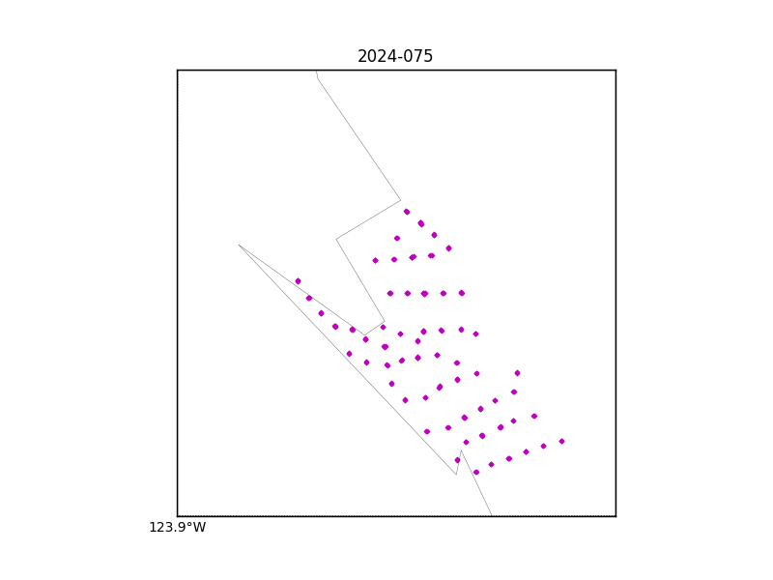

Figure 1 – location of casts.

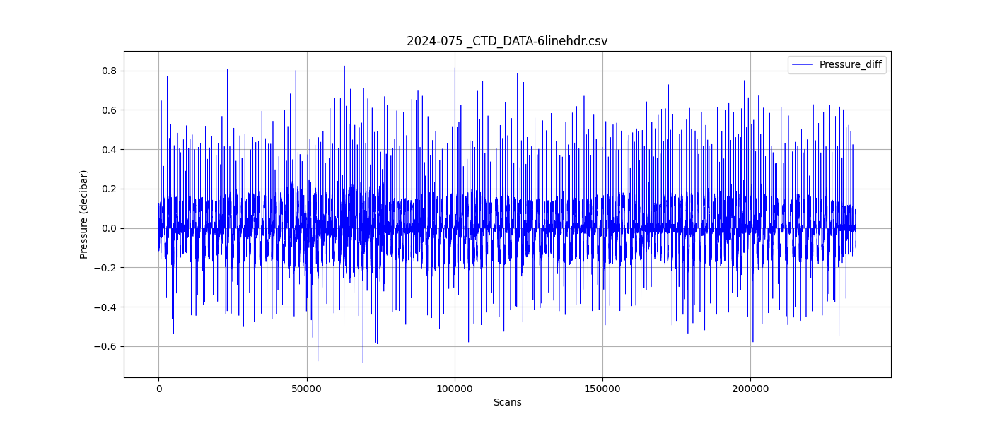

Figure 2 – zero order holds

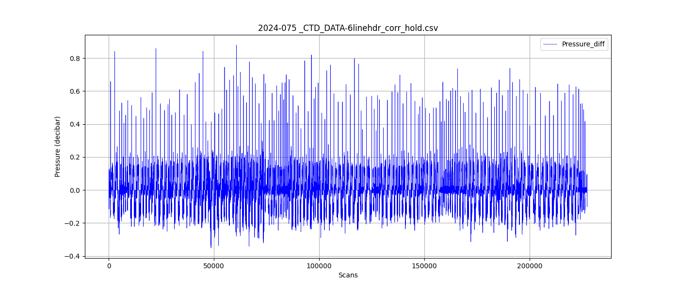

Figure 3 – zero order holds removed