**RBR CTD DATA PROCESSING NOTES**

Cruise: 2024-052

Agency: OSD

Locations: Queen Charlotte Strait

Project: Queen Charlotte Strait Weather Station Network

Party Chief: Cooper G.

Platform: Blackfish

Date: March 19, 2024 – March 21, 2024

Processed by: Samantha Huntington

Date of Processing: April 15, 2024 – April 23, 2024

Number of Raw files: 9 Number of Processed Files: 9

**Instrument Summary**

Equipment: RBR Maestro CTD (s/n 208765) with a Turner Cyclops Fluorometer (s/n 2110792), a JFE Advantech Rinko III oxygen sensor (s/n 0447), and a Trubidity Sensor (Seapoint s/n 208765).

Sampling frequency was at 8Hz.

**Summary of Quality and Concerns**

A cast list of times and locations was provided, “2024-052CTDLogFileFinal.xlxs”. Casts 1 and 7 did not reach the bottom because the cable was not long enough.

The data overall look good with some spikes in Fluorescence and Turbidity. These will be examined after Clip and removing the upcast.

**Processing Summary**

1. **Conversion to IOS Headers**

File 208765_20240321_1643.rsk contained the 9 profiles which were extracted using python function READ_RSK().

A single file (2024-052_CTD_Data.csv) with all the data including event numbers and a single line of headers was prepared using python function MERGE_FILES().

A 6-line header was inserted using python function Add_6Lineheader_2().

File “2024-052_header-merge.csv” was created, based on the information provided by the chief scientist.

* Column “File_Name”: entries were derived from the event number.
* Column “LOC:LATITUDE”: latitude was provided and reformatted to “XX XX.XXXX N !(deg min)”.
* Column “LOC:LONGITUDE”: longitude was provided and reformatted to “XX XX.XXXX W !(deg min)”.
* Column “LOC: Event Number”: entries were event numbers.
* Column “LOC: STATION”: entries were taken from the Log file.

The sampling site was mapped (Figure 1) using from “2024-052_header-merge.csv” using python function Plot_Track_Location() to check the location of all casts.

Prior to conversion to IOS header format, the presence of zero-order holds were checked using Python function Plot_Pressure_Diff() Zero-order holds were found (Figure 2.) these values were replaced with an interpolated value using the python function Correct_Hold().

A new csv file was created “2024-052_CSV_DATA-6Linedr_corr_hold.csv” and the corrected values were checked in python function Plot_Pressure_Diff(). Zero-order holds were found to be removed (Figure 3.).

CONVERT Spreadsheet Files was run to produce files with IOS Header format. Header entries of “Administration”, “File” and “Instrument” were filled in this step.

The routine “Merge:CSV Files to headers” was run to add location headers to the IOS files.

Next CLEAN was run to add a start time and event numbers to headers.

Raw data were plotted and examined:

* Salinity looks good.
* Temperature looks good.
* Conductivity looks good.
* Oxygen looks good with some bad data at the bottom of cast 6.
* Fluorescence has some significant spikes in casts 2, 5, 6 and 8.

Then REORDER was run to reorder the channels in all files.

1. **Data processing**

* Correction to Pressure: there were no negative pressures found so pressure was not calibrated.
* CLIP: Pressure is steady for a variable number of scans. Initial records were removed until the downcast began using file “2024-052_CLIP.csv”.
* Filter: a Gull-winged filter, size 3, was applied to temperature, conductivity, and pressure. Salinity will be calculated in the next step.
* SHIFT: Based on suggested values in document “Guidelines for processing RBR CTD profiles”, the alignment of temperature and conductivity was corrected by applying a shift of -2 scans in conductivity.
* SHIFT: Better alignment with Oxygen profiles was found by advancing it by 11 scans. The advice given in document “Guidelines for processing RBR CTD Profiles” was that an advance between 2 and 3 seconds is appropriate. T-O plots before and after alignment were compared.
* Delete was run to remove records with a descent rate lower than 0.3m/s over 8 points. This was not applied in the top 10m to avoid loss of surface records as the CTD began its descent.
* Profile plots were examined after DELETE and confirm that plots show reasonable values for salinity and conductivity and fluorescence. DO saturation levels at the surface ranged from 92% to 98%. However there was no calibration sampling and no climatology to enable a judgement about the data reliability.
* Data despiking: Fluorescence spikes were manually replaced with PAD values in all casts.

1. **Final checks and header editing**

* REMOVE was run to remove the following channels from all casts: Date, Time:UTC and Event.
* BIN AVERAGE was used to metre-average data.
* CALIBRATE was run to convert conductivity units to S/m using file 2024-052-recal2.ccf.
* Header Edit was used to fix channel names and format as listed below:
  + Pressure: format F11.2 ==> F7.1
  + Salinity:CTD ==> Salinity
  + Fluorescence ==> Fluorescence:URU
  + Oxygen_mL_L ==> Oxygen:Dissolved:Rinko
  + Oxygen_umol_kg ==> Oxygen:Dissolved:Rinko
* CLEAN was run to reset the Maximum and Minimum values in the Header.
* Header Check was run and no problems were found.

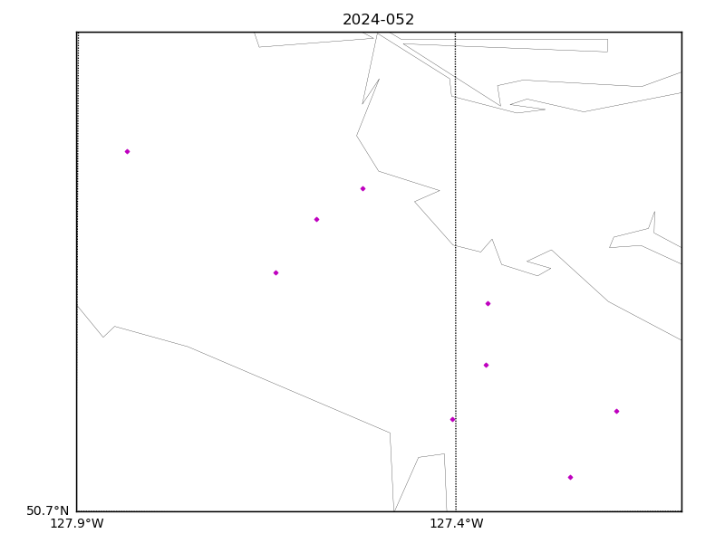

Figure 1 – location of casts.

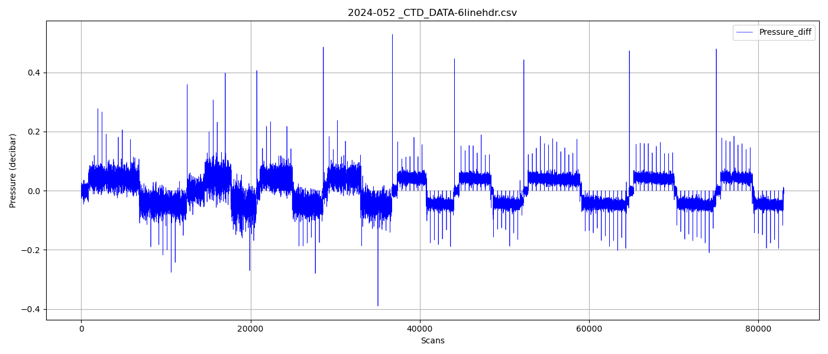

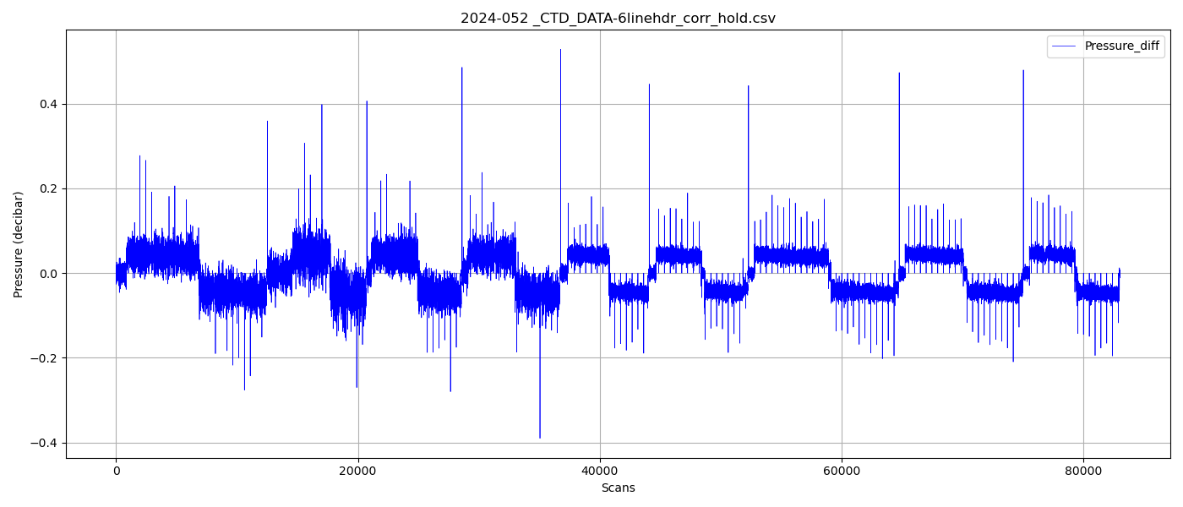

Figure 3 – zero order holds removed