**RBR CTD DATA PROCESSING NOTES**

Cruise: 2024-040

Agency: OSD

Locations: Quatsino Sound, Holberg Inlet and Neroutsos Inlet

Project: Quatsino Sound CTD Monitoring Program

Party Chief: Bianucci, Laura

Platform: Blackfish

Date: January 16, 2024 October 30, 2024

Processed by: Samantha Huntington

Date of Processing: January 15, 2025 – February 11, 2025

Number of Raw files: 250 Number of Processed Files: 250

**Instrument Summary**

Equipment: RBR Concerto CTD (s/n 204694) with a Turner Cyclops Fluorometer (s/n 211012) and a JFE Advantech Rinko III oxygen sensor (s/n 411) for the January casts 1-16.

**NOTE:** Sampling for these casts was done at **1Hz.**

Equipment: RBR Meastro CTD (s/n 208765) with a Turner Cyclops Fluorometer (s/n 21101792) and a JFE Advantech Rinko III oxygen sensor (s/n 447) for the rest of the casts from 17-250.

Sampling frequency was at 8Hz.

Deployed using Hydraulic winch on Blackfish Vessel - decent and recovery rate ~0.38m/s

**Summary of Quality and Concerns**

The following files were provided:

204694_20240122_0921.rsk (Manual range for Chl (5)),

208765_20240212_1002.rsk (Auto range for Chl),

208765_20240321_0824.rsk (Auto range for Chl),

208765_20240416_0851.rsk (Manual range for Chl (5)),

208765_20240515.rsk (Manual range for Chl),

208765_20240716_0900 June CTD.rsk (Manual range for Chl (5)),

208765_20240722_0943 July CTD.rsk (Manual range for Chl (5)),

208765_20240923_1227 Aug CTD.rsk (Manual range for Chl (50)) ,

208765_20241010_0914 Sep CTD.rsk (Manual range for Chl (50))

208765_20241113_1655 Oct.rsk (Manual range for Chl (50)).

A list of casts and locations and stations names was also provided, 2024QuatsinoFirstNations_CTD_Taplog_Final.xlsx.

204694_20240122_0921.rsk was sampled at 1Hz and the output data will be processed differently.

This cruise took place as several distinct excursions and as such, event numbers in the Taplog files are in chronological order starting with 1 for each excursion. The following changes were made to event numbers:

204694_20240122_0921.rsk remained casts 1-16.

208765_20240212_1002.rsk renamed to casts 17-42. One profile had been detected as two, those two output csv files were merged together into one, cast number 38.

208765_20240321_0824.rsk renamed to casts 43-67.

208765_20240416_0851.rsk renamed to casts 68-93.

208765_20240515.rsk renamed to casts 94-119.

208765_20240716_0900 June CTD.rsk renamed to casts 120-145.

208765_20240722_0943 July CTD.rsk renamed to casts 146-172

208765_20240923_1227 Aug CTD.rsk, renamed to casts 173-199

208765_20241010_0914 Sep CTD.rsk, renamed to casts 200-224

208765_20241113_1655 Oct.rsk, renamed to casts 225-250

Samples collected by Quatsino First Nations fisheries guardians Graem Hall, Jacob Nelson, and Mark Wallas as part of a collaborative project.

The data overall look good. There is some very high Oxygen Saturation in many casts, some values reaching 165%.

**Processing Summary**

1. **Conversion to IOS Headers**

Separate Header Merge files were created for each of the Ruskin files and the profiles from each file were extracted using python function READ_RSK(), dissolved Oxygen concentration was calculated from dissolved Oxygen saturation in this step using Python.

A single file (2024-040_CTD_Data.csv) with all the data including event numbers and a single line of headers was prepared using python function MERGE_FILES().

A 6-line header was inserted using python function Add_6Lineheader_2().

File “2024-040_header-merge.csv” was created, based on the information provided by the chief scientist.

* Column “File_Name”: entries were derived from the event number.
* Column “LOC:LATITUDE”: latitude was provided and reformatted to “XX XX.XXXX N !(deg min)”.
* Column “LOC:LONGITUDE”: longitude was provided and reformatted to “XX XX.XXXX W !(deg min)”.
* Column “LOC: Event Number”: entries were event numbers.
* Column “LOC: STATION”: station information was provided.
* Columns “FIL:TIME INCREMENT” and “Inst:Serial Number” and “Inst:Model”: differed between the first 16 casts and the rest of the casts.

The sampling site was mapped (Figure 1) using from “2024-040_header-merge.csv” using python function Plot_Track_Location() to check the location of all casts.

Prior to conversion to IOS header format, the presence of zero-order holds were checked using Python function Plot_Pressure_Diff(). Zero-order holds were found (Figure 2.) and these values were replaced with Nan using the python function Correct_Hold().

A new csv file was created “2024-040_CSV_DATA-6Linedr_corr_hold.csv” and the corrected values were checked in python function Plot_Pressure_Diff(). Zero-order holds were found to be removed (Figure 3.).

CONVERT Spreadsheet Files was run to produce files with IOS Header format. Header entries of “Administration”, “File” and “Instrument” were filled in this step. Some were kept blank to be populated later with Merge:CSV. Time Increment, Instrument and Serial Number were not consistent throughout the cruise.

Using ADD TIME CHANNEL a record number was added to each record.

Next CLEAN was run to add a start time and event numbers to headers.

Raw data were plotted and examined:

* Across all channels there is some bad data at the bottom of casts 9, 26, 51, 55, 60, 63, 64, 66, 79, 90, 92, 94, 114, 115, 134, 167, 168, 169, 183, 194, 203, 213, 215-219, 223,231, 234, 247, 248, 249, 250. Bad data at the top will be examined after the CLIP step, bad data at the bottom will be re-examined after the DELETE step.
* Salinity has a spike in casts 50 and 99,
* Temperature looks good aside from the bad data at the bottom mentioned above.
* Conductivity has some bad data at the bottom o cast 39, a spike in cast 50, 99, 133, the bottom of casts 146 and 173, and a spike in cast 219.
* Oxygen looks good with some bad data at the bottom of cast 31. There is very high Oxygen in casts 98, 99, 121-125, 129-133, 141, 147-161, 166-168, 170-177, 179, 180, 182-184, 186, 187, 190-193. Oxygen in casts 102 and 133 need closer examination after processing.
* Fluorescence has spikes in many casts, these will be examined again after CLIP and DELETE. Casts 94-99, 103-104, 109-111, 114-125, 129-131, 140-150, 152-159, 162-167 and 171-172 did not have enough range at the surface, values are cut off at 5 mg/m^3 which was set manually in the CTD. There is high Oxygen in some of these casts making judgment about the Oxygen values difficult.

The routine “Merge:CSV Files to headers” was run to add location, model, serial number and time increment headers to the files.

Then REORDER was run to reorder the channels in all files.

1. **Data processing**

* Correction to Pressure: Casts had negative pressures of -1 with some casts showing corresponding Conductivity measurements over 30. Pressure weas corrected using file 2024-040-recal1.ccf
* CLIP: Pressure is steady for a variable number of scans. Initial records were removed until the downcast began using file “2024-040_CLIP.csv”.

**CASTS 1-16 Sampling Frequency 1Hz**

* FILTER: no filter was applied due to the sampling frequency.
* SHIFT: Better alignment was found by advancing Oxygen profiles by **5** scans.
* Delete was run to remove records with a descent rate lower than 0.3m/s over 8 points. This was not applied in the top 10m to avoid loss of surface records as the CTD began its descent.

**CASTS 17-250 Sampling Frequency 8Hz**

* Filter: a Gull-winged filter, size 3, was applied to temperature, conductivity, and pressure. Salinity will be calculated in the next step.
* SHIFT: Based on suggested values in document “Guidelines for processing RBR CTD profiles”, the alignment of temperature and conductivity was corrected by applying a shift of -2 scans in conductivity.
* SHIFT: Better alignment with Oxygen profiles was found by advancing it by 11 scans. The advice given in document “Guidelines for processing RBR CTD Profiles” was that an advance between 2 and 3 seconds is appropriate. T-O plots before and after alignment were compared.
* Delete was run to remove records with a descent rate lower than 0.2m/s over 8 points. This was not applied in the top 10m to avoid loss of surface records as the CTD began its descent.

**ALL CASTS**

* CLEAN was run to reset the maximum and minimum values in the header
* DESPIKE and Bad data removal:

Data was plotted to see what bad data and spikes remained after processing.

Bad data was removed from the bottom of casts 9, 26, 39, 51, 55, 63, 64, 66, 79, 90, 92, 94, 114, 115, 119, 134, 140, 144, 146, 150, 154, 167, 168, 169, 178, 182, 183, 187, 215, 223, 231, 247, 248 and 249 .

A spike in Salinity and Conductivity was removed from casts 50, 99, 110, 117, 124, 126, 133, 173, 175, 179, 183, 187, 197, 210, 215 and 219.

A spike in Salinity was removed in cast 209.

There were a few larger negative Fluorescence spikes, CLEAN was run to replace all negative fluorescence values with PAD values.

Large spikes in fluorescence were removed from casts 8, 10- 13, 20, 26- 28, 31, 37, 39, 41, 42, 44, 47- 50, 54, 55, 62- 64, 66, 76, 80, 105, 115, 134, 167, 168, 194-196, 210, 220, 223, 224, 232, 236, 245 and 248.

There was not enough range for Fluorescence (mg/m^3) for casts 96-99, 109-111, 113-125, 131, 141, 145-150, 152-159, 162-166, 171, 172 and 179.

Cast 173 has the highest Dissolved Oxygen value at 165%, the CTD fluorescence was set to manual range of 50 mg/m^3, for this cast this range was not enough.

* Profile plots were examined after DELETE and confirm that plots show reasonable values for salinity and conductivity and fluorescence. DO saturation levels at the surface ranged from 0.15% to 165%. However there was no calibration sampling and no climatology to enable a judgement about the data reliability..

1. **Final checks and header editing**

* REMOVE was run to remove the following channels from all casts: Date, Time:UTC, Event and Record number.
* Turbidity was not on both RBR sensors used in this project, empty Turbidity channels were removed from casts 1-16.
* BIN AVERAGE was used to metre-average data.
* CALIBRATE was run to convert conductivity units to S/m using file 2024-040-recal2.ccf.
* Header Edit was used to fix channel names and format as listed below:
* Pressure: format F11.2 ==> F7.1
* Salinity:CTD ==> Salinity
* Oxygen==> Fluorescence:URU
* mL/L==> %
* F11.4==>F8.2
* Conductivity: F10.5 ==> F10.6
* CLEAN was run to reset the Maximum and Minimum values in the Header.
* Header Check was run and no problems were found.

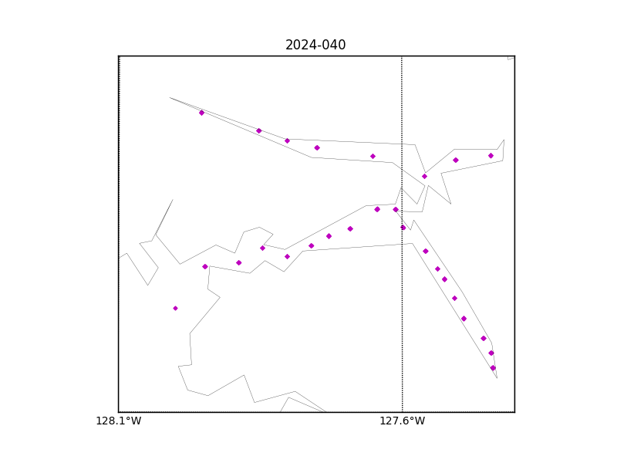

Figure 1 – location of casts.

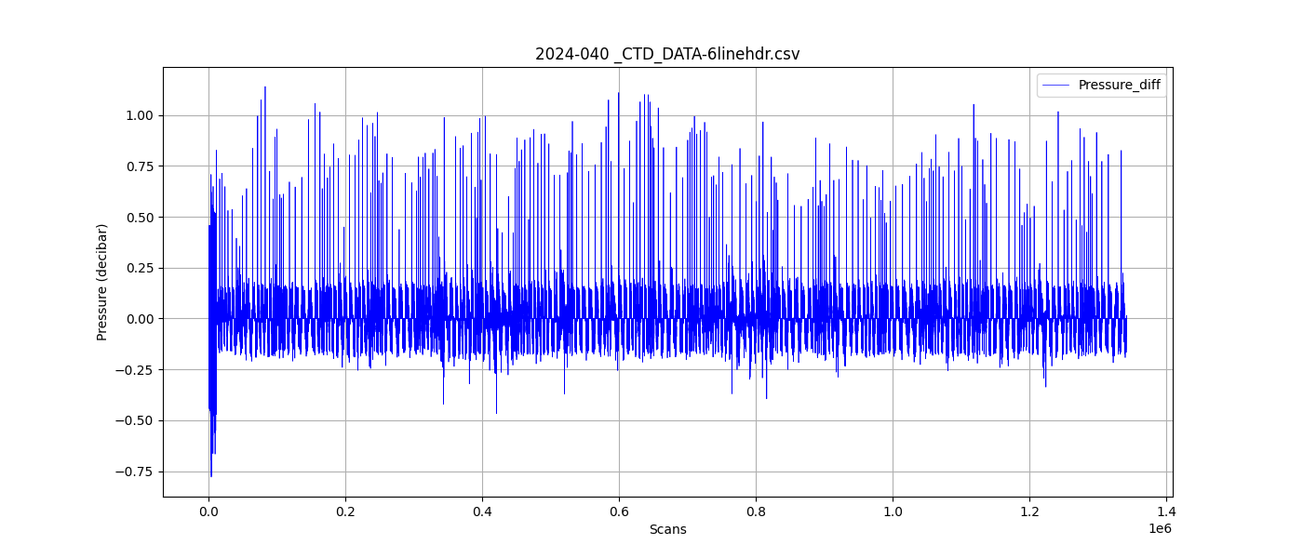

Figure 2 – zero-order holds

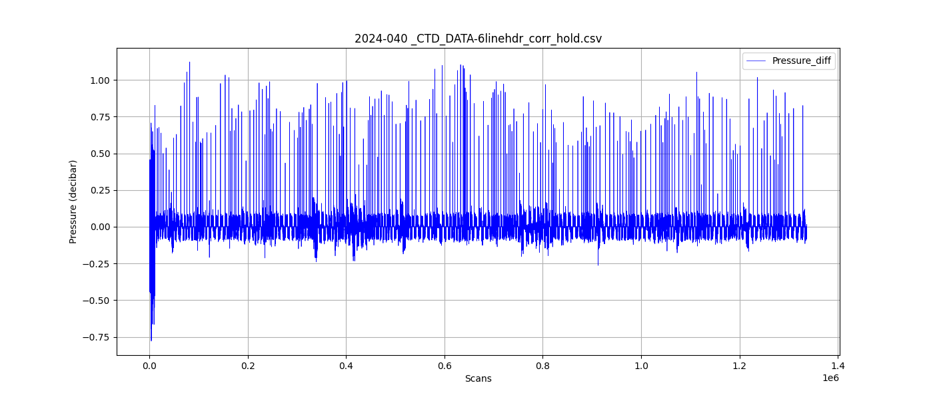

Figure 3 – zero order holds removed