**RBR CTD DATA PROCESSING NOTES**

Cruise: 2024-039

Agency: OSD

Locations: Vancouver Harbour

Project: OPP Vancouver Harbour Survey

Party Chief: Blanken H.

Platform: Doug Anderson

Date: February 19, 2024 – February 23, 2024

Processed by: Samantha Huntington

Date of Processing: May 9, 2024 – May 14, 2024

Number of Raw files: 158 Number of Processed Files: 158

**Instrument Summary**

Equipment: RBR Maestro CTD (s/n 232531) with a Turner Cyclops Fluorometer (s/n 2111617), a JFE Advantech Rinko III oxygen sensor (s/n 0480), and a Turbidity Sensor (Seapoint s/n 208765).

Sampling frequency was at 8Hz.

**Summary of Quality and Concerns**

A cast list of times and locations was provided, “2024-039CTDTapLogFinal.xlxs”. Cast 105 had a delayed start due to ship traffic

The data overall look good with some spikes in Fluorescence. There is a lot of noisy data at the surface and some spikes in Pressure after the CTD is back on the surface. These will be examined after Clip and removing the upcast.

**Processing Summary**

1. **Conversion to IOS Headers**

Two RSK files were provided and converted to excel files using Ruskin software. File 232531_20240220_0731.xlxs contained the 12 profiles from this cruise and several profiles from a previous cruise. Those profiles were excluded. 146 profiles were found in file 232521_2024022_1125. All profiles were extracted using python function READ_Excel().

A single file (2024-039_CTD_Data.csv) with all the data including event numbers and a single line of headers was prepared using python function MERGE_FILES().

A 6-line header was inserted using python function Add_6Lineheader_2(), Dissolved Oxygen Saturation was converted to Dissolved Oxygen Concentration during this step.

File “2024-039_header-merge.csv” was created, based on the information provided by the chief scientist.

* Column “File_Name”: entries were derived from the event number.
* Column “LOC:LATITUDE”: latitude was provided and reformatted to “XX XX.XXXX N !(deg min)”.
* Column “LOC:LONGITUDE”: longitude was provided and reformatted to “XX XX.XXXX W !(deg min)”.
* Column “LOC: Event Number”: entries were event numbers.
* Column “LOC: STATION”: entries were taken from the Log file.

The sampling site was mapped (Figure 1) using from “2024-039_header-merge.csv” using python function Plot_Track_Location() to check the location of all casts. The coastline in the python mapping package did not have all the small inlets that were sampled during this cruise.

Prior to conversion to IOS header format, the presence of zero-order holds were checked using Python function Plot_Pressure_Diff() Zero-order holds were found (Figure 2.) these values were replaced with an interpolated value using the python function Correct_Hold().

A new csv file was created “2024-039_CSV_DATA-6Linedr_corr_hold.csv” and the corrected values were checked in python function Plot_Pressure_Diff(). Zero-order holds were found to be removed (Figure 3.).

CONVERT Spreadsheet Files was run to produce files with IOS Header format. Header entries of “Administration”, “File” and “Instrument” were filled in this step.

The routine “Merge:CSV Files to headers” was run to add location headers to the IOS files.

Next CLEAN was run to add a start time and event numbers to headers.

Raw data were plotted and examined:

* Salinity looks good.
* Temperature looks good with some bad data at the surface of many casts.
* Conductivity looks good.
* Oxygen looks good with some bad data at the surface of many casts.
* Fluorescence has some significant spikes many casts, these will be examined after the upcast is removed.

Then REORDER was run to reorder the channels in all files.

Record numbers were then added to the files using ADD TIME CHANNEL.

1. **Data processing**

* Correction to Pressure: there were no negative pressures found in the downcast, there were some positive and negative spikes after the CTD had come out of the water. Pressure was not calibrated.
* CLIP: Pressure is steady for a variable number of scans. Initial records were removed until the downcast began using file “2024-039_CLIP.csv”.
* Filter: a Gull-winged filter, size 3, was applied to temperature, conductivity, and pressure. Salinity will be calculated in the next step.
* SHIFT: Based on suggested values in document “Guidelines for processing RBR CTD profiles”, the alignment of temperature and conductivity was corrected by applying a shift of -2 scans in conductivity.
* SHIFT: Better alignment with Oxygen profiles was found by advancing it by 11 scans. The advice given in document “Guidelines for processing RBR CTD Profiles” was that an advance between 2 and 3 seconds is appropriate. T-O plots before and after alignment were compared.
* Delete was run to remove records with a descent rate lower than 0.3m/s over 8 points. This was not applied in the top 10m to avoid loss of surface records as the CTD began its descent.
* Profile plots were examined after DELETE and confirm that plots show reasonable values for salinity and conductivity and fluorescence. DO saturation levels at the surface ranged from 92% to 98%. However there was no calibration sampling and no climatology to enable a judgement about the data reliability.
* Data despiking: Fluorescence spikes examined and spikes did not occur due to a gain change in the CTD sensor, spikes were within reasonable limits and so despiking was not done.

1. **Final checks and header editing**

* REMOVE was run to remove the following channels from all casts: Date, Time:UTC and Event.
* BIN AVERAGE was used to metre-average data.
* CALIBRATE was run to convert conductivity units to S/m using file 2024-039-recal2.ccf.
* Header Edit was used to fix channel names and format as listed below:
  + Pressure: format F11.2 ==> F7.1
  + Salinity:CTD ==> Salinity
  + Fluorescence ==> Fluorescence:URU
  + Oxygen_mL_L ==> Oxygen:Dissolved:Rinko
  + Oxygen_umol_kg ==> Oxygen:Dissolved:Rinko
* CLEAN was run to reset the Maximum and Minimum values in the Header.
* Header Check was run and no problems were found.

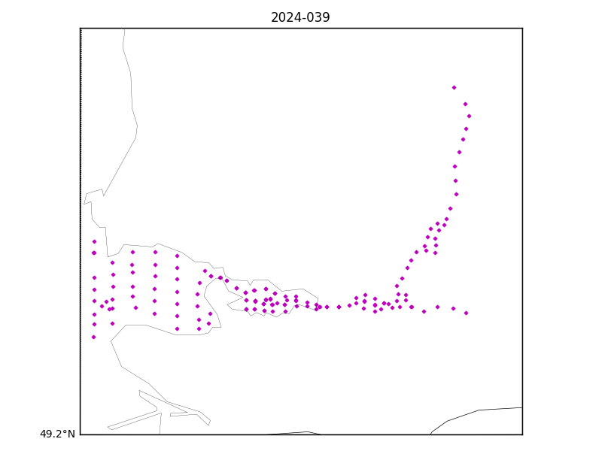

Figure 1 – location of casts.

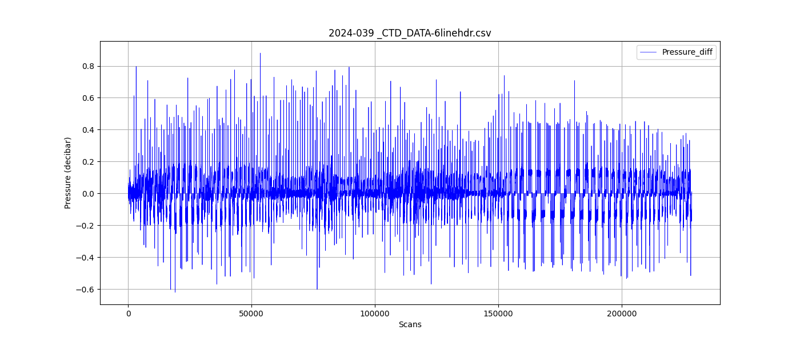

Figure 2 – Zero order holds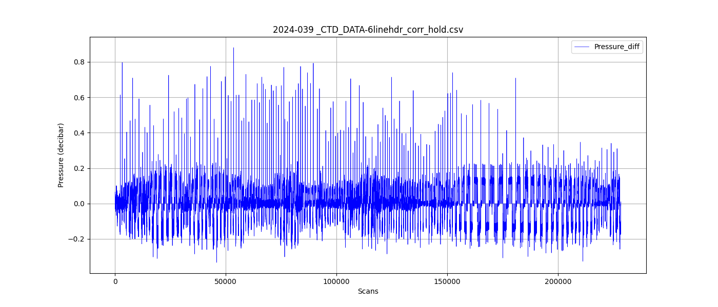

Figure 3 – zero order holds removed