EVISION NOTICE TABLE
DATE | DESCRIPTION OF REVISION

PROCESSING NOTES
Cruise: 2024-038
Agency: OSD
Location: Queen Charlotte Sound, Hecate Strait
Project: Working Together Ocean Sciences Expedition
Chief Scientist: Page S.
Platform: John P. Tully
Date: June 29, 2024 – July 8, 2024

Processed by: Germaine Gatien
Dates of Processing: 1 October 2025 – 5 November 2025
Number of HEX files: 40 Number of CTD files processed: 39 (Event #21 upcast only)
Number of rosette files: 15 Number of CHE files processed: 12 (Event #54 Lugols only & #85 no sampling)
Number of TSG files: 7

INSTRUMENT SUMMARY
CTD #0443 was mounted in a rosette and attached were 2 Wetlabs CSTAR transmissometers (1185DR and 1883DG), a SBE 43 DO sensor on the primary pump (#4372), SeaPoint Fluorometer (#4186) with 3X gain on the secondary pump, WetLabs ECO fluorometer (#2216), a PAR sensor (#70613) and an altimeter (#76341).
No changes were made to equipment during the cruise.

Seasave version 7.26.7.121was used for acquisition.
The data logging Computer was a Lenovo ThinkCentre.
The deck unit was a Seabird model 11+ #508.
A Guildline model 8400B Autosal serial # 73274 was used to analyze salinity samples.
An IOS rosette with 24 10L bottles was used.
A thermosalinograph (SeaBird 21 S/N 3411) was believed to be in use, but data were missing at time of initial processing.

SUMMARY OF QUALITY AND CONCERNS
The Daily Science Log Book was in good order with many comments on problems or conditions experienced. There was a complete list of CTD equipment. There were no changes during the cruise.

The SBE DO sensor has a fairly long response time so data accuracy is not as high when it is in motion as it is during stops for bottles. This will be especially true when vertical DO gradients are large. To get an estimate of the accuracy of the SBE DO data during downcasts (after recalibration) a rough comparison was made between downcast SBE DO and upcast titrated samples. Some of the difference will be due to problems with flushing of Niskin bottles and/or analysis errors, so the following statement likely underestimates SBE DO accuracy.

Downcast (CTD files) Oxygen:Dissolved:SBE data for this cruise are considered, very roughly, to be:
±0.6 mL/L from 0-100db
±0.3 mL/L from 100db to 125db
±0.03 mL/L below 125db.
For details see files 2024-038-dox-comp3.xls.

The thermosalinograph data were generally of good quality, with flow meters performing better than during the pervious cruise on the Tully and no serious spiking issues. TSG Fluorescence compared reasonably well with the CTD fluorometer when adjustments were made to the offset in the calibration. It would be good to replace the fluorometer on the Tully TSG.

The only serious problem concerned TSG salinity data. A post-cruise factory service indicated that there was very large drift in the sensor calibration. Fortunately, there was consistent information from comparisons with co-incident CTD casts and loop samples that enabled recalibration of the salinity. Since corrections were large (-0.41psu to +0.73psu) the quality of these data are lower than usual, so they are reported with only 2 decimal points.

This cruise offers an example of the great value of taking loop samples when the TSG is in use; there were only 7 available but they provided confirmation that the results of the comparisons with CTD data were valid.

PROCESSING SUMMARY

Seasave
This step was completed at sea; the raw data files have extension HEX.

Preliminary Steps
- The configuration files used at sea were checked. No errors were found nor changes during the cruise.
- The file was saved as 2024-038-ctd.xmlcon.
- The Log Book and rosette log sheets were obtained. They were in good order.
- Dissolved oxygen, extracted CHL, nutrient and salinity data were obtained in QF spreadsheet format from the analysts.
- The cruise summary sheet was completed.
- The history of the T, C and P sensors was checked and noted in section 14.

BOTTLE FILE PREPARATION
The ROS files were created using file 2024-038-ctd.xmlcon.
The ROS files were converted to IOS Header format with extension *.BOT.
The IOS files were put through CLEAN to create BOT files.
Temperature and salinity were plotted for all BOT files to check for outliers. No editing was found necessary. Near the surface there were larger differences, but no clear spikes.

One bottle was fired on the fly during cast #54 with only lugols sampling so the file will not be processed further.

One bottle was fired during the upcast of cast #60. A bottle file will be processed in case needed by the researcher who requested it, but it will not be archived.
For event 85 there was no sampling recorded on the rosette sheet although a ROS file was produced. No sample numbers are entered in the Daily Science log and no samples were sent by analysts for this cast. It was dropped from the file list.

The BOT files were bin-averaged on bottle number.
The output was used to create file ADDSAMP.csv. First, the file was sorted on event number and Bottle Position order. Then sample numbers were added based on the rosette logs.
The ADDSAMP file was sorted on sample numbers.

The ADDSAMP file was used to add sample numbers to the BOT files – output *.SAM.
The SAM files were bin-averaged on bottle # and called SAMAVG.
The addsamp.csv file was converted to CST files, which will form the framework for the bottle files.

Next, each of the analysis spreadsheets were examined to see what comments the analysts wanted included in the header file. These were used to create file 2024-038-bot-hdr.txt which will be updated as needed during processing. All loop samples were copied to file 2024-038-loops.xlsx and are not included in the following individual csv files.

DISSOLVED OXGYEN
Dissolved oxygen data were provided in spreadsheet QF2024-038_OXY*.xlsx which includes flags, comments and a precision study. Draw temperatures are available. The spreadsheet page with the final data was simplified and saved as 2024-038oxy.csv. That file was converted into individual *.OXY files.
There were 2 samples (82 and 416) in the DO file that had comments starting with “ALL:” and NUTS were drawn from those bottles, so the same flags were added to the NUTS files. CHL and Salinity samples were not drawn from those 2 bottles.
EXTRACTED CHLOROPHYLL
Extracted chlorophyll and phaeo-pigment data were obtained in file QF2024-038_CHL QF*.xlsx. The file included comments, flags and a precision study. A simplified version of the spreadsheet (without loop samples) was prepared and saved as 2024-038chl.csv.
The csv file was then converted to individual CHL files.
Loop samples were copied to a separate loop spreadsheet.
NUTRIENTS
The nutrient data were obtained in spreadsheet QF2024-038_NUTS*.xlsx. This includes a precision study. The file was simplified, saved as 2024-038nuts.csv. The file was converted to individual NUT files.
SALINITY
Salinity analysis was obtained in file QF2024-038_SAL.xlsx; there were no duplicates taken. The analyses were carried out at IOS 4-9 days after collection. The files were simplified and saved as 2024-038sal.csv. That file was then converted to individual SAL files. There were no duplicates.

The SAL, CHL, OXY and NUTS data files were merged with CST files in 4 steps.
The files were then put through CLEAN to reduce the headers to File and Comment sections only.
These files are ordered on sample number, but the SAMAVG files are ordered on bottle number, so the MRGCLN1 files were reordered on Bottle_Number and saved as *. MRGCLN1s.
The MRGCLN1s files were then merged with SAMAVG files using merge channel Bottle_Number.
There was no sampling from file #85, so it was dropped from the file list.

The output of the MRG files were exported to a spreadsheet. A few problems were found in flags and comments and they were resolved.
Cast #62 was misnamed as 63 – this was fixed.

A header check, cross-reference list and track plot were produced and no problems were found.

Compare
Salinity
Compare was run with pressure as reference channel.
Outliers were removed based on standard deviation in the CTD data during the 10s window being >0.001psu.
This left only a few significant outliers. Two of those look to be likely due to incomplete Niskin flushing as there were large local vertical salinity gradients. One was a stop after a very noisy patch as the CTD slowed down; it is already flagged 4 due to poor replicates..
Noe of those outliers look like they need updates to quality flags.

When data are excluded above 500db the primary salinity is higher than bottles by an average of <0.0001psu and the secondary is lower than bottles by an average of 0.0022db. The secondary sensor has more pressure dependence than the primary. But the primary has a little more time dependence than the secondary. The standard deviation in both fits was 0.0009psu.
For full details for the COMPARE run see file 2024-038-sal-comp1.xls.

Dissolved Oxygen
COMPARE was run with pressure as the reference channel.
Recent cruises using this CTD including DO sensor #4372 have had anomalous comparisons between CTD and titrated samples with the CTD values reading higher than samples instead of the usual pattern of mostly reading lower.
The fit for this cruise is tighter than those from the previous cruise (2024-069) and a reasonable fit was achieved when 5 outliers were excluded based on residuals:
SBE DO Corrected = 0.9797*SBE DO original + 0.04812
There is still considerable scatter in the fit, but it looks quite good at the high and low end of the range of DO values where local gradients tend to be lower; in the middle range of DO values there is more scatter due to high vertical DO gradients.

This is remarkably close to the results for 2024-069 during which the offset was forced to have an offset of 0.05mL/L based on a few deep samples.
SBE DO Corrected = 0.980*SBE DO original + 0.05 (2024-069)
A plot of differences versus file pair number shows little variation except for with cast #10 which was a shallow cast.
The plot versus pressure shows the DO being high in shallow deep water, very low near the Oxygen Minimum Zone and slightly below the OMZ.
For full details for the COMPARE run see file 2024-038-dox-comp1.xls.

Outliers in the fits are all associated with large vertical gradients and/or high standard deviations in SBE DO.
Plots of Titrated DO and CTD DO against CTD salinity were examined. All outliers found were in high vertical gradients, so no quality flags are recommended as the samples are likely fine.

Fluorescence
COMPARE was run with pressure as the reference channel.
Uranine tests in February 2024 found a voltage threshold of 0.001 for the SeaPoint Fluorometer and 0.058 for the ECO.
Tests were done to see how well the ECO and Seapoint fluorometers compared and differences were found to be slight.
First, the dark values were found by examining plots below 300db.
Dark Values: SeaPoint 4186 +0.012ug/L
ECO 2216 +0.029ug/L (rough value)

The SeaPoint fluorescence is higher than the extracted CHL for CHL<1ug/L, close to CHL for 1<CHL<3 and mostly about 50% of CHL for CHL>3ug/L.
The ECO fluorescence is also higher than the extracted CHL for CHL<1ug/L, but it is also higher for 1<CHL<3, and lower than CHL for CHL>3ug/L but not as low as the SeaPoint fluorescence. It is hard to say which is the better choice

The ECO is closer to CHL samples though still significantly lower when CHL is >3ug/L.
No corrections will be applied to either fluorescence channel.

For more details see document 2024-038-fl-chl-comp1.xls.

Conversion of Full Files from Raw Data
All files were converted using 2024-038-ctd.xmlcon.
The Tau function and the hysteresis function were selected since there was at least 1 deep cast. Depth was included in the conversion.
A few casts were examined.
The T and C pairs were close during downcasts but, as usual, further apart during upcasts.
The transmissivity, DO and fluorescence profiles look normal. Altimetry looks excellent.

WILDEDIT
Program WILDEDIT was run to remove spikes from the pressure, depth, conductivity & temperature only in the full cast files (*.CNV).
Parameters used were: Pass 1 Std Dev = 2 Pass 2 Std Dev = 5 Points per block = 50
The parameter “Keep data within this distance of the mean” was set to 0 so all spikes would be removed.

ALIGN DO
The setting of +2.5s has worked well for many SBE DO sensors in recent years. ALIGNCTD was run on all casts using +2.5s.

CELLTM
CELLTM was run using the default setting of (α = 0.0245, β=9.5) for both the primary and secondary conductivity.

DERIVE and Channel Comparisons
Program DERIVE was run on all casts to calculate primary and secondary salinity, descent rate and dissolved oxygen concentration.

Tests were run to see if the previous steps performed as expected:
- Some spikes noted in conductivity profiles were removed by WILDEDIT. One multi-record spike was reduced but not eliminated.
- The dissolved oxygen upcasts are quite noisy so hard to assess, but the alignment is definitely improved and downcast features are in good agreement with temperature traces, so ALIGNCTD appears to have worked well.
- CELLTM worked as expected, lowering salinity where temperature is decreasing (cell warms water raising conductivity but temperature sensor reading is correct, so salinity is overestimated). Conversely, it raises salinity where temperature is increasing (conductivity too low). This brings downcast and upcast traces closer together, so T-S downcast and upcast plots are in better agreement after this step.

DERIVE was run a second time on a few of the deeper casts to find the differences between the pairs of temperature, conductivity and salinity channels.
The sensors were used during cruise 2024-001 and 2024-069. Differences were found to be small during 2024-006 but values were not available.

Cast # | Press | T1-T0 | C1-C0 | S1-S0 | Descent Rate
2024-001-0030 | 550 | -0.0003 | -0.00038 | -0.0038 | High, V. Steady
2024-001-0050 | 550 | -0.0004 | -0.00033 | -0.0037 | High, F. Steady
2024-001-0074 | 550 | -0.0003 | -0.00032 | -0.0031 | High, F. Steady
2024-069-0025 | 500 | -0.0010 | -0.00014 | -0.0008 | High, Moderate
 | 1000 | -0.0006 | -0.00017 | -0.0015 | “
 | 1500 | -0.0003 | -0.00020 | -0.0020 | “
 | 2000 | -0.0001 | -0.00021 | -0.0024 | “
2024-069-0036 | 500 | -0.0005 | -0.00014 | -0.0011 | High, Moderate
 | 1000 | -0.0004 | -0.00016 | -0.0016 | “
 | 1500 | -0.0002 | -0.00017 | -0.0019 | ‘
 | 2000 | +0.0001 | -0.00018 | -0.0023 | ‘
2024-069-0069 | 500 | -0.0006 | -0.00014 | -0.0011 | High, V. Steady
2024-039-0180 | 500 | -0.0008 | -0.00024 | -0.0018 | High, V. Steady
2024-038-0036 | 500 | -0.0009 | -0.00018 | -0.0013 | High, Noisy
 | 1000 | -0.0008 | -0.00022 | -0.0022 | “
 | 2000 | -0.0002 | -0.00025 | -0.0030 | “
 | 2500 | +0.0001 | -0.00027 | -0.0038 | “
2024-038-0048 | 500 | -0.0005 | -0.00019 | -0.0016 | High, Noisy
 | 1000 | -0.0004 | -0.00021 | -0.0022 | “
 | 2000 | +0.0002 | -0.00025 | -0.0035 | “
 | 2500 | +0.0009 | -0.00026 | -0.0042
2024-038-0060 | 500 | -0.0004 | -0.00017 | -0.0017 | High, Noisy
 | 1000 | -0.0002 | -0.00021 | -0.0024 | “
 | 2000 | +0.0004 | -0.00024 | -0.0037 | “
 | 2500 | -0.0010 | -0.00026 | -0.0045 | “

Temperature differences are mostly small. They show some pressure dependence especially between 2000 and 2500db. There is little temporal drift.
Conductivity differences are also small but have some increase with both pressure and time.
Salinity differences have significant pressure dependence and some increase with time.
The differences based on the bottle comparison are on the order of 0.0023psu; this is fairly close to the differences above 2000db.

Conversion to IOS Header Format
The IOSSHELL routine was used to convert Sea-Bird 911+ CNV files to IOS Headers.
CLEAN was run to add event numbers and to replace pad values in the pressure channel with interpolated values based on record number.
There are some negative values in the ECO fluorescence channel; they are very small coming from a jitter in the signal when it is very low. Most will be removed by CLIP, DELETE or BIN AVERAGE. Any that remain will be removed later.

A cross-reference list was produced; station names were compared to those in the log; log entries were substituted where there were differences:
- Event 29 station name ~HG2 GL. The ~ may cause problems but was left in place as the cast was close to HG2.
- Event 55 station name missing in file 505F; changed to match log and other casts at the same site: 503F. The changes for event #55 were also applied to the SAM, SAMAVG and MRG files

There was a 10m soak for some casts lasting about 1 minutes, with a return to ~3m and a full cast run after a wait of about 30-45s.
For those with a 3m soak, there was usually a long wait near the surface, then a wait of about 1 to 3 minutes at 3m, with most waits around 2 minutes.
Plots were used to determine how many records should be removed from each cast. File clip.csv was prepared with those entries.
Plots were made to identify cases of too much removed and the CLIP file was adjusted and CLIP rerun.
There remain surface data that are very spiky but these will be addressed with the graphical editor.

Cast #21 contains only upcast data and will not be processed further There was no bottle sampling for that event.

Pressure, Water Depth and Position checks
- Surface check was run and found an average of 1.4db for downcasts and 3.2 for upcasts.
- A header check was run after CLIP. No problems were noted.
- There were no deck pressure recorded in the log but there were some from the previous cruise using this equipment; they ranged from 1db to 1.2db. Those measurements are not always found to be reliable but in that case they matched observations in Saanich Inlet and near-surface data in a few other casts.
- Cruise tracks were plotted, looked reasonable and were added to the end of this report.

- Header values for altimetry and water depth were exported to file 2024-038-altimeter-ctd.xlsx. The water depth when the CTD is at the bottom of casts is of more interest than when it is at the surface, especially if there is bottle sampling.
A “check value” was calculated as follows:
Check Value = Absolute Values Altimetry header + Max. depth sampled - Water depth in Header}
This value is expected to be close to 0, but in an area with narrow channels and steep slopes larger check values are common. All cases with that value >5m were checked. There were 13 such casts.
Plots of altimetry at the bottom show a few cases of noisy spikes, but the algorithm did a good job of making an estimate for the header. So altimetry headers are reliable.
For the following casts no problems were found and the check value is not large and is likely due to shoaling: 33, 36, 48, 67, 72, 74, 82.
For 4 casts the sounder readings look unreliable, so a calculated value (Max depth sampled + Altimetry Header) was substituted for the Water Depth Entry: 12, 50, 52, 60.
For cast #8 the water depth entry in the log shows that at the bottom it was 133db rather than 140 as recorded at the beginning. So 133 was entered in the Water Depth header.
- Changes were made to the CLN and CLIP files for the affected casts.
- The same changes were made to bottle files (SAM, SAMAVG, MRG & MRGCLN2) for casts #50, 52 and 60.

Shift
Fluorescence
SHIFT was run on the SeaPoint fluorescence channel in all casts using the usual advance of +24 records. Plots show that the fluorescence offset is closer to the temperature offset after this step and the 2 fluorescence profiles are closer.
No change was made to the ECO fluorometry since it is not pumped and the alignment looks ok.

Dissolved Oxygen
The Dissolved Oxygen voltage channel was aligned earlier and the results look good. No further alignment will be applied.

Conductivity
Tests were run on a few casts to assess what settings are best to align conductivity with temperature (as judged by the effect on salinity as seen in T-S space). The best setting was -0.9 records for the primary and -0.35 for the secondary.
SHIFT was run twice to apply those settings on all casts. Salinity was recalculated.

DELETE
The following DELETE parameters were used:
Surface Record Removal: Last Press Min
Maximum Surface Pressure (relative): 10.00
Surface Pressure Tolerance: 1.0 Pressure filtered over 15 points
Swells deleted. Warning message if pressure difference of 2.00
Drop rates < 0.30m/s (calculated over 11 points) will be deleted.
Drop rate applies in the range: 10db to 10db less than the maximum pressure
Sample interval = 0.042 seconds. (taken from header)
COMMENTS ON WARNINGS: The only warning was for cast #21 which was an upcast only and will not be processed further.
It was later discovered that too many records were removed from event #54, so all steps from CLIP to DELETE were rerun on that cast. The CLIP.CSV file was updated.

Other Comparisons
Experience with these sensors since last factory service –
CTD #0443 has been used for many cruises since it was last serviced at the factory. Some of those cruises have not yet been processed.
- No issues were noted with pressure.
- The dissolved oxygen sensor was used during 7 previous cruises, of which only 2 had dissolved oxygen sampling. For 2024-001 there was only inland sampling; the fit of differences against bottles looked much different from the normal drift, so an estimate of drift was made at that time, but later reversed due to results of 2024-006. For 2024-006 it was found the CTD DO was reading high by about 1.5%. For 2024-069 it was corrected by using SBE DO Corrected = 0.987*SBE DO original + 0.03.
- The primary conductivity sensor has been used for many cruises with variable comparison but all within ±0.002psu. At the factory check in Dec. 2024 it was within 0.001psu.
- The secondary conductivity sensor has been used for 3 previous cruises with the only comparison available showing it to be within ±0.002psu and the factory check before service in Dec. 2024 suggests salinity was very slightly low.
Historic ranges –Profile plots were made with 3-standard deviation climatology ranges of T and S superimposed. Events #5-8 and 12-19 were in narrow inlets not represented in the climatology; in those inlets deep temperature was higher and salinity lower than in the climatology. Elsewhere both temperature and salinity values fell within the climatology at all depths.
Post-Cruise Calibration – Factory checks were available for conductivity from December 2024 and conductivity from November 2024. There were significant errors in dissolved oxygen (reading high by roughly 5%) while both salinity channels looked to be within 0.002psu.

DETAILED EDITING
The primary temperature and salinity channels were chosen for archival since the primary salinity was closer to bottles and showed less pressure dependence than the secondary. is not clear.

The DEL files were zipped and submitted to the QC CTD program.

The DEL files were copied to *.EDT to ensure there would be a complete set of EDT files whether they needed editing or not.
CTDEDIT was used to remove records that appear to be corrupted by shed wakes and to clean salinity where small spikes appear to be due to small misalignment or instrumental noise.
All casts needed some editing, mostly at the top and bottom of casts.
Notes about editing applied were added to the files.
The edited files were copied to *.EDT.

After editing T-S plots were examined for all casts. Small unstable features remain in some casts which is expected with many casts being close to shore and/or in areas of tidal mixing.
The files for events 60, 80 and 82 had too many records removed in CLIP. They were rerun and resubmitted to QC CTD before editing.

The output files were submitted to the QC CTD program.

Corrections to Pressure, Salinity and Dissolved Oxygen Concentration
Silicate does not require recalibration since there was no salinity was <25psu during bottle sampling.

Comparisons with bottles from this cruise showed the primary salinity to be very close to bottles. When checked at the factory in December 2024 the drift in salinity was within 0.002psu. No recalibration is required.
As in previous 2024 uses of this sensor, the comparison results were odd, with the dissolved oxygen sensor reading higher than titrated samples, except at very low DO levels. The comparison of SBE Dissolved Oxygen compared with titrated samples gave similar results to the previous use during 2024-069 and several earlier cruises.
Pressure appears to be reading high by 1.0 to 1.2db, similar to the result of 2024-069 when it was high by ~1.1db.

File 2024-038-recal1.ccf was prepared to apply the following corrections:
Pressure Corrected = Pressure -1.1
SBE DO Corrected = 0.980*SBE DO original + 0.048

These corrections were first applied to the SAM and MRGCLN2 files.
COMPARE was rerun on dissolved oxygen and shows that the corrections were applied properly
Pressures were also found to have been corrected appropriately.
Calibrate was then run the EDT files.

The following information was added to the sensor history files in Data:\OSD_DataProcessing\Cruise_Data\Sensor_History.
Pressure
#0443 – high by ~1.1db– subtracted 1.1db.
Conductivity
#2754 – Based on COMPARE -Salinity- High by 0.0001no recalibration applied.
#1766 – Based on COMPARE -Salinity - Low by 0.0022; not used in files for archive, so not recalibrated. Showed some pressure dependence.
Oxygen-Dissolved - #4372 – COMPARE fit: DO Corrected = 0.980*SBE DO original + 0.048.

Final Calibration of DO
The initial recalibration of dissolved oxygen corrects for sensor calibration drift. Alignctd corrects for transit time errors. Those 2 steps may partly correct for response time errors, but to see if a further correction is needed, a comparison is made of downcast CTD data to bottle data from the same pressure. Small differences are expected due to ship drift, temporal changes, incomplete flushing of Niskin bottles and delayed response and noise in CTD data.

Downcast recalibrated files (bin-averaged to 0.5m-bins) were thinned and compared to the bottle values in the MRG files. COMPARE was run to study the differences between the downcast CTD DO data and the titrated samples from upcast bottles. Outliers were removed based on residuals in a fit against DO. Plots were then made against pressure using the same data.

Downcast (CTD files) Oxygen:Dissolved:SBE data for this cruise are considered, very roughly, to be:
±0.6 mL/L from 0-100db
±0.3 mL/L from 100db to 125db
±0.03 mL/L below 125db.
For details see files 2024-038-dox-comp3.xls

Fluorescence Processing
A median filter, size 11, was applied to the fluorescence channel in the COR1 files. Plots of a few casts showed that the filter was effective. (Output:*.FIL)

BIN AVERAGE of CTD files
The following Bin Average values were applied to the FIL files (output AVG):
Bin channel = pressure Averaging interval = 1.000 Minimum bin value = .000
Average value will be used. Interpolated values are NOT used for empty bins.
On-screen T-S plots were examined. There only significant unstable features are in narrow passages where unstable features are likely to be real.
Profile plots were examined to see if there any problems. None were found. PAR had been removed where appropriate.

Final CTD File Steps (REMOVE and HEADEDIT)
REMOVE was run to remove the following channels from all casts:
Scan_Number, Temperature:Secondary, Conductivity:Secondary, Oxygen:Voltage:SBE, Descent_Rate, Status:Pump, Altimeter, Salinity:T1:C1 and Flag and Flag:Prediction.
A second SBE DO channel (with umol/kg units) was added.
REORDER was run to get the two DO channels together.

HEADER EDIT was used to fix formats and channel names and to add the comments about processing.
The Standards Check routine was run and no problems were found.
The Header Check was run; no problems were found.
Profile and T-S plots were examined. No problems were found.

Dissolved Oxygen Study
As a final check of dissolved oxygen data, % saturation was calculated and plotted. Given the wide variety of environments sampled it is not surprising that values at 2m ranged between 75% and 128% with most between 98% and 120%. This study is not very useful near shore.

Final Bottle Files
MRGSORT was run to get files in pressure order.
REMOVE was run to remove the following channels from all casts:
Scan_Number, Temperature:Secondary, Conductivity:Secondary, Oxygen:Voltage:SBE, Descent_Rate, Status:Pump, Altimeter, Salinity:T1:C1 and Flag as well as PAR from events: 36, 48, 50, 52, 60, 62, 64, 65, 67, 69, 70.
A second SBE DO channel with mass units was added for both the CTD DO and titrated DO and REORDER was run to get the pairs of DO channels together.
HEAD EDIT was run to add comments to the headers and to fix the project and vessel names.

Data were exported from the CHE files to file 2024-038-bottles-final.xlsx. The entries were compared with the compiled sampling document and no data were found to be missing. However, several problems were discovered:
All casts with dissolved oxygen samples had were missing units with which led to trouble in the derivation of mass units. Units (mL/L) were added to the oxygen channel in the MRGCLN2 files for casts with DO sampling.
Those casts were then put through the steps from SORT to Head Edit again.
Event 62 – sample #s were missing. They were in the bottle files but not the SAM file, so that step was rerun after fixing the ADDSAMP file. The problem arose because the file was misnamed at sea. Some files had been fixed, but obviously something was missed.
A few problems were suspected because the dups for NO3 and PO4 were from different Niskins than the SIL but this is due to frozen SIL being treated separately from the non-frozen samples. No changes were needed.
The data were exported again and no further problems were found.

A Header Check and Standard Check were prepared and no problems were found.
The track plot looks ok.
A cross-reference listing and header check were produced for the CHE files.

TSG
An IOS TSG45 was used for this cruise and data were saved in a single text file together with data from some other cruises.
The relevant data were extracted and saved as a single file 2024-038-TSG.dat.
There are no known gaps in the data that spanned this cruise but it stops before the end of the cruise at 17:58 on July 7, 2024.

The file was renamed and opened in EXCEL and saved as a CSV file.
Header entries were added, quotation marks removed and the order of channels changed.
The file was opened in Ultraedit to separate Date and Time with quotation marks around both.
There were quotation marks in the time/date columns; those were removed using REPLACE.
There were no NaN entries.
Headers were added in 2 lines with variable names and units.

Records were removed from the file until just before the ship started moving early on June 30th.

The fluorescence channel is in volts. It was moved to column M with Paste Special to retain values and a concentration value was calculated in column F using scale 14.6 as determined in the most recent factory recalibration of the fluorometer. The offset was 0.081 when last calibrated but that was in 2021 and this value has been steadily reduced over the years, with +0.066 chosen for some cruises and +0.022 for the most recent cruise studied in depth. When applied to these data the result was very poor with +0.066 leading to many negative values and +0.022 comparing poorly with CTD fluorescence, for both moderate and low CHL levels. Using an offset of -0.01 provided a reasonably good comparison for low values. For higher CHL the choice of -0.01 does give lower fluorescence than either the CTD fluorescence or the CHL.

A file break column was added and entries made with format 2024041-MMDD-HHMMSS.
The files were then converted to IOS Header format with header info added. There are 7 IOS files, each covering all or part of 1 day.
Files lists were prepared for all casts, and for 2 groups of 4 or 3 days each to enable plotting.

CLEAN was run to reset the number of records, min and max values, set the start and end times, and latitude and longitude limits.

ADD TIME CHANNEL was used to add Julian dates (Offset from Time Zero – i.e. Day of Year).
A scan number was also added to enable averaging (for use in comparison to CTD files).
Time zero was set to 31 December 2023 0:00:00. (Note that this step leads to problems plotting until REORDER is run.)
DERIVED QUANTITIES was run twice, first to derive salinity using the lab temperature and next to derive sigma-T.
REORDER was run to move the Julian date to after the Time/Date channels and to put salinity and fluorescence after the lab temperature. Also the record # was moved to the end.

a.) Plots
A track plot was produced and looked fine; it was added to the end of this report.

Time-series plots were produced. The traces were remarkably spike-free. Flow rates were steady ranging mostly between 1.1 and 1.3 for the flow to the TSG and from 0.8 to 1.0 to the fluorometer. There was a notable increase in fluorescence in the last few hours but given the location and accompanying changes in temperature and salinity, this looks fine. No editing was found necessary.

A plot of all differences (Lab Temp – Intake Temp) through the whole record shows enormous variability, with an average difference of 0.39Cº and standard deviation of 0.30Cº with the noisiest sections associated with noisy intake temperature.

b.) Checking Time Channel
The CTD files were thinned to reduce the files to a single point from the downcast at or within 0.5db of 4.5db. These were exported to a spreadsheet which was saved as 2024-038-tsg-ctd-loop-rosette-comp.xlsx. There are 35 CTD casts in the comparison.
There were also 8 loop samples but one has no record of when it was collected and 1 was collected after the TSG was turned off, so there are 6 samples for the comparison.

On one worksheet the CTD data were combined with TSG data.
The TSG files were averaged over 6 records (30 seconds) to reduce the noise and file size. Standard deviations were included.
Data were extracted with TSG time closest to CTD cast start times.
Necessary channels are date, time, Tintake & std dev, Tlab & std dev, Sal & std dev, FL & std dev, latitude, longitude, both flow rates and record #. Other channels were removed.

TSG data were found at closest times to the loops and added to the Loop vs TSG worksheet.
A comparison was also made of extracted CHL from near-surface rosette samples and TSG fluorescence at the beginning of casts. The times don’t match exactly but as the ship was stopped there is not likely much temporal variation.

First, a comparison was made of positions for the CTD and TSG data to check for good matches. The differences in positions are expected to be small despite the averaging because the ship was stopped at these times. The median differences were 0.0000º for both latitude and longitude. The largest differences were 0.0005º. The position matches are excellent.

c.) Comparisons
- Comparison of T, S and Fluorescence from TSG and CTD data
The initial comparison between TSG and CTD data using all casts was:
 |  |  | Using all data
 | Tlab-Tint | Tlab-Tctd |  | Tint-Tctd | SALlab-SALctd | FL:Lab/FL:CTD
median | 0.4390 | 0.4703 |  | 0.0303 | 0.1171 | 0.9848
average | 0.3781 | 0.5442 |  | 0.1742 | 0.0846 | 1.5225
stdev | 0.5918 | 0.3450 |  | 0.4089 | 0.5000 | 1.0363
max | -0.9471 | 0.1764 |  | -0.2340 | -1.0308 | 0.4731
min | 1.2795 | 1.3467 |  | 1.1788 | 0.8427 | 3.5270

When the 16 casts were chosen that had the lowest standard deviation over 30s for each variable, the median differences were:
 | Tlab-Tint | Tlab-Tctd | Tint-Tctd | SALlab-SALctd | FL:Lab/FL:CTD
median | 0.4597 | 0.5147 | 0.0416 | 0.1194 | 0.8577

The intake temperature is as close to CTD temperature as we can expect.
Heating in the loop looks reasonable.
The unusual aspect is seeing TSG salinity higher than CTD data.
Investigation found that salinity differences varied with TSG salinity, but showed no significant dependence on event number. There is little dependence on CTD salinity as well, which is a little puzzling but possibly just because the range of CTD salinity was much smaller.
A check of the post-cruise service report (Dec. 2024) showed little drift in temperature, but large drift in conductivity. During service the conductivity sensor was cleaned and re-platinized.

TSG fluorescence is close to the CTD fluorescence overall, but it shows less variability than the CTD fluorescence. This may be due to mixing in the loop.

- Comparisons of Loop samples and TSG data
There were 8 loop samples taken. One loop had no time recorded and one was running while the TSG was off, so there are only 7 available for comparison. The one with no time recorded does seem to fit reasonably well if it is assumed to be from event 10.
The comparison shows differences strongly-dependent on TSG salinity.

When the offset in this fit was changed to match the one in the fit from the comparison of (TSG Sal-CTD Sal) vs TSG salinity (-24.93), the slope of the fit (0.7775) was very close to that found in the comparison against TSG salinity (0.7798).

So there is a consistent result from comparisons with CTD and Loop data.
- Comparison of TSG and 5m Niskin Samples
Comparisons were made between Niskin sampling and TSG data, but to simplify the task TSG data were taken from the beginning of the casts. It was hoped that since the ship was stopped this would not introduce too large an error. However, for one cast there was a large difference that disappeared when the end time was used.

The usual pattern is seen with the TSG fluorescence tending to read too high for CHL<1ug/L, close at about 1ug/L and low above 2ug/L.

There were only 6 salinity bottle samples from Niskins fired between 4db and 5.4db available for comparison with TSG data and the range of salinity was too small to detect a reliable pattern. As noted above, the times don’t match as the samples came from the end of casts. In one case this made a big difference, but the others were not investigated as this does not seem to be useful in determining how to recalibrate TSG salinity. The comparison does show the TSG salinity reading slightly high around 32psu.

d.) Calibration History
The TSG was serviced and recalibrated in early 2022. The intake thermistor was recalibrated in early 2024.

- During 2022-008 the TSG fluorescence was higher than Extracted CHL by up to a factor of 2.5 for the samples with CHL < 0.4ug/L. It dropped sharply as CHL increased. It was close to CHL for CHL=0.7ug/L and about 20% of CHL for CHL=11.6ug/L. The TSG salinity was lower than the loop samples by a median of 0.021psu (std dev 0.024psu).
- During 2022-022 TSG fluorescence was lower than loop CHL for all but 1 sample. It was also lower than CTD fluorescence. For the 2 samples with CHL>7ug/L fluorescence was 50-60% of CHL values which is typical of this type of fluorometer. The TSG salinity was lower than the loop samples by a median of 0.0365psu and CTD by 0.0368psu. It was recalibrated by adding 0.036psu.
- During 2022-068 TSG fluorescence was higher than loop samples but CHL was extremely low. TSG fluorescence was higher than CTD fluorescence by about 38%, while the CTD fluorometer compared reasonably well with CHL from rosette casts. It was thought that the TSG fluorometer might be reading too high but it was hard to judge. TSG salinity was lower than loops by a median of 0.052psu and lower than CTD salinity b 0.047psu.
- During 2024-002 salinity was low by 0.038psu in the offshore and 0.314psu in the Strait of Georgia. It was lower than loops by 0.041psu. The intake temperature was high by a median of 0.019C° but standard deviations were 0.025C°. Heating in the loop was about 0.45C°. TSG Fluorescence was about 67% of CTD fluorescence offshore and 70% inshore
- During 2024-006 no recalibration was applied as average differences were near 0.
- During 2024-069 there were problems with flow rates combined with high temporal variability, so comparisons with CTD data were very noisy. Fluorescence, lab temperature and salinity all looked unreliable and there was insufficient evidence to recalibrate. Only intake temperature was archived.
- During 2024-041 which followed this cruise the salinity was lower than the CTD by about 0.24psu but there was considerable variability. Near-surface CTD salinity was quite low throughout. Heating in the loop was highly variable as well. Results of 2024-038 suggest that the TSG salinity is reading low when input salinity is <31psu but moves towards reading high as salinity increases. The recalibration of this cruise is likely ok because the TSG salinity at the surface did not vary much.

e.) Conclusions re TSG
1. The TSG clock worked well and position information was available.
2. Both flow rates were in a good range, with no drop-outs.
3. Thermosalinograph fluorescence data compared well with CTD fluorescence. The comparison with samples from 5m rosettes and loop samples had the usual pattern with the TSG fluorescence tending to read too high for CHL<1ug/L, close at about 1ug/L and low above 2ug/L.
4. Thermosalinograph salinity showed dependence on salinity with values lower than CTD salinity for CTD<32psu and differences rose as CTD values rose with the TSG reading too high for salinity >32psu..The correction looks roughly linear and results were very similar from both comparisons with loops and CTD, so recalibration is possible.
5. Thermosalinograph intake temperatures were higher than CTD temperatures by an amount likely due to heating in the loop.

f.) Editing
No graphical editing was applied.

g.) CALIBRATE, REMOVE and CLEAN
CALIBRATE was run using file 2024-038-tsg-recal.ccf to apply the following correction to channel Salinity based on the comparison with CTD salinity; that fit was confirmed as appropriate in the comparison with loop salinity samples:
Salinity (corrected) = 0.2202 Salinity (original) + 24.93
For the data in the TSG files this will lead to corrections from +0.75psu to -0.0.41psu.
Given the recalibration method, there is less confidence in the salinity data quality than usual, so only 2 decimal places will be reported.

REMOVE was run to remove channels Temperature:Difference, Scan #. Pressure was removed earlier at the REORDER stage.

h) Preparing Final Files
HEADER EDIT was used to change the DATA DESCRIPTION to THERMOSALINOGRAPH and add the depth of sampling to the header and to change channel names to standard names and formats and to add comments.
Plots were examined and no problems were found.
Standards checks were run and the only warning of note concerned the salinity format which was a deliberate choice.
As a final check plots were made of the cruise track and all look fine.

The TSG conductivity sensor history was updated.

Particulars - Many entries say “surface soak”
5. Saved as 4 at sea; name changed in raw files. Sound depth <sampling depth
7. Sounder depth < Sampling depth in relatively shallow water. Rosette logger problem.
8. Bottom of sounder sees thick red layer. Sounder sees top of layer; altimeter sees bottom.
9. Pump ran in air for 50 minutes after cast.
19. Bottom shows as thick red zone on sounder.
20. Downcast only
21. Upcast only
22. Scattering layer 25-35m.
36. PAR Off
54. PAR On
60. PAR Off. Station entered as 505E – should be 503E. Fixed in converted and raw files.
63. Saved as 63, should be 62.
67. Lots of scatterers on the sounder; surface, 70m and bottom.
69. Kink I S,T, DO curves ~450m – water mass boundary.
70. Interesting profile; at least 4 different water masses in 200m.
72. PAR on.
85. 8 bottles closed, no sampling noted on log.

2024-038 CRUISE SUMMARY – CTD
CTD# | Make | Model |  | Serial# |  | Used with Rosette? |  | CTD Calibration Sheet Competed?
1 | SEABIRD | 911+ |  | 0443 |  | Yes |  | Yes
Calibration Information - 0443
Sensor |  |  |  |  | Pre-Cruise |  |  |  | Post Cruise
Name |  |  | S/N |  | Date |  | Location |  | Date | Location
Temperature |  |  | 2106 |  | 15Feb2023 |  | Factory
Conductivity |  |  | 2754 |  | 14Feb2023 |  | Factory |  | 23Dec2024 | Factory
Secondary Temp. |  |  | 5130 |  | 18Mar2023 |  | Factory
Secondary Cond. |  |  | 1766 |  | 18Jan2023 |  | Factory |  | 18Dec2024 | Factory
Transmissometer |  |  | 1185DR |  | 11Jan2024 |  | IOS
Transmissometer |  |  | 1883DG |  | 11Jan2024 |  | IOS
SBE 43 DO sensor |  |  | 4372 |  | 27Mar2023 |  | Factory |  | 14Nov2024 | Factory
PAR |  |  | 70613 |  | 24Feb2024 |  | Factory
SeaPoint Fluor. |  |  | 4186 |  | Aug 2023 |  | Factory
WetLabs ECO Fluor |  |  | 2216 |  | 8Mar2017 |  | Factory
Pressure Sensor |  |  | 0443 |  | 23Mar2022 |  | Factory
Valeport Altimeter |  |  | 76341 |  | 10Feb2021 |  | Factory

Calibration Information
Sensor |  | Pre-Cruise |  | Post Cruise
Name | S/N | Date | Location | Date | Location
Temperature-SBE45 | 45-0620 | 12Jan22 | Factory
Conductivity-SBE45 | 45-0620 | 12Jan22 | Factory
Wetlabs WETStar Fluor.  For depths deeper than, and including, 125 dbar, we would wait 30 seconds before closing a bottle. For depths shallower than, and including, 100 dbar, we would wait 60 seconds before closing a bottle. | 1656 | 12Mar2021 | Factory
Temperature-SBE38 | 603 | 4Jan 2024 | Factory

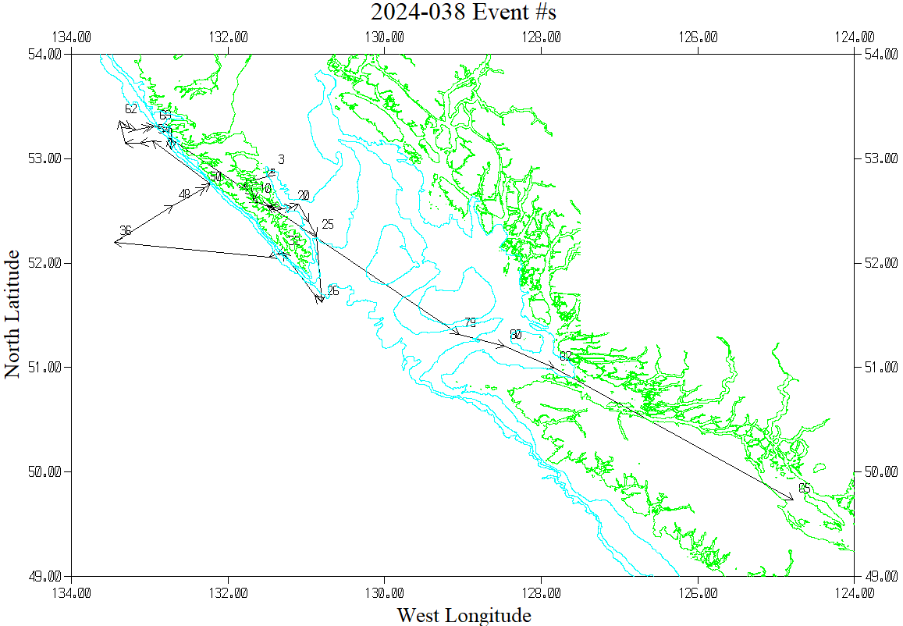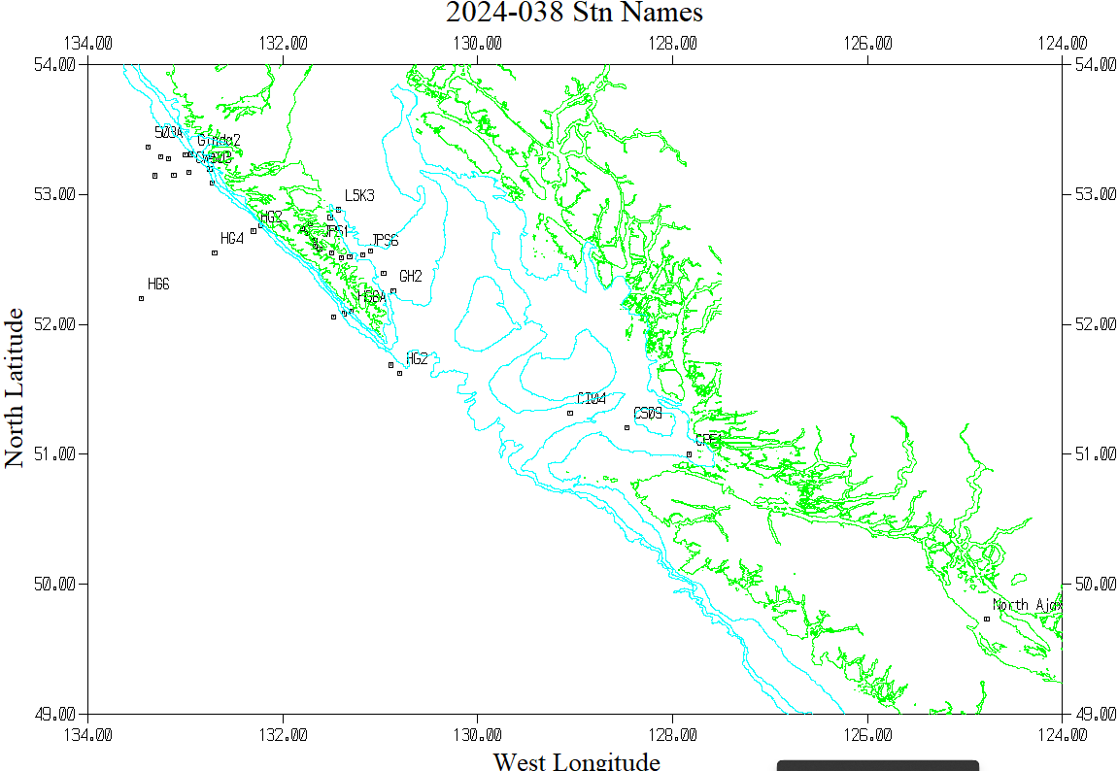
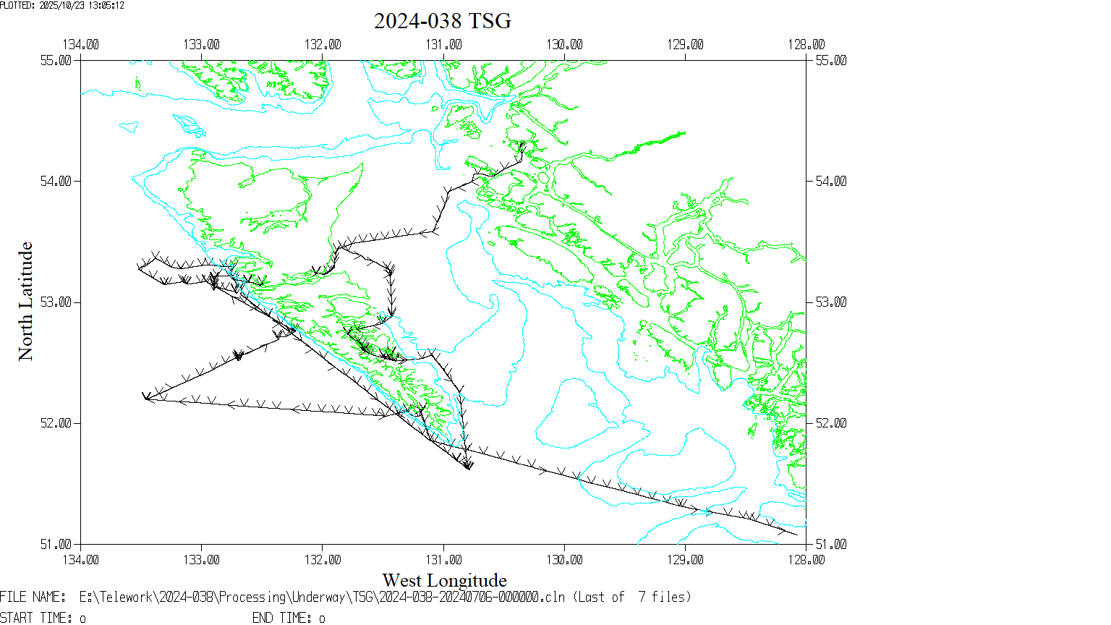

Symbol plotted every 30 minutes

