**RBR CTD DATA PROCESSING NOTES**

Cruise: 2024-017

Agency: OSD

Locations: Clayoquot Sound

Project: Clayoquot Weather Station Network - ACRDP

Party Chief: Cooper G.

Platform: Doug Anderson

Date: February 4, 2024 – February 7, 2024

Processed by: Samantha Huntington

Date of Processing: May 21, 2024 – May 14, 2024

Number of Raw files: 51 Number of Processed Files: 51

**Instrument Summary**

Equipment: RBR Maestro CTD (s/n 232531) with a Turner Cyclops Fluorometer (s/n 21101617), a JFE Advantech Rinko III oxygen sensor (s/n 0480), and a Turbidity Sensor (Seapoint s/n 232531).

Sampling frequency was at 8Hz.

**Summary of Quality and Concerns**

A cast list of times and locations was provided, “2024-017CTDLogFile_Final.xlxs”. The winch stopped at 20m for cast 20 and had to be re-cast. The log file contained 56 casts, five of which were zooplankton nets, these five casts were removed when making the header merge file. For cast 18 the winch stopped working at 20m, the CTD was brought back to the surface and the cast restarted.

The data overall look good with a few spikes in Fluorescence. There is a some noisy data at the surface during the CTD soak. These will be examined after Clip and removing the upcast.

**Processing Summary**

1. **Conversion to IOS Headers**

File 232531_20240206_1745.rsk contained the 51 profiles. All profiles were extracted using python function READ_RSK(). Profile numbers were matched to the event numbers provided in the log file.

A dummy profile of 918 was assigned to the rsk profile for the first attempt at cast 18 using the header merge csv. The extracted csv file from this function was then deleted before the next step.

A single file (2024-017_CTD_Data.csv) with all the data including event numbers and a single line of headers was prepared using python function MERGE_FILES().

A 6-line header was inserted using python function Add_6Lineheader_2(), Dissolved Oxygen Saturation was converted to Dissolved Oxygen Concentration during this step.

File “2024-017_header-merge.csv” was created, based on the information provided by the chief scientist.

* Column “File_Name”: entries were derived from the event number.
* Column “LOC:LATITUDE”: latitude was provided and reformatted to “XX XX.XXXX N !(deg min)”.
* Column “LOC:LONGITUDE”: longitude was provided and reformatted to “XX XX.XXXX W !(deg min)”.
* Column “LOC: Event Number”: entries were event numbers.
* Column “LOC: STATION”: entries were taken from the Log file.

The sampling site was mapped (Figure 1) using from “2024-017_header-merge.csv” using python function Plot_Track_Location() to check the location of all casts. The coastline in the python mapping package did not have all the small inlets that were sampled during this cruise.

Prior to conversion to IOS header format, the presence of zero-order holds were checked using Python function Plot_Pressure_Diff() Zero-order holds were found (Figure 2.) these values were replaced with an interpolated value using the python function Correct_Hold().

A new csv file was created “2024-017_CSV_DATA-6Linedr_corr_hold.csv” and the corrected values were checked in python function Plot_Pressure_Diff(). Zero-order holds were found to be removed (Figure 3.).

CONVERT Spreadsheet Files was run to produce files with IOS Header format. Header entries of “Administration”, “File” and “Instrument” were filled in this step.

The routine “Merge:CSV Files to headers” was run to add location headers to the IOS files.

Next CLEAN was run to add a start time and event numbers to headers.

Raw data were plotted and examined:

* Salinity looks good with some noisy data during the soak for a few casts.
* Temperature looks good with some bad data at the surface of many casts and the bottom of cast 43.
* Conductivity looks good with some noisy data during the soak for many casts.
* Oxygen looks good with some bad data at the surface of many casts.
* Fluorescence has some significant spikes in the downcast of casts 3, 13, 31, 33, 34, 46, 47, 51, 52 and 56. These will be examined again toward the end of processing.

Then REORDER was run to reorder the channels in all files.

Record numbers were then added to the files using ADD TIME CHANNEL.

1. **Data processing**

* Correction to Pressure: there were no negative pressures found in the downcast, there were some negative pressures on the surface. Pressure was not calibrated.
* CLIP: Pressure is steady for a variable number of scans. Initial records were removed until the downcast began using file “2024-017_CLIP.csv”.
* Filter: a Gull-winged filter, size 3, was applied to temperature, conductivity, and pressure. Salinity will be calculated in the next step.
* SHIFT: Based on suggested values in document “Guidelines for processing RBR CTD profiles”, the alignment of temperature and conductivity was corrected by applying a shift of -2 scans in conductivity.
* SHIFT: Better alignment with Oxygen profiles was found by advancing it by 11 scans. All three Oxygen channels went through Shift. The advice given in document “Guidelines for processing RBR CTD Profiles” was that an advance between 2 and 3 seconds is appropriate. T-O plots before and after alignment were compared.
* Delete was run to remove records with a descent rate lower than 0.3m/s over 8 points. This was not applied in the top 10m to avoid loss of surface records as the CTD began its descent.
* Profile plots were examined after DELETE and confirm that plots show reasonable values for salinity and conductivity and fluorescence. DO saturation levels at the surface ranged from 92% to 98%. However there was no calibration sampling and no climatology to enable a judgement about the data reliability.
* Data despiking: Fluorescence spikes examined and most were within reasonable limits, one significant spike was manually removed from cast 52.

1. **Final checks and header editing**

* REMOVE was run to remove the following channels from all casts: Date, Time:UTC , Event and Record Number.
* BIN AVERAGE was used to metre-average data.
* CALIBRATE was run to convert conductivity units to S/m using file 2024-017-recal2.ccf.
* Header Edit was used to fix channel names and format as listed below:
  + Pressure: format F11.2 ==> F7.1
  + Salinity:CTD ==> Salinity
  + Fluorescence ==> Fluorescence:URU
  + Oxygen_mL_L ==> Oxygen:Dissolved:Rinko
  + Oxygen_umol_kg ==> Oxygen:Dissolved:Rinko
* CLEAN was run to reset the Maximum and Minimum values in the Header.
* Header Check and Standards Check were run and no problems were found.

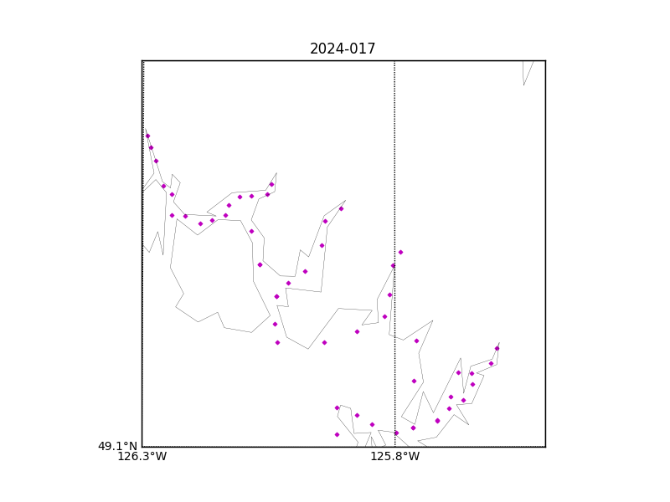

Figure 1 – location of casts.

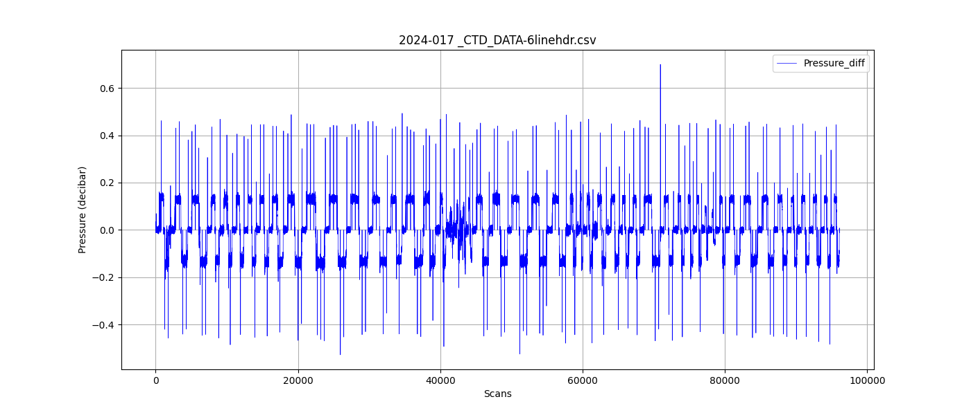

Figure 2 – Zero order holds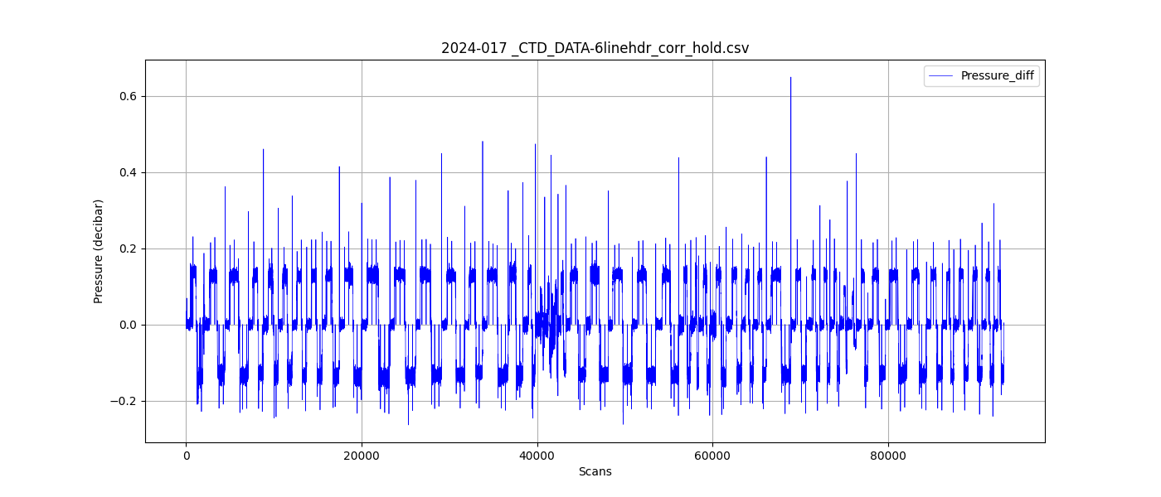

Figure 3 – zero order holds removed