REVISION NOTICE TABLE
DATE | DESCRIPTION OF REVISION

PROCESSING NOTES
Cruise: 2024-007
Agency: Ocean Sciences Division (OSD)
Location: Salish Sea
Project: Salish Sea Biophysical Survey
Party Chief: Bluteau C.
Platform: Vector
Date: 26 June 2024 – 9 July 2024

Processed by: Germaine Gatien
Date of Processing: 29 July 2025 – 13 August 2025
Number of original HEX files: 74
Number of CTD files: 74 Number of CTD casts processed: 73 (deck pressure test not archived)
Number of bottle files: 26 Number of bottle casts processed: 26
Number of TSG files: 3 Number of TSG files processed: 3

INSTRUMENT SUMMARY
An SBE911+ CTD #0585 was mounted in a rosette and attached were a Wetlabs CSTAR transmissometer (#1201DR), a SBE 43 DO sensor (#1176), a SeaPoint fluorometer (#3950), an SBE pH sensor (#0691), a Biospherical PAR sensor (#4565), a reference SPAR sensor (#20518) and an altimeter (#73171).

Seasave version 7.26.7.121 was used for acquisition.
The salinometer used at IOS was a Guildline model 8400B Portasal, serial # 73274.
An IOS rosette with 24 10L bottles was used.
A thermosalinograph (SeaBird 45 S/N 3411) was used.

SUMMARY OF QUALITY AND CONCERNS
The Science Log was in digital format. The header page had complete information about participants and equipment except that the pH sensor was not in the list. The was also a loops log. There were notes in the comments sections of both the CTD and Sampling logs about problems encountered, but those about firing out of order were not always completely clear. The cast at station 69 had the wrong event number in the rosette sampling log and the sample numbers were misaligned which caused some confusion for the analysts.

The station names for this project are usually given with upper-case letters. This was not the case in the log or in many of the file headers. These were changed to match the standard syntax. Two station names had other errors and were corrected. In one case a short comment was attached to a station names.

There were very few salinity calibration samples, but a post-cruise calibration was available for the primary conductivity.

Differences between the SBE DO sensor and titrated samples were larger than expect based on the post-cruise factory calibration. Observations during cruise 2024-034 which immediately preceded 2024-007 suggest that there was some contamination of the sensor membrane that gradually cleared.

The SBE DO sensor has a fairly long response time so data accuracy is not as high when it is in motion as it is during stops for bottles. This will be especially true when vertical DO gradients are large. To get an estimate of the accuracy of the SBE DO data during downcasts (after recalibration) a rough comparison was made between downcast SBE DO and upcast titrated samples. Some of the difference will be due to problems with flushing of Niskin bottles and/or analysis errors and small mismatches in depth in the presence of large DO gradients, so the following statement likely underestimates SBE DO accuracy.

Downcast (CTD files) Oxygen:Dissolved:SBE data for events #27-58 for this cruise are considered, very roughly, to be:
±0.40 mL/L from 10 - 50db
±0.15 mL/L from 50db - 150db
±0.10 mL/L from 150db - 250db
±0.04 mL/L below 250db

The Thermosalinograph performed well except for the final 2 hours of the 2nd file when position information froze. There was no flow meter or intake thermistor. A proxy for intake temperature was created (Temperature:Primary) by recalibrating lab temperature based on comparisons with CTD data.
There were only 3 loop samples. The chlorophyll loop samples were helpful but the salinity samples all fell out of line with CTD and TSG data and the analyst noted that 1 salinity sample could not be analyzed because salinity was too high. Recalibration was based on comparisons with CTD data from about 2m.

PROCESSING SUMMARY
GENERAL

Seasave
This step was completed at sea; the raw data files have extension HEX.

Preliminary Steps
- A deck pressure check was run at the dock. That file was converted and pressures ranged from 0.22db to 0.33db.
- The digital daily log and rosette log sheets were obtained and checked for comments.
- Extracted CHL, Salinity, Nutrients and Dissolved Oxygen data were obtained in QF spreadsheets.
- The cruise summary sheet was completed.
- The history of the pressure sensor, conductivity and dissolved oxygen sensors were checked. The only use previous to this cruise was 2024-034 which has not yet been processed. There were few casts and they were in areas unlikely to produce reliable calibration checks
- The calibration control files were obtained – as they stayed the same through out the cruise 2024-007-0001.xmlcon was used for processing.

BOTTLE FILE PREPARATION
The ROS files were created using 2024-007-0001.xmlcon. The hysteresis correction was not selected since there were no very deep casts; the Tau correction was selected.

The ROS files were converted to IOS format
The files were put through CLEAN to create BOT files. Temperature and salinity were plotted for all BOT files to check for outliers, none were found.
The BOT files were bin-averaged on bottle number and the output was used to create file ADDSAMP.csv. Sample numbers were added based on the rosette logs.

The ADDSAMP file was then sorted on event number & then sample number. Converted to CST files using Convert Spreadsheet.
It was used to add sample numbers to the BOT files – output *.SAM.
The SAM files were bin-averaged on bottle # and called SAMAVG.
The addsamp.csv file was converted to CST files, which will form the framework for the bottle files.

Next, the analysis spreadsheets were examined to see what comments the analysts wanted included in the header file. These were saved in file 2024-007-bot-hdr.txt.

SALINITY
Salinity analysis was obtained in file QF2024-007_SAL*.xlsx. The analyses were carried out in a temperature-controlled lab within 6-10 days of collection. The files were simplified and saved as 2024-007SAL.csv. Loop samples were moved to file loops.xlsx. That file was then converted to individual SAL files.
DISSOLVED OXGYEN
Dissolved oxygen data were provided in spreadsheet QF2024-007OXY*.xlsx which includes flags, comments and a precision study. Draw temperatures are available. The spreadsheet page with the final data was simplified and saved as 2024-007_OXY.csv. That file was converted into individual *.OXY files. There was one sample (#71) which had no event number of station name attached and no such sample was found in the rosette sampling log sheets. That sample was removed from the csv file.
NUTRIENTS
The nutrient data were obtained in spreadsheet QF2024_007_NUTS*.xlsx which includes flags, comments and a precision study. The spreadsheet page with the final data was simplified and saved as 2024-007NUTS.csv. That file was converted into individual *.NUTS files.
CHLOROPHYL
The chlorophyl data were obtained in spreadsheet QF2024_007_CHL*.xlsx which includes flags, comments and a precision study. The spreadsheet page with the final data was simplified and saved as 2024-007CHL.csv. Loop samples were moved to file loops.xlsx. That That file was converted into individual *.CHL files.

A problem was found with the samples from station 69.
The Science log shows samples for station 69, event 20, to be #71-82.
The Rosette log shows samples for station 69, event 21, to be #72-83.
The samples were labelled 71-82.
The labels are in agreement with the Daily Science log, so the Sampling Log is assumed to have errors.

Changes were made as follows to the CSV files:
Event number 21 was changed to 20.
A prefix “ALL:” was added to the comments in the nutrient file since they apply to all sampling. Flag 2 was added to all samples for this event.
DO sample 71 was moved in the to the first entry in event 20.
After those fixes the csv files were converted again.
The ADDSAMP file was adjusted and reconverted.

The SAL, CHL, OXY, and NUTS files were merged with CST files in 4 steps. The files were then put through CLEAN to reduce the headers to File and Comment sections only. These files were ordered on sample number, but the SAMAVG files are ordered on bottle number, so the MRGCLN1 files were reordered on Bottle_Number and saved as *. MRGCLN1s. The MRGCLN1s files were then merged with SAMAVG files using merge channel Bottle_Number.

The output of the MRG files were exported to a spreadsheet and compared to the rosette log sheets to look for omissions. None were found.
The minimum salinity is <25psu so silicate will require recalibration.
A header check was run and no problems were found.

Compare
Salinity
This cruise had only 6 salinity calibration samples. One was rejected as an extreme outlier that is due to a misassignment in sample numbers. The Addsamp and CST files were fixed for that cast and the merge process repeated.

Two samples from near the surface are outliers and have large standard deviations in the CTD salinity.
One of the deeper samples also has a fairly large standard deviation but is only slightly out of line. Another sample was taken at the bottom of a cast where incomplete flushing of bottles may lead to lower salinity in the bottle than ambient waters.
The average of the 3 remaining samples was +0.0030psu for the primary and +0.0044psu for the secondary.
The secondary is higher than the primary by an average of 0.0014psu.
For more detail see file 2024-007-sal-comp1.xls.

Dissolved Oxygen
COMPARE was run with pressure as the reference channel. The casts were from a coastal environment and most casts were shallow.
There were 2 very low DO samples from Saanich Inlet. The SBE DO sensor values were higher than one of the titrated samples by 0.053mL/L and was high by 0.0003mL/L for the other. A plot shows that the SBE DO values dropped from 0.08mL/L to 0.05mL/L during the stop at 177db, and continued to fall during the first part of the upcast until the CTD reached 150db. So the sample at 150db is likely the more reliable measure. That shows that the SBE DO sensor can measure near-zero DO, but it takes a long wait.

The fit of differences versus SBE DO suggests that the CTD is reading low by about 5.4%. This is larger than a post-cruise calibration would suggest, so may be reflective of slow response so that upcast DO has lower values than expected. Where DO gradient is very low, the errors are still mostly 5% to 6%.
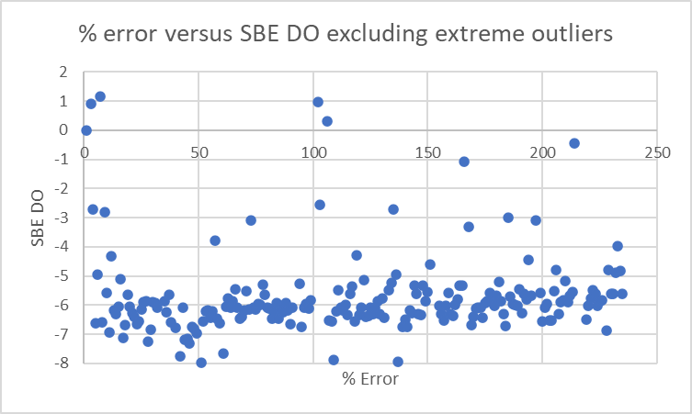
NOTE: Data from cruise 2024-034 which preceded 2024-007 was processed after this study was run. The 2024-034 comparisons showed even larger differences that gradually reduced. This suggests that the low sensor DO values were due to contamination of the sensor membrane.

SBE Fluorescence
COMPARE was run with extracted chlorophyll and CTD Fluorescence using pressure as the reference variable.
CTD fluorescence read lower than extracted CHL samples overall.
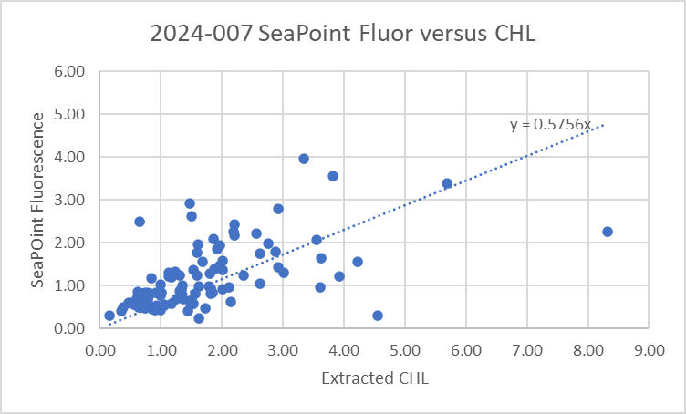
As is typical for these fluorometers the ratio FLUOR/CHL is high when CHL is low and quickly drops as CHL increases. Because this cruise had few very low CHL values the ratio is low overall.
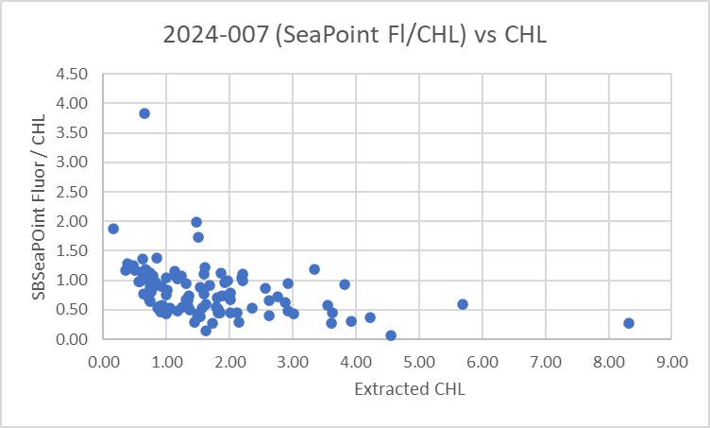
For full details for the COMPARE run see file 2024-007-fl-chl-comp1.xls.

Conversion of Full CTD Files from Raw Data
All files were converted using files 2024-007-0001.xmlcon. The hysteresis correction was not selected since there were no deep casts; the Tau correction was selected. A few casts were examined and all expected channels are present.

WILDEDIT
Program WILDEDIT was run to remove spikes from the pressure, conductivity & temperature only in the
full cast files (*.CNV).
Parameters used were: Pass 1 Std Dev = 2 Pass 2 Std Dev = 5 Points per block = 50
The parameter “Keep data within this distance of the mean” was set to 0 so all spikes would be removed.

ALIGN DO
ALIGNCTD was run on all casts using +2.5s.

CELLTM
CELLTM was run using the default settings (α = 0.0245, β=9.5) for both the primary and secondary conductivity.

DERIVE
Program DERIVE was run on all casts to calculate primary and secondary salinity and dissolved oxygen concentration.
There are some odd features in conductivity and salinity, sometimes in the primary and sometimes in the secondary, but not seen in both. This will be examined at the CTDEDIT stage of processing.

Tests were run to see if the previous steps performed as expected:
- Most downcast spikes noted in conductivity profiles were removed by WILDEDIT but some were not since they contained multiple points. Most spiky data are in the upcasts.
- The dissolved oxygen alignment is definitely improved; ALIGNCTD appears to have worked well.
- CELLTM worked as expected, lowering salinity where temperature is decreasing (cell warms water raising conductivity but temperature sensor reading is correct, so salinity is overestimated). Conversely, it raises salinity where temperature is increasing (conductivity too low). This brings downcast and upcast traces closer together, so T-S downcast and upcast plots are in better agreement after this step, most obvious in simple casts where temperature decreases with pressure..

DERIVE was run a second time on a few of the deeper casts to find the differences between the pairs of temperature, conductivity and salinity channels. The differences in salinity channels is slightly larger than the 0.0014psu found in the bottle comparison, but that was based on only 3 bottles.

Cast # | Press | T1-T0 | C1-C0 | S1-S0 | Descent Rate
2024-007-0005 | 220 | -0.0010 | +0.00004 | +0.0010 | Mod. F.Steady
2024-007-0054 | 310 | -0.0012 | +0.00012 | +0.0022 | High, Steady
2024-007-0075 | 310 | -0.0011 | +0.00010 | +0.0019 | High, Steady
2024-007-0086 | 310 | -0.0011 | +0.00013 | +0.0020 | High, Steady

Because this is an area where calibration sampling is shallow and more affected by incomplete flushing of Niskin bottles than offshore, there is less confidence in bottle sampling. Since there was a post-cruise calibration available for temperature, conductivity, pressure and dissolved oxygen sensors, there is an extra way to judge calibration. It appears that this CTD was not used between this cruise and the December 2024 service. However, some drift is expected even when equipment is sitting on the shelf, so this method is also subject to error.

A configuration file containing the data from the post-cruise calibration was prepared (2024-007-post.xmlcon). Two casts (events 1 and 94) were processed using the post-cruise configuration data and otherwise using all the same steps.

Cast #94 was fairly deep and at the end of the cruise, so was chosen for study.
- Pressure using 2024-007 configuration file is lower than the post-cruise pressure by 0.2db. This is very close to the deck pressure test run before 2024-007, so it is reasonable to assume that the pressure was reading high. While a small correction, the strong evidence suggests subtracting 0.2db from all pressure and 0.2m from depth. The differences in pressure mean it is not reliable to compare temperature and conductivity from the pre-cal and post-cal results at levels where the vertical gradients are large; comparisons were limited to deep water where the gradients were very low.
- The pre-cruise primary temperature was higher than the post-cruise by about 0.0014Cº. The pre-cruise secondary temperature was higher than the post-cruise by about 0.0007Cº. This is a rough comparison as only a few levels were compared, but it does not suggest a significant error in either temperature sensor, especially given considerable time between this cruise and the post-calibration check.
- Next salinity data were examined. Unfortunately, the secondary sensor was found to have excessive drift at the time of the post-cal, so had extensive repairs done. The salinity using the post-cruise calibration is only of use in assessing the primary salinity. It appears that most of the secondary drift happened on the shelf after this cruise or in transit.
- The post-cruise calibration shows the primary salinity values to be high by <0.002psu, but much larger errors are reported for very high salinity, higher than the salinity range in this area.
- The post-cruise calibration suggests that the dissolved oxygen values are low by about 2%. There are often larger differences seen from bottle comparisons than are explained by calibration drift, so other factors such as response time may be significant.

Conversion to IOS Header Format
The IOSSHELL routine was used to convert SeaBird 911+ CNV files to IOS Headers.
CLEAN was run to add event numbers and to replace pad values in the pressure channel with interpolated values based on record number. There are no negative fluorescence values.

Checking Headers
A header check was run and no problems were found; fluorescence values were all >0.
A cross-reference list was produced. The station names in some files had non-standard syntax (lower case rather than upper case letters and in one case a comment added to the site name). In 2 cases the station name was wrong. They were fixed in the IOS files and CLEAN was rerun. They were also fixed in SAMAVG files and the merge of SAMAVG and MRGCLN1s was rerun and CLEAN was rerun on the MRG files.

Surface check – mean surface pressure was 2.2db, with a minimum of 1.6 db which is within the expected range for Vector cruises. The check was then run on reversed files which gave a minimum of 1.7db from upcasts. Neither check is useful for assessment of pressure accuracy.

The track plots were added to the end of this report.

A check was made of the water depths entered in the file headers by adding the maximum depth sampled plus the altimetry reading when the CTD was at the bottom of the cast. Eight out of the casts had values above ± 5m.
- For cast #22 the water depth entry is clearly wrong; the log depth looks right, so that was entered in the file headers for the profile and bottle files.
- For cast #23 the header and log entries are close but it is likely that significant shoaling occurred during the cast, so the header entry was replaced with sum of Max Depth Sampled + Altimetry header. It is likely there was significant shoaling and it is best to match depth when CTD was at bottom of cast.
- For 2 casts (28, 83) the entry in the log for water depth is different from the header and looks like a better choice.
- For cast #43 there were both BE and BO entries in the header and the BO entry produces a very low check value. Likely there was shoaling, and the bottom value is most useful, so that was substituted in the header.
- For 3 casts (29, 70, 78) there was little or no difference from the log and the check values are only slightly >5m. There is evidence of shoaling during cast 70 which has both BE and BO entries. No changes were made.
The changes were made to the CLN files for 5 casts and to the SAM and MRGCLN2 files for cast #22.

Shift
Fluorescence
SHIFT was run on the fluorescence channel with an advance of 24 records. Plots showed this setting was appropriate.
Dissolved Oxygen
The Dissolved Oxygen voltage channel was aligned earlier using Seabird software. No further alignment is needed for the DO concentration channel.
Conductivity
Tests were run on 3 casts to determine the best setting to align conductivity and temperature by judging the effect on salinity as seen in T-S space. SHIFT was run on all casts using -0.8 records for the primary conductivity and -0.4 records for the secondary. Salinity was recalculated for both channels.
pH
Tests were run using a variety of settings and +60 records looked best overall.
SHIFT was run on all casts using +60 records.

DELETE
The following DELETE parameters were used:
Surface Record Removal: Last Press Min
Maximum Surface Pressure (relative): 10.00
Surface Pressure Tolerance: 1.0 Pressure filtered over 15 points
Swells deleted. Warning message if pressure difference of 2.00
Drop rates < 0.30m/s (calculated over 11 points) will be deleted.
Drop rate applies in the range: 10db to 10db less than the maximum pressure
Sample interval = 0.042 seconds. (taken from header)
There were no warnings.

The DEL files were zipped and sent to the CTD-QC program and DELPRED files were returned.

Other Comparisons
Previous experience with these sensors – The only use of these sensors between factory service and this cruise was during 2024-034 which has not been processed yet; sampling from that cruise are not likely to be very useful for calibration purposes.
Historic ranges – These casts were all taken in coastal sites where excursions from the climatology are common. Temperature and salinity data were mostly within the climatology with some excursions towards higher and lower values, so are not systematic excursions. There is no indication of calibration problems.
Post-Cruise Calibration – There was a post-cruise conductivity calibration available that showed excessive drift in the secondary sensor though it likely occurred primarily after this cruise. The primary had drifted high, but the largest errors were at very high salinity values; in the range of interest for this cruise the primary salinity was high by about 0.002psu. Temperature calibrations showed little drift.

DETAILED EDITING
The primary T-S pair were chosen for editing and eventual archiving.
In the course of editing it was found that while there were small spikes in salinity in both channels, for a few casts the secondary looked better than the primary. So the secondary channels were selected for events #18 and #65.
For this cruise both primary and secondary were very similar.

All DEL files were uploaded into the CTD-QC File Processor to obtain AI generated data quality flags.

CTDEDIT was used to clean salinity and to remove records near the top and bottom of the many casts as well as records with clear evidence of shed wake corruption.
The edited files were copied to *.EDT.
After editing T-S plots were examined for all casts; there remain many small unstable features but they are in areas when they may well reflect real conditions. No further editing was applied.

Recalibration
Pressure and depth will be corrected by subtracting 0.2db/0.2m based on deck test and post-cruise calibration.
Primary salinity will be corrected by subtracting 0.002psu based on the post-cruise calibration. This is slightly less than the bottle comparison result but that was based on very few samples.
Secondary salinity will be corrected by subtracting 0.0034psu based on the difference from the primary channel during the 3 bottle stops used in the comparison, in order to bring the two channels into correspondence.
Dissolved oxygen will be corrected by multiplying all values by 1.055 based on the bottle comparison. This is higher than the post-cruise calibration, but response time errors appear to be significant based on COMPARE results.
(NOTE: Processing of data from cruise 2024-034 which preceded this cruise, suggest that there was some contamination of the SBE DO sensor which gradually disappeared.)

First, the bottle files were recalibrated and comparisons run again to ensure the choices were appropriate.
Calibrate was run using 2024-007-recal-SIL.ccf to correct silicate in MRGCLN2 files where salinity is <25psu. Output: *.mrgcorsil.
Calibrate was run using 2024-007-recal1.ccf to recalibrate pressure, depth, Salinity:T0:C0, Salinity:T1:C1 and Dissolved Oxygen. Output: *.samcor1 and *.mrgcor1.

COMPARE was rerun on salinity and dissolved oxygen to ensure the corrections were applied correctly.
For salinity both salinity channels were high by an average of 0.001psu based on 3 samples only.
For dissolved oxygen the correction looks excellent, with values a little high at very low and vey high DO and slightly low in between. The CTD DO is low by an average of 0.013mL/L.

Fluorescence Processing
A median filter, size 11, was applied to the fluorescence channel in the COR1 files. Plots of a few casts showed that the filter was effective. (Output:*.FIL)

BIN AVERAGE of CTD files
The following Bin Average values were applied to the FIL files (output AVG):
Bin channel = pressure Averaging interval = 1.000 Minimum bin value = .000
Average value will be used. Interpolated values are NOT used for empty bins.
On-screen T-S plots were examined.
Profile plots were examined to see if there any problems. No problems were noted.

A final run of COMPARE was done to determine whether the downcast dissolved oxygen data correspond well to the bottle samples from the upcast. When displayed against pressure differences were found to be large in the top 10m where there are large gradients. Based on this comparison we can make an estimate of accuracy of downcast CTD DO, but this is expected to be a conservative assessment since
some of the difference will be due to problems with flushing of Niskin bottles and/or analysis errors and small mismatches in depth in the presence of large DO gradients. So the following statement likely underestimates SBE DO accuracy:
Downcast (CTD files) Oxygen:Dissolved:SBE data for events #27-58 for this cruise are considered, very roughly, to be:
±0.40 mL/L from 10 - 50db
±0.15 mL/L from 50db - 150db
±0.10 mL/L from 150db - 250db
±0.04 mL/L below 250db

Final Bottle Files
- The MRGCOR1 files were put through SORT to order on increasing pressure.
- The following channels were removed from the bottle files: Scan_Number, Salinity:T1:C1, Temperature:Secondary, Conductivity:Secondary, Altimeter, Status:Pump, Descent_Rate, Flag, Oxygen:Voltage:SBE. (There was no rosette sampling during casts #18 and 65.)
- A second SBE DO channel with mass units was added for both the SBE DO and REORDER was run to get the pair of DO channels together.
- HEADER EDIT was run to ensure formats and units are correct
- Standards check was run and no problems were found.
- Plots were examined and no problems were found.
- Bottle data were exported to a spreadsheet and no problems were found.
- A header check were run. No problems were found.
- A cross-reference listing was produced for the CHE files.

Final CTD File Steps (REMOVE and HEADEDIT)
- For all casts except #18 and #65 REMOVE was run to remove the following channels:
Scan_Number, Temperature:Secondary, Conductivity:Secondary, Oxygen:Voltage:SBE, Descent_Rate, Status:Pump, Altimeter, Salinity:T1:C1, Flag and Prediction_Flag.
- For casts #18 and #65 REMOVE was run to remove the following channels:
Scan_Number, Temperature:Primary, Conductivity:Primary, Oxygen:Voltage:SBE, Descent_Rate, Status:Pump, Altimeter, Salinity:T0:C0, Flag and Prediction_Flag.
- A second SBE DO channel (with umol/kg units) was derived.
- REORDER was run to arrange channels in usual order.
- HEADER EDIT was used to fix formats and channel names and to add comments to the headers.
- The Standards Check routine was run and no problems were found.
- The Header Check was run; no problems were found.
- Profile and T-S plots were examined and no problems were found.
- The sensor history was updated.

Oxygen saturation was derived and ranged from 60% to 130%. This is typical of this region with low values in Juan de Fuca Strait, Haro Strait and at station 21 and high values in Saanich Inlet and most of Georgia Strait.

Thermosalinograph processing
There were 3 thermosalinograph files. The configuration file was the same for all 3.
There was no flow meter or intake thermistor. The intake is at about 2m.
There were 3 loop samples.
The loops were taken before or after CTD casts so matching samples to CTD times and depths is inexact.

a.) Checking calibrations
The configuration file parameters were checked and are correct.

b.) Conversion of Files
The file was converted to CNV format.
The file was converted to IOS HEADER format.
CLEAN was run to add End times and Longitude and Latitude minima and maxima to the headers.
Add Time Channel was used to add Time and Date channels.

Time-series plots were produced and look fine.
There is a long gap between then 2nd and 3rd files.
The track plot looks fine and was added to the end of this report.

c.) Comparing TSG to near-surface CTD cast data
The CTD files were thinned to 2db to file 2024-007-ctd-tsg-comp.xlsx. Some casts had no data from that level.
The TSG files were open in Excel and thinned to the times of CTD casts. Where no corresponding TSG data were available, those lines were removed from the CTD-TSG comparison file.
TSG data were then added to the comparison file.
There were 49 points of comparison.
Latitude and longitude from the 2 data sources were compared to ensure a good match.
With one exception the differences were small with the largest being 0.004º in longitude and 0.002º in latitude. The median difference was 0.0000º in latitude and 0.0001 º in longitude.

The one exception was during event #83 when the differences were large. Examination of the file shows that latitude and longitude did not vary at all for almost 2 hours although the ship was clearly moving.
There is some variation in temperature and salinity and while the differences are large they are not the most extreme in the comparison. However, given the positions are clearly not accurate, the data from the end of the 2nd file will be deleted.
There are no CTD casts intersecting with the 3rd file, but the track plot looks fine.
The largest differences in positions other that described above was during cast #28, but the positions were not stuck.

When cast #83 is excluded the differences are as follows:

 | Lat Diff | Long Diff | Ttsg-Tctd | SALtsg-SALctd
min | -0.0004 | -0.0031 | -0.9853 | -7.4580
max | 0.0020 | 0.0038 | 3.0212 | 2.1781
average | 0.0001 | 0.0000 | 0.4008 | -0.9045
median | 0.0000 | -0.0001 | 0.2538 | -0.3566
stdev | 0.0004 | 0.0009 | 0.7193 | 1.8929

These differences are large, but this is an area of large surface gradients and CTD data are not considered very accurate at the surface due to ship effects.
The temperature in the lab is higher than the CTD by about 0.25Cº. This is a reasonable estimate for heating in the loop for the Vector at this time of year. A rough, but reasonable, estimate for intake temperature will be made by subtracting 0.25Cº from the lab temperature.

The salinity comparison is so noisy that it looks impossible to make a reasonable recalibration. But a plot of salinity differences versus event number shows that there are areas where the variability is much lower.

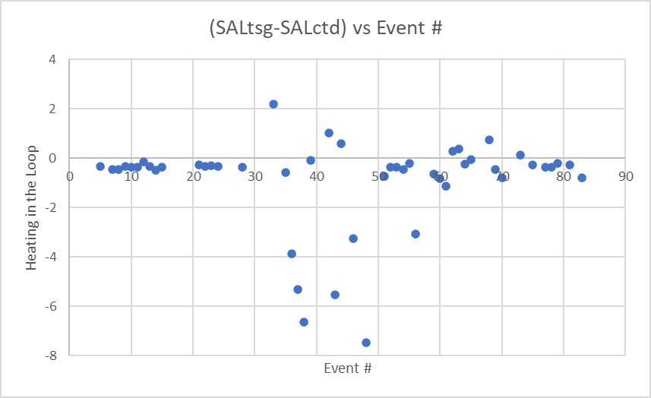

Differences from cast #5 to #28 plus a few casts at the end show lower variability. Near-surface profiles were examined and the casts that were well-mixed and had useful data from 2m were casts 5-28, 75, 77 and 81. The ones from early in the cruise in Juan de Fuca and Haro Straits were the best mixed and those indicate that the salinity was low by a median of 0.343psu and standard deviation of 0.080psu. Later in the cruise in well-mixed areas the differences were slightly lower, ~-0.28psu, likely due to fewer bubbles as they were less well mixed. Variable near-surface gradients also affect the comparison. The median difference is larger than that from Juan de Fuca due to many very low TSG salinity, so is not the best choice for an estimate. Using the Juan de Fuca comparison is the most reliable source, given great variability in bubbles and vertical gradients.

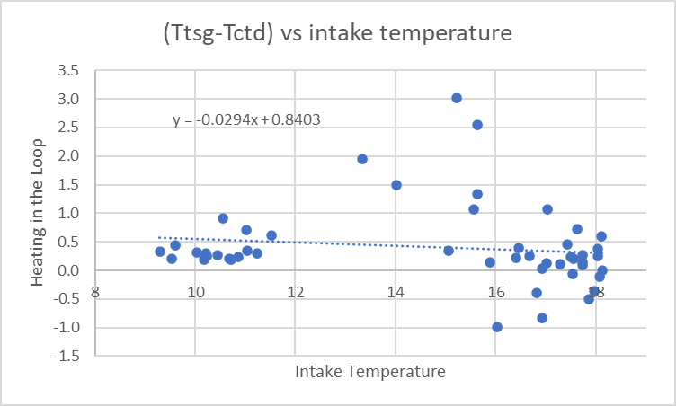

TSG temperature is higher than CTD temperature by a median of 0.254Cº when all casts are used and by 0.294Cº in Juan de Fuca Strait. Heating in the loop varies with input temperature, so we expect it to be higher in Juan de Fuca than in the central Strait of Georgia. We don’t get a good estimate from the Strait of Georgia because of the large near-surface gradients, but the well-mixed casts in the northern Strait have differences close to the median. Using the median looks reasonable.

d.) Loop comparison
Salinity and extracted chlorophyll samples were taken from the loop at 3 sites. There was no fluorometer on the TSG but the loops were compared to CTD casts taken before or after the samples were taken.
- Event 5041 – Loop taken before CTD cast.
Salinity from loop was ~27.05psu while from the CTD at ~2m it was ~15psu. The salinity value looks like what is observed around 8db in the CTD profile.
Loop CHL was 6.78ug/L and CTD fluorescence was ~3ug/L during the downcast. It is typical for fluorescence to be about 50% of CHL when CHL values are high.
The TSG salinity was 13.61psu which is in reasonable agreement with the CTD but is much lower than the loop sample.
- Event 5066 – Loop taken after CTD cast.
Duplicate salinity values from loop were 25.43psu and 25.5psu while CTD salinity from the downcast was ~27.1psu and upcast was ~27.2psu.
Loop CHL was 0.69ug/L and CTD fluorescence about 0.8ug/L during downcast and 0.84ug/L during upcast. It is typical for SBE fluorescence to read higher than CHL when CHL<1ug/L.
There was no rosette sampling for that CTD cast.
The TSG salinity was 27.14psu which is close to the CTD salinity, especially from the upcast which is closest in time to the TSG reading. It is much higher than the loop sample.
- Event 5076 – Loop taken after CTD cast.
No salinity loop data available – salinity too high for salinometer to read.
Loop CHL was 0.85ug/L and CTD Fluorescence was 0.46ug/L during upcast. We would expect fluorescence to be closer to CHL than this, but both variables tend to be noisy.
Samples from the rosette were about 0.9ug/L at 1db and 5db.
The TSG salinity was 25.57psu which is very close to the CTD reading.

The TSG salinity does not compare well with loop salinity. There were clear problems with 2 of the 3 loop samples.
The TSG salinity does agree well with the CTD salinity around the time loops were taken.
The loop CHL samples compare well with the CTD, so the problems with the salinity loop samples does not appear to be due to a problem with flow in the loop.

Calibration History
This TSG was used on 1 previous cruise since calibration, but those data have not been processed yet.

e.) Editing
Data was relatively clean (i.e. no spikes).
The ATC files were copied to EDT.
CTDEDIT was used to remove the data from the last 2 hours of file 2024-007-0002.atc when the position data were constant. (Scans 5368-5590.) The temperature and salinity look fine but we cannot say where they occurred.
The output file (ED1) was copied to EDT.

f.) Addition of intake temperature proxy and Calibration
Add Channel was run to add channel Temperature:Lab, setting it equal to Temperature:Primary and channel Pressure set to 2.0db to enable derivation of sigma-T.
CALIBRATE was run to 0.34psu to salinity and to subtract 0.25Cº from Temperature:Primary.
Sigma-T was derived used Temperature:Primary and Salinity.
Derived Quantities was run to calculate sigma-T.

REMOVE was used to remove the following channels: Scan Number, Flag and Pressure.

h.) Preparing Final Files
HEADER EDIT was used to change the DATA DESCRIPTION to THERMOSALINOGRAPH and to change channel names to standard names and formats. Comments about the data were added.
The TSG sensor history was updated.

Particulars
8. 100m bottle missed, went up to 75 but returned to 100m so bottles fired in usual order.
18. Sal noise around 104-100db on upcast, DO noise around 106 db on upcast
28. PAR status says NO but there is a signal and values look reasonable for time of day. “NO” likely refers to cleaning of sensor.
35. Closed bottle 6 at 50m without soaking first, so tripped bottle 13 after 1 min soak instead. Bottle 6 not sampled.
41. Loop sal/chl
51. Stop at 100m for a minute for no reason.
62. Lugols sample was a mix of bottles 15 and 16 since 16 ran out. FLC sample was taken from bottle 15 not 16.
66. Loop sal/chl
73. Drifted into shallower water during cast
76. Loop sal/chl
87. Echosounder depth was jumping around a bit so went to 10m off bottom instead of 5m
92. Sal at bot-5m added last-minute
93. Sounder depth and altimeter height were not in agreement. Small spike in oxygen at bottom of cast. (This cast was saved as #94 due to a restart. But Event #94 was a grab according to the log.)
CRUISE SUMMARY – CTD & TSG
CTD# | Make | Model | Serial# |  | Used with Rosette? |  | CTD Calibration Sheet Competed?
1 | SEABIRD | 911+ | 0585 |  | Yes |  | Yes
3 | SEABIRD | 21 | 3411 |  | n/a |  | Yes
Calibration Information - 0585
Sensor |  |  |  | Pre-Cruise |  |  |  | Post Cruise
Name |  | S/N |  | Date |  | Location |  | Date | Location
Temperature |  | 2449 |  | 23Feb2023 |  | Factory |  | 11 Dec 2024 | Factory
Conductivity |  | 1764 |  | 17Feb2023 |  | Factory |  | 19 Dec 2024 | Factory
Secondary Temp. |  | 4484 |  | 22Feb2023 |  | Factory |  | 11 Dec 2024 | Factory
Secondary Cond. |  | 2128 |  | 17Feb2023 |  | Factory |  | 17 Jan 2025 | Factory
Transmissometer |  | 1201DR |  | 11Jan2024 |  | Factory
pH:SBE |  | 0691 |  | 9Mar2023 |  | Factory
SBE 43 DO sensor |  | 1176 |  | 1Mar2023 |  | Factory |  | 13 Dec 2024 | Factory
PAR |  | 4615 |  | 24Feb2021 |  | Factory
SPAR |  | 20518 |  | 16Feb2024 |  | Factory
SeaPoint Fluor. |  | 3950 |  | May 2023 |  | Factory
Pressure Sensor |  | 0585 |  | 20Feb2023 |  | Factory |  | 9 Dec 2024 | Factory
Altimeter |  | 73171 |  | 30Jan2024 |  | Factory

Calibration Information – TSG 3411
Sensor |  | Pre-Cruise |  | Post Cruise
Name | S/N | Date | Location | Date | Location
Temperature | 3411 | 25Jan2024 | Factory
Conductivity | 3411 | 25Jan2024 | Factory

