## REVISION NOTICE TABLE

|  |  |
| --- | --- |
| DATE | DESCRIPTION OF REVISION |
|  |  |
|  |  |

## PROCESSING NOTES

Cruise: 2024-006 Agency: OSD

Location: North-East Pacific Project: Line P

Chief Scientist: Robert M. Platform: John P. Tully

Date: 26 April 2024 – 13 May 2024

Processed by: Jeannette Bedard Date of Processing: Nov 2024 – Aug 2025

Number of original HEX files: 52 Number of processed CTD files: 48

Number of rosette casts: 42 Number of processed CHE files: 42

Number of original TSG txt files: 3 Number of processed TOB files: (1 per day) 12

# INSTRUMENT SUMMARY

Two SeaBird 911+ CTDs was used for this cruise:

1 - Events 1-44: CTD #0550 was mounted in a rosette and attached were 2 Wetlabs CSTAR transmissometers (1185DR & #1883DG), a SBE 43 DO sensor on the primary pump (#3038), SeaPoint Fluorometer on the secondary pump (#3641), a WetLabs fluorometer (#2216), a Biospherical QSP-400 PAR sensor (#70613) and a Valeport altimeter (#73171 for events 1-18 and #76341 for events 19-44).

2. Events 45-106: CTD #0443 was mounted in a rosette and attached were 2 Wetlabs CSTAR transmissometer (1185DR & #1883DG), a SBE 43 DO sensor on the primary pump (#4372), SeaPoint Fluorometer on the secondary pump (#4186), a WetLabs fluorometer (#2216), a Biospherical QSP-400 PAR sensor (#70613) and a Valeport altimeter (#76341).

A thermosalinograph (SeaBird 45 S/N 0620) was mounted with a Wetlabs WETStar fluorometer (#1656), intake thermometer (SeaBird 38 #603) and flow meter; sampling interval was 5s.

Seasave version 7.26.7.121 was used for acquisition. The data logging computer was TULLY. The deck unit was a Seabird model 11+ #508. An IOS rosette with 24 10L bottles was used.

# SUMMARY OF QUALITY AND CONCERNS

The Daily Science Log Book was in excellent order with comments about problems encountered and a detailed list of equipment. The sampling logs were in good order. There were reports from the Chief Scientist outlining sampling methods and problems, and one from the CTD technician on problems with the CTD including an altimeter swap.

The standard deployment procedure for this cruise as follows:

The rosette was brought to the surface. Pumps were turned ON. The rosette was brought down to 10m and kept there for 30 seconds. Once back at the surface, the data started to be archived, with the rosette at the surface for 30 seconds longer. Then the cast would start.

For all rosette casts on Line P:

* Niskin bottles closed from 0 to 400 db had a wait time of 60 seconds if there was dissolved oxygen sampling and 30 seconds if there was no dissolved oxygen sampling.
* All Niskin bottles deeper than 400 db had a wait time of 30 seconds.

There were 2 WetLabs CStar transmissometers in use during this cruise:

* Channel Transmissometer refers to sensor #1185DR (650nm - red)
* Channel Transmissometer:Green refers to sensor #1883DG (530nm - green)

For comparison with other Institute of Ocean Sciences cruises, note that the transmissometer wavelength is 650nm unless otherwise stated.

The SBE DO sensor has a fairly long response time so data accuracy is not as high when it is in motion as it is during stops for bottles. This will be especially true when vertical DO gradients are large. To get an estimate of the accuracy of the SBE DO data during downcasts (after recalibration) a rough comparison was made between downcast SBE DO and upcast titrated samples. Some of the difference will be due to problems with flushing of Niskin bottles and/or analysis errors and small mismatches in depth in the presence of large DO gradients, so the following statement likely underestimates SBE DO accuracy.

Downcast (CTD files) Oxygen:Dissolved:SBE data for this cruise are considered, very roughly, to be:

For casts 1 - 43:

<0.08mL/L for pressure <200db

<0.04mL/L for pressure between 200-300db

<0.02mL/L for pressure >300db

For casts 45 - 105:

<0.05mL/L for pressure <400db

<0.03mL/L for pressure >400db

Despite the flow meter for the TSG not reporting a flow, the data appeared to be fine (suggesting the flow meter was faulty). There was good agreement between the different data types.

# PROCESSING SUMMARY

##### Seasave

This step was completed at sea; the raw data files have extension HEX.

##### Preliminary Steps

* The Log Book and rosette log sheets were obtained.
* Nutrients, extracted chlorophyll, dissolved oxygen, salinity and DMS/DMSP data were obtained in QF spreadsheet format from the analysts.
* The cruise summary sheet was completed.

The configuration files changed during the cruise. Files used in conversion were:

* 2024-006-ctd1.xmlcon for events #1-18 (CTD #0550 with altimeter 73171)
* 2024-006-ctd2.xmlcon for events #19-44. (CTD #0550 with altimeter 76341)
* 2024-006-ctd3.xmlcon for events #45-105 (CTD #0443)

##### BOTTLE FILE PREPARATION

* For CTD #0550 and #0443 ROS files were created using 2024-006-ctd*.xmlcon. The hysteresis correction and tau corrections were selected.
* The IOS files were put through CLEAN to create BOT files.
* Temperature and salinity were plotted for all BOT files to check for significant outliers.

**For CTD #0550**

* The BOT files were bin-averaged on bottle number.
* The output was used to create file ADDSAMP.csv.
* The file was then sorted on event number and Bottle Position order. Then sample numbers were added based on the rosette logs.
* The ADDSAMP file was then reordered on event # & sample #.
* The ADDSAMP file was used to add sample numbers to the BOT files – output *.SAM.
* The SAM files were bin-averaged on bottle # and called SAMAVG.
* The addsamp.csv file was converted to CST files, which will form the framework for the bottle files.

**For CTD #0443**

* The BOT files were bin-averaged on bottle number.
* The output was used to create file ADDSAMP.csv.
* The file was then sorted on event number and Bottle Position order. Then sample numbers were added based on the rosette logs.
* The ADDSAMP file was then reordered on event # & sample #.
* The ADDSAMP file was used to add sample numbers to the BOT files – output *.SAM.
* The SAM files were bin-averaged on bottle # and called SAMAVG.
* The addsamp.csv file was converted to CST files, which will form the framework for the bottle files.
* Next, each of the analysis spreadsheets were examined to see what comments the analysts wanted included in the header file. These were used to create the header comments file which was updated during processing.

DISSOLVED OXGYEN

Dissolved oxygen data were provided in spreadsheet QF2024-006_OXY*.xlsx which includes flags, comments and a precision study. Draw temperatures are available. The spreadsheet page with the final data was simplified and saved as 2024-006_OXY.csv. That file was converted into individual *.OXY files.

EXTRACTED CHLOROPHYLL

Extracted chlorophyll and phaeo-pigment data were obtained in file QF2024-006_CHL QF*.xlsx. The file included comments and flags and a precision study. A simplified version of the spreadsheet was prepared and saved as 2024-006_CHL.csv. The csv file was then converted to individual CHL files.

SALINITY

Salinity analysis was obtained in file QF2024-006_SAL.xlsx which included a precision study. The analyses were carried out in a temperature-controlled lab 11 to 25 days after collection. The files were simplified and saved as 2024-006_SAL.csv. That file was then converted to individual SAL files.

NUTRIENTS

The nutrient data were obtained in spreadsheet QF2024-006_NUTS*.xlsx. This includes a precision study. The file was simplified, saved as 2024-006_NUTS.csv. The file was converted to individual NUTS files.

DMS

DMS data were obtained in spreadsheet DMS Summary (2024-006).xls which includes duplicate analysis. Details on analysis are in file 2024-006 DMS report.doc. Only 2 figures are considered significant. Event #s were added to the file. All stations were run on an 8890 gas chromatograph.

DMSP

DMSP-D and DMSP-T data were obtained in file 2024-006 DMSP QF file.xls. Details on analysis are in file 2024-006 DMS report.doc. The data were converted into DMSP files. Only 2 figures are considered significant.

The SAL, CHL, OXY, NUTS, DMS and DMSP files were merged with CST files in 6 steps.

The files were then put through CLEAN to reduce the headers to File and Comment sections only.

These files are ordered on sample number, but the SAMAVG files are ordered on bottle number, so one or the other set needs to be reordered in order to merge them. The MRGCLN1 files were reordered on Bottle_Number and saved as *. MRGCLN1s.

The MRGCLN1s files were then merged with SAMAVG files using merge channel Bottle_Number.

The output of the MRG files were exported to a spreadsheet and compared to the rosette log sheets to look for omissions.

**Special cases** - **casts 14, 15, 37, 41, 73 and 74** – the only bottle analysis is cesium, however that data is not ready yet. To keep a placeholder for this data to be added later, these two casts were processed separately. First, the bottle numbers from the chemistry file were merged with SAMAVG (due to the volume of water required for this sampling, many bottles were fired but only one bottle number corresponded to the sample number). They were then bin averaged on pressure with an averaging interval of 5db. The sample numbers were confirmed to be correct based on the sampling log. Casts were sorted on bottle number and combined with the rest of the files.

CTD salinity was checked and there are values <25psu, so silicate correction was applied.

##### Compare

Salinity

Compare was run with pressure as reference channel.

The comparison was done in two parts due to the change in CTD.

***CTD 0550***

For CTD 0550, only the primary temperature and conductivity pair were evaluated because a number of casts with the secondary pair had bad data.

Once the surface values were removed, fits against pressure were quite flat. There was only one outlier (cast #28 at 997 db) that gave a positive difference, removing it made the fit flatter with little effect on the average difference. This was likely a case of a Niskin just not flushing quite as well as for the others.

The primary salinity was lower than samples by an average of 0.003 psu (std dev 0.001 psu). It was determined that this value was small enough to not warrant shifting the data, as a result CTD salinity might be slightly low.

For full details for the COMPARE run see file 2024-006-sal-comp1-ctd1.xls.

Dissolved Oxygen

COMPARE was run with pressure as the reference channel for each CTD.

***CTD 0550***

* No previous comparisons available for this sensor

When a few outliers were excluded based on residuals the fit was:

CTD DO Corrected = CTD DO *1.0551 + 0.0182 (1)

For full details for the COMPARE run see file 2024-006-oxy-comp1-ctd1.xls.

***CTD 0443***

When a few outliers were excluded based on residuals the fit was:

CTD DO Corrected = CTD DO *1.000008 - 0.0303 (2)

For full details for the COMPARE run see file 2024-006-oxy-comp1-ctd2.xls.

Fluorescence – During 2024 pairs of fluorometers were deployed together on many cruises to determine the impact of switching from using SeaPoint fluorometers to ECO fluorometers.

##### Conversion of Full Files from Raw Data

The configuration files changed during the cruise. Files used in conversion were:

* 2024-006-ctd1.xmlcon for events #1-18 (CTD #0550 with altimeter 73171)
* 2024-006-ctd2.xmlcon for events #19-44. (CTD #0550 with altimeter 76341)
* 2024-006-ctd3.xmlcon for events #45-105 (CTD #0443)

**CTD 0550**

* Hex files were converted using 2024-006-ctd1.xmlcon for events #1-18 (altimeter 73171) and 2024-006-ctd2.xmlcon for events #19-44. (altimeter 76341)

##### WILDEDIT

Program WILDEDIT was run to remove spikes from the pressure, depth, conductivity & temperature only in the full cast files (*.CNV).

* Parameters used were: Pass 1 Std Dev = 2 Pass 2 Std Dev = 5 Points per block = 50
* The parameter “Keep data within this distance of the mean” was set to 0 so all spikes would be removed.

##### ALIGN DO

ALIGNCTD was run on all casts to advance the oxygen voltage by +2.5s, a setting which has worked well in the past for this type of sensor.

##### CELLTM

The noise in the upcast data makes tests for the best parameters for this routine very difficult to interpret. In the past when upcast data were not so noisy, the default setting of (α = 0.0245, β=9.5) was generally found to be the best choice—these values were used here.

##### DERIVE

Program DERIVE was run on all casts to calculate primary and secondary salinity, dissolved oxygen concentration (ml/l) and descent rate.

**IOS Shell**

##### Conversion to IOS Header Format

The IOSSHELL routine was used to convert the final SeaBird CNV files to IOS Headers.

CLEAN was run to add event numbers and to replace pad values in the pressure channel with interpolated values based on record number.

***CTD 0550***

The ECO Fluorometer slightly below zero values were replace with PAD values.

***CTD 0443***

Cast 57, 58 and 59 were testing done on deck, these casts were removed from processing. Cast 49 wasn’t logging when it was sent down, at 435m this was noticed and logging commenced, however the instrument was brought back up. Since there was only an upcast and the cast was repeated with Cast 50, Cast 49 was removed from processing.

##### Checking Headers

* The cross-reference check and header check were run. No problems were noted.
* Surface check was run for each CTD.
  + For CTD 0550 the average surface value was 2.74 db with a minimum of 1.27 db.
  + For CTD 0443 the average surface value was 3.91 db with a minimum of 3.93 db.
* Cruise tracks were plotted and added to the end of this report.

The altimeter and water depth readings from the headers were exported to a spreadsheet. A check value was calculated by subtracting water depth from maximum depth sampled plus altimetry header.

* **CTD 0550** -- the altimeter didn’t work for casts 1 – 18. After cast 18 the altimeter was swapped for a different instrument. Only two casts were found with working altimeter values, cast 28 and 43. Based on the calculation above, resulting values were 64.12 m and -16.46 m, both of which are way off from the target of > 5 m.
  + For both casts the sounder depth from the log was compared to the Water Depth value in the file header. Cast 28 matched the log while cast 43 depth sounder was 3614 m, while in the file it was 3616 m. The header entry was changed to match the log, but result (-18.46 m) remained well above the > 5 m target.
* **CTD 0443** -- many of the listed maximum depths did not approach the bottom.
  + Casts 88, 90, 94, 96, 97, 99, 101, and 103 all approached the bottom and have reasonable altimetry values (i.e. > 5 m).
  + Deep casts 47, 55, 62, 70 and 83 had much greater discrepancies (i.e. much greater than 5 m)—for these casts a calculated value (max cast depth + altimetry at the bottom) was used. Checks were made of the previous three cruses to ensure these values were reasonable. Both CTD and Bottle files were changed.
  + Cast 105 also had a large discrepancy (i.e. much greater than 5 m), upon checking the science log it was found that the sounder depth had be logged incorrectly, this was changed in the files.

Note:

* Primary channels for salinity and temperature for CTD1 (0550) were chosen at this point because many casts has missing or improbable secondary values – casts 19, 20, 21, 24 and 34. Other than the noted casts, primary and secondary temperatures and salinities were very similar though out.
* For CTD2 (0443) the primary and secondary temperature and salinity were closely aligned. For further processing the primary sensors were chosen.

##### Shift

Fluorescence

SHIFT was run on the SeaPoint fluorescence channel for all casts using the usual advance of +24 records. Plots show that the fluorescence offset is reasonably close to the temperature offset after this step.

Dissolved Oxygen

The Dissolved Oxygen voltage channel was aligned earlier. A few casts were checked to see if the alignment looked ok, and it did. No further alignment was needed for the DO concentration channel.

Conductivity

Tests were run on a selection of casts to find the alignment shift best for the conductivity sensors as judged by noise in T-S space.

* For CTD 1 (0550) it was very difficult to distinguish between shifts between -0.4, -0.5 and -0.65 (the previous value used for a shift). After a careful study, a shift of -0.5 records was chosen.
* For CTD 2 (0443) a shift of -0.6 records was chosen.

Salinity was recalculated.

##### DELETE

DELETE was run on the shifted files. The following DELETE parameters were used:

* Surface Record Removal: Last Press Min
* Maximum Surface Pressure (relative): 10.00
* Surface Pressure Tolerance: 1.0 Pressure filtered over 9 points
* Swells deleted. Warning message if pressure difference of 2.00
* Drop rates < 0.30m/s (calculated over 11 points) will be deleted.
* Drop rate applies in the range: 10db to 10db less than the maximum pressure
* Sample interval = 042 seconds. (taken from header)

##### Other Comparisons

Experience with these sensors since last factory service –

* For CTD #0550 – serviced just prior to this cruise.
* For CTD2 (0443) --This CTD was last used for 2024-001, however the data was found to be noisy. It functioned fine during the previous cruse 2023-011.

##### DETAILED EDITING

***CTD1 – 0550***

* The *.DEL files were zipped in and submitted to the CTD-QC-File Processor. DELPRED files were returned.
* Most casts had small shed wakes and spikes which were removed along with all data captured when the descent rate was below 0.2 m/s.
* Cast 34 data below 1051 m was clearly nonsense with temperatures reaching -15 deg C and salinities of 55 psu, this data was removed.
* After editing, T-S plots were examined for all casts and no further editing was found necessary for temperature and salinity; a few unstable features remain but may be real.
* Spikes were found in the dissolved oxygen and a round of editing was performed to remove them along with a few fluorescence spikes.

***CTD2 – 0443***

* The *.DEL files were zipped in and submitted to the CTD-QC-File Processor. DELPRED files were returned.
* Most casts had shed wakes and spikes which were removed along with all data captured when the descent rate was below 0.2 m/s. Some of the deep casts had quite large shed wakes.
* Casts 45m 47m 50 and 55 had some dissolved oxygen spikes removed.
* After editing, T-S plots were examined for all casts and no further editing was found necessary for temperature and salinity; a few unstable features remain but may be real.

##### Corrections to Pressure, Salinity and Dissolved Oxygen Concentration

File 2024-006-recal-sil.ccf was prepared to recalibrate silicate where salinity is <25psu.

File 2024-006-recal-CTD1.ccf was prepared apply corrections to CTD 0550 as follows:

* Salinity:T0:C0 was recalculated as: CTD Salinity Corrected = CTD Salinity + 0.0029
* dissolved oxygen was recalculated as: CTD DO Corrected = CTD DO *1.0551 + 0.0182

File 2024-006-recal-CTD2.ccf was prepared apply corrections to CTD 0550 as follows:

* Salinity:T0:C0 was recalculated as: CTD Salinity Corrected = CTD Salinity - 0.0015
* dissolved oxygen was recalculated as: CTD DO Corrected = CTD DO *0.9869 + 0.0297
* pressure was recalculated as with a 1.1 db offset added (2024-006-recal-CTD2.ccf)

COMPARE was rerun after recalibration.

##### Fluorescence Processing

A median filter, size 11, was applied to the fluorescence channel in the COR1 files. Plots of a few casts showed that the filter was effective. (Output:*.FIL)

##### BIN AVERAGE of CTD files

The following Bin Average values were applied to the FIL files (output AVG):

* Bin channel = pressure; Averaging interval = 1.000; Minimum bin value = .000
* Average value will be used. Interpolated values are NOT used for empty bins.

On-screen T-S plots were examined and no significant differences were found from climatology.

##### Final CTD File Steps (REMOVE and HEADEDIT)

For all casts REMOVE was run to remove the following channels: Scan_Number, Temperature:Secondary, Conductivity:Secondary, Oxygen:Voltage:SBE, Descent_Rate, Status:Pump, Altimeter, Salinity:T1:C1, Flag and Prediction_Flag.

From CTD 1:

* PAR from casts 6, 27, 28, 34, 43

From CTD 2:

* PAR from casts 45,47,55,61,62,66,70,83,88
* Transmissivity 1 from cast 61
* Transmissivity 2 from cast 61,62,66,70,73,74
* Both Fluorometers from casts 61,62,66,70,73,74,76,79

A second SBE DO channel (with umol/kg units) was added.

REORDER was run to get the two DO channels together.

HEADER EDIT was used to fix formats and channel names and to add comments about processing.

The Standards Check routine and Header Check were run; no problems were found.

Profile and T-S plots were examined and look ok.

##### Final Bottle Files

There was salinity is <25psu so silicate was recalibrated using file 2024-006-recal-sil.ccf for both CTDs.

CALIBRATE was run to correct Salinity:T0:C0 and Oxygen:Dissolved:SBE for both CTDs.

* For CTD 1 used 2024-006-recal-CTD1.ccf
* For CTD 2 used 2024-006-recal-CTD2.ccf

CTD 1:

* SORT was run to arrange casts in pressure order.
* For all casts REMOVE was run to remove the following channels:
* Scan_Number, Temperature:Secondary, Conductivity:Secondary, Oxygen:Voltage:SBE, Descent_Rate, Status:Pump, Altimeter, Salinity:T1:C1,and Flag
* Removed PAR from casts 6, 27, 28, 34, 43.
* A second SBE DO channel with mass units was added for both the CTD DO and titrated DO and REORDER was run to get the pairs of DO channels together.
* EDIT HEADERS was run to fix formats and channel names and to add comments about analyses and CTD processing.
* Data were exported from the CHE files to file 2024-002-bottles-final.xlsx. The entries were compared with the rosette log sheets and no problems were found.
* Standards check was run. No problems were found.
* The track plot looks fine.
* Plots of each file were examined and no problems were found.
* A cross-reference listing and header check were produced for the CHE files.

CTD 2:

* SORT was run to arrange casts in pressure order.
* For all casts REMOVE was run to remove the following channels:
* Scan_Number, Temperature:Secondary, Conductivity:Secondary, Oxygen:Voltage:SBE, Descent_Rate, Status:Pump, Altimeter, Salinity:T1:C1,and Flag
* Removed the following channels because there was no data in the cast:
  + PAR - 45, 47, 55, 61, 62, 66, 70, 83
  + Transmissivity 1 – 61
  + Transmissivity 2 – 61, 62, 66, 70, 73, 74
  + Fluorometer: Seapoint and Eco – 61, 62, 66, 70, 73, 74, 76, 79
* A second SBE DO channel with mass units was added for both the CTD DO and titrated DO and REORDER was run to get the pairs of DO channels together.
* EDIT HEADERS was run to fix formats and channel names and to add comments about analyses and CTD processing.
* Standards check was run. No problems were found.
* The track plot looks fine.
* Plots of each file were examined and no problems were found.
* A cross-reference listing and header check were produced for the CHE files.

##### Thermosalinograph Data

An IOS TSG45 was used for this cruise and separate flow to a fluorometer in the lab.

* TSG data came in three text files and contained extra fields with data from other instruments. These files were moved to excel and simplified to only include the relevant TSG data.
* Two-line Headers were added with variable names and units. Data were rearranged to separate date and time, convert fluorescence in volts to ug/L (using the Wetlabs chlorophyll characterization sheet), add a pressure column with all values set to 4. All NAN values were replaced with -99. A “File Name” column was then added with format “2024-002-2024MMDD”. This will be used as a file break column to create 1 file per day. These files were saved in CSV format.
* The .csv was converted into IOSShell format with a file per day.
* CLEAN was run to reset the number of records, min and max values, set the start and end times, and latitude and longitude limits.
* ADD TIME CHANNEL was used to add Julian dates (Offset from Time Zero – i.e. Day of Year). A record number was also added to enable averaging (for use in comparison to CTD files).
* Time zero was set to 31 December 2023 0:00:00. (Note that this step leads to problems plotting until REORDER is run.)
* DERIVED QUANTITIES was run to derive salinity using the lab temperature. (Sigma-T was derived later.)
* REORDER was run to move the Julian date to after the Time/Date channels and to put salinity and fluorescence after the lab temperature. Also the record # was moved to the end. Pressure was dropped.

a.) Plots

* A track plot was produced and looked fine; it was added to the end of this report.
* Time-series plots were produced and there are some large distinct spikes in salinity that can mostly be removed using a graphical editor.
* A plot of all differences (Lab Temp – Intake Temp) through the whole record shows variability, but in quieter sections heating in the loop is in the 0.4 to 0.5C° range which looks reasonable.
* The main flow rate was zero for most of the cruise, however reasonable flow rates were recorded (1.4-1.6 m/s) for the fluorescence sensor. However TSG data appeared good through out and matched well with the CTD data.

b.) Comparison of TSG data to CTD data

* The CTD files were thinned to reduce the files to a single point from the downcast at or within 0.5db of 4.5db. These were exported to a spreadsheet.
* The TSG files were averaged over 5 records (~30 seconds). Records were picked out for the times that match the CTD casts and added to the spreadsheet 2024-006-CTDvsTSG.xlsx. Columns were added to calculate the differences between TSG and CTD latitude and longitude. This is used to ensure the matches are good.
* TSG data were also found at closest times to loops and a the TSG-Loop comparison was done.
* A comparison was made of positions for the CTD and TSG data to check for good matches. The differences in positions are expected to be small despite the averaging because the ship was stopped at these times.

The initial comparison between TSG and CTD data using all casts was:

|  |  |  |  |  |
| --- | --- | --- | --- | --- |
|  | **Tintake-Tctd** | **Tlab-Tctd** | **TSG Sal-CTD Sal** | **TSGfl/TSGctd** |
| **average** | 0.1846 | 0.5958 | -0.3117 | 0.1846 |
| **stdev** | 0.3281 | 0.5517 | 1.4255 | 0.3281 |
| **median** | 0.1398 | 0.5160 | -0.0815 | 0.1398 |
| **min** | -0.5673 | -0.1912 | -7.9621 | -0.5673 |
| **max** | 1.412 | 3.4364 | 0.6244 | 1.412 |

The median and average differences are reasonably close together. There were a few spikes in the data which will be removed manually.

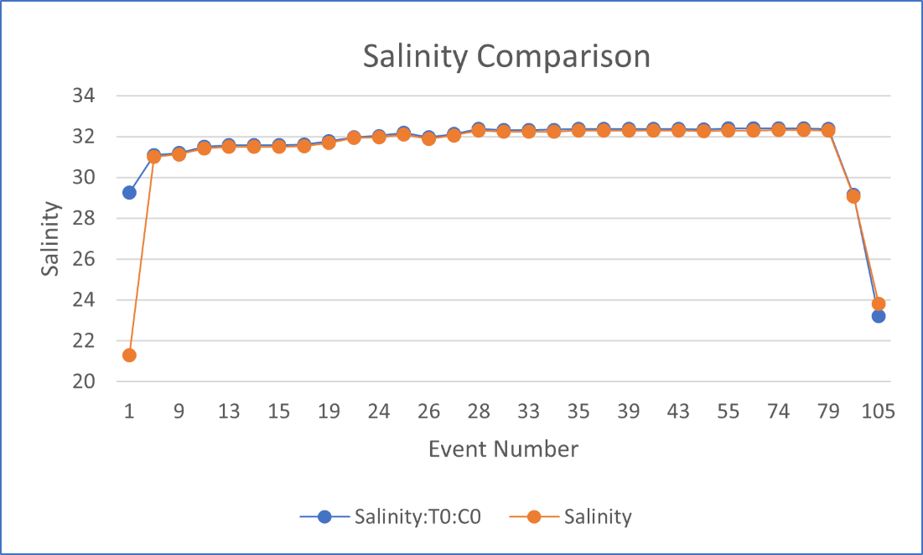

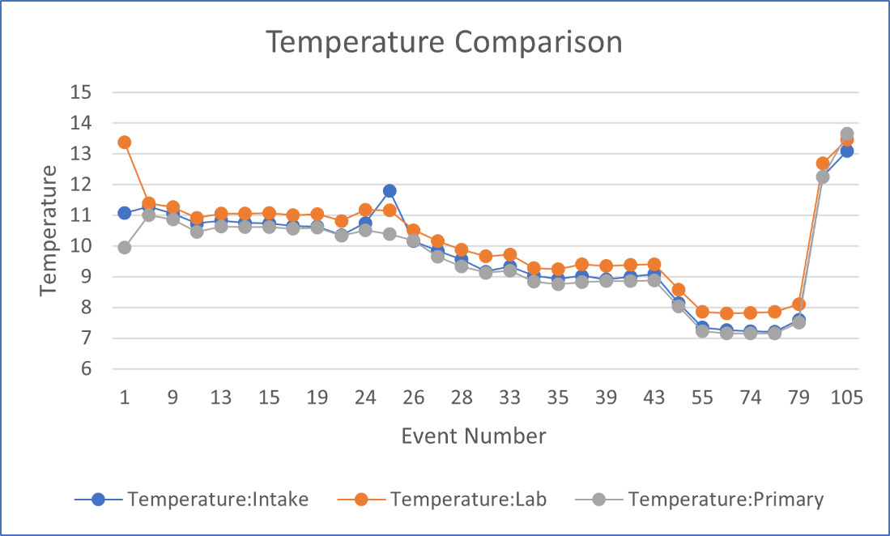

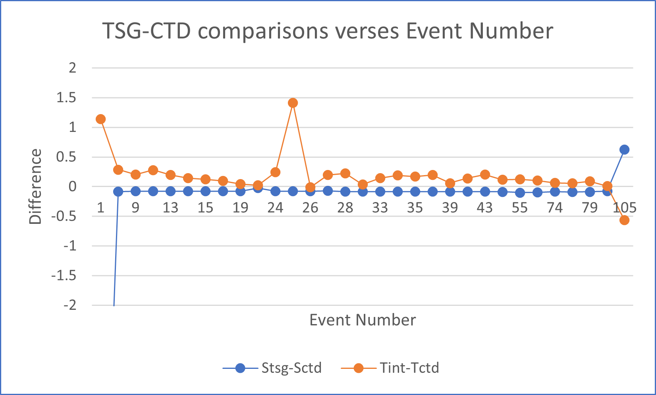

Heating in the Loop

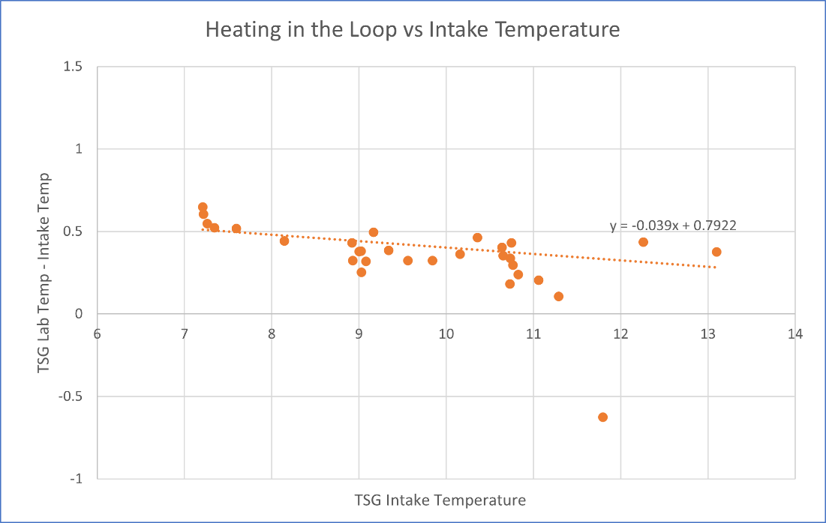

The average difference between the intake temperature and lab temperature was 0.4 deg C with a standard deviation of 0.4 deg C.

**Comparisons of Loop samples and TSG data**

There were 34 overlapping loop CHL samples and 10 salinity samples.

The TSG salinity is lower than loop samples by a median of 0.0039 PSU with a minimum of 0.002 PSU and a maximum of 0.894 PSU. The 0.894 PSU difference is an outlier—if it is removed the median difference drops to 0.004 PSU.

The loop CHL values are mostly lower than the fluorometer values. After a single outlier was removed, the median difference was 0.109 ug/L with a minimum of -2.711 ug/L and a maximum of 1.519 ug/L.

There is good agreement between both the salinity and CHL samples between the Loop samples and TSG data.

f.) Editing

TSG data were edited using CTDEDIT.

* The first 30 minutes were removed due to high variability.
* From 1900hr to midnight on 11 May 2024, pumps were turned off due to ship being at dock. These data were removed.
* Isolated spikes were removed throughout.

g.) CALIBRATE, REMOVE and CLEAN

* Based on the small salinity difference between the bottle and TSG CALIBRATE was deemed unnecessary.
* Sigma-T was derived earlier. First, Pressure needed to be added to enable the calculation. ADD CHANNEL was run to add pressure = 4.5db. Then DERIVE was run to derive sigma-T.
* REMOVE was run to remove channels Temperature:Difference, Record # and pressure. The flow rate channels were left in the files.

h) Preparing Final Files

* HEADER EDIT was used to change the DATA DESCRIPTION to THERMOSALINOGRAPH and add the depth of sampling to the header and to change channel names to standard names and formats and to add comments.
* The TSG sensor history was updated.
* As a final check plots were made of the cruise track and time-series and all look fine.
* A cross-reference list was prepared.

##### Loop File

* The chief scientist provided file 2024-002-loops.csv with times for each CTD rosette surface bottle and loop sample plus results from analyses; the end time of casts were used when loops were during CTD casts.
* The sampling method column indicates ROS or USW for loops.
* 6-line headers were added and the usual headers removed.
* The columns were rearranged into the usual order of the 6linehdr files.
* Derived Quantities was run to derive Sigma-T for the CHE files. Sigma-T, event # and sample # were exported to a spreadsheet, ordered on pressure and all P>7db were removed. Sample #s from the 6linehdr file were added and the file was reorganized so that sample #s matched and blanks were entered for loop samples. Sigma-T data were added to the 6linehdr.
* The file was saved as 2024-006-surface-6linehdr.csv.
* The file break column was filled with value 1 so all data to ensure only a single file is created in conversion.
* CONVERT was run to produce an IOS Header file.
* CLEAN was run to get start and stop times and to add flag 0 to empty flag cells.
* Edit Headers was used to add header comments about the cruise, CTD data and sample analysis.
* Plots were made and no errors were found.
* The track plot looks reasonable.

|  |  |  |  |  |  |  |  |  |  |
| --- | --- | --- | --- | --- | --- | --- | --- | --- | --- |
| **CTD#** | **Make** | **Model** | **Serial#** | | **Used with Rosette?** | | **CTD Calibration Sheet Competed?** | | |
| **1** | **SEABIRD** | **911+** | **0550** | | **Yes** | | **Yes** | | |
| **2** | **SEABIRD** | **911+** | **0443** | | **Yes** | | **Yes** | | |
| **Calibration Information - 0550** | | | | | | | | | | |
| **Sensor** | | | | **Pre-Cruise** | | | | **Post Cruise** | | |
| **Name** | | **S/N** | | **Date** | | **Location** | | **Date** | **Location** | |
| **Temperature** | | **2095** | | **24Jan2023** | | **Factory** | |  |  | |
| **Conductivity** | | **3531** | | **24Jan2023** | | **Factory** | |  |  | |
| **Secondary Temp.** | | **4700** | | **3Feb2023** | | **Factory** | |  |  | |
| **Secondary Cond.** | | **3396** | | **24Jan2023** | | **Factory** | |  |  | |
| **Transmissometer** | | **1185DR** | | **11Jan2023** | | **Factory** | |  |  | |
| **Transmissometer** | | **1883DG** | | **11Jan2023** | | **Factory** | |  |  | |
| **SBE 43 DO sensor** | | **3038** | | **10Feb2023** | | **Factory** | |  |  | |
| **PAR sensor** | | **70613** | | **24Feb2021** | | **Factory** | |  |  | |
| **SeaPoint Fluor.** | | **3641** | | **May 2023** | | **Factory** | |  |  | |
| **WetLabs Fluor.** | | **2216** | | **8 Mar2017** | | **Factory** | |  |  | |
| **Pressure Sensor** | | **0550** | | **17-Jan-2023** | | **Factory** | |  |  | |
| **Valeport Altimeter** | | **73171** | | **23Nov2021** | | **Factory** | |  |  | |
| **Valeport Altimeter** | | **76341** | | **23Nov2021** | | **Factory** | |  |  | |

# *Altimeter changed to 76341 before cast 19

|  |  |  |  |  |  |
| --- | --- | --- | --- | --- | --- |
| **Calibration Information - 0443** | | | | | |
| **Sensor** | | **Pre-Cruise** | | **Post Cruise** | |
| **Name** | **S/N** | **Date** | **Location** | **Date** | **Location** |
| **Temperature** | **2106** | **16Feb2023** | **Factory** |  |  |
| **Conductivity** | **2754** | **18Jan23** | **Factory** |  |  |
| **Secondary Temp.** | **5130** | **23Feb2023** | **Factory** |  |  |
| **Secondary Cond.** | **1766** | **18Jan2023** | **Factory** |  |  |
| **Transmissometer** | **1185DR** | **11Jan2023** | **Factory** |  |  |
| **Transmissometer** | **1883DG** | **11Jan2023** | **Factory** |  |  |
| **SBE 43 DO sensor** | **4372** | **25Jan2023** | **Factory** |  |  |
| **PAR sensor** | **70613** | **24Feb2021** | **Factory** |  |  |
| **SeaPoint Fluor.** | **4186** | **May 2023** | **Factory** |  |  |
| **WetLabs Fluor.** | **2216** | **27Nov2018** | **Factory** |  |  |
| **Pressure Sensor** | **0443** | **22Feb2023** | **Factory** |  |  |
| **Valeport Altimeter** | **76341** | **23Nov2021** | **Factory** |  |  |

# TSG Make/Model/Serial#: SEABIRD/45/0620

|  |  |  |  |  |  |
| --- | --- | --- | --- | --- | --- |
| **Calibration Information** | | | | | |
| **Sensor** | | **Pre-Cruise** | | **Post Cruise** | |
| **Name** | **S/N** | **Date** | **Location** | **Date** | **Location** |
| **Temperature-SBE45** | **45-0620** | **12Jan22** | **Factory** |  |  |
| **Conductivity-SBE45** | **45-0789** | **2Feb24** | **Factory** |  |  |
| **Wetlabs WETStar Fluor.**  For depths deeper than, and including, 125 dbar, we would wait 30 seconds before closing a bottle. For depths shallower than, and including, 100 dbar, we would wait 60 seconds before closing a bottle. | **1656** | **12Mar2021** | **Factory** |  |  |
| **Temperature-SBE38** | **603** | **4Jan 2024** | **Factory** |  |  |

