|  |  |
| --- | --- |
| **Revision Table** |  |
| June 6, 2024 | Casts 8-13 added to this cruise from files “203655_20231122_1901.rsk”, “203655_20231211_1711.rsk” and “203655_20231211_1814.rsk”.  The same processing steps from casts 1-7 have been followed, all documents are named the same with an indicator of ‘_2.csv’. RBR Maestro 203655 was used for these casts so pH is not present. Cast locations were provided in “2023 Haoom_CTD_metadata_2024_05_10.xlsx”.  2024 casts from this project can be found in cruise 2024-097. |

**RBR CTD DATA PROCESSING NOTES**

Cruise: 2023-097

Agency: OSD

Locations: Clayoquot Sound

Project: Clayoquot Sound Biological Oceanography (Ha-oom Fisheries Society)

Party Chief: Kelly Young

Platform: Unknown

Date: September 21, 2023 – September 30, 2021

Processed by: Samantha Huntington

Date of Processing: November 1, 2023 – December 11, 2023

Number of Raw files: 7 Number of Processed Files: 7

**Instrument Summary**

Equipment Casts 1-6:

RBR Maestro3 CTD (s/n 203982) with a Marine CT Conductivity and Temperature sensor, an RBR Pressure sensor, an RBRcoda T.ODO Fast Temperature and Dissolved Oxygen concentration sensor, an Idronaut pH sensor and a Li-cor PAR sensor, as well as a Seapoint Tu turbidity sensor. The CTD belongs to the Nuu-chah-nulth Tribal Council.

Equipment Cast 7:

RBR Maestro3 CTD (s/n 203655) with all the same sensors as noted above with the exception of pH. No pH sampling was done for this cast.

All sampling was done at 8Hz.

**Summary of Quality and Concerns**

A cast list of times and locations was provided“Haoom_CTD_metadata_2023_11_23.xlsx”..

The data overall look good. A long soak below 0.5m is present in all casts. All casts start around 1m below the surface.

CTD casts were conducted as the sun sets using the following protocols as provided by the Ha-oom Fishery Society.

* **Depth Measurement:** Determine the depth at the site in feet using a depth sounder. Convert it to meters and subtract 5 meters to establish the maximum CTD depth.
* **Avoiding Depth Contours**: Ensure CTD sampling avoids depth contours and potential obstructions to prevent snags or entanglements.
* **Cap Management**: Remove and securely store all caps in a safe location.
* **Initiate Recording**: Twist the knobs to initiate data recording.
* **Calibration Procedure**: Allow the CTD to calibrate for 2 minutes near the water's surface before lowering it to the desired depth.
* **Controlled Descent**: Allow the CTD to freefall at the desired recording rate, eliminating the need for consistent manual adjustments.
* **Data Upload Protocol:** After cast is done, stop recording by twisting the knob. Upload data on the same day.

**Processing Summary**

1. **Conversion to IOS Headers**

Four files were provided, 203892_20230922_1621.rsk and 203892_20230930_1923.rsk, 203892_20231014_1825 2.rsk and 203655_20231106_1708 2.rsk. Seven profiles were found in the files and they were extracted using python function READ_EXCELrsk().

A single file (2023-097_CTD_Data.csv) with all the data including event numbers and a single line of headers was prepared using python function MERGE_FILES().

A 6-line header was inserted using python function Add_6Lineheader_2().

File “2023-097_header-merge.csv” was created, based on the information provided by the chief scientist.

* Column “File_Name”: entries were derived from the event number.
* Column “LOC:LATITUDE”: latitude was provided and reformatted to “XX XX.XXXX N !(deg min)”.
* Column “LOC:LONGITUDE”: longitude was provided and reformatted to “XX XX.XXXX W !(deg min)”.
* Column “LOC: Event Number”: entries were event numbers.
* Colmun “LOC: STATION”: all stations were set according to the information provided.

The sampling site was mapped (Figure 1) using from “2023-097_header-merge.csv” using python function Plot_Track_Location() to check the location of all casts.

Prior to conversion to IOS header format, the presence of zero-order holds were checked using Python function Plot_Pressure_Diff(). Zero-order holds were found (Figure 2.) and these values were replaced with Nan using the python function Correct_Hold().

A new csv file was created “2023-097_CSV_DATA-6Linedr_corr_hold.csv” and the corrected values were checked in python function Plot_Pressure_Diff(). Zero-order holds were found to be removed (Figure 3.).

CONVERT Spreadsheet Files was run to produce files with IOS Header format. Header entries of “Administration”, “File” and “Instrument” were filled in this step.

The routine “Merge:CSV Files to headers” was run to add location headers to the IOS files.

Raw data were plotted and examined:

* Salinity looks good with a long soak at the top of the casts.
* Temperature looks good with a long soak at the top of the casts.
* Conductivity looks good with a long soak at the top of the casts.
* Oxygen concentration looks good with a long soak at the top of the casts. Oxygen Saturation is a derived channel in this RBR data and has some spikes. This channel will be removed since there is already an Oxygen concentration channel that is not derived.
* pH looks OK for casts 1-6.
* Turbidity has some spikes in all casts.
* PAR looks OK with some noise at the top of cast 7.

Next CLEAN was run to add a start time and event numbers to headers.

1. **Data processing**

* Correction to Pressure: a negative pressure was found in cast 7 but it was not consistent across all casts, so pressure was not calibrated.
* Data despiking: There are no significant spikes in temperature, conductivity and salinity. So there is no need to apply data despiking. Despiking was not applied to turbidity.
* Time was provided in local time, this was adjusted to UTC used ADD TIME CHANNEL, 7 hours were added to the first 6 casts. Cast 7 happened after PDT ended so 8 hours were added to that cast.
* CLIP: Pressure is steady for a variable number of scans. Initial records were removed until the downcast began using file “2023-097_CLIP.csv”. Pressure is very steady for a while below 0.5 m, appears to be a deep soak. Clipped data to where the RBR started to go down, around 0.8m. Will not be much surface data. Cast 4 starts after 1.2m.
* Filter: a Gull-winged filter, size 5, was applied to temperature, conductivity, and pressure. Salinity will be calculated in the next step.
* SHIFT: Based on suggested values in document “Guidelines for processing RBR CTD profiles”, the alignment of temperature and conductivity was corrected by applying a shift of -2 scans in conductivity.
* SHIFT: Better alignment with Oxygen profiles was found by advancing it by 11 scans. The advice given in document “Guidelines for processing RBR CTD Profiles” was that an advance between 2 and 3 seconds is appropriate. T-O plots before and after alignment were compared.
* Delete was run to remove records with a descent rate lower than 0.3m/s over 8 points. This was not applied in the top 10m to avoid loss of surface records as the CTD began its descent.
* Profile plots were examined after DELETE and confirm that plots show reasonable values for salinity and conductivity and fluorescence. DO concentration levels at the surface ranged from 50 umol/L to 400 umol/L. However there was no calibration sampling and no climatology to enable a judgement about the data reliability.
* REORDER was run to put the channels in the correct order.

1. **Final checks and header editing**

* REMOVE was run to remove the following channels from all casts: Date, Time:UTC and Event. Dissolved Oxygen Saturation was also removed and pH was removed from cast 7 since there was no pH sensor for that cast.
* BIN AVERAGE was used to metre-average data.
* CALIBRATE was run to convert conductivity units to S/m using file 2023-097-recal2.ccf.
* Header Edit was used to fix channel names and format as listed below:
* Pressure: format F11.2 ==> F7.1
* Salinity:CTD ==> Salinity
* F11.4==>F8.2
* Conductivity: F10.5 ==> F10.6
* CLEAN was run to reset the Maximum and Minimum values in the Header.
* Header Check was run and no problems were found.

Figure 1 – location of casts.

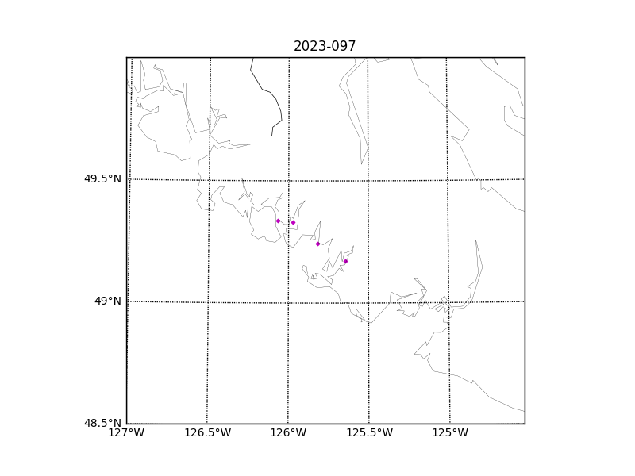

Figure 2 – zero-order holds

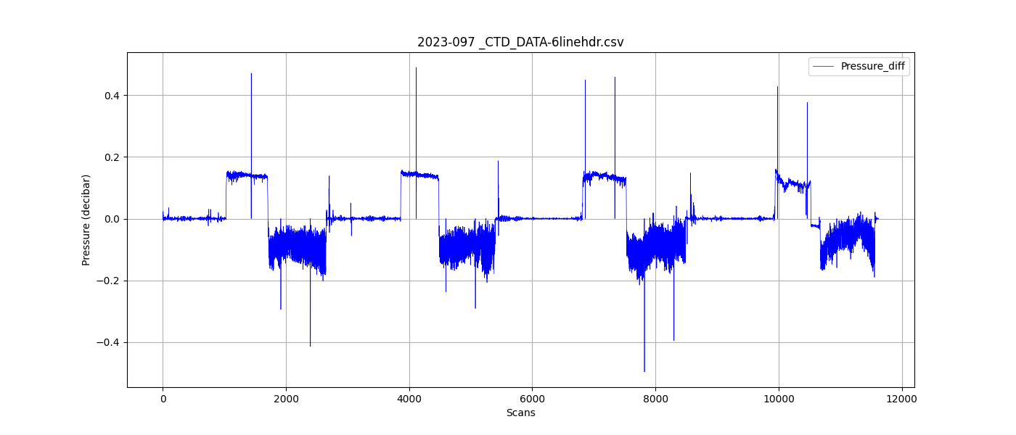

Figure 3 – zero order holds removed

