**RBR CTD DATA PROCESSING NOTES**

Cruise: 2023-097

Agency: OSD

Locations: Clayoquot Sound

Project: Clayoquot Phytoplankton (Ha-oom Fisheries Society)

Party Chief: Kelly Young

Platform: Unknown

Date: September 21, 2023 – September 30, 2021

Processed by: Samantha Huntington

Date of Processing: November 1, 2023 – November 6, 2023

Number of Raw files: 4 Number of Processed Files: 4

**Instrument Summary**

Equipment: RBR Maestro3 CTD (s/n 203982) with an Idronaut pH sensor and a Li-cor PAR sensor, as well as a Dissolved Oxygen sensor. Serial numbers were not provided for these sensors. The CTD was belongs to the Nuu-chah-nulth Tribal Council.

Sampling frequency was at 8Hz.

**Summary of Quality and Concerns**

A cast list of times and locations was provided, “Haoom_CTD_metadata_2023-10-16.xlsx”.

The data overall look good. A long soak below 0.5m is present in all casts. All casts start around 1m below the surface.

**Processing Summary**

1. **Conversion to IOS Headers**

Two files were provided, 203892_20230922_1621.rsk and 203892_20230930_1923.rsk. Two profiles were found in each file and they were extracted using python function READ_EXCELrsk().

A single file (2023-097_CTD_Data.csv) with all the data including event numbers and a single line of headers was prepared using python function MERGE_FILES().

A 6-line header was inserted using python function Add_6Lineheader_2().

File “2023-097_header-merge.csv” was created, based on the information provided by the chief scientist.

* Column “File_Name”: entries were derived from the event number.
* Column “LOC:LATITUDE”: latitude was provided and reformatted to “XX XX.XXXX N !(deg min)”.
* Column “LOC:LONGITUDE”: longitude was provided and reformatted to “XX XX.XXXX W !(deg min)”.
* Column “LOC: Event Number”: entries were event numbers.
* Colmun “LOC: STATION”: all stations were set according to the information provided.

The sampling site was mapped (Figure 1) using from “2023-097_header-merge.csv” using python function Plot_Track_Location() to check the location of all casts.

Prior to conversion to IOS header format, the presence of zero-order holds were checked using Python function Plot_Pressure_Diff(). Zero-order holds were found (Figure 2.) and these values were replaced with Nan using the python function Correct_Hold().

A new csv file was created “2023-097_CSV_DATA-6Linedr_corr_hold.csv” and the corrected values were checked in python function Plot_Pressure_Diff(). Zero-order holds were found to be removed (Figure 3.).

CONVERT Spreadsheet Files was run to produce files with IOS Header format. Header entries of “Administration”, “File” and “Instrument” were filled in this step.

The routine “Merge:CSV Files to headers” was run to add location headers to the IOS files.

Raw data were plotted and examined:

* Salinity looks good with a long soak at the top of the casts.
* Temperature looks good with a long soak at the top of the casts.
* Conductivity looks good with a long soak at the top of the casts.
* Oxygen looks good with a long soak at the top of the casts.

Next CLEAN was run to add a start time and event numbers to headers.

1. **Data processing**

* Correction to Pressure: no negative pressures were found in the data, so pressure was not calibrated.
* Data despiking: There are no significant spikes in temperature, conductivity and salinity. So there is no need to apply data despiking.
* **Time was provided in local time, this was adjusted to UTC used ADD TIME CHANNEL**
* CLIP: Pressure is steady for a variable number of scans. Initial records were removed until the downcast began using file “2023-097_CLIP.csv”. Pressure is very steady for a while below 0.5 m, appears to be a deep soak. Clipped data to where the RBR started to go down, around 0.8m. Will not be much surface data. Cast 4 starts after 1.2m.
* Filter: a Gull-winged filter, size 5, was applied to temperature, conductivity, and pressure. Salinity will be calculated in the next step.
* SHIFT: Based on suggested values in document “Guidelines for processing RBR CTD profiles”, the alignment of temperature and conductivity was corrected by applying a shift of -2 scans in conductivity.
* SHIFT: Better alignment with Oxygen profiles was found by advancing it by 11 scans. The advice given in document “Guidelines for processing RBR CTD Profiles” was that an advance between 2 and 3 seconds is appropriate. T-O plots before and after alignment were compared.
* Delete was run to remove records with a descent rate lower than 0.3m/s over 8 points. This was not applied in the top 10m to avoid loss of surface records as the CTD began its descent.
* Profile plots were examined after DELETE and confirm that plots show reasonable values for salinity and conductivity and fluorescence. DO saturation levels at the surface ranged from 90% to 130%. However there was no calibration sampling and no climatology to enable a judgement about the data reliability.
* A record number was added to the files using ADD TIME CHANNELS. At this point the data was extracted from IOS shell format after adding using Python package rbr_oxy.py/get_rbr_data(). Once the data was back in spreadsheet format, Oxygen was converted to mass units using Python package rbr_oxy.py/convert_oxy().
* The spreadsheet ‘2023-097_Oxygen_forIOSshell.csv’ was converted to IOS Shell format using CONVERT SPREADSHEET to create files with the new Dissolved Oxygen channels.
* MERGE was run to add the converted oxygen to the files.
* REORDER was run to put the channels in the correct order.

1. **Final checks and header editing**

* REMOVE was run to remove the following channels from all casts: Date, Time:UTC and Event.
* BIN AVERAGE was used to metre-average data.
* CALIBRATE was run to convert conductivity units to S/m using file 2023-097-recal2.ccf.
* Header Edit was used to fix channel names and format as listed below:
* Pressure: format F11.2 ==> F7.1
* Salinity:CTD ==> Salinity
* Oxygen==> Oxygen:Dissolved:Saturation
* Oxygen_mL_L==> Oxygen:Dissolved:Rinko mL/L
* Oxygen_umol_kg==> Oxygen:Dissolved:Rinko umol/kg
* F11.4==>F8.2
* Conductivity: F10.5 ==> F10.6
* CLEAN was run to reset the Maximum and Minimum values in the Header.
* Header Check was run and no problems were found.

Figure 1 – location of casts.

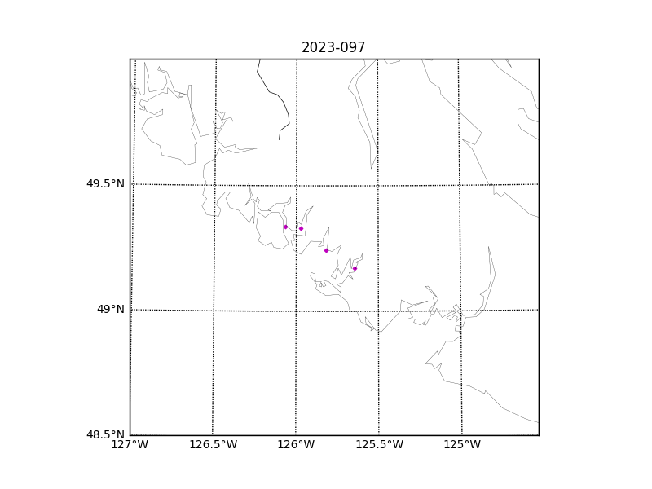

Figure 2 – zero-order holds

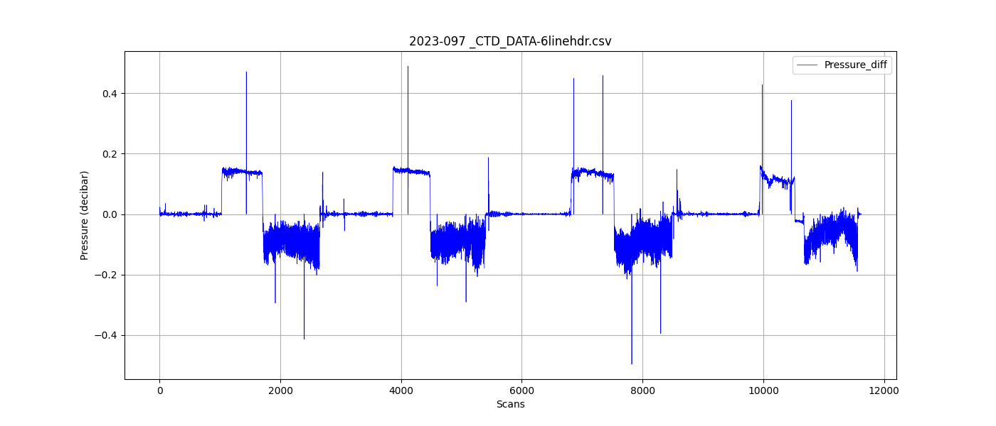

Figure 3 – zero order holds removed

