**RBR CTD DATA PROCESSING NOTES**

Cruise: 2023-084

Agency: OSD

Locations: Quatsino Sound, Holberg Inlet and Neroutsos Inlet

Project: Aquaculture Collaborative Research and Development Program (ACRDP)

Party Chief: Cooper, Glenn

Platform: Blackfish

Date: January 24, 2023 – December 12, 2023

This project will continue into 2024.

Processed by: Samantha Huntington

Date of Processing: February 27, 2024 – August 22, 2024

Number of Raw files: 163 Number of Processed Files: 162

**Instrument Summary**

Equipment: RBR Concerto CTD (s/n 204694) with a Turner Cyclops Fluorometer (s/n 21101282) and a JFE Advantech Rinko III oxygen sensor (s/n 411) for the January, April, May, July and December casts. (1-106, 137-163)

Equipment: RBR Concerto CTD (s/n 208765) with a Turner Cyclops Fluorometer (s/n 21101792) and a JFE Advantech Rinko III oxygen sensor (s/n 447) for the September and October casts. (107-036)

Sampling frequency was at 8Hz.

**Summary of Quality and Concerns**

Files 204694_202302025_1001.rsk and 204694_20230919_0842.rsk were provided with file 2023084TapLog_CTDLog_Jan2023-Jul2023_Final.xlsx.

Files 208765_20230921_0822.rsk and 208765_20231006_0728.rsk were provided with 2023_09QuatsinoFirstNations_CTD_Taplog_Final.xlsx.

204694_20231214_0933.rsk was provided with 2023_12QuatsinoFirstNations_CTD_Taplog_Final.xlsx

This cruise took place as several distinct excursions and as such, event numbers in the Taplog files are not in chronological order. The following changes were made to event numbers:

204694_202302025_1001.rsk (January 2023): Contained 26 profiles from 2022 which were excluded prior to processing . Events 27-52 in the Taplog changed to Events 1-26.

204694_20230919_0842.rsk (April & May & July 2023): Events 1-80 changed to Events 27-106.

208765_20230921_0822.rsk (September 2023): Events 1-10 changed to Events 107-116

208765_20231006_0728.rsk (October 2023): Events 11-30 changed to Events 117-136

204694_20231214_0933.rsk (December 2023): Events 1-27 changed to Events 137-163

Cast 79 (*formerly 53 in 2023084TapLog_CTDLog_Jan2023-Jul2023_Final.xlsx*) ended at 9.5 meters and was brought back to the surface to restart. This cast was discarded prior to processing.

Cast 90 (*formerly 64 in 2023084TapLog_CTDLog_Jan2023-Jul2023_Final.xlsx)* had an issue with the DO sensor, DO will be removed from this cast at the end of processing. Cast 90 does not have an upcasts.

These data were collected by the Quatsino First Nations Guardians as part of a collaborative

project that will continue into 2024, see cruise 2024-040 for the 2024 data.”

The data overall look good. There is some very high Oxygen Saturation in many casts from cast 60-100, some values reaching over 180%. After discussion with the Chief Scientists it was determined that these were not likely due to a calibration issue. High Fluorescence was found in the same casts.

**Processing Summary**

1. **Conversion to IOS Headers**

Separate Header Merge files were created for each of the five Ruskin files and the profiles from each file were extracted using python function READ_RSK().

A single file (2023-084_CTD_Data.csv) with all the data including event numbers and a single line of headers was prepared using python function MERGE_FILES().

A 6-line header was inserted using python function Add_6Lineheader_2().

File “2023-084_header-merge.csv” was created, based on the information provided by the chief scientist.

* Column “File_Name”: entries were derived from the event number.
* Column “LOC:LATITUDE”: latitude was provided and reformatted to “XX XX.XXXX N !(deg min)”.
* Column “LOC:LONGITUDE”: longitude was provided and reformatted to “XX XX.XXXX W !(deg min)”.
* Column “LOC: Event Number”: entries were event numbers.
* Column “LOC: STATION”: station information was provided.

The sampling site was mapped (Figure 1) using from “2023-084_header-merge.csv” using python function Plot_Track_Location() to check the location of all casts.

Prior to conversion to IOS header format, the presence of zero-order holds were checked using Python function Plot_Pressure_Diff(). Zero-order holds were found (Figure 2.) and these values were replaced with Nan using the python function Correct_Hold().

A new csv file was created “2023-084_CSV_DATA-6Linedr_corr_hold.csv” and the corrected values were checked in python function Plot_Pressure_Diff(). Zero-order holds were found to be removed (Figure 3.).

CONVERT Spreadsheet Files was run to produce files with IOS Header format. Header entries of “Administration”, “File” and “Instrument” were filled in this step.

The routine “Merge:CSV Files to headers” was run to add location headers to the IOS files.

Raw data were plotted and examined:

* Salinity looks good with some bad data at the top of casts 11, 36, 46 and 51. There is some bad data at the bottom of casts 1, 27, 34, 67-69, 93, 95, 133, 135 and 160. There are some spikes in casts 98 and 104.
* Temperature looks good with some bad data at the top of casts 9-11, 25, 36, 46, 51 and 108. There is some bad data at the bottom of casts 1, 27, 34.
* Conductivity looks good with some bad data at the top of casts 11, 36, 46 and 51. There is some bad data at the bottom of casts 1, 27, 34, 67-69, 93, 95, 133, 135 and 160. There are some spikes in casts 98 and 104.
* Oxygen looks good with some bad data at the top of casts 46, 51, 143, and at the bottom of casts 1, 27, 34, 83 and 113. Very high Oxygen Saturation levels (140% - 180%) can be found in casts 52, 62-70, 76-89, and 91-100.
* Fluorescence has spiky data in many casts, particularly those with high Oxygen Saturation, these spikes will be examined later in the processing.

Using ADD TIME CHANNEL a record number was added to each record.

Next CLEAN was run to add a start time and event numbers to headers.

Then REORDER was run to reorder the channels in all files.

1. **Data processing**

* Correction to Pressure: negative pressures were not seen and no calibration was applied.
* Data despiking: There are no significant spikes in temperature, conductivity and salinity. There are spikes in Fluorescence which will be handled later in processing. A few smaller spikes in Salinity and Conductivity will be handled at the same time.
* CLIP: Pressure is steady for a variable number of scans. Initial records were removed until the downcast began using file “2023-084_CLIP.csv”.
* Filter: a Gull-winged filter, size 3, was applied to temperature, conductivity, and pressure. Salinity will be calculated in the next step.
* SHIFT: Based on suggested values in document “Guidelines for processing RBR CTD profiles”, the alignment of temperature and conductivity was corrected by applying a shift of -2 scans in conductivity.
* SHIFT: Better alignment with Oxygen profiles was found by advancing it by 11 scans. The advice given in document “Guidelines for processing RBR CTD Profiles” was that an advance between 2 and 3 seconds is appropriate. T-O plots before and after alignment were compared.
* Delete was run to remove records with a descent rate lower than 0.3m/s over 8 points. This was not applied in the top 10m to avoid loss of surface records as the CTD began its descent.
* DESPIKE:

Bad data was removed from the bottom of casts 6, 7, 27, 34, 44, 51, 67, 68, 93, 113, 119 and 135.

Large fluorescence spikes below 30m were removed from casts 1, 2, 3, 33, 48 and 119. Bad fluorescence data is found in casts 158-163 and this channel will be removed from those casts.

A spike in Conductivity and Salinity was removed from cast 118.

* Profile plots were examined after DELETE and confirm that plots show reasonable values for salinity and conductivity and fluorescence. DO saturation levels at the surface ranged from 0.2% to 182%. However there was no calibration sampling and no climatology to enable a judgement about the data reliability. As mentioned at the beginning of this report, Oxygen values were discussed prior to processing.

1. **Final checks and header editing**

* REMOVE was run to remove the following channels from all casts: Date, Time:UTC, Event and Record number.
* Oxygen was removed from cast 90.
* Turbidity was not on both RBR sensors used in this project, empty Turbidity channels were removed from casts 1-116 and 137-163.
* Fluorescence data was bad for casts 158-163 and removed from these casts.
* BIN AVERAGE was used to metre-average data.
* CALIBRATE was run to convert conductivity units to S/m using file 2023-084-recal2.ccf.
* Header Edit was used to fix channel names and format as listed below:
* Pressure: format F11.2 ==> F7.1
* Salinity:CTD ==> Salinity
* Oxygen==> Fluorescence:URU
* mL/L==> %
* F11.4==>F8.2
* Conductivity: F10.5 ==> F10.6
* CLEAN was run to reset the Maximum and Minimum values in the Header.
* Header Check was run and no problems were found.

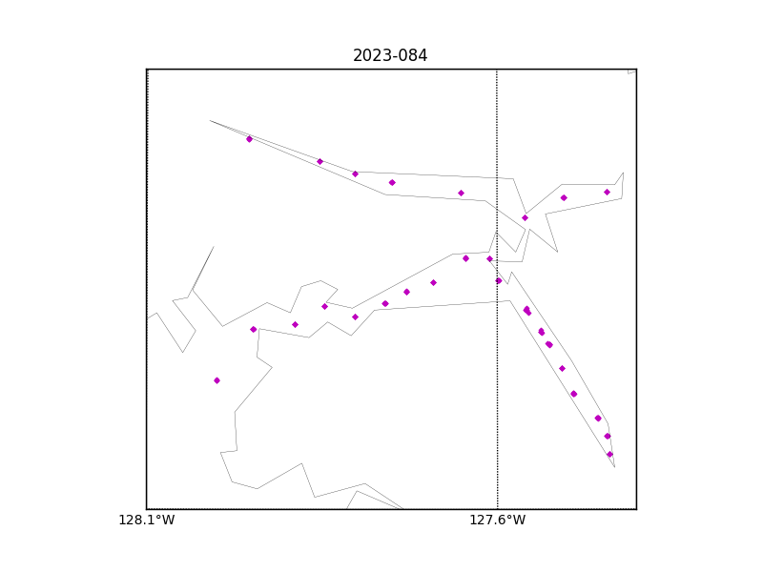

Figure 1 – location of casts.

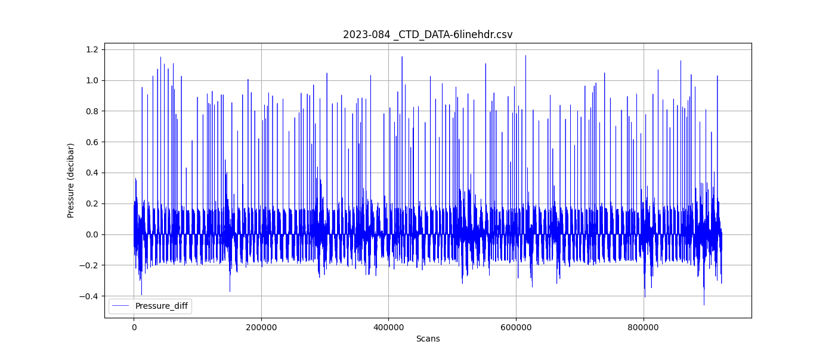

Figure 2 – zero-order holds

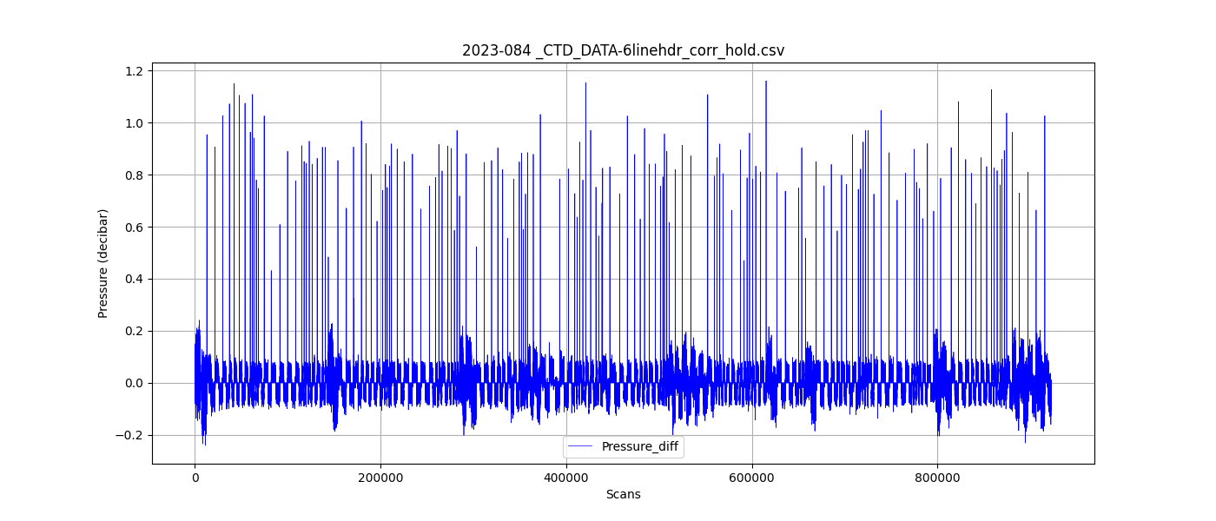

Figure 3 – zero order holds removed