**RBR CTD DATA PROCESSING NOTES**

Cruise: 2023-083

Agency: OSD

Locations: Quatsino Sound, Holberg Inlet and Neroutsos Inlet

Project: Quatsino Sound RELIPS survey

Party Chief: Cooper G.

Platform: Doug Anderson

Date: November 2, 2023 – November 9, 2021

Processed by: Samantha Huntington

Date of Processing: February 20, 2024 - March 4, 2024

Number of Raw files: 165 Number of Processed Files: 165

**Instrument Summary**

Equipment: RBR Concerto CTD (s/n 208765) with a Turner Cyclops Fluorometer (s/n 21101792) and a JFE Advantech Rinko III oxygen sensor (s/n 447).

Sampling frequency was at 8Hz.

**Summary of Quality and Concerns**

Event log ‘2023-083CTDLogFile_Final.xlsx’ was provided and some events were repeated or out of sequence causing the events to be non-sequential. The first instance of event 23 was changed to 22 and the events 34, 36, 37, 37 were changed to 34, 35, 36, 37.

The following comments about the casts were provided in the log:

19: 2 min soak at surface.

81: Winch lost power on upcast at 100m

86: Winch lost power on upcast at 15m

89: Winch lost power on upcast.

92: Winch lost power on upcast at 18m

111 – 114: Fluorometer hitting max values at surface while soaking. Water was very turbid so not sure these are reliable.

121: Winch lost power on upcast at 140m, fixed by power cycling.

129: Winch lost power on upcast at 92m, fixed by power cycling.

142: Winch clutch slipped on downcast.

|  |  |
| --- | --- |
|  |  |

**Processing Summary**

1. **Conversion to IOS Headers**

165 profiles were found in the 208765_20231110_1456.rsk file and extracted using python function READ_RSK().

A single file (2021-0045_CTD_Data.csv) with all the data including event numbers and a single line of headers was prepared using python function MERGE_FILES().

A 6-line header was inserted using python function Add_6Lineheader_2(), Dissolved Oxygen Saturation was converted to Dissolved Oxygen Concentration in this step.

File “2023-083_header-merge.csv” was created, based on the information provided by the chief scientist.

* Column “File_Name”: entries were derived from the event number.
* Column “LOC:LATITUDE”: latitude was provided and reformatted to “XX XX.XXXX N !(deg min)”.
* Column “LOC:LONGITUDE”: longitude was provided and reformatted to “XX XX.XXXX W !(deg min)”.
* Column “LOC: Event Number”: entries were event numbers.
* Column “LOC: STATION”: all stations were provided in the event log.
* Column “LOC: Water Depth”: was provided in the log.

The sampling site was mapped (Figure 1) using from “2023-083_header-merge.csv” using python function Plot_Track_Location() to check the location of all casts.

Prior to conversion to IOS header format, the presence of zero-order holds were checked using Python function Plot_Pressure_Diff(). Zero-order holds were found (Figure 2.) and these values were replaced with Nan using the python function Correct_Hold().

A new csv file was created “2023-083_CSV_DATA-6Linedr_corr_hold.csv” and the corrected values were checked in python function Plot_Pressure_Diff(). Zero-order holds were found to be removed (Figure 3.).

CONVERT Spreadsheet Files was run to produce files with IOS Header format. Header entries of “Administration”, “File” and “Instrument” were filled in this step.

The routine “Merge:CSV Files to headers” was run to add location headers to the IOS files.

Raw data were plotted and examined, where the winch lost power on the upcasts noisy data and spikes were noticed but these will be removed when the upcast is deleted. Bad and noisy data noted in casts will be reviewed after the upcast is deleted:

* Salinity looks good.
* Temperature looks good with some bad data at the bottom of cast 1, 2, 13, 20. Noisy data is found in casts 33-37 and at the surface for casts 121, 127-130.
* Conductivity looks good.
* Oxygen looks good with some surface noise for casts 127-30 and 150-158.
* Fluorescence looks good with some spikes in most casts, these will be revisited after the upcast is removed.

Next CLEAN was run to add a start time and event numbers to headers.

Then REORDER was run to reorder the channels in all files.

1. **Data processing**

* Correction to Pressure: some negative pressures were found in but corresponding Conductivity was found to be less than 0.01 mS/cm, so pressure was not calibrated.
* Data despiking: There are no significant spikes in temperature, conductivity and salinity. So there is no need to apply data despiking. Fluorescence spikes will be examined after the upcast is removed. Small spikes and remaining bad data at the bottom of casts will also be examined after the upcast is removed.
* Add Time Channels: A record number was added to be used in the creation of 2023-083_CLIP.csv.
* CLIP: Pressure is steady for a variable number of scans. Initial records were removed until the downcast began using file “2023-083_CLIP.csv”.
* Filter: a Gull-winged filter, size 3, was applied to temperature, conductivity, and pressure. Salinity will be calculated in the next step.
* SHIFT: Based on suggested values in document “Guidelines for processing RBR CTD profiles”, the alignment of temperature and conductivity was corrected by applying a shift of -2 scans in conductivity.
* SHIFT: Better alignment with Oxygen profiles was found by advancing it by 11 scans. The advice given in document “Guidelines for processing RBR CTD Profiles” was that an advance between 2 and 3 seconds is appropriate. T-O plots before and after alignment were compared.
* Delete was run to remove records with a descent rate lower than 0.3m/s over 8 points. This was not applied in the top 10m to avoid loss of surface records as the CTD began its descent.
* CLEAN: was run to reset the maximum and minimum values.
* Profile plots were examined after DELETE and confirm that plots show reasonable values for salinity and conductivity and fluorescence. DO saturation levels at the surface ranged from 60% to 103%. However there was no calibration sampling and no climatology to enable a judgement about the data reliability.
* CTDEDIT: Fluorescence spikes were noted and removed 66 casts.
* Python: Fluorescence spikes were edited on files that did not have the completed steps in them. The fluorescence data was extracted using Python into file 2023-083.csv
* CONVERT spreadsheet was run on 2023-083.csv to create IOS shell format files for the extracted Fluorescence. The full set of steps was run from Clip to Clean2 on all 165 casts.
* REMOVE: the un-edited Fluorescence channel was dropped from the 66 casts that had been previously edited.
* MERGE: the 66 files containing the edited Fluorescence channel were merged into the full files.
* CLEAN: clean was run on the 66 files to reset maximum and minimum amounts.
* EDIT: Salinty and Temperature plot were examined and bad data was removed from the bottom of casts 13, 14, 35, 47 and 152 . Spikes in salinity and Conductivity were removed manually from cast 78.
* REMOVE: Fluorescence was reaching maximum value on some casts as noted by the Chief Scientist, further instances of this were noted and so Fluorescence was removed from casts 111-116, 118, 124 and 139.

1. **Final checks and header editing**

* REMOVE was run to remove the following channels from all casts: Date, Time:UTC, Event and Record Number.
* BIN AVERAGE was used to metre-average data.
* CALIBRATE was run to convert conductivity units to S/m using file 2023-083-recal2.ccf.
* Header Edit was used to fix channel names and format as listed below:
  + Pressure: format F11.2 ==> F7.1
  + Salinity:CTD ==> Salinity
  + Fluorescence ==> Fluorescence:URU
  + Oxygen_mL_L ==> Oxygen:Dissolved:Rinko
  + Oxygen_umol_kg ==> Oxygen:Dissolved:Rinko
* CLEAN was run to reset the Maximum and Minimum values in the Header.
* Header Check was run and no problems were found.

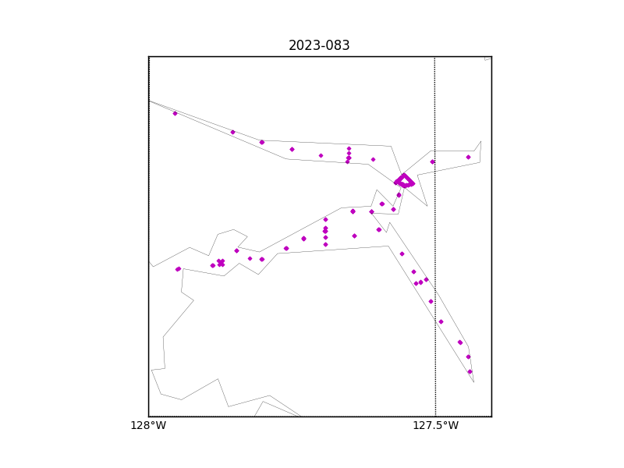

Figure 1 – location of casts.

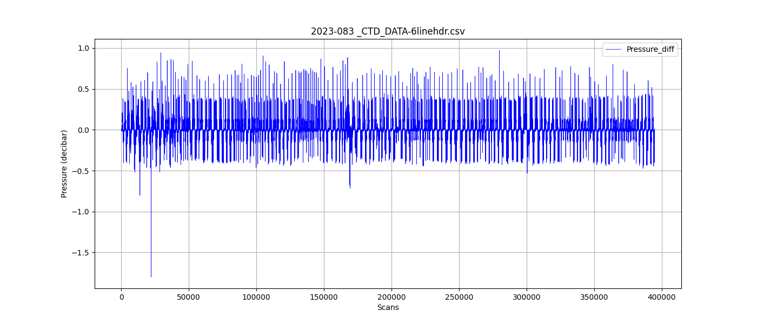

Figure 2 – zero-order holds

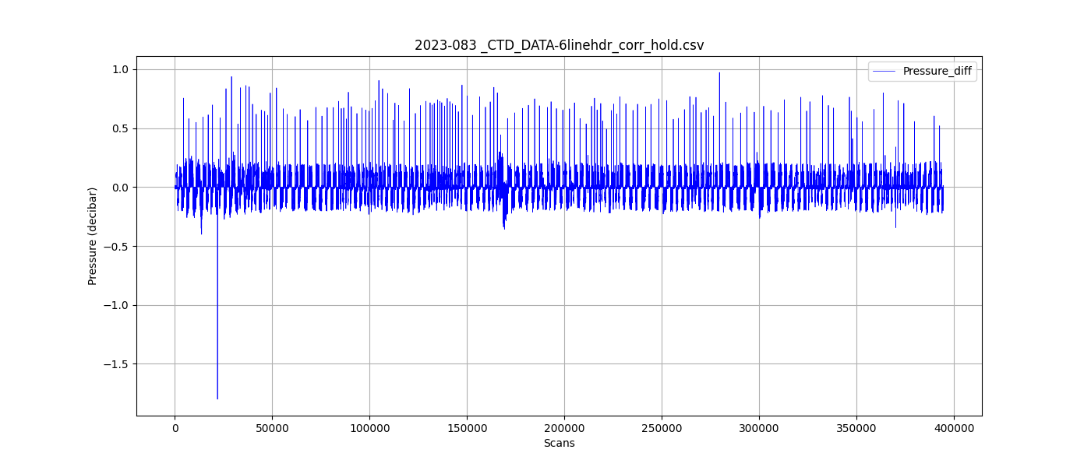

Figure 3 – zero order holds removed