## REVISION NOTICE TABLE

|  |  |
| --- | --- |
| DATE | DESCRIPTION OF REVISION |
|  |  |

## PROCESSING NOTES

Cruise: 2023-081

Agency: OSD

Location: WCVI

Project: Acoustic Moorings and Oceanography

Chief Scientist: O’Neill C.

Platform: John P. Tully

Cruise Dates: 4 October 2023 – 10 October 2023

Processed by: Germaine Gatien

Date of Processing: 24 May 2024 – 30 May 2024

Number of original HEX files: 41 Number of processed CTD files: 41

Number of rosette casts: 9 Number of processed CHE files: 9

# INSTRUMENT SUMMARY

CTD #1515 was mounted in a rosette and attached were 2 Wetlabs CSTAR transmissometer (1185DR & #1883DG), a SBE 43 DO sensor on the primary pump (#1119), SeaPoint Fluorometer on the secondary pump (#3950), a Biospherical QSP-400 PAR sensor (#70613), a SPAR sensor (#16504) and an altimeter (#79787).

# SUMMARY OF QUALITY AND CONCERNS

The Daily Science Log Book did not have a list of equipment. There were excellent notes on problems encountered. It was especially appreciated to have notes on the deployment strategy used in the inlets and a pressure test at the end of 1 cast.

A bottle summary file was provided that is very useful.

There were two deployment procedures used during this cruise, as follows:

* For open ocean casts the standard method was used that included a 10m soak.
* For casts in inlets there was no 10m soak. There was a surface soak but it is not known how long it lasted.

For rosette casts there was a wait time of at least 80 seconds for bottles at all depths.

There were 2 WetLabs CStar transmissometers in use during this cruise:

Channel Transmissometer refers to sensor #1185DR (650nm - red)

Channel Transmissometer:Green refers to sensor #1883DG (530nm - green)

For comparison with other Institute of Ocean Sciences cruises, note that the transmissometer wavelength is 650nm unless otherwise stated.

Data acquisition for cast #19 did not begin until the CTD was at 26db.

There are too few data to make an estimate of errors in CTD Dissolved Oxygen. However, the comparison with bottles was close to that found during cruise 2023-026, so the recalibration used for that cruise was applied to these data.

There was only 1 cast with salinity sampling. Normally recalibration would not be based on so few data, but the conductivity sensors on the CTD are known to be drifting based on earlier cruises, and the comparison with bottles is consistent with a continuing drift. Salinity recalibration was based on the comparison from this cruise.

# PROCESSING SUMMARY

##### Seasave

This step was completed at sea; the raw data files have extension HEX.

##### Preliminary Steps

The Log Book and rosette log sheets were obtained.

* Nutrients, extracted chlorophyll, dissolved oxygen and salinity data were obtained in QF spreadsheet format from the analysts.
* The cruise summary sheet was completed.
* The history of use of the pressure, conductivity and dissolved oxygen sensors was obtained.

They were all used during part of cruise 2023-066, all of 2023-069, 2023-088, 2023-026 and 2023-032 since they were last serviced at the factory.

The configuration files were checked and no problems were found.

##### BOTTLE FILE PREPARATION

The HEX files were converted to ROS files using file 2023-081-ctd.xmlcon.

The ROS files were converted to IOS format.

The IOS files were put through CLEAN to create BOT files.

Temperature and salinity were plotted for all BOT files to check for significant outliers. Cast #37 had a few outliers around 400db that were padded using a text editor.

A preliminary header check was run; and no errors were found.

A cross-reference list turned up no errors.

The BOT files were bin-averaged on bottle number.

The output was used to create file ADDSAMP.csv. First, the file was sorted on event number and Bottle Position order. Then sample numbers were added based on the rosette logs.

The ADDSAMP file was then reordered on event # & sample #.

The ADDSAMP file was used to add sample numbers to the BOT files – output *.SAM.

The SAM files were bin-averaged on bottle # and called SAMAVG.

The addsamp.csv file was converted to CST files, which will form the framework for the bottle files.

Next, each of the analysis spreadsheets were examined to see what comments the analysts wanted included in the header file. These were used to create file 2023-081-bot-hdr.txt which will be updated as needed during processing.

There were no loop samples.

DISSOLVED OXGYEN

Dissolved oxygen data were provided in spreadsheet QF2023-081_OXY*.xlsx which includes flags, comments and a precision study. Draw temperatures are available. The spreadsheet page with the final data was simplified and saved as 2023-081oxy.csv. That file was converted into individual *.OXY files.

EXTRACTED CHLOROPHYLL

Extracted chlorophyll and phaeo-pigment data were obtained in file QF2023-081_CHL QF*.xlsx. The file included comments and flags and a precision study. A simplified version of the spreadsheet was prepared and saved as 2023-081chl.csv. The csv file was then converted to individual CHL files.

SALINITY

Salinity analysis was obtained in file QF2023-081_SAL.xlsx which included a precision study. The analyses were carried out in a temperature-controlled lab 25 days after collection. The files were simplified and saved as 2023-081sal.csv. That file was then converted to individual SAL files.

NUTRIENTS

The nutrient data were obtained in spreadsheet QF2023-081_NUTS*.xlsx. This includes a precision study. The file was simplified, saved as 2023-081nuts.csv. The file was converted to individual NUT files.

The SAL, CHL, OXY and NUT files were merged with CST files in 4 steps.

After the 4th step the files were put through CLEAN to reduce the headers to File and Comment sections only.

These files are ordered on sample number, but the SAMAVG files are ordered on bottle number, so one or the other set needs to be reordered in order to merge them. The MRGCLN1 files were reordered on Bottle_Number and saved as *. MRGCLN1s.

The MRGCLN1s files were then merged with SAMAVG files using merge channel Bottle_Number.

The output of the MRG files were exported to a spreadsheet and compared to file 2023-081_Bottle_Summary.xlsx to look for omissions. No problems were found:

##### Compare

Salinity

Compare was run with pressure as reference channel.

There were only 7 samples from a single cast. One bottle was associated with very noisy CTD salinity.

When that outlier was excluded the average difference is -0.0110psu for the primary (std dev 0.0019psu) and the secondary is low by 0.0110psu; standard deviation is 0.0018psu for both.

When the fit through the selected points is made as flat as possible the differences are 0.0106psu and 0.0086psu. The differences for the deepest sample are very close to the average.

There has been a steady drift in both primary and secondary CTD salinity since August 2023. While there is little sampling from this cruise it appears to fall into line with recent drift.

For full details for the COMPARE run see file 2023-081-sal-comp1.xls.

Dissolved Oxygen

COMPARE was run with pressure as the reference channel.

Sampling was done at only 4 casts of which 2 were offshore and 2 in inlets though fairly close to open water.

When all casts were included the fit and outliers removed based on residuals the fit was:

CTD DO Corrected = CTD DO * 1.0154 + 0.0288

Or if the offset is forced to -0.0319 which was used for the past 2 cruises the fit was:

CTD DO Corrected = CTD DO * 1.0146 + 0.0319

That is remarkably close to the results of 2023-026 and SeaBird documentation suggests that the offset is constant while slope can drift.

The large outliers were all from the inlets. If only the 2 offshore casts are included the fit

CTD DO Corrected = CTD DO * 1.0116 + 0.0457

If only the 2 offshore casts are included and the offset is forced to -0.0319 the fit is:

CTD DO Corrected = CTD DO * 1.0145 + 0.0319

So using the results of cruise 2023-026 which included more deep sampling is appropriate to use for this cruise.

CTD DO Corrected = CTD DO * 1.0148 + 0.0319

The outliers came from the top 10m and 75m of cast #43 plus 1sample at 100db and from the top 75m of cast #58.

The only significant outlier is from 2m during cast #43, but it is associated with extremely noisy CTD DO during the 10s window, so there is no evidence of a problem with sampling or analysis. No quality flag is justified.

Cast #58 has many outliers but it is the sort of profile that most challenges these sensors, having extremely low DO from the bottom up to 75db and then a rapid increase to 25db. There is slight evidence of incomplete flushing but longer soaking likely was effective.

For full details for the COMPARE run see file 2023-081-dox-comp1.xls.

Fluorescence

COMPARE was run with extracted chlorophyll and CTD Fluorescence using pressure as the reference variable.

All casts came from inlets or nearshore at the mouth of inlets.

The range of CHL values 0 to 10ug/L. The CTD fluorescence was higher than CHL samples at the lowest values, close to CHL around 1-2ug/L and lower when CHL was >2ug/L. After that the CTD fluorescence is about 50% of CHL. This is typical of CTD fluorescence performance.

For full details for the COMPARE run see file 2023-081-fl-chl-comp1.xls.

##### Conversion of Full Files from Raw Data

Hex files were converted to CNV files using 2023-081-ctd.xmlcon.

The Tau function and the hysteresis function were selected since there was deep sampling. Depth was included in the conversion.

A few casts were examined and all expected channels are present. No spikes were noted but the descent rate of the CTD looked extremely noisy for at least one cast.

##### WILDEDIT

Program WILDEDIT was run to remove spikes from the pressure, depth, conductivity and temperature on the CNV files.

Parameters used were: Pass 1 Std Dev = 2 Pass 2 Std Dev = 5 Points per block = 50

The parameter “Keep data within this distance of the mean” was set to 0 so all spikes would be removed.

##### ALIGN DO

ALIGNCTD was run on all casts using +2.5s since it is generally found to be the best choice. Tests were run after derivation of oxygen concentration and the alignment was much improved by this step.

##### CELLTM

CELLTM was run using default values (α = 0.0245, β=9.5) for both the primary and secondary conductivity. Tests were run after DERIVE was run and the T-S curves for downcast and upcast were much closer after this step.

##### DERIVE and Channel Comparisons

Program DERIVE was run on all casts to calculate primary and secondary salinity and dissolved oxygen concentration.

Checks were made to see that steps 6, 7, 8 worked reasonably well and they did.

The alignment of dissolved oxygen with temperature looks ok.

Celltm worked well to bring downcasts and upcasts into agreement in T-S space.

DERIVE was run a second time on some of the deeper casts to find the differences between the pairs of temperature, conductivity and salinity channels.

All differences were small, and pressure dependence slight.

The shaded entries are from previous cruises during which this CTD was in use since last factory service.

|  |  |  |  |  |  |
| --- | --- | --- | --- | --- | --- |
| Cast # | Press | T1-T0 | C1-C0 | S1-S0 | Descent Rate |
| 2023-066-0046 | 1000 | -0.0002 | -0.00007 | -0.0008 | High, Noisy |
|  | 2000 | -0.0003 | -0.00009 | -0.0008 | “ |
|  | 2500 | -0.0003 | -0.00009 | -0.0007 | High, Noisy |
| 2023-066-0052 | 1000 | -0.0002 | -0.00004 | -0.0003 | “ |
|  | 2000 | -0.0005 | -0.00006 | -0.0003 | “ |
|  | 2500 | -0.0007 | -0.00007 | -0.0002 | “ |
|  | 3000 | -0.0008 | -0.00006 | -0.0001 | “ |
|  | 3500 | -0.0008 | -0.00008 | 0 | “ |
| 2023-088-0033 | 1000 | -0.0003 | +0.00002 | +0.0003 | High, Moderate |
| “ | 2000 | -0.0005 | -0.00002 | +0.0003 | “ |
| “ | 3000 | -0.0006 | -0.00003 | +0.0005 |  |
| 2023-088-0064 | 1000 | -0.0003 | -0.00009 | -0.0009 | Mod, VNoisy |
| “ | 2000 | -0.0005 | -0.00012 | -0.0010 | “ |
| “ | 3000 | -0.0007 | -0.00012 | -0.0007 | “ |
| “ | 3900 | -0.0008 | -0.00012 | -0.0007 | “ |
| 2023-088-0076 | 1000 | -0.0003 | -0.00014 | -0.0015 | High, Noisy |
| “ | 2000 | -0.0005 | -0.00015 | -0.0015 | “ |
| “ | 3000 | -0.0007 | -0.00016 | -0.0013 | “ |
| “ | 4000 | -0.0009 | -0.00017 | -0.0011 | “ |
| 2023-026-0036 | 500 | -0.0001 | -0.00006 | -0.0004 | High, Moderate |
|  | 1000 | -0.0003 | -0.00007 | -0.0007 | “ |
| 2023-026-0098 | 500 | -0.0002 | -0.00005 | -0.0003 | High, F. Noisy |
|  | 1000 | -0.0003 | -0.00007 | -0.0007 | “ |
| 2023-026-0150 | 500 | -0.0002 | -0.00004 | -0.0003 | High, Noisy |
|  | 1000 | -0.0003 | -0.00006 | -0.0005 | High, V. Noisy |
| 2023-032-0006 | 1000 | -0.0003 | +0.00007 | +0.0012 | High, V. Noisy |
|  | 1800 | -0.0005 | +0.00006 | +0.0012 |  |
| 2023-032-0053 | 1000 | -0.0002 | +0.00004 | +0.0007 | High, Noisy |
|  | 1800 | -0.0004 | +0.00002 | +0.0006 |  |
| 2023-032-0061 | 800 | -0.0002 | +0.00007 | +0.0009 | High, F.Noisy |
| 2023-032-0037 | 500 | ~0 | +0.00022 | +0.0027 | High, Noisy |
|  | 1000 | -0.0002 | +0.00017 | +0.0023 | “ |
|  | 1500 | -0.0003 | +0.00016 | +0.0022 | “ |
|  | 1750 | -0.0003 | +0.00015 | +0.0022 | “ |
| 2023-032-0039 | 500 | -0.0002 | +0.00022 | +0.0027 | High, Noisy |
|  | 1000 | -0.0002 | +0.00019 | +0.0024 | “ |
|  | 1500 | -0.0002 | +0.00017 | +0.0024 | “ |
|  | 1750 | -0.0002 | +0.00017 | +0.0023 | “ |
|  | 2400 | -0.0005 | +0.00010 | +0.0024 | “ |

The temperature differences are very close to those seen previously while the conductivity differences and salinity differences continue the direction of change noted during 2023-032.

##### Conversion to IOS Header Format

The IOSSHELL routine was used to convert Sea-Bird 911+ CNV files to IOS Headers.

CLEAN was run to add event numbers and to replace pad values in the pressure channel with interpolated values based on record number.

Plots were examined to see how many records should be removed from each cast; these were entered in file clip.csv. CLIP was run on all casts.

Plots were made after this step and the settings revised and CLIP rerun for a few casts.

##### Checking Headers

* The cross-reference check was run and compared to the Daily Science Log. The station name for cast #55 was wrong – MU6 was changed to MUC6 in the CLIP, SAM, SAMAVG and MRG files.
* The header check were run. There are negative pressure values for cast #54 but it was noted in the log that the CTD came out of the water briefly and was soaked again before the downcast.
* Surface check was run and the average surface value was 2db with no negative values. Cast #19 did not start until 26db.
* During cast #3 the CTD was left running as the CTD passed through the surface. The pressure read about 0.4db. Given this is within specifications and surface readings do show some variability, this is not considered sufficient evidence to justify recalibration.
* The bottle file header check shows silicate will need recalibration.
* Cruise tracks were plotted and added to the end of this report.

The altimeter and water depth readings from the headers of the CLN files were exported to a spreadsheet. A check value was calculated by subtracting water depth from maximum depth sampled plus altimetry header. One cast did not get within 15m of the bottom, so there is no entry in the header.

There were 3 cases of the check value being ≥5db.

* For cast 14 the depth in the header was 168 and in the log was 78. The log entry is obviously right and was entered in the header of the CLIP file.
* For cast #37 there are some errors in the log entries concerning maximum pressure sampled. The log depth entry is a little different from the header entry, but only makes the check value worse. The maximum depth sampled is greater than either depth entry. It may be there was shoaling or some problem with the sounder; on the next 2 casts sounder problems were reported in the log. The sum of max depth sampled + altimetry header was entered in the water depth in the SAM, SAMAVG, MRG and CLIP files.
* For cast #57 the log entry differs from the header and reduces the check value to a reasonable size, so that was entered in the CLIP file header.

##### Shift

Fluorescence

SHIFT was run on the SeaPoint fluorescence channel in all casts using the usual advance of +24 records. Plots show that the fluorescence offset is reasonably close to the temperature offset after this step.

Dissolved Oxygen

The Dissolved Oxygen voltage channel was aligned earlier. A few casts were checked to see if the alignment looked ok, and it did. No further alignment is needed for the DO concentration channel.

Conductivity

Tests were run on 3 casts to choose the best settings as judged by noise in T-S space; the best results were with a shift of -0.4 for both the primary and secondary conductivity.

SHIFT was run twice on all SBE911 casts using -0.4 records for the primary and -0.4 for the secondary. Salinity was recalculated for both channels.

##### DELETE

The following DELETE parameters were used:

Surface Record Removal: Last Press Min

Maximum Surface Pressure (relative): 10.00

Surface Pressure Tolerance: 1.0 Pressure filtered over 15 points

Swells deleted. Warning message if pressure difference of 2.00

Drop rates < 0.30m/s (calculated over 11 points) will be deleted.

Drop rate applies in the range: 10db to 10db less than the maximum pressure

Sample interval = 0.042 seconds. (taken from header)

COMMENTS ON WARNINGS: There were no warnings.

##### Other Comparisons

Experience with these sensors since last factory service –

The pressure, temperature, conductivity and dissolved oxygen sensors were used for 5 cruises between the last factory service and this cruise.

* 2023-066 -The pressure, temperature, conductivity and dissolved oxygen sensors were used for part of the cruise. Results were not as secure as usual due to spiking and some casts had averaging of CTD data in acquisition. Primary salinity was low by 0.0018psu; secondary was low by 0.0023psu; standard deviation was 0.0013 for both channels. Pressure was thought to be low by 0.5db, but lab tests later showed no significant error. Oxygen was corrected using linear correction with slope 1.0227 and offset 0.0113. Fluorescence comparisons with extracted chlorophyll were very noisy but roughly as expected.
* 2023-069 – Salinity estimated to be low by 0.002psu for both channels. Dissolved oxygen was recalibrated using preliminary results of 2023-088. Pressure was considered ±0.2db.
* 2023-088 – Time-dependent correction applied to salinity channels. Pressure did not need recalibration. DO correction was:

CTD DO Corrected = CTD DO * 1.0165 + 0.025

* 2023-026 – No time dependence noted in salinity. Pressure fine. Added 0.0053psu to the primary salinity and 0.0063 to the secondary salinity. DO correction:

CTD DO Corrected = CTD DO * 1.0148 - 0.0319

* 2023-032 – No time dependence noted in salinity during the cruise. Pressure fine. Added 0.0078psu to the primary salinity and 0.0069 to the secondary salinity. There was only 1 cast with DO sampling which gave similar results to 2023-026, so the 2023-026 correction was applied.:

CTD DO Corrected = CTD DO * 1.0148 - 0.0319

Historic ranges – Profile plots were made with 3-standard deviation climatology ranges of T and S superimposed. Local climatology was not available for most inlet sites. Temperatures were all within local climatology, where available, except for slightly high values near the bottom of Haro Strait and below 60db for station EFF16. EFF16 was very close to shore but the local climatology range has mostly data from further from shore. All salinity values were within local climatology.

Post-Cruise Calibration – None available.

##### DETAILED EDITING

The DEL files were sent to the QC program for predictions.

There was little difference between primary and secondary T-S plots but the primary looked slightly easier to edit. The primary sensor pair were chosen to edit and archive.

All DEL files were copied to *.EDT.

CTDEDIT was used to remove records that appear to be corrupted by shed wakes. Salinity was cleaned to remove spikes that appear to be due to small misalignment or instrumental noise.

All files required some editing. Notes about editing applied were added to the files.

After editing, T-S plots were examined for all casts; a few casts have some unstable features but they were close to the surface where unstable features may be real and will disappear in bin averaging. No further editing was applied.

##### Corrections to Salinity and Dissolved Oxygen Concentration

There are salinity values <25psu in CTD in the bottle files (MRG) and sampling included silicate, so CALIBRATE was run on MRG files to correct silicate. (MRGCORSIL)

CALIBRATE was run on MRGCORSIL and SAM files using file 2023-081-recal1.ccf to add 0.0106psu to the primary salinity and 0.0086 to the secondary salinity and to apply the following correction to dissolved oxygen concentration:

CTD DO Corrected = CTD DO * 1.0148 - 0.0319

COMPARE was rerun for dissolved oxygen and shows that the correction improved the fit greatly. When the same data were included as in the original fit, the SBE DO was found to be high by an average of 0.0016mL/L and standard deviation of 0.017mL/L. This shows the recalibration worked well; slight incomplete flushing of Niskin bottles will make the CTD values appear to be a little high.

COMPARE was rerun for salinity and when the same data were included as in the original fit the primary salinity was low by an average of 0.0004psu and the secondary was low by 0.0005psu. Standard deviations were 0.0018psu for both.

CALIBRATE was then run on the EDT files using file 2023-081-recal1.ccf.

##### Final Calibration of DO

The initial recalibration of dissolved oxygen corrects for sensor calibration drift. Alignctd corrects for transit time errors. Those 2 steps may partly correct for response time errors, but to see if a further correction is needed, a comparison is made of downcast CTD data to upcast bottle data at the same pressure. Small differences are expected due to ship drift, temporal changes, incomplete flushing of Niskin bottles and delayed response and noise in CTD data.

The downcast files were bin-averaged to 0.5m bins. That file was then thinned and compared to the bottle values in the MRG files. COMPARE was run to study the differences between the downcast CTD DO data and the titrated samples from upcast bottles.

The CTD DO was higher than the titrated samples by an average of 0.054mL/L when outliers were removed based on residuals but the standard deviation was 0.044mL/L. There are very few bottles below 200db and only 3 below 500db. Below 800db the CTD DO is slightly lower than bottles and higher than bottles above that level. That is expected since errors due to incomplete flushing and slow response time errors change sign below the OMZ.

There are too few bottles to make a reasonable identification of outliers. The largest differences were 0.6mL/L. Below 50db differences were mostly high and differences are within 0.27mL/L. Below 400db they are within 0.02mL/L. This is good correspondence, but there are insufficient data to make an estimate of errors.

##### Fluorescence Processing

A median filter, size 11, was applied to the fluorescence channel in the COR1 files. Plots of a few casts showed that the filter was effective. (Output:*.FIL)

##### BIN AVERAGE of CTD files

The following Bin Average values were applied to the FIL files (output AVG):

Bin channel = pressure Averaging interval = 1.000 Minimum bin value = .000

Average value will be used. Interpolated values are NOT used for empty bins.

On-screen T-S plots were examined and no problems noted.

Profile plots were examined.

##### Final CTD File Steps (REMOVE and HEADEDIT)

REMOVE was run to remove the following channels:

Scan_Number, Temperature:Secondary, Conductivity:Secondary, Oxygen:Voltage:SBE, Descent_Rate, Status:Pump, Altimeter, Salinity:T1:C1, Prediction_Flag and Flag.

At this stage the EDT files were zipped and sent to Lee Croft using CTD-QC-Client 1.1.0.

A second SBE DO channel (with umol/kg units) was added.

REORDER was run to get the two DO channels together.

HEADER EDIT was used to fix formats and channel names and to add comments about processing.

The Standards Check routine was run and no problems were found.

The Header Check was run; no problems were found.

Profile and T-S plots were examined. A few small unstable features were found but may well be due to active mixing. No other problems were found.

The sensor history was updated.

##### Dissolved Oxygen Study

As a final check of dissolved oxygen data, % saturation was calculated and plotted. Values at 2 to 3m ranged from ~65% to 165%. The 2 highest values were from Saanich Inlet and Effingham Inlet. The lowest values were from Haro Strait and Juan de Fuca Strait. The offshore values were 104% to 107% which is within the normal range of values in that area.

##### Final Bottle Files

SORT was run to arrange casts in pressure order.

REMOVE was run to remove the following channels:

Scan_Number, Temperature:Secondary, Conductivity:Secondary, Oxygen:Voltage:SBE, Descent_Rate, Status:Pump, Altimeter, Salinity:T1:C1 and Flag.

A second SBE DO channel with mass units was added for both the CTD DO and titrated DO and REORDER was run to get the pairs of DO channels together.

EDIT HEADERS was run to fix formats and channel names and to add comments about analyses and CTD processing.

The standard check was run and no problems were found.

Data were exported from the CHE files to file 2023-081-bottles-final.xlsx. A few random checks were made by comparing with the rosette log sheets and no problems were found.

A header check were run. No problems were found.

The track plot looks ok.

Plots of each file were examined and no problems were found.

A cross-reference listing and header check were produced for the CHE files.

P**articulars - Notes from Daily Science Log and Rosette Logs**

CTD notes

1. BE time was part way through downcast.

3. Left archive on until CTD on deck for 0 pressure measurement. EN time stamp when CTD at surface.

38. Sounder suddenly gave depth of 16m.

39. Sounder problems – when nav chart depth suggested 54m off bottom, sounder indicated 2519m depth; stopped at 2500m to be on safe side.

46. Extra-long soak due to LARS training.

48. Subsurface fluorescence max ~50m.

51. Small salinity and temperature spikes at bottom of profile.

54. CTD came out of water at start of downcast, so re-soaked and started downcast again after ~3min. BE timestamp is for restarted downcast.

55. Bottle 7 leaking from spigot when vent was engaged.

63. Log booms close to station so vessel moved 3 cables north. Oil drops from LARS into water above the rosette.

64. Oil drops from LARS into water above the rosette.

65. Station shifted to the south to have safe distance from rocks/land.

66. Archiving on before 10m soak. BE time is beginning of cast.

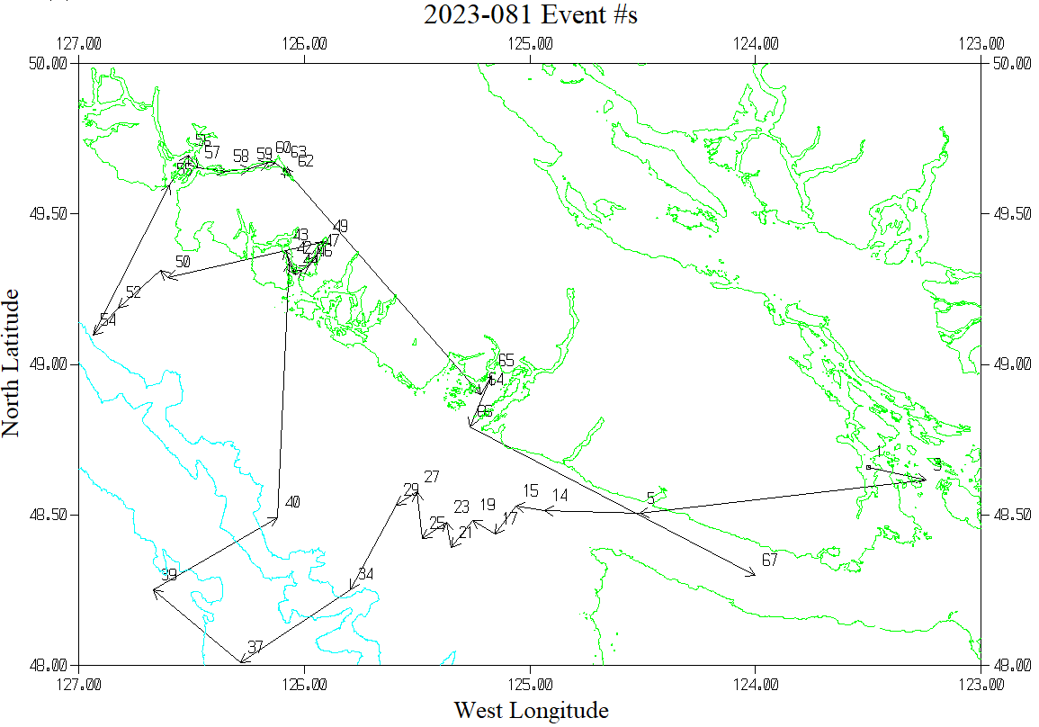

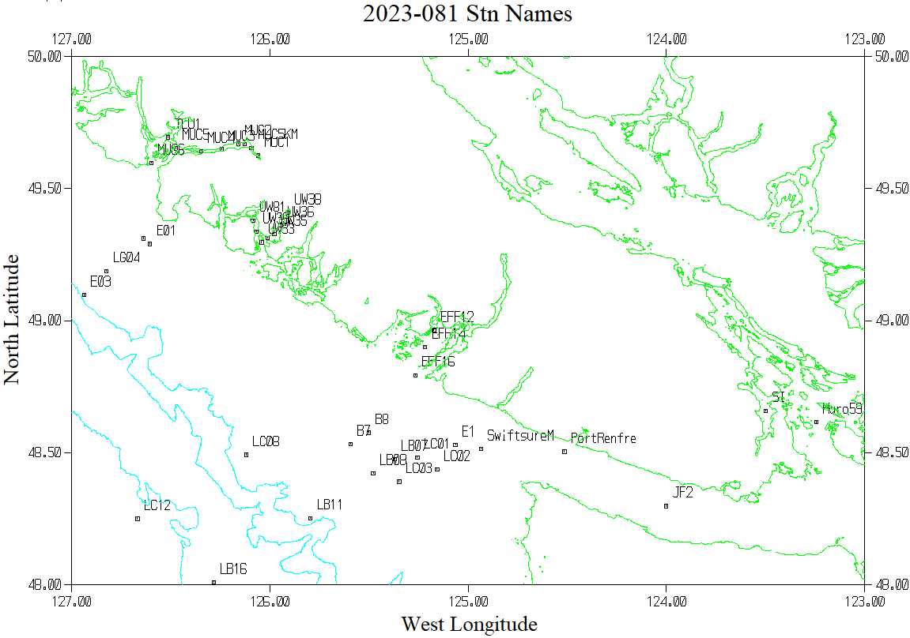

**CRUISE SUMMARY – CTD 2023-081**

|  |  |  |  |  |  |
| --- | --- | --- | --- | --- | --- |
| **CTD#** | **Make** | **Model** | **Serial#** | **Used with Rosette?** | **CTD Calibration Sheet Competed?** |
| **1** | **SEABIRD** | **911+** | **1515** | **Yes** | **Yes** |

|  |  |  |  |  |  |
| --- | --- | --- | --- | --- | --- |
| **Calibration Information - 1515** | | | | | |
| **Sensor** | | **Pre-Cruise** | | **Post Cruise** | |
| **Name** | **S/N** | **Date** | **Location** | **Date** | **Location** |
| **Temperature** | **6754** | **24Jan2023** | **Factory** |  |  |
| **Conductivity** | **6141** | **24Jan2023** | **Factory** |  |  |
| **Secondary Temp.** | **6736** | **3Feb2023** | **Factory** |  |  |
| **Secondary Cond.** | **6146** | **24Jan2023** | **Factory** |  |  |
| **Transmissometer** | **1185DR** | **23Mar2023** | **Factory** |  |  |
| **Transmissometer** | **1883DG** | **23Mar2023** | **Factory** |  |  |
| **SBE 43 DO sensor** | **1119** | **10Feb2023** | **Factory** |  |  |
| **PAR sensor** | **70613** | **24Feb2021** | **Factory** |  |  |
| **SeaPoint Fluor.** | **3650** |  |  |  |  |
| **Pressure Sensor** | **1515** | **17-Jan-2023** | **Factory** |  |  |
| **Valeport Altimeter** | **79487** |  | **Factory** |  |  |
| **Reference PAR** | **16504** | **3Mar2016** | **Factory** |  |  |