**RBR CTD DATA PROCESSING NOTES**

Cruise: 2023-077

Agency: OSD

Locations: Nootka Sound

Project: Meteorological Network

Party Chief: Cooper G.

Platform: Doug Anderson

Date: August 29, 2023 – August 31, 2023

Processed by: Samantha Huntington

Date of Processing: August 28, 224 -

Number of Raw files: 61 Number of Processed Files: 61

**Instrument Summary**

Equipment: RBR Concerto CTD (s/n 28765) with a Turner Cyclops Fluorometer (s/n 2110792), a JFE Advantech Rinko III oxygen sensor (s/n 447)and a Seapoint Turbidity sensor (s/n 208765).

Sampling frequency was at 8Hz.

**Summary of Quality and Concerns**

A cast list of times and locations was provided, “2023-077TapLog_CTDFinal.xlxs”. Cast 46 was stopped during the ascent and recorded as two casts, this had to be corrected at the beginning of processing. The clutch also disengaged on casts 47-49.

The data overall look good with some bad data at the top of cast 28, 34 and 53.

**Processing Summary**

1. **Conversion to IOS Headers**

Casts from 2023-063 were found in the 208765_20230830_1955.rsk file, the extracted excel file was edited so that only the events for 2023-077 were present. The file was saved as 208765_2023_0830_1955_077only.xlsx

Cast 46 was recorded as two casts by Ruskin due to the CTD getting stuck for a bit. The excel file was also altered to ensure that this was only one cast.

Cast 6 is repeated in the taplog 3 times, this was changed to be casts 6, 7 and 8.

A single file (2021-0045_CTD_Data.csv) with all the data including event numbers and a single line of headers was prepared using python function MERGE_FILES().

A 6-line header was inserted using python function Add_6Lineheader_2().

File “2023-077_header-merge.csv” was created, based on the information provided by the chief scientist.

* Column “File_Name”: entries were derived from the event number.
* Column “LOC:LATITUDE”: latitude was provided and reformatted to “XX XX.XXXX N !(deg min)”.
* Column “LOC:LONGITUDE”: longitude was provided and reformatted to “XX XX.XXXX W !(deg min)”.
* Column “LOC: Event Number”: entries were event numbers.
* Colmun “LOC: STATION”: all stations were set according the to taplog file.

The sampling site was mapped (Figure 1) using from “2023-077_header-merge.csv” using python function Plot_Track_Location() to check the location of all casts.

Prior to conversion to IOS header format, the presence of zero-order holds were checked using Python function Plot_Pressure_Diff(). Zero-order holds were found (Figure 2.) and these values were replaced with Nan using the python function Correct_Hold().

A new csv file was created “2023-077_CSV_DATA-6Linedr_corr_hold.csv” and the corrected values were checked in python function Plot_Pressure_Diff(). Zero-order holds were found to be removed (Figure 3.).

CONVERT Spreadsheet Files was run to produce files with IOS Header format. Header entries of “Administration”, “File” and “Instrument” were filled in this step.

The routine “Merge:CSV Files to headers” was run to add location headers to the IOS files.

Next CLEAN was run to add a start time and event numbers to headers.

Then REORDER was run to reorder the channels in all files.

ADD TIME CHANNEL was run to add a record number to each file.

Raw data were plotted and examined:

* Salinity looks good.
* Temperature looks good.
* Conductivity looks good.
* Oxygen looks good.
* Fluorescence has spikes in many casts.

1. **Data processing**

* Correction to Pressure: Negative pressures were seen in the raw data at the end of the upcasts so pressure was not calibrated.
* Data despiking: There are no significant spikes in temperature, conductivity and salinity. So there is no need to apply data despiking. Flourescence spikes will be examined after DELETE.
* CLIP: Pressure is steady for a variable number of scans. Initial records were removed until the downcast began using file “2023-077_CLIP.csv”.
* Filter: a Gull-winged filter, size 3, was applied to temperature, conductivity, and pressure. Salinity will be calculated in the next step.
* SHIFT: Based on suggested values in document “Guidelines for processing RBR CTD profiles”, the alignment of temperature and conductivity was corrected by applying a shift of -2 scans in conductivity.
* SHIFT: Better alignment with Oxygen profiles was found by advancing it by 11 scans. The advice given in document “Guidelines for processing RBR CTD Profiles” was that an advance between 2 and 3 seconds is appropriate. T-O plots before and after alignment were compared.
* Delete was run to remove records with a descent rate lower than 0.3m/s over 8 points. This was not applied in the top 10m to avoid loss of surface records as the CTD began its descent.
* Profile plots were examined after DELETE and confirm that plots show reasonable values for salinity and conductivity and fluorescence. DO saturation levels at the surface ranged from 0% to 142%. However there was no calibration sampling and no climatology to enable a judgement about the data reliability.
* DESPIKING: Fluorescence spikes were removed from casts 14, 26-29, 31, 32, 35-40, 42, 45, 47-49, 56, 58 and 60.

1. **Final checks and header editing**

* REMOVE was run to remove the following channels from all casts: Date, Time:UTC and Event.
* BIN AVERAGE was used to metre-average data.
* CALIBRATE was run to convert conductivity units to S/m using file 2023-077-recal2.ccf.
* Header Edit was used to fix channel names and format as listed below:
* Pressure: format F11.2 ==> F7.1
* Salinity:CTD ==> Salinity
* Oxygen==> Fluorescence:URU
* mL/L==> %
* F11.4==>F8.2
* Conductivity: F10.5 ==> F10.6
* CLEAN was run to reset the Maximum and Minimum values in the Header.
* Header Check was run and no problems were found.

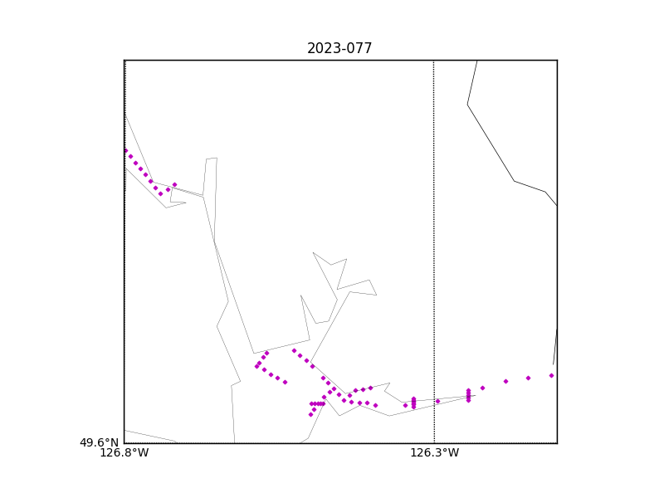

Figure 1 – location of casts.

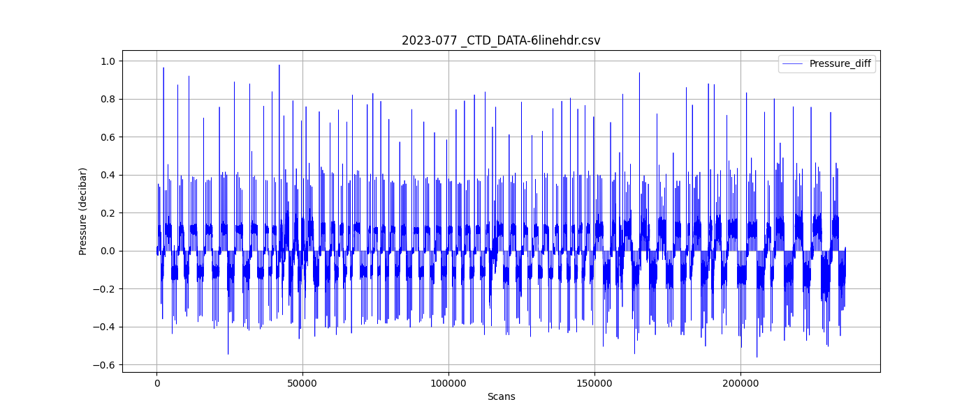

Figure 2 – zero-order holds

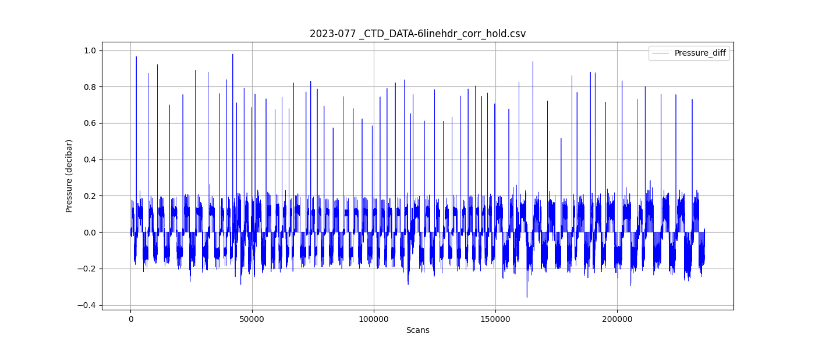

Figure 3 – zero order holds removed