**RBR CTD DATA PROCESSING NOTES**

Cruise: 2023-063

Agency: OSD

Locations: Clayoquot Sound

Project: Meteorological Network

Party Chief: Cooper G.

Platform: Doug Anderson

Date: June 7, 2023 – June 10, 2023

Processed by: Samantha Huntington

Date of Processing: December 12, 2023 – December 20, 2023

Number of Raw files: 55 Number of Processed Files: 50

**Instrument Summary**

Equipment: RBR Concerto CTD (s/n 208765) with a Turner Cyclops Fluorometer (s/n 2110792) set to manual and a JFE Advantech Rinko III oxygen sensor (s/n 0447) and a Seapoint turbidity sensor (s/n 208765.

Sampling frequency was at 8Hz.

**Summary of Quality and Concerns**

A cast list of times and locations was provided, “2023-063Taplog_CTDLog.xlxs”. There were 55 casts in total but 5 of them were zooplankton events only so the event numbers for the RBR casts were not sequential and were matched to this list.

The data overall look good with some bad Temperature data present at the top of many casts and some gain change related spikes in the Fluorescence profiles. There is one spike in Conductivity and Salinity in cast 36. Most casts start at around 1m following a soak.

Dissolved Oxygen is very high. After discussion with the chief scientist and looking at other cruises during the summer it was decided that these data were real and that a calibration was not required.

**Processing Summary**

1. **Conversion to IOS Headers**

Multiple profiles were found in the 208765_20230609_1816.rsk file.

Profiles were identified by date and time and extracted using python function READ_EXCELrsk().

A single file (2023-063_CTD_Data.csv) with all the data including event numbers and a single line of headers was prepared using python function MERGE_FILES().

A 6-line header was inserted using python function Add_6Lineheader_2().

File “2021-063_header-merge.csv” was created, based on the information provided by the chief scientist.

* Column “File_Name”: entries were derived from the event number.
* Column “LOC:LATITUDE”: latitude was provided and reformatted to “XX XX.XXXX N !(deg min)”.
* Column “LOC:LONGITUDE”: longitude was provided and reformatted to “XX XX.XXXX W !(deg min)”.
* Column “LOC: Event Number”: entries were event numbers.
* Column “LOC: STATION”: station names were provided

The sampling site was mapped (Figure 1) using from “2023-064_header-merge.csv” using python function Plot_Track_Location() to check the location of all casts.

Prior to conversion to IOS header format, the presence of zero-order holds were checked using Python function Plot_Pressure_Diff(). Zero-order holds were found (Figure 2.) and these values were replaced with Nan using the python function Correct_Hold().

A new csv file was created “2023-063_CSV_DATA-6Linedr_corr_hold.csv” and the corrected values were checked in python function Plot_Pressure_Diff(). Zero-order holds were found to be removed (Figure 3.).

CONVERT Spreadsheet Files was run to produce files with IOS Header format. Header entries of “Administration”, “File” and “Instrument” were filled in this step.

The routine “Merge:CSV Files to headers” was run to add location headers to the IOS files.

Raw data were plotted and examined:

* Salinity looks good with some bad data at the bottom of casts 12 and 25, at the top of cast 52, and a spike in cast 36.
* Temperature looks good with some bad data at the top of casts, 5, 6, 19, 27, 28, 29, 39, 40, 41, 52, 54, 55. And some bad data at the bottom of cast 29.
* Conductivity looks good with some bad data at the bottom of cast 12 and a spike in cast 36.
* Oxygen looks good with some bad data at the bottom of cast 12, 28 and 50, and at the top of casts 28 and 41. Derived Oxygen Concentration plots compared well to measured Oxygen Saturation plots.
* Fluorescence looks OK but some spikes in all casts.
* Turbidity looks OK with spikes in many casts and an extreme spike at the bottom of cast 12 and top of cast 50.

Next CLEAN was run to add a start time and event numbers to headers.

Then REORDER was run to reorder the channels in all files.

1. **Data processing**

* Correction to Pressure: negative pressures were seen in the raw data for all casts at the end of the data, with Conductivity over 30 so pressure was calibrated.
* CLIP: Pressure is steady for a variable number of scans. Initial records were removed until the downcast began using file “2023-063_CLIP.csv”.
* Filter: a Gull-winged filter, size 5, was applied to temperature, conductivity, fluorescence and pressure. Salinity will be calculated in the next step.
* SHIFT: Based on suggested values in document “Guidelines for processing RBR CTD profiles”, the alignment of temperature and conductivity was corrected by applying a shift of -2 scans in conductivity.
* SHIFT: Better alignment with the three Oxygen profiles was found by advancing it by 11 scans. The advice given in document “Guidelines for processing RBR CTD Profiles” was that an advance between 2 and 3 seconds is appropriate. T-O plots before and after alignment were compared.
* Delete was run to remove records with a descent rate lower than 0.3m/s over 8 points. This was not applied in the top 10m to avoid loss of surface records as the CTD began its descent.
* Profile plots were examined after DELETE and confirm that plots show reasonable values for salinity and conductivity and fluorescence. DO saturation levels at the surface ranged from 0% to 165%. However there was no calibration sampling and no climatology to enable a judgement about the data reliability.

* Despiking: At this point some bad data was manually removed from the bottom of cast 12 and the spike in Salinity and Conductivity was padded in cast 36. Fluorescence spikes were easier to spot with the upcast removed. Plots were examined together with the gain change information provided in the excel that was extracted from the rsk file. Spikes were not found to not be related to gain changes in the fluorometer. Spikes were padded in casts: 1, 2, 17, 32, 40, 41 and 51.

1. **Final checks and header editing**

* REMOVE was run to remove the following channels from all casts: Date, Time:UTC and Event, the derived Oxygen Concentration from the Ruskin software was removed here as well.
* BIN AVERAGE was used to metre-average data.
* CALIBRATE was run to convert conductivity units to S/m using file 2023-063-recal2.ccf.
* Header Edit was used to fix channel names and format as listed below:
* Pressure: format F11.2 ==> F7.1
* Salinity:CTD ==> Salinity
* Fluorescence ==> Fluorescence:URU
* Oxygen_mL_L ==> Oxygen:Dissolved:Rinko
* Oxygen_umol_kg ==> Oxygen:Dissolved:Rinko
* CLEAN was run to reset the Maximum and Minimum values in the Header.
* Header Check was run and no problems were found.

Figure 1 – location of casts.

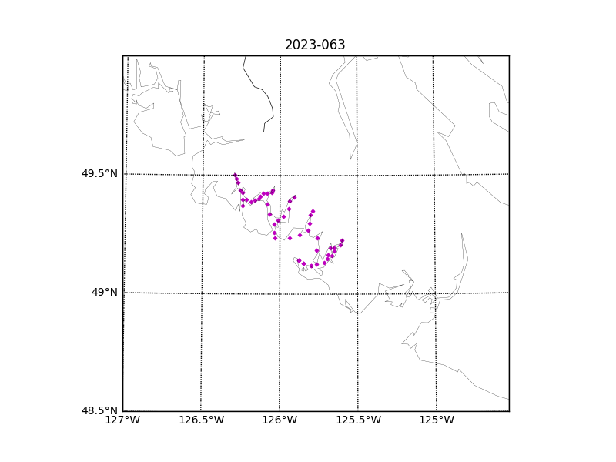

Figure 2 – zero-order holds

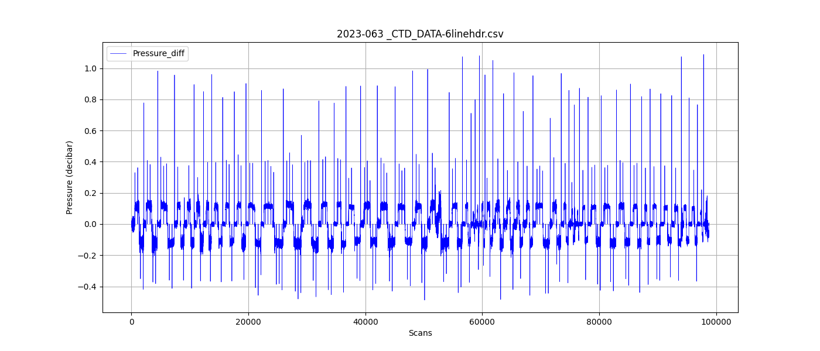

Figure 3 – zero order holds removed