|  |  |
| --- | --- |
| **Revision Table Notice** | |
| **Date** | **Description of Revision** |
| **29 June 2023** | **DO Saturation converted to DO concentration. SH** |

**RBR CTD DATA PROCESSING NOTES**

Cruise: 2023-058

Agency: OSD

Locations: Queen Charlotte Strait

Project: Queen Charlotte Strait Weather Station Network

Party Chief: Cooper G.

Platform: Blackfish

Date: May 11, 2023 – May 12, 2023

Processed by: Samantha Huntington

Date of Processing: June 6, 2023 – June 8, 2023

Number of Raw files: 1 Number of Processed Files: 14

**Instrument Summary**

Equipment: RBR Maestro CTD (s/n 208765) with a Turner Cyclops Fluorometer (s/n 2110792), a JFE Advantech Rinko III oxygen sensor (s/n 0447), and a Seapoint turbidity sensor (s/n 208765). Sampling frequency was at 8Hz.

**Summary of Quality and Concerns**

A cast list of times and locations was provided, so this was cross-referenced against the dates and times in the RSK files. The dates and times in the RSK files match the dates and times in the cast list.

Descent and recovery rates were about -.35 m/s. The fluorometer was set to a fixed gain rather than an autogain to reduce gain change spikes.

The data overall look good.

**Processing Summary**

1. **Conversion to IOS Headers**

There was one .rsk file from this cruise containing 14 events. All 14 casts were extracted using the python function READ_EXCELrsk().

A single file (2023-058_CTD_Data.csv) with all the data including event numbers and a single line of headers was prepared using the Python function MERGE_FILES().

A 6-line header was inserted using the Python function Add_6Lineheader_2().

File “2023-058_header-merge.csv” was created, based on the information provided by the chief scientist.

* Column “File_Name”: entries were derived from the event number.
* Column “LOC:LATITUDE”: latitude was provided and reformatted to “XX XX.XXXX N !(deg min)”.
* Column “LOC:LONGITUDE”: longitude was provided and reformatted to “XX XX.XXXX W !(deg min)”.
* Column “LOC: Event Number”: entries were event numbers.
* Column “LOC: STATION”: all stations were set to those provided in the cruise log.
* Column “LOC: Water Depth:” was set to the water depth provided in the cruise log.

The sampling site was mapped (Figure 1) using from “2023-058_header-merge.csv” using the Python function Plot_Track_Location() to check the location of all casts.

Prior to conversion to IOS header format, the presence of zero-order holds were checked using the Python function Plot_Pressure_Diff() (Figure 2). It was unclear if there were zero-order holds from the output figure, so a differential was calculated on pressure in 2023-058_CSV_DATA-6linehdr.csv. Holds were found to occur at regular intervals in the file. A correction was applied using the Python function CORRECT_HOLD() and the corrected data were plotted (Figure 3).

CONVERT Spreadsheet Files was run to produce files with IOS Header format. Header entries of “Administration”, “File” and “Instrument” were filled in this step.

Raw data were plotted and examined:

* Conductivity looks fine.
* Salinity looks fine with a few spikes in casts 6, 7, 9 and 14.
* Oxygen looks there is a spike in cast 1 and cast 1 is not as smooth as the rest of the casts.
* Fluorescence looks to be spiky in all casts.
* Temperature looks fine.
* Pressure looks fine for all but cast 14 with a spike at 100db on the upcast.

T-S plots were also made.

The routine “Merge:CSV Files to headers” was run to add location headers to the IOS files.

Next CLEAN was run to add a start time and event numbers to headers as well.

Then REORDER was run to reorder the channels in all files.

1. **Data processing**

* No correction to pressure was needed for this cruise.
* Pressure is steady for variable records in each cast. CLIP was done using 2023-058_CLIP.csv
* De-spiking: The spike in Oxygen is during the upcast so this was not de-spiked since the upcast will be discarded later in processing. Spikes in Fluorescence were not associated with gain changes which happened prior to the descent and at the end of the upcast. Records at the time of gain changes were either clipped or will be removed when the upcast is discarded later in processing. Salinity spikes will be handled later.
* Filter: a Gull-winged filter, size 3, was applied to temperature, conductivity, fluorescence, and pressure. Salinity will be recalculated after the shift steps.
* SHIFT: The suggested number of scans for shifting conductivity to align with temperature is -2 in the document “Guidelines for processing RBR CTD profiles”. Conductivity was lagged -2 records and salinity was recalculated after alignment. Salinity profile plots before and after alignment were compared.
* SHIFT: Better alignment with Oxygen profiles was found by advancing it by 11 scans, which corresponds to a shift of +1.375s for an 8Hz sampling frequency. The advice given in document “Guidelines for processing RBR CTD Profiles” was that an advance between 2 and 3 seconds is appropriate. T-O plots before and after alignment were compared.
* Delete was run to remove records with a descent rate lower than 0.3m/s over 8 points. This was not applied in the top 10m to avoid loss of surface records as the CTD began its descent, nor in the bottom 10m.
* Salinity spikes were replaced with Pad values using a text editor in casts 6, 7, 9 and 14.
* Profile plots were examined after DELETE. The plots show reasonable values for salinity, conductivity and fluorescence. DO saturation levels at the surface ranged from about 85% to 100%. There was no calibration sampling and no climatology to enable a judgement about the data reliability.
* CLEAN was run to replace negative Turbidity values with Pad values.

1. **Final checks and header editing**

* REMOVE was run to remove the following channels from all casts: Date, Time:UTC, and Event.
* BIN AVERAGE was used to average the data by pressure into 1 dbar bins.
* CALIBRATE was run to convert conductivity units to S/m using file 2023-058-recal2.ccf.
* CLEAN was run to reset the Maximum and Minimum values in the Header.
* Header Edit was used to fix channel names and format as listed below:
* Depth: meters ==> metres
* Temperature: deg C(ITS90) ==> deg C (ITS90)
* Salinity:CTD ==> Salinity
* Fluorescence ==> Fluorescence:URU
* Conductivity: F10.5 ==> F10.6
* Oxygen:Dissolved ==> Oxygen:Dissolved:Saturation:RBR, format F11.4 ==> F8.2
* Turbidity ==> Turbidity:Seapoint
* Header Check was run and no problems were found. Standards check was run and no problems were found.
* Final profile and T-S plots were made and checked.

Figure 1 – Location of casts for cruise 2023-058.

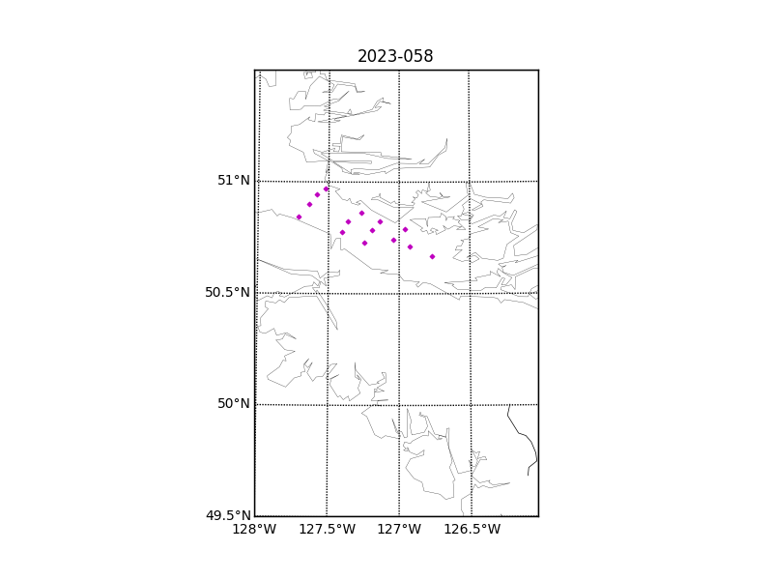

Figure 2 – Zero-order holds prior to correction.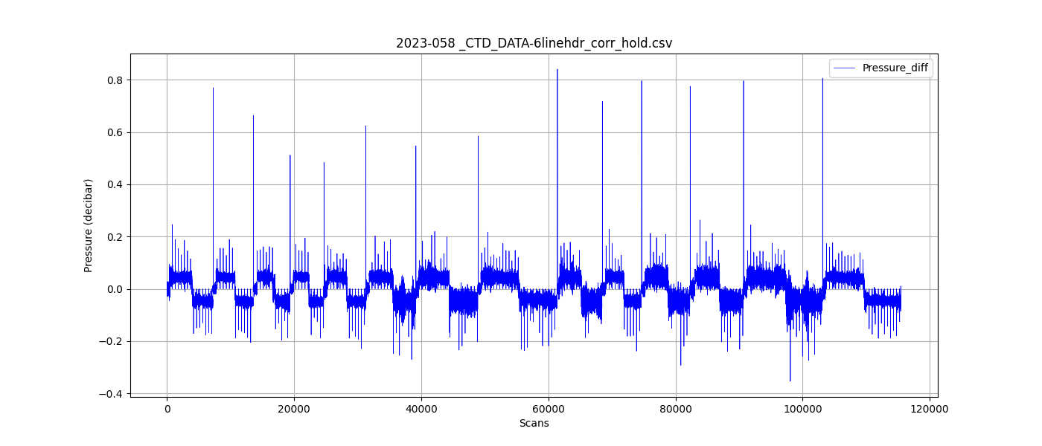

Figure 3 – Pressure differentials after the zero-holds correction. 