**RBR CTD DATA PROCESSING NOTES**

Cruise: 2023-042

Agency: OSD

Locations: Quatsino Sound, Holberg Inlet and Neroutsos Inlet

Project: Meteorological Network

Party Chief: Cooper G.

Platform: Blackfish

Date: March 6, 2023 – March 10, 2023

Processed by: Samantha Huntington

Date of Processing: December 20, 2023 – February 14, 2024

Number of Raw files: 27 Number of Processed Files: 27

**Instrument Summary**

Equipment: RBR Concerto3 CTD (s/n 204694) with a Fluorometer (Chlorophyll a Turner Cyclops s/n 211012) and oxygen sensor (JFE Advantech Rinko III BT s/n 411)

Sampling frequency was at 8Hz.

**Summary of Quality and Concerns**

A cast list of times and locations was provided, “2023-042CTDLogFileFinal.xlxs”. Cast 7 experienced and Oxygen sensor failure. The Oxygen channels will be removed from this cast. Position coordinates for this cast were also incorrect, the coordinates had been duplicated from the previous cast. After confirming with the chief scientist the coordinates were corrected.

The data overall look good. A summary of the initial plots can be found in the next section.

**Processing Summary**

1. **Conversion to IOS Headers**

Multiple profiles were found in the file ‘204694_20230308_1348.rsk’ and extracted using python function READ_EXCELrsk().

A single file (2023-042_CTD_Data.csv) with all the data including event numbers and a single line of headers was prepared using python function MERGE_FILES().

A 6-line header was inserted using python function Add_6Lineheader_2().

File “2023-042_header-merge.csv” was created, based on the information provided by the chief scientist.

* Column “File_Name”: entries were derived from the event number.
* Column “LOC:LATITUDE”: latitude was provided and reformatted to “XX XX.XXXX N !(deg min)”.
* Column “LOC:LONGITUDE”: longitude was provided and reformatted to “XX XX.XXXX W !(deg min)”.
* Column “LOC: Event Number”: entries were event numbers.
* Colmun “LOC: STATION”: entries were the stations provided

The sampling site was mapped (Figure 1) using from “2023-042_header-merge.csv” using python function Plot_Track_Location() to check the location of all casts.

Prior to conversion to IOS header format, the presence of zero-order holds were checked using Python function Plot_Pressure_Diff(). Zero-order holds were found (Figure 2.) and these values were replaced with Nan using the python function Correct_Hold().

A new csv file was created “2023-042_CSV_DATA-6Linedr_corr_hold.csv” and the corrected values were checked in python function Plot_Pressure_Diff(). Zero-order holds were found to be removed (Figure 3.).

CONVERT Spreadsheet Files was run to produce files with IOS Header format. Header entries of “Administration”, “File” and “Instrument” were filled in this step.

The routine “Merge:CSV Files to headers” was run to add location headers to the IOS files.

Raw data were plotted and examined:

* Salinity looks good with some bad data at the bottom of casts 4-6, 16-18, and 28.
* Temperature looks OK.
* Conductivity looks good with some bad data at the bottom of casts 4-6, 16-18, and 28.
* Oxygen looks good with some bad data at the bottom of casts 16-18 , cast 7 is bad and will be removed.
* Fluorescence looks OK but will be examined for spikes after the upcast is deleted.

Next CLEAN was run to add a start time and event numbers to headers.

Then REORDER was run to reorder the channels in all files.

1. **Data processing**

* Correction to Pressure: although there were negative pressure spikes seen in the raw data, they were at the end of the upcast for, and the corresponding Conductivity was found to be less than 0.01 mS/cm, so pressure was not calibrated.
* Data despiking: There are no significant spikes in temperature, conductivity and salinity. So there is no need to apply data despiking. Plots will be examined after delete to see if bad data needs to be removed from the bottom of some casts.
* CLIP: Pressure is steady for a variable number of scans. Initial records were removed until the downcast began using file “2023-042_CLIP.csv”.
* Filter: a Gull-winged filter, size 3, was applied to temperature, conductivity, and pressure. Salinity will be calculated in the next step.
* SHIFT: Based on suggested values in document “Guidelines for processing RBR CTD profiles”, the alignment of temperature and conductivity was corrected by applying a shift of -2 scans in conductivity.
* SHIFT: Better alignment with all Oxygen profiles was found by advancing it by 11 scans. The advice given in document “Guidelines for processing RBR CTD Profiles” was that an advance between 2 and 3 seconds is appropriate. T-O plots before and after alignment were compared.
* Delete was run to remove records with a descent rate lower than 0.3m/s over 8 points. This was not applied in the top 10m to avoid loss of surface records as the CTD began its descent.
* Profile plots were examined after DELETE and confirm that plots show reasonable values for salinity and conductivity and fluorescence. DO saturation levels at the surface ranged from 0% to 101%. However there was no calibration sampling and no climatology to enable a judgement about the data reliability.
* Despiking: Final records containing some bad data were removed from the bottom of casts 2-6 and 16-18. Fluorescence spikes were removed from casts 4-6, 11, 12, 16, 17, 23, 24, 27.

1. **Final checks and header editing**

* REMOVE was run to remove the following channels from all casts: Date, Time:UTC and Event. Oxygen was removed from cast 7.
* BIN AVERAGE was used to metre-average data.
* CALIBRATE was run to convert conductivity units to S/m using file 2023-042-recal2.ccf.
  + Pressure: format F11.2 ==> F7.1
  + Salinity:CTD ==> Salinity
  + Fluorescence ==> Fluorescence:URU
  + Oxygen_mL_L ==> Oxygen:Dissolved:Rinko
  + Oxygen_umol_kg ==> Oxygen:Dissolved:Rinko
* CLEAN was run to reset the Maximum and Minimum values in the Header.
* Header Check was run and no problems were found.

Figure 1 – location of casts. 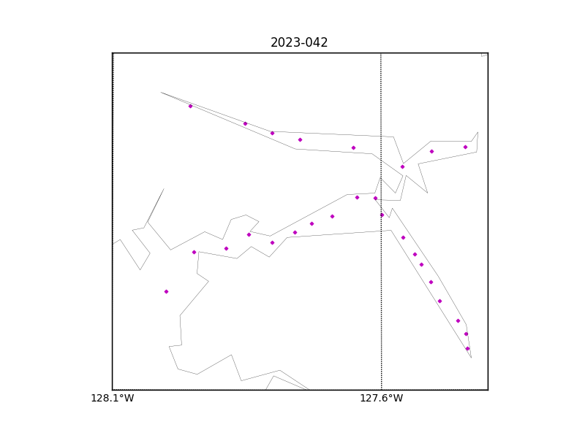

Figure 2 – zero-order holds

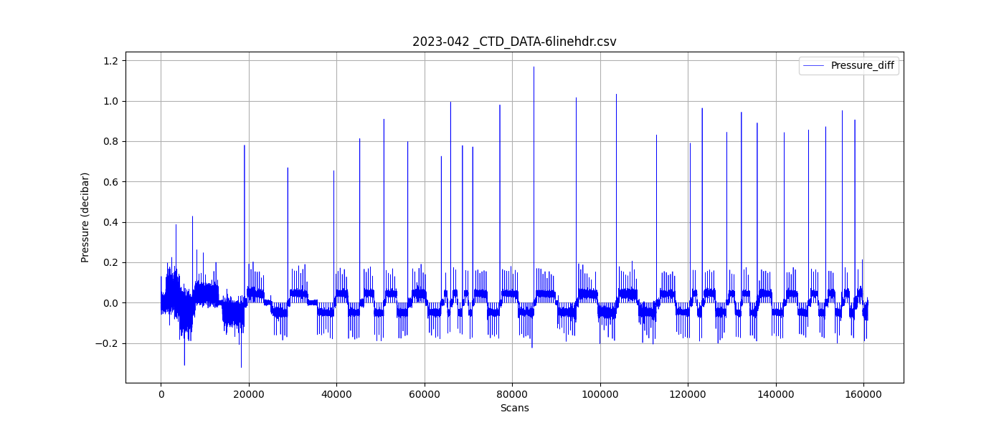

Figure 3 – zero order holds removed