## REVISION NOTICE TABLE

|  |  |
| --- | --- |
| DATE | DESCRIPTION OF REVISION |
|  |  |

## PROCESSING NOTES

Cruise: 2023-030

Agency: OSD

Location: North-East Pacific

Project: Deep Sea Marine Conservation Survey

Chief Scientist: Norgard T.

Platform: John P. Tully

Cruise Dates: 26 May 2023 – 12 June 2023

Processed by: Germaine Gatien

Date of Processing: 18 January 2024 – 30 January 2024

Number of original HEX files: 9 Number of processed CTD files: 8 (1st cast shallow test only)

Number of rosette casts: 6 Number of processed CHE files: 6

Number of ROPOS SBE25 HEX files: 11 Number of ROPOS files: 11

# INSTRUMENT SUMMARY

SBE911+ CTD #0550 was mounted in a rosette and attached were 2 WetLabs CSTAR transmissometer (1185DR & #1883DG), a SBE 43 DO sensor on the primary pump (#3791), SeaPoint Fluorometer on the secondary pump (#4108- for casts 1-28; #3640 for casts #29-37), a Biospherical QSP-400 PAR sensor (#70613) and an altimeter (#73171).

The data logging computer WP #102.

The deck unit was a Seabird model 11+ #424.

An IOS rosette with 24 10L bottles was used.

SBE25+ CTD #1094 was mounted on the ROPOS and had a SeaPoint fluorometer #2228 and an SBE oxygen sensor #1483 attached.

# SUMMARY OF QUALITY AND CONCERNS

The Daily Science Log Book and rosette log sheets were in good order with comments about problems encountered and a detailed list of equipment. The Bottle_Summary spreadsheet was very helpful.

The standard deployment procedure for this cruise was as follows:

The rosette was brought to the surface. The rosette was brought down to 10m. Once back at the surface, the data started to be archived.

For all rosette casts:

Niskin bottles closed from 0 to 400 db had a wait time of at least 60 seconds.

All Niskin bottles deeper than 400 db had a wait time of at least 30 seconds.

There were 2 WetLabs CStar transmissometers in use during this cruise:

Channel Transmissometer refers to sensor #1185DR (650nm - red)

Channel Transmissometer:Green refers to sensor #1883DG (530nm - green)

For comparison with other Institute of Ocean Sciences cruises, note that the transmissometer wavelength is 650nm unless otherwise stated.

PAR data were bad with very low values and odd profiles. The channel was removed.

Channel Fluorescence:URU:Seapoint was removed from events #11-28. It was noted in the log that the data were bad. After replacement of the fluorometer, data for events #29-35 looked good.

The SBE DO sensor has a fairly long response time so data accuracy is not as high when it is in motion as it is during stops for bottles. This will be especially true when vertical DO gradients are large. To get an estimate of the accuracy of the SBE DO data during downcasts (after recalibration) a rough comparison was made between downcast SBE DO and upcast titrated samples. Some of the difference will be due to incomplete flushing of Niskin bottles and imperfect matches in levels from the two data sets as well as errors in sample analysis/collection, so the following statement likely underestimates SBE DO accuracy. For this cruise the results were very good with differences above the oxygen minimum zone (OMZ) mostly showing the CTD DO to be reading higher than titrated samples and lower than samples below the OMZ. Vertical DO gradients have opposite above and below the OMZ, so errors due to slow response time and incomplete flushing of bottles also having opposite signs.

Downcast (CTD files) Oxygen:Dissolved:SBE data for this cruise are considered, very roughly, to be:

±0.10 mL/L from 0 - 200db except in areas of very large DO gradients

±0.06 mL/L from 200db - 600db

±0.05 mL/L from 600db - 900db

±0.03 mL/L below 900db

CTD files that were mounted on the ROPOS were processed. The configuration file used at sea contained out-of-date parameters. The correct parameters were found and used in processing. Times were added for each record and start positions were added to the headers.

The files with extension ROPOS contain the full record for each dive.

# PROCESSING SUMMARY

##### Seasave

This step was completed at sea; the raw data files have extension HEX.

##### Preliminary Steps

The Log Book and rosette log sheets were obtained.

* Nutrients, extracted chlorophyll, dissolved oxygen and salinity were obtained in QF spreadsheet format from the analysts.
* The cruise summary sheet was completed.
* The history of use of the pressure, conductivity and dissolved oxygen sensors was obtained. Since the last factory service, those sensors were used during part of cruise 2023-066 and all of 2023-019 which occurred before this cruise. They were also used for cruise 2023-025 which occurred after this cruise.

The configuration files were checked; there was a change of fluorometer starting at cast #29 but the configuration file was not changed. This does not affect data since the settings were the same.

Dissolved oxygen hysteresis factor E was reset from 0.036 to 0.033 based on a study during 2023-066.

##### BOTTLE FILE PREPARATION

One of the files used at sea was saved as file 2023-030-ctd1.xmlcon.

A second file with the corrected fluorometer serial number was saved as 2023-030-ctd2.xmlcon.

The HEX files were converted to ROS files:

* using 2023-030-ctd1.xmlcon for casts 1- 28
* using 2023-030-ctd2.xmlcon for casts 29-37.

The ROS files were converted to IOS format.

The IOS files were put through CLEAN to create BOT files.

Temperature and salinity were plotted for all BOT files to check for significant outliers and none were found.

A preliminary header check was run; the only problem noted is that fluorescence values are unreasonably high, but it is already known that the fluorometer malfunctioned until it was replaced before cast #29.

The BOT files were bin-averaged on bottle number.

The output was used to create file ADDSAMP.csv. First, the file was sorted on event number and Bottle Position order. Then sample numbers were added based on the rosette logs.

The ADDSAMP file was then reordered on event # & sample #.

The ADDSAMP file was used to add sample numbers to the BOT files – output *.SAM.

The SAM files were bin-averaged on bottle # and called SAMAVG.

The SAMAVG file for event #1 was reduced to just 1 record as only Niskin 1 was sampled.

The addsamp.csv file was converted to CST files, which will form the framework for the bottle files.

At this stage cast #1 was dropped from processing since there was only eDNA sampling and a CHE file is not needed; there are no rosette files for any other eDNA sampling.

Next, each of the analysis spreadsheets were examined to see what comments the analysts wanted included in the header file. These were used to create file 2023-030-bot-hdr.txt which will be updated as needed during processing.

DISSOLVED OXGYEN

Dissolved oxygen data were provided in spreadsheet QF2023-030_OXY*.xlsx which includes flags, comments and a precision study. Draw temperatures are available. The spreadsheet page with the final data was simplified and saved as 2023-030oxy.csv. That file was converted into individual *.OXY files.

EXTRACTED CHLOROPHYLL

Extracted chlorophyll and phaeo-pigment data were obtained in file QF2023-030_CHL QF*.xlsx. The file included comments and flags and a precision study. A simplified version of the spreadsheet was prepared and saved as 2023-030chl.csv. The csv file was then converted to individual CHL files.

SALINITY

Salinity analysis was obtained in file QF2023-030_SAL.xlsx which included a precision study. The analyses were carried out in a temperature-controlled lab 3 to 7 days after collection. The files were simplified and saved as 2023-030sal.csv. That file was then converted to individual SAL files.

NUTRIENTS

The nutrient data were obtained in spreadsheet QF2023-030_NUTS*.xlsx. This includes a precision study. The file was simplified, saved as 2023-030nuts.csv. The file was converted to individual NUT files.

The SAL, CHL, OXY and NUT files were merged with CST files in 4 steps.

After the 4th step the files were put through CLEAN to reduce the headers to File and Comment sections only.

These files are ordered on sample number, but the SAMAVG files are ordered on bottle number, so one or the other set needs to be reordered in order to merge them. The MRGCLN1 files were reordered on Bottle_Number and saved as *. MRGCLN1s.

The MRGCLN1s files were then merged with SAMAVG files using merge channel Bottle_Number.

The output of the MRG files were exported to a spreadsheet and compared to the rosette log sheets to look for omissions. The sample numbers for cast #18 were wrong. The addsamp file was corrected, converted and the merge process begun again. The merge process was repeated after corrections.

##### Compare

Salinity

Compare was run with pressure as reference channel. A fit was done excluding cases where pressure<200db and 7 outliers to achieve a fit that is fairly flat with pressure. The primary salinity was found to be high by an average of 0.0010psu and the secondary salinity low by 0.0019psu.

That fit excluded a significant portion of the samples, but when all data below 200m were included the result was not very different with the primary high by 0.0012psu and the secondary low by 0.0017psu.

In each case the primary was higher than the secondary by 0.0029psu.

Salinity was analyzed quickly so evaporate/desorption errors should be very small.

Some of the bottles were fired at the bottom of casts where any flushing errors have the opposite effect to those from upcast bottles; this might account for some of the deepest bottles showing the CTD salinity looking a little out of line on the high side, while the shallowest bottles tend to show the opposite effect. However, it might just as easily be that the deepest bottles are more reliable with the shallower ones having small flushing errors. So the fit including all bottles below 200m is probably most reliable.

Both primary and secondary are within 0.002psu, so recalibration will not be needed unless a mix of primary and secondary are selected for archiving, to bring them into line with each other.

There are insufficient data to make plots against time useful.

The only significant outlier had a very high standard deviation in the CTD salinity and was in an area of high salinity gradient.

For full details for the COMPARE run see file 2023-030-sal-comp1.xls.

Dissolved Oxygen

COMPARE was run with pressure as the reference channel.

There were 3 extreme outliers:

* Nutrient samples from 2 of those bottles were flagged 5 and presumed to be a case of a bottle closing at the wrong depth. The oxygen samples #70 and 72 were also flagged 5 and padded.
* Sample #60 DO is also significantly out of line but nutrients look ok. Flagged 4.

A few other outliers were removed based on residuals and the resulting fit was:

CTD DO Corrected = CTD DO * 1.0293 - 0.0354

A separate fit was down for cast #24 which had 3 outliers to see if the whole cast was out of line but the fit was similar to that for the whole cruise:

CTD DO Corrected = CTD DO * 1.0321 - 0.0375

During 2023-019 before this cruise the fit was:

CTD DO Corrected = CTD DO * 1.0245 + 0.0143

The difference between the 2023-019 and 2023-030 ranges from 0.04mL/L at DO=1 to 0.01mL/L at DO=6, so they are reasonably close with the largest differences at low values. This could be due to slight hysteresis remaining in the oxygen sensor settings since 2023-030 had much deeper sampling. DO sensor response and flushing differences are also affected by different vertical gradients.

For full details for the COMPARE run see file 2023-030-dox-comp1.xls.

Fluorescence

COMPARE was run with extracted chlorophyll and CTD Fluorescence using pressure as the reference variable.

Two fluorometers were used.

The results for the first fluorometer were very bad, with extremely high fluorescence values compared to extracted chlorophyll, large by a factor of from 13 to 144.

For the second fluorometer, used for casts 29-37 the results are better, but with only 4 points of comparison and CHL low for all of them, it is hard to judge. Fluorescence is higher than CHL by a factor of from 2.8 to 4.9. It is typical of these fluorometers to have fluorescence higher for low CHL.

For full details for the COMPARE run see file 2023-030-fl-chl-comp1.xls.

##### Conversion of Full Files from Raw Data

Hex files were converted to CNV files:

* using 2023-030-ctd1.xmlcon for casts 1- 28.
* using 2023-030-ctd2.xmlcon for casts 29-37.

The only difference between the two xmlcon files was the fluorometer.

The Tau function and the hysteresis function were selected since there was deep sampling. Depth was included in the conversion.

A few casts were examined and all expected channels are present. A few problems were noted:

* The PAR data are bad except in the first cast which was very shallow and is not intended for the archive. After that values were either 0 or very low and often higher at depth than near the surface. The log column “PAR Status” has only 1 entry -YES for event #24. That cast had no signal at all. This channel should be removed from casts 11-37.
* The previous cruise had severe spiking in many channels but that did not occur for this cruise. There were some spikes in conductivity (small and isolated) and many in transmissivity (not unusual and possibly reflecting real conditions.
* The fluorescence data are bad until the sensor was replaced before cast #29. The fluorescence channel should be removed from casts 1-28. This problem was noted in the log.
* Altimetry looks good but there are spikes at the bottom in most casts.

##### WILDEDIT

Program WILDEDIT was run to remove spikes from the pressure, depth, conductivity, temperature and dissolved oxygen voltage on the CNV files. It is unusual to apply this step to dissolved oxygen but there were many spikes in that channel.

Parameters used were: Pass 1 Std Dev = 2 Pass 2 Std Dev = 5 Points per block = 50

The parameter “Keep data within this distance of the mean” was set to 0 so all spikes would be removed.

##### ALIGN DO

A few casts were examined; both temperature channels were noisy during upcasts so the tests were not easy to interpret, but using +2.5s improved the alignment and overall looks like a good choice. That value is the one most often chosen for the SBE911s. ALIGNCTD was run on all casts using +2.5s.

##### CELLTM

CELLTM was run using default values (α = 0.0245, β=9.5) for both the primary and secondary conductivity.

##### DERIVE and Channel Comparisons

Program DERIVE was run on all casts to calculate primary and secondary salinity and dissolved oxygen concentration.

A few casts were examined to see how well the previous 3 steps worked.

The few spikes in conductivity were removed.

The alignment of DO looks reasonably good.

The CELLTM adjustment is hard to evaluate but looks reasonable.

Transmissivity has some large spikes but they appear mostly in the upcasts or near the surface.

DERIVE was run a second time on 2 of the deeper casts to find the differences between the pairs of temperature, conductivity and salinity channels.

All differences were small, but there is a slight pressure dependence. The profiles are very noisy so the deeper values are likely most dependable since vertical gradients are low so any differences in flow rates have less effect there.

The shaded entries are from the previous 2 cruises and the one that followed which was very shallow. The differences at 2000db are consistent with those from the latter part of 2023-066 and 2023-019, so there does not appear to be significant calibration drift.

|  |  |  |  |  |  |
| --- | --- | --- | --- | --- | --- |
| Cast # | Press | T1-T0 | C1-C0 | S1-S0 | Descent Rate |
| 2023-066-0052 | 1000 | -0.0002 | -0.00004 | -0.0003 | High, Noisy |
|  | 2000 | -0.0005 | -0.00006 | -0.0003 | “ |
|  | 3000 | -0.0008 | -0.00006 | -0.0001 | “ |
|  | 3500 | -0.0008 | -0.00008 | 0 | “ |
| 2023-066-0079 | 1000 | -0.0002 | -0.00023 | -0.0026 | High, Noisy |
|  | 2000 | -0.0005 | -0.00020 | -0.0020 | “ |
|  | 3000 | -0.0003 | -0.00019 | -0.0020 | “ |
|  | 3500 | -0.0001 | -0.00017 | -0.0021 | “ |
| 2023-066-0086 | 1000 | +0.0003 | -0.00025 | -0.0032 | High, XNoisy |
|  | 2000 | -0.0002 | -0.00023 | -0.0026 | “ |
|  | 3000 | -0.0002 | -0.00021 | -0.0024 | “ |
|  | 3500 | -0.0001 | -0.00020 | -0.0024 | “ |
|  | 4000 | +0.0001 | -0.00020 | -0.0025 | “ |
| 2023-019-0039 | 500 | +0.0003 | -0.00041 | -0.0047 | High, FSteady |
|  | 1000 | +0.0003 | -0.00029 | -0.0036 | “ |
|  | 1400 | +0.0002 | -0.00022 | -0.0033 | “ |
| 2023-019-0092 | 500 | +0.0001 | -0.00040 | -0.0046 | High, Noisy |
|  | 1000 | +0.0001 | -0.00030 | -0.0037 | “ |
|  | 1500 | +0.0000 | -0.00027 | -0.0033 | “ |
|  | 2000 | -0.0004 | -0.00024 | -0.0025 | “ |
| 2023-019-0108 | 500 | +0.0002 | -0.00033 | -0.0040 | High, V Noisy |
|  | 1000 | +0.0002 | -0.00024 | -0.0041 | “ |
|  | 1500 | +0.0000 | -0.00023 | -0.0031 | “ |
|  | 2000 | -0.0004 | -0.00020 | -0.0021 | “ |
| 2023-030-0011 | 500 | +0.0004 | -0.00041 | -0.0056 | High, X Noisy |
|  | 1000 | +0.0004 | -0.00036 | -0.0045 | “ |
|  | 2000 | +0.0003 | -0.00029 | -0.0040 | “ |
| 2023-030-0037 | 500 | +0.0003 | -0.00035 | -0.0045 | High, X Noisy |
|  | 1000 | +0.0001 | -0.00026 | -0.0034 | “ |
|  | 2000 | 0 | -0.00020 | -0.0025 | “ |
|  | 3000 | 0 | -0.00019 | -0.0024 | “ |
| 2023-025-0042 | 220 | +0.0005 | -0.00052 | -0.0060 | High, Steady |
| 2023-025-0053 | 335 | +0.0005 | -0.00050 | -0.0054 | High, Steady |
| 2023-025-0058 | 390 | +0.0003 | -0.00038 | -0.0039 | High, F.Steady |

##### Conversion to IOS Header Format

The IOSSHELL routine was used to convert Sea-Bird 911+ CNV files to IOS Headers.

CLEAN was run to add event numbers and to replace pad values in the pressure channel with interpolated values based on record number.

##### Checking Headers

* Initial track plots looked good and were added to the end of this report.
* The cross-reference check looks fine.
* The only problem found in the header check was a typo that was corrected in the CLN file headers. There were no negative fluorescence values.
* Surface check was run and the average surface value was 2.0db. This is the measure of the first reading after the 10m soak, which is somewhat low for the offshore. Examining near-surface data at the start of each file showed some very low values for the early casts, as low as 0.8db, and several would have resulted in the rosette being partly in air, which seems unlikely. So it does suggest that the pressure is reading low. It was discovered at this stage that the pressure offset had been changed to 0.8db for casts 29-37 based on earlier cruises using this CTD, but it was accidentally set to 0.08db for the early casts. This explains why the early casts have such low values. Adding 0.72db to those casts leads to more reasonable values, though still a little low for the offshore, but rough conditions could lead to considerable vertical motion. The early casts will be recalibrated later by adding 0.72db.
* The bottle file header check shows silicate will not need recalibration.

The altimeter and water depth readings from the headers of the CLN files were exported to a spreadsheet. A check value was calculated by subtracting water depth from maximum depth sampled plus altimetry header. Most values were very low except for events #14 and 35 which were 10.6 and 23.9m. For each of them the log entry is different, but would produce an even bigger check value, which is likely due to being in an area of steep slopes. No changes were made to the altimetry or water depth.

##### Shift

Fluorescence

SHIFT was run on the SeaPoint fluorescence channel for all casts using the usual advance of +24 records.

The first 6 casts have bad fluorescence. For the later 3, the plots were difficult to compare before and after this step because fluorescence is unusually noisy. But some improvement is noticeable.

Dissolved Oxygen

The Dissolved Oxygen voltage channel was aligned earlier. A few casts were checked to see if the alignment looked ok, and it did. No further alignment is needed for the DO concentration channel.

Conductivity

Tests were run on a few casts to find the alignment shift best for the 2 conductivity sensors as judged by noise in T-S space. There are many unstable features that may be real around seamounts, so this judgment was difficult. Overall the best choices was the last time this CTD was used seem best: -0.8 records for the primary and -0.65 records for the secondary channels.

SHIFT was run twice on all SBE911 casts using -0.8 records for the primary and -0.65 for the secondary. Salinity was recalculated for both channels.

##### DELETE

The following DELETE parameters were used:

Surface Record Removal: Last Press Min

Maximum Surface Pressure (relative): 10.00

Surface Pressure Tolerance: 1.0 Pressure filtered over 15 points

Swells deleted. Warning message if pressure difference of 2.00

Drop rates < 0.30m/s (calculated over 11 points) will be deleted.

Drop rate applies in the range: 10db to 10db less than the maximum pressure

Sample interval = 0.042 seconds. (taken from header)

COMMENTS ON WARNINGS: There were no warnings.

##### Other Comparisons

Experience with these sensors since last factory service –

The pressure, temperature, conductivity and dissolved oxygen sensors were used for 2 cruise between the last factory service and this cruise. Cruise 2023-025 occurred after this cruise.

* During 2023-066 the primary salinity was high by 0.0011psu and the secondary was low by 0.0001psu. Pressure calibration was recalibrated by adding 0.8db. There was hysteresis noted in the dissolved oxygen channel so the configuration parameter E was changed to 0.033. The DO data were recalibrated using slope 1.0115 and offset -0.0094. A different fluorometer was used than during 2023-030.
* During 2023-019 the primary salinity was recalibrated by subtracting 0.002psu to match the secondary since the secondary was selected for 3 casts and the primary for all others. There was hysteresis noted in the dissolved oxygen channel so the configuration parameter E was again set to 0.033.

The DO data were recalibrated using CTD DO Corrected = CTD DO * 1.0245 + 0.0143.

Pressure was recalibrated by adding 0.8db. A different fluorometer was used then for this cruise.

* During 2023-025 the primary salinity was found to be high by 0.0029 and the secondary low by 0.0009psu; neither were recalibrated since the secondary was chosen for archival. The DO data were recalibrated using slope 1.021. Pressure was recalibrated by adding 0.8db.

Historic ranges – Profile plots were made with 3-standard deviation climatology ranges of T and S superimposed. The only excursion from the climatology was a small area of low salinity around 300db.

Post-Cruise Calibration – None available.

Repeat Casts –There were no casts close enough in time and space to do a reasonable comparison..

##### DETAILED EDITING

The primary temperature and salinity were selected for editing and eventual archiving since they appear a little less noisy in T-S space, but there was not a large difference.

All DEL files were copied to *.EDT.

CTDEDIT was used to remove records that appear to be corrupted by shed wakes. The descent rate was very noisy so many records were removed. Salinity was cleaned to remove spikes that appear to be due to small misalignment or instrumental noise.

All files required some editing. Notes about editing applied were added to the files.

After editing, T-S plots were examined for all casts; no further editing was found necessary.

##### Corrections to Pressure, Salinity and Dissolved Oxygen Concentration

No recalibration is needed for salinity.

There was no salinity <25psu in CTD salinity in the bottle files (MRG) so silicate does not need correction in the bottle files.

In section 11 an error was discovered in the pressure calibration. An offset of 0.8db was applied in the creation of CNV conversion stage to casts 29-37 while it was set to 0.08db in the earlier casts. So the earlier casts require the recalibration of pressure by adding 0.72db, so all casts have a correction of 0.8db.

File 2023-030-recal1.ccf was prepared to apply corrections as follows:

CALIBRATE was run on MRGCORCLN2 and SAM files using file 2023-030-recal1.ccf to apply the following corrections:

For casts 11 to 28

* Add 0.8 to Pressure and Depth
* CTD DO Corrected = CTD DO * 1.0293 - 0.0354

For casts 29-37:

* CTD DO Corrected = CTD DO * 1.0293 - 0.0354

COMPARE was rerun for dissolved oxygen and shows that the correction improved the fit greatly. When the same outliers were removed as in the original fit, the CTD DO is high by an average of 0.00004mL/L with a standard deviation of 0.011mL/L. Usually we find the CTD DO reads slightly higher than titrated bottle samples, but this cruise included a lot of sampling below the OMZ so the effects of slow sensor time response and incomplete flushing above and below the OMZ likely offset each other.

CALIBRATE was then run on the EDT files using file 2023-030-recal1.ccf.

##### Final Calibration of DO

The initial recalibration of dissolved oxygen corrects for sensor calibration drift. Alignctd corrects for transit time errors. Those 2 steps may partly correct for response time errors, but to see if a further correction is needed, a comparison is made of downcast CTD data to upcast bottle data at the same pressure. Small differences are expected due to ship drift, temporal changes, incomplete flushing of Niskin bottles and delayed response and noise in CTD data.

Downcast files were bin-averaged to 0.5m bins for the casts with DO bottle samples. Those files were then thinned and compared to the bottle values in the MRG files. COMPARE was run to study the differences between the downcast CTD DO data and the titrated samples from upcast bottles.

The CTD DO was higher than the titrated samples by an average of 0.007mL/L (standard deviation 0.058mL/L). This is a good result. We expect the downcast data to be slightly too high due to slow response and the bottle data to be too low above the OMZ due to incomplete flushing and the opposite to apply below the OMZ. Above 900db the CTD read high by an average of 0.011mL/L and below 900db it read low by an average of 0.001mL/L.

A plot of differences versus pressure was then done, excluding outliers as determined in a fit against bottle DO. Based on this an estimate is made of errors in DO in different pressure ranges. This is likely too severe a method given time differences and inexact matches in depths. The deepest bottles read somewhat lower than bottles while the shallow ones trend to be higher. This is partly due to incomplete flushing leading to the bottles having higher values than ambient conditions above the OMZ and lower below the OMZ.

Downcast (CTD files) Oxygen:Dissolved:SBE data for this cruise are considered, very roughly, to be:

±0.10 mL/L from 0 - 200db except in areas of very large DO gradients

±0.06 mL/L from 200db - 600db

±0.05 mL/L from 600db - 900db

±0.03 mL/L below 900db

For more detail see file 2023-030-dox-comp3.xls.

##### Fluorescence Processing

A median filter, size 11, was applied to the fluorescence channel in the COR1 files. Plots of a few casts showed that the filter was effective. (Output:*.FIL)

##### BIN AVERAGE of CTD files

The following Bin Average values were applied to the FIL files (output AVG):

Bin channel = pressure Averaging interval = 1.000 Minimum bin value = .000

Average value will be used. Interpolated values are NOT used for empty bins.

On-screen T-S plots were examined and no problems noted.

Profile plots were examined and a few items investigated:.

* The PAR signal is extremely low and higher at depth than at the surface. The surface values are no higher in daylight hours than night time. Deep values are full of spikes. None of the data look useful, so that channel will be removed.
* As noted in the log the fluorescence data are bad for the first 5 casts and will be removed.

##### Final CTD File Steps (REMOVE and HEADEDIT)

REMOVE was run to remove the following channels:

Scan_Number, Temperature:Secondary, Conductivity:Secondary, Oxygen:Voltage:SBE, Descent_Rate, PAR, Status:Pump, Altimeter, Salinity:T1:C1 and Flag.

Fluorescence was removed from casts 11-28.

A second SBE DO channel (with umol/kg units) was added.

REORDER was run to get the two DO channels together.

HEADER EDIT was used to fix formats and channel names and to add comments about processing.

The Standards Check routine was run and no problems were found.

The Header Check was run; no problems were found.

Profile and T-S plots were examined. A few small unstable features were found but may well be due to active mixing. No other problems were found.

The sensor history was updated.

##### Dissolved Oxygen Study

As a final check of dissolved oxygen data, % saturation was calculated and plotted. Values at 2 to 3m ranged from ~104% to 110%. This is a similar range to that observed in June 2022 in this region.

##### Final Bottle Files

SORT was run to arrange casts in pressure order.

REMOVE was run to remove the following channels:

Scan_Number, Temperature:Secondary, Conductivity:Secondary, Oxygen:Voltage:SBE, Descent_Rate, Status:Pump, Altimeter, Salinity:T1:C1 and Flag.

Fluorescence was removed from casts 11, 18 and 24.

A second SBE DO channel with mass units was added for both the CTD DO and titrated DO and REORDER was run to get the pairs of DO channels together.

EDIT HEADERS was run to fix formats and channel names and to add comments about analyses and CTD processing.

The standard check was run and no problems were found.

Data were exported from the CHE files to file 2023-030-bottles-final.xlsx. A few random checks were made by comparing with the rosette log sheets and no problems were found.

A header check were run. No problems were found.

The track plot looks ok.

Plots of each file were examined and no problems were found.

A cross-reference listing and header check were produced for the CHE files.

**ROPOS CTD**

There were 11 ROPOS casts with CTD data acquired. Names R2306 to R2316.cnv.

The configuration files used at sea contained parameters from 2021 but all sensors except the fluorometer were recalibrated in 2022 or 2023. A new configuration file was prepared with correct parameters.

It was saved as 2023-030-ropos.xmlcon and was used to convert all casts. The hysteresis factor was used.

DERIVE was run to calculate salinity and dissolved oxygen to determine how best to process these data.

Plots were examined to look for problems:

* Pressure – looks accurate at the surface with values <0.5db.
* Temperature and conductivity are noisy in the deepest water but this is assumed to be real variability. The alignment looks reasonable, but could be fine-tuned later.
* There were some fairly large spikes in salinity so runs of Windows Filter (cosine size 6, 8, 10 and 12) were made on temperature and conductivity and DERIVE rerun. Salinity spikes remain though they are smaller. But the larger the filter the smaller the spikes, and a value of 8 is considered normal for this type of CTD, so details in temperature may be lost for a minimal reduction in salinity spikes. Fine-tuning of T/C alignment is unlikely to help since T and C vary little in the deep water.
* WILDEDIT didn’t help with spikes.
* The spikes are not seen in the downcast or upcast sections of the casts.
* Dissolved oxygen looks like it needs alignment with temperature.

The data from the original conversion were then put through the following steps:

WFILTER was run using a cosine filter size 8 on temperature and conductivity.

ALIGNCTD was run on all casts applying an advance of +2.5s to the oxygen voltage channel.

CELLTM was run using default values (α = 0.04, β=8) for both the primary conductivity.

DERIVE was run to calculate salinity and dissolved oxygen (mL/L).

Plots were examined and the DO alignment is much improved.

CONVERT to IOS Headers was run.

CLEAN was run to enter an event number in the header based on the file name.

Tests were run on settings for SHIFT to reduce salinity spikes, but none made a significant difference since variations in T and C vary little at the depths where spikes occur.

A spreadsheet with positions at the beginning and end of the ROPOS cast was used to add Latitude and Longitude to the headers using program “Merge CSV File ot Headers”. (An attempt to add end positions proved diffficult and since intermediate positions aren’t available, that step was abandoned.)

Add Time Channel was run to calcuate times for each record and to add END TIME

REMOVE was run to remove channels Oxygen:Voltage, Descent Rate and Flag.

Change Units was run to derive Oxygen:Dissolved in

Edit Headers was used to add comments.

The files were saved with extension ROPOS.

A cross-reference file and track plot were prepared and may be found at the end of this report.

P**articulars - Notes from Daily Science Log and Rosette Logs**

CTD notes

1. Digital Log says NET cast but there is a hex file; only 13db sampled – presume test only -not processed.

14. Fluorometer data unreliable; sensor not functioning properly.

29. Fluorometer changed to #3640 but configuration file was not changed.

37. Bucket of cups may be interfering with CTD – profiles seem more noisy than usual.

**2023-030**

|  |  |  |  |  |  |
| --- | --- | --- | --- | --- | --- |
| **CTD#** | **Make** | **Model** | **Serial#** | **Used with Rosette?** | **CTD Calibration Sheet Competed?** |
| **1** | **SEABIRD** | **911+** | **0550** | **Yes** | **Yes** |

**CRUISE SUMMARY – CTD**

|  |  |  |  |  |  |
| --- | --- | --- | --- | --- | --- |
| **Calibration Information - 0550** | | | | | |
| **Sensor** | | **Pre-Cruise** | | **Post Cruise** | |
| **Name** | **S/N** | **Date** | **Location** | **Date** | **Location** |
| **Temperature** | **2663** | **15Feb2023** | **Factory** |  |  |
| **Conductivity** | **2280** | **14Feb2023** | **Factory** |  |  |
| **Secondary Temp.** | **2106** | **3Feb2023** | **Factory** |  |  |
| **Secondary Cond.** | **2754** | **24Jan2023** | **Factory** |  |  |
| **Transmissometer** | **1185DR** | **23Mar2023** | **Factory** |  |  |
| **Transmissometer** | **1883DG** | **23Mar2023** | **Factory** |  |  |
| **SBE 43 DO sensor** | **3791** | **10Feb2023** | **Factory** |  |  |
| **PAR sensor** | **70613** | **24Feb2021** | **Factory** |  |  |
| **SeaPoint Fluor.** | **3640** |  |  |  |  |
| **SeaPoint Fluor.** | **4108** |  |  |  |  |
| **Pressure Sensor** | **0550** | **20Feb2023** | **Factory** |  |  |
| **Valeport Altimeter** | **37171** |  | **Factory** |  |  |

|  |  |  |  |  |  |
| --- | --- | --- | --- | --- | --- |
| **Calibration Information – 1091 – on ROPOS** | | | | | |
| **Sensor** | | **Pre-Cruise** | | **Post Cruise** | |
| **Name** | **S/N** | **Date** | **Location** | **Date** | **Location** |
| **Temperature** | **6376** | **1Mar2021** | **Factory** |  |  |
| **Conductivity** | **4799** | **5Mar2021** | **Factory** |  |  |
| **SBE 43 DO sensor** | **1483** | **5Mar2021** | **Factory** |  |  |
| **SeaPoint Fluor.** | **2228** | **Jan 2019** |  |  |  |
| **Pressure Sensor** | **1091** | **10Mar2021** | **Factory** |  |  |

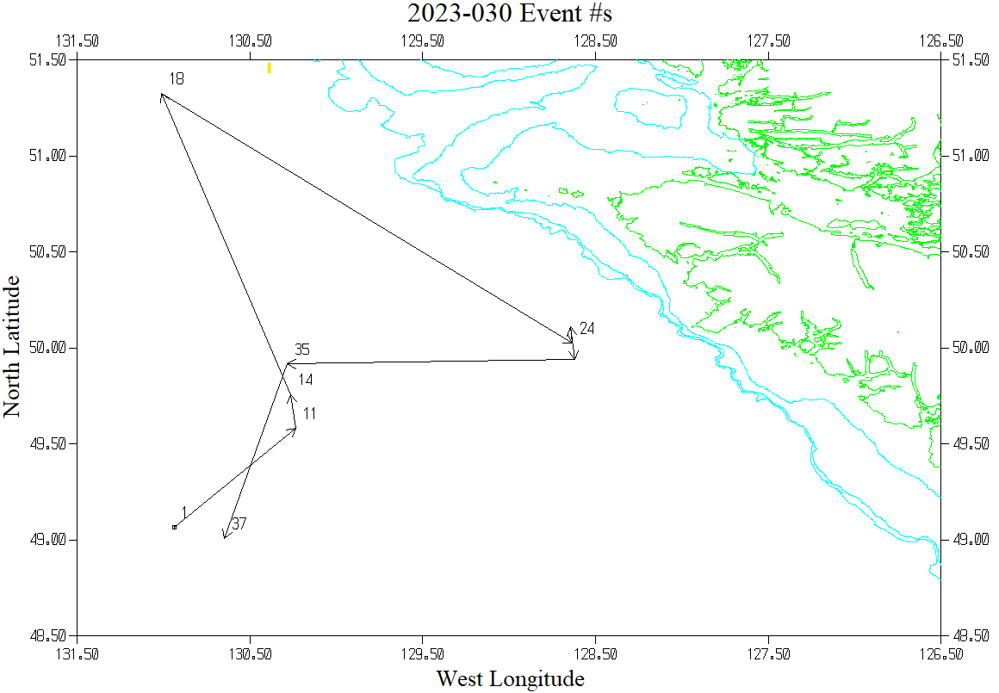

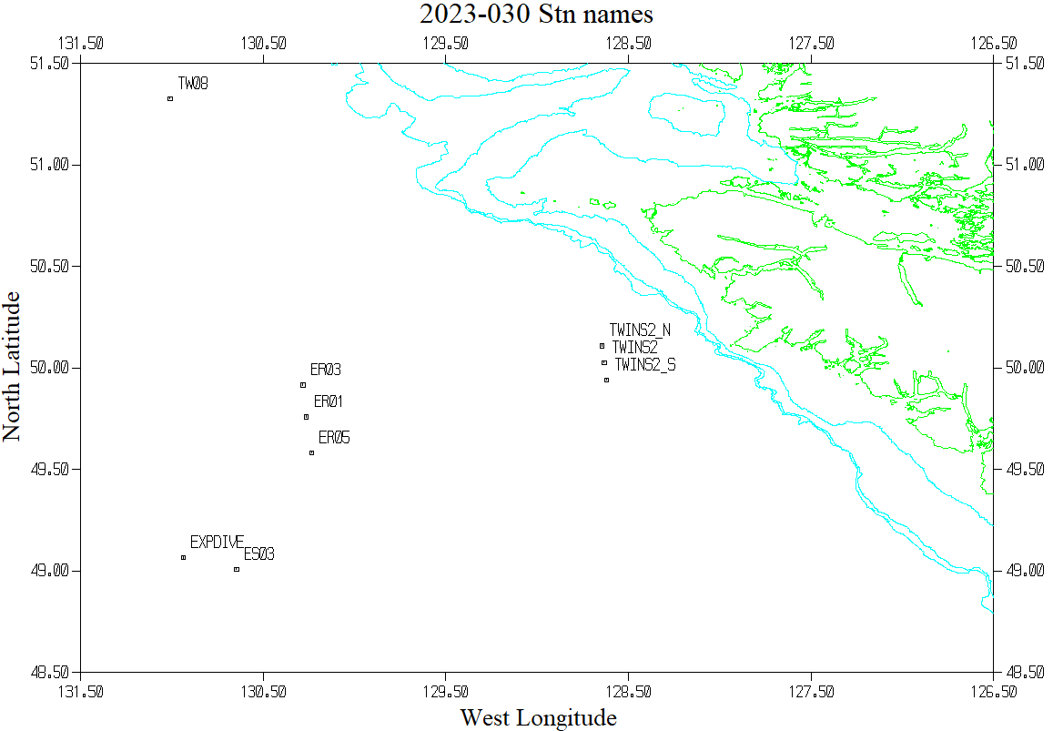

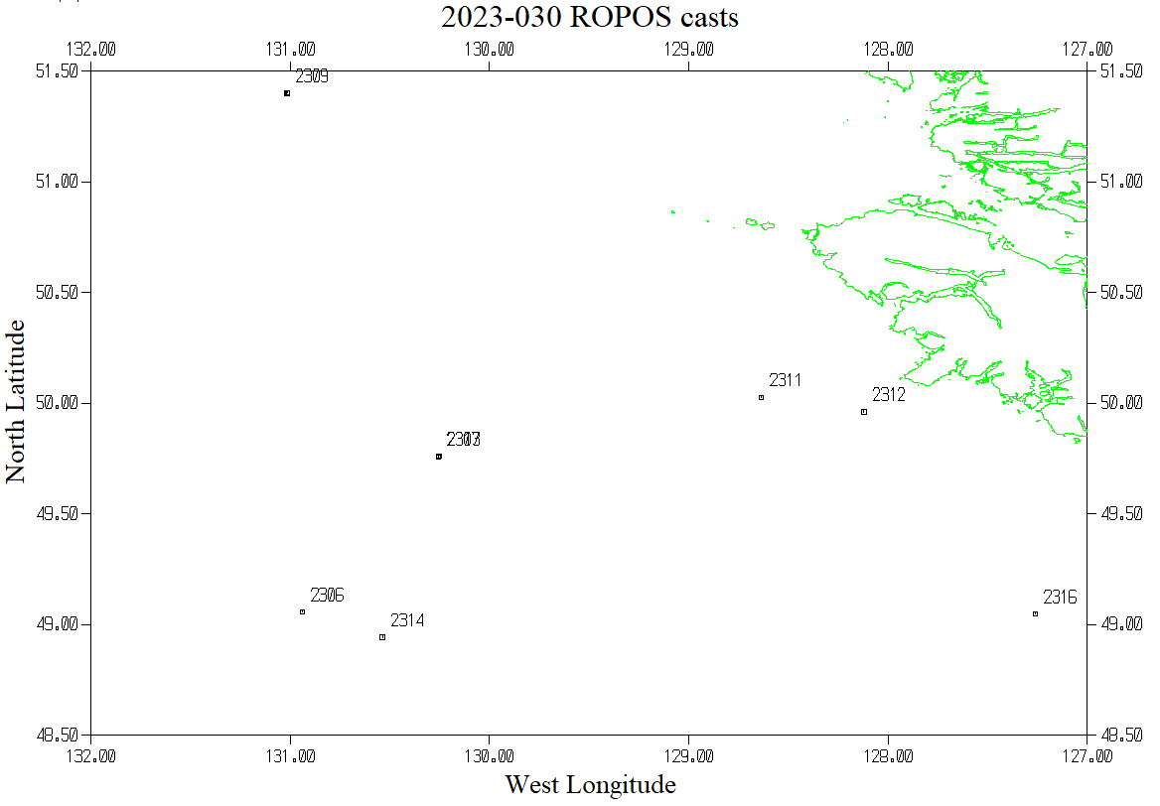

CROSS_REFERENCE LIST FOR ROPOS CASTS

Filename Event Station Latitude Longitude Date Time

---------------- ----- ------- ---------- ----------- -------------- -----

RCTD2306.ropos 2306 Explore 49 3.41 N 130 56.40 W UTC 2023/05/30 19:25

RCTD2307.ropos 2307 o 49 45.60 N 130 15.38 W UTC 2023/05/31 15:15

RCTD2308.ropos 2308 o 49 45.40 N 130 15.37 W UTC 2023/06/01 14:32

RCTD2309.ropos 2309 o 51 24.06 N 131 0.92 W UTC 2023/06/02 14:23

RCTD2310.ropos 2310 o 51 24.21 N 131 0.70 W UTC 2023/06/03 14:49

---------------- ----- ------- ---------- ----------- ---------- ---------

RCTD2311.ropos 2311 o 50 1.60 N 128 38.18 W UTC 2023/06/04 16:14

RCTD2312.ropos 2312 o 49 57.64 N 128 7.20 W UTC 2023/06/05 14:20

RCTD2313.ropos 2313 o 49 45.59 N 130 15.25 W UTC 2023/06/06 14:05

RCTD2314.ropos 2314 o 48 56.54 N 130 32.20 W UTC 2023/06/07 14:17

RCTD2315.ropos 2315 o 48 56.53 N 130 32.20 W UTC 2023/06/08 14:01

---------------- ----- ------- ---------- ----------- ---------- ---------

RCTD2316.ropos 2316 o 49 2.89 N 127 15.63 W UTC 2023/06/09 14:18