REVISION NOTICE TABLE
DATE | DESCRIPTION OF REVISION
18 March 2025 | Updated channel names & formats in TOB file. GG

PROCESSING NOTES
Cruise: 2023-029
Agency: Ocean Sciences Division (OSD)
Location: Salish Sea
Project: Salish Sea Biophysical Survey
Party Chief: Dosser, H.
Platform: Vector
Date: 8-14 October 2023

Processed by: Jeannette Bedard
Date of Processing: 8 July 2024 – 18 September 2024
Number of original HEX files: 77
Number of CTD files: 77 Number of CTD casts processed: 77
Number of bottle files: 77 Number of bottle casts processed: 28
Number of TSG files: 1 Number of TSG files processed: 1

INSTRUMENT SUMMARY
An SBE911+ CTD #0443 was mounted in a rosette and attached were a Wetlabs CSTAR transmissometer (#1201DR), a SBE 43 DO sensor (#4372), a SeaPoint fluorometer (#4186), an SBE pH sensor (#0691), a Biospherical PAR sensor (#4615), a reference SPAR sensor (#20518) and an altimeter (#76341).

Note: the pH sensor was not listed in the 2023-068_Daily Science Log_V.FEB2023_Cl.xlsx

Seasave version 7.26.7.121 was used for acquisition.

The salinometer used at IOS was a Guildline model 8400B Portasal, serial # 73274.

An IOS rosette with 24 10L bottles was used.

A thermosalinograph (SeaBird 45 S/N 3411) was used.

SUMMARY OF QUALITY AND CONCERNS
The Science Log was in digital format. The header page had complete information about participants and equipment. There were good notes in the comments sections of both the CTD and Sampling logs about problems encountered.

The Thermosalinograph performed well once the intake issues were sorted out. The good TSG data starts 11 Oct 2023 at 11:44 am. There was no flow meter, intake thermistor or loop sampling. There wasn’t enough shallow CTD data to perform any real comparisons between the two.

PROCESSING SUMMARY
GENERAL

Seasave
This step was completed at sea; the raw data files have extension HEX.

Preliminary Steps
- The digital daily log and rosette log sheets were obtained and checked for comments.
- Salinity, Nutrients and Dissolved Oxygen data were obtained in QF spreadsheets.
- The cruise summary sheet was completed.
- The history of the pressure sensor, conductivity and dissolved oxygen sensors were checked.
- The calibration control files were obtained – as they stayed the same through out the cruise 2023-029-0001.xmlcon was used for processing.

BOTTLE FILE PREPARATION
The ROS files were created using 2023-029-0001.xmlcon. The hysteresis correction was not selected since there were no very deep casts; the Tau correction was selected.

The ROS files were converted to IOS format

The files were put through CLEAN to create BOT files. Temperature and salinity were plotted for all BOT files to check for outliers, none were found.

The BOT files were bin-averaged on bottle number and the output was used to create file ADDSAMP.csv. Sample numbers were added based on the rosette logs.

The ADDSAMP file was then sorted on event number & then sample number. Converted to CST files using Convert Spreadsheet.

It was used to add sample numbers to the BOT files – output *.SAM.
The SAM files were bin-averaged on bottle # and called SAMAVG.
The addsamp.csv file was converted to CST files, which will form the framework for the bottle files.

Next, the analysis spreadsheets were examined to see what comments the analysts wanted included in the header file. These were saved in file 2023-068-bot-hdr.txt.

SALINITY
Salinity analysis was obtained in file QF2023-029_SAL_30Nov2023.xlsx. The analyses were carried out in a temperature-controlled lab within 30-34 days of collection. The files were simplified and saved as 2023-069_SAL.csv. That file was then converted to individual SAL files.

DISSOLVED OXGYEN
Dissolved oxygen data were provided in spreadsheet QF2023-029_OXY_14Mar2024.xlsx which includes flags, comments and a precision study. Draw temperatures are available. The spreadsheet page with the final data was simplified and saved as 2023-029_OXY.csv. That file was converted into individual *.OXY files.

NUTRIENTS
The nutrient data were obtained in spreadsheet QF2023_029_NUTS_2023-11-14.xlsx which includes flags, comments and a precision study. The spreadsheet page with the final data was simplified and saved as 2023-029_NUTS.csv. That file was converted into individual *.NUTS files.

CHLOROPHYL
The chlorophyl data were obtained in spreadsheet QF2023_029_CHL_29Jan2024.xlsx which includes flags, comments and a precision study. The spreadsheet page with the final data was simplified and saved as 2023-029_CHL.csv. That file was converted into individual *.CHL files.

The SAL, CHL, OXY, and NUTS files were merged with CST files in 4 steps. The files were then put through CLEAN to reduce the headers to File and Comment sections only. These files were ordered on sample number, but the SAMAVG files are ordered on bottle number, so the MRGCLN1 files were reordered on Bottle_Number and saved as *. MRGCLN1s. The MRGCLN1s files were then merged with SAMAVG files using merge channel Bottle_Number.

The output of the MRG files were exported to a spreadsheet and compared to the rosette log sheets to look for omissions. None were found.

A header check was run and no problems were found.

Compare

Salinity
This cruise had salinity sampling between 100-350 m. The fit against pressure is reasonably flat. There is a single outlier is cast 85 where the difference between the bottle and measured salinity was 2 at 250 m. For more detail see file 2023-029-sal-comp1.xls.

Dissolved Oxygen
COMPARE was run with pressure as the reference channel. There was more variability at shallower depths, otherwise the fit is reasonably flat. Note, the cast were from a coastal environment and most casts were shallow.

Conversion of Full CTD Files from Raw Data

All files were converted using files 2023-029-0001.xmlcon. The hysteresis correction was not selected since there were no deep casts; the Tau correction was selected. A few casts were examined and all expected channels are present.

WILDEDIT
Program WILDEDIT was run to remove spikes from the pressure, conductivity & temperature only in the
full cast files (*.CNV).
Parameters used were: Pass 1 Std Dev = 2 Pass 2 Std Dev = 5 Points per block = 50
The parameter “Keep data within this distance of the mean” was set to 0 so all spikes would be removed.

ALIGN DO
ALIGNCTD was run on all casts using +2.5s.

CELLTM
CELLTM was run using the default settings (α = 0.0245, β=9.5) for both the primary and secondary conductivity.

DERIVE
Program DERIVE was run on all casts to calculate primary and secondary salinity and dissolved oxygen concentration.

Conversion to IOS Header Format
The IOSSHELL routine was used to convert SeaBird 911+ CNV files to IOS Headers.

CLEAN was run to add event numbers and to replace pad values in the pressure channel with interpolated values based on record number. There are no negative fluorescence values.

Checking Headers
A header check and cross-reference list was run. Both looked okay.

Surface check – mean surface pressure was 2.594 db, with a minimum of 1.96 db and a maximum of 3.73 db, which is within the expected range from the Vector.

The track plots were added to the end of this report, however due to the number of casts the labels were left off.

A check was made of the water depths entered in the file headers by adding the maximum depth sampled plus the altimetry reading when the CTD was at the bottom of the cast. Eight out of the 77 casts had values above ± 5m.
- Cast 87 was out by ~227m. The echo sounder reported a depth of 87m while the CTD descended past 309.67m with an altimeter reading of 5.13m. Based on other casts taken during previous cruises at that station, a water depth of 315m seemed more reasonable. The water depth in the file header was changed to 315m.
- Casts 56, 67, 65, 42, 28, 27 and 64 were all out by less than 11m. After cross-checking with the log, it was determined the difference was most likely due to the complex bathymetry found in coastal environments.

Shift
Fluorescence
SHIFT was run on the fluorescence channel with an advance of 24 records. Plots showed this setting was appropriate.
Dissolved Oxygen
The Dissolved Oxygen voltage channel was aligned earlier using Seabird software. No further alignment is needed for the DO concentration channel.
Conductivity
Tests were run on 3 casts to determine the best setting to align conductivity and temperature by judging the effect on salinity as seen in T-S space. SHIFT was run on all casts using -0.65 records for the primary conductivity and -0.2 records for the secondary. Salinity was recalculated for both channels.
pH
SHIFT was run on all casts using +80 records.

DELETE
The following DELETE parameters were used:
Surface Record Removal: Last Press Min
Maximum Surface Pressure (relative): 10.00
Surface Pressure Tolerance: 1.0 Pressure filtered over 15 points
Swells deleted. Warning message if pressure difference of 2.00
Drop rates < 0.30m/s (calculated over 11 points) will be deleted.
Drop rate applies in the range: 10db to 10db less than the maximum pressure
Sample interval = 0.042 seconds. (taken from header)

Other Comparisons
Previous experience with these sensors – These sensors were used on 2023-068 right before this cruise.

Historic ranges – These casts were all taken in coastal sites and fit within climatology values for the most part. The main excursions were at shallower depths. There is no indication of calibration problems.

Post-Cruise Calibration – There were no post-cruise calibrations available.

DETAILED EDITING
The primary T-S pair were chosen for editing and eventual archiving. For this cruise both primary and secondary were very similar.

All DEL files were uploaded into the CTD-QC File Processor to obtain AI generated data quality flags.

CTDEDIT was used to remove records near the top and bottom of the casts where the descent rate was below 0.2 m/s. Most casts had a number of shed wakes, these were also removed.

The edited files were copied to *.EDT.

After editing T-S plots were examined for all casts; there remain many small unstable features but they are in areas when they may well reflect real conditions. No further editing was applied.

Fluorescence Processing
A median filter with a width that varies with pressure was applied to the fluorescence channel using:
- Up to pressure of 10 db, filter width of 3
- Up to pressure of 40 db, filter width of 5
- Up to pressure of 100 db, filter width of 7

Recalibration
The minimum CTD Salinity was ~27 psu, above the <25 psu threshold that requires correction to silicate samples.

Remove unwanted channels
The following channels were removed from the bottle files:
- Scan_Number
- Salinity:T1:C1
- Temperature:Secondary
- Conductivity:Secondary
- Altimeter
- Status:Pump
- Descent_Rate
- Flag
- Oxygen:Voltage:SBE

For cast 42 and 64 – pH the data are bad because the cap was left on. Only cast 42 had bottle samples, and the pH channel was removed.

BIN AVERAGE of CTD files
The following Bin Average values were applied to the FIL files (output AVG):
Bin channel = pressure Averaging interval = 1.000 Minimum bin value = .000
Average value will be used. Interpolated values are NOT used for empty bins.
On-screen T-S plots were examined.
Profile plots were examined to see if there any problems. No problems were noted.

Final CTD File Steps (REMOVE and HEADEDIT)
- For all casts REMOVE was run to remove the following channels:
Scan_Number, Temperature:Secondary, Conductivity:Secondary, Oxygen:Voltage:SBE, Descent_Rate, Status:Pump, Altimeter, Salinity:T1:C1, Flag and Prediction_Flag.
- For cast 42 and 64 channel pH:SBE was also removed because the cap was left on.
- A second SBE DO channel (with umol/kg units) was derived.
- HEADER EDIT was used to fix formats and channel names and to add comments to the headers.
- The Standards Check routine was run and no problems were found.
- The Header Check was run; no problems were found.
- Profile and T-S plots were examined and no problems were found.
- The sensor history was updated.

Final Bottle Files
- The MRGCOR1 files were put through SORT to order on increasing pressure.
- A second SBE DO channel with mass units was added for both the CTD DO and REORDER was run to get the pair of DO channels together.
- HEADER EDIT was run to ensure formats and units are correct
- Standards check was run and no problems were found.
- Bottle data were exported to a spreadsheet and no problems were found.
- A header check were run. No problems were found.
- A cross-reference listing was produced for the CHE files.

Thermosalinograph processing
There was 1 thermosalinograph file.
There were no loop samples, flow meter or intake thermistor. The intake is at about 2m. The only method to check calibration is to compare with the CTD casts.

The following note was in the daily science log: ‘The exhaust was plugged for most of the trip. Bypassing the ship's exhaust solved the problem.’
- The earlier data was not archived. TSG data starts 11 Oct 2023 at 11:44 am.

a.) Checking calibrations
The configuration file parameters were checked and are correct.

b.) Conversion of Files
The file was converted to CNV format.
The file was converted to IOS HEADER format.
CLEAN was run to add End times and Longitude and Latitude minima and maxima to the headers.
ADD TIME CHANNEL was used to add Time and Date channels.

A time-series plot was produced.

The track plot looks fine and was added to the end of this report.

c.) Comparing TSG to near-surface CTD cast data – there were only 6 casts with shallow enough (~2db) data to allow for comparison.
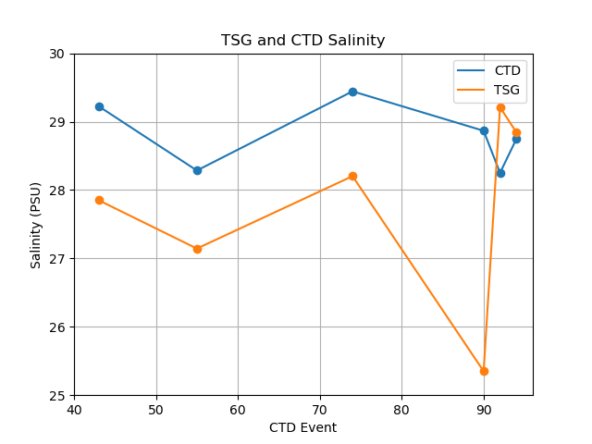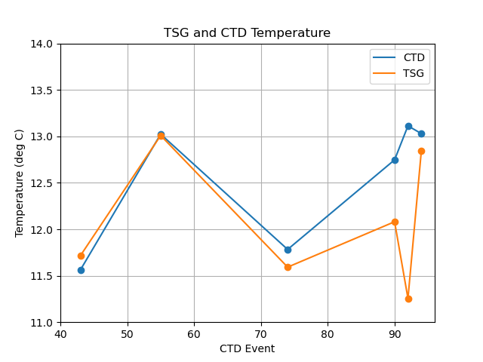

This comparison is not conclusive due to the limited data, however, T and S may be reading low. There is insufficient evidence to recalibrate.

Calibration History
This TSG was used on two previous cruises since calibration, on the last cruise data appeared to be fine.

d.) Editing
Data was relatively clean (i.e. no spikes), no manual editing was done.

REMOVE was used to remove the following channels: Scan Number, Record #, Flag, Pressure and the duplicate Time channels.

- Temperature:Primary was changed to Temperature:Lab
- Sigma-t was derived

h.) Preparing Final Files
HEADER EDIT was used to change the DATA DESCRIPTION to THERMOSALINOGRAPH and to change channel names to standard names and formats.
The TSG sensor history was updated.

CRUISE SUMMARY – CTD & TSG
CTD# | Make | Model | Serial# |  | Used with Rosette? |  | CTD Calibration Sheet Competed?
1 | SEABIRD | 911+ | 0443 |  | Yes |  | Yes
3 | SEABIRD | 21 | 3411 |  | n/a |  | Yes
Calibration Information - 0443
Sensor |  |  |  | Pre-Cruise |  |  |  | Post Cruise
Name |  | S/N |  | Date |  | Location |  | Date | Location
Temperature |  | 4700 |  | 5Jan2022 |  | Factory
Conductivity |  | 3531 |  | 8Feb2022 |  | Factory
Secondary Temp. |  | 4888 |  | 14Jan2022 |  | Factory
Secondary Cond. |  | 4513 |  | 8Feb2022 |  | Factory
Transmissometer |  | 1201DR |  | 17Feb2022 |  | Factory
pH:SBE |  | 0691 |  | 9Mar2023 |  | Factory
SBE 43 DO sensor |  | 4372 |  | 27Mar2023 |  | Factory
PAR |  | 4615 |  | 24Feb2021 |  | Factory
SPAR |  | 20518 |  | 24Feb2021 |  | Factory
SeaPoint Fluor. |  | 4186 |  | 17Feb2022 |  | Factory
Pressure Sensor |  | 0443 |  | 23Mar2022 |  | Factory
Altimeter |  | 76341 |  | 10Feb2021 |  | Factory

Calibration Information – TSG 3411
Sensor |  | Pre-Cruise |  | Post Cruise
Name | S/N | Date | Location | Date | Location
Temperature | 3411 | 5Feb2023 | Factory
Conductivity | 3411 | 5Feb2023 | Factory

