## REVISION NOTICE TABLE

|  |  |
| --- | --- |
| DATE | DESCRIPTION OF REVISION |
| 18 March 2025 | Updated channel names & formats for TSG files. Removed unnecessary channels from one file . GG |

## PROCESSING NOTES

Cruise: 2023-026

Agency: OSD

Location: WCVI

Project: La Perouse

Chief Scientist: Sastri A.

Platform: John P. Tully

Cruise Dates: 24 August 2023 – 5 September 2023

Processed by: Germaine Gatien

Date of Processing: 17 January 2024 – 7 May 2024

Number of original HEX files: 100 Number of processed CTD files: 98 (2 casts <10m dropped)

Number of SBE25 XML files: 6

Number of rosette casts: 59 Number of processed CHE files: 55 (4 for water only)

Number of original TSG files: 6 Number of processed TOB files: 11

# INSTRUMENT SUMMARY

CTD #1515 was mounted in a rosette and attached were 2 Wetlabs CSTAR transmissometer (1185DR & #1883DG), a SBE 43 DO sensor on the primary pump (#1119), SeaPoint Fluorometer on the secondary pump (#3950), a Biospherical QSP-400 PAR sensor (#70613) and an altimeter (#79787).

A thermosalinograph (SeaBird 45 S/N 0789) was mounted with a Wetlabs WETStar fluorometer (#1656) and flow meter; sampling interval was 10s.

Seasave version 7.26.7.121 was used for acquisition.

The data logging computer WP #104.

The deck unit was a Seabird model 11+ #508.

An IOS rosette with 24 10L bottles was used.

# SUMMARY OF QUALITY AND CONCERNS

The Daily Science Log Book and rosette log sheets were in good order with comments about problems encountered and a detailed list of equipment. A loop summary was included in the log which is very helpful. There was no information about the thermosalinograph in either the digital or paper logs.

The standard deployment procedure for this cruise was as follows:

The rosette was brought to the surface. Pumps were turned ON. The rosette was brought down to 10m and kept there for 30 seconds. Once back at the surface, the data started to be archived, with the rosette at the surface for 30 seconds longer. Then the cast would start.

For all rosette casts:

Niskin bottles closed from 0 to 400 db had a wait time of 60 seconds.

All Niskin bottles deeper than 400 db had a wait time of 30 seconds.

There were 2 WetLabs CStar transmissometers in use during this cruise:

Channel Transmissometer refers to sensor #1185DR (650nm - red)

Channel Transmissometer:Green refers to sensor #1883DG (530nm - green)

For comparison with other Institute of Ocean Sciences cruises, note that the transmissometer wavelength is 650nm unless otherwise stated.

The SBE DO sensor has a fairly long response time so data accuracy is not as high when it is in motion as it is during stops for bottles. This will be especially true when vertical DO gradients are large. To get an estimate of the accuracy of the SBE DO data during downcasts (after recalibration) a rough comparison was made between downcast SBE DO and upcast titrated samples. Some of the difference will be due to

problems with flushing of Niskin bottles and/or analysis errors, so the following statement likely underestimates SBE DO accuracy.

Downcast (CTD files) Oxygen:Dissolved:SBE data for this cruise are considered, very roughly, to be:

±0.60 mL/L from 0 - 75db except in areas of very large DO gradients

±0.25 mL/L from 75db - 225db

±0.08 mL/L from 225db - 500db

±0.05 mL/L below 500db

The thermosalinograph data were delivered in 5 files with names that were not helpful and in one case misleading. There was no TSG log available and no entries in the Daily Science Log concerning the TSG. Even if it is meant to be left on the ship, a scan of the log would be sufficient or a note concerning problems.

The Thermosalinograph was not recording between 2:23 and 3:26 on August 28th and between 15:40 on August 28th and 19:00 on August 29th. This includes much of the LD line and most of the LG line. There were some other sections where flow was off; records were kept to record the ship track but data were padded from times when the flow was off or very low. The flow to the fluorometer was on in one section during which there was no flow to the thermosalinograph.

TSG salinity was recalibrated by adding 0.132psu based on comparisons with CTD salinity. Slightly larger differences were found in comparison with loop samples. Bubbles in the loop water can lower salinity, so this should not be considered a measure of calibration drift. Loop samples were only collected while the ship was underway, so no comparison of loops with rosette samples was possible. TSG fluorescence was about 50% of CTD fluorescence except late in the cruise when it was close to the CTD. It was close to loop chlorophyll samples but most of those came late in the cruise.

# PROCESSING SUMMARY

##### Seasave

This step was completed at sea; the raw data files have extension HEX.

##### Preliminary Steps

The Log Book and rosette log sheets were obtained.

* Nutrients, extracted chlorophyll, dissolved oxygen, salinity and NH4 data were obtained in QF spreadsheet format from the analysts.
* The cruise summary sheet was completed.
* The history of use of the pressure, conductivity and dissolved oxygen sensors was obtained.

They were all used during part of cruise 2023-066 and all of 2023-088 since they were last serviced at the factory.

The configuration files were checked and no problems were found.

##### BOTTLE FILE PREPARATION

The HEX files were converted to ROS files using file 2023-026-ctd.xmlcon.

The ROS files were converted to IOS format.

The IOS files were put through CLEAN to create BOT files.

Temperature and salinity were plotted for all BOT files to check for significant outliers. Casts #9 and 58 had a few outlier values in salinity which were cleaned by interpolation using CTDEDIT.

The output files *.ED1 were copied to *.BOT.

A preliminary header check was run; there are some errors in the headers that will be fixed later.

The BOT files were bin-averaged on bottle number.

The output was used to create file ADDSAMP.csv. First, the file was sorted on event number and Bottle Position order. Then sample numbers were added based on the rosette logs.

The ADDSAMP file was then reordered on event # & sample #.

The ADDSAMP file was used to add sample numbers to the BOT files – output *.SAM.

The SAM files were bin-averaged on bottle # and called SAMAVG.

The SAMAVG file for event #1 was removed since there was no sampling.

The addsamp.csv file was converted to CST files, which will form the framework for the bottle files.

Next, each of the analysis spreadsheets were examined to see what comments the analysts wanted included in the header file. These were used to create file 2023-026-bot-hdr.txt which will be updated as needed during processing.

Loops samples were moved from the salinity and chlorophyll CSV files to a combined loop data file for later use.

DISSOLVED OXGYEN

Dissolved oxygen data were provided in spreadsheet QF2023-026_OXY*.xlsx which includes flags, comments and a precision study. Draw temperatures are available. The spreadsheet page with the final data was simplified and saved as 2023-026oxy.csv. That file was converted into individual *.OXY files.

EXTRACTED CHLOROPHYLL

Extracted chlorophyll and phaeo-pigment data were obtained in file QF2023-026_CHL QF*.xlsx. The file included comments and flags and a precision study. A simplified version of the spreadsheet was prepared and saved as 2023-026chl.csv. The csv file was then converted to individual CHL files.

SALINITY

Salinity analysis was obtained in file QF2023-026_SAL.xlsx which included a precision study. The analyses were carried out in a temperature-controlled lab 11 to 20 days after collection. The files were simplified and saved as 2023-026sal.csv. That file was then converted to individual SAL files.

NUTRIENTS

The nutrient data were obtained in spreadsheet QF2023-026_NUTS*.xlsx. This includes a precision study. The file was simplified, saved as 2023-026nuts.csv. The file was converted to individual NUT files.

AMMONIUM

NH4 data were obtained in spreadsheet QF2023-026 QF NH4*.xlsx. This includes a precision study. The file was simplified and saved as 2023-026NH4.csv. This file was converted to NH4 files.

The SAL, CHL, OXY, NUT and NH4 files were merged with CST files in 5 steps.

After the 5th step the files were put through CLEAN to reduce the headers to File and Comment sections only.

These files are ordered on sample number, but the SAMAVG files are ordered on bottle number, so one or the other set needs to be reordered in order to merge them. The MRGCLN1 files were reordered on Bottle_Number and saved as *. MRGCLN1s.

The MRGCLN1s files were then merged with SAMAVG files using merge channel Bottle_Number.

The output of the MRG files were exported to a spreadsheet and compared to file 2023-026_Bottle_Summary.xlsx to look for omissions. A few problems were found:

* For cast #61 there was a sample 177 but the same sample number was used during the following cast. The only sampling from the first instance was for Chito, so this bottle will not be needed in the CHE file.
* Cast #61 had been mislabelled as 60 in analysis files.
* Cast #180 was mistakenly named 179 in raw files. This was fixed in the raw and converted files.
* The salinity from LC11 was given event #55 should be 66. Changed in S/S.
* There is salinity sample #510 not indicated on the bottle summary, station 46.
* Some samples were missed from casts 116 to the end. Rerunning merges fixed it.

The merge process was repeated after corrections.

##### Compare

Salinity

Compare was run with pressure as reference channel. A fit was done excluding cases where the standard deviation in the CTD salinity during the 10s window was >0.0008psu and data from the top 10db.

All of the large outliers were removed by that step.

There is some evidence of incomplete flushing in the top 100db. When bottles above 300db and 2 significant outliers are excluded, the primary salinity is low by 0.0052psu (stdev 0.0012psu).

The secondary salinity is low by 0.0061psu (stdev 0.0012psu).

The 2 outliers below 300db were :

File 135 500.4db – difference: -0.0078psu. Bottle value looks like CTD about 15db lower – likely incomplete flushing.

File 183 351.7db – difference: +0.0104psu. CTD was returned from above 300db to 350 for missed sample. Bottle contents resemble those at 295db. Difference is too large to be due to incomplete flushing and other samples do not suggest there was a problem. The sample is much closer the CTD salinity at 300db which would have been a better choice as samples taken at the bottom of a cast are less reliable. However, it would still be an outlier, so it should likely be flagged at least 4. The analyst changed the flag to 4 with comment “out of line in comparison with CTD salinity; may have come from wrong Niskin bottle”.

When the same bottles were chosen in plots against file pair number there is little time dependence, especially in the primary salinity. When last used there was drift through the cruise. Fits were done using only bottles below 500db to see if there is a different picture in deeper water. That fit looked even flatter with a very small increase in the primary differences and a slight decrease in the secondary. Recalibration by adding 0.0053psu to the primary salinity and 0.0063psu to the secondary looks appropriate. The primary correction is very close to that applied to data near the end of 2023-088 and the secondary is a little lower than the one used at that time, but the secondary was not chosen for the archive.

|  |  |  |  |  |
| --- | --- | --- | --- | --- |
| **Applying the correction based on the trendline for bottles below 500** | | | | |
| **file pair** | **Sal0-bot** | **Sal1-bot** | **Sal1-Sal** | **Event#** |
| 1 | -0.0049 | -0.0062 | -0.0013 | 9 |
| 2 | -0.0049 | -0.0062 | -0.0013 | 27 |
| 3 | -0.0050 | -0.0062 | -0.0013 | 36 |
| 4 | -0.0050 | -0.0062 | -0.0013 | 47 |
| 5 | -0.0050 | -0.0063 | -0.0013 | 58 |
| 6 | -0.0050 | -0.0063 | -0.0012 | 66 |
| 7 | -0.0050 | -0.0063 | -0.0012 | 71 |
| 8 | -0.0051 | -0.0063 | -0.0012 | 78 |
| 9 | -0.0051 | -0.0063 | -0.0012 | 81 |
| 10 | -0.0051 | -0.0063 | -0.0012 | 98 |
| 11 | -0.0051 | -0.0063 | -0.0012 | 117 |
| 12 | -0.0051 | -0.0063 | -0.0012 | 120 |
| 13 | -0.0052 | -0.0063 | -0.0012 | 123 |
| 14 | -0.0052 | -0.0063 | -0.0012 | 135 |
| 15 | -0.0052 | -0.0064 | -0.0012 | 142 |
| 16 | -0.0052 | -0.0064 | -0.0011 | 165 |
| 17 | -0.0052 | -0.0064 | -0.0011 | 183 |
| 18 | -0.0053 | -0.0064 | -0.0011 | 198 |
| 19 | -0.0053 | -0.0064 | -0.0011 | 201 |
| 20 | -0.0053 | -0.0064 | -0.0011 | 203 |

For full details for the COMPARE run see file 2023-026-sal-comp1.xls.

Dissolved Oxygen

COMPARE was run with pressure as the reference channel.

A fit was done of the difference between the CTD DO and titrated DO samples versus CTD DO. There were 3 large outliers:

* Event 27, sample 29, 137db – this sample was already flagged 3 but should be flagged 5 since the value is way out of line in profile and an extreme outlier in comparison to CTD. Nutrients and NH4 were flagged 3 by the analyst due to comments about spigot and vents being open.
* Event 54, sample 142, 5.5db – the CTD data are noisy during the bottle stop and local gradients large. The value looks quite believable.
* Event 148, sample 414, 91db – The bottle value (0.214mL/L) looks extremely low but the value on the analysis log sheet is a much better fit. (2.494mL/L). The analyst padded the sample and applied flag 5.

When further outliers were excluded based on residuals, the fit was:

CTD DO Corrected = CTD DO * 1.0141 - 0.0333 (1)

Excluding bottles with DO > 6mL/L before excluding outliers increased the slope a little, while the offset was almost the same.

CTD DO Corrected = CTD DO * 1.0148 - 0.0319 (2)

During cruise 2023-088 the fit found was:

CTD DO Corrected = CTD DO * 1.0165 + 0.025

Using fit (1) but setting the offset to match that from 2023-088, led to a larger gradient so that the fit was very close to that of 2023-088:

CTD DO Corrected = CTD DO * 1.0168 - 0.025 (3)

Fits 2 and 3 differ by a range of about 0.009mL/L to 0.02mL/L as DO increases from 1 to 7mL/L. These fits are rough given the variable gradients within and among casts. Fit (2) looks most appropriate for recalibration since the near-surface data tend to have small DO reversals and higher gradients so the difference in level of bottle sample and CTD data are more significant.

A fit of differences versus file pair numbers showed that the casts in the Strait of Georgia were out of line with the other casts. It has been noted in the past that there is poorer flushing of Niskin bottles in the Strait due to quiet sea state. This would lead to the contents of bottles having lower DO than seen by the CTD, so the CTD appears to be reading high. For other areas flushing tends to be better, though there is likely still some mismatch.

For full details for the COMPARE run see file 2023-026-dox-comp1.xls.

Fluorescence

COMPARE was run with extracted chlorophyll and CTD Fluorescence using pressure as the reference variable.

The comparison with extracted chlorophyll looks normal with the fluorometer reading higher when CHL is low, dropping gradually until it is close to chlorophyll when 1<CHL<3ug/L and then lower than CHL beyond that. The pattern versus file pair # is complex as the ship moves away from and then towards shore with higher CHL nearshore, together with nighttime/daytime variations.

For full details for the COMPARE run see file 2023-026-fl-chl-comp1.xls.

##### Conversion of Full Files from Raw Data

Hex files were converted to CNV files using 2023-026-ctd.xmlcon.

The Tau function and the hysteresis function were selected since there was deep sampling. Depth was included in the conversion.

A few casts were examined and all expected channels are present, but there are spikes in both conductivity channels in some files, and spikes in altimetry that could lead to a header value entry when the CTD never got within 15m of the bottom.

##### WILDEDIT

Program WILDEDIT was run to remove spikes from the pressure, depth, conductivity and temperature on the CNV files.

Parameters used were: Pass 1 Std Dev = 2 Pass 2 Std Dev = 5 Points per block = 50

The parameter “Keep data within this distance of the mean” was set to 0 so all spikes would be removed.

Conductivity spikes noted in the previous step were removed.

##### ALIGN DO

ALIGNCTD was run on all casts using +2.5s since it is generally found to be the best choice. Tests were run after derivation of oxygen concentration and the alignment was much improved by this step.

##### CELLTM

CELLTM was run using default values (α = 0.0245, β=9.5) for both the primary and secondary conductivity. Tests were run after DERIVE was run and the T-S curves for downcast and upcast were much closer after this step.

##### DERIVE and Channel Comparisons

Program DERIVE was run on all casts to calculate primary and secondary salinity and dissolved oxygen concentration.

A few casts were examined to see how well the Alignctd and Celltm steps worked by comparing results with and without those steps.

The DO alignment looks good and the CELLTM adjustment worked well.

One cast would not convert to IOS Headers with an error message about altimetry array overload. No problems were noted in the altimetry or any other channel in the file and the file was not particularly large. STRIP was used to remove channel Altimetry and it then converted successfully. Since the bottle file did convert without a problem, the altimetry header from the BOT file was copied to the headers of the full IOS file.

DERIVE was run a second time on some of the deeper casts to find the differences between the pairs of temperature, conductivity and salinity channels.

All differences were very small, but there is a slight pressure dependence.

The shaded entries are from previous cruises during which this CTD was in use since last factory service.

|  |  |  |  |  |  |
| --- | --- | --- | --- | --- | --- |
| Cast # | Press | T1-T0 | C1-C0 | S1-S0 | Descent Rate |
| 2023-066-0046 | 1000 | -0.0002 | -0.00007 | -0.0008 | High, Noisy |
|  | 2000 | -0.0003 | -0.00009 | -0.0008 | “ |
|  | 2500 | -0.0003 | -0.00009 | -0.0007 | High, Noisy |
| 2023-066-0052 | 1000 | -0.0002 | -0.00004 | -0.0003 | “ |
|  | 2000 | -0.0005 | -0.00006 | -0.0003 | “ |
|  | 2500 | -0.0007 | -0.00007 | -0.0002 | “ |
|  | 3000 | -0.0008 | -0.00006 | -0.0001 | “ |
|  | 3500 | -0.0008 | -0.00008 | 0 | “ |
| 2023-088-0033 | 1000 | -0.0003 | +0.00002 | +0.0003 | High, Moderate |
| “ | 2000 | -0.0005 | -0.00002 | +0.0003 | “ |
| “ | 3000 | -0.0006 | -0.00003 | +0.0005 |  |
| 2023-088-0054 | 1000 | -0.0003 | -0.00003 | -0.0001 | Mod, Noisy |
| “ | 2000 | -0.0005 | -0.00005 | -0.0002 | “ |
| “ | 3000 | -0.0007 | -0.00006 | +0.0004 | “ |
| 2023-088-0064 | 1000 | -0.0003 | -0.00009 | -0.0009 | Mod, VNoisy |
| “ | 2000 | -0.0005 | -0.00012 | -0.0010 | “ |
| “ | 3000 | -0.0007 | -0.00012 | -0.0007 | “ |
| “ | 3900 | -0.0008 | -0.00012 | -0.0007 | “ |
| 2023-088-0076 | 1000 | -0.0003 | -0.00014 | -0.0015 | High, Noisy |
| “ | 2000 | -0.0005 | -0.00015 | -0.0015 | “ |
| “ | 3000 | -0.0007 | -0.00016 | -0.0013 | “ |
| “ | 4000 | -0.0009 | -0.00017 | -0.0011 | “ |
| 2023-026-0036 | 500 | -0.0001 | -0.00006 | -0.0004 | High, Moderate |
|  | 1000 | -0.0003 | -0.00007 | -0.0007 | “ |
| 2023-026-0098 | 500 | -0.0002 | -0.00005 | -0.0003 | High, F. Noisy |
|  | 1000 | -0.0003 | -0.00007 | -0.0007 | “ |
| 2023-026-0150 | 500 | -0.0002 | -0.00004 | -0.0003 | High, Noisy |
|  | 1000 | -0.0003 | -0.00006 | -0.0005 | High, V. Noisy |

The temperature differences are very close to those seen previously while the conductivity and salinity differences are higher than in most of the previous uses but lower than during cast 2023-088-0076.

##### Conversion to IOS Header Format

The IOSSHELL routine was used to convert Sea-Bird 911+ CNV files to IOS Headers.

File 2023-026-0009 would not convert. The error message was “array size exceeded in subroutine ALTIMETER”. No reason for this was found; the altimetry had no spikes and the cast was shallow. The altimetry channel was removed using routine STRIP and conversion worked. Since the signal was clear an estimated header entry was inserted in the file.

CLEAN was run to add event numbers and to replace pad values in the pressure channel with interpolated values based on record number.

##### Checking Headers

* Initial track plots turned up no problems.
* The cross-reference check and header check were run. Station C2* was changed to Station C2 in file 2023-026-0020.cln since the log does not have the *.
* Surface check was run and the average surface value was 0.04db. This is the measure at the end of the cast with pumps on. Salinity values were low and differences between channel pairs quite high, all indicating the CTD was very close to the surface. Pressure does not need recalibration.
* The bottle file header check shows silicate will not need recalibration for the final file.
* Cruise tracks were plotted and added to the end of this report.

The altimeter and water depth readings from the headers of the CLN files were exported to a spreadsheet. A check value was calculated by subtracting water depth from maximum depth sampled plus altimetry header.

Some casts did not get within 15m of the bottom, so there is no entry in the header unless there are spikes to less than 15m that are misinterpreted by the algorithm. There were 13 cases of the check value being >7db. They were investigated to if there were errors in header entry or unreliable altimetry.

* The altimetry values all look reliable.
* The log entry for depth differs from that in the file headers for many casts, but in only 4 cases did using the log value produce a check entry <7m. The header entry was adjusted for those casts: 23, 59, 78, 122.
* The following casts have differences <15m and are in areas where steep slopes may be present: 65, 66, 98, 99, 105, 120, 122, 145. The water depths were not changed.
* Casts 80 and 119 have check values of 23m and 63m. Calculated values (Max Depth Sampled + Altimetry at bottom) were substituted for the header entries in casts: 80, 119.

The same changes were made to SAM file for cast #78. SAMAVG and MERGE were rerun.

##### Shift

Fluorescence

SHIFT was run on the SeaPoint fluorescence channel in all casts using the usual advance of +24 records. Plots show that the fluorescence offset is reasonably close to the temperature offset after this step.

Dissolved Oxygen

The Dissolved Oxygen voltage channel was aligned earlier. A few casts were checked to see if the alignment looked ok, and it did. No further alignment is needed for the DO concentration channel.

Conductivity

Tests were run on a 2 casts to see if the alignment shift used during 2023-088 looked best for the 2 conductivity sensors as judged by noise in T-S space; those settings looked best for these data as well.

SHIFT was run twice on all SBE911 casts using -0.35 records for the primary and -0.6 for the secondary. Salinity was recalculated for both channels.

##### DELETE

The following DELETE parameters were used:

Surface Record Removal: Last Press Min

Maximum Surface Pressure (relative): 10.00

Surface Pressure Tolerance: 1.0 Pressure filtered over 15 points

Swells deleted. Warning message if pressure difference of 2.00

Drop rates < 0.30m/s (calculated over 11 points) will be deleted.

Drop rate applies in the range: 10db to 10db less than the maximum pressure

Sample interval = 0.042 seconds. (taken from header)

COMMENTS ON WARNINGS: The only warnings were for 2 casts (40 and 140) that sampled less than 10m. In both cases there were full casts taken at the site and the 2nd cast was just to get a surface sample. CTD files for casts #40 and #140 will not be produced so these events were dropped from the processing list; bottle files will be prepared. These were casts just to fire a surface bottle.

##### Other Comparisons

Experience with these sensors since last factory service –

The pressure, temperature, conductivity and dissolved oxygen sensors were used for 2 cruises between the last factory service and this cruise.

* 2023-066 -The pressure, temperature, conductivity and dissolved oxygen sensors were used for part of cruise. Results were not as secure as usual due to spiking and some casts had averaging of CTD data in acquisition. Primary salinity was low by 0.0018psu; secondary was low by 0.0023psu; standard deviation was 0.0013 for both channels. Pressure was thought to be low by 0.5db but lab tests later showed no significant error. Oxygen was corrected using linear correction with slope 1.0227 and offset 0.0113. Fluorescence comparisons with extracted chlorophyll were very noisy but roughly as expected.
* 2023-069 – Salinity estimated to be low by 0.002psu for both channels. Dissolved oxygen was recalibrated using preliminary results of 2023-088. Pressure was considered ±0.2db.
* 2023-088 – Time-dependent correction applied to salinity channels. Pressure did not need recalibration. DO correction was:

CTD DO Corrected = CTD DO * 1.0165 + 0.025

Historic ranges – Profile plots were made with 3-standard deviation climatology ranges of T and S superimposed.

* Temperatures were slightly high near the surface for a few casts, and in mid-depth sections for some casts on the LG, LD and CS lines west of the shelf break. These look like real variations. Temperature was also high at Station 46 between 40db and 50db and below 100db. Temperatures were often close to the maximum of the climatology.
* There are a few excursions from the climatology for salinity, sometimes high and sometimes low.
* These excursions do not suggest calibration problem.

Post-Cruise Calibration – None available.

Repeat Casts –There were no deep repeat casts.

##### DETAILED EDITING

The primary sensor pair were chosen to edit and archive but the secondary pair looked almost as good.

All DEL files were copied to *.EDT.

CTDEDIT was used to remove records that appear to be corrupted by shed wakes. Salinity was cleaned to remove spikes that appear to be due to small misalignment or instrumental noise.

All files required some editing. Notes about editing applied were added to the files.

After editing, T-S plots were examined for all casts; a few casts have some unstable features but they were close to the surface or in areas where tidal mixing does occur. After bin averaging most of those features look stable. No further editing was applied.

##### Corrections to Salinity and Dissolved Oxygen Concentration

There was no salinity <25psu in CTD salinity in the bottle files (MRG) so silicate does not need correction in the bottle files.

CALIBRATE was run on MRG and SAM files using file 2023-026-recal1.ccf to add 0.0053psu to the primary salinity and 0.0063 to the secondary salinity and to apply the following correction to dissolved oxygen concentration:

CTD DO Corrected = CTD DO * 1.0148 - 0.0319

COMPARE was rerun for dissolved oxygen and shows that the correction improved the fit greatly. When outliers were removed based on standard deviation in the CTD DO and residuals, the SBE DO was found to be high by an average of 0.0052mL/L and standard deviation of 0.034mL/L.

COMPARE was rerun for salinity and when the same data were included as in the original fit the primary salinity was high by an average of 0.0001psu and the secondary was high by 0.0002psu. Standard deviations were 0.0012psu for both.

CALIBRATE was then run on the EDT files using file 2023-026-recal1.ccf.

##### Final Calibration of DO

The initial recalibration of dissolved oxygen corrects for sensor calibration drift. Alignctd corrects for transit time errors. Those 2 steps may partly correct for response time errors, but to see if a further correction is needed, a comparison is made of downcast CTD data to upcast bottle data at the same pressure. Small differences are expected due to ship drift, temporal changes, incomplete flushing of Niskin bottles and delayed response and noise in CTD data.

Downcast files were bin-averaged to 0.5m bins for the casts with DO bottle samples. Those files were then thinned and compared to the bottle values in the MRG files. COMPARE was run to study the differences between the downcast CTD DO data and the titrated samples from upcast bottles.

The CTD DO was higher than the titrated samples by an average of 0.043mL/L when outliers were removed based on residuals (standard deviation = 0.049mL/L). This is a reasonable result.

The data used for the fit against SBE DO was then sorted on pressure. Above the OMZ we expect the downcast CTD DO data to be slightly too high due to slow sensor response and the bottle data to be too low due to incomplete flushing; so the CTD DO is expected to be higher than bottle values. Below the OMZ the reverse is expected. That is clearly the case for these data with CTD generally higher than the titrated samples above 400db and lower for most cases from 800db to the bottom. Between 400db and 800db the differences are close to zero.

Based on the plot of differences versus pressure an estimate was made of errors in DO in different pressure ranges. This is likely too severe a method given time differences and inexact matches in depths. The deepest bottles read somewhat lower than bottles while the shallow ones trend to be higher. This is expected due to incomplete flushing leading to the bottles having higher values than ambient conditions above the OMZ and lower below the OMZ.

Downcast (CTD files) Oxygen:Dissolved:SBE data for this cruise are considered, very roughly, to be:

±0.60 mL/L from 0 - 75db except in areas of very large DO gradients

±0.25 mL/L from 75db - 225db

±0.08 mL/L from 225db - 500db

±0.05 mL/L below 500db

For more detail see file 2023-026-dox-comp3.xls.

##### Fluorescence Processing

A median filter, size 11, was applied to the fluorescence channel in the COR1 files. Plots of a few casts showed that the filter was effective. (Output:*.FIL)

##### BIN AVERAGE of CTD files

The following Bin Average values were applied to the FIL files (output AVG):

Bin channel = pressure Averaging interval = 1.000 Minimum bin value = .000

Average value will be used. Interpolated values are NOT used for empty bins.

On-screen T-S plots were examined and no problems noted.

Profile plots were examined and no issues noted.

##### Final CTD File Steps (REMOVE and HEADEDIT)

REMOVE was run to remove the following channels:

Scan_Number, Temperature:Secondary, Conductivity:Secondary, Oxygen:Voltage:SBE, Descent_Rate, Status:Pump, Altimeter, Salinity:T1:C1 and Flag.

At this stage the EDT files were zipped and sent to Lee Croft using CTD-QC-Client 1.1.0.

A second SBE DO channel (with umol/kg units) was added.

REORDER was run to get the two DO channels together.

HEADER EDIT was used to fix formats and channel names and to add comments about processing.

The Standards Check routine was run and no problems were found.

The Header Check was run; no problems were found.

Profile and T-S plots were examined. A few small unstable features were found but may well be due to active mixing. No other problems were found.

The sensor history was updated.

##### Dissolved Oxygen Study

As a final check of dissolved oxygen data, % saturation was calculated and plotted. Values at 2 to 3m ranged from ~60% to 170%. The lowest values were in nearshore waters in the southern and northern parts of the cruise as well as in Haro Strait. Values offshore (>500db deep) ranged from about 102% to 110%). The values are reasonable and do not suggest a DO calibration problem.

##### Final Bottle Files

Since there were no sample numbers for casts 56, 74, 133 and 152 they were removed from the cast list and will not be processed further. They were collected for UBC. If there is a need for them later, the MRG files will be available in the backed up Processing Files.

SORT was run to arrange casts in pressure order.

REMOVE was run to remove the following channels:

Scan_Number, Temperature:Secondary, Conductivity:Secondary, Oxygen:Voltage:SBE, Descent_Rate, Status:Pump, Altimeter, Salinity:T1:C1 and Flag.

A second SBE DO channel with mass units was added for both the CTD DO and titrated DO and REORDER was run to get the pairs of DO channels together.

There were 4 files with records that had no sample numbers; those lines were removed from casts #9, 37, 98, 116. The header limits were adjusted.

EDIT HEADERS was run to fix formats and channel names and to add comments about analyses and CTD processing.

The standard check was run and no problems were found.

Data were exported from the CHE files to file 2023-026-bottles-final.xlsx. A few random checks were made by comparing with the rosette log sheets and no problems were found.

A header check were run. No problems were found.

The track plot looks ok.

Plots of each file were examined and no problems were found.

A cross-reference listing and header check were produced for the CHE files.

##### SBE25 - SBE911 Comparison

There were 6 casts using an SBE25 after an SBE911 cast. They were run off the aft deck.

All casts were converted using file 25P - 1255 May2023.xmlcon.

5 of the casts had very few data, nothing deeper than 12db. This was likely a battery problem. Data from those depths were useless for comparison with the SBE911 because there was no 10m soak and the flow had clearly not been fully established; temperature did not compare with SBE911 and conductivity was clearly not equilibrated.

Cast #62 was deep. It was put through the following SeaBird processing steps:

DATCNV, Windows Filter (T and C), Alignctd (raw DO), CELLTM, DERIVE (Salinity and DO concentration).

It was then converted to IOS Header format and put through steps: CONVERT, CLEAN, CLIP (to remove spikes in top 2db), DELETE (to remove upcast and CTD reversals during downcast), BIN AVERAGE.

Plots were then made to compare the two CTD types. Since the 2 casts were not simultaneous the best comparisons are by matching density, so T-S plots were examined.

The first showed that the SBE25 data were poor until about 50db.

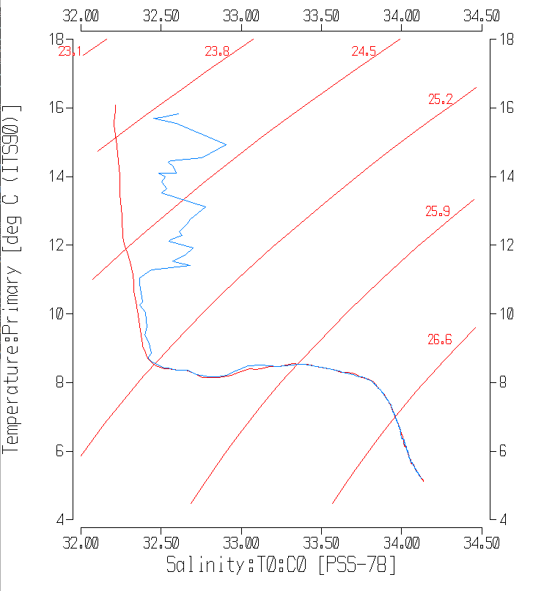



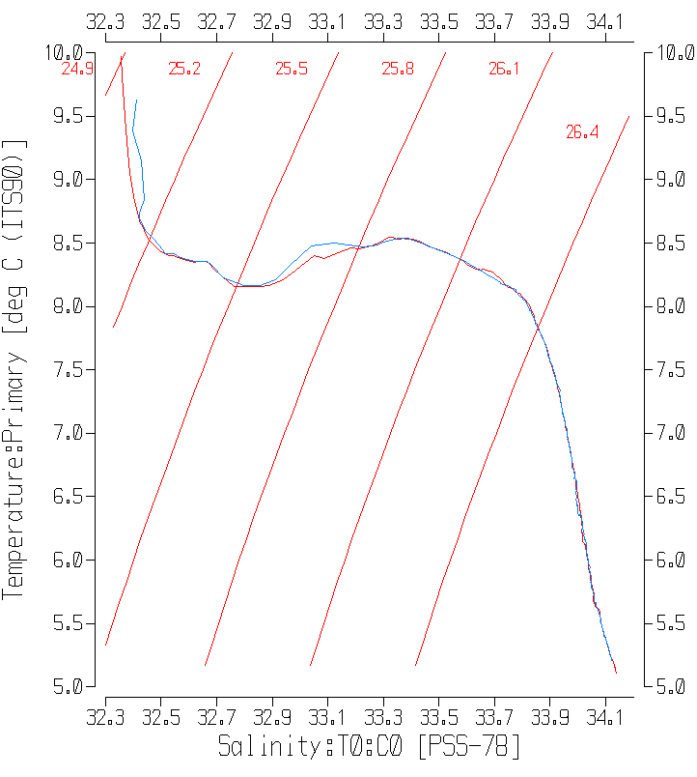

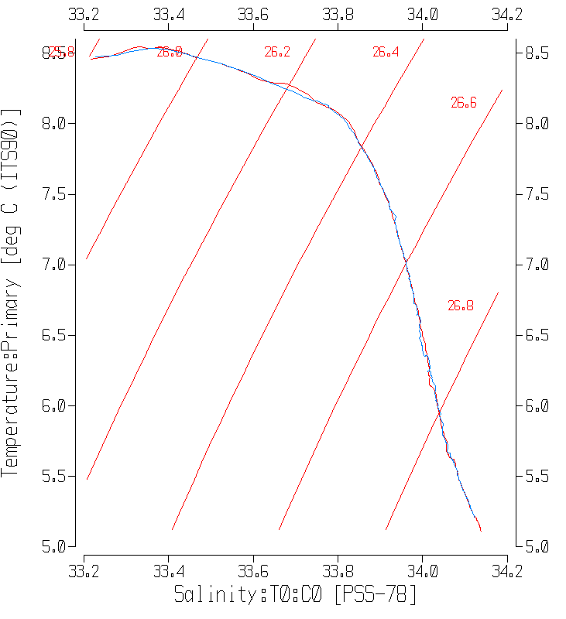

Below 50db the comparison is much closer and especially so below 150db.

Sigma-T was derived and readings were taken at 8 levels from 100db to 560db for the 2 casts. Temperature, salinity and sigma-T were recorded from the SBE911 cast and temperature and salinity were found in the SBE25 cast by matching sigma-T as closely as possible.

The results are shown in the following table:

|  |  |  |  |  |  |  |  |  |  |  |
| --- | --- | --- | --- | --- | --- | --- | --- | --- | --- | --- |
| 61-sig | 61-Press | 61 Sal | 61 Temp | 62-sig | 62 Press | 62 Sal | 62 Temp | Sal 62-61 | Temp 62-61 | sig62-61 |
| 26.0937 | 100 | 33.5413 | 8.4062 | 26.0927 | 84 | 33.5404 | 8.4078 | -0.0009 | 0.0016 | -0.0010 |
| 26.561 | 200 | 33.9330 | 7.3115 | 26.5615 | 303 | 33.9349 | 7.3186 | 0.0019 | 0.0071 | 0.0005 |
| 26.7127 | 300 | 33.9958 | 6.5633 | 26.7139 | 307 | 33.9949 | 6.5462 | -0.0009 | -0.0171 | 0.0012 |
| 26.7668 | 343 | 34.0161 | 6.2691 | 26.7671 | 348 | 34.0125 | 6.2446 | -0.0036 | -0.0245 | 0.0003 |
| 26.7776 | 350 | 34.0163 | 6.1856 | 26.7775 | 357 | 34.0206 | 6.2132 | 0.0043 | 0.0276 | -0.0001 |
| 26.8508 | 400 | 34.0493 | 5.8111 | 26.8507 | 411 | 34.0473 | 5.7994 | -0.0020 | -0.0117 | -0.0001 |
| 26.916 | 500 | 34.0844 | 5.5042 | 26.9160 | 515 | 34.0842 | 5.5027 | -0.0002 | -0.0015 | 0.0000 |
| 26.9691 | 560 | 34.1155 | 5.2644 | 26.9690 | 576 | 34.1149 | 5.2612 | -0.0006 | -0.0032 | -0.0001 |
|  |  |  |  |  |  |  | median | -0.0008 | -0.0024 | 0.0000 |

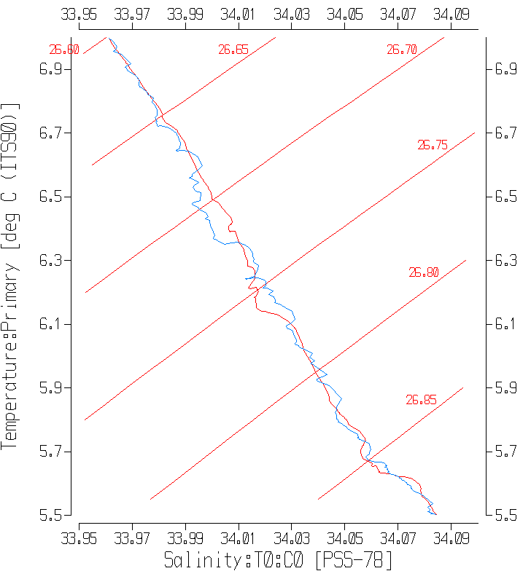

The salinity from the 2 CTDs is remarkably close in most cases. Temperature correspondence is a little less impressive but can be explained by looking at local gradients. The comparisons around 343-350db are the poorest, but a close examination of the T-S plot shows that this was an area of active mixing.

The salinity variations are relatively small through this section explaining the smaller differences in the table. Temperature changes are larger. Also keep in mind that the SBE25 data have not been through all normal processing steps, especially the fine-tuning of alignment of the conductivity sensor. This is difficult to do based on only one cast. Both CTDs indicate mixing is occurring. Another differences is that the 911+ data had been edited but not the SBE25 data.

The SBE25 performed well once it had equilibrated. Along lines of constant sigma-T the SBE25 read slightly warmer and saltier than the SBE911 from 50db to 80db, but the differences varied in sign below 80db.

To compare the oxygen sensors on the 2 CTDs, values were picked out at 9 Sigma-T levels below 50m. There are many sources of error in the comparison, but in 8 of the 9 cases the sensor on the SBE25 read lower than that on the SBE911. The one exception is seen at the site around 225db where there is a local reversal in DO and slight misalignment of either sensor may account for this outlier. When that point is excluded the SBE 25 is found to read low by 10.8 percent.

|  |  |  |  |  |  |  |
| --- | --- | --- | --- | --- | --- | --- |
| Sigma-T | PR-911 | SBE911 | Pr-25 | SBE25 | SBE25-SBE911 | % diff |
| 25.3 | 54 | 5.94 | 54 | 5.53 | -0.41 | -7.41 |
| 25.47 | 72 | 5.45 | 68 | 5.006 | -0.444 | -8.87 |
| 25.6 | 75 | 5.14 | 68 | 4.62 | -0.52 | -11.26 |
| 26 | 93 | 3.76 | 81 | 3.35 | -0.41 | -12.24 |
| 26.4 | 147 | 2.84 | 146 | 2.64 | -0.2 | -7.58 |
| 26.476 | 173 | 2.62 | 176 | 2.374 | -0.246 | -10.36 |
| 26.6 | 225 | 1.76 | 231 | 1.79 | 0.03 | 1.68 |
| 26.75 | 333 | 1.54 | 336 | 1.37 | -0.17 | -12.41 |
| 26.95 | 541 | 0.78 | 551 | 0.7 | -0.08 | -11.43 |
|  | median using all data | | | |  | -10.36 |
|  | median excluding 1 outlier | | | |  | -10.81 |

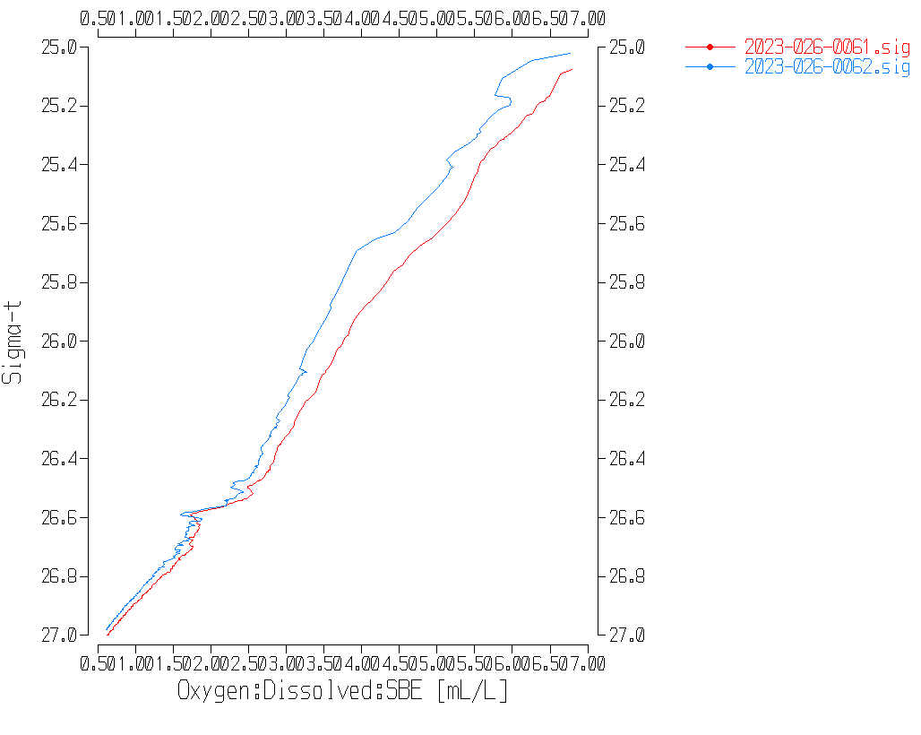

Plots of DO versus sigma-T show fairly consistent differences though the SBE25 data suggest that even by 50db the sensor may not have fully equilibrated. The alignment of the SBE25 sensor may also need some adjustment which might reduce the difference a little.

##### Thermosalinograph Data

An IOS TSG45 was used for this cruise.

Data were delivered in 6 files and it was not at all clear which should be processed. Those highlighted contained data that are relevant to this cruise though one contains only a few hours of data that will be included.

* 2023-026-TSG_Aug28restartAgain.dat Starts August 28 3:36 to Sept 4 1:40 but there is a gap between Aug. 28 at 15:40 to Aug 29 at 19:00.
* TSG2023_026 Sept 2 2023.txt – no data
* 2023-026-TSG_Aug28restart.dat – Aug 25 6:45 to August 28 3:36
* 2023-026-TSG_Start.dat - August 21 14:43 to August 25 6:45 with a gap – relevant part starts at 6:20.
* 2023-026-TSG_start_2023_08_25_06_33_41.dat – August 21 14:44 to August 25 6:35
* 2023-026-TSG_all.dat - August 21 14:30 – August 25 6:21

The data were extracted from the highlighted files and combined in a single file named 2023-026-TSG.dat.

The date and time were in a single column. Using LEFT and RIGHT formulae to separate them only worked if it was first copied to another column. Remember to use PASTE SPECIAL to keep separate date and time formats.

The spreadsheets were adjusted as follows:

* 2 lines of headers were added – channel names and units.
* Flow was on from the beginning
* A column with pressure was added with all values set to 4.5 (to enable derivation of salinity).
* A temperature difference column was included in the data file (Lab - Intake).
* The fluorescence channel is in volts. It was moved to column M. Then a concentration value was calculated in column F using scale 14.6 as determined in the most recent factory recalibration of the fluorometer. The clean water offset value was 0.081. For previous uses of this equipment it was sometimes found necessary to adjust the offset to obtain reasonable values. The offset used has steadily decreased. During the previous cruise a value of 0.066 was used and for this one 0.062 was necessary to avoid negative values. Using 0.062 led to a minimum of 0.01ug/L which is still rather low. A few checks were made looking at CHL sampling:

|  |  |  |  |  |
| --- | --- | --- | --- | --- |
| Cast # | Station | TSG Fluorescence | CHL from rosette | Comments |
| 9 | LB01 | 1.33 | 3.57 | Expect TSG to read lower than CHL when CHL>2 |
| 37 | LB15 | 0.2 | 0.3 | Expect TSG to read higher than CHL when CHL<1 |
| 123 | LBP2 | 1.17 | 1.85 | Expect TSG and CHL to be close when CHL 1-2ug/L |
| 142 | CS02 | 2.25 | 3 | Expect TSG to read lower than CHL when CHL>2 |
| 165 | CS06 | 1.21 | 1.25 | Expect TSG and CHL to be close when CHL 1-2ug/L |

So, while there is some evidence of the TSG fluorescence being slightly lower than expected for low CHL values, it is reasonably close when CHL is between 1 and 3ug/L. There is insufficient evidence to increase the offset further.

Further checks were made using Loop samples. Thee were 16 loops taken but for 2 there were no corresponding TSG data. The fit is encouraging with a slope close to 1 when forced through the origin As usual the fluorescence tends to read a little high relative to CHL when CHL is low and a little lower when CHL is high; there were no CHL samples >4 among the loops so this is not obvious.

The files were then converted to IOS Header format with header info added.

There are 11 IOS files, each covering all or part of 1 day.

CLEAN was run to reset the number of records, min and max values, set the start and end times, and latitude and longitude limits.

ADD TIME CHANNEL was used to add Julian dates – i.e. Decimal Year. A record number was also added to enable averaging (for use in comparison to CTD files). Time zero was set to 31 December 2022 0:00:00. (Note that this step leads to problems plotting until REORDER is run.)

DERIVED QUANTITIES was run twice, first to derive salinity using the lab temperature and again to derive sigma-T.

REORDER was run to move the Julian date after the Time/Date channels and salinity and fluorescence after the lab temperature. Also the record # was moved to the end. Channels not selected will be removed.

a.) Plots

A track plot was produced and added to the end of this report.

Time-series plots were produced:

* On August 25 flow rate was briefly 0 so fluorescence and salinity will need editing.
* On August 28 there were 2 breaks but since no data were acquired no editing is needed there but after 12:00 the flow gradually dropped and there is no flow from 1400 to 1600 so T, C, S, sigma-T will need padding for some of that cast. Fluorescence looks ok.
* On August 29th there was no data were acquired until 19:00; no editing is needed.
* The are about 45 minutes of data on Sept. 4th after which there was a gap and then just a few records with no flow and the ship was not moving, so those final records were removed from the IOS file and the routines were rerun.
* Salinity has only a few spikes and they look real rather than bubble induced.
* The temperature differences are very noisy but most values are between 0.3 and 0.5C°.
* The flow rates were mostly fairly steady, mostly ~1.2 for the TSG and ~1 for the fluorometer except for some of August 28th.

b.) Checking Time Channel

The CTD files were thinned to reduce the files to a single point from the downcast at or within 0.5db of 4.5db. These were exported to a spreadsheet which was saved as 2023-026-tsg-ctd-loop-comp.xlsx. There were 79 points of comparison

For comparison with CTD data, the TSG files were averaged over 6 records (30s) on record number to reduce the noise and file size. Standard deviations were included. Then required records (times, positions, temperatures with standard dev, salinity with standard dev, fluorescence with standard dev, flow rates) were exported to a spreadsheet and that file was thinned to the closest times of CTDs and added to file 2023-026-tsg-ctd-loop-comp.xlsx.. The same file was thinned to the closest times to loop samples and added to the TSG-Loop comparison. There were 14 loop samples that overlapped with TSG records.

A comparison was made of positions for the CTD and TSG data to check for good matches. The differences in positions are expected to be small despite the averaging because the ship was stopped at these times. The median differences were 0.0000º for latitude and 0.0002º for longitude. There were no differences> 0.0022º. So the matches are good.

c.) Comparisons

* Comparison of T, S and Fluorescence from TSG and CTD data

|  |  |  |  |  |
| --- | --- | --- | --- | --- |
|  | Tint-Tctd | Tlab-Tint | SALtsg-SALctd | FLtsg/FLctd |
| min | -0.6934 | -0.3169 | -2.2693 | 0.23 |
| max | 2.3738 | 2.4111 | 0.4653 | 1.66 |
| median | 0.0270 | 0.3247 | -0.1460 | 0.53 |
| average | 0.1293 | 0.3776 | -0.1997 | 0.66 |
| Std Dev | 0.3687 | 0.3840 | 0.2822 | 0.32 |

A plot of differences against event number shows great variability with the largest differences generally nearshore.

The temperature and salinity comparisons are reasonable though the standard deviations were high. The 25 casts with the lowest standard deviations in TSG temperature were selected and then thinned to the 15 of those that had the lowest standard deviations in TSG salinity. This eliminated most near-shore casts where variability was very high. The following differences were found:

|  |  |  |  |  |
| --- | --- | --- | --- | --- |
|  | Tint-Tctd | Tlab-Tint | SALtsg-SALctd | FLtsg/FLctd |
| min | 0.0076 | 0.2666 | -0.1315 | 0.53 |
| max | 0.3900 | 0.3662 | -0.1165 | 1.32 |
| median | 0.0076 | 0.2666 | -0.1315 | 0.53 |
| average | 0.0421 | 0.2620 | -0.1350 | 0.59 |
| stdev | 0.1026 | 0.0776 | 0.0127 | 0.28 |

The intake temperature is in better agreement with the CTD temperature and heating in the loop looks lower than in the full comparison. The ambient temperature in the lab is likely a little lower offshore than inshore, but so is the intake temperature and with north-south influence to further complicate matters, there is no reason to expect the reduced set to be more or less reliable in assessing heating in the loop by eliminating near-shore casts. But for the TSG temperature and salinity we would expect more reliable results in the reduced group.

Salinity was low by a median of 0.1460psu using all casts and by 0.1315psu using the 15 casts with low standard deviation in both T and S. This difference looks typical of the TSG performance, with small bubbles in the loop water likely explaining the difference.

The fluorometer read lower than the CTD fluorometer in most casts, with exceptions late in the cruise when CTD fluorescence values were lower and TSG fluorescence higher than elsewhere.

* Comparisons of Loop samples and TSG data

|  |  |  |
| --- | --- | --- |
|  | TSG Sal - Loop Sal | TSG FL/Loop CHL |
| min | -0.1918 | 0.28 |
| max | -0.1003 | 2.97 |
| median | -0.1570 | 1.08 |
| average | -0.1533 | 1.19 |
| stdev | 0.0220 | 0.62 |

The TSG salinity was lower than loop samples by a median of 0.1570psu. This is a larger difference than found in the comparison with CTD data. This may be due to the ship being underway when all loops were taken which could affect bubble density and/or the level from which water is drawn into the loop. The standard deviation is higher than seen in the CTD-TSG comparison.

The TSG fluorescence compared quite well with loop extracted CHL samples, being somewhat higher when CHL was low and a little lower for high CHL It did not compare as well with CTD fluorescence early in the cruise, but later the two were quite close.

* Heating in the Loop

The difference between the Intake temperature and Lab temperature due to heating in the loop show the usual relationship to the intake temperature. The fit would suggest that there would be no change if the input temperature was about 22°C, which is likely close to the ambient temperature of the ship.

d.) Calibration History

The TSG was serviced and recalibrated shortly in early 2022.

* During 2023-066 the intake temperature data looked bad throughout the cruise, with sudden shifts and did not compare well with CTD temperatures. A proxy for intake temperature was created by subtracting 0.53C from the lab temperature based on comparisons to CTD data. Salinity comparisons varied greatly but were, on average, reasonably close to CTD salinity. It was not recalibrated and was reported with 3 significant figures to indicate decreased quality. TSG fluorescence was about 80% of CTD fluorescence in the offshore and about 92% close to shore. Fluorescence was converted with scale 14.6 and offset 0.69.
* During 2023-019 the intake thermistor malfunctioned. TSG salinity was recalibrated by adding 0.03psu which was thought to be an error due to bubbles. Fluorescence was converted using a scale of 14.6 and offset of 0.69. TSG fluorescence was about 80% of CTD fluorescence and 70% of loop samples.
* During 2023-069 the flow rates varied greatly with little effect on the data. Intake temperature was higher than CTD by ~0.002C°. The lab temperature was higher than intake temperatures by 0.273C°. Salinity was recalibrated by adding 0.011psu based on comparisons with CTD and loops. TSG Fluorescence was ~67% of that from the CTD fluorometer and about 50% of extracted CHL samples from the loop.
* During 2023-088 the flow rates had some major drop-outs with more variability in the flow to the fluorometer than to the TSG. TSG salinity was recalibrated by adding 0.12psu based on comparisons to the loop samples, CTD and rosette samples. Fluorescence was about 50% of that from the CTD.
* A post cruise calibration report noted little drift tin temperature but excessive drift in conductivity. There were 2 cruises between 2023-026 and the post-cruise check that have not yet been processed.

e.) Conclusions re TSG

1. The TSG clock worked well and position information is reliable.

2. Both flow rates were in a good range except for a section on August 28th when flow to the TSG was low or off.

3. The TSG salinity was lower than loops by a median of 0.1570psu and lower than the CTD salinity by a median of 0.1315psu using the 15 casts with lowest variability in TSG data. The differences may be related to all loop samples being taken while the ship was underway which may affect the level from which the loop draws water. It was lower than CTD salinity by 0.1460psu using all casts; where the TSG temporal variability is high, the vertical gradient will likely be higher as well so if the which is likely due to higher salinity gradients so a small vertical offset leads to larger differences.

4. The TSG intake temperatures are higher than the CTD by about 0.008Cº which is good agreement.

5. The TSG lab temperature was higher than CTD temperature by a median of 0.267Cº in the reduced set of casts. Plots of differences versus intake temperature show the expected relationship of heating decreasing as the intake temperature approaches the ambient temperature of the ship.

5. TSG fluorescence was about 50% of CTD fluorescence except late in the cruise when it was close to the CTD. It was close to loop chlorophyll samples but most of those came late in the cruise.

f.) Editing

All REO files were copied to EDT.   
The only files that needed editing were those from August 25 and 28 to pad T:intake, T:lab, S, FL and Sigma-T when flows were very low or off. For Augst 28 the fluorometer flow was good.

g.) Calibrate and Remove

CALIBRATE was run using file 2023-026-tsg-recal.ccf to add 0.132psu to channel Salinity.

REMOVE was run to remove channels Temperature:Difference and Record #.

h) Preparing Final Files

HEADER EDIT was used to change the DATA DESCRIPTION to THERMOSALINOGRAPH and add the depth of sampling to the header and to change channel names to standard names and formats and to add comments.

The TSG sensor history was updated.

As a final check plots were made of the cruise track and time-series and all looks fine.

P**articulars - Notes from Daily Science Log and Rosette Logs**

TSG notes

Loop samples taken.

CTD notes

SBE – 6 casts were run for comparison of new CTD with SBE911.

33. Went 3 off bottom by mistake.

36. Stop at 387m

56. 2 min stop on downcast at 26m; bottles 1 & 2 bulk water for UBC – no CHE file needed.

60. Event # should be 61 – changed in raw files.

61. Sample #177 was used in 2 casts. During cast #61 it was used only for CHITO sampling so the sample # was changed to 9177 in the CHE file. Sample #77 was used in cast #66.

62. SBE25p cast off aft deck – same station as SBE911 at cast 61

67. SBE25p cast off aft deck – same station as SBE911 at cast 66

79. SBE25p cast off aft deck – same station as SBE911 at cast 78

90. Incomplete message about bottle 4.

97. SBE25p cast off aft deck – same station as SBE911 at cast 98

110. Greywater present on station.

133. UBC bottles.

139. Meant to take just 1 surface bottle, but was missed. No CHE file produced.

140. Event to collect 5m bottle missed on event #139 at the same site. CHE file produced.

152. Bottles for UBC.

180. Missed 200m bottle, went back for it.

182. SBE25p cast off aft deck – same station as SBE911 at cast 180

183. Went from 250 back to 350 to get bottle 5.

**CRUISE SUMMARY – CTD 2023-026**

|  |  |  |  |  |  |
| --- | --- | --- | --- | --- | --- |
| **CTD#** | **Make** | **Model** | **Serial#** | **Used with Rosette?** | **CTD Calibration Sheet Competed?** |
| **1** | **SEABIRD** | **911+** | **1515** | **Yes** | **Yes** |

|  |  |  |  |  |  |
| --- | --- | --- | --- | --- | --- |
| **Calibration Information - 1515** | | | | | |
| **Sensor** | | **Pre-Cruise** | | **Post Cruise** | |
| **Name** | **S/N** | **Date** | **Location** | **Date** | **Location** |
| **Temperature** | **6754** | **24Jan2023** | **Factory** |  |  |
| **Conductivity** | **6141** | **24Jan2023** | **Factory** |  |  |
| **Secondary Temp.** | **6736** | **3Feb2023** | **Factory** |  |  |
| **Secondary Cond.** | **6146** | **24Jan2023** | **Factory** |  |  |
| **Transmissometer** | **1185DR** | **23Mar2023** | **Factory** |  |  |
| **Transmissometer** | **1883DG** | **23Mar2023** | **Factory** |  |  |
| **SBE 43 DO sensor** | **1119** | **10Feb2023** | **Factory** |  |  |
| **PAR sensor** | **70613** | **24Feb2021** | **Factory** |  |  |
| **SeaPoint Fluor.** | **3650** |  |  |  |  |
| **Pressure Sensor** | **1515** | **17-Jan-2023** | **Factory** |  |  |
| **Valeport Altimeter** | **79487** |  | **Factory** |  |  |

# TSG Make/Model/Serial#: SEABIRD/45/0789

|  |  |  |  |  |  |
| --- | --- | --- | --- | --- | --- |
| **Calibration Information** | | | | | |
| **Sensor** | | **Pre-Cruise** | | **Post Cruise** | |
| **Name** | **S/N** | **Date** | **Location** | **Date** | **Location** |
| **Temperature** | **45-0789** | **1Feb22** | **Factory** |  |  |
| **Conductivity** | **45-0789** | **1Feb22** | **Factory** |  |  |
| **Wetlabs WETStar Fluor.**  For depths deeper than, and including, 125 dbar, we would wait 30 seconds before closing a bottle. For depths shallower than, and including, 100 dbar, we would wait 60 seconds before closing a bottle. | **1656** | **12Mar2021** | **Factory** |  |  |

# 

# 

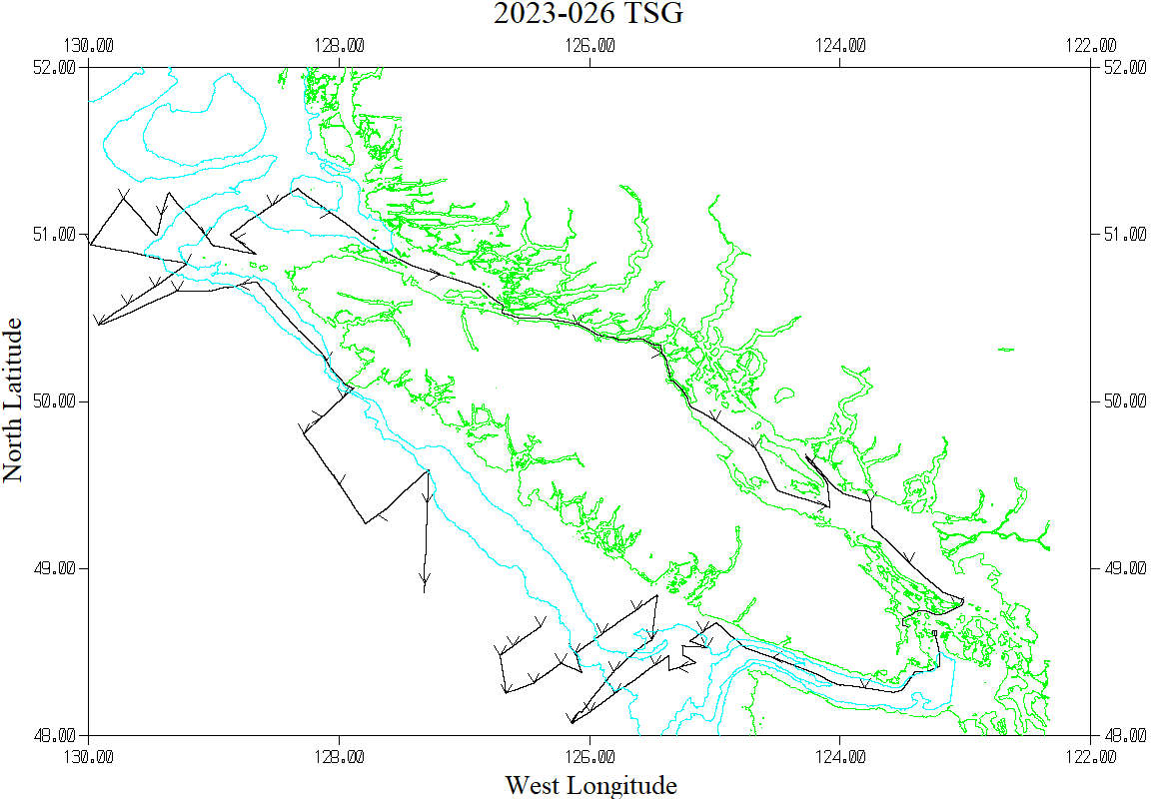

NOTE: The Thermosalinograph was not recording between 15:40 on August 28th and 19:00 on August 29th.

This includes much of the the LD line and most of the LG line.