##### SBE25 - SBE911 Comparison

There were 6 casts using an SBE25 after an SBE911 cast. They were run off the aft deck.

All casts were converted using file 25P - 1255 May2023.xmlcon.

5 of the casts had very few data, nothing deeper than 12db. This was likely a battery problem. Data from those depths were useless for comparison with the SBE911 because there was no 10m soak and the flow had clearly not been fully established; temperature did not compare with SBE911 and conductivity was clearly not equilibrated.

Cast #62 was deep. It was put through the following SeaBird processing steps:

DATCNV, Windows Filter (T and C), Alignctd (raw DO), CELLTM, DERIVE (Salinity and DO concentration).

It was then converted to IOS Header format and put through steps: CONVERT, CLEAN, CLIP (to remove spikes in top 2db), DELETE (to remove upcast and CTD reversals during downcast), BIN AVERAGE.

Plots were then made to compare the two CTD types. Since the 2 casts were not simultaneous the best comparisons are by matching density, so T-S plots were examined.

The first showed that the SBE25 data were poor until about 50db.

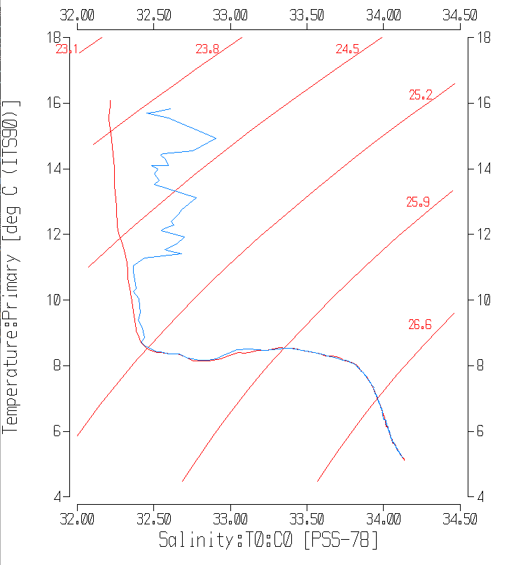



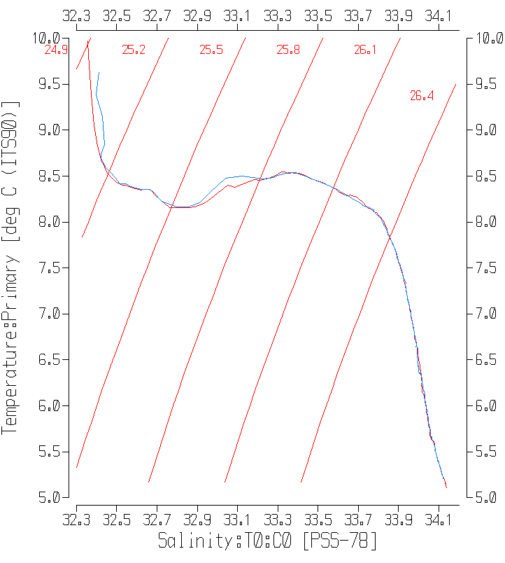

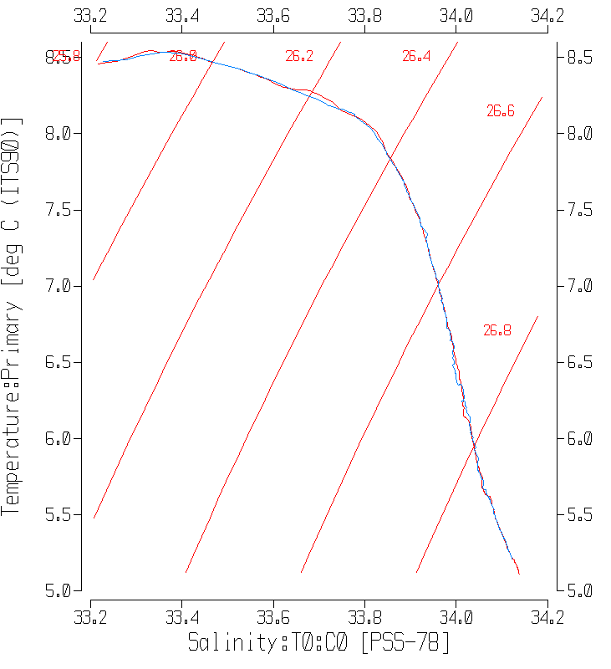

Below 50db the comparison is much closer and especially so below 150db.

Sigma-T was derived and readings were taken at 8 levels from 100db to 560db for the 2 casts. Temperature, salinity and sigma-T were recorded from the SBE911 cast and temperature and salinity were found in the SBE25 cast by matching sigma-T as closely as possible.

The results are shown in the following table:

|  |  |  |  |  |  |  |  |  |  |  |
| --- | --- | --- | --- | --- | --- | --- | --- | --- | --- | --- |
| 61-sig | 61-Press | 61 Sal | 61 Temp | 62-sig | 62 Press | 62 Sal | 62 Temp | Sal 62-61 | Temp 62-61 | sig62-61 |
| 26.0937 | 100 | 33.5413 | 8.4062 | 26.0927 | 84 | 33.5404 | 8.4078 | -0.0009 | 0.0016 | -0.0010 |
| 26.561 | 200 | 33.9330 | 7.3115 | 26.5615 | 303 | 33.9349 | 7.3186 | 0.0019 | 0.0071 | 0.0005 |
| 26.7127 | 300 | 33.9958 | 6.5633 | 26.7139 | 307 | 33.9949 | 6.5462 | -0.0009 | -0.0171 | 0.0012 |
| 26.7668 | 343 | 34.0161 | 6.2691 | 26.7671 | 348 | 34.0125 | 6.2446 | -0.0036 | -0.0245 | 0.0003 |
| 26.7776 | 350 | 34.0163 | 6.1856 | 26.7775 | 357 | 34.0206 | 6.2132 | 0.0043 | 0.0276 | -0.0001 |
| 26.8508 | 400 | 34.0493 | 5.8111 | 26.8507 | 411 | 34.0473 | 5.7994 | -0.0020 | -0.0117 | -0.0001 |
| 26.916 | 500 | 34.0844 | 5.5042 | 26.9160 | 515 | 34.0842 | 5.5027 | -0.0002 | -0.0015 | 0.0000 |
| 26.9691 | 560 | 34.1155 | 5.2644 | 26.9690 | 576 | 34.1149 | 5.2612 | -0.0006 | -0.0032 | -0.0001 |
|  |  |  |  |  |  |  | median | -0.0008 | -0.0024 | 0.0000 |

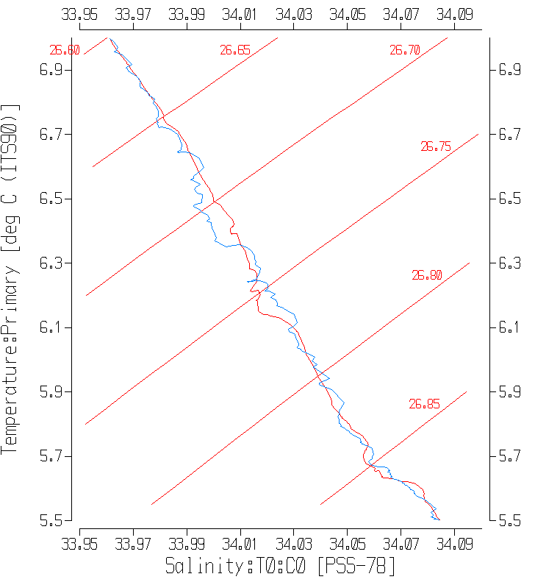

The salinity from the 2 CTDs is remarkably close in most cases. Temperature correspondence is a little less impressive but can be explained by looking at local gradients. The comparisons around 343-350db are the poorest, but a close examination of the T-S plot shows that this was an area of active mixing.

The salinity variations are relatively small through this section explaining the smaller differences in the table. Temperature changes are larger. Also keep in mind that the SBE25 data have not been through all normal processing steps, especially the fine-tuning of alignment of the conductivity sensor. This is difficult to do based on only one cast. Both CTDs indicate mixing is occurring. Another differences is that the 911+ data had been edited but not the SBE25 data.

The SBE25 performed well once it had equilibrated. Along lines of constant sigma-T the SBE25 read slightly warmer and saltier than the SBE911 from 50db to 80db, but the differences varied in sign below 80db.

To compare the oxygen sensors on the 2 CTDs, values were picked out at 9 Sigma-T levels below 50m. There are many sources of error in the comparison, but in 8 of the 9 cases the sensor on the SBE25 read lower than that on the SBE911. The one exception is seen at the site around 225db where there is a local reversal in DO and slight misalignment of either sensor may account for this. When that point is excluded the SBE 25 is found to read low by 10.8 percent.

|  |  |  |  |  |  |  |
| --- | --- | --- | --- | --- | --- | --- |
| Sigma-T | PR-911 | SBE911 | Pr-25 | SBE25 | SBE25-SBE911 | % diff |
| 25.3 | 54 | 5.94 | 54 | 5.53 | -0.41 | -7.41 |
| 25.47 | 72 | 5.45 | 68 | 5.006 | -0.444 | -8.87 |
| 25.6 | 75 | 5.14 | 68 | 4.62 | -0.52 | -11.26 |
| 26 | 93 | 3.76 | 81 | 3.35 | -0.41 | -12.24 |
| 26.4 | 147 | 2.84 | 146 | 2.64 | -0.2 | -7.58 |
| 26.476 | 173 | 2.62 | 176 | 2.374 | -0.246 | -10.36 |
| 26.6 | 225 | 1.76 | 231 | 1.79 | 0.03 | 1.68 |
| 26.75 | 333 | 1.54 | 336 | 1.37 | -0.17 | -12.41 |
| 26.95 | 541 | 0.78 | 551 | 0.7 | -0.08 | -11.43 |
|  | median using all data | | | |  | -10.36 |
|  | median excluding 1 outlier | | | |  | -10.81 |

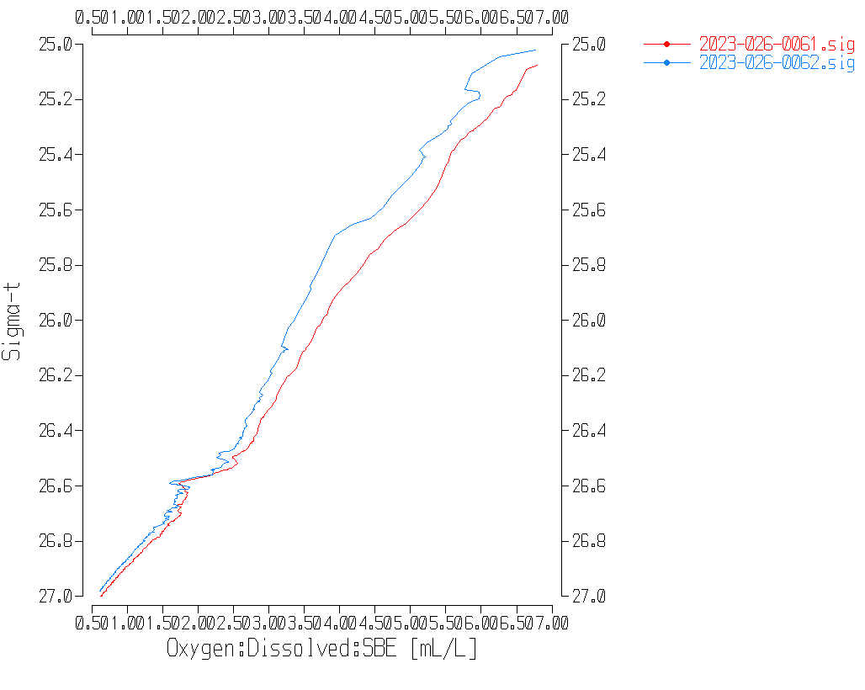

Plots of DO versus sigma-T show fairly consistent differences though the SBE25 data suggest that even by 50db the sensor may not have fully equilibrated. The alignment of the SBE25 sensor may also need some adjustment which might reduce the difference a little.