## REVISION NOTICE TABLE

|  |  |
| --- | --- |
| DATE | DESCRIPTION OF REVISION |
|  |  |
| 13 March 2025 | Updated TSG channel names and formats. GG |

## PROCESSING NOTES

Cruise: 2023-025

Agency: IOS, Ocean Sciences Division, Sidney BC

Chief Scientist: Donnet S.. Platform: Vector

Location: Strait of Georgia/ Juan de Fuca Strait Project: Salish Sea Biophysical Survey, Spring

Date: 24 June 2023 –29 June 2023

Processed by: Germaine Gatien

Date of Processing: 15 December 2023 – 16 January 2024

Number of original HEX files: 37 (15 from the SBE25 and 22 from SBE911+)

Number of CTD files: 37

Number of BOT files: 4 Number of CHE files: 18

Number of original TSG files: 3 Number of TOB files: 1

### INSTRUMENT SUMMARY

A SeaBird Model SBE-25+ CTD (s/n 334) was used with temperature sensor #2663, conductivity sensor #3396, Seapoint Fluorometer #2214, SeaBird dissolved oxygen sensor #1438 and strain gauge pressure sensor #464.

A SeaBird Model SBE-911+ CTD (s/n 0550) was mounted in a rosette and attached were a Seapoint Fluorometer (#3641) on the secondary pump, a SBE 43 DO sensor (#3791) on the primary pump, a PAR sensor #4565,a SPAR sensor #20518, a pH sensor #691, transmissometer (#983DR) and an altimeter (#76341).

A Seabird Model SBE-21 Thermosalinograph (s/n 2488) was used with no added sensors.

# SUMMARY OF QUALITY AND CONCERNS

There was a digital log with positions and notes about problems and sampling, as well as individual rosette log sheets. This was a complex cruise with 2 different CTDs in use and a thermosalinograph. This report is divided into 3 sections: SBE25, SBE911 and TSG.

There were many problems during the cruise. The main winch was not usable until event #27, so that the rosette could not be deployed. A SBE25 was used for that part of the cruise with a hydro cast of 4 bottles at 4 casts. Bottle files were constructed in different ways for the two sections of the cruise.

* For the SBE25 hydro casts BOT files were prepared by combining sample data with downcast CTD data from as close to the sample depths as possible. The Event Number from the CTD cast was used for the BOT files.
* Once the regular winch was available rosette casts were done using an SBE911+. CHE files were prepared with sample data plus CTD data gathered during the bottle stops.

For the SBE25 there were no NMEA data available for the first few cruises, but header information, including latitude and longitude, was entered in the raw files in a format that enabled easy conversion into IOS Header format. This step is much appreciated since it simplifies data processing.

The various instrument problems led to time limitations for the cruise, so near the end some bottles were either not sampled or not fired. On one occasion the science crew thought a bottle had misfired when it really did fire, though possibly it did not close. These issues complicated preparation of the bottle files, but logs were helpful in sorting out problems.

Sampling for the SBE25 casts did not include salinity or dissolved oxygen and there was no history available for the sensors since they were last serviced at the factory. Recalibration was limited to the pressure channel based on near-surface values.

For the SBE911+ casts there was salinity and dissolved oxygen sampling and the CTD had been used on 2 previous cruises with good sampling. The secondary salinity was very close to bottle samples. Pressure values were found to be low and dissolved oxygen and pressure were recalibrated.

Downcast (CTD files) Oxygen:Dissolved:SBE data for events #27-58 for this cruise are considered, very roughly, to be:

±0.30 mL/L from 0 - 50db except in areas of very large DO gradients

±0.10 mL/L from 50db - 150db

±0.04 mL/L from 150db - 200db

±0.02 mL/L below 200db

The thermosalinograph data were in 3 files:.

* File 2023-025-0001 had bad temperature and salinity, so was only used to prepare a track plot which is included at the end of this report. No data will be archived.
* File 2023-025-0002 lasted only 14 minutes and there were no co-incident CTD casts. While the data look reasonable there is no way to assess quality and initial records can be unreliable.
* File 2023-025-0003 had good data quality after the first 2.7 hours. Comparisons with CTD casts had very high variability, but based on a 2 well-mixed casts and recent calibration of the TSG it is believed that salinity is reasonably accurate; no recalibration was applied. A proxy for intake temperature was produced by subtracting 0.02Cº from the lab temperature based on the history of TSG use on the Vector at this time of year, recent recalibration of sensors and comparison with 2 casts with well-mixed surface water.

# PROCESSING SUMMARY

# PART I – SBE25 processing

##### Seasave

This step was completed at sea.

##### Preliminary Steps

A digital daily log was obtained as well as a sampling log.

The cruise summary sheet was completed.

CTD Deployment method: CTD was lowered to 10m for a soak of about 1.5 minutes, then bought back to surface. There was a 15s to 50s stop at the surface (most being ~25s) before the full cast was run.

BOTTLES:

For 4 casts there were 4 1.7L Niskins on a wire, with sampling of Nutrients and Chlorophyll. The event #s in the log are 3, 13, 16, 19. There were CTD casts at the same sites with event #s 2, 4, 17, 20.

BOT files will be prepared that include CTD data from approximate depths of the samples.

In order to provide accompanying CTD data, the event numbers for the CTD casts will be used.

##### Conversion of Raw Data

The configuration file for the SBE25 could not be confirmed at the beginning of processing, but was later found to be correct. The same one was used through the cruise. One file was saved as 2023-025-ctd1.xmlcon and used to convert sbe25 hex files.

The pressure looks too low with conductivity changing very rapidly between -0.9 and -1.5db at the beginning and end of casts. Conversion was rerun with the offset -1.2. Pressures at the end of files varied from -0.4db to +0.4db.

Plots were made of all casts and all expected variables were present.

Temperature profiles had surface spikes but otherwise look normal. It is noisy at the bottom of cast #11.

Conductivity profiles had surface spikes and spikes at the bottom of cast #11.

Fluorescence frequently had surface spikes that should disappear after the 10m soak data are removed. The dark value is ~0.12ug/L with no values <0. There are noisy data at the bottom of cast #11.

Oxygen voltage looks normal with just small spikes at the surface and noisy at the bottom of cast #11.

The log says “may have hit bottom” and the profiles confirm that it did.

##### WILDEDIT

WILDEDIT was run on P, D, T and C, though no obvious spikes were noted except at the top and bottom.

##### FILTER

Pressure and depth were put through the FILTER routine at this stage, with a setting of 0.5 (4*sampling rate). This removed the “step” structure in the profiles.

Tests were run to see if the usual approach of applying a cosine filter to temperature and conductivity using routine WFILTER did a good job of removing small reversals. A filter size roughly equal to the scan rate is recommended so WFILTER was run on all casts using size 8.

##### ALIGNCTD

Based on tests run for other cruises in this project using the same DO sensor, ALIGNCTD was run on all casts to advance the DO channel by 2.5s. Plots were examined after this step and the results look good.

##### CELLTM

CELLTM was run on all casts using the SeaBird recommended parameters, (α, 1/β) = (0.04, 8).

##### DERIVE

Program DERIVE was run to calculate salinity and dissolved oxygen concentration (tau correction included). Plots were examined and confirmed that steps 5, 6 and 7 had improved the data.

##### Conversion to IOS Headers

The IOSSHELL routine was used to convert the CNV files to IOS Headers.

CLEAN was run to add event numbers and replace pad values in the pressure channel with interpolated values.

##### Checking Headers

A cross-reference list was produced. There are some inconsistencies in times with most casts in PDT and some in UTC and the ones in UTC have the wrong date; this will be investigated and fixed later in processing. Positions are ok.

Track plots looked ok.

Surface Check was run and the average was +0.37db with a range from 0.05 to +2.22db. The 2.22 value was surprising but appears to be before the pressure sensor had fully equilibrated because it rose to near-zero values soon after acquisition began.

HEADER CHECK was run. The speed check includes some speeds <0 due to time zone inconsistencies noted above. No other problems were found.

##### CLIP

The next step is to remove the data collected during soaks at 10m. Plots were examined to see how many records should be removed from each cast. File clip.csv was prepared with 2 columns containing event # and # of records to removed. CLIP was run and output plots examined until all choices looked appropriate.

##### SHIFT

Conductivity

SHIFT was run using a variety of settings followed by a pass through DELETE to see which made the most improvement to stability in T-S space. Profiles were also examined comparing differences between down and upcast temperature and salinity. The best choice found was -0.2records.

Shift was run on all casts using -0.2 records..

Fluorescence

The fluorometer was unpumped, so no shift in alignment is expected to be needed and comparing temperature and fluorescence profiles confirmed that.

Dissolved Oxygen

This channel was aligned earlier, but checks were made by examining plots of temperature and dissolved oxygen. No further adjustment was made.

##### DELETE

DELETE was run on all casts using the following parameters:

Surface Record Removal: Last Press Min. Surface Swell Pressure Tolerance: 1.0

Pressure filtered over width: 5

Swells deleted. Warning message if pressure difference of 2.00

Drop rates < 0.3m/s (calculated over 5 points) was deleted from 10db to 10db above the maximum pressure.

COMMENTS ON WARNINGS: There were no warnings.

##### Graphical Editing

CTDEDIT was used to apply light editing to all files except #6.

The edited files were copied to *.EDT.

Careful checks were made of time/date header entries.

ADD TIME CHANNELS was run to add 7 hours to times for casts 1-14 so that all casts are in UTC.

ADD TIME CHANNELS was run to add 24 hours to times for casts 17-25.

##### Initial Bottle Data Steps

There was no rosette available for this part of the cruise.

The files were bin-averaged using 0.5db bins.

Dissolved oxygen was derived in mass units.

The data from casts 2, 14, 17 and 20 were exported to a spreadsheet and reduced to the depths where samples were taken. Those data were saved in file 2023-025-bottles_plus_SBE25_CTD_6linehdr.csv.

Sample data were added to the spreadsheets:

* Chlorophyll analysis was obtained in spreadsheet QF 2023-025_CHL*.xlsx.
* Nutrient analysis was obtained in spreadsheet QF2023-025_NUTS..xlsx.

##### Compare

Fluorescence

Despite the time difference and possible depth difference, the Extracted Chlorophyll samples were close to those of CTD fluorescence, with the ratio FL/CHL ranging from 0.8 to 2.2. In a typical pattern for the fluorometers the higher ratios come from cases where CHL<1.5ug/L.

For details see document 2023-025_SBE25_Bottle_Comp_CHL.xlsx.

##### Other calibration checks

Sensor History – First cruise since factory calibration.

Historic Ranges – All salinity data were all within the local climatology as were all temperature data except for patches of slightly high values around 20db at the 2 most northernmost stations, QU39 and 18. There is no indication of poor calibration.

Post-cruise calibrations – None were available.

##### CALIBRATE

No re-calibration was applied.

##### Fluorescence Filter

The fluorescence data did not require filtering.

**Bin Average, Remove, Derive DO in mass units, Reorder**

The files were bin averaged using 1db bins.

REMOVE was run to remove Scan_Number, Oxygen:Voltage, Descent Rate and Flag channels.

Dissolved Oxygen was derived in mass units and that was used to calculate DO saturation. Plots of near-surface saturation show a range of 106% to 118%, with the highest values in the middle of the Strait of Georgia. This region is noted for great variability. This type of check rarely offers calibration guidance except well offshore.

REORDER was used to get the 2 dissolved oxygen channels together.

##### HEADER EDIT and final checks of CTD files.

Header Edit was used to fix headers (scientist name), fix formats and to add comments about processing.

A cross-reference listing was produced but another will be produced later tougher with SBE911+ data.

A header check and standards check were run on the CTD files and no errors were found.

The sensor history was updated.

Plots of CTD casts were examined. No problems were found.

##### Final BOT file preparation – SBE25

To enable searching of bottle data, BOT casts were created that contain sample data and CTD data from the downcast at the same site. The spreadsheet file 2023-025_SBE25_Bottle_Comp_CHL.csv) prepared previously when doing comparison of CTD and bottle CHL was now converted to IOS Header files for each cast.

The time and date are present as channels as these cannot be converted directly into header entries.

CLEAN was run to add START and END time to the headers. The END TIME is identical so the START time so it will be removed later. CLEAN was also used to enter 0 flags where the flag channels are empty.

There are salinity values <25, so CALIBRATE was run to correct affected silicate values.

REMOVE was run to remove Date and Time channels.

The final CTD data include DO in mass units.

There was no DO sampling so there is no need to derive mass units for the sample data.

SORT was run to get data in pressure order.

Header Edit was run to add comments and to remove END TIME since it is the same as START TIME and TIME ZERO.

The final files have extensions BOT.

The standards check was run and no errors were found.

A cross-reference list and header check were run on the BOT files and no problems were found.

Plots were made of all BOT casts. With just 4 levels these were not very useful but looked sensible.

Finally all data from BOT files were extracted to a spreadsheet and compared to the event log; all expected data are present.

# PART I I– SBE911+ processing

##### Seasave

This step was completed at sea; the raw data files have extension HEX.

##### Preliminary Steps

The Log Book and rosette log sheets were obtained.

* Nutrients, extracted chlorophyll, dissolved oxygen and salinity data were obtained in QF spreadsheet format from the analysts.
* The cruise summary sheet was completed.
* The history of use of the pressure, conductivity and dissolved oxygen sensors was obtained.

All were used on 2023-066 and 2023-019.

The configuration files were checked; the only change during the cruise was to the NMEA download and SPAR settings after cast #34. Cast #34 itself was very confusing as the configuration file did not have the NMEA and SPAR entries ticked, but the hex file could only be converted using the configuration file with those choices. This is mysterious but the data looks ok. It is possible that some change occurred in files during set-up and the wrong con file was somehow saved.

An error was found in the transmissivity configuration parameters; they were from 2020. Values from a July 2023 calibration were entered in both 2023-025-ctd2.xmcon (for casts #27-33) and 2023-025-ctd3.xmcon (for casts 34-58).

##### BOTTLE FILE PREPARATION

The HEX files were converted to ROS files:

* using 2023-025-ctd2.xmlcon for casts 27-33. (No NMEA or SPAR)
* using 2023-025-ctd3.xmlcon for casts 34-58

Cast #34 did not convert properly because there were no entries in the BL file. Conversion was successful when the “Bottle confirm bit” selection was made instead of the BL file.

The water depth information was not present in the headers after conversion to IOS header format. This was because there was no colon after Depth. This was corrected in the HEX files for casts 30-58. Headers for casts #27 and 29 were missing the entry so that was added based on the log entries. Conversion was then rerun.

The ROS files were converted to IOS format.

The IOS files were put through CLEAN to create BOT files.

Temperature and salinity were plotted for all BOT files to check for significant outliers. There were none.

Because of spiking issues during a previous cruise using this CTD, plots were also made of dissolved oxygen and fluorescence. No evidence of spiking was found. No editing of BOT files was required.

A preliminary header check was run; no problems were found.

The BOT files were bin-averaged on bottle number.

The output was used to create file ADDSAMP.csv. First, the file was sorted on event number and Bottle Position order. Then sample numbers were added based on the rosette logs.

A number of adjustments had to be made to the file:

* In cast #49 a second surface bottle was fired but not recorded in the rosette log and no sample # was assigned. Sample -99 was entered in the addsamp file.
* In cast #50 18 bottles were fired but only 17 sampled and given sample #s. For bottle #3 the log indicates it misfired, but in fact it did fire. A second bottle was fired and sampled. For Niskin #3 sample # -99 was entered.
* In cast #56 only 9 bottles were fired but sample #s were assigned according to the original plan for 17 bottles.

The ADDSAMP file was then reordered on event # & sample #.

The ADDSAMP file was used to add sample numbers to the BOT files – output *.SAM.

The SAM files were bin-averaged on bottle # and called SAMAVG.

The SAMAVG files for events #49 and #50 were edited to remove 1 record for each where a bottle was not sampled or assigned a sample #.

The addsamp.csv file was converted to CST files, which will form the framework for the bottle files.

Next, each of the analysis spreadsheets were examined to see what comments the analysts wanted included in the header file. These were used to create file 2023-025-bot-hdr.txt which will be updated as needed during processing.

DISSOLVED OXGYEN

Dissolved oxygen data were provided in spreadsheet QF2023-025_OXY*.xlsx which includes flags, comments and a precision study. Draw temperatures are available. The spreadsheet page with the final data was simplified and saved as 2023-025oxy.csv. That file was converted into individual *.OXY files.

EXTRACTED CHLOROPHYLL

Extracted chlorophyll and phaeo-pigment data were obtained in file QF2023-025_CHL QF*.xlsx. The file included comments and flags and a precision study. A simplified version of the spreadsheet was prepared and saved as 2023-025chl.csv. The csv file was then converted to individual CHL files.

SALINITY

Salinity analysis was obtained in file QF2023-025_SAL.xlsx which included a precision study. The analyses were carried out in a temperature-controlled lab 11 to 14 days after collection. The files were simplified and saved as 2023-025sal.csv. That file was then converted to individual SAL files.

NUTRIENTS

The nutrient data were obtained in spreadsheet QF2023-025_NUTS*.xlsx. This includes a precision study. The file was simplified, saved as 2023-025nuts.csv. The file was converted to individual NUT files.

The SAL, CHL, OXY and NUT files were merged with CST files in 4 steps.

After the 4th step the files were put through CLEAN to reduce the headers to File and Comment sections only.

These files are ordered on sample number, but the SAMAVG files are ordered on bottle number, so one or the other set needs to be reordered in order to merge them. The MRGCLN1 files were reordered on Bottle_Number and saved as *. MRGCLN1s.

The MRGCLN1s files were then merged with SAMAVG files using merge channel Bottle_Number.

The output of the MRG files were exported to a spreadsheet and compared to the Bottle_Summary file. The only differences concerned bottles intended to be fired, but not actually fired.

##### Compare

Dissolved Oxygen

COMPARE was run with pressure as the reference channel.

A fit was done of the difference between the CTD DO and titrated DO samples versus CTD DO. All data below 50m from Saanich Inlet were excluded from the fit due to the extreme DO gradient; this cast generally does not fall within the general fit. A few more outliers were excluded based on residuals. None of the samples flagged 3 or 4 were far out of line, so were included. The fit found was:

CTD DO Corrected = CTD DO * 1.0171 + 0.0113

There are no reliable samples for DO<1.4mL/L, so if the offset was set to 0 and the fit was:

CTD DO Corrected = CTD DO * 1.0197

A fit was done for cast #33 (Stn 102) at the mouth of Juan de Fuca Strait where the descent rate was very noisy:

CTD DO Corrected = CTD DO * 1.0218

And if 1 outlier is excluded:

CTD DO Corrected = CTD DO * 1.0209

The Station 102 fits are close to the general fit suggesting that flushing was fairly good for the whole cruise.

Another fit was done excluding the same points as in the main fit PLUS the 2 casts (33 and 34) closest to the mouth of Juan de Fuca where flushing is presumed best. The fit was:

CTD DO Corrected = CTD DO * 1.0194

So there is some evidence of reduced flushing away from the mouth of Juan de Fuca, but the difference is insignificant. This may be due to the fact that DO gradients were fairly low so even if bottles don’t flush well the resulting error is small.

When used for 2 pervious cruises the fits were:

CTD DO Corrected = CTD DO * 1.0115 - 0.0094 2023-066

CTD DO Corrected = CTD DO * 1.0252 + 0.0155 2023-019

The correction for 2023-025 lies between the 2 previous cruises which were both from the offshore where flushing is thought to be good. Having a smaller correction for 2023-025 than for 2023-019 may be due partly to poorer flushing conditions, but since there are lower vertical DO gradients, errors due to slow response of the CTD DO sensor would be smaller as well.

The correction that looks most reliable is:

CTD DO Corrected = CTD DO * 1.021

The only major outlier came from Saanich Inlet where DO vertical gradients are very high and flushing tends to be weak.

For full details for the COMPARE run see file 2023-025-dox-comp1.xls.

Salinity

Compare was run with pressure as reference channel. A fit was done excluding cases where the standard deviation in the CTD salinity during the 10s window was >0.001psu or pressure was <180db. There is some evidence of poor flushing in the shallower samples, though the effect does not look large.

The primary salinity was higher than bottles by an average of ~0.0033psu (std dev 0.0012psu) and the secondary salinity was lower by an average of ~0.0006psu (std dev 0.0011psu). If only the bottles below 300db are included (excluding 1 outlier) the primary is high by an average of 0.0029psu and the secondary is low by 0.0009psu. So the differences between the 2 channels are 0.0039psu or 0.0038psu for the deeper samples.

There is some variation with time which is likely a reflection of flushing conditions. The bottles from casts with very quiet descent rates tend to show the CTD reading lower relative to bottles than in areas with noisier descent rates. The bottles from the mouth of Juan de Fuca Strait tend to be the most reliable for calibration purposes and they indicate that the primary CTD salinity is high by about 0.0036psu and the secondary low by ~0.0001psu. Even that cast shows some evidence of poorer flushing in shallower water. These are not large differences and there are few bottles to guide us. Flushing may be better than usual, though the dissolved oxygen comparison suggests some effect.

A best guess is that the primary salinity is high by about 0.004psu and the secondary very close to bottles.

During 2023-066 the primary was high by ~0.001psu and the secondary was very close to bottles.

During 2023-019 the primary was high by ~0.002psu and the secondary was very close to bottles.

There appears to be drift in the primary salinity but no significant drift in the secondary salinity.

There was only 1 major outlier.

Sample #251 from cast #58 is an extreme outlier; it was intended to come from 5db but has a value close to CTD salinity at 340db. There are no values remotely close to this above 200m. This looks like a case of sampling from the wrong bottle; it was the only shallow sample during the cruise which could have led to some confusion. The value is very close to the duplicates from 350db. The nutrients and extracted chlorophyll values from that Niskin look reasonable for 5db so the bottle apparently closed at the intended depth. The analyst flagged the sample 5 and gave it a pad value.

The differences between the 2 fits are similar to the differences between downcast salinity channels reported in section 31 .

For full details for the COMPARE run see file 2023-025-sal-comp1.xls.

Fluorescence

COMPARE was run with extracted chlorophyll and CTD Fluorescence using pressure as the reference variable.

CTD fluorescence read a little lower than extracted CHL samples.

As is typical for these fluorometers the ratio FLUOR/CHL is high when CHL is low and quickly drops as CHL increases.

For full details for the COMPARE run see file 2023-025-fl-chl-comp1.xls.

##### Conversion of Full Files from Raw Data

Hex files were converted to CNV files:

* using 2023-025-ctd2.xmlcon for casts 27- 33.
* using 2023-025-ctd3.xmlcon for casts 34-58.

The Tau function was selected but not the hysteresis correction since there was no deep sampling.

A few casts were examined and all expected channels are present. There are some spikes in altimetry near the bottom.

##### WILDEDIT

Program WILDEDIT was run to remove spikes from the pressure, depth, conductivity and temperature channels in the CNV files. During the last cruise using this CTD spikes were found in dissolved oxygen, but not during this cruise.

Parameters used were: Pass 1 Std Dev = 2 Pass 2 Std Dev = 5 Points per block = 50

The parameter “Keep data within this distance of the mean” was set to 0 so all spikes would be removed.

##### ALIGN DO

ALIGNCTD was run with the usual setting of +2.5s applied to the dissolved oxygen channel and produced good alignment with temperature profiles.

ALIGNCTD was run on all casts using +2.5s.

##### CELLTM

CELLTM was run using default values (α = 0.0245, β=9.5) for both the primary and secondary conductivity.

##### DERIVE and Channel Comparisons

Program DERIVE was run on all casts to calculate primary and secondary salinity and dissolved oxygen concentration.

A few casts were examined to see how well the previous 3 steps worked; no problems were found.

DERIVE was run a second time on 3 casts to find the differences between the pairs of temperature, conductivity and salinity channels. None of the casts were very deep so pressure-dependence could not be assessed. The shaded entries are from the previous 2 cruises which had much deeper sampling.

|  |  |  |  |  |  |
| --- | --- | --- | --- | --- | --- |
| Cast # | Press | T1-T0 | C1-C0 | S1-S0 | Descent Rate |
| 2023-066-0052 | 1000 | -0.0002 | -0.00004 | -0.0003 | High, Noisy |
|  | 2000 | -0.0005 | -0.00006 | -0.0003 | “ |
|  | 3000 | -0.0008 | -0.00006 | -0.0001 | “ |
|  | 3500 | -0.0008 | -0.00008 | 0 | “ |
| 2023-066-0086 | 1000 | +0.0003 | -0.00025 | -0.0032 | High, XNoisy |
|  | 2000 | -0.0002 | -0.00023 | -0.0026 | “ |
|  | 3000 | -0.0002 | -0.00021 | -0.0024 | “ |
|  | 4000 | +0.0001 | -0.00020 | -0.0025 | “ |
| 2023-019-0039 | 500 | +0.0003 | -0.00041 | -0.0047 | High, FSteady |
|  | 1000 | +0.0003 | -0.00029 | -0.0036 | “ |
|  | 1400 | +0.0002 | -0.00022 | -0.0033 | “ |
| 2023-019-0092 | 500 | +0.0001 | -0.00040 | -0.0046 | High, Noisy |
|  | 1000 | +0.0001 | -0.00030 | -0.0037 | “ |
|  | 2000 | -0.0004 | -0.00024 | -0.0025 | “ |
| 2023-019-0108 | 500 | +0.0002 | -0.00033 | -0.0040 | High, V Noisy |
|  | 1000 | +0.0002 | -0.00024 | -0.0041 | “ |
|  | 2000 | -0.0004 | -0.00020 | -0.0021 | “ |
| 2023-025-0042 | 220 | +0.0005 | -0.00052 | -0.0060 | High, Steady |
| 2023-025-0053 | 335 | +0.0005 | -0.00050 | -0.0054 | High, Steady |
| 2023-025-0058 | 390 | +0.0003 | -0.00038 | -0.0039 | High, F.Steady |

The differences from cast #58 are close to those from 500db during 2023-019 so there does not appear to be significant calibration drift.

##### Conversion to IOS Header Format

The IOSSHELL routine was used to convert Sea-Bird 911+ CNV files to IOS Headers.

CLEAN was run to add event numbers and to replace pad values in the pressure channel with interpolated values based on record number.

##### Checking Headers

* Initial track plots look ok.
* The cross-reference check and header check were run.
  + The minimum pressure was -2.2db which was a single value near the end of the first cast using this CTD. It occurred with the pumps on at a time when pressure was full of spikes before CLEAN was run.
  + pH data were bad during cast #29, starting with fairly low and constant values and moving to extremely lower values later; this channel should be removed.
  + Other extreme values appear to only occur at the surface.
* Surface check was run and the average surface value was 1.5db with a range of 0.3 to 2.4db. This is the measure after the 10m soak. The values <1.5db would imply that the rosette was partly above water when acquisition began and this is unlikely. For the Saanich Inlet site it is more likely that the top was just below the surface implying that pressure is reading low by roughly 1db.
* The altimeter and water depth readings from the headers of the CLN files were exported to a spreadsheet. A check value was calculated by subtracting water depth from maximum depth sampled plus altimetry header. 7 casts had check values >5m. Of those 2 had header depths different from the log records and using the log values led to check values <5m, so those headers were edited using the log depths (Events 32 and 40). The other cases are only slightly above 5m and shoaling during the cast may well account for them, so no further changes were made. None of the changes concern bottle casts.

##### Shift

Dissolved Oxygen

The Dissolved Oxygen voltage channel was aligned earlier. A few casts were checked to see if the alignment looked ok, and it did. No further alignment is needed for the DO concentration channel.

Conductivity

Tests were run on a few casts to find the alignment shift best for the 2 conductivity sensors as judged by noise in T-S space. Results varied between various features but overall the best choices were -0.8 records for the primary and -0.65 records for the secondary channels. Those were the choices made during the last cruise that used this CTD.

SHIFT was run twice on all SBE911 casts using -0.8 records for the primary and -0.65 for the secondary. Salinity was recalculated for both channels.

pH

Tests were run on a few casts to decide on the best setting to improve pH alignment with temperature. Due to hysteresis in pH comparisons are difficult, but a setting of +20 scans did appear to improve alignment. SHIFT was run on all casts with a setting of +20 records.

Fluorescence

SHIFT was run on the SeaPoint fluorescence channel in all casts using the usual advance of +24 records. Plots show that the fluorescence offset is reasonably close to the temperature offset after this step.

##### DELETE

The following DELETE parameters were used:

Surface Record Removal: Last Press Min

Maximum Surface Pressure (relative): 10.00

Surface Pressure Tolerance: 1.0 Pressure filtered over 15 points

Swells deleted. Warning message if pressure difference of 2.00

Drop rates < 0.30m/s (calculated over 11 points) will be deleted.

Drop rate applies in the range: 10db to 10db less than the maximum pressure

Sample interval = 0.042 seconds. (taken from header)

COMMENTS ON WARNINGS: There were no warnings.

##### Other Comparisons

Experience with these sensors since last factory service –

The pressure, temperature, conductivity and dissolved oxygen sensors on CTD 0550 were used for only 2 cruises between the last factory service and this cruise.

* During 2023-066 the primary salinity was high by 0.0011psu and the secondary was low by 0.0001psu. Pressure calibration was recalibrated by adding 0.8db. There was hysteresis noted in the dissolved oxygen channel so the configuration parameter E was changed to 0.033. The DO data were recalibrated using slope 1.0115 and offset -0.0094. A different fluorometer was used than during this cruise.
* During 2023-019 the primary salinity was recalibrated by subtracting 0.002psu to match the secondary since the secondary was selected for 3 casts and the primary for all others. There was hysteresis noted in the dissolved oxygen channel so the configuration parameter E was changed to 0.033. The DO data were recalibrated using slope 1.0245 and offset -0.0143. Pressure was recalibrated by adding 0.8db. A different fluorometer was used then for this cruise.

Historic ranges – Profile plots were made with 3-standard deviation climatology ranges of T and S superimposed.

* The only excursion from climatology in temperature were slightly high values between 10db and 15db in Satellite Channel.
* The salinity at station 56 is well above the climatology. It has been noted in the past that the cast fits well within the Gulf Islands climatology, but is defined to be within the South Georgia Strait. So this is a problem with the climatology, not with the sensor calibration or performance. Cast #46 at station 46 has a slight excursion towards higher salinity at the bottom of the cast; this is likely real and another limitation in the climatology.

Post-Cruise Calibration – None available.

Repeat Casts –There were no repeat casts..

##### DETAILED EDITING

The secondary T-S plots show fewer spikes than the primary and the secondary salinity was found to be close to bottles, so those channels were selected for editing.

All DEL files were moved to another folder, copied to *.EDT and then both DEL and EDT were moved back to folder IOS. This was done so the EDT files from the SBE25 were not changed.

CTDEDIT was used to remove records that appear to be corrupted by shed wakes. Salinity was cleaned to remove spikes that appear to be due to small misalignment or instrumental noise.

In some casts the salinity was very noisy in deep water, but the variations were 2-sided and likely to be ok after bin-averaging.

Light editing was applied to all casts except for cast #43.

Notes about editing applied were added to the files.

After editing, T-S plots were examined for all casts; there are some unstable features but they are common in this region of active mixing and look real.

##### Corrections to Pressure, Salinity and Dissolved Oxygen Concentration

There are cases of CTD salinity <25psu in the bottle files (MRG) so silicate needs correction in the bottle files.

CALIBRATE was run on the MRGCLN2 files using file 2023-025-sil.ccf to correct silicate when salinity < 25psu, with output *.MRGCORSIL.

CALIBRATE was run on MRGCORSIL and SAM files using file 2023-025-recal1.ccf to apply the following corrections:

* Add 0.8 to Pressure and Depth
* CTD DO Corrected = CTD DO * 1.021
* Only secondary salinity was used, so no recalibration is required for that channel.

COMPARE was rerun for dissolved oxygen and shows that the correction improved the fit greatly. When outliers were removed based on residuals plus 2 SI bottles that were excluded from the original fit, the SBE DO was found to be high by an average of 0.0046mL/L and standard deviation of 0.022mL/L.

CALIBRATE was then run on the EDT files using file 2023-025-recal1.ccf.

##### Final Calibration of DO

The initial recalibration of dissolved oxygen corrects for sensor calibration drift. Alignctd corrects for transit time errors. Those 2 steps may partly correct for response time errors, but to see if a further correction is needed, a comparison is made of downcast CTD data to upcast bottle data at the same pressure. Small differences are expected due to ship drift, temporal changes, incomplete flushing of Niskin bottles and delayed response and noise in CTD data.

Downcast files were bin-averaged to 0.5m bins for the casts with DO bottle samples. Those files were then thinned and compared to the bottle values in the MRG files. COMPARE was run to study the differences between the downcast CTD DO data and the titrated samples from upcast bottles.

The CTD DO was higher than the titrated samples by an average of 0.023mL/L when outliers were removed based on residuals (standard deviation 0.039mL/L). This is a good result. We expect the downcast CTD data to be slightly too high due to slow response and the upcast bottle data to be too low due to incomplete flushing.

A plot of differences versus pressure was then done, excluding outliers as determined in a fit against bottle DO. Based on this an estimate is made of errors in DO in different pressure ranges. This is likely too severe a method given time differences and inexact matches in depths.

Downcast (CTD files) Oxygen:Dissolved:SBE data for this cruise are considered, very roughly, to be:

±0.30 mL/L from 0 - 50db except in areas of very large DO gradients

±0.10 mL/L from 50db - 150db

±0.04 mL/L from 150db - 200db

±0.02 mL/L below 200db

For more detail see file 2023-025-dox-comp3.xls.

##### Fluorescence Processing

A median filter, size 11, was applied to the fluorescence channel in the COR1 files. Plots of a few casts showed that the filter was effective. (Output:*.FIL)

##### BIN AVERAGE of CTD files

The following Bin Average values were applied to the FIL files (output AVG):

Bin channel = pressure Averaging interval = 1.000 Minimum bin value = .000

Average value will be used. Interpolated values are NOT used for empty bins.

On-screen T-S plots were examined and no problems noted.

Profile plots were examined and no problems were found. Unstable features are very small and may well be real.

##### Final CTD File Steps (REMOVE and HEADEDIT)

REMOVE was run to remove the following channels:

Scan_Number, Temperature:Primary, Conductivity:Primary, Oxygen:Voltage:SBE, Descent_Rate, Status:Pump, Altimeter, Salinity:T0:C0 and Flag.

Channel pH:SBE was removed from event #29

A second SBE DO channel (with umol/kg units) was added.

REORDER was run to get the two DO channels together.

HEADER EDIT was used to fix formats and channel names and to add comments about processing.

Final Checks:

* The Standards Check routine was run and no problems were found.
* A Cross-Reference list and Header Check were including data from both CTDs; no problems were found.
* Profile and T-S plots were examined. Surface PAR values are much higher than PAR values towards the end of the cruise, but when full files are examined the upcast PAR maxima look closer to SPAR than seen in downcasts, presumably due to those files having few data above 2db and transmissivity being quite low near the surface.
* The sensor history was updated.

##### Dissolved Oxygen Study

As a final check of dissolved oxygen data, % saturation was calculated and plotted. Values at 2 to 3m ranged from ~75% to 135%. As usual, the lowest values were in Juan de Fuca Strait. This is an area subject to large variations, so this offers no guidance on sensor calibration.

##### Final Bottle Files

SORT was run to arrange casts in pressure order.

REMOVE was run to remove the following channels:

Scan_Number, Temperature:Primary, Conductivity:Primary, Oxygen:Voltage:SBE, Descent_Rate, Status:Pump, Altimeter, Salinity:T0:C0 and Flag.

Channel pH:SBE was removed from event #29

A second SBE DO channel with mass units was added for both the CTD DO and titrated DO and REORDER was run to get the pairs of DO channels together.

EDIT HEADERS was run to fix formats and channel names and to add comments about analyses and CTD processing.

The standards check was run and showed that the chlorophyll and phaeo-pigment channels were empty. There was an intention to gather samples from 4 Niskins but none of them closed. Empty channels are not usually removed in processing since there are often flags indicating why a sample was rejected, so we don’t want to lose that information. But in this case, there is no record for the relevant bottles, so the steps from CLEAN onwards were re-run on file 2023-025-0033.MRG to remove empty channels and Edit Headers was run again.

Data were exported from the CHE files to file 2023-025-bottles-final.xlsx. A few random checks were made by comparing with the rosette log sheets. One bad salinity value was replaced with a pad value as discussed earlier.

A header check was run for SBE911 files. No problems were found.

The track plot looks ok.

Plots of each file were examined and no problems were found.

A cross-reference listing combining both CTD types was prepared.

A header check was produced for the CHE files.

# PART III – TSG processing

There were 3 thermosalinograph files

There were no loop samples, flow meter or intake thermistor. The intake is at about 2m. The only method to check calibration is to compare with the CTD casts.

##### Checking calibrations

The configuration file parameters were all correct.

##### Conversion of Files

The files were converted to CNV format.

The CNV files were converted to IOS HEADER format.

CLEAN was run to add End times and Longitude and Latitude minima and maxima to the headers.

ADD TIME CHANNEL was used to add Time and Date channels.

Time-series plots were produced.

The times covered and CTD casts during those periods are:

* 2023-025-0001 – June 25 18:00 to June 26 17:43. (CTD casts 7-25)
* 2023-025-0002 – June 26 18:26 to June 26 18:40. (No CTD cast – in Gulf Islands)
* 2023-025-0003 – June 27 01:23 to June 29 16:38. (CTD casts 27-58)

The first file has bad data at the beginning and end of the file as it appears the flow was coming on and off until about 20:00 on the 25th. There is noise in both T and S at the end of station stops as the ship began to move. Salinity seems high and varies little. It will need editing, if it is to be archived.

The second file is very short – about 14 minutes. It looks noisy so should be examined in an editor.

The third file has a lot of noise while the ship was at station SI. After that the data look generally ok though local variability makes it unclear if there is noise at the end of station stops Editing will be needed.

Track plots were produced in 2 sections. The first shows the first 2 files and the second only the 3rd – these correspond to the 2 different CTDs in use.

The plots looks good and were added to the end of this report.

##### Checking Time Channel

* The CTD files for casts 7 to 58 were thinned to reduce the files to a single point from the downcast within 0.5db of 2db. These were exported to a spreadsheet which was saved as 2023-025-ctd-tsg-comp.xls. There were 28 CTD casts from times that overlapped with TSG records, and had data within 0.5m of 2m.
* The TSG ATC files were opened in EXCEL and reduced to times of CTD data in the spreadsheet. They were added to 2023-025-tsg-ctd-comp.xls.
* To check for problems in the TSG clock or bad matches of TSG and CTD data, the differences between latitudes and longitudes were found. The median differences were <0.0000º for both with maximum differences of 0.002 and 0.005 for latitude and longitude. The largest differences all took place during the first leg of the cruise which did not have NMEA time and small differences are expected depending on when CTD positions were recorded. The TSG clock appears to have worked well.

##### Comparison of Temperature and Salinity from TSG and CTD data

When all casts were included the TSG temperature was higher than the CTD temperature by a median of 0.7471Cº but there was a very high standard deviation, 2.8625Cº. Salinity ranged from being higher by 27psu to lower by 10psu. However, the first 2 casts had 0psu salinity in the TSG, so obviously there was no flow to the TSG.

When casts #7 and #8 were removed from the comparison the salinity looked a little better for a few casts, but soon the ship moved into fresher water as seen by the CTD, but the TSG continued with high salinity. TSG temperature in the lab ranged from 21.8 to 23.7ºC while CTD temperatures were 16-17 ºC . It is impossible to believe that heating of water in the Vector loop could be this high at normal flow rates. Presumably flow was very low or off, making the comparison unreliable.

In the plot below the two salinity values are very close from cast #27 onwards. That corresponds to TSG file 2023-025-0003 from the second leg of the cruise. File 2023-025-0002 is very short with no co-incident CTD casts. Temperature and salinity in file #2 look reasonable but can’t be confirmed. This was likely a test and opening records are often of poor quality poor as the system starts up.

Differences were analyzed over the whole cruise and then the data were divided into the 2 legs and the second leg produced results that are highly variability but reasonable.

**Differences between TSG and CTD records**:

|  |  |  |  |  |  |
| --- | --- | --- | --- | --- | --- |
|  |  | **Latitude** | **Longitude** | **Temp** | **Salinity** |
| **Casts 9-58** | **average** | -0.00002 | -0.00028 | 2.59181 | 0.91747 |
|  | **median** | -0.00002 | -0.00006 | 0.69740 | -0.00435 |
|  | **stdev** | 0.00056 | 0.00107 | 2.81275 | 2.49583 |
|  | **min** | -0.00193 | -0.00498 | 0.11380 | -2.29300 |
|  | **max** | 0.00196 | 0.00070 | 7.16740 | 10.10060 |
|  |  | **Latitude** | **Longitude** | **Temp** | **Salinity** |
| **Casts 9-25** | **average** | 0.00000 | -0.00082 | 6.24916 | 3.12820 |
|  | **median** | -0.00003 | -0.00014 | 6.43530 | 2.41980 |
|  | **stdev** | 0.00098 | 0.00172 | 0.70423 | 3.22081 |
|  | **min** | -0.00193 | -0.00498 | 4.85780 | -0.15010 |
|  | **max** | 0.00196 | 0.00056 | 7.16740 | 10.10060 |
|  |  | **Latitude** | **Longitude** | **Temp** | **Salinity** |
| **Casts 27-58** | **average** | -0.00003 | 0.00000 | 0.6556 | -0.2529 |
|  | **median** | -0.00001 | -0.00006 | 0.4689 | -0.0449 |
|  | **stdev** | 0.00010 | 0.00025 | 0.7787 | 0.5846 |
|  | **min** | -0.00021 | -0.00027 | 0.1138 | -2.2930 |
|  | **max** | 0.00021 | 0.00070 | 3.4923 | 0.0949 |

The largest differences were all during the first leg even excluding casts #7 and #8. It is hard to believe that heating in the loop could raise temperatures by 4.8 Cº to 7.2 Cº and the salinity differences are mostly very large.

During the second leg the differences are much smaller except during the first cast in Saanich Inlet which looked very noisy on the time-series plot. However, the standard deviations are still very large for both temperature and salinity.

If vertical gradients are large these comparisons will be noisy as the CTD data are averaged and subject to some corruption near the surface and the depth from which water is drawn by the loop may not match the depth of the CTD data in the comparison. So unless surface waters are well-mixed, this type of comparison is not reliable. Examination of near-surface gradients turned up only 2 CTD casts that looked well-enough mixed near the surface to make a good comparison likely. For events #33 and #43 the TSG temperature was high by 0.2281Cº and 0.1860Cº. These values are in line with expectations for the Vector TSG when heating in the loop in June has been found in the past to be about 0.2Cº. Salinity was low by 0.0018psu compared to event #33 at the mouth of Juan de Fuca and high by 0.0048psu for #43 near the Gulf Islands. The TSG was reading lower at the station at the mouth of Juan de Fuca could well be due to bubbles in the loop water. There is insufficient evidence to conclude more than that salinity values are reasonable.

See 2023-025-tsg-ctd-comp.xls for details.

##### Calibration History

There is no history for this TSG since it was last serviced at the factory. In previous years a typical result for June was to find heating in the loop to be ~0.2Cº and for salinity to be low by about 0.02psu.

##### Conclusions

1.) The TSG clock worked well.

2.) No recalibration is appropriate for salinity. Since it was recently calibrated at the factory and differences appear fairly small for 2 well-mixed casts, it is likely that the TSG salinity is reasonably accurate, with some values low where there are more bubbles in the loop water.

3.) An estimate of intake temperature for the TSG is more practical based on recent recalibration and the history of this TSG system. Temperatures are likely lower by about 0.2Cº, so a proxy for intake temperature can be provided.

4.) Files 1 and 2 will not be archived since data were bad in the first file and the second lasted only 14 minutes and there is insufficient information to confirm quality.

##### Editing

Only file 2023-025-0003 will be archived. It was opened in CTDEDIT and the first 320 records were removed due to highly unstable temperature and salinity data even though the ship was stopped for the SI cast.

##### Recalibration

Add Channels was used to add Channel Temperature:Lab with values set equal to Temperature:Primary.

Calibrate was run using file 2023-025-tsg-recal1.ccf to subtract 0.20 from Temperature:Primary.

REMOVE was used to remove the following channels: Scan Number and Records #.

##### Preparing Final Files

HEADER EDIT was used to change the DATA DESCRIPTION to THERMOSALINOGRAPH and add the depth of sampling to the header and to change channel names to standard names and formats.

The TSG sensor history was updated.

As a final check plots were made of the cruise track and time-series and all look fine.

The cruise plot was added to the end of this report including data from all 3 TSG files.

PARTICULARS

Notes from logs

1. CTD clock not set / sync to UTC.

3. 4 bottles on wire. BOT files has event #2 corresponding to the CTD cast at the same site.

3. Niskin #4 leaking.

7. CTD switched on too early on deck.

8. Accidental stop ~160m

11. May have hit bottom. (Noisy data at bottom of cast, so quite sure it hit bottom.)

13. 4 Niskins on wire. Soaked for 60s after surface bottle deployed. Bottom pressure stated is from keel. BOT files has event #14 corresponding to the CTD cast at the same site.

9. Likely hit bottom. CTD flushed and cleaned once on deck (some mud found on bottom part)

16. . 4 bottles on wire. BOT files has event #17 corresponding to the CTD cast at the same site.

19. 4 bottles on wire. BOT files has event #20 corresponding to the CTD cast at the same site.

27. Rosette casts start; NMEA feed not working

29. Missed BE and EN times. Channel pH:SBE data bad – removed.

33. Lost communication on way up at 50m. Flag 1 for samples 42-48.

33. Swapped deck unit.

27-34. Con files differ from later casts. SPAR conversion factor and NMEA settings different.

36. NMEA feed reinstated. SPAR added to configuration.

38. Niskin 1 fired mistakenly at bot-5. BO time delayed by 5 minutes.

42. ran out of water Niskin 12 – could not finish all sampling.

46. Pause at 30m on upcast

48. Fraser plume floated over the rosette during upcast. Scripps DIC: A double dose of mercuric chloride MAY have been given to sample #138C and 138D.

49. Bottle 18 was fired as bottle 17 was breaching. All samples marked with bottle 17 (sample #164) are actually bottle 18. #17 was not sampled.

49. DO sample 155 – had to redraw from Niskin 9 due to zoop in first draw.

50. No DO done above DIC bottles due to shortage (DO boxes full.)

50. Misfired bottle #3 – using 4 to end as 3-end. Hook on bottle #14 broken – repaired using cable tie.

56. Time constraint: reduced # of bottles taken based on profile visual.

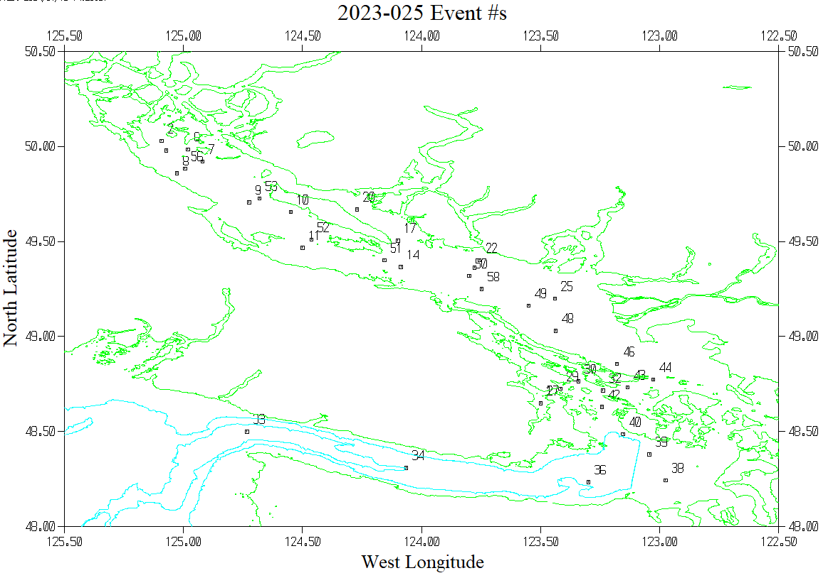

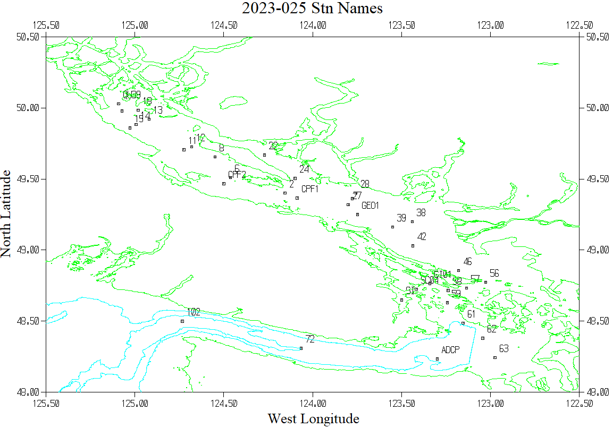

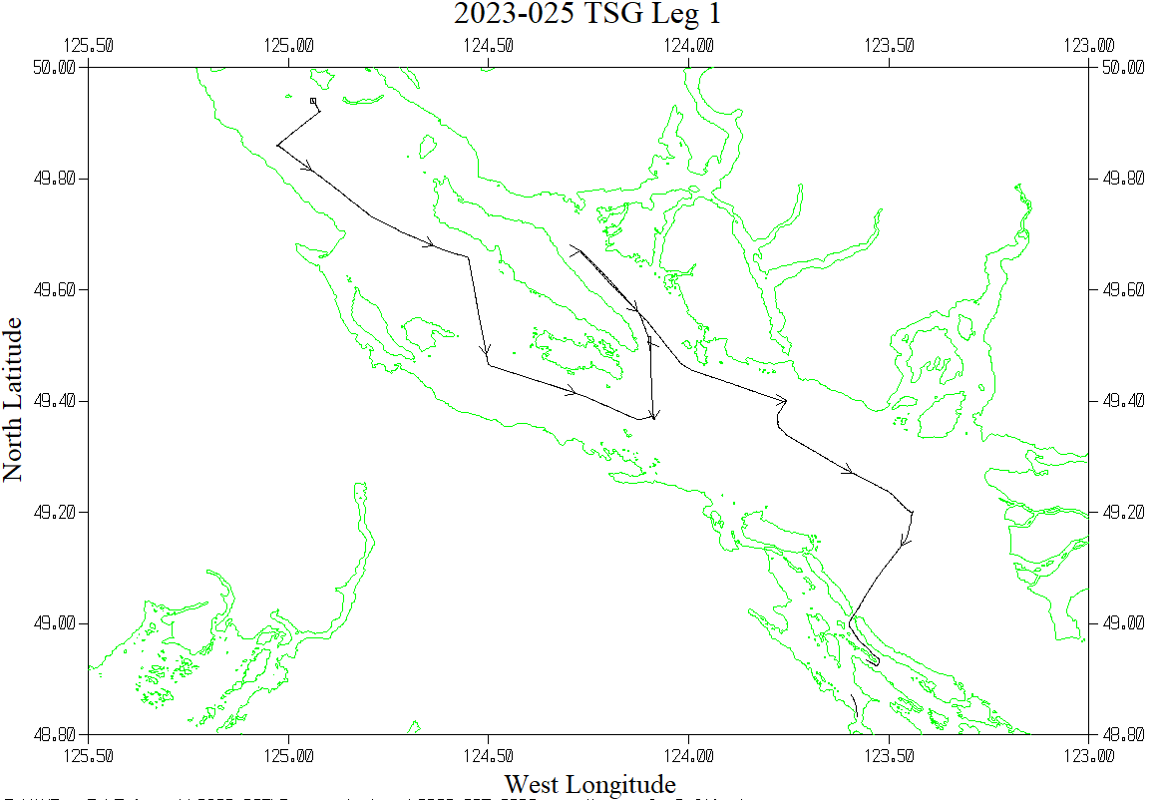

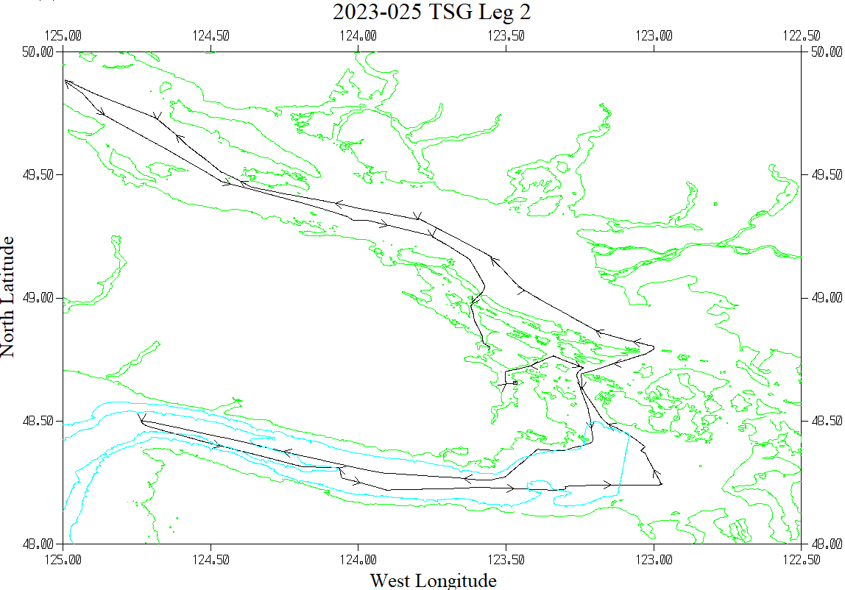

**CRUISE SUMMARY**

|  |  |  |  |  |  |
| --- | --- | --- | --- | --- | --- |
| Cruise ID#: 2023-025 | | | | | |
| Dates: Start: 24 June 2023 End: 29 June 2023 | | | | | |
| Location: Juan de Fuca Strait / Strait of Georgia | | | | | |
| Chief Scientist: Donnet S. | | | | | |
| **CTD#** | **Make** | **Model** | **Serial#** | **Used with Rosette?** | **CTD Calibration Sheet Competed?** | |
| 1 | SEABIRD | 25 | 334 | No | Yes | |
| 2 | SEABIRD | 911+ | 550 | Yes |  | |

**CTD CALIBRATION INFORMATION**

|  |  |  |  |  |  |  |  |  |  |  |
| --- | --- | --- | --- | --- | --- | --- | --- | --- | --- | --- |
| **Calibration Information - 0334** | | | | | | | | | | |
| **Sensor** | | | **Pre-Cruise** | | | | **Post Cruise** | | | |
| **Name** | | **S/N** | **Date** | | **Location** | | **Date** | | **Location** | |
| **Temperature** | | **2095** | **3Sep2022** | | **Factory** | |  | |  | |
| **Conductivity** | | **3396** | **8Jul2022** | | **Factory** | |  | |  | |
| **Seapoint Fluorometer** | | **2214** | **19Jan2022** | | **Factory** | |  | |  | |
| **SBE43 Oxygen** | | **1438** | **2Apr2022** | | **Factory** | |  | |  | |
| **Press**    **D:\Telework\2022-0** **28\Processing\ios\** | | **0464** | **18July2022** | | **Factory** | |  | |  | |
| **Calibration Information - 0550** | | | | | | | | | | | |
| **Sensor** | | | | **Pre-Cruise** | | | | **Post Cruise** | | | |
| **Name** | **S/N** | | | **Date** | | **Location** | | **Date** | | **Location** | |
| **Temperature** | **2663** | | | **15Feb2023** | | **Factory** | |  | |  | |
| **Conductivity** | **2280** | | | **14Feb2023** | | **Factory** | |  | |  | |
| **Secondary Temp.** | **2106** | | | **3Feb2023** | | **Factory** | |  | |  | |
| **Secondary Cond.** | **2754** | | | **24Jan2023** | | **Factory** | |  | |  | |
| **Transmissometer** | **983DR** | | | **4Jul2022** | | **IOS** | |  | |  | |
| **SBE 43 DO sensor** | **3791** | | | **10Feb2023** | | **Factory** | |  | |  | |
| **PAR sensor** | **70613** | | | **24Feb2021** | | **Factory** | |  | |  | |
| **SPAR** | **4565** | | | **24Feb2021** | | **Factory** | |  | |  | |
| **SeaPoint Fluor.** | **3641** | | | **?** | | **Factory** | |  | |  | |
| **pH** | **0691** | | | **9Mar2023** | | **Factory** | |  | |  | |
| **Pressure Sensor** | **0550** | | | **20Feb2023** | | **Factory** | |  | |  | |
| **Valeport Altimeter** | **76341** | | | **10Feb2021** | | **Factory** | |  | |  | |

|  |  |  |  |  |  |
| --- | --- | --- | --- | --- | --- |
| **Calibration Information – TSG 3411** | | | | | |
| **Sensor** | | **Pre-Cruise** | | **Post Cruise** | |
| **Name** | **S/N** | **Date** | **Location** | **Date** | **Location** |
| **Temperature** | **3411** | **5Feb2023** | **Factory** |  |  |
| **Conductivity** | **3411** | **5Feb2023** | **Factory** |  |  |