**Neocaligus Cruise IOS 2023-023**

**22-27 July 2023**

**Crew: Mark Belton, Meghan Molnar**

**Table 1.** Sampling stations – see excel file: “[2023-023 Neo sampling plan_v2.xlsx](2023-023%20Neo%20sampling%20plan_v2.xlsx)”

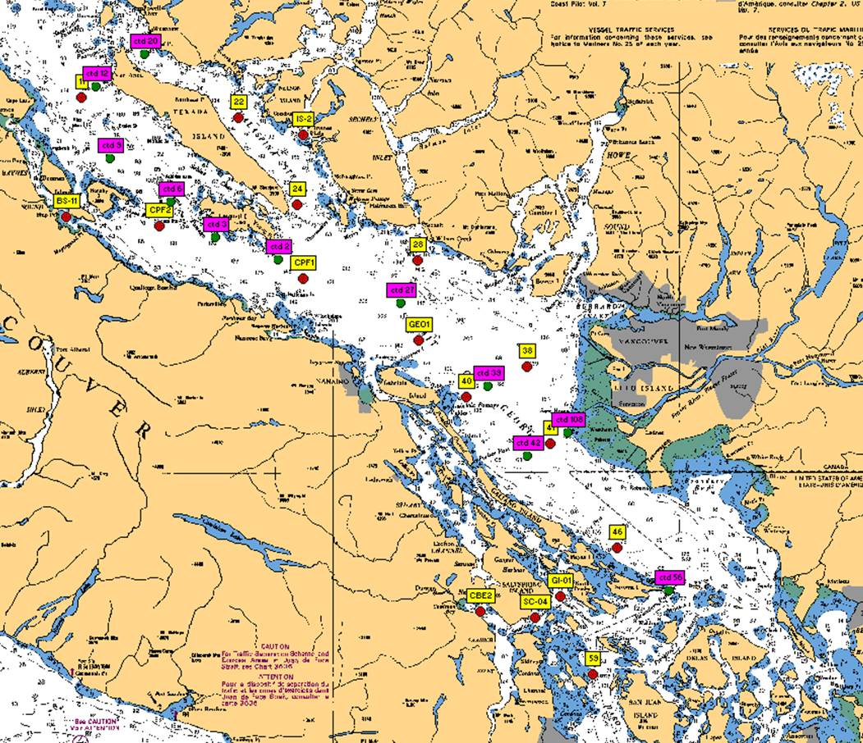

**Figure 1**. Station locations for IOS 2023-023 Strait of Georgia zooplankton survey. Yellow – CTD + zooplankton net stations; Pink – CTD + surface water sampling stations.

**Cruise Objectives**: To conduct biological (through vertical plankton hauls and water sampling) and physical (though CTD) monitoring at 28 stations throughout the Northern Salish Sea (Strait of Georgia). To continue a monthly time series of observations to better understand plankton seasonal cycles and year-to-year variability within the Strait. These surveys will contribute to other regional DFO and external partner (eg: Universities) projects by providing baseline (prey field) data for fisheries research. Also having Snuneymuxw First Nation’s technicians join the Neocaligus on the water when in their territory. I’ve suggested it be on the first day (July 22) for station work at GEO1, or a couple days later as we head south through the region again (would be in the area again around Monday July 24th).

**At each zooplankton/net station, collect:**

* Full depth (10m off bottom to surface) CTD profile including oxygen, fluorometer and PAR using SBE25p CTD with SBE 43 DO, Wetlabs fluorometer and PAR sensors. **2 minute soak at start** (Turn on, down 10m and up, wait remaining time and start). If more time is needed at the start of the cast (attaching a bottle, etc), record how long the CTD was on before start of cast. **Note:** CTD fluorometer usually has an end cap that needs to be removed before the first cast! Also have reference surface PAR (Licor) set up above bridge and logging entire trip.
* Full depth (10m off bottom to surface) zooplankton tow, using BONGO net with 250um mesh (new style ’spectacles’). Samples preserved in 10% buffered formalin, other side flash-frozen in a whirlpak (dry shipper, transferred to -80 back at IOS. If dry shipper gets full, transfer already frozen samples to ship’s deep freeze in hold). Upcast speed approx. 1 m/s. Net equipped with a TSK flowmeter and an RBRSolo that logs the net casts (depth and time).
* ***NEW*:** Where there are lots of euphausiids captured in the net, pick out ~ 30 individuals and freeze in a cryotube (HPLC size). Note number taken, species and approx. size in log. For Valentina Melica, Ph.D. Post-doctoral research scientist, Marine Mammal Conservation Physiology program, Pacific Science Enterprise Centre, Fisheries and Oceans Canada, looking at stable isotopes of whale prey
* ***NEW:*** duplicate full depth (10m off bottom to surface) net casts with SCOR net (original black mesh, 56cm, 236um mesh; RBR SoloD attached), preserved in 10% formalin (normal procedure). At stations 40, CPF1, CPF2, 11 and 22

**At select stations, collect:** (see “[2023-023 Sampling Log.xlsx](2023-023%20Sampling%20Log.xlsx)” for complete summary per station).

* Record event number(s), sample number on ‘Sampling Log’ sheets and in daily cruise log. Use CTD event number for main event number on each station’s ‘Sampling Log sheet’ (can note the actual event used for water collects in comments, typically occurs immediately after the CTD or during CTD soak for surface sampling). Each Niskin gets unique sample number, all samples from that Niskin uses that number. Assign numbers in ascending (bottom to surface) order *

*Salinity (SAL)* – Follow sampling as listed in 2023-023 Sampling Log.xlsx for some surface and at least one deep water (>200m) salinity sample (in duplicate) per day (approx.), using 1.7 L Niskin attached approx. 1m above CTD (please measure distance above CTD and record on Sampling Log in ‘confirmed pressure’ column) to collect a near-bottom salinity sample during CTD cast (CTD sensor check). Record sample number, depth collected in log.

*Nutrients (NUT)* – take nutrient sample at almost all the same stations as HPLC, and where there is a bottom SAL take NUT at bottom and surface. At least 1 duplicate per station, frozen in quick freeze block in ship’s deep freezer immediately after collecting.

*HPLC –* Surface HPLC sample collected in duplicate. See “2023 NEO_HPLC protocols and equipment.doc” for full methods. Briefly, 620-1985mL of water (depending on phyto biomass) filtered onto 47 mm GF/F filters, the filters blotted, folded once and rolled into a cryovial, and then frozen in small dry shipper. Remember to fill out HPLC sampling/filtration log sheet.

- To be collected at stations: 59, 56, SC-04, 42, 46, 39, 27, 2, 3, 6, 9, 12, 22, BS-11, GEO1

*Chlorophyll-a (chl-a)* – Chl-a samples taken at select stations from same surface Niskin as HPLC and phyto.

Water sampled into 304ml brown bottles and filtered onto 25 mm GF/F filters (IOS standard method, 20% in duplicates). Store filter folded in half in small cryovial in small dry shipper. *Record the sample number with the depth and volumes filtered in the Sampling Log*. Make sure labels have sample number and volume filtered as well.

- To be collected at stations: 59, SC-04, 46, 42, 27, 12, 22, BS-11, GEO1

*Phytoplankton (phyto)* – surface phyto sample preserved with Lugol’s, collected from same Niskin used for HPLC at surface; for taxonomy. Do not rinse jars (pre-filled with Lugol’s).

* To be collected at stations: 42, SC-04, 27, 2, 22, 12 and BS-11

*Chitobiase (chito) water sample* – secondary production estimates at GEO1, 12 and 42; Depths: 5, 10, 20, 50, 150, 250 and 350/300m (depends on bottom depth of station)

*LabStaff (FLC) water sample* – primary production estimates at phyto stations (surface only) and 5m at chito stations (listed with * below). At select stations, collect a surface water sample to measure photosynthetic activity (a measure the photosynthetic yield (Fv/Fm) of cells in a water sample) with LabStaff instrument for primary production estimates.

* To be collected at stations: 42*, SC-04, 27, 2, 22, 12*, BS-11 and GEO1*

**Housekeeping**

* Run the Oziexplorer program with the GPS puck on the bridge, logging the cruise track and saving one per day. See “Oziexplorer.docx”. If the program is set to record one track per day, it will automatically start a new file each day if left running.
* Use the WP electronic cruise log system. There are 2 logs to fill out (Daily cruise log, includes zooplankton log), plus a Sampling Log sheet to record sampling information. Each station with water sampling will have one ‘rosette’ log sheet but may have multiple events. Please fill out the cruise log with all events that occur, and give each event a number, and record CTD event on the Sampling Log sheet as well. Record BE, BO and EN time (note what time zone you are using! Eg: use local time if you want, but indicate so in the log and be consistent for the entire trip). **Check that the GPS has the correct time (may need to be manually changed between Daylight ST and PST)
* Plankton log – enter information for all plankton tows.
* Update the electronic cruise log (excel file) daily. Back up all files to USB.
* Make sure the CTD laptop is set up with the correct .con file before uploading the data.
* Upload the CTD data at the end of the day. Make sure the laptop has the correct date and time before uploading. Upload the files individually (don’t do as a batch). When uploading the file, *name them with standard format names using the cruise number-event number, such as 2018-037-0001.hex*(or .xml for SBE25+) for event #1. Put location, station name, and bottom depth in the header (comments box) of the file, using the format in the “CTD Header.txt” file on the CTD laptop (the : plus N and W are needed for processing)
* View the CTD data in Seasave to make sure everything looks good (make sure your CTD config file is correct).
* Also check that the batteries have enough voltage, change if they drop below 10V (for SBE25).
* Provide the “2023 dangerous goods.docx” to Captain at start of the trip

Make sure CTD internal date/time is correct (listed with files when downloading). Can be reset using command in SeaTermv2 (Set real-time clock month, day, year, hour, minute, second: e.g to Set date and time to UTC October 6, 2018 at 9:05 am = SETDATETIME=2018-10-06T09:05:00