**REVISION NOTICE TABLE**

|  |  |
| --- | --- |
| **DATE** | **Description of Revision** |
| 21 July 2023 | DO Saturation converted to DO Concentration. SH. |

**RBR CTD DATA PROCESSING NOTES**

Cruise: 2023-015

Agency: OSD

Locations: WCVI, Barkley Sound

Project: Clayoquot Weather Station Network

Party Chief: Cooper G.

Platform: CME Anderson

Date: Jan. 16, 2023 – Jan. 23, 2023

Processed by: Hana Hourston

Date of Processing: Feb. 26, 2023 – Feb. 28, 2023

Number of Raw files: 1 Number of Processed Files: 44

**Instrument Summary**

Equipment: RBR Maestro CTD (s/n 208765) with a Turner Cyclops Fluorometer (s/n 2110792), a JFE Advantech Rinko III oxygen sensor (s/n 0447), and a Seapoint turbidity sensor (s/n 208765). Sampling frequency was at 8Hz.

**Summary of Quality and Concerns**

The first 53 events contained in the .rsk file were from a previous cruise, so these were discarded.

A cast list of times and locations was provided, so this was cross-referenced against the dates and times in the RSK files. The dates and times in the RSK files match the dates and times in the cast list.

The first six casts didn’t have a digital logging system. Descent and recovery rates were about 1 m/s.

The data overall look good.

**Processing Summary**

1. **Conversion to IOS Headers**

There was one .rsk file from this cruise containing 98 events. The first 53 events from the previous cruise were deleted from the Excel file output from RUSKIN. There were two attempts of cast 1: the first one only went down to 5.5m before being returned to the surface because of an issue with the counter, while the second was done without issues. Both were recorded by the instrument so the first was discarded. All remaining 44 casts were extracted using the python function READ_EXCELrsk().

A single file (2023-015_CTD_Data.csv) with all the data including event numbers and a single line of headers was prepared using the Python function MERGE_FILES().

A 6-line header was inserted using the Python function Add_6Lineheader_2().

File “2023-015_header-merge.csv” was created, based on the information provided by the chief scientist.

* Column “File_Name”: entries were derived from the event number.
* Column “LOC:LATITUDE”: latitude was provided and reformatted to “XX XX.XXXX N !(deg min)”.
* Column “LOC:LONGITUDE”: longitude was provided and reformatted to “XX XX.XXXX W !(deg min)”.
* Column “LOC: Event Number”: entries were event numbers.
* Column “LOC: STATION”: all stations were set to those provided in the cruise log.
* Column “LOC: Water Depth:” was set to the water depth provided in the cruise log.

The sampling site was mapped (Figure 1) using from “2023-015_header-merge.csv” using the Python function Plot_Track_Location() to check the location of all casts.

Prior to conversion to IOS header format, the presence of zero-order holds were checked using the Python function Plot_Pressure_Diff() (Figure 2). It was unclear if there were zero-order holds from the output figure, so a differential was calculated on pressure in 2023-015_CSV_DATA-6linehdr.csv. Holds were found to occur at regular intervals in the file. A correction was applied using the Python function CORRECT_HOLD() and the corrected data were plotted (Figure 3).

CONVERT Spreadsheet Files was run to produce files with IOS Header format. Header entries of “Administration”, “File” and “Instrument” were filled in this step.

Raw data were plotted and examined:

* Conductivity looks fine.
* Salinity looks fine.
* Oxygen looks fine.
* Fluorescence looks fine.
* Temperature spikes looks fine.
* Pressure looks bad at the surface of cast 21 before the downcast, and spikes after the upcast of cast 39, but otherwise looks fine.

T-S plots were also made.

The routine “Merge:CSV Files to headers” was run to add location headers to the IOS files.

Next CLEAN was run to add a start time and event numbers to headers.

Then REORDER was run to reorder the channels in all files.

1. **Data processing**

* No correction to pressure was needed for this cruise.
* CLIP was not needed as none of the casts contained an initial soak below the surface.
* Filter: a Gull-winged filter, size 3, was applied to temperature, conductivity, fluorescence, and pressure. Salinity will be recalculated after the shift steps.
* SHIFT: The suggested number of scans for shifting conductivity to align with temperature is -2 in the document “Guidelines for processing RBR CTD profiles”. Conductivity was lagged -2 records and salinity was recalculated after alignment. Salinity profile plots before and after alignment were compared.
* SHIFT: Better alignment with Oxygen profiles was found by advancing it by 11 scans, which corresponds to a shift of +1.375s for an 8Hz sampling frequency. The advice given in document “Guidelines for processing RBR CTD Profiles” was that an advance between 2 and 3 seconds is appropriate. T-O plots before and after alignment were compared.
* Delete was run to remove records with a descent rate lower than 0.3m/s over 8 points. This was not applied in the top 10m to avoid loss of surface records as the CTD began its descent, nor in the bottom 10m.
* Profile plots were examined after DELETE. The plots show reasonable values for salinity, conductivity and fluorescence. DO saturation levels at the surface ranged from about 85% to 100%. There was no calibration sampling and no climatology to enable a judgement about the data reliability.

1. **Final checks and header editing**

* REMOVE was run to remove the following channels from all casts: Date, Time:UTC, and Event.
* BIN AVERAGE was used to average the data by pressure into 1 dbar bins.
* CALIBRATE was run to convert conductivity units to S/m using file 2023-015-recal2.ccf.
* CLEAN was run to reset the Maximum and Minimum values in the Header.
* Header Edit was used to fix channel names and format as listed below:
* Depth: meters ==> metres
* Temperature: deg C(ITS90) ==> deg C (ITS90)
* Salinity:CTD ==> Salinity
* Fluorescence ==> Fluorescence:URU
* Conductivity: F10.5 ==> F10.6
* Oxygen:Dissolved ==> Oxygen:Dissolved:Saturation:RBR, format F11.4 ==> F8.2
* Header Check was run and no problems were found. Standards check was run and no problems were found.
* Final profile and T-S plots were made. A small unstable feature was found in the T-S plot of cast 26 at the surface, but it may be real so it was left in. Unstable features were found at the bottom of casts 1-6 and 19 but these were likewise left in. A track plot was also made using IOS Shell to map the sampling order.

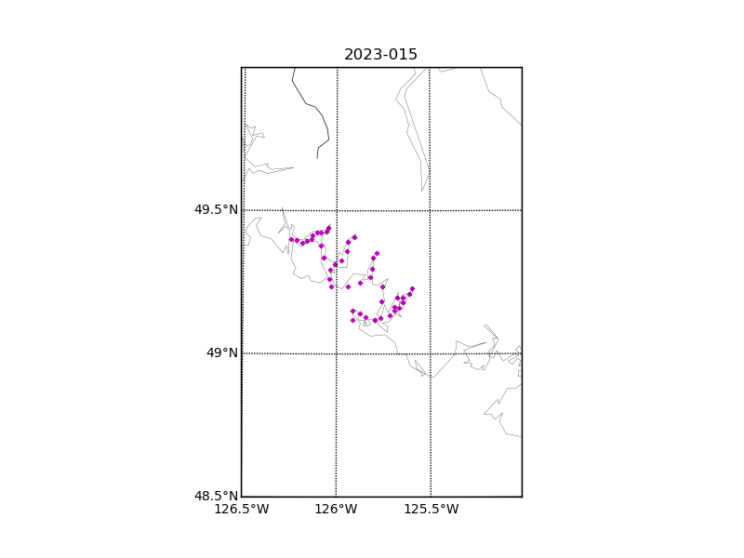

Figure 1 – Location of casts for cruise 2023-015.

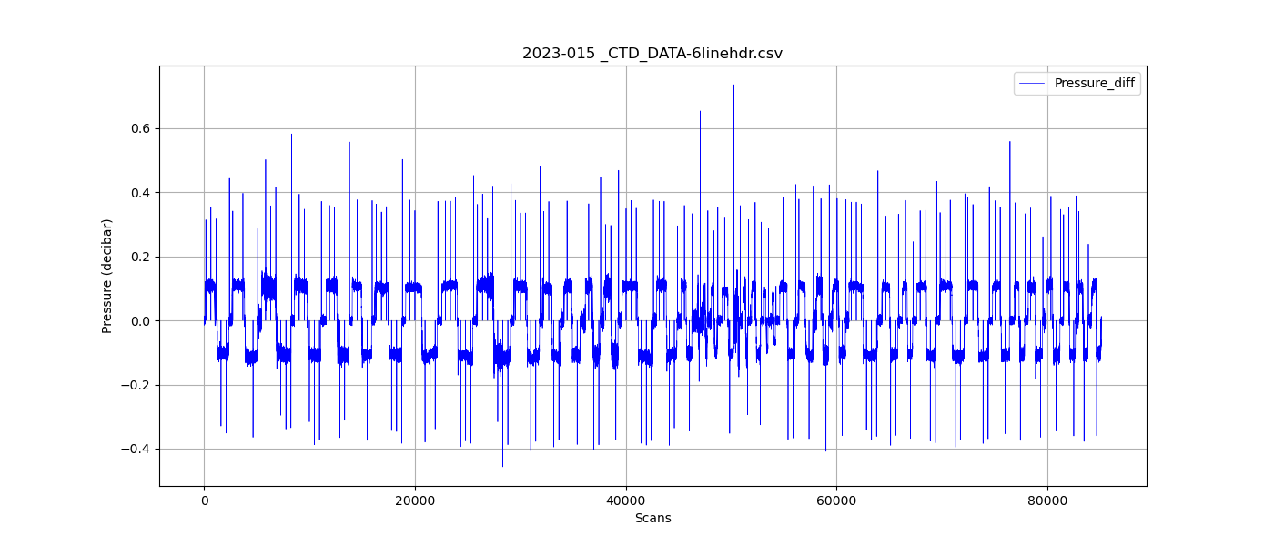

Figure 2 – Zero-order holds prior to correction.

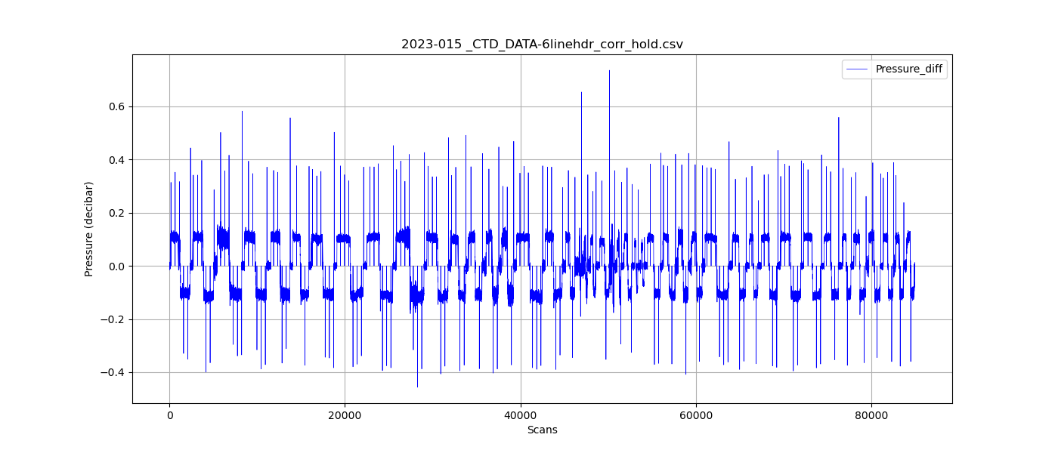

Figure 3 – Pressure differentials after the zero-holds correction.