REVISION NOTICE TABLE
DATE | DESCRIPTION OF REVISION

PROCESSING NOTES
Cruise: 2023-011
Agency: OSD
Location: Strait of Georgia, Juan de Fuca Strait, WCVI
Project: Acoustic Moorings
Chief Scientist: O’Neill C.
Platform: Vector
Date: 29 June 2023 – 5 July 2023

Processed by: Jeannette Bedard
Date of Processing: 19 December 2023 – 5 February 2024
Number of HEX files: 57 Number of CTD files processed: 57
Number of original TSG files: 1 Number of TSG files processed: 0

INSTRUMENT SUMMARY
CTD #550 was mounted in a rosette and attached were a Seapoint Fluorometer (#3641), a SBE 43 DO sensor (#3791) and an altimeter (#76341).

The TSG was a SeaBird SBE21 (#3411).

Seasave V 7.26.7.121 was used for acquisition.

SUMMARY OF QUALITY AND CONCERNS
The digital Daily Science Log Book was in good order however it did not include useful comments about the CTD and the Thermosalinograph. Water Depths were not entered in the CTD headers.

The thermosalinograph data was rejected for two reasons. First the pump was not on for the mid part of the cruise, something that was not noted in the log. Secondly, both the salinity and temperature data were significantly off-set from the surface CTD values, but not in a regular way that could be corrected for. These data were not archived.

PROCESSING SUMMARY

Seasave
This step was completed at sea; the raw data files have extension HEX.

Preliminary Steps
- Primary conductivity and temperature were calibrated in February 2023 and this is the fourth cruise since then
- Secondary conductivity and temperature were calibrated in February 2023 and this is the second cruise since then
- The digital Log Book was obtained.
- The cruise summary sheet was completed.

The configuration file used at sea had the latest calibration parameters. No changes were made during the cruise. The file was saved as 2023-011-ctd.xmlcon.

Conversion of Full Files from Raw Data
All files were converted using file 2023-011-ctd.xmlcon.

The Tau function was selected but not the hysteresis function since there was no deep sampling.
A few casts were examined. The T and C pairs were close during downcasts with upcasts a little further apart and noisy. Fluorescence, dissolved oxygen and altimetry look normal.

WILDEDIT
Program WILDEDIT was run to remove spikes from the pressure, depth, conductivity & temperature only in the full cast files (*.CNV).
Parameters used were: Pass 1 Std Dev = 2 Pass 2 Std Dev = 5 Points per block = 50
The parameter “Keep data within this distance of the mean” was set to 0 so all spikes would be removed.

ALIGN DO
A few casts were examined; both temperature channels were noisy during upcasts, so the tests were not easy to interpret, but using +2.5s certainly improves the alignment and overall looks like a good choice for both sensors. That setting has worked well for many SBE DO sensors in recent years.
ALIGNCTD was run on all casts using +2.5s.

CELLTM
CELLTM was run using (α = 0.0245, β=9.5) for both the primary and secondary conductivity.

DERIVE and Channel Comparisons
Program DERIVE was run on all casts to calculate primary and secondary salinity and dissolved oxygen concentration. The DO alignment looks reasonably good. There were no deep casts.

Conversion to IOS Header Format
The IOSSHELL routine was used to convert SEA-Bird 911+ CNV files to IOS Headers.
CLEAN was run to add event numbers and to replace pad values in the pressure channel with interpolated values based on record number.

Checking Headers
- The cross-reference check and header check were run and turned up no problems.
- Surface check was run and found an average of 1.657 db which is reasonable for the Vector when many casts were in areas where conditions were likely rough.
- Cruise tracks were plotted and no problems were found. The track with event numbers was added to the end of this report. The one with station names was too crowded to be useful.

Water depths were not in the original headers. Water depth were taken from the original log file and merged into the files.

The altimeter and water depth readings from the headers of the CLN files were exported to spreadsheets.
A check value was calculated as follows:
CHECK VALUE = Max Depth Sampled + Altimetry Header - Water Depth from Header
- 5 casts had a check value > +/- 5m: cast 41, 45, 59, 81 and 82. The log files have no comments for these casts. However, due to the coastal area these altimetry readings are likely real.

Shift

Fluorescence
SHIFT was run on the SeaPoint fluorescence channel in all casts using the usual advance of +24 records. Plots show that the vertical offset between downcast and upcast for fluorescence is reasonably close to that for temperature after this step.

Dissolved Oxygen
The Dissolved Oxygen voltage channel was aligned earlier. A few casts were checked to see if the alignment looked good, and it did. No further alignment is needed for the DO concentration channel,

Conductivity
Tests were run on a few casts to assess what settings are best to align conductivity with temperature (as judged by the effect on salinity as seen in T-S space). The best settings were -0.7 and -0.6 records for the primary and secondary, respectively.

SHIFT was run twice on all SBE911 casts using -0.7 records for the primary and -0.6 records for the secondary conductivity. Salinity was recalculated.

DELETE
The following DELETE parameters were used:
Surface Record Removal: Last Press Min
Maximum Surface Pressure (relative): 10.00
Surface Pressure Tolerance: 1.0 Pressure filtered over 15 points
Swells deleted. Warning message if pressure difference of 2.00
Drop rates < 0.30m/s (calculated over 11 points) will be deleted.
Drop rate applies in the range: 10db to 10db less than the maximum pressure
Sample interval = 0.042 seconds. (taken from header)
COMMENTS ON WARNINGS: no warnings

Other Comparisons
Experience with these sensors since last factory service – This CTD was used just prior to this cruise, the corrections from that cruise were applied to this one.
Historic ranges – Profile plots were made with 3-standard deviation climatology ranges of T and S superimposed. The only excursion from the climatology was near the surface.
Post-Cruise Calibration – There were no post-cruise calibrations available.

DETAILED EDITING
The primary channels were chosen for recalibration.

Active mixing in this region leads to unstable features that may be real. Most casts required light editing, specifically when there were negative descent rates at the top and bottom. Only a few, very minor salinity spikes were removed.

Notes about editing applied were added to the files.
The edited files were copied to *.EDT.
After editing T-S plots were examined for all casts. No further editing was needed.

Corrections to Pressure, Salinity and Dissolved Oxygen Concentration
Calibrations were applied based on the previous time these instruments were deployed using 2023-011-recal1.CCF.
- Pressure: offset: 0.8 slope: 0
- Depth: offset: 0.8 slope: 0
- Dissolved Oxygen: offset: 0 slope: 1.021

Fluorescence Processing
A median filter, size 11, was applied to the fluorescence channel in the COR1 files. Plots of a few casts showed that the filter was effective. (Output:*.FIL)

BIN AVERAGE of CTD files
The following Bin Average values were applied to the FIL files (output AVG):
Bin channel = pressure Averaging interval = 1.000 Minimum bin value = .000
Average value will be used. Interpolated values are NOT used for empty bins.
On-screen T-S plots were examined. No problems were found.
Profile plots were examined. NO problems were found

Final CTD File Steps (REMOVE and HEADEDIT)
For all casts REMOVE was run to remove the following channels:
Scan_Number, Temperature:Secondary, Conductivity:Secondary, Oxygen:Voltage:SBE, Descent_Rate, Status:Pump, Altimeter, Salinity:T1:C1 and Flag.

A second SBE DO channel (with umol/kg units) was added.
REORDER was run to get the two DO channels together.
HEADER EDIT was used to fix formats and channel names and to add comments about processing.
The Standards Check routine was run and no problems were found.
The Header Check was run; no problems were found.
Profile and T-S plots were examined. No problems were found.
The sensor history was updated.

Dissolved Oxygen Study
As a final check of dissolved oxygen data, % saturation was calculated and plotted. Values at 2 to 3m ranged from ~65% to 120%. The test cast had surface values ~155%. A dissolved oxygen surface spike was removed from cast 041. These numbers are typical of this coastal region.

While these values are stated as surface saturation, the CTD casts only start at ~2m.

Thermosalinograph Data

There was 1 thermosalinograph file.

There were no loop samples, flow meter or intake thermistor. The intake is at about 2m. The only method to check calibration is to compare with the CTD casts.

a.) Checking calibrations
The configuration file parameters were all correct.

b.) Conversion of Files
The file was converted to CNV format.

The CNV file was converted to IOS HEADER format.
CLEAN was run to add End times and Longitude and Latitude minima and maxima to the headers.
ADD TIME CHANNEL was used to add Time and Date channels.

A time-series plot was produced.

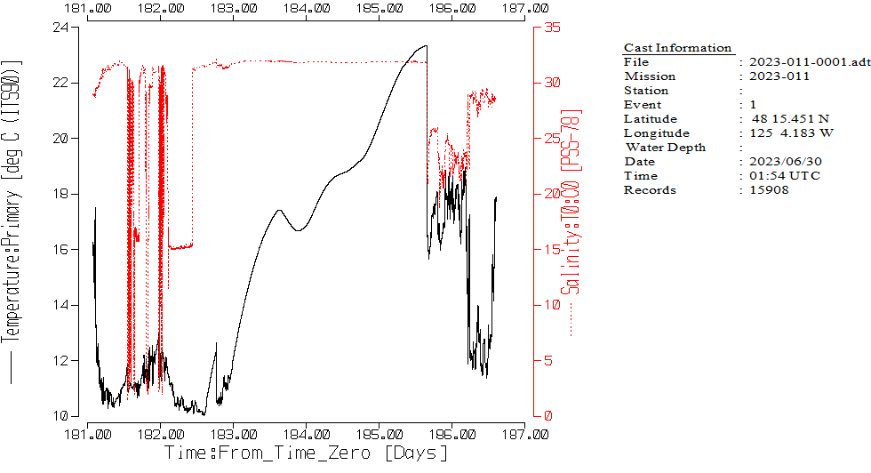
. There are a number of potential issues with these data.
- The middle section where complexity declines suggests that the pump was not working properly. Scientist on board confirmed that the pump was off during this time.
- Temperature values above 18 deg C and salinities above 30 PSU are suspect and will be investigated further.

c.) Comparison of Temperature and Salinity from TSG and CTD data

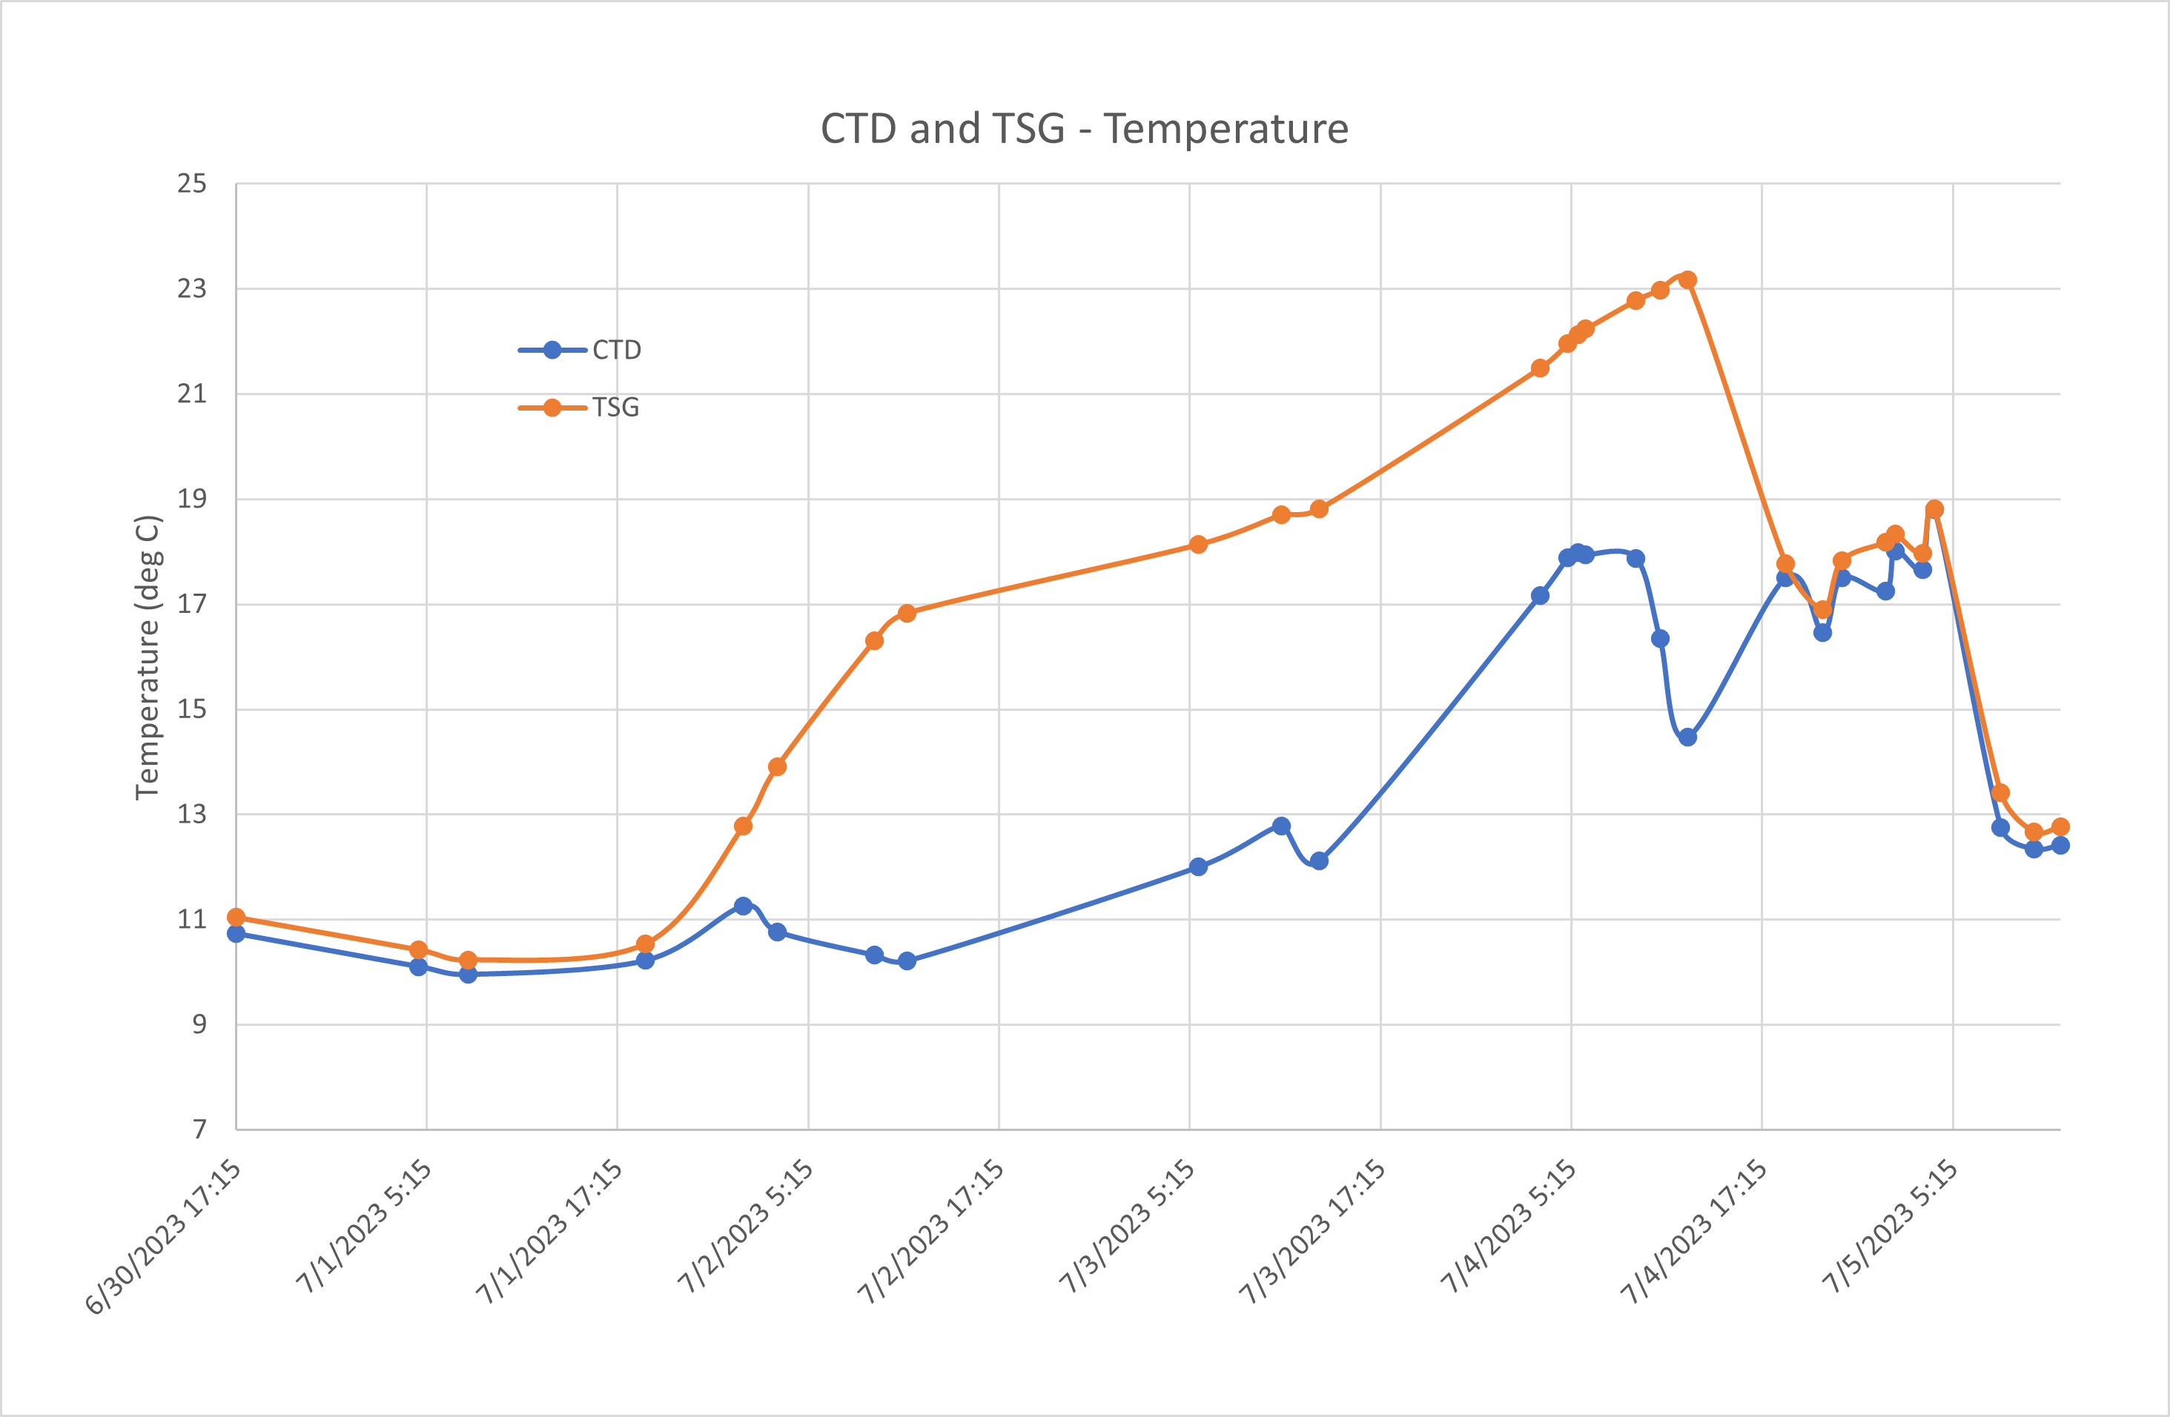

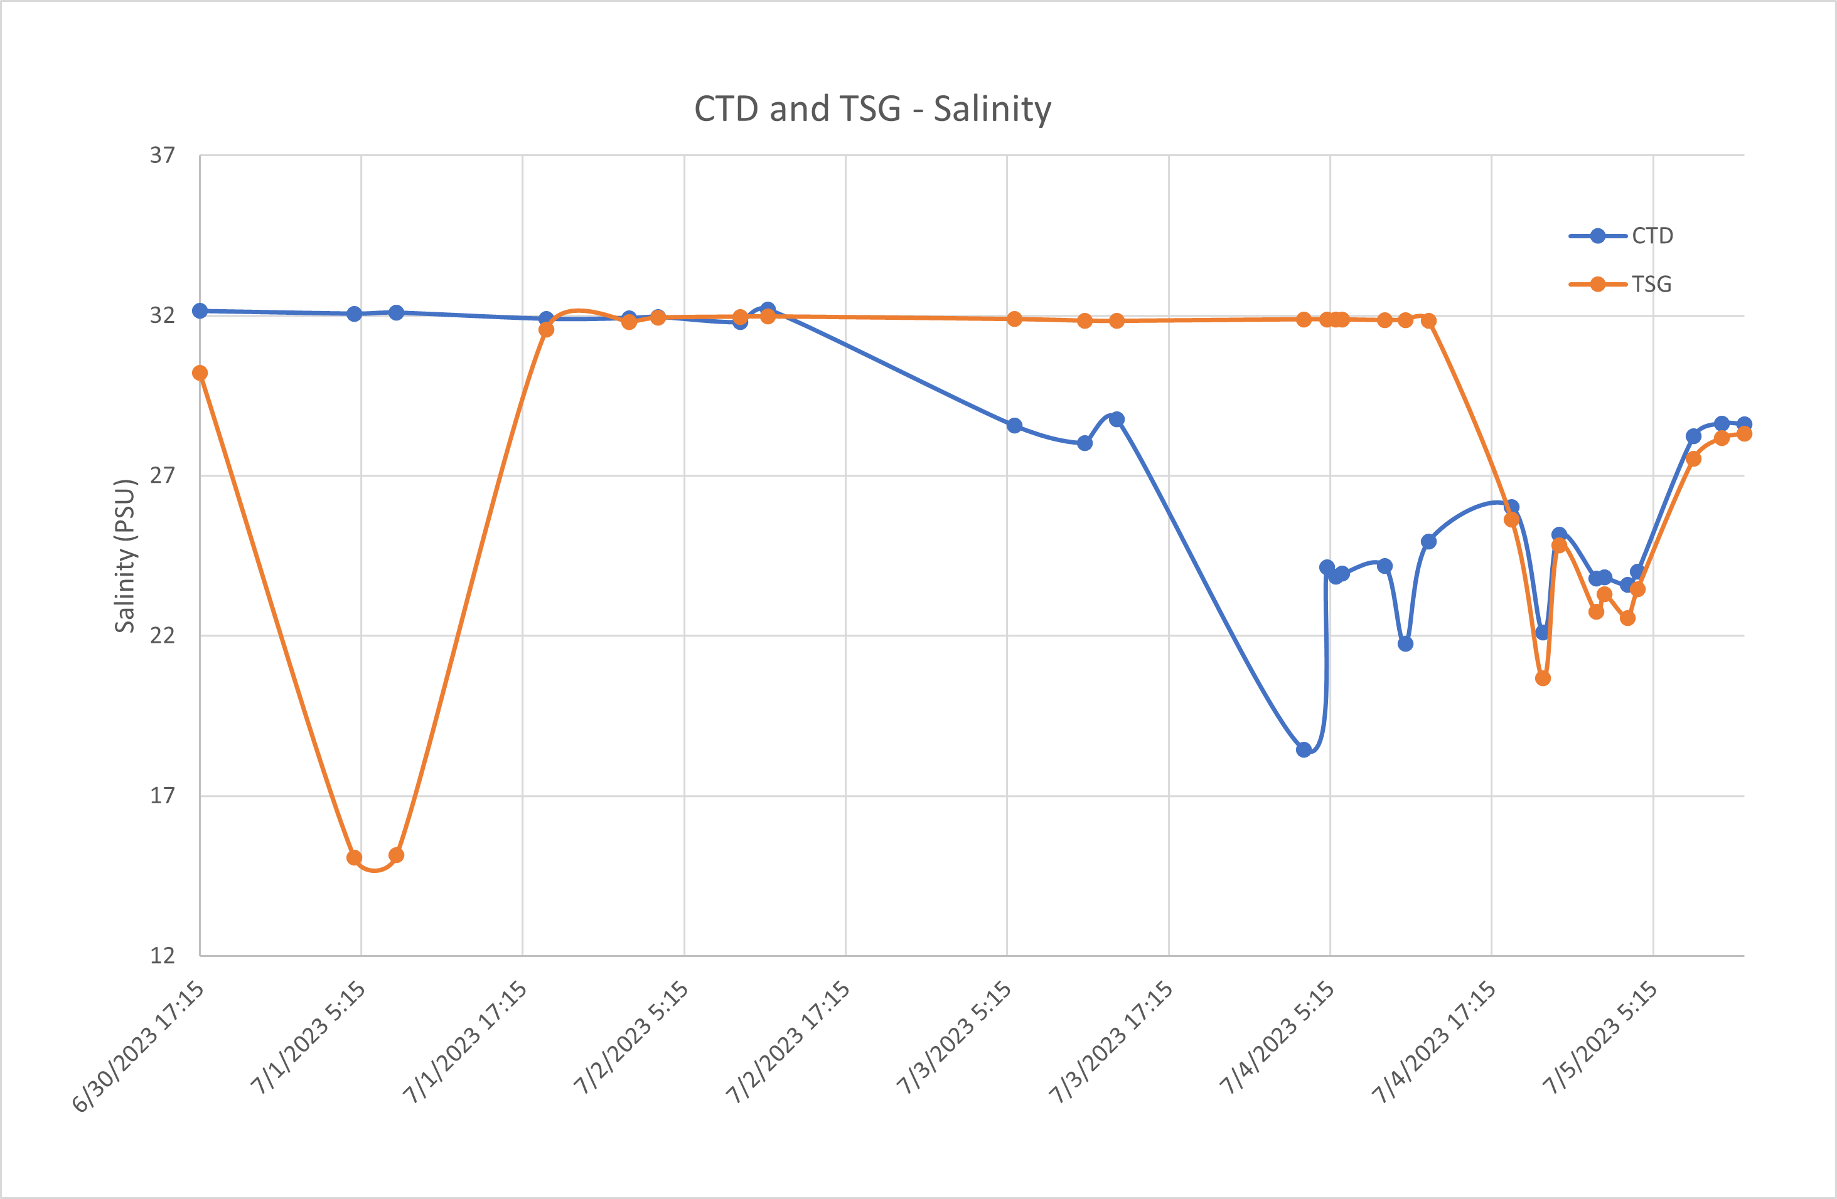

The above two plots compare near-surface values of the CTD with corresponding TSG data. Both the temperature and the salinity from the TSG vary by different amounts at different times from the CTD data. This combined with the fact that the pump was off for the middle part of the cruise suggests that this data is unusable. Processing was stopped at this point and no TSG data will be archived.

CRUISE SUMMARY – CTD
CTD# | Make | Model | Serial# | Used with Rosette? | CTD Calibration Sheet Competed?
1 | SEABIRD | 911+ | 550 | No | Yes
Calibration Information - 550
Sensor |  |  | Pre-Cruise |  | Post Cruise
Name |  | S/N | Date | Location | Date | Location
Temperature |  | 2663 | 14/02/2023 | Factory
Conductivity |  | 2280 | 14/02/2023 | Factory
Secondary Temp. |  | 2106 | 14/02/2023 | Factory
Secondary Cond. |  | 2754 | 14/02/2023 | Factory
SBE 43 DO sensor |  | 3791 | 10/02/2023 | Factory
Transmissometer – Wetlabs C-STAR |  | 983DR | 7/04/2023 | Factory
Fluorometer - Seapoint SCF |  | 3641
Altimeter |  | 76341
Pressure Sensor |  | 550 | 20/02/2023 | Factory

Calibration Information – TSG 3411
Sensor |  | Pre-Cruise |  | Post Cruise
Name | S/N | Date | Location | Date | Location
Temperature | 3411 | 31Dec2019 | Factory
Conductivity | 3411 | 31Dec2019 | Factory

