REVISION NOTICE TABLE
DATE | DESCRIPTION OF REVISION

PROCESSING NOTES
Cruise: 2023-010
Agency: IOS, Ocean Sciences Division, Sidney BC
Chief Scientist: Young K. Platform: Alta
Location: Barkley Sound Project: Barkley Sound Euphausiid Study
Date: 2 February 2023 –2 November 20223

Processed by: Germaine Gatien
Date of Processing: 26 July 2024 – 31 July 2024
Number of original HEX files: 24
Number of CTD files: 24 Number of BOT files: 48

INSTRUMENT SUMMARY
SeaBird Model SBE-19 CTD (S/N 8241) was mounted with dissolved oxygen sensor #4354 and ECO fluorometer #7495.
A Niskin bottle was mounted above the CTD to collect near-bottom samples; a separate Niskin was lowered from the vessel to collect surface samples.

SUMMARY OF QUALITY AND CONCERNS
This program involved repeat visits to 5 sites in February, March, April, May, June, July, August, October and November 2023. At 2 of the sites there was near-bottom salinity and nutrient sampling during a CTD cast as well as surface sample, and at some sites only a surface CHL sample was taken. Extracted Chlorophyll surface samples were taken at most sites even when there was no CTD sampling.

Calibration samples were available for comparison with CTD salinity and fluorescence. The CTD salinity at the bottom was reasonably close to samples, so calibration errors are likely very small. The comparison of CTD fluorescence and extracted chlorophyll indicates that the fluorometer read too high when CHL was low, dropped to about the same as CHL at about 2ug/L and steadily fell to about 50% of CHL when CHL was >10ug/L. This is typical performance for these sensors.

The CTD was lowered to ~10m and soaked for 1 to 2 minutes. The CTD was then brought to the surface and the full cast was run. The wait at the surface was very short, just a few seconds. It is recommended that the wait be at least 30s to allow the wake effects from the rising CTD to dissipate. This wait is especially helpful in quiet areas where the boat is not moving away from the disturbance.

Three types of bottle files have been prepared.
1. Where there was a CTD cast , bottle files were created by combining analysis results with CTD data selected from the approximate levels of the samples. The match is approximate in depth and time. A few CTD times were adjusted to match the log due to a 1 hour discrepancy.
2. For 2 casts there was a CTD cast but no data were acquired. However, there was sampling at both the surface and at depth. Those BOT files contain only analysis results plus estimated pressure and depth, and time and location information from the log.
3. For 22 casts with no CTD in use, files were prepared using times and positions from the log and pressure and depth were set to 1db and 1m.

PROCESSING SUMMARY

1. Seasave
This step was completed at sea.

2. Preliminary Steps
Preliminary processing was done on these data after the first trip and it was found that there was an error in the fluorometer entry in the configuration file. This was corrected and fluorescence looked ok.
But fixing cast #1 is not so simple as rerunning it with the correction. The correction did increase fluorescence values by the amount expected (0.036ug/L), but the deep water values are still significantly negative. Adding 0.2ug/L brings it into line with deep values from other casts and is reasonably close to the extracted chlorophyll sample at the surface. But what could have caused that offset? In the absence of a reasonable explanation, it seems wise to remove fluorescence from the first cast. Unfortunately, the parameters used in acquisition are not added to the headers, so it is possible that the configuration file had other errors at that stage.

All casts were converted using file 2023-010-ctd.xmlcon.
Three casts were missing headers. Those will be added after conversion to IOS Headers.
Cast #1 had a non-standard file name which was adjusted before conversion.
The deep bottles were taken using a Niskin bottle mounted approximately 1m above the CTD.
Surface samples were taken using a Niskin bottle just below the surface.
The cruise summary sheet was completed.

3. Conversion of Raw Data
The configuration file used at sea was correct. It was saved as 2023-010-ctd.xmlcon.
All files were converted using that file.
Test plots were made. All channels have normal profiles. Only cast #1 had negative fluorescence.
No spikes were noted except in fluorescence where they are expected.

The deployment scheme included a 10m soak for 1 to 2 minutes. The CTD was then brought to the surface and the full cast began. The time at the surface was very short, usually just a few seconds. It is recommended that at least 30s be taken at the surface to let the wake effects of the rising CTD settle down.

4. WILDEDIT
The only single-point spikes noted in the data occurred at the beginning or end of the casts or in fluorescence, so WILDEDIT was not run.

5. FILTER
The resolution of this instrument appears to be good and the pressure does not obviously need filtering. While, a test showed no major effect, there was a very slight improvement in salinity so program FILTER was run using a low-pass filter, size 1s, on pressure and depth.
The temperature and conductivity were examined and the usual approach of applying a cosine filter size 8 in routine WFILTER did a good job of removing small reversals.

6. ALIGNCTD
Based on tests run for other cruises using similar equipment, ALIGNCTD was run on all casts to advance the DO channel by 2.5s. Plots were examined after this step and the results looked poor, with the dissolved oxygen clearly overcorrected. Similar findings for the same CTD from cruise 2023-064 led to a choice of 0.5s for this step, which worked well..
ALIGNCTD was run using a 0.5s advance on all casts.

7. CELLTM
CELLTM was run on all casts using the SeaBird recommended parameters, (α, 1/β) = (0.04, 8).

8. DERIVE
Program DERIVE was run to calculate salinity and dissolved oxygen concentration (tau correction included).
Plots were examined to see if steps 5, 6 and 7 had worked well and they did improve the data. The dissolved oxygen alignment is in excellent correspondence to temperature.

9. Conversion to IOS Headers
The IOSSHELL routine was used to convert the CNV files to IOS Headers.
CLEAN was run to add event numbers (though most are present already) and replace pad values in the pressure channel with interpolated values.
Most casts had times in PST but casts 79-92 were in PDT.
ADD TIME CHANNEL was run to add 8 hours to files 1-78 and 7 hours to files 79-92.
Note: A few times were later adjusted.

10. Checking Headers
A cross reference list was checked to see which casts were missing positions and they were events # 1, 37 and 40. They were also missing station names but had times. The missing information was entered based on log entries.
The CLEAN and ADD TIME CHANNEL steps were then repeated.

Surface Check was run and the average was -0.033db with a range from -0.23 to 0 to +0.07db.
This is in good agreement with the 2023-064 results.
The pressure sensor has a resolution of ~1db so these readings are excellent.
No recalibration will be applied.

HEADER CHECK was run. There were some negative values in pressure, conductivity and fluorescence that are likely from surface spikes. This will be checked again after CLIP removes soak data.

11. CLIP and CALIBRATE
The next step is to remove the data collected during soaks either at the surface or at 10m.
CLIP was run to remove 500 records from each file; plots were checked and the number had to be adjusted for 3 files to remove sufficient records to insure DELETE would choose only data from the full cast. A test run of DELETE was made to see if the results were good and they were excellent.

12. SHIFT
Conductivity
Tests were run on the data from 2023-064 to see what shift to conductivity made the best improvement to stability in T-S space. A shift of -2.2 records was found best. That was tried on these data and also proved to make a significant improvement. That setting was applied to all casts.
Fluorescence
The fluorometer was not pumped, so a shift in alignment is expected to be small or unnecessary. Profile plots of temperature and fluorescence were examined and confirm that the alignment is ok.
Dissolved Oxygen
This channel was aligned earlier, but checks were made by examining plots of temperature and dissolved oxygen. No further adjustment was made.

13. DELETE
DELETE was run on all casts using the following parameters:
Surface Record Removal: Last Press Min. Surface Swell Pressure Tolerance: 1.0
Swells deleted. Warning message if pressure difference of 2.00
Drop rates < 0.3m/s (calculated over 5 points) was deleted from 10db to 10db above the maximum pressure.
COMMENTS ON WARNINGS: There were no warnings.

Plots were made the results look good, but most casts appeared to need editing at the surface.
The DEL files were renamed as *.DEL1
CLIP was rerun to remove 1.25db. The output files were named DEL.
The renaming was done in order to enable the files to be submitted to the CTD-QC program.
All DEL files were copied to *.EDT

14. DETAILED EDITING
The DEL files were submitted to CTD-QC and DELPRED files were returned.
All DEL files were copied to *.EDT so there will be a complete set of files even if some need no editing.

CTDEDIT was used to do some light editing of all files except #22, 87, 89 and 92; this was limited to removal of records corrupted by shed wakes near the bottom as well as light editing of salinity for 7 casts.
Notes of editing details were made in the headers.
The output files were zipped and submitted to CTD-QC.
T-S plots were examined after this step and the results look good.

15. Initial Bottle Data Steps
There was no rosette available for this cruise. There were surface bottles fired at all sites and deep bottles at many sites. CTD casts failed to record data at 2 of the sites.

Each of the analysis spreadsheets were examined to see what comments the analysts wanted included in the header file. These were used to create file 2021-030-bot-hdr.txt which will be updated as needed during processing.

The EDT files were bin-averaged and thinned to the shallowest value available (1db or 2db) plus the maximum pressure in the files; after editing the CTD files will usually have some deep water removed, so the match to bottle height will be fairly good. Those data were exported to a spreadsheet.

Spreadsheet 2023-010-bottles_plus_CTD_6linehdr. csv was created using entries from the event log relevant to Niskin sampling plus bottle data. Space was made for CTD data.
Headers and CTD data were downloaded from the thinned CTD files with the exception of casts #58 and #62 for which no CTD data were acquired though samples were taken. The log entries were used for time/position information those 2 casts.
Some lines with maximum values were deleted where there was only a surface sample.
The data from the analyst’s spreadsheets were entered into the file.

The spreadsheet was converted to individual BOT1 files.
CLEAN was used to add start time and positions. This also added Stop times and positions which just repeat the start entries, so those will be removed later.

16. Compare
Data from the 6-line header file were exported to file 2023-010-bottle comparisons.xlsx. Separate sheets were used to compare salinity and extracted chlorophyll samples with CTD salinity and fluorescence.

Salinity Comparison
There were 33 samples with both CTD and bottle salinity available.
The bottle values are likely from slightly higher in the water column than the CTD, though most CTD files had some data removed from the bottom due to corruption by shed wakes.
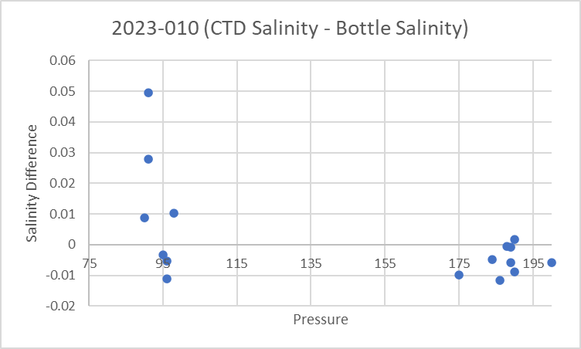
Near the surface the differences are large with the CTD salinity being higher by an average of 0.082psu (std dev 0.382psu); when 4 outliers are removed the CTD is low by an average of -0.0031psu. But using the same data the median differences is +0.0035psu, so this comparison does not look very reliable.
Between 90 and 175db the CTD is high by an average of 0.0084psu (std dev 0.0211) and when one outliers is excluded the CTD is high by 0.0025psu. Again the median is -0.0032psu so
Between 180 and 200db the CTD is low by 0.0045psu (std dev 0.0045) and when 1 outlier is excluded it is low by 0.0035psu.
CTD Salinity – Bottle Salinity
Pressure Range | Average | Std Dev | Average excluding outliers | Median excluding outliers
1-2 | 0.0823 | 0.3824 | -0.0031 | 0.0035
90-175 | 0.0084 | 0.0211 | 0.0025 | -0.0032
180-200 | -0.0045 | -0.0045 | -0.0035 | -0.0047

There is too much variability in the surface comparison to be useful, but the deeper samples are encouraging, especially the ones near the bottom. We might expect the CTD to read high at the bottom if the Niskin bottle doesn’t flush well, though we have no evidence that was the case. Nonetheless, it is possible that CTD salinity is reading even lower than it appears if the Niskin didn’t flush completely. On the other hand, it is possible that bottles are reading a little high due to storage time before analysis.

In some cases analysis was done quickly but for several trips there was a 4 to 6 week storage time. This could lead to salinity in bottles being slightly high due to desorption and/or evaporation, but the effect should not be large. There is no obvious sign that storage time was a significant factor. There are too few data and too many variables to determine the effects of storage time, poor flushing or local gradient variability according to season.

Cast #7 was examined since it had quick analysis and the local gradient at the bottom was fairly low. If the water in the Niskin came from as much as 30m above bottom, the result would be a difference of only 0.003psu. That case had the CTD reading high by about 0.002psu.

CTD salinity looks reliable within 0.01psu and likely is within ±0.005psu.

Fluorescence vs extracted chlorophyll
The comparison of extracted chlorophyll with CTD fluorescence looks typical of these fluorometers. The fluorescence is mostly ≤CHL when CHL is ≤ 2.5ug/L and gradually drops to about 50% of CHL as CHL rises. The samples are likely taken slightly higher than the CTD values and not at the same time.
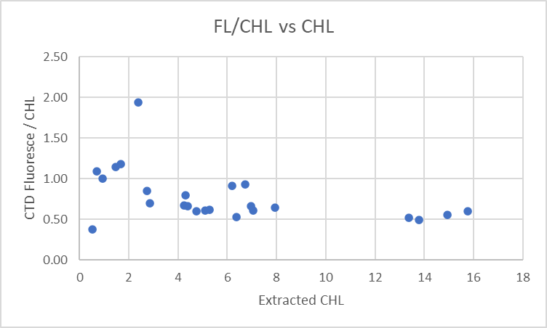 for

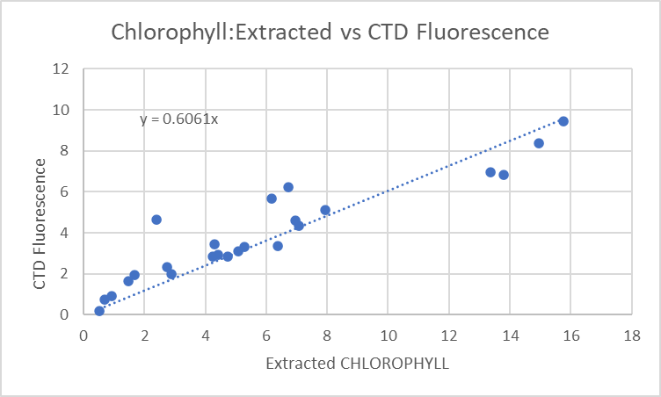

17. Other calibration checks
Sensor History – This cruise and 2023-064 which overlapped with 2023-010 are the first known uses of this CTD.
Historic Ranges – There was no local climatology available, but all temperatures fell within a climatology for a large area around Barkley Inlet except that surface temperature were sometimes high and salinity often low at the surface, as expected nearshore. The climatology in use covered the whole year, so is not very informative.
Post-cruise calibrations – None were available.

18 CALIBRATE
Pressure does not require recalibration.
Salinity calibration sampling was available, but the limited numbers and depth of samples mean the results are only useful in judging whether the sensor worked properly. They do show that the CTD values from near the bottom are generally close to the bottle samples.
No recalibration was applied.

19. Fluorescence Filter
The fluorescence data do not require editing.

20. Bin Average, Remove, Derive DO in mass units, Reorder
The files were bin averaged using 1db bins.
REMOVE was run to remove Scan_Number, Oxygen:Voltage, Descent Rate, Prediction Flag and Flag channels.
For file 2023-010-0001 the fluorescence channel was removed because the values were bad and no method was found to correct it.

Dissolved Oxygen was derived in mass units and that was used to calculate DO saturation. Plots of near-surface saturation show a range of 90% to 145%, with low values in February, rising through the year until they drop to low values again in November.
REORDER was used to get the 2 dissolved oxygen channels together.

21. HEADER EDIT and final checks of CTD files.
Header Edit was used to fix headers, fix formats and to add comments about processing.
A cross-reference listing was produced.
A header check and standards check were run on the CTD files and no errors were found.
The sensor history was updated.
Plots of CTD casts were examined and no problems were found.

2. Final BOT file preparation
Preparation of bottle files was complex due to various deployment types.
1.) For casts with CTD data available
The CLN files do not include SBE DO in mass units, so Change Units was run to add that channel. This will only work where there are CTD data as Temperature:Primary and Salinity:T0:C0 are required.
Change Units was run to derive mass units for the Oxygen:Dissolved:SBE channel.
CALIBRATE was run using file 2023-010-recalsil.ccf to correct SILICATE where salinity is <25psu.
[Formula 120 : coefficients 0.904/0.003/25; source channel: Salinity*]

REMOVE was run to remove the DATE, TIME:UTC. Latitude and Longitude channels.
REORDER was run to get the 2 DO channels together.
SORT was not needed since the data were already in pressure order.

Header Edit was run to add comments and to remove END TIME (same as START TIME), TIME ZERO, Latitude2 and Longitude2.
Plots were made of all BOT casts. With just 1 or 2 levels these were not very useful.

2.) For the 2 casts with CTD in use but no CTD data available (#58 and 62).
The BOT1 file was created like all the other casts.
A text editor was used to:
- add header information copied from the log file
- add analysis comments
- add comments to explain why the files are different.
- add data description
- replace pad values with estimates of pressure and depth
- reorder data lines in increasing pressure order.
Those files were saved as BOTSORT.

CLEAN was used to:
- Add 0 to empty flag entries and update header limits.
- Remove empty channels
REMOVE was run to remove the DATE/TIME and LAT/LONG columns. (BOTREM)
Header Edit was used to fix the formats for Pressure and Depth.
Those files were saved as BOT.

3.) For cases with no CTD in use - surface chlorophyll sampling only.
Event Number, Station, Water Depth, Time, and position data were downloaded from the digital log.
The positions, date and time were converted to suitable formats for conversion. CHL sample data were added and aligned with proper sample #s.
CLEAN was run to remove empty channels, add time and positions to headers and update headers.
REMOVE was run to remove the Time, Date, Longitude and Latitude from the data records.
HEADER EDIT was used to add analysis comments and fix formats and remove header entries for END TIME, TIME ZERO and LATITUDE2 and LONGITUDE2.

Finally all data from BOT files were extracted to a spreadsheet and compared to the Bottle Summary spreadsheet; no problems were found.
A map was produced with station positions and no problems were found.
The standards check was run until all errors had been corrected.

A cross-reference list and header check were run on the BOT files and a few problems were found and resolved.
One error was the creation of file 2023-010-0057.BOT with a CHL sample. This was based on the log entry, but in fact the sample was from event #58 and had been included in that file. So the file for #57 was deleted.
Time errors were noted in the Speed Summary and were fixed in the headers of files #12, 22 and 40.

The CTD files for casts #12, 22 and 58 also have times that differ by an hour from the log. No explanation was found for this random discrepancy, but the times were changed to match the bottle files which were based on log times.

Particulars
1. CTD went into water then came out for boat to re-position before going back into water for 2 min soak. Was not turned off during all this
7. First cast drifted off station, turned CTD off and re-deployed.
19. went to 20m on soak- came back up to 10m right away to complete soak
40. Fluorometer not cleaned but was cleaned for cast #37 at the boat shed.
58. No CTD - cut out after 260 scans.
62. No CTD - cut out after 260 scans.
68. Bottle 1m above CTD. Only cleaned fluorometer at start of trip.
78. Surface sample #907 from NET cast #76 to be compared with this CTD cast.
79. Reset CTD time at start of this survey – PDT, previous times PST.
88. Fluorometer cleaned at start of trip – surface bottle sample.

CRUISE SUMMARY

Cruise ID#: 2023-010
Dates: Start: 2 February 2023 End: 2 November 2023
Location: Barkley Sound
Chief Scientist: Young K.
CTD# | Make | Model | Serial# | Used with Rosette? | CTD Calibration Sheet Competed?
1 | SEABIRD | 19+ | 8241 | No | Yes

CTD CALIBRATION INFORMATION
Make/Model/Serial#: SEABIRD/SBE19+/8241 Cruise ID#: 2023-064
Calibration Information
Sensor |  | Pre-Cruise |  | Post Cruise
Name | S/N | Date | Location | Date | Location
Temperature | 8241 | 9Dec2022 | Factory
Conductivity | 4345 | 9Dec2022 | Factory
ECO Fluorometer | 4185 | 4Dec2022 | Factory
SBE43 Oxygen | 3234 | 20Dec2022 | Factory
Press | 4345 | 3Dec2022 | Factory

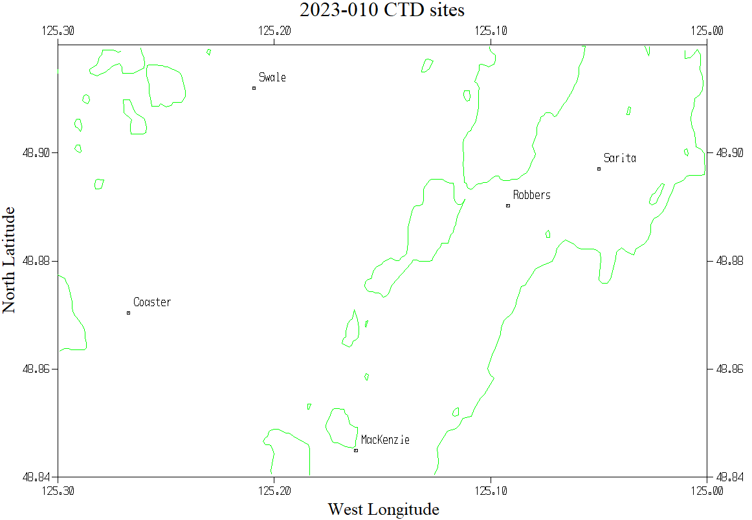
Station positions are approximate as they varied slightly among different legs of the program.

