REVISION NOTICE TABLE
DATE | DESCRIPTION OF REVISION

PROCESSING NOTES
Cruise: 2023-008
Agency: Ocean Sciences Division (OSD)
Location: WCVI
Project: WCVI Integrated Pelagic Ecosystem Science
Chief Scientist: King J.
Platform: Sir John Franklin
Date: 4 July 2023 – 2 August 2023

Processed by: Germaine Gatien
Date of Processing: 13 June 2024 – 25 June 2024
Number of HEX files: 54 Number of CTD casts processed: 53 (1 surf only-no sampling)
Number of bottle files: 53 Number of bottle files processed: 53

INSTRUMENT SUMMARY
An SBE911+ CTD #1453 was mounted in a rosette and attached were a Wetlabs CSTAR transmissometer (#983DR), a SBE 43 DO sensor (#3038), a SeaPoint fluorometer (#3949), an SBE pH sensor (#0691) and an altimeter (#76341).
Seasave version 7.26.7.121 was used for acquisition.
The salinometer used at IOS was a Guildline model 8400B Portasal, serial # 73274.

SUMMARY OF QUALITY AND CONCERNS
The Daily Science Log and rosette logs were available in digital format. The header page had complete information about participants and equipment. There were useful comments in both logs about problems encountered.

Sample #s were missing from the Daily Science log for Leg 2. There were many errors in entries of water depth during Leg 2, likely due to a misunderstanding that it was the maximum depth sampled that was to be entered. The standard CTD deployment method was used for Leg 1 but an alternate strategy was used for Leg 2; this was not noted in the log and led to some confusion in data processing.

Given the nature of this program, calibration sampling was well planned and useful. Shallow samples are not the best, but there were 60s waits before firing bottles and sufficient samples to establish variability with depth. The differences between salinity channels is similar to what was found for this CTD earlier in 2023. Similarly, estimates of dissolved oxygen drift are rough, but a post-cruise calibration check in early 2024 shows drift to lower values by about 6%, which is line with the bottle comparison for this cruise.

The upcast CTD data are noisier than usual. We usually see small-scale noise in upcasts due to the influence of the rosette above the CTD, but there were larger excursions than usual. This is not very important since we archive downcast CTD data and include upcast data for bottle files only when the CTD was stopped. However, it does make it difficult to assess settings used to align CTD dissolved oxygen and for the cell thermal mass correction. The usual values for those 2 steps were applied and we do not usually have to adjust them, so this is likely not a problem.

Calibration sampling was limited and no estimate is possible for accuracy of downcast dissolved oxygen.

PROCESSING SUMMARY

Seasave
This step was completed at sea; the raw data files have extension HEX.
The first cast was saved as 2023-008-0001test.cnv but as it is a full cast it will be processed so the “test” part of the name was removed. There was only 1 bottle sampled but there was a sample from that, so the hydro file will be renamed as well, and reduced to one record later.

Preliminary Steps
- The digital daily log and rosette log sheets were obtained and checked for comments.
- Salinity, Extracted CHL and Dissolved Oxygen data were obtained in QF spreadsheets.
- The cruise summary sheet was completed.
- The history of the pressure sensor, conductivity and dissolved oxygen sensors were checked.
- The calibration control files were obtained; there were no errors in parameters and no changes during the cruise.

BOTTLE FILE PREPARATION
The ROS files were created using files 2022-021-ctd.xmlcon.
The ROS files were converted to IOS format; the hysteresis correction was not selected since there were no deep casts; the Tau correction was selected.
The files were put through CLEAN to create BOT files.
Temperature and salinity were plotted for all BOT files and no significant outliers were found.
A preliminary header check was run. No obvious problems were found.

The BOT files were bin-averaged on bottle number and the output was used to create file ADDSAMP.csv. First, the file was sorted on event number and Bottle Position order. Then sample numbers were added based on the rosette logs.
The ADDSAMP file was then sorted on event number & then sample number.
It was used to add sample numbers to the BOT files – output *.SAM.
The SAM files were bin-averaged on bottle # and called SAMAVG.
The addsamp.csv file was converted to CST files, which will form the framework for the bottle files.

Next, the analysis spreadsheets were examined to see what comments the analysts wanted included in the header file. These were saved in file 2023-008-bot-hdr.txt.
DISSOLVED OXGYEN
Dissolved oxygen data were provided in spreadsheet QF2023-008_OXY*.xlsx which includes flags and comments but there were too few samples for a precision study. Draw temperatures are available. The spreadsheet page with the final data was simplified and saved as 2023-008oxy.csv. That file was converted into individual *.OXY files.
Sample #4 in the DO file had a comments starting with “ALL:”so flag 9 was added to all sample types.
SALINITY
Salinity analysis was obtained in file QF2023-008 SAL*.xlsx. The analyses were carried out in a temperature-controlled lab within 17-37 days of collection. The files were simplified and saved as 2023-008sal.csv. That file was then converted to individual SAL files.
EXTRACTED CHLOROPHYLL
Extracted chlorophyll and phaeo-pigment data were obtained in file QF2023-008_CHL QF*.xlsx. The file included comments and flags and a precision study. A simplified version of the spreadsheet was prepared and saved as 2023-008chl.csv. The csv file was then converted to individual CHL files.

Sample 4 is included in the sampling log and it was planned for salinity and dissolved oxygen, but although the bottle was fired, it didn’t close. The DO sample is already flagged 9 with comment applying to all samples, so the SAL sample was flagged 9. There was no CHL sample planned for that depth

The SAL, CHL and OXY CSV files were converted into individual files for each cast.
Then they were merged with CST files in 3 steps.

The files were then put through CLEAN to reduce the headers to File and Comment sections only.
These files are ordered on sample number, but the SAMAVG files are ordered on bottle number, so the MRGCLN1 files were reordered on Bottle_Number and saved as *. MRGCLN1s.
The MRGCLN1s files were then merged with SAMAVG files using merge channel Bottle_Number.

The output of the MRG files were exported to a spreadsheet and compared to the rosette log sheets.
There are 4 casts for which Niskin bottles were fired but not assigned sample #s; those were given a pad value for sample #.
The output of the MRG files were exported to a spreadsheet and compared to the rosette log sheets to look for omissions. None were found.

There are no silicate samples so low salinity checks are not needed.
A header check was run and no problems were found.

Compare
Salinity
There were only 3 casts with salinity sampling and the deepest was 142db, so the comparison of bottles and CTD is not a strong one. The deepest samples were from the bottom of casts, but one was well off the bottom; samples from the bottom of a cast tend to be outliers in comparison to CTD salinity, especially if they are near the ocean bed. Comparisons are also likely to be affected by poor flushing of Niskin bottles in the presence of large vertical salinity gradients.

When bottles above 100db are excluded as well as 1 near-bottom outlier, the primary salinity was found to be low by 0.0053psu (Std Dev 0.0098) and the secondary is low by 0.0098psu (Std Dev 0.0024). Even with that limited set of samples there is obvious pressure dependence which suggests that the Niskin bottles are not well flushed which means they will contain some deeper, saltier water than ambient values. So the CTD is probably not reading as low as it appears. It is recommended that outliers be removed until a fairly flat fit versus pressure is achieved; that is impossible with this data set.

When last used, during 2023-007, the primary was found to be high by 0.0015psu and the secondary was low by 0.003psu. That cruise had even less reliable sampling as almost all bottles came from near the bottom where the flushing errors may have the opposite sign as shed wakes come from above, though deeper water was sampled where gradients might be lower. The current cruise has likely better flushing due to long waits before firing bottles and rougher sea state which should help the bottles flush.

It is encouraging that the difference between the sensors is very similar for the 2 cruises. Neither cruise had ideal salinity sampling. It is likely that the primary salinity is reading within 0.003psu.

There were no outliers that could not be explained by real variability and incomplete flushing.
For more detail see file 2023-008-sal-comp1.xls.

Dissolved Oxygen
COMPARE was run with pressure as the reference channel.
First, 4 obvious outliers were removed. 3 of them were associated with high standard deviations in the CTD DO and further investigation shows very high vertical gradients.
The remaining outlier had a titrated sample value that is way out of line in profile. The analyst looked at sample #39 and found an error. It had been flagged 2 due to a problem in titration, but there was an error in the correction. The analyst immediately understood what went wrong and provided a value of 1.321mL/L. Checks show this value falls right in the middle of other low DO samples. COMPARE was rerun with this correction.

When those 3 outliers are removed the fits found using 3 methods are:
CTD DO Corrected = CTD DO * 1.0690 -0.0193 (offset left free)
CTD DO Corrected = CTD DO * 1.0633 (offset forced to =0)
CTD DO Corrected = CTD DO * 1.0774 -0.048 (offset forced to that found during 2023-007)
Judging by eye, the zero offset looks like the best fit and given the limited number of samples available from this and previous cruises, it is likely the best choice to not put weight on the offset.

There was a post-cruise calibration in spring 2024 that showed the DO sensor reading low by roughly 6% so the first 2 fits are reasonable. The correction may include some response-time effect as well as calibration drift. Generally offsets do not drift, but our ability to find the value of the offset is limited in cruises without sampling of DO with values close to 0.
In the absence of strong evidence applying a simple 6.3% correction looks appropriate.

For more detail see file 2023-008-oxy-comp1.xls.

Fluorescence
COMPARE was run with extracted chlorophyll and CTD Fluorescence using pressure as the reference variable. All samples came from about 5m and high gradients at that level lower reliability of the comparisons. Chlorophyll values ranged from 0.3 to 23.7ug/L. Overall the fluorescence reads higher than CHL, but that is because there are many low CHL values. When a fit is forced through the origin, Fluorescence is 78% of extracted chlorophyll. But that fit is heavily influenced by the few high CHL values.
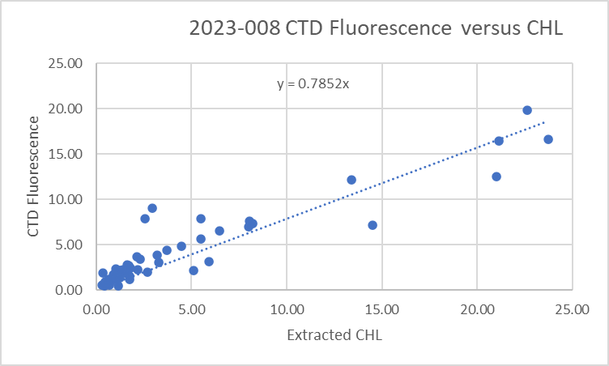

When the ratio FL/CHL is plotted against CHL the picture is clearer, with FL higher than CHL when CHL is <1ug/L and lower at higher CHL value. The shape is typcial of the performance for the fluroometer, though somewhat noiser than usual, likely due to all samples coming from the high-gradient zone.
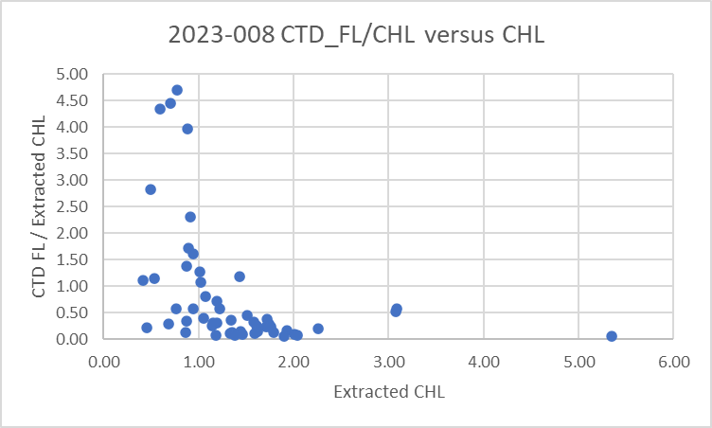
For full details for the COMPARE run see file 2023-008-fl-chl-comp1.xls.

Conversion of Full Files from Raw Data
All files were converted using files 2022-081-0001.xmlcon.
The Tau function was selected but not the hysteresis function as there was no sampling below 1000db.
A few casts were examined and all expected channels are present.
- The upcast is too noisy to judge the alignment of the DO traces well, but it looks reasonable.
- The minimum DO value in Saanich Inlet was 0.07mL/L.
- The secondary temperature has more detail than the primary, though it is not clear which is more reliable. There seems to be a vertical offset that could be misalignment or it could be something affecting response in one of the pair. Small misalignment is expected at this stage, but not this much. Conductivity also has some problems, with secondary more suspicious. The comparison with bottles showed no particular problem present when stopped.
- The transmissivity, fluorescence and pH look good.
- The altimetry looks excellent .

WILDEDIT
Program WILDEDIT was run to remove spikes from the pressure, conductivity & temperature only in the
full cast files (*.CNV).
Parameters used were: Pass 1 Std Dev = 2 Pass 2 Std Dev = 5 Points per block = 50
The parameter “Keep data within this distance of the mean” was set to 0 so all spikes would be removed.

ALIGN DO
A selection of casts were examined; the temperature profiles were complex, so the tests were not easy to interpret, but using +2.5s certainly improves the alignment and overall looks like a good choice for the DO sensor. ALIGNCTD was run on all casts using +2.5s.

CELLTM
CELLTM was run using the default settings (α = 0.0245, β=9.5) for both the primary and secondary conductivity. A few casts were checked and those parameters appear to have worked well.

DERIVE and Channel Comparisons
Program DERIVE was run on all casts to calculate primary and secondary salinity and dissolved oxygen concentration.

The differences between the channel pairs was examined for the only cast that sampled deeper than 250m. Samples from 4 other cruises that used these sensors previously and since they were last serviced are reported as well as the current cruise. Most sampling was shallow.
Cast # | Press | T1-T0 | C1-C0 | S1-S0 | Descent Rate
2022-019-0030 | 200 | -0.0006 | -0.0004 | -0.003 | shallow
2023-007-0009 | 300 | +0.0007 | -0.0004 | -0.004 | steady
2022-081-0001 | 280 | +0.0011 | -0.00035 | -0.0045 | High, steady
2023-007-0047 | 300 | +0.0018 | -0.00041 | -0.0056 | High, steady
 | 650 | +0.0008 | -0.00044 | -0.0051 | “
2023-007-0075 | 300 | +0.0015 | -0.00040 | -0.0056 | High, steady
 | 590 | +0.0009 | -0.00045 | -0.0052 | “
2023-008-0022 | 300 | -0.0004 | -0.00051 | 0.0055 | High, V Noisy
 | 720 | -0.0004 | -0.00057 | -0.0055 | “
The differences suggest slight drift in calibrations ,but the evidence is weak.

Conversion to IOS Header Format
The IOSSHELL routine was used to convert SEA-Bird 911+ CNV files to IOS Headers.
The station name for event 18 was changed from 8790 to 8537 based on a note in the 2023-008_CTD_Event spreadsheet.
CLEAN was run to add event numbers and to replace pad values in the pressure channel with interpolated values based on record number.
CLIP was not needed for Leg 1, but the deployment method changed for Leg 2. This was not noted in the log about this which caused some confusion. Clip was run on casts for which acquisition started before the 10m soak in cases where the DELETE step did remove the unwanted data.

Checking Headers
A header check was run on CLN files and there is evidence of spikes.
There are no negative fluorescence values.
The files were put through REVERSE and Surface check was run to see if there are any opportunities for checking the pressure calibration. During events #145 and 149 transmissivity drops to near 0% just as pressures dropped to -0.04db and -0.06db respectively. The pumps were off so other channels do not provide evidence. Surface tension or slicks may affect transmissivity values, but it does show that pressure errors at the surface are small.

A cross-reference list was checked. No problems were found.

A check was made of the water depths entered in the file headers by adding the maximum depth sampled plus the altimetry reading when the CTD was at the bottom of the cast. We usually expect to get values within ±10m. We investigate differences >5m to ensure header entries for water depth agree with the log and that the altimetry minimum was clear. There were many differences between the log and headers, including a surprisingly large number that differed by exactly 10m or 11m during the second leg, which suggests that the maximum depth sampled was entered rather than the water depth.

The log depths will be entered in the headers for casts: 10, 26, 145, 154 to 208.
For event #22 the header depth is clearly wrong but the log depth also looks off. There is a note in the 2023-008_Event_Info spreadsheet that there was a sudden drop-off from 48m to 725m. The most reliable estimate comes from the sum of the maximum depth sampled plus altimetry value at the bottom so 763m will be entered for that cast..
Changes were made to the SAM files after which the Bin Average, Merge and CLEAN steps were rerun.
Changes were made to the full profile IOS files after which CLEAN was rerun.

Surface check was run. The average was 2.4db.

Shift
Fluorescence
SHIFT was run on the fluorescence channel with an advance of 24 records. The fluorescence was very noisy making a judgement difficult, the data are definitely better aligned after this step.
Dissolved Oxygen
The Dissolved Oxygen voltage channel was aligned earlier. It is very hard to judge the alignment due to extremely noisy upcast data, but it appears that no further adjustment is needed for the DO concentration channel.
Conductivity
This CTD had been used on cruise 2022-081 when the best settings found for alignment of conductivity were -0.9 records for the primary sensor and -0.3 records for the secondary. During a more recent cruise -2023-007 settings of -1.1 and -0.7 records looked better, but there was no pH sensor during that cruise which may have affected the results. The best choice for this cruise was -0.9 records for the primary and -0.3 for the secondary, but the differences between the two choices were small.
pH
When last used there was too little variability in pH and too much hysteresis to make a fine-tuned judgement about the alignment of pH with temperature. The last time the sensor was used in 2022 a shift of +15 records was applied. Tests showed that shift a larger shift was needed for these data.
SHIFT was run on all casts with a setting of +40 records. The results look ok.

DELETE
The following DELETE parameters were used:
Surface Record Removal: Last Press Min
Maximum Surface Pressure (relative): 10.00
Surface Pressure Tolerance: 1.0 Pressure filtered over 15 points
Swells deleted. Warning message if pressure difference of 2.00
Drop rates < 0.30m/s (calculated over 11 points) will be deleted.
Drop rate applies in the range: 10db to 10db less than the maximum pressure
Sample interval = 0.042 seconds. (taken from header)
COMMENTS ON WARNINGS: There were no warnings.

Other Comparisons
Previous experience with these sensors –
The P, T, S and DO sensors had been used on 1 other cruise since they were last recalibrated.
- 2022-019 – No calibration sampling; no recalibration applied.
- 2022-021 – Primary salinity within 0.002psu (only 5 samples) Dissolved oxygen low by 5.5%.
- 2022-081 – No recalibration sampling. Recal based on 2022-021. Sal difference ~0.004
- 2023-007 – Limited sampling. Primary salinity high by ~0.0015 and secondary low by ~0.003psu. DO recalibrated using slope 1.0445 and offset +0.048. Surface pressure variable but all within ±0.5db.
Historic ranges All temperature data fell within the local climatology where available. A few casts had a brief and small excursion in salinity above the climatology minimum near 40m. One cast in Queen Charlotte Strait had high salinity from 10 to 40m. These are unusual but they are found in both channels and are not found in most casts, so this not thought to be due to a calibration issue.
Repeat Casts – There were no repeat casts.
Post-Cruise Calibration – The dissolved oxygen sensor was recalibrated in March 2024 when it was found to be reading low by about 6%.

DETAILED EDITING
The DEL files were sent to the QC-CTD site for predictions.
In the search to decide which sensor pair are best for archiving, and hence editing, a problem was found.
At this stage it was discovered that some files looked bad near the top; both sensor pairs were affected. A return was made to look at the CLN files and had data from the 10m soak included, and those from 141-208 did. But DELETE removed the soak data from about half of the affected files. It turned out that if the CTD returned to a pressure less than the minimum depth up to that point, DELETE removed the soak data. If it returned to a pressure greater than that minimum, DELETE treated the first drop to 10db as good, and removed the drop from 0-10db in the main part of the cast.

A return was made to the stage after CLEAN; CLIP was run then the 4 SHIFT steps and DELETE were rerun on those files.
For the casts that merged the initial drop to the main drop from 10db down, the prediction files (DELPRED) produced are not useful since the CTD data are bad. But if program MERGE was used to combine the new DEL files with the predictions from the DELPRED files (using scan numbers as merge channel) useful DELPRED2 files could be created. The predictions for the top 10db would be missing, but the rest would be fine. It turned out that for some files with the 10m soak data included DELETE did work well, so the DELPRED files can be used for them.

The files which did not work well without a CLIP run were: 145, 157, 165, 177, 190, 196, 200 and 208. Those will be edited using DELPRED2 files.

For this cruise neither sensor pair is without problems, but the primary looks like the best choice overall based on stability in T-S space, being closer to bottles and being the choice for previous cruises using this CTD. But there were bad sections in some casts. The secondary T/S channels were selected for casts #10 and 92.

Many of the casts had T and S reversals around 4-8db which may be real, though ship effects may be a factor. Only light editing was applied to these features.

For cast #88 there was a clear problem with pumped channels below 29db that persisted through the upcast. All records were removed below 29db.
For cast #92 there are large differences in salinity, ~0.05psu. Compared to nearby casts the primary values look out of line, while the secondary look reasonable and the T-S plot looks more stable with the secondary channels than primary. The secondary T and S were chosen for editing those 2 casts.

All DEL files were copied to *.EDT.

CTDEDIT was used to remove records that appear to be corrupted by shed wakes near the top and bottom of casts. Salinity was cleaned to remove spikes that appear to be due to small misalignments.
All files required editing, mostly near the top and bottom of casts.
The edited files were copied to *.EDT.
After editing T-S plots were examined for all casts; there remain many small unstable features but they are in areas when they may well reflect real conditions.

Recalibration
Pressure appears to be accurate and will not be recalibrated.

The evidence for salinity calibration is weak from this cruise and previous cruises that used the same sensors since they were last serviced. The primary appeared to be low by 0.0053psu and the secondary low by 0.0098psu, but flushing is believed to have been poor and the comparison lacked the pressure independence needed for confidence in the result. Both sensors are likely more accurate than these values suggest. The most consistent result in the history of these sensors is that the primary salinity is reading higher than the secondary by about 0.0045psu. The primary may be reading low, but is likely within ±0.003psu. A post-cruise calibration suggests that the primary is low by roughly 0.0033psu and the secondary by 0.0077; that difference is similar to what was found in the current comparison. However, there were at least 3 more cruises between this one and the post-cruise calibration. A reasonable estimate is that the primary is low by 0.003psu and the secondary low by 0.0075psu.

Sampling for dissolved oxygen was also very limited but there was a post-cruise calibration that suggests it was reading low by roughly 6% in early 2024. That is close to the results of the comparison for this cruise, though again, there were 3 more cruises between this one and that post-cruise calibration and poor flushing tends to minimize the correction. Nonetheless, being low by 6% is the best available information.

File 2023-008-recal1.ccf was prepared to add 0.003psu to channel Salinity:T0:C0 and 0.0075 to channel Salinity:T1:C1 and to apply a correction as follows:
CTD DO Corrected = CTD DO * 1.06

CALIBRATE was first run on the MRGCLN2 files and SAM files. Note that there was no silicate sampling.
COMPARE was rerun on salinity and dissolved oxygen to check that the corrections were applied properly and 1 error was found and corrected.

CALIBRATE was run on the *EDT files.

Fluorescence Processing
A median filter, size 11, was applied to the fluorescence channel. It worked well to reduce noise.

Final Calibration of DO
The initial recalibration of dissolved oxygen corrects for sensor calibration drift. Alignctd corrects for transit time errors. Those 2 steps may partly correct for response time errors, but to see if a further correction is needed, a comparison is made of downcast CTD data to bottle data from roughly the same pressure. Small differences are expected due to ship drift, temporal changes, incomplete flushing of Niskin bottles and delayed response and noise in CTD data.

Downcast files were bin-averaged to 0.5m bins for the casts with DO bottle samples. Those files were then thinned and compared to the bottle values in the MRG files. COMPARE was run to study the differences between the downcast CTD DO data and the titrated samples from upcast bottles.

The CTD DO was higher than the titrated samples by an average of 0.081mL/L and the standard deviation was 0.043mL/L. We expect the CTD data to be higher than bottles due to incomplete flushing of bottles and slow response of the SBE DO, but this is larger than usual. However, there were very few bottles and they are all shallow. Below 100db the average difference is 0.05mL/L and the differences are gradually dropping as pressure increases. This step is not expected to work well on just 2 shallow casts, but it does look at though the recalibration worked reasonably well.

There are too few samples to make an estimate of SBE dissolved oxygen accuracy.

BIN AVERAGE of CTD files
The following Bin Average values were applied to the FIL files (output AVG):
Bin channel = pressure Averaging interval = 1.000 Minimum bin value = .000
Average value will be used. Interpolated values are NOT used for empty bins.
On-screen T-S plots were examined.
Profile plots were examined to see if there any problems. No problems were noted.

Final CTD File Steps (REMOVE and HEADEDIT)
- For all casts except #10 & 92 REMOVE was run to remove the following channels:
Scan_Number, Temperature:Secondary, Conductivity:Secondary, Oxygen:Voltage:SBE, Descent_Rate, Status:Pump, Altimeter, Salinity:T1:C1 and Flag.
- For casts #10 & 92 REMOVE was run to remove the following channels:
Scan_Number, Temperature:Primary, Conductivity:Primary, Oxygen:Voltage:SBE, Descent_Rate, Status:Pump, Altimeter, Salinity:T0:C0 and Flag.
- A second SBE DO channel (with umol/kg units) was derived.
- Oxygen saturation was calculated and surface values varied from 80% to 140% with only 1 cast >130% and 2 <80%. Given that most casts were in shallow water nearshore, this variability is to be expected, with high gradients near the surface.
- HEADER EDIT was used to fix formats and channel names and to add comments to the headers.
- The Standards Check routine was run and no problems were found.
- The Header Check was run; no problems were found.
- Profile and T-S plots were examined and no problems were found.
- The sensor history was updated.

Final Bottle Files
- The MRGCOR1 files were put through SORT to order on increasing pressure.
- For all casts except #10 and #92 REMOVE was run to remove the following channels:
Scan_Number, Temperature:Secondary, Salinity:T1:C1, Conductivity:Secondary, Oxygen:Voltage:SBE, Transmissivity, Altimeter, Status:Pump, Descent_Rate and Flag.
- For casts #10 and #92 REMOVE was run to remove the following channels:
Scan_Number, Temperature:Primary, Salinity:T0:C0, Conductivity:Primary, Oxygen:Voltage:SBE, Transmissivity, Altimeter, Status:Pump, Descent_Rate and Flag.
- A second SBE DO channel with mass units was added for both the CTD DO and Bottle DO
- REORDER was run to get the pair of DO channels together.
Casts #1, 26, 76 and 121 were edited to remove bottles that were just for tests or not planned to close.
Cast #196 was edited to add a flag and comments about bottle that did not close.
- EDIT HEADERS was run to ensure formats and units are correct, change the channel name Bottle_Number to Bottle:Firing_Sequence and the name Bottle:Position to Bottle_Number and to add a comment about quality flags and analysis methods and a few notes about the CTD data processing.
- Standards check was run and a few problems found. Edit Headers was run until all problems were resolved.
- Bottle data were exported to a spreadsheet and a few problems were found and corrected in the bottle files.
- A header check were run. No problems were found.
- Plots of each file were examined and no problems were found.
- A cross-reference listing was produced for the CHE files.

Particulars
1. Only 1 bottle sampled. Rest fired as test so removed from file.
8. Bottle 2 did not fire.
18. Station 8537 instead of planned 8790. Fixed in IOS file.
26. 2 bottles fired – only bottle 1 intended.
28. Downcast clearly bad below 29db; spiky upcast – pump or rosette problem – swell is minimal
52. pH buffer bottle left on overnight before this cast.
64. Winch stalled on way down.
68. Fluorescence spiky ~30m.
76. Rosette may have hit bottom due to winch operator mistake. Profile is thus full water column. Fired bottle 2 and 3 as a test; only sampling from bottle 1. Others removed from file.
84. Odd flat line from O2, SAL and TEMP sensors on upcast at ~12m. Hit a jelly fish – tentacles all over the rosette - may explain flat line.
87. Upcast had unusual flatline for temp, oxygen and salinity. Might have been a jellyfish that was strung out all over the rosette when it reached the surface.
88. Poor data – perhaps due to jellyfish encounter on previous cast? Some noise in CTD data persisted during rest of cruise.
92. Huge offset between 2 salinity channels. Primary looks much lower than nearby casts and T-S noisy. Use secondary channels.
96. Winch operator stalled at 10-15m downcast.
133. Odd fluor spike at BO of cast Temp and Sal signals flat lined at 5m.
137. Test cast – surface data only and no sampling. NET event. CTD data not processed.
141. Start of Leg 2
186& 190. Both channels extremely noisy top 20m.
196. Bottle 2 did not close. Known problem. Only bottle 8 had originally been assigned a sample # (65). To avoid confusion sample numbers with leading 90 were used for this cast. (9065-9072).
196.
No sampling during Leg 3.

CRUISE SUMMARY – CTD

CTD# | Make | Model | Serial# | Used with Rosette? | CTD Calibration Sheet Competed?
1 | SEABIRD | 911+ | 1453 | Yes | Yes
Calibration Information - 1453
Sensor |  |  | Pre-Cruise |  | Post Cruise
Name |  | S/N | Date | Location | Date | Location
Temperature |  | 2023 | 15Jul2022 | Factory | 8Feb2024
Conductivity |  | 3500 | 19Jul2022 | Factory | 23Feb2024
Secondary Temp. |  | 6565 | 15Jul2022 | Factory | 17Feb2024
Secondary Cond. |  | 5043 | 15Jul2022 | Factory | 23Feb2024
SBE 43 DO sensor |  | 3038 | 26Febl2022 | Factory | 11March 2024 | Factory
Altimeter |  | 76341 | 2Oct2021
Pressure Sensor |  | 1453 | 21Jul2022 | Factory
Transmissometer |  | 983DR | 28Apr2021 | IOS
pH:SBE |  | 0692 | 14Jan2020 | Factory
SeaPoint Fluor. |  | 3949 | ? | Factory

Cast # 1 is not shown to better display the west coast casts.

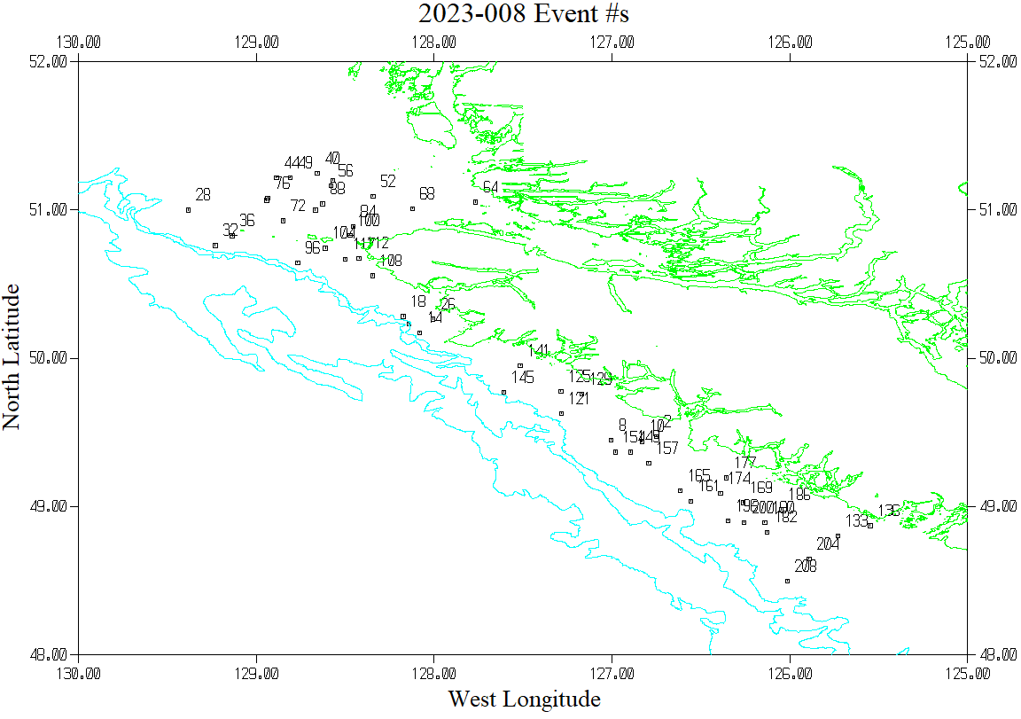

Cast # 1 is not shown to better display the west coast casts

