**Study of CTD0456 – Seabird 25 8Hz.**

Problems were discovered in salinity data from 2023-003 and possibly in dissolved oxygen. There were many spikes and clearly bad values in salinity. Since the CTD had been used for many cruises in 2023, data from 6 cruises were studied to see if the cause could be determined and if there was a way to recalibrate data.

A SeaBird Model SBE-25 CTD (s/n 0456) was used with temperature sensor #6566, conductivity sensor #5046, Wetlabs ECO Fluorometer #2216, dissolved oxygen sensor #3779, PAR sensor (4565) and pressure sensor #0464.

For 2023-053 there was no PAR sensor and there was a pH sensor.

The order of the cruises was:

2023-002 – Feb

2023-003 – March

2023-020 – April

2023-021 – Early May

2023-022 - May/June

2023-053 – mid-June -terrible salinity, spiky, conductivity and DO bad. No calibration sampling.

All were in the Strait of Georgia – the first 5 were SoG Zooplankton cruises.

Calibration sampling for the first 5 cruises are limited to a few bottles at the bottom of casts and a few at the surface. The CTD data are not reliable at the surface since they come from a little deeper and so the CTD salinity appears to be reading higher than it really is. For the deep samples the same thing happens because the Niskin bottle may not flush completely so samples may have lower salinity than the ambient waters. However, the near-bottom differences are usually small if local vertical gradients are low.

There was no sampling during the 6th of these cruises, 2023-053.

At the time this issue came to light only cruise 2023-002 had been fully processed. The other cruises were processed in a quick fashion to see how extensive the problem was. Some steps were skipped that would make small differences to salinity, but the data should be of high enough quality to enable comparisons.

The data were put through DELETE to remove the upcast data and they were metre-averaged. The temperature looks ok in all the files.

* 2023-002 – These data were fully processed and looked good. Salinity read a little lower than bottles by 0.003 to 0.005psu for 3 bottles, and one read higher by 0.03psu. DO profiles looked normal.
* 2023-003 - Data were sent from sea and looked good at first sight as there were no spikes and the shape of profiles looked ok. But with more complete processing it was clear that salinity values were much too high. Whatever the source of error, it decreased slightly through the cruise. Adjustments to alignment of T and C failed to bring salinity values much closer to the climatology.
* 2023-020 – All salinity below 50m were above the climatology max with exception of a Gulf Islands cast. The early casts were the most out of line with subsequent casts gradually getting closer to climatology.
* 2023-021 – All salinity below 50m above climatology max. No spikes.
* 2023-022 – File sent from sea seemed ok – sensible profile shape. There was an odd DO profile but down and up matched. Salinity below 50m all look high compared to climatology, but not as high as during earlier cruises. Above 50m the climatology has wide range of values, so falling within the climatology is not very significant. Late in the cruise much of the deep salinity data is very bad, spiky, rapid changes, some extremely high values. This looks like a pump/flow problem.
* 2023-053 – The sea-going crew noted many spikes, high salinity, bad conductivity, bad DO.

DO was erratic – some casts look ok, others bad. Salinity were all extremely high, worse than in the previous 2023 cruises.

So while the salinity are all out of line with climatology they seem to get gradually closer through March, April and May. But, in mid-June the salinity values are much higher and there are spiky data and sudden changes and some high very high values appear as time went on.

SALINITY

Two studies were pursued in order to understand the problem and try to find a way to recalibrate salinity:

1. During 2023-022 two CTDs were used at one site on casts 9 and 11, about 15 minutes apart, so an intercomparison was done.

Document CTD456_vs_CTD1255.xlsx contains the results.

The new CTD 1255 has a much higher sampling rate (24Hz) than the older CTD 456 (8Hz), so there is a lot more detail near the surface where gradients are high. Differences between all channels were large in the top 30m.

Differences shown below are taken from bin-averaged files for the 2 casts.

|  |  |  |  |  |  |  |
| --- | --- | --- | --- | --- | --- | --- |
| all depths | Press | Temp new-old | Cond new-old | Fluor new-old | SAL new-old | DO new-old |
| median | 0.00 | 0.0112 | -0.07180 | -0.9105 | -0.7405 | -0.643 |
| max | 0.34 | 2.6690 | 0.03238 | -0.5040 | -0.5451 | 0.063 |
| min | -0.14 | -0.3087 | -0.08948 | -3.1600 | -1.6326 | -0.998 |
| stdev | 0.06 | 0.5596 | 0.02252 | 0.4470 | 0.192 | 0.1942 |
|  |  |  |  |  |  |  |
| from 35m to 50m | Press | Temp new-old | Cond new-old | Fluor new-old | SAL new-old | DO new-old |
| median | 0.00 | 0.0101 | -0.07176 | -0.6980 | -0.7374 | -0.596 |
| max | 0.34 | 0.0475 | -0.06760 | -0.5720 | -0.7286 | -0.530 |
| min | -0.02 | -0.0118 | -0.07379 | -0.8020 | -0.7465 | -0.698 |
| stdev | 0.09 | 0.0147 | 0.00147 | 0.0719 | 0.0054 | 0.054 |

* Unfortunately, they were not deep casts, but below 30m there is decent agreement in temperature.
* For fluorescence there is a difference of 0.7ug/L but it is fairly consistent with depth, so this looks like a scale or offset issue. Fluorometer ECO #2216 gives higher values than the new one ECO #8046. The chlorophyll samples were not available at the time of this study and are only gathered at the surface where a good match is not expected.
* Conductivity differences decrease with depth as do salinity differences.
* Dissolved oxygen differences are large but fairly consistent below 30m. DO sensors are expected to drift lower so it is surprising the new CTD is reading lower than the older one. This might be due to problems noted during this cast that affected conductivity, and possibly DO during event #9. It is recommended that the new sensor be used on a cruise with DO sampling.

There is no way to establish whether all the differences are due to instrumental problems in CTD 0456.

1. For most of the cruises there were some salinity bottle samples.

A comparison was done for each of the March, April, May and May/June cruises, and then data were combined to include all 4.

These are limited in value because there are few, some are at the surface and some at the bottom of the CTD casts. Both cases tend to lead to the Niskin containing lower salinity water than seen by the CTD, thus making the CTD salinity appear to read higher than it really is. At the surface it is because the CTD does not give reliable values as shallow as the sample depth. At the bottom there is an issue of the Niskin bottles not flushing completely so the samples come from shallower water, but the errors should be fairly small if the local gradients are low, as is often the case near the bottom.

The results show that CTD salinity is gradually growing closer to the bottle salinity with a few exceptions which may be due to larger near-bottom salinity gradients. While this is interesting, the information available is insufficient to allow a time-dependent correction. The bottle data from 2023-022 looked like the differences had stabilized somewhat, so that recalibration might be possible, but examination of the full profiles revealed that there were many spikes and sudden changes in values, so the salinity data appears to be unreliable even if a suitable correction could be found. There was no sampling during 2023-053, but the salinity was extremely high by from 5psu to 25psu.

When the problems were discovered a new CTD was used for Cruise 2023-023.

DISSOLVED OXYGEN

There is no reliable way to judge the accuracy of the dissolved oxygen data. A few things were studied:

* Downcast oxygen profiles were compared to temperature profiles; they usually look similar.
* There is always some offset between downcast and upcast profiles due to slow response time, and some effects of upcast shed wake corruption. But we expect a similar shape except near the surface.
* Comparisons with previous years are not very useful given the variable timing and locations of blooms, tidal mixing, river inputs and weather conditions.
* We expect oxygen % saturation to be near 100-105% offshore but it does vary widely inshore making this only a very rough guide. Moreover, the calculation involves salinity. Tests using salinity values higher by 2psu led to % DO saturation higher by ~1.5% and salinity higher by 6psu led to salinity higher by ~5%. So we can look at % saturation at the surface, but assume the values are high due to problems in the calculation.

2023-002 – No problems were noted during this cruise.

2023-003 – The profiles looked ok up until cast #12. After that the alignment between downcast and upcast increases. Adjusting alignment settings to +6s produced a better correspondence between DO and temperature during downcasts, but not upcasts. Upcasts mostly have the same shape, just less well aligned with temperature, but in a few cases the upcasts are quite different, perhaps indicating poorer flow during upcasts. These all suggest an increase in response time which might indicate a damaged membrane, but in the cruise that followed the alignment looked good. The problem is more likely related to flow to the sensor. At the bottom of casts the DO decreases significantly. Examination of Chito casts that had many stops during downcasts and upcasts showed DO values dropping during all stops, not just the stop at the bottom of casts. (See plots at end of this report.) The DO profiles recover after the stops. The surface saturation values ranged from 79% to 106%, excluding 2 casts with no 10m soak. It is likely that the DO values from downcasts are reliable except at the bottom of the casts.

2023-020 – DO profiles mostly had good correspondence between up and down, but cast #17 had a spike to 13mL/L around 10m on the downcast (but not during the 10m soak) that is not seen on the upcast. Temperature and salinity show no such feature. There are many points in the feature so this is assumed to be due to either a flow problem or sensor problem. There are many cases of significant differences in the top 20m but both look typical of problems due to shed wakes and slow sensor response.

The surface saturation values ranged from 90% to 117% excluding the 2 casts with no 10m soak. Other than the odd data from cast #17 the DO data look ok.

2023-021 – DO profiles look ok with good correspondence between up and downcasts except very close to the surface in some cases. Surface saturation varied from 84% to 130% except for the 2 casts with no 10m soak. The lowest value was at station 56 which was very well mixed from top to bottom. The highest was in Cowichan Bay where the near-surface gradient was very high. Other values ranged from 100% to 120%. So DO looks worth archiving.

2023-022 – DO profiles look ok up to cast #24. After that most have poor correspondence, some odd low values at the bottom of casts and more small-scale variability than normally seen. The downcast surface DO saturations were between 97% and 130% except one at station 56 which was ~70% which could be due to active mixing. Those results look close to those observed in July 2021 in this region including higher values to the north and a low value near the Gulf Islands. This suggests that downcast DO is reasonable at the surface for all casts. Those data could be included in bottle files at the surface with some warning.

Looking at deep DO values compared to other cruises in the area showed most DO values higher than those seen in July 2019 and lower than most in April 2019 though a few of the early 2023 casts were significantly higher. Local variability is so high that this is not a very useful comparison except to show that values are not greatly out of the expected range. Deep DO values up to cast #31 appear ok to use and surface values at all stations that had a 10m soak. After cast #31 dissolved oxygen data look bad below the surface with spikes and odd offset sections. Oxygen:Dissolved:SBE data were removed from CTD casts #32 to #48. For bottle files DO was derived in mass units as the salinity error was small enough to have no significant effect. Mass units were not derived in the CTD files.

2023-053 – DO quality was erratic – sometimes profiles look ok, sometimes clearly bad with some spiky casts and frequent sudden shifts in values. Some data looked worth archiving, some not. For 3 casts a different CTD was used and the data look good. A comparison between 2 casts using the 2 different CTDs looked reasonably close given some distance and time between casts and expecting the #0456 value to be lower than it looks given very high salinity.

CONCLUSIONS:

1. Preliminary examination of data sent from sea has been limited to seeing if all sensors had a signal, profiles had an appropriate shape and sensor values looked reasonable. In future, the data could be converted to IOS Header format so that values of temperature and salinity could be plotted with climatology, though the large variability in the Strait of Georgia makes this a very rough guide.

2. The salinity and conductivity data from cruises 2023-003, -020-, -021, -022 and -053 should not be archived.

3. Dissolved oxygen data quality varies.

* For 2023-003 DO data appear to be reliable except at the bottom. Alignment settings for DO need to be changed between casts #12 and #15. Some editing was needed to remove data from the bottom of casts.
* For cruises 2023-020 and 2023-021 the DO data looks mostly useful.
* For 2023-022 the first few casts look ok, but after cast #31 DO should be removed but surface values look ok to use in bottle files. Salinity errors were smaller so dissolved oxygen in mass units were derived for bottle files.
* For 2023-053 DO is clearly bad and should be removed.

4. While salinity sampling does not usually lead to recalibration for programs with a limited ability to sample, having a few samples is useful for detecting major malfunctions such as these.

5. Temperature data look reliable and there are no obvious problems with fluorescence.

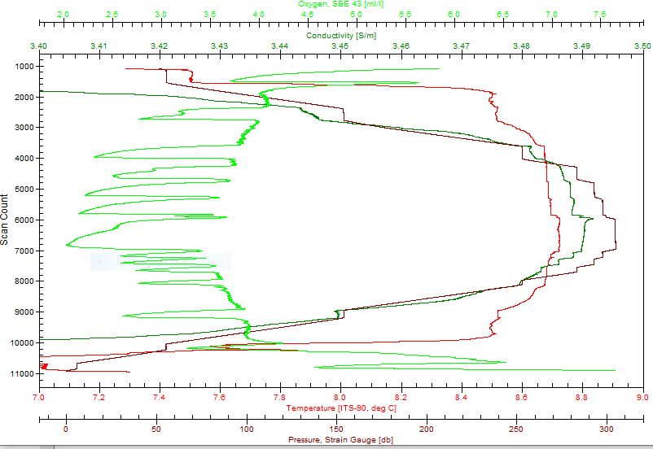

2023-003 during Chito Cast