## REVISION NOTICE TABLE

|  |  |
| --- | --- |
| DATE | DESCRIPTION OF REVISION |
|  |  |
|  |  |

## PROCESSING NOTES

Cruise: 2023-003

Agency: IOS, Ocean Sciences Division, Sidney BC

Chief Scientist: Young K. Platform: Neocaligus

Location: Strait of Georgia Project: Strait of Georgia Plankton

Date: 14 March 2023 –19 March 2023

Processed by: Germaine Gatien

Date of Processing: 18 July 2023 – 3 August 2023

Number of original HEX files: 31 (including 3 files from Chito casts)

Number of CTD files: 28 Number of BOT files: 15

##### INSTRUMENT SUMMARY

A SeaBird Model SBE-25 CTD (s/n 0456) was used with temperature sensor #6566, conductivity sensor #5046, Wetlabs ECO Fluorometer #2216, dissolved oxygen sensor #3779, PAR sensor (4565) and pressure sensor # 0573.

# SUMMARY OF QUALITY AND CONCERNS

There was a digital log with positions and notes about sampling and a digital sampling log. Header information was entered in the raw files in a format that enabled easy conversion into IOS Header format.

CTD casts were run at 28 sites; there were 3 sites which also had a separate CTD cast to enable Chito sampling. The Chito casts were not prepared for the archive due to frequent stops during downcasts; there was a standard CTD cast at each of those sites.

Surface bottles were fired at 15 sites, sometimes during the CTD soak. During 2 regular CTD casts and 3 Chito CTD casts salinity and nutrient samples were taken at the bottom of the cast using a Niskin mounted ~3m above the CTD. CTD data were extracted from the Chito casts for the bottles fired at the bottom of the cast. The files prepared for the archive will contain only 1 BOT file per site with the event number matching the regular CTD cast.

No data will be archived from channels Salinity:T0:C0 and Conductivity:Primary due to salinity values being much higher than bottle samples and well above the local climatology. The error became smaller through the cruise but the data remained unusable with no objective method found to correct it. Subsequent cruises using this equipment had similar problems.

Channel Oxygen:Dissolved:SBE also had some odd data features at the bottom of casts and during upcasts that appeared to be related to slower response time than usual. Downcasts looked normal for the first few casts, but after cast #12 the usual alignment parameter of +2.5s was increased to +6s. With that change the downcast oxygen profiles corresponded well to temperature profiles, but upcast data did not.

The cause of the problems was not established at the time these data were processed, but since both oxygen and conductivity were affected, problems with the pump and/or flow to sensors are suspected. Oxygen:Dissolved:SBE data are considered nominal.

The waits at the surface after the 10m soak period were occasionally less than 10s; longer waits, preferably 30s, should allow near-surface waters to recover from the stirring caused by the CTD rising.

The fluorometer generally read higher than CHL when CHL was <1ug/L, but otherwise read lower, about 30% to 40% of CHL. The fluorescence generally looks a little lower relative to CHL than usual, which may be due to the chlorophyll samples coming from a little higher in the water column than the CTD fluorescence. Overall, the pattern looks similar to what is usually seen and suggests that the CTD fluorometer was performing in the expected manner. As usual, these data are considered nominal.

A +0.7db offset was applied to pressure in the configuration file, based on a trial conversion with 0 offset.

A report on the problems with this CTD during 2023 cruises between March and June may be found in document “Study of CTD0456.docx”.

# PROCESSING SUMMARY

##### 1. Seasave

This step was completed at sea.

##### 2. Preliminary Steps

A digital daily log was obtained as well as a sampling log.

The cruise summary sheet was completed.

Deep samples were taken during CHITO casts; those casts will be used to obtain CTD data to go with the samples, but no CTD files are needed.

Surface samples were taken while the CTD was soaking.

##### 3. Conversion of Raw Data

The configuration file used at sea was correct, but during the previous use of this equipment a pressure offset of 0.7db was found more appropriate. A test conversion was done using a 0.7db offset and starting and ending pressures were very close to 0.

The file used at sea, with the adjusted pressure offset, was saved as 2023-003-ctd.xmlcon and used to convert all HEX files.

Plots were made of a few casts and all expected variables were present.

Fluorescence dark value is ~0.38ug/L with no values <0; while a little high for deep water, this is not unusual in the Strait of Georgia. The pressure has steps but no reversals were noted.

Waits at the surface were sometimes shorter than 10s. A 30s wait at the top is recommended to allow surface waters to settle from the mixing caused in raising the CTD.

##### 4. WILDEDIT

The only spikes noted in the data occurred at the beginning or end of the casts or included many points, and will be removed in the normal course of editing. So WILDEDIT was not run.

##### 5. FILTER

Normally pressure is filtered later in processing when running DELETE, but the poor resolution of this sensor means it is necessary to do this early to make sense of the other data which update more often than pressure. So program FILTER was used to apply a low-pass filter with a time constant of 0.5s to pressure and depth. The results were excellent.

Next the temperature and conductivity were examined and the usual approach of applying a cosine filter, size 8, in routine WFILTER did a good job of removing small reversals.

In the past running WFILTER without the previous pressure filter did not produce as good results.

##### 6. ALIGNCTD

Generally, a setting of +2.5s is found suitable for this equipment, so ALIGNCTD was run with that setting on all casts, Plots were examined after this step and the results look fairly good for the first few casts, but poor later. No setting produced good alignment for the later casts, but using +6s did produce downcasts profiles with features matching temperature features.

The upcast dissolved oxygen looks very odd at times and there is generally more noise in dissolved oxygen than usual. The profiles of T and DO were extremely complex; given the slow response of the DO sensor this test is difficult to interpret.

ALIGNCTD was run with a setting of +2.5s for casts 1-12 and +6s for casts 15-49.

##### 7. CELLTM

CELLTM was run on all casts using the SeaBird recommended parameters, (α, 1/β) = (0.04, 8).

##### 8. DERIVE

Program DERIVE was run to calculate salinity and dissolved oxygen concentration (tau correction included). Plots were examined and confirmed that steps 5, 6 and 7 had improved the data.

At this point the CHITO files were renamed with a leading 9 in the event number to make them easier to handle in IOS SHELL routines.

The salinity and dissolved oxygen data look unreliable. A later cruise using the same equipment was found to have bad problems in DO and conductivity. Processing was suspended and preliminary processing performed on all cruises that used this equipment in the first half of 2023.

Document “Study of CTD0456.docx” compared the performance of this equipment during the following cruises which were all in the Strait of Georgia:

2023-002 – Feb

2023-003 – March

2023-020 – April

2023-021 – Early May

2023-022 - May/June

2023-053 – mid-June

The conclusion was that all sensors performed well during 2023-002, and the temperature and fluorescence sensors appear to have performed well during all the cruises. Conductivity looks bad for all cruises from March to June. Dissolved Oxygen was harder to assess, looking generally ok for cruises 2023-020 and 2023-021 with some problems during other cruises. Salinity looks unreliable throughout due to the bad conductivity data.

The temperature and fluorescence sensors performed as expected with temperature values falling within local climatology and fluorescence comparing reasonably well with extracted chlorophyll given different depths of sampling. In particular, the highest fluorescence values came from casts with the highest CHL values.

Dissolved oxygen data from the first few casts have so little variation that it is hard to judge alignment. For casts #10 and #12 the downcast features in temperature and salinity match well with the usual alignment setting of +2.5s, though the vertical offset between downcast and upcast is slightly larger than that for temperature.

Cast #15 is markedly different with small-scale variability in the dissolved oxygen signal that is most unusual. There is also an odd decrease of DO at the bottom of the cast, a feature seen in all subsequent casts and suggestive of slow sensor response. However, the quick recovery to the previous value once the CTD heads upwards argues against that explanation. This is confirmed by looking at the CHITO casts which had stops during both downcast and upcast. Whenever the CTD stopped, DO dropped significantly.

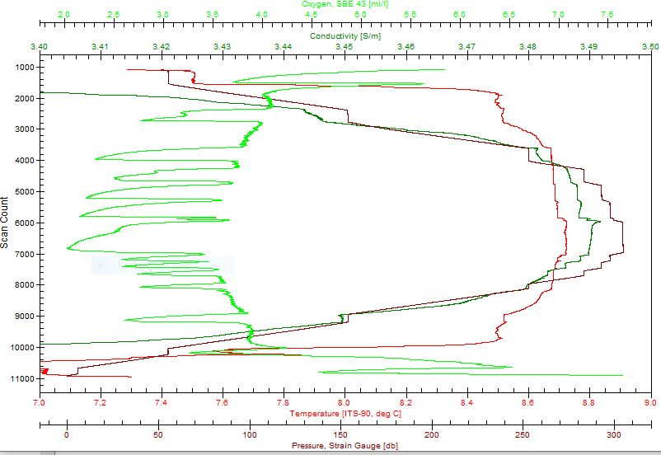

But the values then rose to the levels they had before the stop. They appear to rise before the end of the stop, but that is likely because of the window size used to derive DO concentration. When the alignment setting was increased to +6s the DO downcast profiles lined up well with temperature profiles. So the profiles look ok and oxygen saturation values at the surface are reasonable, so dissolved oxygen values from the downcast look reliable until the stop at the bottom. The bottom of the DO profiles will need editing, but the rest of the downcast DO data look ok.

It does not seem that conductivity behaves in the same way since salinity values are clearly bad even when the CTD is in motion. Looking at a small window to see how conductivity reacts to a stop during a downcast indicates that it rises through the stop and falls a little as it starts to move again, but the pattern is not as easy to see as in oxygen. The plot below looks at a smaller window using symbols for each point rather than lines.

It appears that while oxygen values are poor during the stop, they do recover. Conductivity and salinity values usually increase slightly during the stops in a very smooth fashion, and values drop a little when the CTD moves again, but all salinity values are too high.

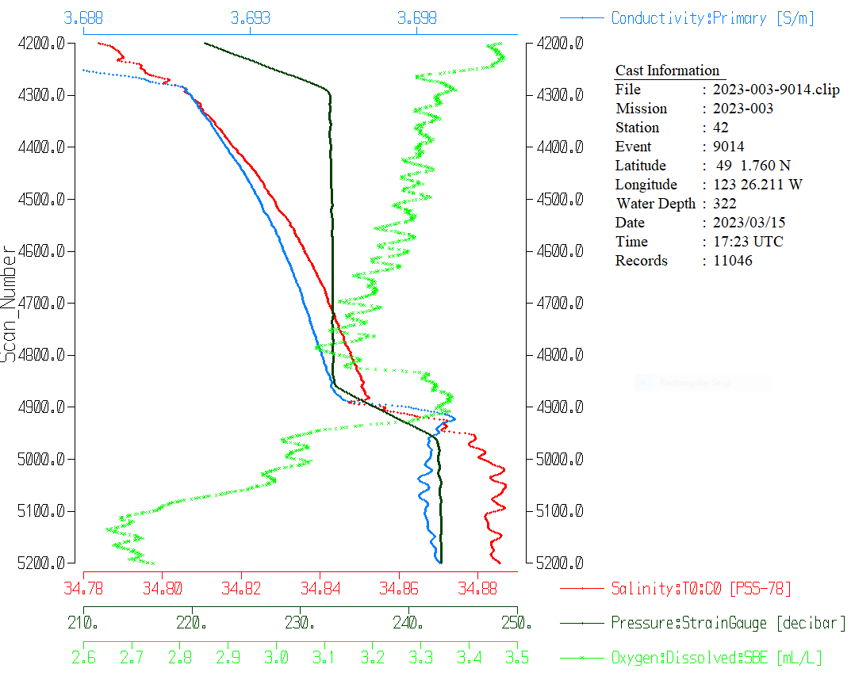

##### 9. Conversion to IOS Headers

The IOSSHELL routine was used to convert the CNV files to IOS Headers.

CLEAN was run to add event numbers and replace pad values in the pressure channel with interpolated values.

##### 10. Checking Headers

A cross-reference list was produced and 1 error was found. The longitude for cast #36 was wrong due to a format error in the CNV file; that was fixed the conversion and CLEAN routines were rerun.

Times agree with log book.

Track plots looked ok so were added to the end of this report.

Surface Check was run on the CLN files and the average was -0.019db, so using 0.7db as pressure offset in conversion was appropriate.

HEADER CHECK was run. The speed check turned up a problem in the longitude entry for cast #36; the format was wrong in the header, so it was fixed in the CNV file and CONVERT and CLEAN were run again.

##### 11. CLIP

The next step is to remove the data collected during soaks at 10m. Plots were examined to see how many records should be removed from each cast. File clip.csv was prepared with 2 columns containing event # and # of records to removed. CLIP was run and output plots examined until all looked appropriate.

The surface check was then run on CLIP files and the average was 0.9db.

##### 12. SHIFT

Conductivity

Tests were run to see if salinity data could be improved by realigning conductivity, but only small changes could be achieved with advances as large as -25 records.

This step was skipped.

Fluorescence

The fluorometer was not pumped, so a shift in alignment is expected to be small or unnecessary. Profile plots of temperature and fluorescence were examined and there was too little variation to judge alignment. Shift was not run on fluorescence.

Dissolved Oxygen

This channel was aligned earlier, but checks were made by examining plots of temperature and dissolved oxygen. No further adjustment was made.

##### 13. DELETE

DELETE was run on all casts using the following parameters:

Surface Record Removal: Last Press Min. Surface Swell Pressure Tolerance: 1.0

Swells deleted. Warning message if pressure difference of 2.00

Drop rates < 0.3m/s (calculated over 5 points) was deleted from 10db to 10db above the maximum pressure.

COMMENTS ON WARNINGS: There were no warnings.

##### 14. DETAILED EDITING

All DEL files were copied to *.EDT so there will be a complete set of files even if some need no editing.

CTDEDIT was used to remove some data corrupted by shed wakes at the bottom of files and at the surface for a few casts. The bad dissolved oxygen points found at the bottom were partly removed by that step, but more bad dissolved oxygen data that remained were removed.

All casts needed editing except cast #10.

Notes of editing details were made in the headers.

##### 15. Initial Bottle Data Steps

There was no rosette available for this cruise. There were surface bottles fired at 15 sites. At 5 sites there was also a Niskin mounted 3m above the CTD to collect near-bottom samples. This included 3 deep samples from Chito casts.

Each of the analysis spreadsheets were examined to see what comments the analysts wanted included in the header file. These were used to create file 2023-003-bot-hdr.txt which will be updated as needed during processing.

File 2023-003-bottles_plus_CTD_6linehdr. csv was created. A 6-line header was added and analysis data from the QF worksheets were added. Space was included for the addition of CTD data.

CTD data were bin-averaged in 0.5m bins. Data were then extracted from the shallowest data available below 0.5db and the sampling level for the 5 casts with deep bottles.

Workbook 2023-003-Bottles_Plus_CTD-comparison.xlsx was prepared to do a comparison of CTD and bottle data for salinity and fluorescence.

##### 16. Compare

Fluorescence

The only extracted chlorophyll sampling was at the surface. The CTD fluorescence data is generally from slightly lower in the water column so some difference is expected. As usual the fluorescence reads lower than the extracted CHL except when CHL is very low.

This is seen better by looking at the ratio FL/CHL vs CHL.

The fluorometer generally reads higher than the CHL when CHL is <1ug/L, but otherwise reads lower. The fluorescence generally looks a little lower relative to CHL than usual, which may be due to the mismatch in depth. Overall, the pattern looks similar to what is usually seen and suggests that the CTD fluorometer was performing in the expected manner. As usual, these data are considered nominal.

See 2023-003-CTD-bottle-comparison.xlsx for more detail.

Salinity Comparison

There were 10 bottle samples, 5 from the surface and 5 near the bottom.

CTD Salinity was higher than bottles by an average of 2.50psu; the average difference for surface bottles was 2.48 and deep bottles was 2.53psu. So pressure dependence is relatively small, but when differences are plotted against event number it is clear that the errors are decreasing with time.

After seeing this unusual comparison preliminary processing was done of data from the following cruises that used the same equipment:

2023-003 – March (#1 in plot below)

2023-020 – April (#2 in plot below)

2023-021 – Early May (#3 in plot below)

2023-022 - May/June (#4 in plot below)

2023-053 – mid-June

It showed that the salinity continued to be higher than bottles but that the differences gradually decreased with time until the mid-June cruise when conductivity, salinity and dissolved oxygen data were full of spikes. The CTD was sent for service after that cruise.

The CTD salinity is clearly bad and with both time and pressure dependence and few samples, no justifiable method was found to enable recalibration. Conductivity and salinity channels will be removed from files to be placed in the OSD Data Archive.

(For more information see documents 2023-003_CTD_Bottle_comparisons.xlsx and CTD456_vs_Bottles.xlsx.)

##### 17. Other calibration checks

Sensor History –

2023-002: The sensors were all used during cruise 2023-002. Pressure was found to be low by 0.7db. Salinity data were in reasonable agreement with the few bottles collected and all salinity profiles fell within local climatology. Some temperature profiles were occasionally outside the climatology but the variations looked real and certainly did not look like evidence of calibration drift. There was no dissolved oxygen sampling but profiles looked reasonable..

Data from later cruises were examined as discussed earlier in this report. There were many problems with salinity and sometimes with dissolved oxygen. During 2023-053 in June 2023 there were even worse problems with salinity, although 2 casts in the middle looked fine. Temperatures all fell within the historic ranges.

Historic Ranges – All salinity data were above the historic ranges except for a few near-surface values where the ranges were very wide. Temperatures were often below the historic minima, but casts in Satellite channel and Haro Strait were within the ranges as were casts #26 to 35 and cast 49 in the central Strait of Georgia. In the southern Strait temperature was low below 150m in the stations in the thalweg and up as far as GEO1. (Similar excursions were seen in March 2022 in the eastern central section of the Strait.) To the north there were sections of low temperatures between 20 and 75m for casts around Texada Island (casts #36 to 47). These features do not suggest calibration drift as they are not systematic and this is a region of high variability.

Post-cruise calibrations – None were available.

##### 18 CALIBRATE

Pressure looks good.

Salinity cannot be corrected and will not be archived.

There was no dissolved oxygen calibration sampling. Without reliable salinity values dissolved oxygen could not be derived in mass units and hence surface DO saturation could not be derived except for bottle files where there were 5 casts with Salinity:Bottle values at the surface.(see §22.) dissolved oxygen saturation at 1db for 5 casts was found to be 102%, 97%, 97%, 106% and 124%. The two highest saturation values came from the 2 casts with the highest surface fluorescence. The matches are rough and DO saturation values in this region tend to vary a lot, but the results are reasonable.

No recalibration was applied.

##### 19. Fluorescence Filter

The fluorescence data did not require filtering.

**20. Bin Average, Remove, Derive DO in mass units, Reorder**

The files were bin averaged using 1db bins.

REMOVE was run to remove Scan_Number, Conductivity, Salinity:T0:C0, Oxygen:Voltage, Descent Rate and Flag channels.

Dissolved Oxygen could not be derived in mass units since the salinity data are not reliable. So near-surface saturation could not be calculated.

##### 21. HEADER EDIT and final checks of CTD files.

Header Edit was used to fix headers, fix formats and to add comments about processing.

A cross-reference listing was produced.

A header check and standards check were run on the CTD files and no errors were found.

The sensor history was updated.

Plots of CTD casts were examined and no problems were found.

##### 2. Final BOT file preparation

For 3 sites, there were 2 CTD casts, a regular cast and a CHITO cast. The CHITO casts have no 10m soak and multiple stops during both the downcast and the upcasts, so no CTD file was prepared for those.

A single bottle file will also be produced for each site with event # matching the regular casts.

There were surface bottles fired when the regular cast began. During the CHITO cast bottles were fired at the surface and at the bottom of the cast. The only sampling in the surface bottles from the CHITO casts was extracted chlorophyll. Those data will not be included in the bottle files since the CTD data collected at that time is not of good quality with pumps not yet on and fluorescence had not equilibrated, and we have chlorophyll data from the surface of the regular casts. The samples from the bottom of the CHITO cast are useful as there was a sufficient wait before firing and CTD data look ok, so those will be included in the BOT files.

Workbook 2023-003-bottles_plus_CTD_6linehdr. csv was adjusted to change the event # for the CHITO bottom bottle record to match that of the regular cast.

That file was converted to IOS Header files for each cast.

The time and date are present as channels as these cannot be converted directly into header entries.

CLEAN was run to add START and END time to the headers. The END TIME is identical so the START time so it will be removed later. CLEAN was also used to enter 0 flags where the flag channels are empty.

None of the bottle salinity samples was <25psu. The downcast salinity is not reliable, but does not appear to be <25psu at 1db even allowing for values being too high 2 to 4psu. So silicate correction is impossible, and fortunately, does not appear necessary.

Change Units was run to get the dissolved oxygen data in mass units; this will only succeed where Salinity:Bottle data are available.

DERIVED Quantities was run to derive dissolved oxygen saturation where Salinity:Bottle data were available. The saturation was available near the surface for 5 casts and values there were 102%, 97%, 97%, 106% and 124%.

REORDER was run to get the 2 DO channels together.

REMOVE was run to remove Date and Time channels.

Header Edit was run to add comments and to remove END TIME (same as START TIME) and TIME ZERO.

The final files have extensions BOT.

The standards check was run and some empty channels were reported. In most cases there was no sampling and it is good to remove those as there was never any plan to sample and no flag was attached. So the steps from CLEAN to the end were repeated choosing to remove empty channels at the CLEAN stage. Empty channels remain for DO in mass units, but it is useful to retain these as they make it clear that mass units were not always derivable due to the lack of reliable CTD salinity data.

No other errors were found.

A cross-reference list and header check were run on the BOT files and no problems were found.

Plots were made of all BOT casts. With just 1 or 2 levels these were not very useful.

Finally all data from BOT files were extracted to a spreadsheet and compared to the event log; no problems were found.

PARTICULARS – Notes from log

Surface bottle snapped during CTD soak.

In some cases the bottle sample was recorded with separate event # from CTD cast: 25/23, 39/37. For others event #s the same.

9. Paused CTD cast due to wire contact at 194 on way down.

26. Bottom bottle 3m above CTD on wire.

43. Bottom bottle 3m above CTD on wire.

**CRUISE SUMMARY**

|  |  |  |  |  |  |
| --- | --- | --- | --- | --- | --- |
| Cruise ID#: 2023-003 | | | | | |
| Dates: Start: 14 March 2023 End: 19 March 2023 | | | | | |
| Location: Strait of Georgia Plankton | | | | | |
| Chief Scientist: Young K. | | | | | |
| **CTD#** | **Make** | **Model** | **Serial#** | **Used with Rosette?** | **CTD Calibration Sheet Competed?** | |
| 1 | SEABIRD | 25 | 456 | No | Yes | |

**CTD CALIBRATION INFORMATION**

**Make/Model/Serial#: SEABIRD/SBE25/0456 Cruise ID#: 2022-003**

|  |  |  |  |  |  |
| --- | --- | --- | --- | --- | --- |
| **Calibration Information** | | | | | |
| **Sensor** | | **Pre-Cruise** | | **Post Cruise** | |
| **Name** | **S/N** | **Date** | **Location** | **Date** | **Location** |
| **Temperature** | **6566** | **30Mar2021** | **Factory** |  |  |
| **Conductivity** | **5046** | **30Mar2021** | **Factory** |  |  |
| **ECO Fluorometer** | **2216** | **8Mar2017** | **Factory** |  |  |
| **SBE43 Oxygen** | **3779** | **15Oct2021** | **Factory** |  |  |
| **QSP BiosphericalPAR** | **4565** | **24Feb2021** | **Factory** |  |  |
| **Pressure**    **D:\Te****lewo****rk\2022-0** **28\Process****ing\ios\** | **573** | **4Feb****2022** | **Factory** |  |  |

