REVISION NOTICE TABLE
DATE | DESCRIPTION OF REVISION

PROCESSING NOTES
Cruises: CFMETR Nanoose
Project: Canadian Forces Maritime Experimental Test Range
Area: Nanoose
Date: 1 February 2022 – 7 December 2022
Platform: Redacted

Processed by: Germaine Gatien
Agency: IOS, Ocean Sciences Division, Sidney, B.C.
Date of Processing: 25 October 2023 – 14 November 2023
Number of original Hex files: 34 (1 upcast only) Number of casts processed: 33

INSTRUMENT SUMMARY
Two Sea Bird Model SBE 19 SEACAT CTDs (serial #1449 and 1511) were used with an altimeter attached. The sampling interval was 0.5s.

SUMMARY OF QUALITY AND CONCERNS
These data form part of a long-standing time-series rather than a cruise. They cover sampling by the Canadian Forces Maritime Experimental and Test Ranges during 2021 in Nanoose Bay, BC.

Calibration information for the CTDs could not be confirmed; they had not been recalibrated since 2014.

To assist in analysis, event numbers are helpful and the software in use will only allow 4 digits which suits most cruises. However, a 9-character system (Nyymmdd0#) is used for this project based on the letter N for Nanoose plus the date and 2 digits in case there are multiple casts on a single day. For use as an event number a 4-character format was derived from those IDs based on the month and day of each cast. This means the same event # will appear if there is more than 1 cast on 1 day, as occasionally occurred.

The soak period at 0-1.5m varied greatly, mostly between 25 seconds to 100 seconds, but occasionally longer. It is unknown what pump delay was set or if data logging was delayed. It is recommended that the SBE19+ be soaked for at least 2 minutes to improve salinity quality, but the conductivity appears to have generally equilibrated before pressure begins to change.

There was no salinity calibration sampling. SeaCat salinity is prone to error due to mismatch of conductivity and temperature response times, especially when the descent rate is non-uniform. SeaCat salinity errors are expected to be as high as 0.05units in areas of high gradients. Away from high gradients errors in salinity are expected to be on the order of 0.005. Other errors are expected due to calibration drift over 8 years.

The times given in the SeaBird headers do not include a time zone, but it is believed that local time was used. All times were converted to UTC by adding 7 or 8 hours depending on whether local time was PDT or PST. File names were assigned before time was converted to UTC; dates in the file name where checked and do match the UTC date.
In a few cases no position was available so a nominal position was entered.

PROCESSING SUMMARY
1. Seasave - This step was completed at sea; the raw data files are *.cnv.

2. Preliminary Steps
34 hex and 35 con files were delivered.

The file names were non-standard and contain the letter N followed by the date in YYMMDD format and 2 digits to indicate the sequential casts on a single day. While names are non-standard they are in the usual format for this project.

- Conversion of Raw Data
The raw data were converted by matching the configuration file to the input file name.

A spreadsheet “NanooseCtdStationLocationss2021.xls” was provided with positions for most casts.
The spreadsheet provided was saved as 20232-009NanooseCtdStations_merge_hdr.csv. Some editing was required:
- The format of latitude and longitude in the spreadsheet needed to be changed to:
DD MM.MM N and DDD MM.MM W. Concatenate was used to do this.
For 4 casts where there was no position in the spreadsheet, a nominal position was entered 49.33 N / 124.00 W.
- A column LOC:Station was added with every row having “Nanoose” entered.
- A column of event numbers was added to the CSV file using MMDD part of the file name as event number.

Data were acquired at the surface for between 25s and 100s. It is unknown what pump delay was set or if data logging was delayed. A 2-minute soak is generally advised for the best salinity data. For most casts the conductivity seems to have reached equilibrium before the full cast began.
Temperature and conductivity generally look ok.

The altimetry generally looks good within 15m of the bottom; if the CTD did not get within 15m altimetry will not get entered into the IOS Headers.

- WILDEDIT
There were a few spikes in conductivity and a few bottom spikes, but they will be easily removed later, so WILDEDIT was not run.

- FILTER
A low-pass filter was applied to the temperature and conductivity with a time constant of 0.5s and pressure with a time constant of 2s (4 times sampling rate).

- ALIGNCTD
Temperature was advanced by 0.73s relative to pressure since that has worked well for data from this project in previous years. A few casts were checked and the results were good. Alignment can be fine-tuned later using SHIFT if further adjustment is found useful.

7. CELL THERMAL MASS
CELLTM was run on all casts using the SeaBird recommended parameters, (α, 1/β) = (0.04, 8).

- DERIVE
Program DERIVE was run to calculate salinity.

- Conversion to IOS Headers
The IOSSHELL routine for Sea Bird ASCII files was used to convert the Sea-Bird data to IOS Headers.
The program MERGE CSV FILES TO HEADERS was then used to add positions, station name, event numbers and project name to the headers.

- Checking Headers
- Track Plot was used to ensure positions look normal. There are no problematic outliers though, as usual, there is scatter in locations.
- Header Check was run. There are some outliers that should disappear with further processing.
- The altimetry header information from each file was exported to a spreadsheet. Only 1 cast failed to get within 15m of the bottom as it only went to 33db. No bottom depths were available, so no checks could be made on altimetry accuracy.
- A cross-reference list was produced. The times appear to be in local time which is the usual case for this project. The times of casts are not consistent enough to notice if clocks might have changed from standard to daylight time, but in the past the Nanoose project was thought to use local time with both PST and PDT in use.
- Surface check was run. Values ranged from -0.5 to +2.6db, with the larger values associated with surface spikes. an average of 0.6db Pressure is within specifications.

ADD TIME CHANNEL was used to add 8 hours to casts up to March 12th and from November 5th to the end of the year. ADD TIME CHANNEL was used to add 7 hour to all other casts.

11. SHIFT
These data were aligned earlier in the process, but tests were run to see if a further shift might reduce unstable features. For many casts a shift of -0.5records made slight improvements while -0.7 was better for a few features but mostly looked worse. Variable descent rates and gradients limit the ability to improve alignment. SHIFT was run apply a shift of -0.5 records to the conductivity channel; salinity was recalculated.

11. CLIP
CLIP was used to remove the first 50 scans from the first 4 casts and 100 records from all other files.
Cast N22070703 contains only upcast data so will not be processed further. There are 2 other casts from that day.

12. FILTER
Tests were run using a median filter, size 7 applied to salinity, but it did not improve the data, so this step was skipped.

13. DELETE
DELETE was run on the clipped files using the following parameters:
Surface Record Removal: Last Press Min Maximum Surface Pressure (relative): 10.00
Surface Swell Pressure Tolerance: 1.0 Pressure not filtered
Swells deleted. Warning message if pressure difference of 2.00
Minimum Drop Rate 0.2m/s over 5 records between 10db and 10db above maximum pressure
There were no warnings.

14. CTDEDIT
The DEL files were copied to EDT.
CTDEDIT was used to edit 30 casts.
Salinity was smoothed in cases where unstable features appeared to be due to misalignments of T and C in the presence of temperature gradients. Data were removed from some casts due to shed wake corruption, mostly at the bottom of casts. Some near-surface data were removed.
The edited files were copied to EDT.

15. BIN AVERAGE
The following Bin Average values were used:
Bin channel = pressure Averaging interval = 1.000
Minimum bin value = .000 Average value will be used.
Interpolated values are NOT used for empty bins
Profile plots were examined on-screen.
T-S plots were examined and look good, with just a few very slightly unstable features that may well be real.

16. Intercomparisons
Historic ranges – Profile plots of temperature and salinity data were examined with the local seasonal climatology ranges superimposed. All casts fell within the climatology except for some slightly low salinity near the surface in July and near the bottom in September. Most of the climatology does not include the top 10 to 20m due to extreme variability. There is no evidence of poor calibration.

17. CALIBRATION
No recalibration was applied.

18. REMOVE and HEADEDIT
The following channels were removed from all casts: Scan_Number, Descent_Rate Altimetry and Flag.

The HEADEDIT routine was used to fix formats and to add the following comment to the headers:
-----------------------------------------------------------------------------------------
SeaCat salinity is prone to error due to a mismatch of conductivity and
temperature response times, especially when the descent rate is non-uniform.
Such errors are likely to be larger than calibration errors. SeaCat salinity
errors are expected to be as high as 0.05 units in areas of high gradients,
but on the order of 0.005 where gradients are low and descent rate steady.

There were no salinity calibration data available for this cruise and no recent
factory calibrations, so significant drift in calibration is likely.
CTD sensors #1449 and #1511 had not been calibrated since 2014.
For processing details see 2022-099_Processing_Report.doc.
-----------------------------------------------------------------------------------------
The standards check routine was run and the only comment concerned having “redacted” for platform. That information was removed by the data provider.
T-S plots were examined and no problems were found.

19. Producing final files
a.) The final files were renamed *.ctd.
b.) A cross-reference listing (see below) and header check were produced. No errors were found.

Institute of Ocean Sciences
CRUISE SUMMARY
Cruise ID#: Nanoose Test Range
Dates: Start: 1 February 2022 End: 7 December 2022
Location: Nanoose Test Range Vessel: Redacted

CTDs
CTD# | Make | Model | Serial# | Altimeter | Calibration data – Pressure, Temperature, Conductivity
1 | SEABIRD | 19 | 1449 | 1094 | September / October 2014
2 | SEABIRD | 19 | 1511 | 1095 | August/ September 2014

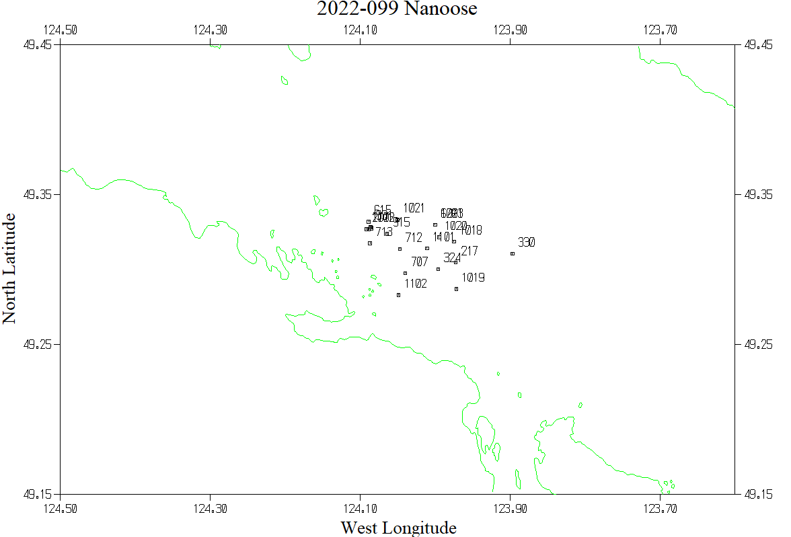

Cross -Reference List 2022-099

