**REVISION NOTICE TABLE**

|  |  |
| --- | --- |
| **Date** | **Description of Revision** |
| 20 July 2023 | DO Saturation converted to DO Concentration. SH |

**RBR CTD DATA PROCESSING NOTES**

Cruise: 2022-082

Agency: OSD

Locations: Nootka Sound and Hecate Channel

Project: Meteorological Network

Party Chief: Cooper G.

Platform: CME Anderson

Date: Nov. 15 2022 – Nov. 19, 2022

Processed by: Hana Hourston

Date of Processing: Feb. 15, 2023 – Mar. 6, 2023

Number of Raw files: 1 Number of Processed Files: 53

**Instrument Summary**

Equipment: RBR Maestro CTD (s/n 208765) with a Turner Cyclops Fluorometer (s/n 2110792), a JFE Advantech Rinko III oxygen sensor (s/n 0447), and a Seapoint turbidity sensor (s/n 208765).

Sampling frequency was at 8Hz.

**Summary of Quality and Concerns**

A cast list of times and locations was provided, so this was cross-referenced against the dates and times in the RSK files. The dates and times in the RSK files match the dates and times in the cast list.

Descent and recovery rates were about 1 m/s. Cast depth was to 5 m off the bottom.

The data overall look good. Oxygen saturation went below the limit of detection in some casts resulting in some small negative values that had to be recalibrated to zero.

**Processing Summary**

1. **Conversion to IOS Headers**

There was one .rsk file from this cruise containing 53 events. All casts were extracted using the Python function READ_EXCELrsk().

A single file (2022-082_CTD_Data.csv) with all the data including event numbers and a single line of headers was prepared using the Python function MERGE_FILES().

A 6-line header was inserted using the Python function Add_6Lineheader_2().

File “2022-082_header-merge.csv” was created, based on the information provided by the chief scientist.

* Column “File_Name”: entries were derived from the event number.
* Column “LOC:LATITUDE”: latitude was provided and reformatted to “XX XX.XXXX N !(deg min)”.
* Column “LOC:LONGITUDE”: longitude was provided and reformatted to “XX XX.XXXX W !(deg min)”.
* Column “LOC: Event Number”: entries were event numbers.
* Column “LOC: STATION”: all stations were set to those provided in the cruise log.
* Column “LOC: Water Depth:” was set to the water depth provided in the cruise log.

The sampling site was mapped (Figure 1) using from “2022-082_header-merge.csv” using the Python function Plot_Track_Location() to check the location of all casts.

Prior to conversion to IOS header format, the presence of zero-order holds were checked using the Python function Plot_Pressure_Diff() (Figure 2). It was unclear if there were zero-order holds from the output figure, so a differential was calculated on pressure in 2022-082_CSV_DATA-6linehdr.csv. Holds were found to occur at regular intervals in the file. A correction was applied using the Python function CORRECT_HOLD() and the corrected data were plotted (Figure 3).

CONVERT Spreadsheet Files was run to produce files with IOS Header format. Header entries of “Administration”, “File” and “Instrument” were filled in this step.

Raw data were plotted and examined:

* Conductivity spikes near the surface of casts 1 and 34 and into negative values at the surface of casts 11, 13, 18-20, 22, 25, 27, 29, 30, 39, and 41-50. This channel otherwise looks okay.
* Salinity looks fine. There is a spike near the surface of casts 1 and 34.
* Oxygen spikes at bottom of cast 1. Oxygen spikes in the middle of casts 5-8 and 48. Oxygen also goes slightly negative at the bottom of a few of the casts.
* Fluorescence spikes at the surface of most casts and at the bottom of casts 1, 7, 13, 14, 18, 23, and 30. Many of the spikes at the surface go into negative values.
* Temperature looks fine.

T-S plots were also made.

The routine “Merge:CSV Files to headers” was run to add location headers to the IOS files.

Next CLEAN was run to add a start time and event numbers to headers.

A CALIBRATE step was needed here to replace negative oxygen saturation values with zero. These negative values were small and occurred at the bottom of casts where oxygen was approaching zero, so it’s likely that the negative values correspond to real values below the limit of detection.

Then REORDER was run to reorder the channels in all files.

1. **Data processing**

* No correction to pressure was needed for this cruise.
* Add Time Channels was executed to add record numbers to the files to help with clipping and manual padding (output: *.adt0).
* CLIP: Pressure is steady for a few of the first scans in all casts. Initial records were removed from the .adt0 files until the downcast began using file “2022-082_CLIP.csv”. Bottom fluorescence spikes and upcasts in casts 1, 13, 14, 18, 23, and 30 were also clipped out. These spikes may have been the result of the CTD getting too close to the sea floor and stirring it up.
* Oxygen spikes in the middle of casts 5-8 and 48 were checked more closely to determine if they needed to be padded by hand using a text editor. There were spikes in the upcast of casts 5, 8, and 48 so they were left in because they would be removed by the DELETE step. There were also spikes in the downcast of casts 5-7 and 48 so these were padded. The spike in cast 41 had been removed by the CLIP step. A fluorescence spike remaining at the bottom of cast 30 was also padded.
* T-S plots were made after CLIP to check for spikes or unreal unstable features. No spikes were found in any downcasts.
* Filter: a Gull-winged filter, size 3, was applied to temperature, conductivity, fluorescence, and pressure. Salinity will be recalculated after the shift steps.
* SHIFT: Based on suggested values in document “Guidelines for processing RBR CTD profiles”, the alignment of temperature and conductivity was corrected by applying a shift of -2 scans in conductivity. Salinity was recalculated after this step. Salinity profile plots before and after alignment were compared, and small spikes in a few casts showed that the alignment was not perfect for these casts.
* SHIFT: Better alignment with Oxygen profiles was found by advancing it by 11 scans. The advice given in document “Guidelines for processing RBR CTD Profiles” was that an advance between 2 and 3 seconds is appropriate. T-O plots before and after alignment were compared.
* Delete was run to remove records with a descent rate lower than 0.3m/s over 8 points. This was not applied in the top 10m to avoid loss of surface records as the CTD began its descent, nor in the bottom 10m.
* Profile plots were examined after DELETE and confirm that plots show reasonable values for salinity, conductivity and fluorescence. A small salinity and conductivity spike was found in cast 44 and was padded by hand using a text editor. DO saturation levels at the surface ranged from about 60% to 90%. There was no calibration sampling and no climatology to enable a judgement about the data reliability.

1. **Final checks and header editing**

* REMOVE was run to remove the following channels from all casts: Date, Time:UTC, Event, and Record Number.
* BIN AVERAGE was used to average the data by pressure into 1 dbar bins.
* CALIBRATE was run to convert conductivity units to S/m using file 2022-082-recal2.ccf.
* CLEAN was run to reset the Maximum and Minimum values in the Header.
* Header Edit was used to fix channel names and format as listed below:
* Depth: meters ==> metres
* Temperature: deg C(ITS90) ==> deg C (ITS90)
* Salinity:CTD ==> Salinity
* Fluorescence ==> Fluorescence:URU
* Conductivity: F10.5 ==> F10.6
* Oxygen:Dissolved ==> Oxygen:Dissolved:Saturation:RBR, format F11.4 ==> F8.2
* Header Check was run and no major problems were found. Standards check was run and no problems were found.
* Final profile and T-S plots were made. A track plot was also made.

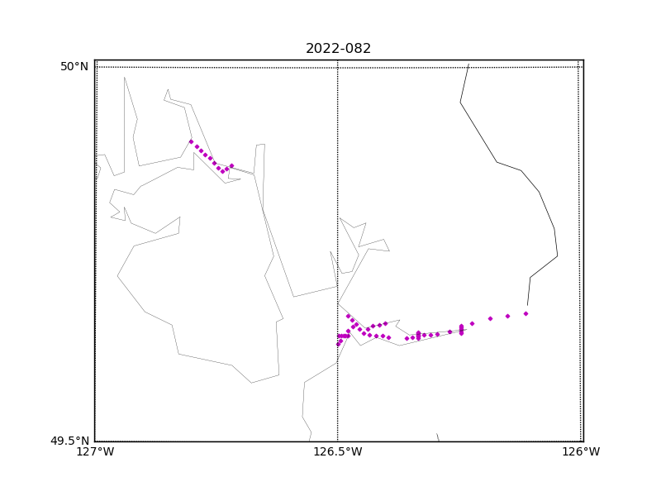

Figure 1 – Location of casts for cruise 2022-082.

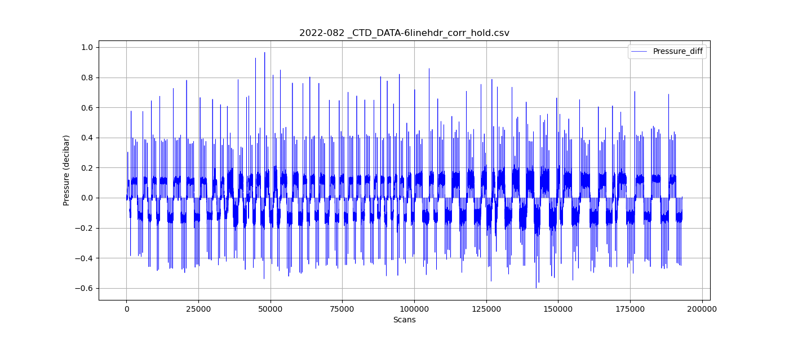

Figure 2 – Zero-order holds prior to correction.

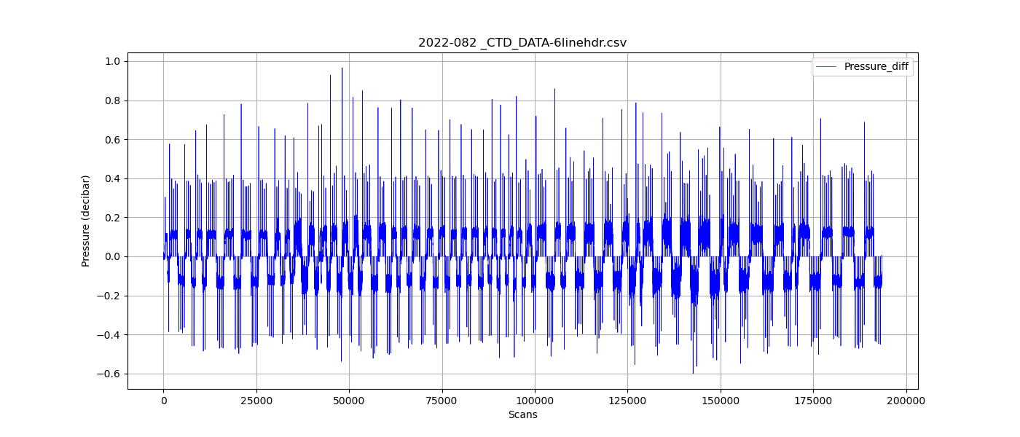

Figure 3 – Pressure differentials after the zero-holds correction.