|  |  |
| --- | --- |
| **Revision Table** | |
| **Date** | **Description** |
| **29 June 2023** | **DO saturation converted to DO concentration . SH.** |

**RBR CTD DATA PROCESSING NOTES**

Cruise: 2022-080

Agency: OSD

Locations: Quatsino Sound, Holberg Inlet and Neroutsos Inlet

Project: Meteorological Network

Party Chief: Cooper G.

Platform: Blackfish

Date: Oct. 19 2022 – Oct. 21, 2022

Processed by: Hana Hourston

Date of Processing: Feb. 22, 2023 – Mar. 23, 2023

Number of Raw files: 1 Number of Processed Files: 26

**Instrument Summary**

Equipment: RBR Maestro CTD (s/n 204694) with a Turner Cyclops Fluorometer (s/n 21101282), and a JFE Advantech Rinko III oxygen sensor (s/n 0411). Sampling frequency was at 8Hz. The fluorometer gain setting was set to “autorange”.

**Summary of Quality and Concerns**

A cast list of times and locations was provided, so this was cross-referenced against the dates and times in the RSK files. The dates and times in the RSK files match the dates and times in the cast list.

Descent and recovery rates were about 0.38 m/s.

There was an issue in most of the casts where fluorescence would spike when the fluorometer’s gain would change, so the spikes were removed using a graphical editor before bin-averaging. Gain changes are recorded in the events log in the .rsk file. The “autorange” setting is known to be sluggish in choosing ranges and to yield noisy data.

The rest of the data overall look good.

**Processing Summary**

1. **Conversion to IOS Headers**

There was one .rsk file from this cruise containing 26 events. All casts were extracted using the Python function READ_EXCELrsk().

A single file (2022-080_CTD_Data.csv) with all the data including event numbers and a single line of headers was prepared using the Python function MERGE_FILES().

A 6-line header was inserted using the Python function Add_6Lineheader_2().

File “2022-080_header-merge.csv” was created, based on the information provided by the chief scientist.

* Column “File_Name”: entries were derived from the event number.
* Column “LOC:LATITUDE”: latitude was provided and reformatted to “XX XX.XXXX N !(deg min)”.
* Column “LOC:LONGITUDE”: longitude was provided and reformatted to “XX XX.XXXX W !(deg min)”.
* Column “LOC: Event Number”: entries were event numbers.
* Column “LOC: STATION”: all stations were set to those provided in the cruise log.
* Column “LOC: Water Depth:” was set to the water depth provided in the cruise log.

The sampling site was mapped (Figure 1) using from “2022-080_header-merge.csv” using the Python function Plot_Track_Location() to check the location of all casts.

Prior to conversion to IOS header format, the presence of zero-order holds were checked using the Python function Plot_Pressure_Diff() (Figure 2). It was unclear if there were zero-order holds from the output figure, so a differential was calculated on pressure in 2022-080_CSV_DATA-6linehdr.csv. Holds were found to occur at regular intervals in the file. A correction was applied using the Python function CORRECT_HOLD() and the corrected data were plotted (Figure 3).

CONVERT Spreadsheet Files was run to produce files with IOS Header format. Header entries of “Administration”, “File” and “Instrument” were filled in this step.

Raw data were plotted and examined:

* Conductivity spikes near the surface of casts 3, 6, and 22, and at the bottom of cast 13. This channel otherwise looks okay.
* Salinity spikes near the surface of casts 1, 3, 6, and 22, and at the bottom of casts 4 and 13. This channel otherwise looks okay.
* Oxygen looks okay.
* Fluorescence is very spiky. Many casts have spikes between 100-120 mg/m^3 near the surface and casts 3, 4, 7, and 10 have at least one spike over 1000 mg/m^3 near the surface.
* Temperature spikes near the surface of cast 24, but otherwise looks okay.

Descent rate was plotted against pressure to confirm that some salinity spikes in casts 4 and 13 corresponded to a change in descent rate. Changes in downcast descent rate in casts 1, 19, and 20 did not explain the salinity spikes in these casts.

T-S plots were also made.

The routine “Merge:CSV Files to headers” was run to add location headers to the IOS files.

Next CLEAN was run to add a start time and event numbers to headers.

Then REORDER was run to reorder the channels in all files.

1. **Data processing**

* No correction to pressure was needed for this cruise.
* Add Time Channels was executed to add record numbers to the files to help with clipping and manual padding next (output: *.adt0).
* CLIP: Most of the spikes found by plotting the raw data occurred on the upcast, so these were left as they will be removed during the DELETE step. The conductivity and salinity spikes in cast 13 were the only ones occurring on the downcast so these were removed using CLIP. These spikes may have been the result of the CTD getting too close to the sea floor and stirring it up.
* T-S plots and profile plots were made after CLIP to check for spikes or unreal unstable features. Salinity and fluorescence still had many spikes at this step.
* Filter: a Gull-winged filter, size 3, was applied to temperature, conductivity, fluorescence, and pressure. Salinity will be recalculated after the shift steps.
* SHIFT: The suggested number of scans for shifting conductivity to align with temperature is -2 in the document “Guidelines for processing RBR CTD profiles”. However, a shift of -2 scans was found to increase the number of small spikes salinity (salinity is recalculated after shifting conductivity), suggesting imperfect alignment between temperature and conductivity. The effect of different shift amounts on salinity were compared in profile plots of salinity before and after shifting conductivity; these showed that a shift of -0.5 scans was a bit better for keeping salinity spikes to a minimum. Salinity profile plots before and after alignment were compared, and showed that spikiness had been reduced a bit.
* SHIFT: Better alignment with Oxygen profiles was found by advancing it by 18 scans, which corresponds to a shift of +2.25s for an 8Hz sampling frequency. The advice given in document “Guidelines for processing RBR CTD Profiles” was that an advance between 2 and 3 seconds is appropriate. T-O plots before and after alignment were compared.
* Delete was run to remove records with a descent rate lower than 0.3m/s over 8 points. This was not applied in the top 10m to avoid loss of surface records as the CTD began its descent, nor in the bottom 10m.
* Profile plots were examined after DELETE. Salinity and fluorescence still had spikes that needed removing. DO saturation levels at the surface ranged from about 50% to 140%. There was no calibration sampling and no climatology to enable a judgement about the data reliability.
* The graphical editor CTD Edit was used to remove spikes from fluorescence, conductivity, and salinity. Profile plots were examined after editing to confirm that all spikes and fluorescence stalls had been padded.

1. **Final checks and header editing**

* REMOVE was run to remove the following channels from all casts: Date, Time:UTC, Event, and Record Number.
* BIN AVERAGE was used to average the data by pressure into 1 dbar bins.
* CALIBRATE was run to convert conductivity units to S/m using file 2022-080-recal2.ccf.
* CLEAN was run to reset the Maximum and Minimum values in the Header.
* Header Edit was used to fix channel names and format as listed below:
* Depth: meters ==> metres
* Temperature: deg C(ITS90) ==> deg C (ITS90)
* Salinity:CTD ==> Salinity
* Fluorescence ==> Fluorescence:URU
* Conductivity: F10.5 ==> F10.6
* Oxygen:Dissolved ==> Oxygen:Dissolved:Saturation:RBR, format F11.4 ==> F8.2
* Header Check was run and no major problems were found. A few minor concerns were that cast 10 had a cruising speed between 10 and 15 knots and cast 21 had a cruising speed between 15 and 20 knots. Standards check was run and no problems were found.
* Final profile and T-S plots were made. A track plot was also made.

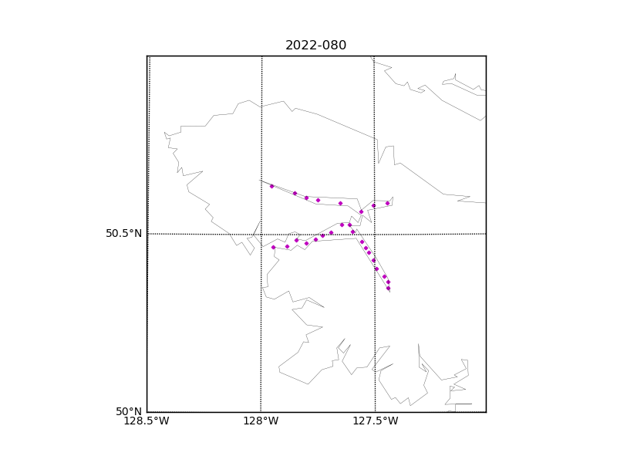

Figure 1 – Location of casts for cruise 2022-080.

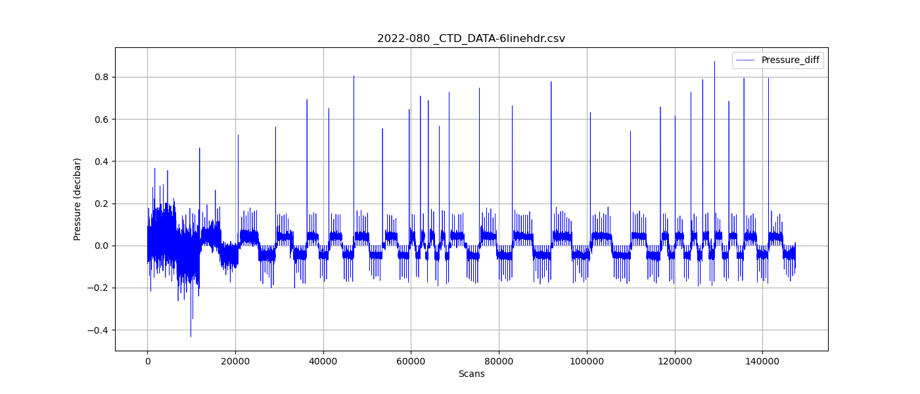

Figure 2 – Zero-order holds prior to correction.

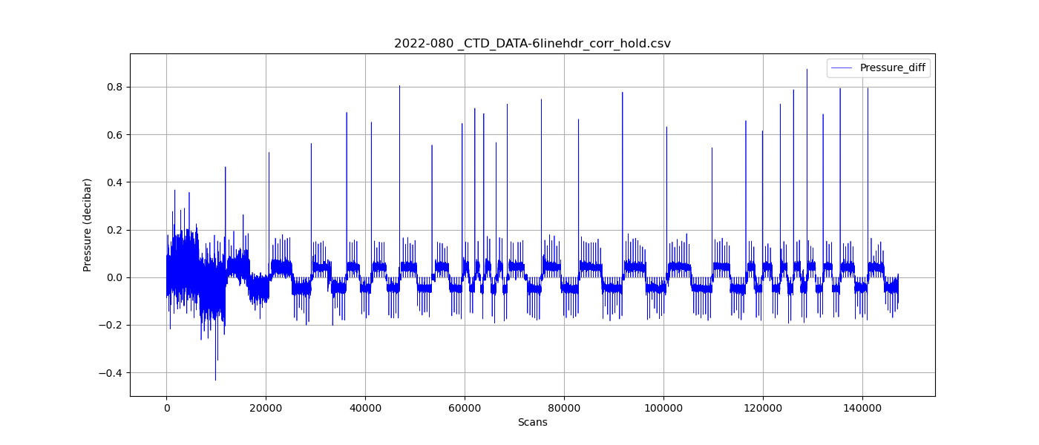

Figure 3 – Pressure differentials after the zero-holds correction.