|  |  |
| --- | --- |
| **Revision Table** | |
| **Date** | **Description of Revision** |
| **29 June 2023** | **DO Saturation converted to DO concentration. SH.** |

**RBR CTD DATA PROCESSING NOTES**

Cruise: 2022-077

Agency: OSD

Locations: NWCVI, Cape Scott, Quatsino Sound, Holberg Inlet, Neroutsos Inlet, Rupert Inlet

Project: Quatsino ADRCP

Party Chief: Cooper G.

Platform: Blackfish

Date: Sept. 19 2022 – Sept. 23, 2022

Processed by: Hana Hourston

Date of Processing: Jan. 31, 2023 – Mar. 22, 2023

Number of Raw files: 1 Number of Processed Files: 27

**Instrument Summary**

Equipment: RBR Maestro CTD (s/n 208765) with a Turner Cyclops Fluorometer (s/n 2110792), a JFE Advantech Rinko III oxygen sensor (s/n 0447), and a Seapoint turbidity sensor (s/n 208765).

Sampling frequency was at 8Hz. The fluorometer gain setting was set to “autorange”.

**Summary of Quality and Concerns**

A cast list of times and locations was provided, so this was cross-referenced against the dates and times in the RSK files. The dates and times in the RSK files match the dates and times in the cast list.

The depth sounder was not working well on the vessel so all depths are approximate. The CTD sat at the surface for 30 seconds before each cast began. Descent and recovery rates were about 0.38 m/s.

The fluorescence data in many of the casts had regular spikes to about 44 mg/m^3 corresponding to gain changes of the fluorometer, which was set to “autorange” instead of a fixed range. Gain changes are recorded in the events log in the .rsk file. The “autorange” setting is known to be sluggish in choosing ranges and to yield noisy data. Spikes were removed using a graphical editor before bin-averaging.

Fluorescence and oxygen were both high at station NE0 (cast 11), possibly due to river outflow near that location and the history of industry in the area including an old pulp mill.

The rest of the data overall look good.

**Processing Summary**

1. **Conversion to IOS Headers**

There was one .rsk file from this cruise containing 74 events. The first 47 casts were from a previous program and were discarded (based on the direction from the chief scientist) after extracting all casts using the Python function READ_EXCELrsk().

A single file (2022-077_CTD_Data.csv) with all the data including event numbers and a single line of headers was prepared using the Python function MERGE_FILES().

A 6-line header was inserted using the Python function Add_6Lineheader_2().

File “2022-077_header-merge.csv” was created, based on the information provided by the chief scientist.

* Column “File_Name”: entries were derived from the event number.
* Column “LOC:LATITUDE”: latitude was provided and reformatted to “XX XX.XXXX N !(deg min)”.
* Column “LOC:LONGITUDE”: longitude was provided and reformatted to “XX XX.XXXX W !(deg min)”.
* Column “LOC: Event Number”: entries were event numbers.
* Column “LOC: STATION”: all stations were set to those provided in the cruise log.
* Column “LOC: Water Depth:” was set to the water depth provided in the cruise log.

The sampling site was mapped (Figure 1) using from “2022-077_header-merge.csv” using the Python function Plot_Track_Location() to check the location of all casts.

Prior to conversion to IOS header format, the presence of zero-order holds were checked using the Python function Plot_Pressure_Diff() (Figure 2). It was unclear if there were zero-order holds from the output figure, so a differential was calculated on pressure in 2022-077_CSV_DATA-6linehdr.csv. Holds were found to occur at regular intervals in the file. A correction was applied using the Python function CORRECT_HOLD() and the corrected data were plotted (Figure 3).

CONVERT Spreadsheet Files was run to produce files with IOS Header format. Header entries of “Administration”, “File” and “Instrument” were filled in this step.

Raw data were plotted and examined:

* Conductivity looks good. There is some bad data at the bottom of casts 14 and 16.
* Salinity looks good. There is some bad data at the bottom of casts 14 and 16.
* Oxygen looks good. In cast 11 it attains a maximum value of about 250% at the surface which may be suspicious. The rest of the casts are under 200% at the surface.
* Fluorescence has some bad data at the bottom of casts 14, 16, and 17. There are also some spikes above 40 mg/m^3 near the surface of casts 3-16 and 20-27. Many of these spikes coincide in time with a fluorometer gain change in the events log from the .rsk file.
* Temperature looks good.

There were spikes in all channels at the surface for many casts.

T-S plots were also made.

The routine “Merge:CSV Files to headers” was run to add location headers to the IOS files.

Next CLEAN was run to add a start time and event numbers to headers.

Then REORDER was run to reorder the channels in all files.

1. **Data processing**

* No correction to pressure was needed for this cruise.
* CLIP: Pressure is steady for a few of the first scans in all casts. Initial records were removed until the downcast began using file “2022-077_CLIP.csv”. Casts 14 and 16 also had records removed from the end with the CLIP file because they contained long duration salinity spikes at the bottom. These spikes may have been the result of the CTD getting too close to the sea floor and stirring it up; the deepest records are deeper than the recorded water depth for those casts, but the water depths are approximate because of the depth sounder not working well. Record numbers were added to the REORDER files (extension “.adt0”) with Add Time Channels to help with finding the last good record number in casts 14 and 16, but CLIP was ultimately carried out on the REORDER files.
* T-S plots were made after CLIP to check for spikes or unreal unstable features. An unstable feature was identified in cast 2, but the profile suggests that it could be real so it was left as is.
* Filter: a Gull-winged filter, size 5, was applied to temperature, conductivity, fluorescence, and pressure. Salinity will be recalculated after the shift steps.
* SHIFT: Based on suggested values in document “Guidelines for processing RBR CTD profiles”, the alignment of temperature and conductivity was corrected by applying a shift of -2 scans in conductivity. Salinity was recalculated after this step. Salinity profile plots before and after alignment were compared.
* SHIFT: Better alignment with Oxygen profiles was found by advancing it by 18 scans. The advice given in document “Guidelines for processing RBR CTD Profiles” was that an advance between 2 and 3 seconds is appropriate. T-O plots before and after alignment were compared.
* Delete was run to remove records with a descent rate lower than 0.3m/s over 8 points. This was not applied in the top 10m to avoid loss of surface records as the CTD began its descent, nor in the bottom 10m.
* Profile plots were examined after DELETE and confirm that plots show reasonable values for salinity and conductivity. Large fluorescence spikes still remained, as well as small salinity spikes in some casts that were likely the result of imperfect alignment of the conductivity sensor. DO saturation levels at the surface ranged from about 80% to 240%. There was no calibration sampling and no climatology to enable a judgement about the data reliability.
* CTD Edit was used to pad fluorescence, salinity, and conductivity spikes, as well as fluorescence stalls. High fluorescence values (> 70 mg/m^3) were left at the surface of cast 11 because the events log from the .rsk file did not count a fluorometer gain change at that time that could have triggered a spike.

1. **Final checks and header editing**

* REMOVE was run to remove the following channels from all casts: Date, Time:UTC and Event.
* BIN AVERAGE was used to average the data by pressure into 1 dbar bins.
* CALIBRATE was run to convert conductivity units to S/m using file 2022-077-recal2.ccf.
* CLEAN was run to reset the Maximum and Minimum values in the Header.
* Header Edit was used to fix channel names and format as listed below:
* Depth: meters ==> metres
* Temperature: deg C(ITS90) ==> deg C (ITS90)
* Salinity:CTD ==> Salinity
* Fluorescence ==> Fluorescence:URU
* Conductivity: F10.5 ==> F10.6
* Oxygen:Dissolved ==> Oxygen:Dissolved:Saturation:RBR, format F11.4 ==> F8.2
* Header Check was run and no major problems were found. One minor concern was that cast 20 had a cruising speed between 10 and 15 knots. Fluorescence and oxygen were both high in cast 11 at station NE0, reaching 81 mg/m^3 and 233%, respectively, but this may be real due to the old pulp mill nearby. Standards check was run and no problems were found.
* Final profile and T-S plots were made. A track plot was also made.

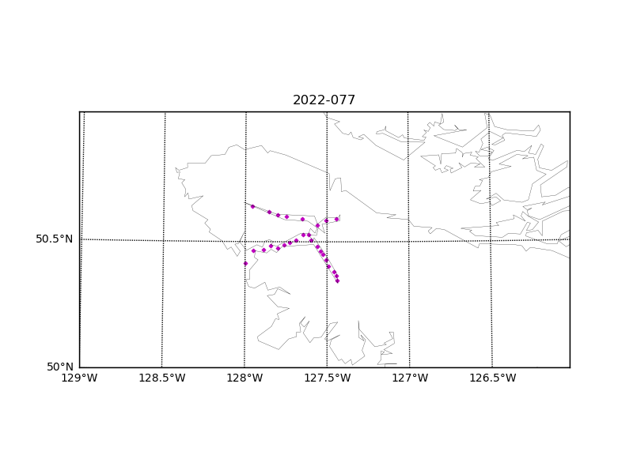

Figure 1 – Location of casts for cruise 2022-077.

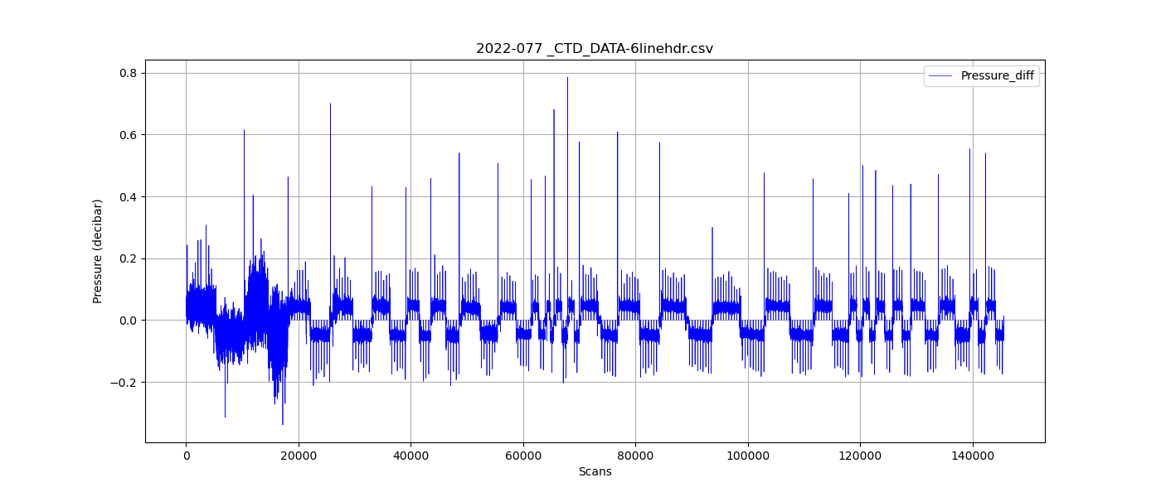

Figure 2 – Zero-order holds prior to correction.

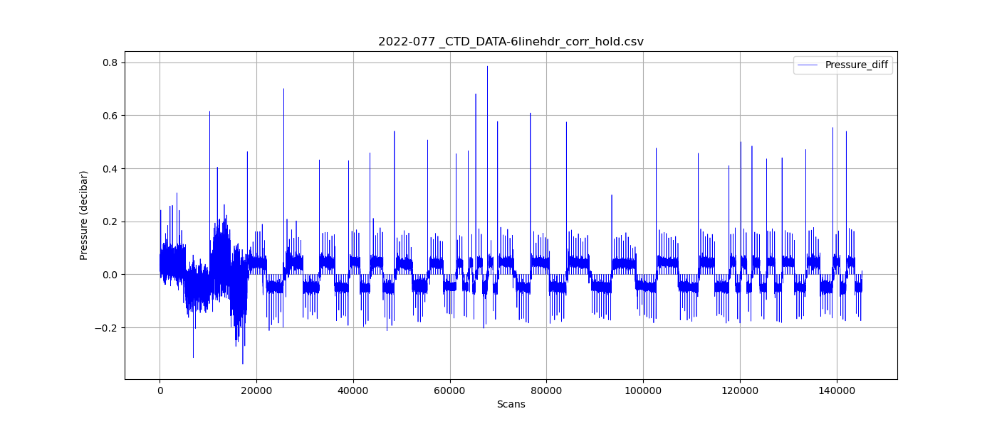

Figure 3 – Pressure differentials after the zero-holds correction.