**Strait of Georgia / Juan de Fuca Strait Biophysical Survey 2022-070 October 5th – 12th , 2022**

|  |  |  |  |  |  |  |  |
| --- | --- | --- | --- | --- | --- | --- | --- |
| **Sta** | **Lat** | **mn** | **Lon** | **mn** | **Depth (m)** | **Stn time (min)** | **# Bot** |
| 51 | 48 | 46.7 | 122 | 51.6 | 155 | 10 |  |
| 52 | 48 | 38.9 | 122 | 43.3 | 91 | 5 |  |
| 53 | 48 | 33.2 | 122 | 45.0 | 60 | 5 |  |
| 54 | 48 | 26.6 | 122 | 44.3 | 77 | 5 |  |
| 56 | 48 | 46.4 | 123 | 1.6 | 214 | 20 | 14 |
| 57 | 48 | 44.0 | 123 | 8.1 | 163 | 10 |  |
| 58 | 48 | 43.0 | 123 | 14.3 | 338 | 15 |  |
| 59 | 48 | 37.8 | 123 | 14.6 | 227 | 35 | 14 |
| 60 | 48 | 33.9 | 123 | 12.8 | 298 | 15 |  |
| 61 | 48 | 29.2 | 123 | 9.2 | 274 | 15 |  |
| 62 | 48 | 22.8 | 123 | 2.6 | 150 | 15 | 11 |
| 63 | 48 | 14.6 | 122 | 58.5 | 154 | 25 | 4 |
| 64 | 48 | 12.8 | 123 | 5.8 | 97 | 5 |  |
| 65 | 48 | 15.9 | 123 | 9.8 | 121 | 15 | 10 |
| 66 | 48 | 19.3 | 123 | 14.1 | 104 | 5 |  |
| 67 | 48 | 22.8 | 123 | 18.1 | 106 | 5 |  |
| 68 | 48 | 12.2 | 123 | 43.0 | 137 | 10 |  |
| 69 | 48 | 15.6 | 123 | 43.2 | 174 | 15 | 12 |
| 70 | 48 | 19.2 | 123 | 43.2 | 154 | 10 |  |
| 71 | 48 | 22.2 | 123 | 59.4 | 115 | 5 |  |
| 72 | 48 | 18.6 | 124 | 4.0 | 192 | 30 | 13 |
| 73 | 48 | 15.0 | 124 | 6.7 | 157 | 10 |  |
| 74 | 48 | 25.1 | 124 | 35.6 | 192 | 10 |  |
| 75 | 48 | 28.2 | 124 | 32.8 | 230 | 20 | 14 |
| 76 | 48 | 31.4 | 124 | 30.0 | 93 | 5 |  |
| 101 | 48 | 25.4 | 124 | 45.1 | 143 | 10 |  |
| 102 | 48 | 30.0 | 124 | 44.0 | 260 | 20 | 14 |
| 103 | 48 | 33.0 | 124 | 43.0 | 125 | 10 |  |
| 104 | 48 | 20.0 | 123 | 18.0 | 70 | 5 |  |
| 105 | 48 | 11.0 | 123 | 19.0 | 80 | 5 |  |
| 109 | 48 | 56.5 | 123 | 21.8 | 196 | 10 |  |
| adcp | 48 | 14.0 | 123 | 18.0 | 113 | 15 | 10 |
| SI | 48 | 39.1 | 123 | 30.6 | 184 | 15 | 9 |
| GEO1 | 49 | 15 | 123 | 44.9 | 400 | 40 | 4 |
| CPF1 | 49 | 22 | 124 | 5.1 | 250 | 25 | 4 |
| CPF2 | 49 | 28 | 124 | 30 | 326 | 25 |  |
| SC-04 | 48 | 43.50 | 123 | 25.0 | 94 | 25 | 4 |
| GI-01 | 48 | 45.86 | 123 | 20.53 | 60 | 25 | 4 |
| QU-39 | 50 | 1.84 | 125 | 5.52 | 260 | 15 | 4 |
|  |  |  |  |  |  |  |  |
|  |  |  |  |  |  |  |  |

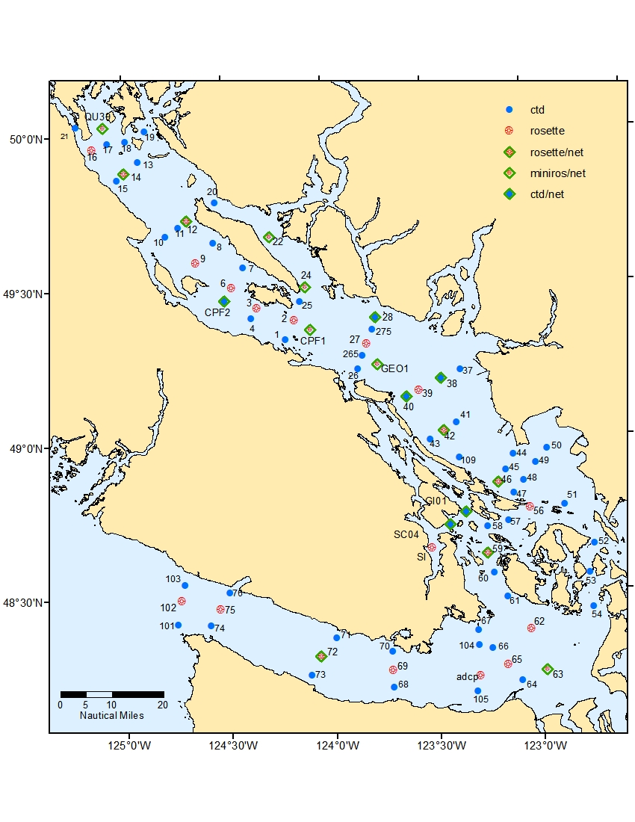

|  |  |  |  |  |  |  |  |
| --- | --- | --- | --- | --- | --- | --- | --- |
| **Sta** | **Lat** | **mn** | **Lon** | **mn** | **Depth (m)** | **Stn time (min)** | **# Bot** |
| 1 | 49 | 20.3 | 124 | 12.1 | 247 | 10 |  |
| 2 | 49 | 24.1 | 124 | 9.3 | 289 | 25 | 15 |
| 3 | 49 | 26.6 | 124 | 20.2 | 327 | 25 | 16 |
| 4 | 49 | 24.5 | 124 | 22.1 | 344 | 15 |  |
| 6 | 49 | 30.6 | 124 | 27.8 | 192 | 20 | 13 |
| 7 | 49 | 34.4 | 124 | 24.2 | 357 | 15 |  |
| 8 | 49 | 39.3 | 124 | 33.0 | 355 | 15 |  |
| 9 | 49 | 35.5 | 124 | 38.3 | 170 | 15 | 12 |
| 10 | 49 | 40.7 | 124 | 47.3 | 95 | 5 |  |
| 11 | 49 | 42.4 | 124 | 43.4 | 289 | 15 |  |
| 12 | 49 | 43.6 | 124 | 40.8 | 357 | 45 | 16 |
| 13 | 49 | 55.3 | 124 | 55.2 | 219 | 10 |  |
| 14 | 49 | 53.0 | 124 | 59.6 | 311 | 40 | 15 |
| 15 | 49 | 51.6 | 125 | 1.6 | 143 | 10 |  |
| 16 | 49 | 57.7 | 125 | 8.8 | 146 | 15 | 11 |
| 17 | 49 | 58.8 | 125 | 4.3 | 265 | 10 |  |
| 18 | 49 | 59.2 | 124 | 58.9 | 146 | 10 |  |
| 19 | 50 | 1.2 | 124 | 52.9 | 283 | 15 |  |
| 20 | 49 | 47.2 | 124 | 32.3 | 311 | 15 |  |
| 21 | 50 | 2.0 | 125 | 13.6 | 72 | 5 |  |
| 22 | 49 | 40.2 | 124 | 16.3 | 358 | 35 | 4 |
| 24 | 49 | 30.3 | 124 | 6.0 | 430 | 40 | 4 |
| 25 | 49 | 27.7 | 124 | 7.5 | 290 | 15 |  |
| 26 | 49 | 14.3 | 123 | 50.8 | 256 | 10 |  |
| 265 | 49 | 16.7 | 123 | 49.5 | 410 | 5 |  |
| 27 | 49 | 19.1 | 123 | 48.0 | 347 | 25 | 16 |
| 275 | 49 | 21.8 | 123 | 46.6 | 110 | 10 |  |
| 28 | 49 | 24.1 | 123 | 45.3 | 134 | 10 |  |
| 37 | 49 | 13.6 | 123 | 20.7 | 219 | 10 |  |
| 38 | 49 | 12.0 | 123 | 26.4 | 296 | 15 |  |
| 39 | 49 | 9.8 | 123 | 33.0 | 388 | 30 | 17 |
| 40 | 49 | 8.6 | 123 | 36.8 | 146 | 10 |  |
| 41 | 49 | 3.3 | 123 | 22.3 | 247 | 25 |  |
| 42 | 49 | 1.8 | 123 | 26.2 | 326 | 25 | 16 |
| 43 | 49 | 0.2 | 123 | 30.1 | 187 | 10 |  |
| 44 | 48 | 56.8 | 123 | 6.0 | 119 | 5 |  |
| 45 | 48 | 53.9 | 123 | 8.4 | 128 | 10 |  |
| 46 | 48 | 51.4 | 123 | 10.8 | 179 | 15 | 12 |
| 47 | 48 | 49.3 | 123 | 6.2 | 188 | 10 |  |
| 48 | 48 | 51.7 | 123 | 3.2 | 220 | 10 |  |
| 49 | 48 | 55.0 | 122 | 59.6 | 132 | 10 |  |
| 50 | 48 | 57.7 | 122 | 56.1 | 26 | 5 |  |
|  |  |  |  |  |  |  |  |

Vertical Net with chl, HPLC & nutrients

Phyto / Domoic Acid

DIC sampling

4

Vertical Net